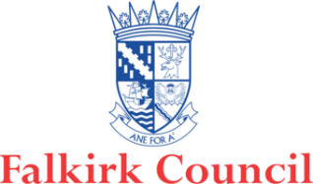

Falkirk Short Breaks Services Guide
A short guide: Information about the short breaks service available for Carers and cared-for persons.

contents

Why do we have a Short Breaks Services Statement? 1
What is a Short Break? 1
Who can Access Short Breaks? 2
Types of Support 2
How to get a Short Break 4
Who is Eligible for a Short Break? 5
Is there a Cost? 5
Contact Details 5

Document information
Date of issue: | 2019
Approval status: | Published
Available from: | Partnership website – www.falkirkhscp.org/publications
Key contact: | sbb@falkirk.gov.uk

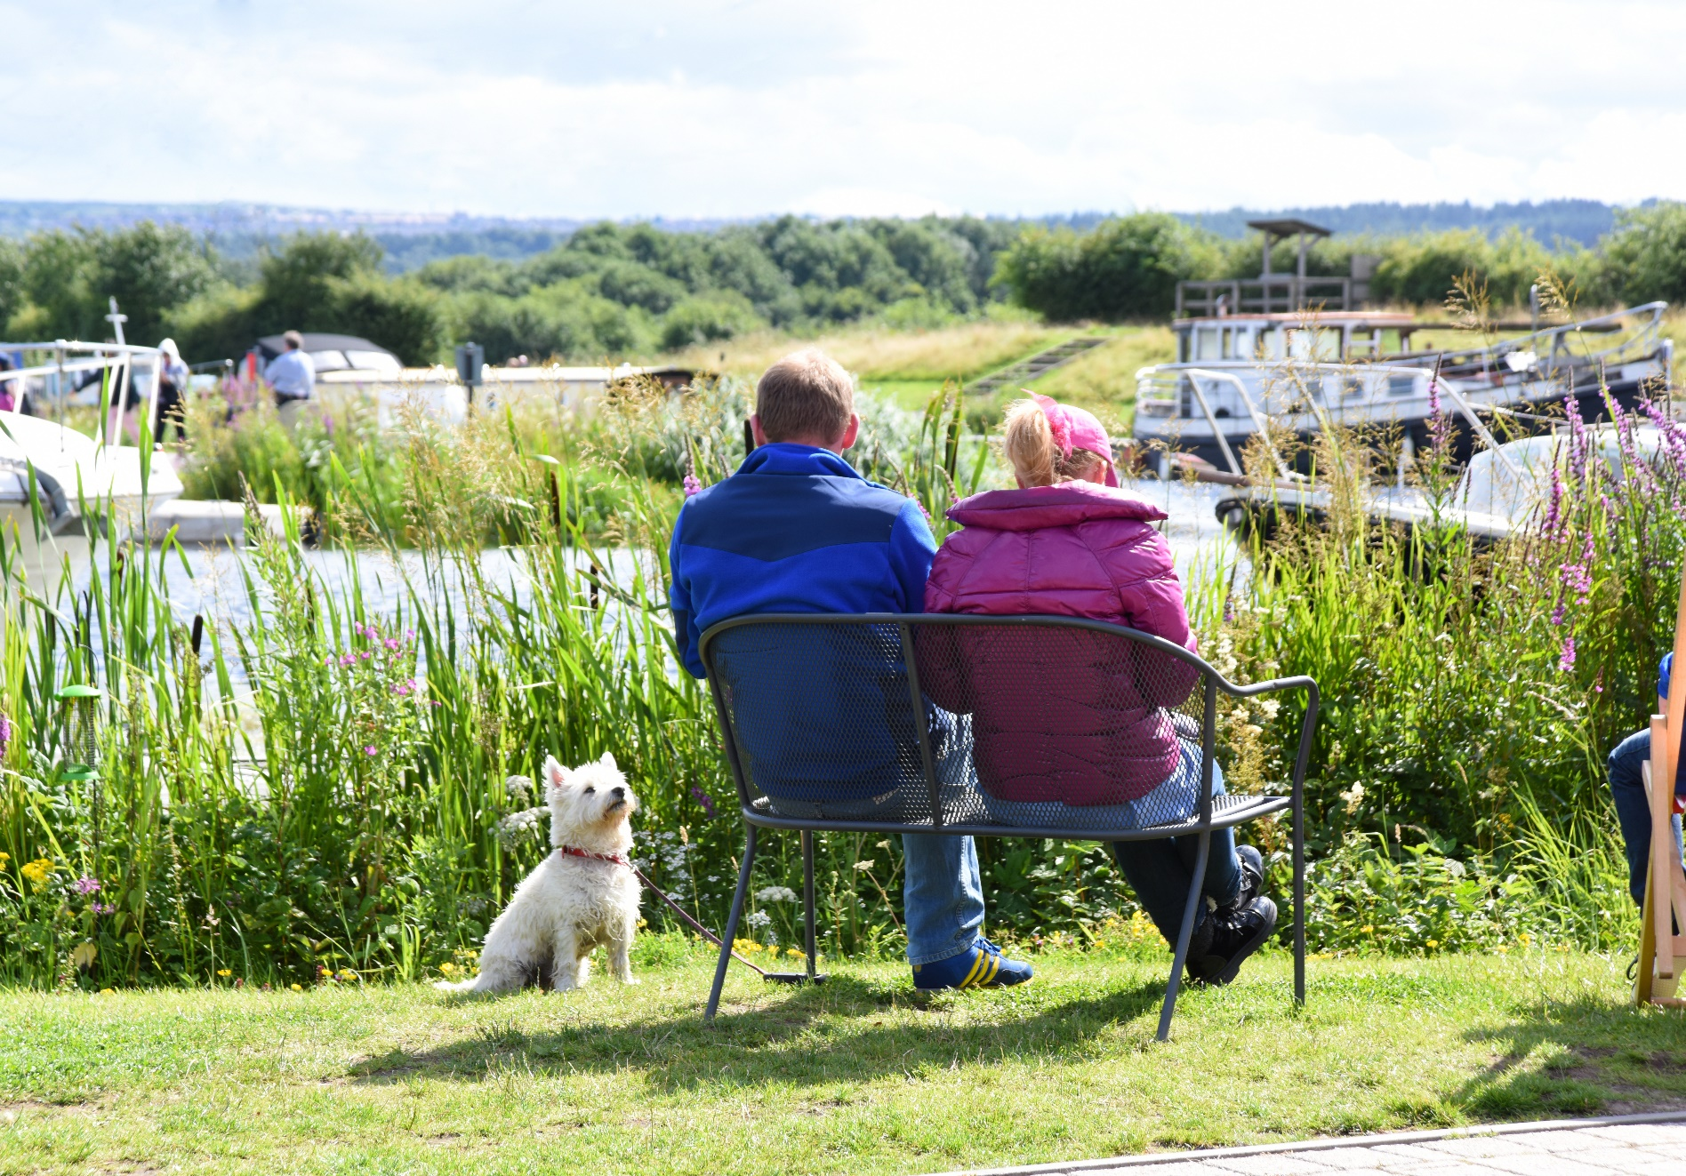
Why do we have a Short Breaks Services Statement?
The Carers (Scotland) Act 2016 requires local authorities to prepare and publish a statement setting out information about short breaks services available for local Carers and those that they care for.

The aim of this document is to provide information to Carers and those that are cared for explaining:
- What short breaks are
- Who can access them
- What short breaks opportunities are available to Carers
- How carers can access Short Breaks and find further information

What is a Short Break?
A short break is something that enables Carers to have time away from their caring routines or responsibilities. This was previously referred to as respite. Short breaks can be long or short and can be during the day or overnight.

Short breaks can allow the Carer and cared-for person time apart from each other. The cared for person can be supported away from home, including overnight, or a care provider can offer support within their own home.

Alternatively, the Carer and cared-for person can go away together.

Falkirk Health and Social Care Partnership want Carers to know what:
- Short breaks are available.
- They can have breaks in a range of ways
- People can have a choice of breaks and the support they access
- Breaks will be a positive experience and benefit both the Carer and the cared-for person.
- Carers and cared-for person will be offered help to identify the need for a break and the potential benefits.

Who can Access Short Breaks?
Short breaks are available for Carers and those who they care for. Carers are people who provide care and support to family members, other relatives, friends, and neighbours.

The people they care for may be affected by disability, physical or mental health issues (often long-term), frailty, substance misuse or some other condition.
A carer does not need to be living with the person they care for to be considered a Carer. Anybody can become a Carer at any time in their life and sometimes for more than one person at a time.

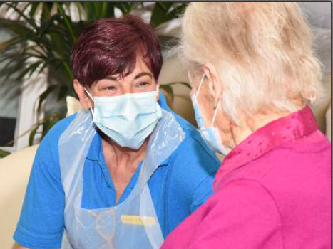

Types of Support

Breaks in care home or specialist/dedicated respite
Breaks can be within care homes (residential or nursing) with a small no. of places set aside for short breaks. Dedicated respite providers also provide accommodation used only for short breaks. These can be guest houses, community flats, purpose-built or adapted accommodation. Facilities can offer specialist care and activities to suit individual needs and interests.

Breaks in the home of families
These involve overnight breaks provided by paid or volunteer carers in their own home. These are sometimes referred to as shared care, family-based or adult placement schemes. Families or individuals offering support are carefully recruited & registered.

Breaks provided at home through a provider or sitting service
These include individual support provided in the home of the cared-for person for periods of a few hours or overnight. The purpose may be to provide support while the Carer is away, or to support the Carer in other ways, e.g. by enabling the Carer to have an undisturbed night’s sleep.
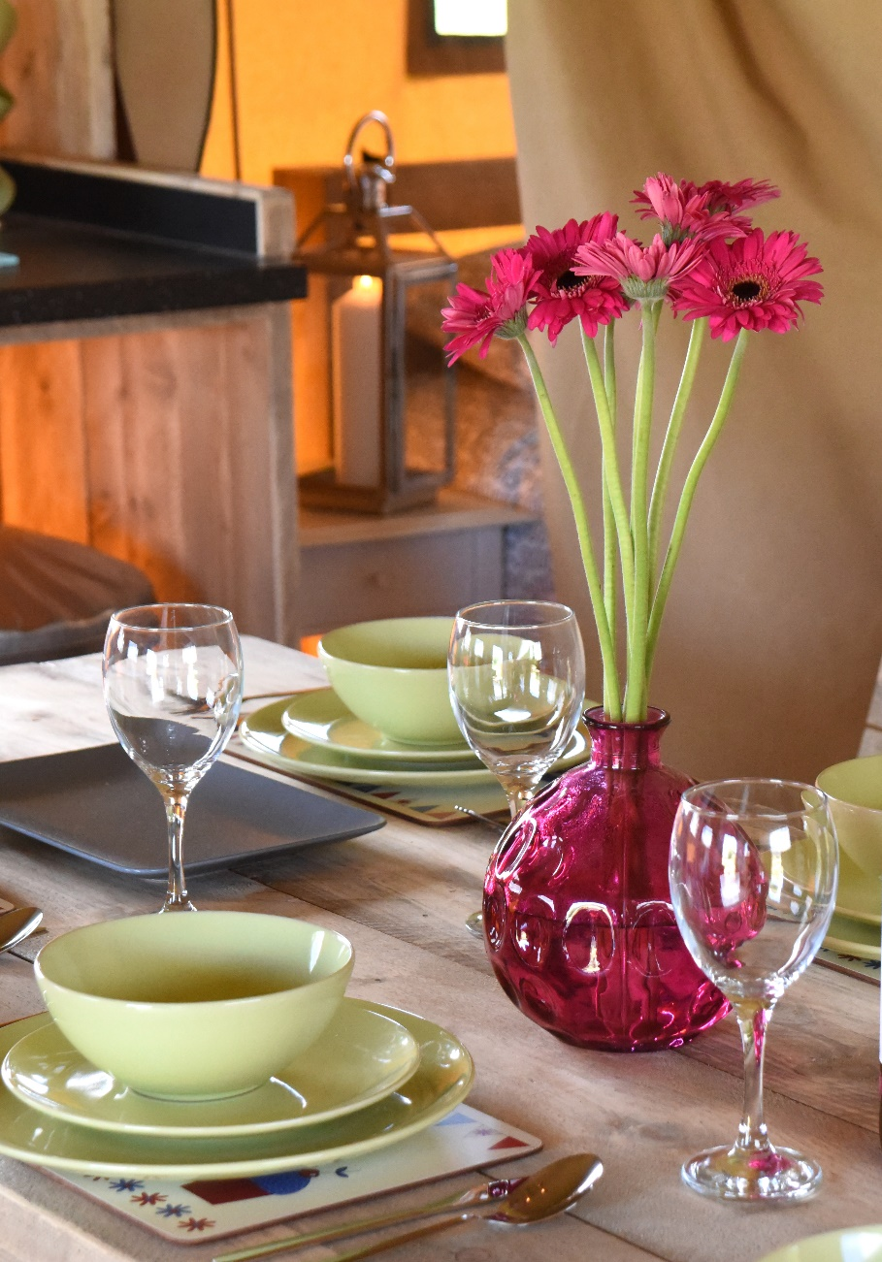

Holiday breaks
These include opportunities for people to have a short break together, or independently. These breaks can be supported in different ways – through an agency specialising in breaks for people with particular needs; in adapted accommodation; or in ordinary hotels and guest houses, perhaps with additional equipment.

Day support (buildings based, within the community, and befriending)
Day Care is typically based in a community building and not generally provided for short break or respite purposes. However services can also offer more flexible arrangements, designed around the needs of both the cared-for person and the Carer. This can be achieved by providing support within the community to take part in activities/clubs.

Befriending normally involves a paid worker or volunteer assisting someone with care and support needs to have access to activities, such as going to the cinema, meeting friends, shopping, swimming, and other such leisure pursuits.

Flexible respite
Increasing, with the development of self-directed support, more people are finding creative ways to take a break using funding to purchase items such as leisure equipment, computers, online classes, garden furniture or anything else that provides a break from the caring role.

Emergency respite breaks
We recognise that in some circumstances people need to have access to emergency support. Where possible, an emergency plan will be completed to ensure that Carers and the cared for person can access emergency support or breaks in a way that minimises stress in an already difficult situation.

In some circumstances an emergency break may be needed where there has been no previous contact with Social Work Services and, in those circumstances, the most appropriate break available will be sought. .

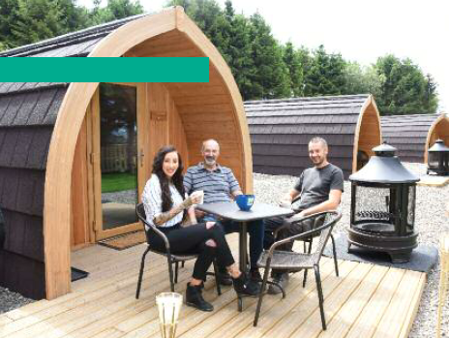

Respitality
‘Respitality’ (Respite and Hospitality) provides a unique way for Carers Centres and the Scottish Hospitality sector to work together to provide short breaks for Carers. The hospitality sector gifts short breaks to Carers through the Carers Centre.

Gifts may include overnight stays, dinner reservations, spa days, beauty treatments – whatever gift the business chooses to donate. A Carer plus a companion can have a break away from their usual caring responsibilities.

Carer Support Groups
Local carer groups provide an opportunity for Carers to meet up, share information and have a short break from caring. Falkirk and Clackmannanshire Carers Centre provides a range of regular support groups and one-off activities for Carers.

Time to Live (TTL) Grants
‘Time to Live’ is part of the Creative Breaks funding programmed operated by Shared Care Scotland on behalf of the Scottish Government.

The purpose of the fund is to increase the range, availability and choice of short breaks for Carers and those they care for across Scotland.

Carers who meet the criteria of the TTL fund can apply through the Carers Centre for grants of up to £300 to fund a flexible short break of their choosing.

Universal (community) services and supported access to clubs or activity groups
These opportunities might focus on a particular activity (e.g. sports clubs, leisure activities) and may be based in a community building. The availability of adapted equipment or trained workers can help people with support needs to enjoy these activities.

Children’s Services
Children’s Services respite is varied, and may include residential breaks at Tayavalla respite unit, activity holidays for children with additional needs or support to access local youth clubs.

For more information, please contact Children’s Services, Sealock House, 2 Inchyra Road, Grangemouth, FK3 9XB, Tel 01324 506 600.

short break stories
You can read some example short break stories on the Shared Care Scotland website at www.sharedcarescotland.org.uk/shortbreaksfund/short-break-stories

How to get a Short Break
Carers should contact the Carers Centre or ask their local social work team to refer them for an Adult Carer Support Plan or Young Carers Statement.

If you already have a plan or statement then you should get in touch with your local social work team.

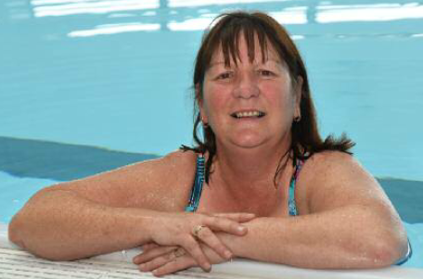

Who is Eligible for a Short Break?
The eligibility criteria sets out what levels of support a Carer might be able to access according to their level of need. This will include whether a carer is likely to be able to meet their desired outcomes through general services and the impact of their caring role on their wellbeing.

Is there a Cost?
We don’t charge carers for short breaks arranged to give them a break from caring.

There are circumstances where the carer and/or the cared-for person will need to pay, for example where funding is provided to support them to take a holiday type break together. Any costs will be explained and agreed before the break goes ahead.

Contact Details
Short Breaks Bureau
sbb@falkirk.gov.uk
01324 504 309
