Participation and Engagement Strategy

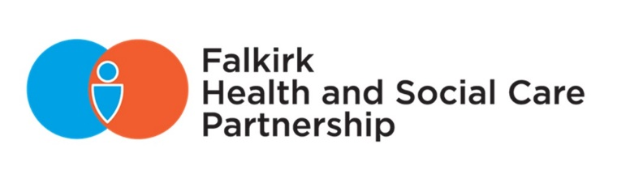
2021-2024

Date of first issue: | June 2021
Approval status: | Approved 04 June 2021 by Integration Joint Board
Current issue date: | June 2021
Review date: | June 2024
Available at: | www.falkirkhscp.org/publications/
Contact: | integration@falkirk.gov.uk

Document information

Contents
Contents 1
Section header (Heading 1) 2
Sub section header (Heading 2) 2
Another sub section header (Heading 2) 2
Appendices (Heading 1) 2
Appendix 1 (Heading 2) 2
Appendix 2Heading 2) 2

Introduction and purpose
Falkirk Health and Social Care Partnership (HSCP) puts people first and involves as many people as possible in the design of its services, ensuring the needs of individuals and communities are met.
Our participation outreach aims to involve people who use our services, their families and carers, our staff, commissioned providers, and delivery partners including statutory agencies and organisations within the third and independent sectors. Together, we combine our resources to deliver the Partnership’s Strategic Plan and most importantly, to provide person-centred and integrated care and support.
The Partnership is tasked with ensuring health and social care services work together to put people at the centre of decisions about their care and support. We will continue to build upon current good practice to change the way we deliver high quality and cohesive services that meet individual need.
This will “enable people to live full, independent and positive lives within supportive communities” forming the vision of the Partnership’s strategic plan.
Our updated Participation and Engagement Strategy 2021-2024 sets out principles for participation and engagement to ensure that people are involved, consulted with, and actively engaged in the design and development of health and social care within the Falkirk area. These principles are relevant to our staff, individuals, Falkirk’s communities, and organisations.

Patricia Cassidy
Chief Officer

Legislative context
The Public Bodies (Joint Working) (Scotland) Act 2014 requires each HSCP to produce a Participation and Engagement Strategy for the Integration Joint Board (IJB), which is the formal body with overall responsibility for the integration of health and social care. This plan forms part of Falkirk HSCP’s Strategic Plan.
The Community Empowerment (Scotland) Act 2015 requires public bodies to engage with communities and community organisations. The 2015 Act requires the Integration Joint Board to put in place a participation process and to report on how engagement has shaped the delivery of local outcomes. Further information on the legislative context that provides people with rights to participate are included within Appendix 1.

Strategic context
The Participation and Engagement Strategy 2021-2024 is part of a set of strategic documents to support implementation of the Partnership’s overall Strategic Plan. It should be reviewed in tandem with the accompanying Communications Strategy 2021-2024 as our engagement and communication activities are intertwined, with communication at the core of our participation and engagement methods.
Figure 1. Legislative and Strategic Context
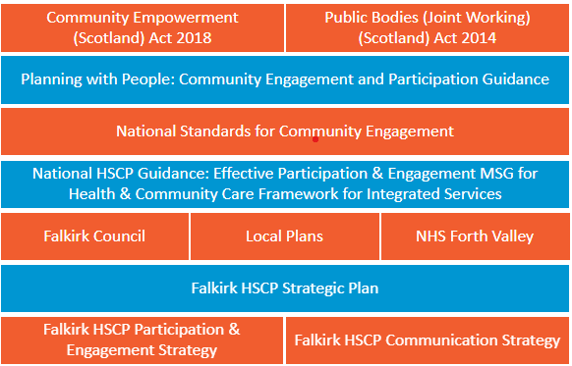

What is participation and engagement and why is it important?
Participation and engagement should be focused on improving the quality of lives and promoting a community’s best interests. People choose to participate for many reasons whether their personal experience has motivated them to participate or they have a general interest in the services delivered in their local area. Participation allows people to take part in activities (such as focus groups) to inform service planning and delivery. This also includes participating in decision-making processes when they are affected by a decision. Information on how to get involved is included within Appendix 2.
Community engagement develops working relationships between public bodies (such as local councils) and community groups. Successful engagement between communities, community organisations, and public and private bodies improves understanding between everyone involved as we work together to identify community needs and take effective action to improve communities.

What is our approach to engagement?
Extension for Community Healthcare Outcomes (Project ECHO)
Based at Strathcarron Hospice, the ECHO model uses videoconferencing to enable health and social care professionals to learn with and from one another and drive participant-led change. There has been excellent engagement from Care Homes in the Falkirk area who have set up a rolling programme of learning. During the Covid-19 pandemic, more care homes have joined the network and have found it to be a valuable space for mutual learning and support.
Public Participation Spectrum Level: COLLABORATE

Principles of engagement
The National Standards for Community Engagement sets out seven principles of engagement: Inclusion, Support, Planning, Working Together, Methods, Communication, and Impact.
These principles should serve as a baseline for measuring the quality and impact of our engagement activity. To achieve greater impact and provide a higher standard of engagement, then we will need to reach beyond what is outlined in the National Standards for Community Engagement. This will involve elevating our approach and embedding engagement into all practice. An evaluation template for monitoring against the National Standards is included in Appendix 3.
Figure 2. National Standards for Community Engagement (2016)
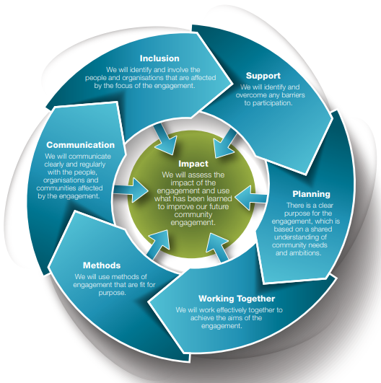

Embedding engagement
Engagement needs to be embedded in all activity as a means of developing mutual understanding and trust between agencies and communities to support both improvement and action. This will help move engagement away from being a bureaucratic tick box exercise to engagement leading effective change.
If engagement is truly embedded in everything that we do, then we are ensuring that services are delivered with service users and carers, and that they remain at the heart of provision. This ensures that we are taking a person-centred and human rights-based approach to engagement.
Dementia Cafés
These drop in cafés provide a gentle introduction for people with dementia, accompanied by their carers, to meet Alzheimer’s Scotland staff and familiarise themselves with the support that is available, as well as meeting others in the same situation. The dementia cafés in Bo’ness and Falkirk had an average of 516 attendances each quarter and the community groups had a further 595 attendances each quarter.
Public Participation Spectrum Level: INVOLVE

Steps to good engagement
National guidance sets out seven steps to good engagement: identify the issue, identify stakeholders who may be affected by the issue, plan engagement, engage those potentially affected, evaluate engagement, decision-making, and feedback.
All steps to good engagement are important and should be applied proportionately to the scale of the activity and the level of change proposed. For further information on the individual steps to good engagement: ‘Care services - planning with people: guidance’.
Figure 3. “Steps to good engagement”, Planning with People (2021)
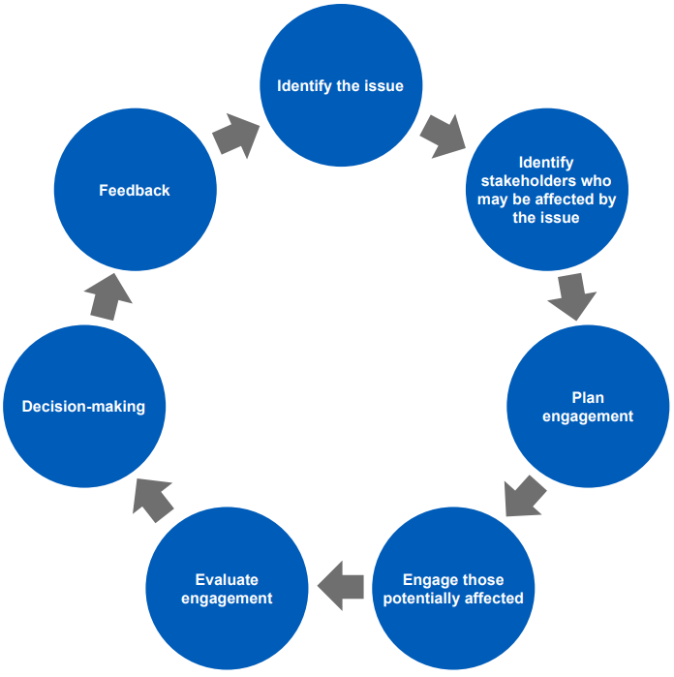

Public Participation Spectrum
The Spectrum of Public Participation was developed by the International Association for Public Participation (IAP2) to help clarify the role of the community in planning and decision-making, and how much influence the community has over planning or decision-making processes.
It identifies five levels of community engagement. The further to the right on the Spectrum, the more influence the community has over decisions, and each level can be appropriate depending on the context. It is important to recognise these are levels, not steps. For each level, it articulates the public participation goal and the promise to the public.
Figure 4. The Spectrum of Public Participation
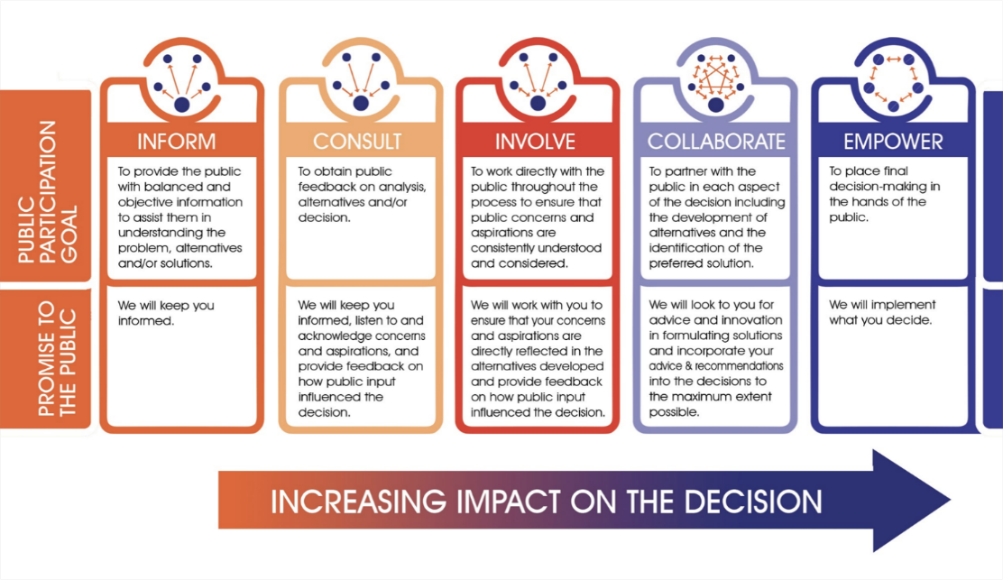

What does a successful engagement process look like?
The success of any engagement activity will vary depending on the objective and the indicators for achieving that objective which has already been determined during the planning process (see Appendix 3 for a planning template).
We know our engagement process is successful by measuring attendance rates and the quality of responses received. We also know our engagement is successful when we’re having open and honest conversations with participants where they feel listened to and valued. We create safe environments and mitigate barriers to participation to ease participant anxiety and help them feel more confident in sharing their opinions and experiences. We welcome positive and negative feedback and take all viewpoints into consideration to reassure participants that we’ve listened to them and valued their participation.
We keep communities informed throughout the engagement process and maintain clear and timely communications so that all roles and expectations are understood. We act and deliver on our promises to communities and keep them informed on how their inputs were used. We evaluate our engagement process and learn from our successes and failures.

Engagement methods
There are a variety of methods that can be used in our engagement activities, e.g., telephone calls, meetings (virtual or in person), email, social media, surveys, focus groups, events, etc. The engagement methods used will be relevant to the objective of the engagement activity and dependent on where the engagement sits on the public participation spectrum. For example, focus groups would be inappropriate if the goal is to inform, but they would be an effective method for a consultation. Engagement methods should be continually reviewed throughout the engagement process and changed or adapted based on feedback and evolving public participation goals.
There is no mainstream solution to community engagement as not all methods of engagement are going to be suitable for everyone. Our engagement methods need to be sensitive to cultural norms, and this will involve including representation of the targeted audience as well as linking within our networks to provide guidance on how to engage with groups where sensitivity is required. As such, engagement methods will be appropriate and tailored to meet the individual needs of each targeted group to minimise barriers to participation.
Thornton Gardens
We successfully transferred respite provision at the Rowans Short-Break Service to Thornton Gardens. Meetings and a consultation exercise were held with service users, parents, carers, and other stakeholders including the Care Inspectorate. Throughout the preparation for the move, people were involved, including a visit whilst the works were being carried out and an open afternoon once near completion. These plans and maintaining staff continuity were accepted as a positive development by the people who value the service provided.
Public Participation Spectrum Level: CONSULT & INVOLVE

Providing feedback
It is important that we provide feedback on all engagement activities to develop trust within communities and support culture change. We need to inform service users how valuable their participation is, communicate the benefits of participation, and demonstrate the impact of their participation by evidencing the action that has been taken towards achieving local outcomes.
We will provide participants with regular updates and feedback on our progress towards achieving local outcomes. Engagement activities should identify how feedback will be provided and participants should be informed of when they can expect to receive this feedback.

Who do we engage with?
The Partnership recognises that engagement with people is a critical aspect to service planning, service delivery and improvement. We engage with communities, staff, and partner and external agencies.
We aim to maintain effective and meaningful engagement across communities. Communities can typically be defined as:
Community | Definition
Community of place | A group of people brought together by geographic boundaries, e.g., a town and village.
Community of identity | A group of people brought together by how they or society identifies them, e.g., LGBTQ+ and women.
Community of interest | A group of people brought together who share the same interest or passion, e.g., sports and hobbies clubs.
Participants will often belong to or identify with more than one of these communities. It is important to involve community representatives in engagement planning so we can respond to the diverse needs of individuals and communities.
We will engage with people as meaningfully as possible which is why engagement should take place where people are rather than expecting people to come to us. By going out into communities to engage with people, we can build on and highlight what is working in our engagement, and we can continue to collaborate with communities and the Community Planning Partnership (CPP) to develop and deliver locality plans.

Listening Events
Over 2018-2019, we have held several engagement events with staff that are supporting redesign and transformational change in services. These include events with home care, day services, and health and social care colleagues.
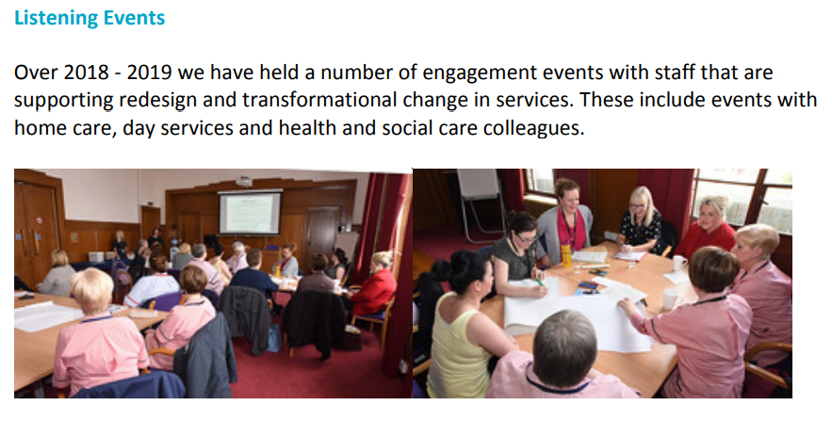
Public Participation Spectrum Level: CONSULT

Participation Barriers
There will be barriers to participation, and this can include (but is not limited to) participation anxiety, digital exclusion, accessibility requirements, etc. It is our responsibility to consider and address these barriers when planning any engagement activity, and we will hold ourselves accountable if we fail to engage with groups by not addressing barriers to their participation.
We will include representation of the groups that we want to engage with to address barriers and minimise the inequalities that people experience. We will provide opportunities for communities to co-design services (i.e., service users and providers work together to develop a service), and we will make communities more aware of all the opportunities they have to get involved.
We will also have clear and accessible ways for people to engage with us within communities. We will ensure information is provided in an understandable and accessible format. The Partnership will support communities to communicate with its services. We will achieve this by supporting individuals to use the most appropriate and accessible method of communication tailored to their individual needs.
Our accompanying Communications Strategy (2021-2024) sets out the principles for inclusive communication, defining the characteristics of accessible, simple, and understandable communication.

When do we engage with communities?
When there is a significant change to a service then we are required by the Public Bodies (Joint Working) (Scotland) Act 2014 to engage with people who are directly affected. This will include service users, carers, and staff.
We need to engage with people who are directly affected by a particular issue or a possible change to a service. We also need to engage with a range of people on any significant decisions made in the Strategic Plan. Communities can participate at different levels and stages of the decision-making process, and we will identify groups or individuals who might be particularly interested in a change to a service we are making and encourage them to participate.
We will give at least six weeks’ notice to community organisations to respond to or attend an engagement event. We will give at least three weeks’ notice to individual community members to respond to or attend an engagement event.
Redesign of Day Services for Younger Adults
The Partnership has taken forward a programme of work to redesign day services for younger adults. This involved engagement with people who use services, their carers, and staff about what changes should happen to develop alternative community-based services.
The Partnership hosted a successful event on 23 April 2018. The purpose of organising the “Believe and Achieve” event was to demonstrate the many opportunities there are for people with a disability and their carers in the Falkirk area. On the day 179 people attended the event where there was information available from 25 exhibitors. These covered a range of services from Falkirk Community Trust, Third Sector organisations and other services.
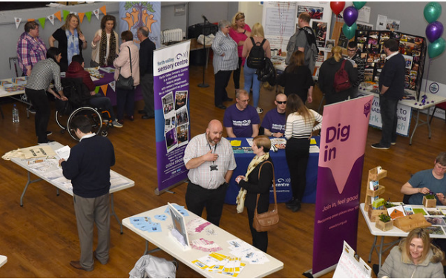
Public Participation Spectrum Level: INFORM

We do not engage with people when decisions have already been taken, but we do ensure that, where relevant, you are made aware of decisions taken. We will also involve communities in making decisions on how local money is allocated and spent. For example, participatory budgeting.

Community Choices
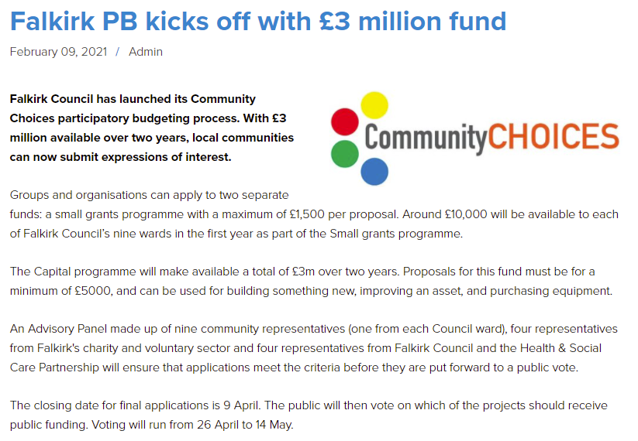
Public Participation Spectrum Level: EMPOWER

How do we monitor the impact of our engagement?
To understand how well we are currently engaging, we need to integrate evaluation into the planning of all engagement activities. A benefit of monitoring our engagement activity is learning from our failures and successes by identifying themes of what is working well and what isn’t working well. We need to be open and honest about our failures and successes and share lessons learned within our networks for the benefit of future engagement activity.
All engagement activity will be evaluated against the National Standards for Community Engagement and these outcomes will be reported to the IJB Board. We will maintain a central log of participation and engagement activities of all engagement monitoring templates that are to be completed and returned by service providers (see Appendix 3).
Participation & Engagement Strategy and Communication’s Strategy Survey (2021), ‘Can you provide an example of a consultation or engagement activity that has worked well and why?’
“We carried out a survey in June 20 to ascertain the impact the pandemic was having on local carers and determine their future support needs. The short survey was emailed and posted to carers on our mailing list and staff encouraged the carers they were working with to complete it. Once the responses had been analysed, we decided to hold a series of focus groups around the main themes that emerged from the survey to allow us to gain a greater insight into what we could provide to meet the needs being described in the survey. The feedback we received from the focus groups demonstrated the need for ongoing emotional support, better communication systems, increased information, and additional short break grants.
We then held an interactive meeting with staff where we used online breakout rooms and surveys to ascertain their views on the past year and the way forward. Interestingly, they came up with a very similar response to the carers.
The staff session worked well because it was very interactive, using small groups and anonymised surveys to allow everyone to have their say. We also kept it fun and thought provoking.
As a result, we have decided to apply for funding to allow us to set up telephone support service, employ a digital worker, and continue to focus on accessing funding to allow us to provide short break grants for carers.” – Central Carers Association
Public Participation Spectrum Level: CONSULT & INVOLVE

What are our participation and engagement commitments?

No. | HSCP Participation and Engagement Commitments | How will we monitor this?
1 | We will always use the most appropriate method relevant to the purpose of our engagement activity and tailored to the needs of our targeted audience. | Evaluation template (NSfCE: Methods)
2 | We will involve community representatives to ensure our engagement activities are inclusive and accessible for our targeted audience. | Evaluation template (NSfCE: Inclusion)
3 | We will provide participants with regular updates and feedback on our progress towards achieving local outcomes. | Evaluation template
4 | We will go out into communities to engage with people as much as possible instead of expecting people to come to us. | Log of participation and engagement activities
5 | We will provide opportunities for communities to co-design services, and we will make communities aware of all opportunities they have to get involved. | Log of participation and engagement activities
6 | We will ensure information is provided in an understandable and accessible format to support the local population to communicate with its services. | Communication’s Strategy (2021-2024); Evaluation template (NSfCE: Communication)
7 | We will engage with people who are directly affected by a particular issue, a possible change to a service, and any significant decisions made in the Strategic Plan. | Evaluation template.
8 | We will give appropriate notice periods to communities to respond to or attend an engagement event. | Evaluation template
9 | We will involve communities in making decisions on how local money is allocated and spent. | Community Choices participatory budgeting
10 | We will maintain a log of participation and engagement activities for evaluation monitoring purposes. | Log of participation and engagement activities
11 | We will evaluate our engagement against the National Standards for Community Engagement and these outcomes will be reported to the IJB for decision-making and accountability purposes. | Evaluation template; Annual Performance Report

Appendix 1: Your Rights

Community Empowerment (Scotland) Act 2015
This Act places a duty on public authorities including the Council, NHS Health Board and HSCP to improve the quality of lives of people living in disadvantaged areas. Communities can make participation requests to public authorities to change the way a service is delivered. The public authority must agree unless there are reasonable grounds not to do so. Under the Act, community bodies can make asset transfer requests to lease or take ownership of a publicly owned building or piece of land. The Act gives local communities the right to buy abandoned or neglected land.
Communities must be engaged by the Community Planning Partnership when Local Outcome Improvement Plans (i.e., strategic plans) and Locality Plans (i.e., Community Action Plans) are being developed. The CPP must also publish annually how it has engaged with communities and responded to participation requests and asset transfer requests. The Act states that communities should be given a direct say in allocation of public resources, e.g., participatory budgeting.

Equality Act 2010
This Act aims to prevent discrimination of nine ‘protected characteristics’. These are: age, disability, gender, gender reassignment, sexual orientation, marriage and civil partnership, pregnancy and maternity, race, and religion or belief.

Human Rights Act 1998
This Act gives people rights: to life, liberty and security, to a fair trial, to marry and start a family, to education, and to participation in free elections. It also gives people freedoms: from torture and inhuman or degrading treatment, slavery and forced labour, of thought, belief and religion, or assembly and association. Public authorities must comply with the European Convention on Human Rights.

NHS Reform (Scotland) Act 2004
This Act places duties of public involvement and equal opportunities on NHS Health Boards. This led to the establishment of the Scottish Health Council (SHS) in 2005 to ensure that the NHS allows patients to participate as fully as possible.

Patient Rights (Scotland) Act 2011
The Act sets out health care principles and a Charter of Patients’ Rights. This includes allowing patients to participate as fully as possible in decisions relating to their health and wellbeing and have full access to the necessary information to do so. The Act provides a right to give feedback (both positive and negative), leave comments, or raise concerns or complaints about the health care they have received. The Act requires that Health Boards encourage, monitor and learn from the feedback and comments they receive.
Good Practice Guidance has been issued to NHS Boards setting out what is required and giving advice on how to handle and learn from feedback and complaints. The Patient Advice and Support Service (PASS) promotes awareness of these rights and provides advice and support. PASS is delivered by Citizens Advice Bureaux (CABs).

Housing (Scotland) Act 2001
This legislation requires all local authorities to have a tenant participation strategy in place.

Housing (Scotland) Act 2010
The Act created an independent Scottish Housing Regulator to look after the interests of tenants, homeless people, and other service users of social landlords. Statutory duties on tenant communication and participation are both outcomes and standards within the Scottish Social Housing Charter.

Planning etc. (Scotland) Act 2006
This Act includes the provision of the Council to consult with and involve ‘the public at large’ in the development of the Local Development Plan. These need to be updated every five years. The Act also enables local people to object or support any planning application through a written representation. Further information can be found here.

The Children and Young People (Scotland) Act 2014
This Act places a duty on Councils to undertake a survey or consultation with service users and parents to gauge views on the existing service provision and to offer the chance to provide comments or suggestions as to how the service could be improved.

Appendix 2: Getting Involved

Participation Requests
If a community body believes it can improve the outcome of a public service, then it can make a participation request to the relevant body, including the Council, NHS Forth Valley, or the HSCP. The community body will need to set out the outcomes it expects to achieve and details of its experience and knowledge. Public authorities must agree to the request unless there are reasonable grounds not to do so. A decision notice must be issued outlining the outcome improvement process, i.e., what was done and what was achieved. More information can be found here.

Locality Planning
Locality planning will provide an opportunity for community groups and organisations across the Falkirk Council area to play a part in identifying local key needs and issues, to be involved in defining relevant outcomes and to propose ways in which the community can draw on its local skills and knowledge. More information can be found here.

Good Feedback, Comments and Complaints
You have the right to give comments, feedback, or make a complaint about the service you receive. We value comments, feedback, and complaints and will use these to improve our services.
In the first instance, contact NHS Forth Valley by email: fv.complaints@nhs.net, phone: 01234 566660, or visit their website for further information.
Alternatively, contact Falkirk Council by email: contact.centre@falkirk.gov.uk, phone: 01234 506070, or visit their website for further information.

Community Councils
Community Councils are made up on local people who give time to, and have a genuine interest in, the wellbeing of their community. They consult the local community on all issues affecting them and tell us, and other public bodies, the views of local people. Community Councils are consulted on licensing and planning applications within their area.
There are currently 15 active Community Councils in the Falkirk Council area out of a possible 23. Each Community Council must meet in public at least 9 times a year. More information can be found here.

Asset Transfer Requests
A community transfer body (of a specified nature) can make a request to buy or lease a relevant authority’s land or building. That relevant authority must consider a range of factors before issuing a decision notice and must have reasonable grounds to refuse an asset transfer request. The authority must explain these if the decision is challenged, and an appeal can be made by the community transfer body to Scottish Ministers. More information can be found here.

Joint Staff Forum
The Joint Staff Forum provides a forum for the Trade Unions and Professional Organisations recognised by Falkirk, Clackmannanshire, and Stirling Councils and NHS Forth Valley to inform, influence, and participate in the development of the health and social care integration in Forth Valley. Staff who are working within services which are in-scope for integration are represented on the Integration Joint Boards by named representatives of the Joint Staff Forum.

Person Centred Health and Care
NHS Forth Valley has four strategic aims for patient and public involvement. The first aim is to ensure that there are robust reporting mechanisms in place to capture feedback, comments, concerns, compliments, and complaints. Secondly, to provide NHS Board assurance that learning from complaints is measurable and fed back to patients and public how we have learned and used the learning to influence change. Third, supporting and developing staff to receive feedback in a positive way and to work with those in their care to improve the services they provide. Lastly, involve patients and the public using wide and varied methods of capturing feedback so they are involved in service change, redesign, and improvement of care health and wellbeing. Find out how you can get involved here.

Patient Public Panel (PPP)
The Patient Public Panel (PPP) is concerned with the delivery of acute services at Forth Valley Royal Hospital and supports NHS Forth Valley’s aim to be of person-centred, safe, and effective. Membership is open to anyone who is a potential user of NHS Forth Valley services, but who is not currently employed by NHS Forth Valley.

Tenants and Residents Organisations
Falkirk Council’s Tenant and Customer Participation Strategy (2019-2022) allows tenants and customers to get involved in shaping and improving its services.
The Tenants’ & Residents’ Forum is the main hub for tenant and resident participation. It is an open forum available to any tenants or residents who wish to attend, meeting approximately once every three months. It provides tenants and residents with the opportunity to discuss how the service is run as well as being able to make suggestions on how it could be improved.
Tenant and resident organisations allow communities to come together to create change in their local area, in partnership with their landlords.
Tenants and residents can also come together and form a group to influence decisions made by their landlord. This is enabled by the Scottish Housing Charter. TPAS Scotland promotes good practice in tenant participation and supports tenants’ groups.

Parents Councils
A Parent Council is a group of parents who represent all the parents at a school. Any parent with a child at the school can volunteer to become a member of the Parent Council. Parents can be members of the Parent Council for as long as they choose. Parent Councils can also invite members of the local community and school staff to join their Parent Council and Elected Members are also invited to attend meetings. In denominational schools, the Parent Council must invite the relevant church or denominational body to nominate a representative to be a member. Almost all schools in the Falkirk Council area have a Parent Council. Further information can be found here.

Volunteering
There are many ways you can volunteer and several organisations you can volunteer with. You can volunteer directly with a Third Sector Organisation or Faith-based Organisation (e.g., your local church), or you can volunteer via a third party (e.g., CVS Falkirk & District, Community Learning and Development (CLD) at Falkirk Council or NHS Forth Valley). Further information is available here.

People’s Panel
The People’s Panel is made up of local people who have volunteered to respond to a range of online questionnaires throughout the year. The questionnaires provide feedback on Council services, as well as information about the needs of local communities and other issues. This information helps improve services and make sure the Council is meeting the needs of local communities.

Third Sector Forums
There are many forums in the Falkirk Council area that focuses on specific issues. These include: The Community Care and Health Forum (CCHF), Community Transport Forum, Connecting Volunteering Forum, Economic Resilience & Employment Forum, Safer Communities Forum, Tackling Poverty & Inequalities Forum, and the Voluntary Sector Children’s Services Forum. Further details can be found here.
These forums provide information on related issues, access to training, support for local Third Sector Organisations, and the opportunity to influence the decision making of local public services, e.g., Police Scotland, Falkirk Council, and NHS Forth Valley.

Appendix 3: Engagement Planning and Self-Evaluation Template
This template is for any service provider planning to carry out any type of engagement activity. It has been designed to help you plan, monitor, and evaluate your engagement activity.
Please return all completed templates to Jennifer.faichney@falkirk.gov.uk for monitoring and reporting purposes.
Contact details
Lead Name
Email Address
Phone Number

About the engagement activity
What is the title of the engagement activity?
Is the engagement activity focused on a specific service area? If so, what service area?
Where will the engagement activity take place?

Step 1: Identify the issue
What is objective of the engagement activity?
What do we already know about the community and the issue?
What do we still need to know?
What are the 3 overarching messages or questions that you want to ask?

Step 2: Identify stakeholders who may be affected by the issue
Who do you want to engage with?
What is the target audience that you want to reach?
(This might be a particular group(s) of people, community, or general population)
Does the subject have an impact on any groups with protected characteristics?
(Age, gender reassignment, marriage & civil partnership, pregnancy & maternity, race, religion, belief, sex, sexual orientation)
What are the barriers to participation on where, when, or how activity takes place?
(This might include session timing, budget, i.e., cost of engagement, travel expenses, etc., participants have restricted mobility, participants live in care facilities, the need to provide respite support, childcare etc.)

Step 3: Plan the engagement
Where does the engagement activity sit on the Public Participation Spectrum?
Public Participation Goal | ☐  Inform  To provide the public with balanced and objective information to assist them in understanding the problem, alternatives, opportunities and/or solutions. | ☐  Consult  To obtain public feedback on analysis, alternatives and/or decisions. | ☐  Involve  To work directly with the public throughout the process to ensure that public concerns and aspirations are consistently understood and considered. | ☐  Collaborate  To partner with the public in each aspect of the decision including the development of alternatives and the identification of the preferred solution. | ☐  Empower  To place final decision making in the hands of the public.
Promise to the public | We will keep you informed. | We will keep you informed, listen to and acknowledge concerns and aspirations, and provide feedback on how public input influenced the decision. | We will work with you to ensure that your concerns and aspirations are directly reflected in the alternatives developed and provide feedback on how public input influenced the decision. | We will look to you for advice and innovation in formulating solutions and incorporate your advice and recommendations into the decisions to the maximum extent possible. | We will implement what you decide.

What outcomes are you looking for and what does success look like?
Outcomes (What are we trying to achieve?) | Indicators (What does success look like?)

What actions will be taken to meet the engagement outcomes?
What | Who | When

What timescale does activity need to be completed within?
Start Date
End Date
Notice period for participants
This should be at least 6 weeks for community organisations and at least 3 weeks for community members.
Date results are required by
Other relevant dates/deadlines

What is your communications plan?
Please contact the Partnership’s communication officer in advance of any communications activity or to discuss additional communications support, advice, and guidance.
Contact email: HSCPComms@falkirk.gov.uk
Objectives
Set out what the communications activity is intending to achieve. Start with the engagement aim and develop communications objectives that will deliver this. Keep your objectives SMART.
Audience Insight
Who are you trying to target? Outline your audiences and any insights you have on them. Are there any barriers that could prevent you from reaching them?
Strategy
Use your audience insight to set out the approach you will apply. You will also need to cover key messaging and the communications channels you will use.
Implementation
How will you deliver your communications and what tactics will you use? Develop a clear plan that allocates resources. Set out timescales for delivery.
Scoring/Evaluation
Focus on your outcomes. Were the outcomes met? Why or why not?

How will you provide feedback to participants?
How will the information gathered be analysed? Who will do the analysis?
How will feedback be presented?
When will you provide feedback to participants?

Step 4: Engage those potentially affected
What actions have you taken so far and what issues have arisen?

Any other relevant information?
E.g., Have you already started any activity, links to any reports or information relating to the activity?

Step 5: Evaluate engagement
Describe how the review process was carried out?

Who was involved in the review?
Where and when did you meet to review?
What evidence was used to judge performance of the engagement?

Did the engagement activity achieve the intended outcomes?
Comments:

Inclusion Standard
We will identify and involve the people and organisations that are affected by the focus of the engagement.
We will know we have met this Standard when:
- The people and groups who are affected by the focus of the engagement are involved at the earliest opportunity.
- Measures are taken to involve groups with protected characteristics and people who are excluded from participating due to disadvantage relating to social or economic factors.
- Participants in the community engagement process commit to continued two-way communication with the people they work with or represent.
- A wide range of opinions, including minority and opposing views, are valued in the engagement process.
How well have you met the Inclusion Standard?
Excellent
Very Good
Good
Satisfactory
Weak
Unsatisfactory

Comments:

Support Standard
We will identify and overcome any potential barriers to participation.
We will know we have met this Standard when:
- An assessment of support needs is carried out, involving all participants.
- Action is taken to remove or reduce any practical barriers which make it difficult for people to take part in engagement activities.
- Access to impartial and independent development support is provided for groups involved in the community engagement process.
How well have you met the Support Standard?
Excellent
Very Good
Good
Satisfactory
Weak
Unsatisfactory

Comments:

Planning Standard
There is a clear purpose for the engagement, which is based on a shared understanding of community needs and ambitions.
We will know we have met this Standard when:
- Partners are involved at the start of the process in identifying and defining the focus that the engagement will explore.
- A clear and agreed engagement plan is in place.
- All available information which can affect the engagement process has been shared and used to develop the community engagement plan.
- Partners agree what the outcomes of the engagement process should be, what indicators will be used to measure success, and what evidence will be gathered.
- The timescales for the engagement process are realistic.
- There are sufficient resources to support an effective engagement process.
How well have you met the Planning Standard?
Excellent
Very Good
Good
Satisfactory
Weak
Unsatisfactory

Comments:

Working Together Standard
We will work effectively together to achieve the aims of the engagement.
We will know we have met this Standard when:
- The roles and responsibilities of everyone involved are clear and understood.
- Decision-making processes and procedures are agreed and followed.
- The methods of communication used during the engagement process meet the needs of all participants.
- Information that is important to the engagement process is accessible and shared in time for all participants to properly read and understand it.
- Communication between all participants is open, honest, and clear.
- The community engagement process is based on trust and mutual respect.
- Participants are supported to develop their skills and confidence during the engagement.
How well have you met the Working Together Standard?
Excellent
Very Good
Good
Satisfactory
Weak
Unsatisfactory

Comments:

Methods Standard
We will use methods of engagement that are fit for purpose.
We will know we have met this Standard when:
- The methods used are appropriate for the purpose of the engagement.
- The methods used are acceptable and accessible to participants.
- A variety of methods are used throughout the engagement to make sure that a wide range of voices is heard.
- Full use is made of creative methods which encourage maximum participation and effective dialogue.
- The methods used are evaluated and adapted, if necessary, in response to feedback from participants and partners.
How well have you met the Methods Standard?
Excellent
Very Good
Good
Satisfactory
Weak
Unsatisfactory

Comments:

Communication Standard
We will communicate clearly and regularly with the people, organisations and communities affected by the engagement.
We will know we have met this Standard when:
- Information on the community engagement process, and what has happened as a result, is clear and easy to access and understand.
- Information is made available in appropriate formats.
- Without breaking confidentiality, participants have access to all information that is relevant to the engagement.
- Systems are in place to make sure the views of the wider community continuously help to shape the engagement process.
- Feedback is a true representation of the range of views expressed during the engagement process.
- Feedback includes information on the engagement process, the options which have been considered, and the decisions and actions that have been agreed, and the reasons why.
How well have you met the Communications Standard?
Excellent
Very Good
Good
Satisfactory
Weak
Unsatisfactory

Comments:

Impact Standard
We will assess the impact of the engagement and use what we have learned to improve our future community engagement.
We will know we have met this Standard when:
- The outcomes the engagement process intended to achieve are met.
- Decisions which are taken reflect the views of participants in the community engagement process.
- Local outcomes, or services, are improved as result of the engagement process.
- Participants have improved skills, confidence, and ability to take part in community engagement in the future.
- Partners are involved in monitoring and reviewing the quality of the engagement process and what has happened as a result.
- Feedback is provided to the wider community on how the engagement process has influenced decisions and what has changed as a result.
- Learning and evaluation helps to shape future community engagement processes.
How well have you met the Communications Standard?
Excellent
Very Good
Good
Satisfactory
Weak
Unsatisfactory

Comments:

Overall, how well have you met the National Standards for Community Engagement?
Excellent
Very Good
Good
Satisfactory
Weak
Unsatisfactory

Comments:

Step 6: Decision-making
How will this engagement activity have an impact on decision making?
What key lessons have been learned because of the engagement?
Have the outcomes of the engagement impacted on the change or design of a service? If so, how?
What will we do next?

Step 7: Feedback
Did participants of the engagement activity receive feedback?
Comments:

Please return all completed templates to Jennifer.faichney@falkirk.gov.uk
c

