Falkirk HSCP 2020-21 Annual Performance Report

2020/21

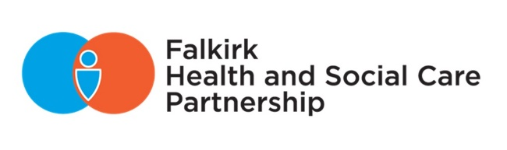

Contents

Introduction 2

Our Communities 4

Our Localities 4

Locality Snapshots 6

Our Challenges 7

Our Partnership 8

Our Priorities 9

Our Outcomes 9

National Health and Wellbeing Outcomes 10

Our Progress 12

Outcome 1 12

Outcome 2 24

Outcome 3 39

Outcome 4 43

Outcome 5 49

Outcome 6 51

Outcome 7 55

Outcome 8 61

Outcome 9 68

Our Governance 83

Our Performance 86

National Integration Indicators 86

Performance at a Glance 87

Looking Forward 91

Glossary 92

|  |  |
| --- | --- |
|  | Decorative |
| Introduction |
|  | WELCOME FROM OUR IJB CHAIR AND CHIEF OFFICER  Our 2020-2021 Annual Performance Report tells the story of a remarkable year. While the experiences of this year have been exceptionally challenging, they have also inspired and lifted spirits.  Looking back, we opened our 2019-2020 Annual Performance Report by acknowledging the significant efforts required to respond to the unfolding Covid-19 pandemic. At the time, we could not fully anticipate the overall impact of the pandemic on our communities, workforce, and services.  It is without a doubt, that every single person has been affected by Covid-19 in some way, and we are still monitoring and responding to challenges as the situation changes. To be direct, we still face many social and financial challenges in the near future.    Our workforce and communities worked tirelessly to respond to the pandemic. Relationships have been strengthened, demonstrating the success of integrated working to support a response which provided person-centred care at pace and at scale.  As our response continues, we will take stock and learn from the challenges and successes. We must continue to develop the good practice adopted and to strengthen our partnerships. We owe thanks to our carers, those who need our services, our staff, partners and communities for joining us on the journey to provide support and care in Falkirk. |

We know we can continue to work together to redesign our services and create innovative ways of delivering care. The Partnership’s Remobilise, Recover and Redesign Plan outlines the key elements for recovery and the potential opportunities for redesign.

Our Strategic Plan sets out a shared vision to “enable people in the Falkirk Health and Social Care Partnership area to live full and positive lives within supportive and inclusive communities”.

The Partnership, Falkirk’s communities, and our external partners continue to work together to deliver this vision, delivering support for those most in need and essential health and social care services.

While services and staff continue to respond and rebuild, our focus remains on ensuring safe, effective care for Falkirk’s communities. This is within the context of implementing the National Framework, the Integration Joint Board’s Strategic Plan, and latest national policy and guidance.

Thank you for taking the time to read our Annual Performance Report, which demonstrates the incredible efforts of our workforce during exceptional circumstances.

Dr Michelle McClung,

Falkirk IJB Chair

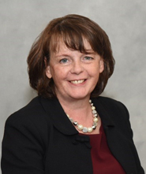

Patricia Cassidy,

Chief Officer

# 

# Our Communities

## Our Localities

The development of three localities within the Falkirk Council area is rooted within the integration legislation - the Public Bodies (Joint Working) (Scotland) Act 2014.

For service planning and delivery purposes, the three identified localities for the Partnership are West, Central and East (illustrated in Figure 1).

1. West
2. Central
3. East

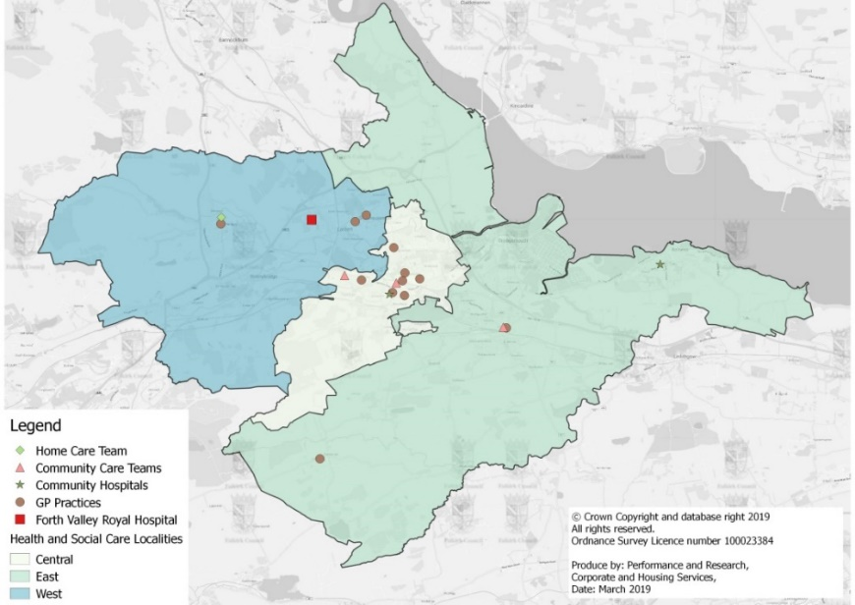

Figure 1: Falkirk Localities Map

During the height of the Covid-19 pandemic, it was even more imperative to deliver integrated services. Our workforce and communities united and formed a collective response, which accelerated many of the changes required that were set out in the Strategic Plan Delivery Plan. We will continue to build on this over the coming year through the Partnership’s Remobilise, Recover and Redesign Plan.

Our Locality Managers will continue to develop Locality Plans that reflect the needs of the local communities reflecting the Strategic Plan priorities. Locality plans will be developed with a community engagement approach along with partners to:

* ensure partners, communities and people who use services have their voices heard
* develop integrated, local services to improve health, promote good health and provide protection support
* build on the community capacity which has grown during the Covid-19 pandemic which is intended to reduce social isolation and improve the well-being of the people of Falkirk.

These Locality Plans will show how the Strategic Plan is being implemented locally to ensure services respond to the needs and issues within our communities.

This will also include working alongside our communities and partners and their plans. This includes the Community Planning Partnership, who are in the process of refreshing the Strategic Outcomes and Local Delivery (SOLD) Plan to form the new 10-year Falkirk Plan 2021-2031.

The following information has been summarised from the [Locality Profiles](https://falkirkhscp.org/wp-content/uploads/sites/9/2018/01/Locality-Profiles.pdf) for each of the locality areas.

## Locality Snapshots

Households

almost 30,000 households in central area, 31,000 in east area, and 21,000 in west area


21,952 31,754 21,520

**Central** **East** **West**

% that live with a long-term health condition

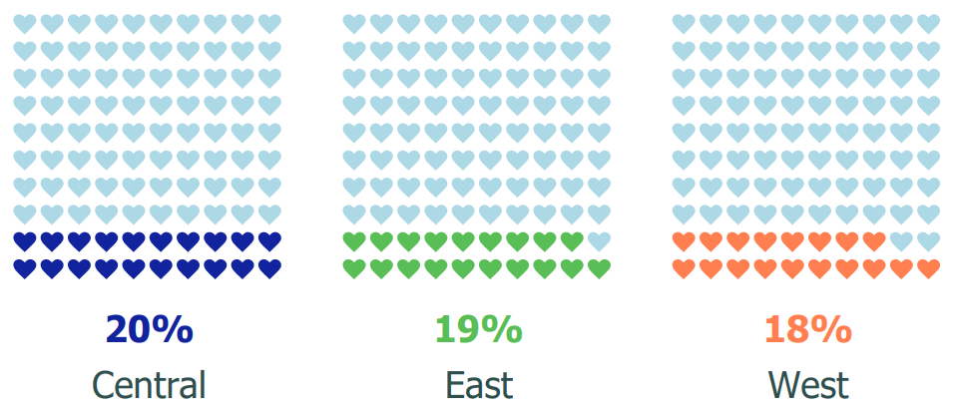

% that live in the most deprived SIMD quintile

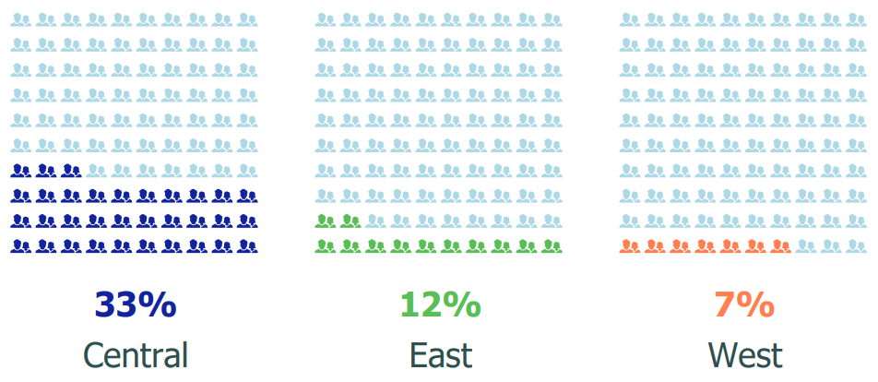

Figure 2

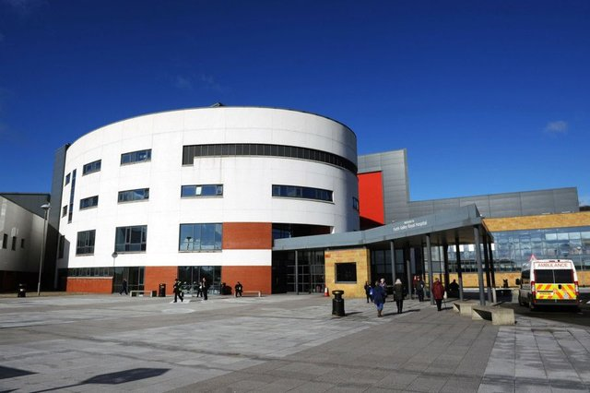

### west

Includes the areas of Larbert, Denny, and Bonnybridge.



central

Includes the areas of Falkirk town centre, Camelon, Bainsford, and Hallglen.



east

Includes the Braes, Redding, Bo’ness, Grangemouth, Stenhousemuir, and Airth.

## Our Challenges

The [Joint Strategic Needs Assessment](https://falkirkhscp.org/wp-content/uploads/sites/9/2018/01/HSCP-SNA-Appendix-1.pdf) provides a clear understanding of the health and care needs of the population. We use this information to help determine our priorities.

The following key issues have emerged from the needs assessment:

### Ageing population

|  |  |
| --- | --- |
| Projections suggest that the elderly population in Falkirk will increase significantly. This is likely to lead to a far greater requirement for health and care service provision, while a reduction in the working age population will ultimately reduce the number of people able to provide such services. | Figure 3 |

### Health inequalities

In Falkirk, all-cause mortality has been increasing for the most deprived areas (SIMD 1) and declining for the least deprived areas (SIMD 5). This shows that health inequalities in Falkirk, not only exist, they are widening.

### Mental health

Mental health is identified as a priority in the Strategic Plan. However, it is challenging to fully understand the level of need and demand. Individuals experiencing mental health issues can be unlikely to interact with services until they reach a crisis.

### 

### Drugs and alcohol

|  |  |
| --- | --- |
| Alcohol and drugs remain a challenge in Falkirk. While alcohol related hospital admissions have fluctuated over the years, the picture for drugs is more concerning with drug related hospital admissions consistently on the rise. This has an impact on the person, their families and communities. | Figure 4 |

|  |  |
| --- | --- |
|  |  |
| Our vision:  “enable people in the Falkirk HSCP area to live full and positive lives within supportive and inclusive communities” | Our Partnership The **Strategic Plan** outlines how we will deliver adult health and social care services in Falkirk over 3 years. It sets out how we will deliver the national outcomes for health and wellbeing, and achieve the core aims of integration to:   * improve the quality and consistency of services for patients, carers, service users and their families * provide seamless, integrated, quality community health and social care services that care for people in their homes, or a homely setting, where it is safe to do so * ensure resources are used effectively and efficiently to deliver services that meet the needs of the increasing number of people with long term conditions and often complex needs, many of whom are older.   Our Strategic Plan, developed in partnership, sets out our vision, local outcomes and priorities that we aspire to achieve for the people of the Falkirk area. |

|  |  |  |  |  |  |  |  |  |  |  |  |  |  |  |  |  |  |  |  |
| --- | --- | --- | --- | --- | --- | --- | --- | --- | --- | --- | --- | --- | --- | --- | --- | --- | --- | --- | --- |
| Our Priorities  |  |  | | --- | --- | | PRIORITY 1 | Deliver local health and social care services, including Primary Care services that are able to respond to people and communities | | PRIORITY 2 | Ensure carers are supported in their carer role | | PRIORITY 3 | Early intervention, prevention, and harm reduction that: | | * Improves people’s mental health and wellbeing | | * Improves support for people with substance use issues, their families, and communities | | * Minimises the impact of health inequalities on individual and communities | | PRIORITY 4 | Make better use of technology to support the delivery of health and social care services |  Our Outcomes  |  |  | | --- | --- | | LOCAL OUTCOME 1: Self-management | Individuals, their carers and families can plan and manage their own health, care and well-being. Where supports are required, people have control and choice over what and how care is provided | | LOCAL OUTCOME 2: Safe | High quality health and social care services are delivered that promote keeping people safe and well for longer | | LOCAL OUTCOME 3: Experience | People have a fair and positive experience of health and social care, delivered by a supported workforce that are skilled, committed, motivated and valued | | LOCAL OUTCOME 4: Strong sustainable communities | Individuals and communities are resilient and empowered with a range of supports in place, that are accessible and reduce health and social inequalities | |

## National Health and Wellbeing Outcomes

The Scottish Government has nine national health and wellbeing outcomes, shown in Table 1, to improve the quality and consistency of services for individuals, carers and their families, and those who work within health and social care.

|  |  |  |
| --- | --- | --- |
|  | 1 | People are able to look after and improve their own health and wellbeing and live in good health for longer |
|  | 2 | People, including those with disabilities or long term conditions or who are frail, are able to live, as far as reasonably practicable, independently and at home or in a homely setting in their community |
|  | 3 | People who use health and social care services have positive experiences of those services, and have their dignity respected |
|  | 4 | Health and social care services are centred on helping to maintain or improve the quality of life of people who use those services |
|  | 5 | Health and social care services contribute to reducing health inequalities |
|  | 6 | People who provide unpaid care are supported to look after their own health and wellbeing, including to reduce any negative impact of their caring role on their own health and wellbeing |
|  | 7 | People who use health and social care services are safe from harm |
|  | 8 | People who work in health and social care services feel engaged with the work they do and are supported to continuously improve the information, support, care and treatment they provide |
|  | 9 | Resources are used effectively and efficiently in the provision of health and social care services |

Table 1: National Health and Wellbeing Outcomes

This performance report sets out progress made towards the National Health and Wellbeing Outcomes, and our Strategic Plan priorities and outcomes during 2020/21.

|  |  |  |  |  |  |  |  |  |  |  |  |  |  |  |  |  |  |  |
| --- | --- | --- | --- | --- | --- | --- | --- | --- | --- | --- | --- | --- | --- | --- | --- | --- | --- | --- |
| Falkirk HSCP Strategic Plan Priorities | National Health and Wellbeing Outcomes | | | | | | | | | | | | | | | | Scottish Government Integration  Priorities | |
|  | 1 | 2 | | 3 | | 4 | | 5 | | 6 | | 7 | 8 | | | 9 |  | | |
| Deliver local health and social care services, including Primary Care services able to respond to people and communities | ✅ | ✅ | ✅ | | ✅ | | ✅ | | ✅ | | ✅ | | | ✅ | ✅ | | | Reduce occupied hospital bed days associated with avoidable admissions and delayed discharges | | |
| Ensure carers are supported in their carer role | ✅ | ✅ | ✅ | | ✅ | | ✅ | | ✅ | | ✅ | | | ✅ | ✅ | | | Increase provision of good quality, appropriate, palliative and end of life care | | |
| Early intervention, prevention and harm reduction that:   * Improve people’s mental health and wellbeing * Improve support for people with substance use issues, their families and communities * Minimise the impact of health inequalities on individual and communities | ✅ | ✅ | ✅ | | ✅ | | ✅ | | ✅ | | ✅ | | | ✅ | ✅ | | | Enhance Primary Care | | |
| Reflect delivery of the new Mental Health Strategy | | |
| Support delivery of agreed service levels of alcohol and drugs partnership work | | |
| Ensure provision of the living wage to adult care workers and plan for sustainability of social care provision | | |
| Make better use of technology to support the delivery of health and social care services | ✅ | ✅ | ✅ | | ✅ | |  | | ✅ | |  | | | ✅ | ✅ | | | Continue implementation of Self-Directed Support | | |
| Prepare for commencement of the Carers (Scotland) Act on 1 April 2018 | | |

Table 2: Association between local Falkirk priorities, Scottish Government Integration Priorities, and National Outcomes

# Our Progress

National Health and Wellbeing Outcomes

### Outcome 1:

People are able to look after and improve their own health and wellbeing and live in good health for longer

Enabling people to look after and improve their health and wellbeing has been particularly challenging during the pandemic and lockdown. Our Partnership activity in the community has therefore focused strongly on supporting shielding or self-isolating individuals directly and underpinning the community response, alongside maintaining, and developing the Living Well Falkirk service and the continuation of community nursing, Primary care and care services.

Support for People

Partners across Falkirk quickly mobilised to establish a co-ordinated approach to responding to the impact of the Covid-19 pandemic. Individuals, communities, third sector organisations, local businesses and the partner agencies came together to provide access to food, medicines, and essential services to meet the needs of the people and communities of Falkirk.

The Support for People co-ordination group had oversight of local activity. The group took an enabling role, setting up the infrastructure that supported and enabled third sector organisations and co-ordinating the diverse range of services provided. As a partner, the HSCP contributed by:

* establishing the Support for People phone line, providing support and advice to people shielding or self-isolating
* swiftly realigning of HSCP community funds to form a Covid-19 response fund for communities
* offering assurance and support to third sector and community-based partners that funding could be used flexibly to enable continuous support for service users
* providing specialist support regarding PPE, food preparation and hygiene for local community food providers
* considering the impact of food insecurity and working to provide a local framework to enable dignified food provision.
* providing information and support to communities to increase awareness about how to identify and raise Adult Support and Protection concerns
* establishing and maintaining links between HSCP service response and local community response to enhance joined up working e.g. working with community pharmacies to deliver prescriptions, provision of emergency food to vulnerable service users.

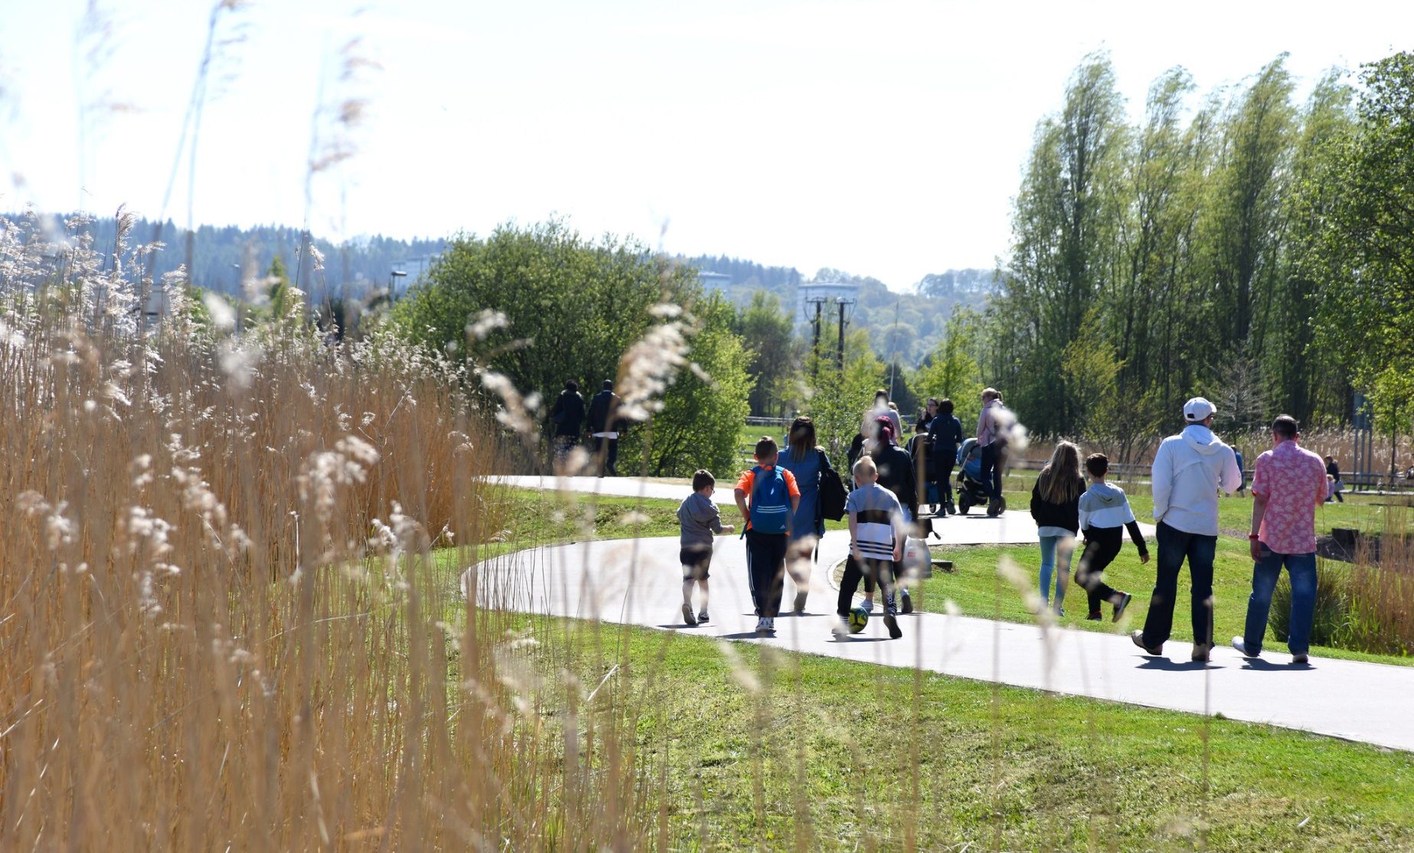The Support for People Co-ordination group has remained active throughout 2020/2021. The group initially met daily. The frequency of meetings has stepped up and down and the group meets depending on the emerging situation and need. The relationship formed between partners has been fundamental to the success of the response. Partners are committed to continuing the approach across other areas of work.

The HSCP commissioned an external evaluation of the community and third sector response to Covid-19 in October 2020. The report highlighted the scale, scope, and speed at which the third sector response to the crisis was remarkable. Although the report was published after the first wave of Covid-19 and so does not reflect the total response, it noted:

* 56 third sector organisations were listed on the Support for People directory offering a range of support to vulnerable people
* Falkirk Council’s Support for People (SFP) service made 1,705 referrals to third sector organisations (104 referrals to statutory services)
* the most immediate and overwhelming need was access to food - of the 2,336 requests for support to the SFP line, 1,572 (66%) required food
* over 20 third sector organisations were directly involved in the provision of food through the Emergency Food Project: third sector organisations provided emergency food to 15,953 households in total (in the period 6 Apr-31 Aug)
* at the peak of demand (end May 2020), organisations delivered emergency food to 1,055 households in one week
* from June to end August, an average of 773 households each week were receiving food through the emergency food project. The total cost of food provided was £192,310.

The public response to the Covid-19 crisis was tremendous. In the first three weeks (April 2020) 403 people registered with CVS Falkirk to volunteer and a further 914 individuals registered their interest through Scottish Government Ready Scotland/Scotland Cares campaign. CVS Falkirk set up a dedicated volunteer centre to manage the response:

* 249 volunteers were signposted to local opportunities
* 159 volunteers were placed with local organisations
* HSCP and Falkirk Council volunteer expenses fund - 18 organisations benefited, claiming expenses for 78 volunteers
* Volunteer expenses (nearly £28,000) show volunteers covered 62,000 miles.

While the emergency response focused on ensuring access to food, prescriptions and essential items, there is a raft of third sector organisations delivering other services to meet the needs of vulnerable people in the community. The third sector adapted their service models to continue to provide support to their service users, and also flexed their delivery to meet the increased levels of need and fill gaps in provision left by pressure in other services.

Third sector organisations responded by putting the safety and needs of the people they supported at the core of their response. Their responses were driven by ‘what we can do’ rather than ‘what we can’t do’. The approach has further demonstrated the value of the third sector and of community led approaches to supporting people in the community.

The approach has built the capacity of local organisations, increased community involvement and built the capacity and resilience of communities in Falkirk. [The full report is available on the Falkirk HSCP website.](https://falkirkhscp.org/wp-content/uploads/sites/9/2021/11/Falkirk-HSCP-External-Evaluation-Third-Sector-Response-to-Coronavirus.pdf)

**Case Study: Hallglen Community Volunteers**

HSCP Community Learning & Development (CLD) staff worked with volunteers in Hallglen to transition from an emergency food provider to a sustainable food pantry. The community initiated this to help alleviate the stigma of giving out ‘free food’. The pantry enables people to pay what they could afford and provides a more dignified approach to addressing food insecurity in their community.

Living and volunteering in their community, and from their own experiences, the group understand the issues facing local people. It is not only about food, but maintaining positive mental health and wellbeing is also a significant challenge.

The group are now operating on a sustainable footing and are now confident in being able to attract additional funding and resources into their community. They have continued to build their own capacity by taking up training opportunities offered by partners e.g. NHS Community Food Development modules.

Hallglen Community Volunteers are now one of four satellite sites for the VIVA Project. This is a community-led health initiative to provide community-based access to mental health services and a mental health champion.

Living Well Falkirk website

Living Well Falkirk is an online tool that promotes healthy, independent living by emphasising people’s ability to stay active and participate in their community. It is a tool for people who live in the Falkirk area and are having difficulties with everyday activities. The tool has been commended by Healthcare Improvement Scotland as positive example of community-led approaches to health and social care.

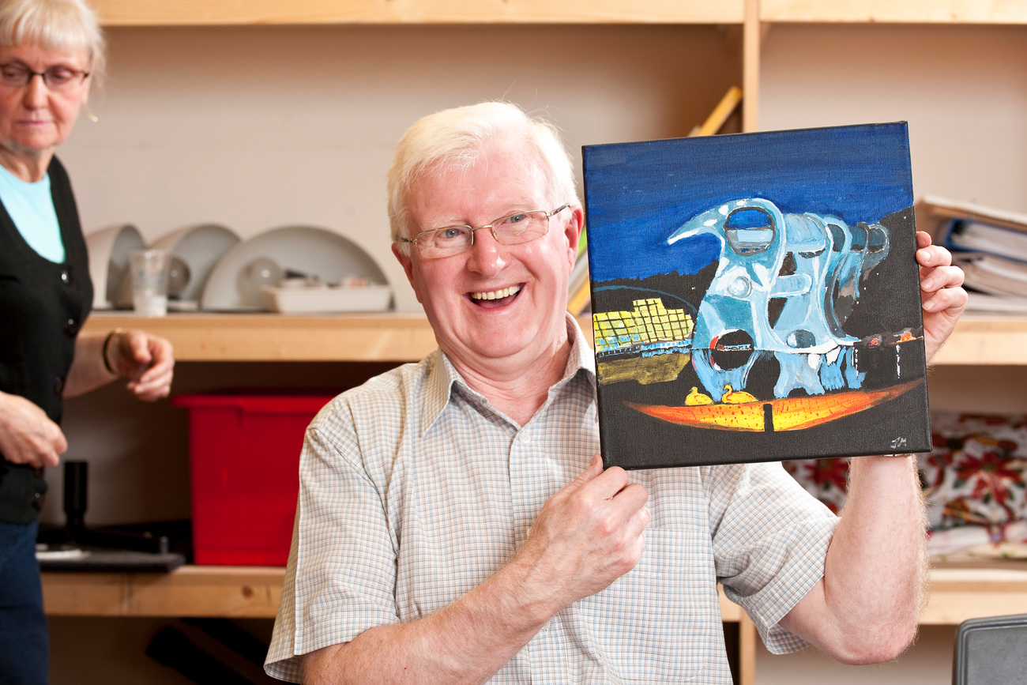

Living Well Falkirk offers:

* 24-hour access to hints and tips on how to stay well and live independently
* information about local and national services
* helpful advice by completing a self-assessment on your abilities
* suggestions on areas such as staying safe at home, preventing falls, help with bathing, etc
* options to purchase, or request the loan of, equipment matched to your needs
* contact information for further support.

The Living Well model emphasises empowerment of individuals within their community and is supported by a steering group with strong representation from third sector groups in Falkirk.

*“I personally received support for my dad and brother who both suffer mental health and physical issues … it made such a difference and allowed me time to organise things better”*

A carer supported by Living Well during Covid-19

The tool is key to achieving Falkirk Health and Social Care Partnership’s remit of bringing services together to support people in their own homes. To learn more about Living Well Falkirk, visit <https://livingwellfalkirk.lifecurve.uk/>

During 2020-2021:

* 3211 people have used the site, with a total of 4733 visits – an increase of 1.6% on users from the previous year
* Most visits to the site were from within Falkirk (1060), followed by Glasgow (583), Edinburgh (492), London (400), then other areas. This indicates there continues to be a significant number of family members or friends from outside Falkirk visiting the site on behalf of their relative or friend living in Falkirk.
* 244 Lifecurve assessments were completed – we would hope to see increased use of this assessment type as people emerge from restrictions and start to look at ways to overcome the deconditioning that can happen with lack of activity, exercise, and movement.

Self-assessment relating to a specific difficulty are broken down into “areas of need”. The most popular area of need assessments were:

* I am finding it quite hard to take a bath - what can I do to manage better?
* I am finding it quite hard to step into the bath and (or) stand to take a shower in the bath
* I struggle when walking up and down the steps at the main entrance to my home.

Living Well Falkirk Centre

The first Living Well Falkirk Centre opened in April 2019 within the Forth Valley Sensory Centre, running three days a week. The Centre offered people who had identified that they have difficulty with daily living tasks, for example bathing or managing the stairs, an opportunity to access to the right support at the right time.

The aim of the Living Well Falkirk Centre is to assess people quickly and where there is a need, provide equipment or adaptations to help maintain independence. The Living Well Centre was suspended in March 2020 in line with national restrictions and local guidance. It is anticipated that the centre will re-open later in 2021.

community link workers

Three Community Link Workers operate within the Falkirk area; one within each locality. Each Link Worker is hosted by a third sector organisation and are aligned to GP Practices with the highest level of deprivation. Community Link Work is one of the priorities within the Primary Care Transformation Programme.

The introduction of the Community Link Work model intends to allow GPs to target their time with an individual to address medical issues, whilst a social prescribing model is used by Community Link Workers to meet wellbeing, economic and social factors affecting their life and in turn their health. This provides a holistic person-centred approach to supporting individuals.

During 2020/2021, although the Link Workers were not able to provide services within GP practices, they have continued to support people remotely, via phone and internet.

|  |  |  |  |
| --- | --- | --- | --- |
| Locality: | East | Central | West |
| Host: | Cyrenians | FDAMH | Strathcarron |
| Support: | Generalist | Therapeutic | Generalist |
| GP Practices: | * Bo’ness Road * Kersiebank | * All Central Practices | * Denny Cross * Carronbank * Bonnybridge |

**CASE STUDY: CARING FOR MUM**

During 2020, a carer called requesting advice for her Mum who recently moved into sheltered accommodation. The carer could not visit her Mum as she was in the shielding category, and she was worried that her Mum was not eating well. The carer was unsure who to turn to, so she called her Community Link Worker for advice.

The Link Worker was able to advise on dementia, diet, hints and tips to try and help the carer understand how a diagnosis can effect taste, texture and motivation/desire to cook and eat a meal. The Link Worker worked with the carer, care provider staff, and management to agree a food diary and all care staff agreed to monitor, encourage and liaise with family to highlight food preferences etc. The carer later contacted the Link Worker to thank her for her support and practical advice, stating that she felt reassured and a lot less anxious now that there is a procedure in place to monitor her Mum’s eating.

Mental Health Improvement Resources

A series of four short YouTube videos from Step on Stress NHS Fife were promoted throughout the Forth Valley during 2020-21. This programme supports individuals with managing their anxiety and depression. You can find these videos [here](https://www.youtube.com/playlist?list=PLCt6GGXbRmi8h-gSrgc7AvYvZSZluTrcB).

The Health Promotion Service provide an online digital bookshelf which hosts several self-help materials for mental health and wellbeing, such as anxiety, low mood and depression, sleep and stress. Their website has been viewed a total of 10,624 times. You can find this resource [here](http://www.nhsforthvalley.com/selfhelp).

Three ‘Ask, Tell’ Animation Workshops were delivered covering the areas of mental wellbeing, suicide prevention and having compassionate conversations with people experiencing mental distress or may be feeling suicidal. In Falkirk, 12 participants started attending these workshops, with 9 participants completing all 3 workshops. Participants came from Aberlour, Falkirk Council, Education, Social Work, and Strathcarron Hospice.

Smile4Life

Smile4Life is the national Oral Health (OH) programme that aims to build the capacity of health and social care staff and volunteers to provide tailored oral health messages to meet the needs of vulnerable people and facilitate their access to dental services.

In 2020-21, 24 staff have been trained in the Smile4Life approach from a variety of settings. Positive links and partnerships have been created between community organisations and local dental health services, so that there is a direct referral pathway for vulnerable people to be supported on their oral health issues.

Feedback from Smile4Life Training Participants:

“I feel more confident about raising OH issues with service users and know where to direct them for local dental health services.”

“A lot of the vulnerable people we work with neglect their oral health and don’t access regular dental services, due to chaotic lifestyles and suffer from dental pain and decayed teeth as a result. With the OH training received, and knowledge provide on risk factors, we can raise the issue when the time is right.”

toothbrush pack dissemination

Toothbrush Packs have been offered to community organisations during the pandemic so that they can be provided to the most vulnerable communities. As a result, there has been a steady demand of requests from food banks and child and family support organisations. There are also toothbrush distributions to Pharmacies who offer Opiate Substitute Therapy twice a year and toothbrush packs are also distributed within the prison population.

661 dental packs for adult and children, 400 adult toothbrushes and about 600 information postcards with key oral health messages around smoking, diet, alcohol and visiting a dentist, have been disseminated across organisations in Falkirk.

Mouth matters

Mouth Matters is the national oral health improvement programme for prisoners. This includes delivering staff training and supporting peer mentors to deliver basic oral health information, as well as working with colleagues to address oral health risk factors including smoking and diet.

678 Toothbrush Packs have been distributed from 35 Community Pharmacies in the Falkirk area, and 550 Toothbrush Packs have been distributed within HMPYO Polmont and 50 child dental packs have been distributed through the Polmont Prison Family Hub.

The Health Promotion Service

The Health Promotion Service delivers Alcohol Brief Intervention (ABI) training which was designed in line with the national ABI training. This helps participants learn more about the effects of alcohol, how to calculate units, and the skills required when offering brief advice.

In 2020-21, Alcohol Brief Intervention training was delivered via LearnPro online learning and a total of 24 participants, including healthcare and prison healthcare staff in Falkirk attended the training. This training will continue to be available to staff working in Falkirk in 2021-22.

The delivery of Overdose Awareness and Naloxone training is targeted to groups most likely to be confronted by an overdose situation and is predicated on the evidence that most drug related deaths occur when other people were present who could have provided emergency life support to prevent death.

This training was adapted for delivery on Teams due to Covid-19 and a total of 36 participants from Falkirk attended training sessions in 2020-21.

The service also delivers online ‘Raising the issue of tobacco’ training via LearnPro. This course is aimed at all NHS staff including prison health care staff. 12 participants from Falkirk completed the training in 2020-21.

The Health Promotion Service worked in partnership with the ADPs to promote and reinforce the ‘rethink your drink’ message raising awareness throughout the festive and summer months. This local campaign maximised the marketing message of the Count 14 National programme and was distributed throughout the Falkirk HSCP.

No Smoking Day took place on Wednesday 10 March 2021. This year’s campaign was driven by ASH Scotland through media platforms and encouraged people to make a quit attempt by sharing stories of individuals who have successfully stopped smoking. Falkirk HSCP and third sector partners supported the campaign through social media.

The Health Improvement Resource Service provides registered library users with access to information on a range of health improvement issues in a range of formats. The following table details the quantity of requested resources disseminated in Falkirk for alcohol, drugs, and tobacco for 2020-21.

|  |  |
| --- | --- |
| Health Improvement Resource Requests | Falkirk |
| Alcohol | 716 |
| Drugs | 130 |
| Tobacco | 615 |
| Total | 1461 |

Table 3

Stop Smoking Service Delivery in Falkirk

Free behavioural support and pharmacotherapy is offered to individuals wanting to stop smoking in Forth Valley. The Stop Smoking Service and Community Pharmacy support delivery of the cessation service to support the wider target of reducing smoking rates to below 5% across the country by 2034.

All face-to-face clinics were suspended during 2020-21 and behavioural support was conducted via telephone and ‘Near Me’ video consultation. The service also adopted a process to post Nicotine Replacement Therapy (NRT) to clients who would have previously received NRT at clinics.

The following table indicates Falkirk specific information on the number of quit dates set, four and 12-week quit success and contribution to the Local Delivery Plan (LDP). Official published data will not be available until October 2021 so final figures may be marginally higher than those below.

|  |  |  |  |  |
| --- | --- | --- | --- | --- |
| 17th June 2021 | Total Quit Date Set | Total 4 Week Success | Total 12 Week Success | LDP Success |
| Stop Smoking Service | 189 | 159 | 114 | 70 |
| Pharmacy | 477 | 252 | 143 | 90 |
| Total | 666 | 411 | 257 | 160 |

Table 4

Information has been regularly disseminated among partners and community groups in order to encourage referrals during the pandemic. The service also engaged with Homestart Falkirk, Central Scotland Regional Equality Council, the Migrant Support Network and Money Advice Services.

A quarterly newsletter was developed and distributed to partners to promote the service and prompt referrals to the Stop Smoking Service. The first issue was distributed in February 2021.

### Outcome 2:

People, including those with disabilities or long-term conditions or who are frail, are able to live, as far as reasonably practicable, independently and at home or in a homely setting in their community.

During 2020/2021, the care and support offered to people within their own home was significantly impacted by the restrictions enforced in response to Covid-19. Many health and social care services changed the focus of their provision to urgent response. Services continue to be re-introduced in accordance with national guidance. The impact of closures and changes to services have had a particularly adverse impact on those with disabilities or with long term conditions, their carers and families.

Day Services

All internal and external Day Care provision was stopped during the first lockdown in 2020, including community-based groups such as lunch clubs. The HSCP has worked with Corporate & Housing Services and third sector partners to ensure that services users, unpaid carers and families have continued to receive support where possible.

Towards the end of March 2021, work had commenced to re-open day care on a phased basis. The focus of this work has been on working closely with provider partners to ensure that they are able to reopen safely. Thorough risk assessments have been undertaken and action plans are being developed to progress phased opening. Initially, people with the highest care needs will be invited to return to our service based at the Dundas Resource Centre. HSCP Community Learning and Development staff and CVS Falkirk are also providing support to volunteer-led groups about safely restarting services.

Review of Older People’s Day Services

Work has been underway throughout 2020-21 to review day services for older people in Falkirk. These services are predominately traditional services, delivered in buildings where people spend the day participating in activities that are social or physical in nature. In the main the services meet people’s needs in terms of social interaction although the

standardised nature of provision makes it difficult to truly meet individual needs in terms of wishes, aspirations and personal outcomes.

With the development of our locality model there is an opportunity to develop local community-led services that encourage social inclusion, community integration and equality. While older people have told us they are satisfied with the services they receive, it is recognised that there are few available alternatives and that future generations may wish to opt for something different. It is clear that people tend only to use day services when they reach a point that they require some form of service provision, rather than as an ongoing community-based support.

The proposed model of Older People’s Day Services has three main elements:

**1. Inclusion and Independence Programme** which combines the benefits of community navigator and befriending interventions, building on the work of the Community Link Workers. The service can provide practical low-level support to those typically aged 65 and older, using a volunteer service delivery model and approach, supported by a dedicated staff team.

Services could include;

* group activities and help to attend these groups or social activities – whether it is accompanying the person or providing an introduction
* volunteer drivers to provide assistance with transport to groups
* short term one to one support
* longer term support/befriending
* telephone support/befriending
* Volunteer Recruitment, Training & Engagement.

**2. Reablement day services**

Reablement day services provision will work with individuals over a number of weeks to ensure they build resilience and skills to achieve and / or maintain their maximum levels of independence. In terms of benefits for service users, reablement is a highly flexible model which can work with people on a wide range of issues aimed at reducing the need for ongoing care unless necessary.

**3. Building Based Day Services**

Some specialist building based day services will be retained that can provide intensive support to individuals that require this level of service, either as a consequence of their own care and support needs or as a form of support to their carers.

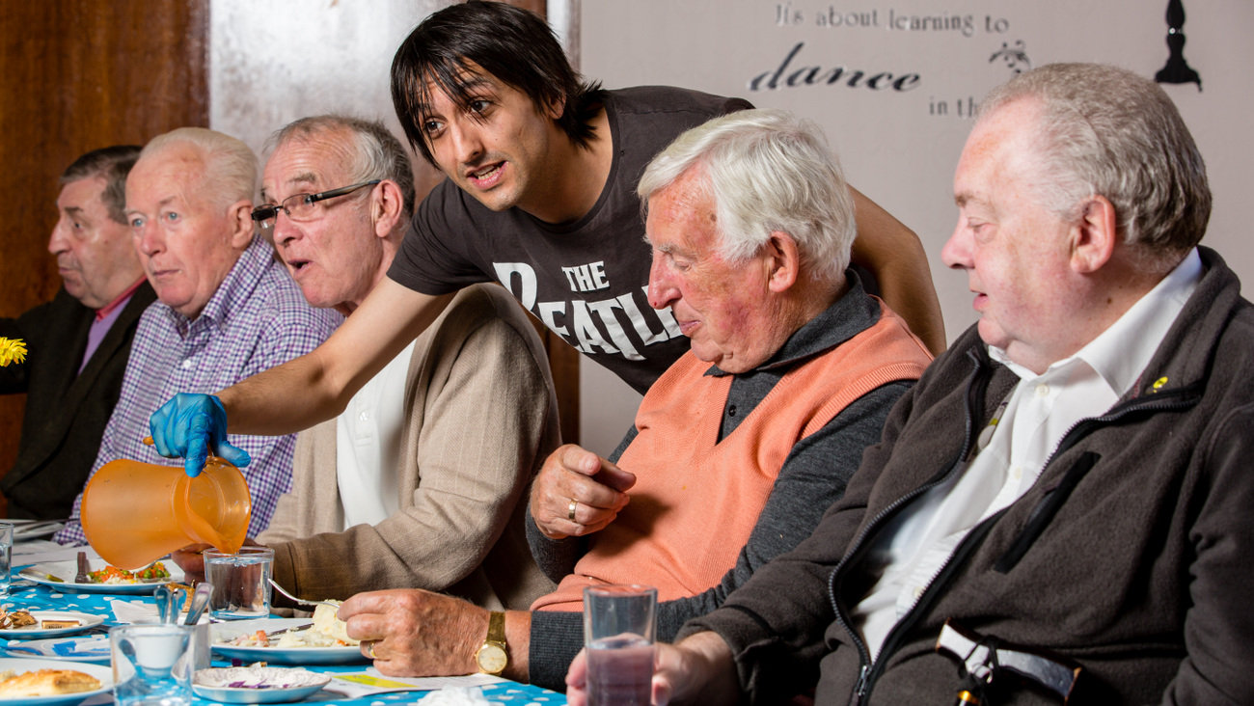

**CASE STUDY: NEIGHBOURHOOD NETWORKS**

**An example of inclusion and independence support for adults as an alternative to building-based day services.**

Neighbourhood Networks is a service that brings people together to form networks and peer groups to make best use of facilities within their own communities.

The service is available to adults with learning disabilities and has an average of 15 members to each group. It was launched in the east locality in 2018 and is now being extended to the wider Falkirk area. This service is an alternative to building based day services for people with learning disabilities.

Neighbourhood Networks were able to remain fully operational during lockdown. Members benefitted from welfare calls on a regular basis, WhatsApp group chats with other members, doorstep visits, and 1:1 health walks in the local community to encourage members to get out the house and build up their confidence again getting back outdoors.

When restrictions allowed, members have met in the local community for health walks for small groups. Members had full access to our digital activities planner which hosts a range of activities all picked by members: Mindfulness, Yoga, Weight Management, Human Rights Courses, Dance, Art, Photography, Creative Writing, and Karaoke amongst other activities.

Members are able to be involved at their own pace as we recognise that individuals have their own anxieties and with the addition of Covid-19 this has heightened them even more. By continuing to offer a service during lockdown, positive relationships were formed between members, which helps them to build up their confidence as an individual as well as out in the local community. Members have the choice of how they wanted to engage e.g. digitally, face to face, or over the phone. By giving this choice, members engage in a way that suited them and didn’t further add to their anxieties.

CASE STUDY: DATES-N-MATES

**An example of inclusion and independence support for adults as an alternative to building-based day services.**

As Scotland’s national dating and friendship agency for adults with learning disabilities, Dates-n-Mates has sought to improve the health and wellbeing of its members in Falkirk by helping them overcome the loneliness and social isolation to which many people with learning disabilities are particularly susceptible.

We have done this by:

* providing opportunities and support to make and sustain friendships and close personal relationships
* supporting people to develop the skills and abilities to make decisions about, develop and sustain friendships and close personal relationships
* increasing social inclusion and the presence of people with learning disabilities in everyday places, events and activities.

Covid-19 has required that we adapt our offer to members and change our activities, delivering social interaction via online channels. Many members have talked of isolation during the period of lockdown, many have been part of a wider shielding population.

Despite this, the mission very much remains to improve the health and wellbeing of members by ensuring they have opportunities and support to make and sustain friendships and close personal relationships. Our offer has included helping members to overcome digital exclusion.

Between January 2020 and March 2020, we delivered face-to-face 12 social events including an open events valentine's night attended by 78 people (20 members and 58 non-members). Open events are attended by members and non-members, providing opportunities to meet new people and recruit them as members.

Despite this exceptional year where the delivery model changed quickly in response to the pandemic and members adjusted to interaction via the internet our members remained positive about events and the opportunities to meet new people.

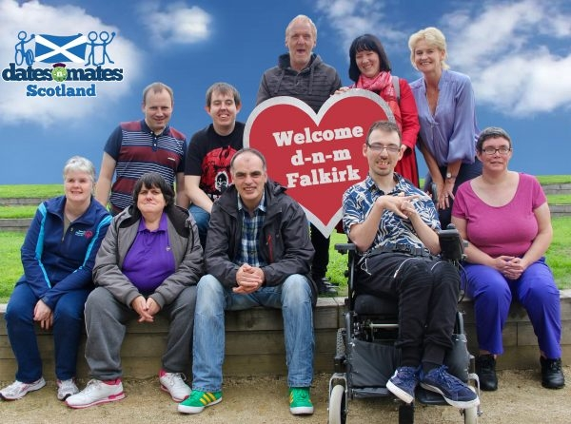It is also important that our members, all vulnerable adults, understand how to keep themselves safe in the current environment. This has led us to further develop our training workshops and as a result we now offer ‘safe social media’ and ‘Keep Safe’ training via video.

Future Model of Care at Home Provision

Our internal Home Care service currently operates from 7am until 11pm providing a mixed model in terms of packages of care to approximately 750 service users in the Falkirk area. In terms of external provision, a further 21 providers deliver services to approximately 1097 service users.

Current service provision is very mixed, and whilst we have aimed to deliver care that is underpinned by a reablement ethos, much of the service delivers maintenance care provision. Furthermore, the current model of in-house provision is very much based on available capacity rather than specific requirement for care.

In addition to capacity issues, the in-house service has also struggled with key areas of efficiency, with only approximately 48% of the available contacted hours being utilised as care delivery hours and the remaining 52% being a combination of absence, training, annual leave and unused hours. These inefficiencies have driven up the cost of an internal hour of home care. It is critical that we refocus our internal service to provide specialist care.

During the course of 2020/21 we have been working to develop a Future Model of Care at Home provision. The new model will be based on:

**1. Dedicated reablement teams**

Reablement Home Care provision will work with individuals over a number of weeks to ensure they build resilience and skills to achieve and / or maintain their maximum levels of independence. In terms of benefits for service users, reablement is a highly flexible person-centred model which can work with people on a wide range of issues aimed at achieving their outcomes and supporting their independence.

**2. Urgent Response provision**

This service will be able to respond to service requests at short notice to support hospital discharges and provide short-term support at home at time of crisis or for those pending allocation for on-going maintenance care provision.

**3. Maintenance Care provision**

Our in-house service will be required to retain an element of maintenance provision to ensure that there is adequate provision for those care packages that have historically proven difficult to allocate a service.

The change of model will ensure the service is fit for purpose and well placed to face rising demands and complexity of support and will ensure that the service is able to meet these challenges in the future.

Home First

Home First is a local initiative focussing on supporting people to avoid a delay in their discharge from hospital. Home First works with the person and their carer / relative to agree how they can support them to get home, without any delays. The team consists of social work professionals who work in collaboration with health professionals to determine people’s needs to return home. The service has assisted over 1200 patients since January 2020.

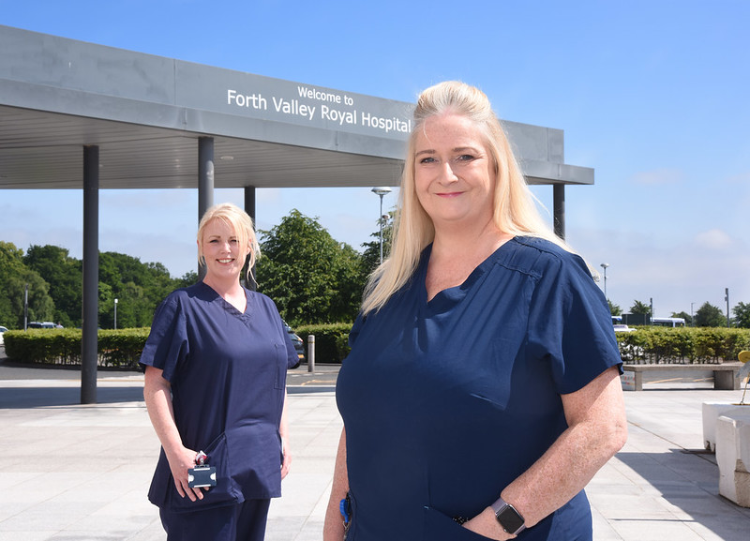Home First manages and facilitates discharges to Bo’ness Hospital, Summerford House intermediate care home, Falkirk Council care homes, Thornton Gardens and intermediate beds procured by the partnership. Home First is also involved in the discharge to assess model evolvement.

The service continues to have strong links with the reablement service within Summerford House care home, working within an integrated approach to facilitate discharges in order to assist patient flow and direction.

The role of Home First Team Practitioner has now been established. The purpose of this role is to work across Forth Valley Royal Hospital within all wards and at the Front Door (which includes a multi-disciplinary team of social workers, Occupational Therapy and home care Liaison workers).

Improving our delayed discharge performance is an area for improvement and remains an area of priority for the Partnership. It has been a challenging year for the service particularly through the Covid-19 peaks.

The Home First service continues to work throughout the pandemic in parallel with our health partners to promote capacity and flow within the system. The Home First team in Falkirk Community Hospital now serves and manages the intermediate beds identified to aid downstream delays within Forth Valley Royal Hospital and to objectively place the person to achieve the correct outcome.

|  |  |  |  |  |
| --- | --- | --- | --- | --- |
|  |  | **Mar-20** | **Mar-21** | **Direction of travel** |
| 54 | Standard delayed discharges | 15 | 15 | **-** |
| 55 | Standard delayed discharges over 2 weeks | 8 | 6 | **▲** |
| 56 | Bed days occupied by delayed discharges | 670 | 209 | **▲** |
| 57 | Number of code 9 delays, including guardianship | 13 | 19 | ▼ |
| 58 | Number of code 100 delays | 2 | 3 | ▼ |
| 59 | Delays - including Code 9 and Guardianship | 28 | 34 | ▼ |
| Table 5 | | | | |

|  |  |  |  |  |
| --- | --- | --- | --- | --- |
|  |  | **At 30 June 2020** | **At 30 June 2021** | **Direction of travel** |
| 85 | The number of overdue 'OT' pending assessments at end of the period | 150 | 204 | ▼ |

Table 6

District Nursing Services

Our District Nursing Team provide a wide range of local community-based services to people across a range of settings including people’s own home, care homes and treatment rooms. We provide increasingly complex care for patients and support their family and carers to meet their needs. This could include access to area wide specialist teams where appropriate, such as the Enhanced Community Health team, tissue viability and the hospice. Providing care at home, or as close to home as possible, reduces avoidable hospital admissions or attendances and helps get people back home quickly and safely.

**Our District Nursing vision:**

**“to support people to live and die well within their own homes. We will do this by delivering excellent nursing care in the community, 24 hours a day”**

The last 12 months has been a challenging time to be working within District Nursing and Community due to the Covid-19 pandemic. There has been an increased emphasis on keeping people at home or in a homely environment and prevention of hospital admission. This was achieved by the “can do” attitude of our Community Nursing Team, with many frail and elderly patients avoiding hospital admission.

The District Nursing service has supported the roll out of the Covid-19 vaccine with approximately 6,000 home visits made to deliver both vaccines to housebound patients across Falkirk.

We also saw an increase of 50% more patients from the previous year being supported to end of life and being enabled to die at home with Community staff providing complex, safe, care options for people in the comfort of their own homes.

District nurses have changed the way we practice reducing footfall in patients homes. Many patients were taught self-care / management of their conditions and technology used to support those who needed it. An area that was particularly successful was in teaching patients to administer their own B12 injections with a significant increase in patients who now manage their own injections.

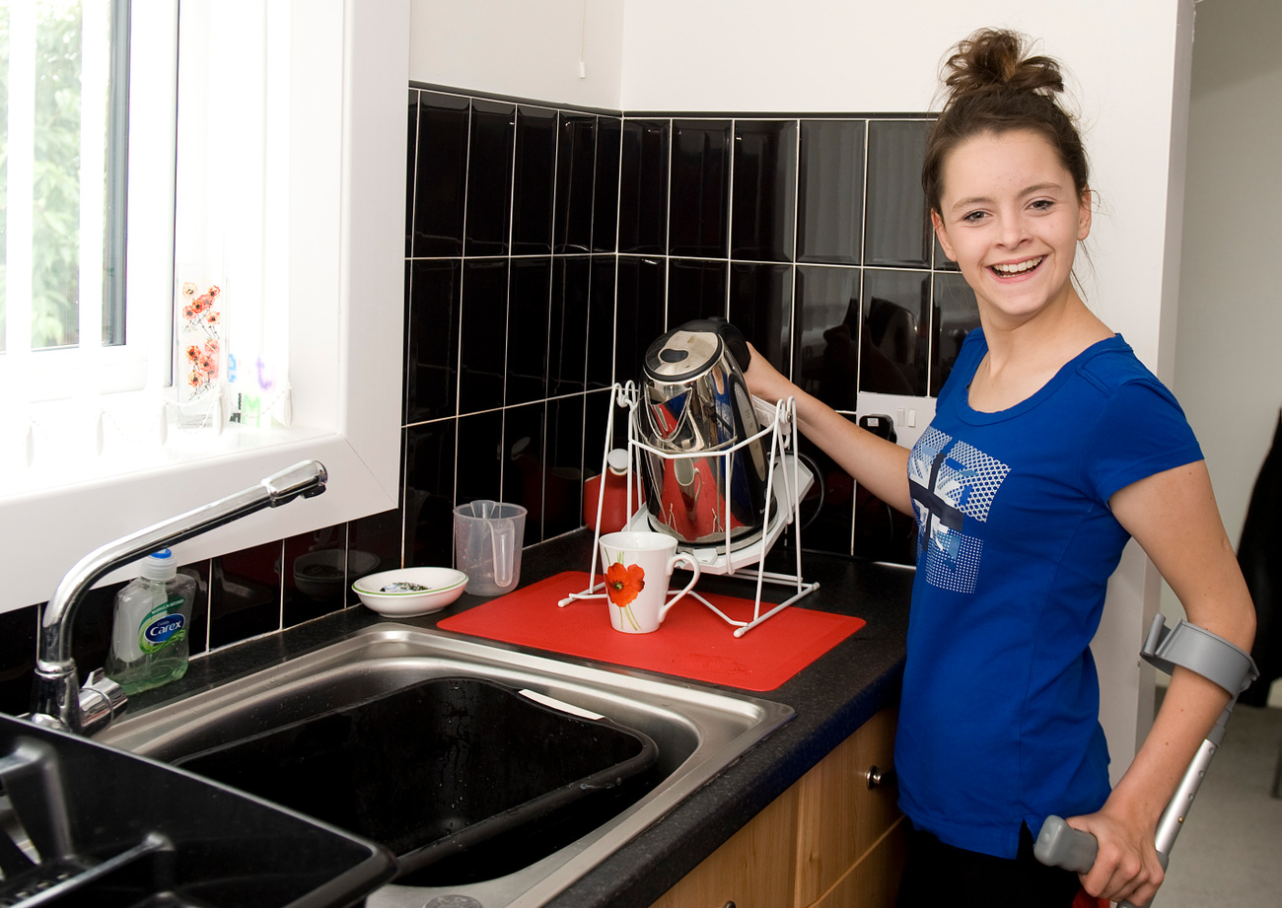

In order to meet the demands of an increasingly elderly population we have been looking at the national career development framework and expanding the training opportunities available. This includes developing skills in Advanced clinical examination and V300 prescribing.

|  |  |  |
| --- | --- | --- |
| **Mar 2020** | **Mar 2021** | **Direction of travel** |
| 33 | Number of patients with an Anticipatory Care Plan in Falkirk | 12,454 | 32,006 | **▲** |
| 34 | Key Information Summary as a percentage of the Board area list size Forth Valley | 8.1% | 18.2% | **▲** |
| 35 | Key Information Summary as a percentage of the Board area list size Falkirk | 7.8% | 10.4% | **▲** |

Table 7

Palliative and End of Life Care (PEOLC)

The Partnership continues to plan our model of palliative and end of life care to provide more care in community settings and as close to home as possible, where this is desired and appropriate. Care often involves a range of health and social care services for those with advanced conditions who are nearing the end of life and this includes access to specialist palliative care services.

Approximately 1730 Falkirk residents die every year. It is estimated that up to 1300 of these people are likely to have palliative or end of life care needs. Our ageing population means that the number of projected deaths is expected to rise, which will also increase demand for palliative and end of life care services.

We measure the percentage of last 6 months of life spent at home or in a community setting to provide a broad indication of progress in implementing our action plan to improve palliative and end of life care. This will help to increase the percentage of time that people spend at home or in a community setting during their last 6 months of life.

|  |  |  |  |  |
| --- | --- | --- | --- | --- |
|  |  | **2015/16** | **2020/21** | **Direction of travel** |
| 86 | Proportion of last six months of life spent at home | 86% | 89.4% | **▲** |

Table 8

**COMPASSIONATE COMMUNITIES:** **LIVING RIGHT UP TO THE END**

Everyone, no matter what stage in life, needs a friend. Strathcarron Hospice compassionate neighbour volunteer programme provides practical and emotional support for people with life-limiting conditions and their carers.

The volunteers at Strathcarron know that palliative care and end of life support is not just about the last days and hours of life but helping to maintain quality of life for the person and their family at every moment from the point of diagnosis.

The Compassionate Neighbours Programme takes a de-medicalised approach to care. Its volunteers are focused on ‘being there’ for people experiencing life-limiting conditions and their carers. By focusing on meaningful social interactions and practical advice, the volunteers support people to live well right up to the end. The programme also aims to combat loneliness, which is known to be damaging to physical and mental health, contributing to lower quality of life.

While these volunteers are known as ‘compassionate neighbours’, many of the people supported by them simply refer to them as friends. As well as providing a friendly listening ear and a bit of welcome chat, the volunteers offer:

* support and advice in a comfortable and non-clinical environment, such as the person’s home or while out and about over a cup of coffee or a walk
* open conversations about planning for the later stages of their life, including anticipatory care planning
* helping people with long term conditions, and their carers, to connect with community activities
* an opportunity for the persons full-time carer to take a break
* practical support with small tasks, which can be as simple as changing a lightbulb.

The compassionate neighbour volunteers are trained by Strathcarron and are matched with people based on interests, suitability, and location. The match-up system is designed to make friendships natural, so that both sides of the relationship benefit.

Despite the challenges of this past year, volunteers have developed digital ways to connect people and having received very positive feedback, will keep these in addition to resuming face-to-face connections. People now feel more confident to participate using digital platforms and feel more connected and involved in their community. For example, two men attending the storytelling Zoom session realised they had been at school together and hadn’t spoken for more than 50 years. They entertained the group with stories from their childhood and exchanged phone numbers for future get togethers.

Anyone can refer themselves to the programme or be introduced by a friend, family member or GP who thinks they might benefit.

There are currently 112 Compassionate Neighbours actively supporting people in the community

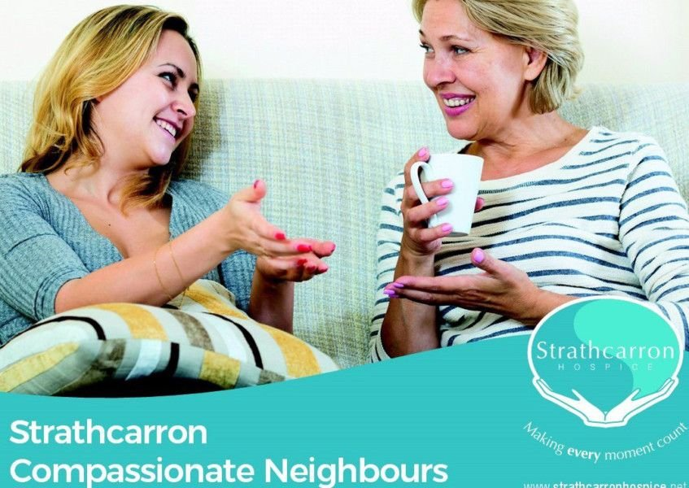

Joint Loan Equipment Service (JLES)

Funded jointly by NHS Forth Valley, Falkirk Council and Stirling Council, the service provides, delivers, uplifts, maintains, and recycles aids and equipment used by people to live as independently as possible in their own home.

Teams across the Partnership assess patient needs and use the loan service to provide access to almost 200 different pieces of equipment, including:

* grab aids and handles
* kitchen, bathing, and toilet aids
* large recliner chairs
* hoists
* hospital style beds.

The service operates 52 weeks a year, providing evening and weekend on-call services too. Illustrating the important role the service plays in supporting people to continue living in their own communities, the service remained fully operational throughout the pandemic. Over the last year, the service has achieved:

* on average, 1200 items loaned out each month
* an average three-day waiting period for non-urgent items
* 98% of items delivered on time and 48% delivered on the same day as the order was placed
* a 9% increase on items loaned compared to previous year
* a consistent service throughout the pandemic, ensuring no backlog waiting list for priority or critical equipment.

During the pandemic, families and carers offered to collect equipment directly from the JLES hub in Grangemouth or at one of the services’ satellite stores. This enabled equipment to get to the person who needs it as quickly as possible, at a suitable time for them. More delivery slots could also be made available for larger items, which families can’t easily transport. The service continues to encourage collection if it is suitable.

### Outcome 3:

People who use health and social care services have positive experiences of those services, and have their dignity respected

Positive experience has remained central to the Partnership’s teams during 2020/2021. While many services had to reduce or adapt their offering, we have continued to place people, their carers, and families at the centre of care. This has meant working in different and innovative ways.

Royal Voluntary Service (RVS)

An example of true resilience, the Royal Voluntary Service has adapted to the immense challenges of the pandemic. It’s flexible approach to the unfolding coronavirus situation ensured people in Falkirk’s communities were supported through uncertain times.

The UK-wide charity works at scale within the health and social care sector to free up staff to dedicate more time to patient care, and within communities to provide practical help and support to people when they need it.

In March 2020, the service changed all of its delivery models within a matter of weeks. Switching from face-to-face delivery to remote, online, and socially-distanced support. The quick adaptation to changing needs and means of delivering support ensured that every Royal Voluntary Service user who needed help was able to access it.

While other services were unfortunately forced to reduce capacity during the pandemic, RVS has continued to support more and more people since adapting to coronavirus pressures.

In numbers, Falkirk’s RVS pandemic activity (March 2020 – March 2021):

* 1,226 Garden Gate Chats
* 10,051 safe and well checks
* 5,575 essential shopping or medication collections and deliveries
* 180,000 volunteer hours.

Volunteers and staff continued to operate services throughout the pandemic, supporting people with companionship telephone calls, bringing together people in Virtual Village Halls, and by delivering essential food and medication. As restrictions eased and guidelines allowed, the service introduced garden gate visits to provide wellbeing support and have resumed home library services.

Now in a Covid-19 recovery footing, the RVS is looking to the future delivery of its support. The team plans to continue adapting its offering as Scotland eases out of lockdown and will integrate service improvements as we move out of the pandemic.

Participation and Engagement

During 2020-2021, participation and engagement has looked very different across the Partnership. We have quickly had to adapt the way that we work with people due to social distancing restrictions. Most engagement and consultation activity has been online. Whilst some people have found this an accessible and convenient, others have faced significant barriers to participation.

The type of challenges that we have found included:

* many people don’t have access to devices or any/sufficient internet connection
* people are not comfortable or don’t know how to use online communication platforms
* Council and NHS security initially prevented staff accessing some online communication platforms
* people don’t have a quiet or secure area within their home to be able to engage online.

We have worked hard to reduce these barriers. We have made use of a range of online packages to ensure that online engagement is meaningful and enjoyable, for example live polling, breakout rooms, visuals and videos, electronic sticky notes etc. In addition, the Partnership has used the Connecting Scotland programme to provide devices and internet access to people.

In line with the Partnership’s commitment to participation and engagement and also effective communication, a refreshed Participation and Engagement Strategy and accompanying Communications Strategy were developed and approved by the IJB during 2020-2021.

Both strategies were developed in conjunction with partners. Stakeholders were surveyed to gather feedback on existing activity and a communications and engagement working group then considered the results and brought their own expertise to identify the Partnership’s participation, engagement and communications priorities. These priorities have been incorporated into the strategies and associated workplans.

Our new volunteer expenses policy has been developed to enable unpaid carer and service user representatives to fully participate. The policy sets out how unpaid carer and service user representatives are fairly reimbursed for expenditure necessarily incurred as a result of their involvement. The policy extends to participation in sub-groups of the IJB and other activity relating to Partnership business.

Though this period has been primarily focused on responding to the Covid-19 crisis, the table below shows some public engagement activity that has taken place during 2020-2021.

| Activity | Who was involved? | | | | | Outcome or impact on transformation |
| --- | --- | --- | --- | --- | --- | --- |
| Service users | Carers | Community | Staff | Partners |
| Public engagement via our social media channel for the sensory service Facebook and twitter page | **P** | **P** | **P** | **P** | **P** | Direct opportunity to inform of the services still continuing/pandemic updates in English and BSL provided for all/current an up to date information provided on services available and current news |
| Partnership Forums led by CVS (Covid-19 Response, Compassionate Communities) | **P** | **P** | **P** | **P** | **P** | Communities and partners worked together to develop solutions to local issues identified. Diverse membership allowed knowledge and information sharing and relationship building. |
| BSL working group | **P** | **P** | **P** | **P** | **P** | A BSL working group has been put together to engage members of the community who use BSL to contribute to Falkirk Council larger BSL plan, this working group is ongoing |
| Support service | **P** | **P** | **P** | **P** | **P** | We continue to provide support to our clients during the pandemic and beyond tailoring the service to their individual needs and requirements, and provide support and information to their carers and family. Also providing information on the local community |
| Interpreting service / translation service | **P** | **P** | **P** | **P** | **P** | We continued to offer an interpreting service to our BSL service users, this was done face to face when required and also via our interpret now app, to ensure our clients communication needs where continued to be met during the pandemic and access to interpreters where accessible for our clients in the community. |

Table 9

### Outcome 4:

Health and social care services are centred on helping to maintain or improve the quality of life of people who use those services

Maintaining and improving quality of life during a global pandemic, with enforced restrictions impacting on everyday life has been challenging for most people. Whilst some services have had to focus only on critical and urgent care, others have changed their delivery to ensure ongoing access to service users and carers.

Mental Health and Wellbeing

Primary and secondary mental health services significantly changed during 2020/2021. Many services were paused, and a high number of staff were temporarily re-deployed to provide urgent support across the Partnership. As restrictions have eased, reintroduction of services has been a priority.

In June 2021, 59% of patients started treatment in Psychological services within 18 weeks of referral. This is a reduction from 64.9% in May 2021 and 93.7% in June 2020. The number of patients waiting is monitored on a weekly basis with evidence of a reduction in those patients waiting the longest. The prioritisation of patients who have experienced long waits adversely impacts on performance against the 90% 18-week referral to treatment standard. The published data for the quarter ending March 2021 is that 51.5% of patients started Psychological Therapies treatment within 18 weeks of referral.

Wherever possible clinical work is carried out remotely, using either Near Me video calls or the telephone. However, where it is either clinically required, or where a patient does not have access to either appropriate technology or a confidential space, face to face appointments are offered if required

Mental Health Nurses based within GP practices across Falkirk have continued to support people throughout the past year. The service has continued to thrive and grow, highlighting the need within our communities.

Like most other third sector agencies, FDAMH have had to alter their modes of provision to ensure that people could continue to access services. The Covid-19 restrictions have had a significant an impact on individuals’ mental wellbeing. Increased demand has included:

* more front-line workers contacting the service, e.g., police, carers, retail workers, etc
* an increase in the number of people with complex relationship issues leading to low mood
* an increase in the number of people having had bereavements due to Covid-19 or other conditions, where the effects of funeral restrictions has had an impact on the grieving process
* an increase of older people who have been socially isolated and have either been able to address their mental health and wellbeing prior to lockdown or lockdown has caused issues for the first time
* people who have required support in the absence of being able to contact their Primary Care resource
* people who continue to have issues around anxiety and panic attacks due to lockdown/Covid-19 restrictions and working at home.

**CASE STUDY: JOHN’S STORY**

“John” is a young man who was referred to Social Spark through our Immediate Help Service. John was looking for help with his mood, which had been very low for some time, and for his lack of confidence. We met with John and after careful consideration it was agreed that John would feel most suited to one of Social Spark’s Men’s Groups which met fortnightly. This was going well for John, but unfortunately Covid-19 restrictions came into place and all in-person social groups had to come to an end.

To support John in the absence of his group, he agreed to the new telephone support service set up in response to the pandemic. John really appreciates and enjoys this contact. During one of these calls John told Michelle that he had been furloughed and he was feeling very low and was finding it increasingly difficult to motivate himself even to get out of bed. After careful discussion with John, we suggested he join our Positive Wellbeing Course on Zoom to help him understand and cope with his current thinking.

John was glad to take up a place on the course and really got a lot out of taking part each week. As he was furloughed, he had time to attend and to work on the things he was learning in the course. Once the course came to an end, John reported to Michelle in his fortnightly call that the course had made a great difference in his thinking, and he felt more positive about the future.

Six weeks later John secured part time employment which he is enjoying, and it is also helping him to make new connections. We continue to support John with a fortnightly call.

Mental Health Officers

The Mental Health Officer Service has experienced a significant rise in the number of applications made for Compulsory Treatment Orders under the Mental Health (Care and Treatment) (Scotland) Act 2003. 41 Orders were granted during 2020/21, meaning that a total of 82 are now in place. Short Term Detentions in Hospital also significantly increased to 142 Orders in 2020/21 compared with 119 in 2019/2020.

Although there was also an increase in Emergency Detentions, we have worked with partner agencies across Forth Valley to minimise their use completely during working hours and ensure a Mental Health Officer consultation in each case.

From March 2021 the Chief Social Work Officer has responsibility for 414 Welfare Guardianships with 24 new orders being granted. 86 requests for Private Guardianship Orders were received, and a total of 117 Case conferences managed, each of which is attended by a Mental Health Officer.

We have worked in consultation with partner agencies across Forth Valley to promote the uptake of Advanced Statements and are in the process of recommissioning for local Advocacy Services.

Through Covid-19, the Mental Health Officers have continued to work with the Integrated Teams to provide the service with the advice provided from the Mental Welfare Commission.

**POST DIAGNOSTIC SUPPORT (PDS)**

Alzheimer Scotland provide a significant amount of PDS within Falkirk. They have been unable to visit people in their home throughout the Covid-19 period so have moved to phone calls and virtual meetings using the Near Me and GoTo platforms.

The uptake of using digital platforms has been better than anticipated, however, it doesn’t suit everyone as confidence and IT skills can get in the way. Where possible digital platforms have been used to bring people together to promote peer support, which has worked well for people. Implementing digital support was challenging for staff in terms of skilling up, as well as those using it.

Different platforms and approaches were tested to identify the most suitable. For example, Dementia Cafes were trialled in April, but the initial digital platform didn’t lend itself well to some people. This was changed to using Go To, which means that more people can participate. The Brain Gyms and a Friday Feeling Group have also been delivered online. Approximately 100 Activity packs are sent out each week to those who attend the Community Connection programmes and others identified by Link Workers.

As lockdown continued, more people were experiencing challenges around stress and distress. Many calls were dedicated to supporting carers to manage the impact of isolation by providing them suggestions and tips of how to keep well during this period and signposting to community supports that were able to help with practical matters such as shopping.

Link workers are creating a new virtual PDS course, which is being phased in a return to groups and 1-1 visits as lockdown eases. This will be a taken slowly and reviewed regularly.

Social Work colleagues and Link Workers should be commended for the speed and efficiency of how they have responded to requests for additional support to avert crisis, it’s been phenomenal.

Primary Care Improvement Plan

The Primary Care Improvement Plan sets out the aims for new models of working within primary care across 6 priority areas. The vision of the Plan is for enhanced and expanded multi-disciplinary teams, made up of a variety of professionals, contributing unique skills towards person-centred care and support that improves outcomes for individuals and our local communities.

As of end of March 2021, all 25 Falkirk GP practices have a level of additional multi-disciplinary support in place. Whilst all practices are offered all services, some practices have prioritised a greater level of one service over others in line with practice population needs. The general spread of implementation is described below:

|  |  |
| --- | --- |
| PCIP Services | Falkirk GP practices with service at 31.3.21 |
| Primary Care Mental Health Nurses | 23 (out of 25) |
| Urgent Care Practitioners (Advance Practice nurses and paramedics) | 15 (out of 23) |
| Phlebotomy | 14 (out of 25) |
| First Contact Advanced Practice Physiotherapists | 16 (out of 23) |
| Pharmacotherapy Service | 25 (out of 25) |
| Children’s Vaccination Service | 25 (out of 25) |
| Maternity Vaccination service | 25(2 out of 5) |
| Flu Vaccination service | 25 hybrid model |
| Other adult vaccinations (shingles/pneumococcal will link with flu) | 0 |
| Treatment room Service | 25(out of 25) |
| Link workers (partnership funded) | 12 (out of 12) |

Table 10

Despite a very challenging year, the Improvement Plan programme has largely progressed as planned.

Digital Telecare Implementation Award

In January 2021, the Health & Social Care Partnership and Falkirk Council received the Silver Digital Telecare Implementation Award by the Digital Telecare for Scottish Local Government Programme, in recognition of the progress made in the transition to digital telecare. The Mobile Emergency Care Service (MECS), which traditionally relied on analogue phone lines to operate, is now the first telecare service provided by a Scottish Council to be digitally enabled end-to-end, four years before telecommunication providers switch off all analogue lines in the UK.

The award acknowledges the service, which provides users with personal and home alarms that alert a control centre when they fall or are in difficulty so help can be sent. The team have successfully replaced 4,000 analogue MECS alarm systems in people’s homes with pre-programmed digital-ready ones. The team is now working to transfer the remaining 3,200 MECS service users to the fully digital service by end 2021.

Work has also been progressed with Chubb Systems to develop and install a digital Alarm Receiving Centre, which provides immediate and secure information 24/7 to call handlers when a MECS personal alarm or sensor in a home is activated.

### Outcome 5:

Health and social care services contribute to reducing health inequalities

We know that Covid-19 has disproportionately impacted on specific groups of people and particularly those living in more deprived communities. Our focus during 2020/2021 has been to continue to provide care and support to the most vulnerable groups in our communities.

Health Promotion Service

The Health Promotion Service aims to improve health and wellbeing, address inequalities and prevent ill health for all who live and work in Forth Valley.

The team work in partnership to improve the health and wellbeing of individuals or communities through enabling and encouraging positive health behaviour changes as well as addressing the underlying determinants of health such as poverty and educational opportunities.

With our partners, we work to shape policy, service provision and environmental factors that support positive health outcomes for our population, especially those in greatest need.

**The service has two overarching principles which are embedded in all our work to:**

* **reduce health inequalities, and**
* **improve mental health and wellbeing**

**The service organises activities under three themes:**

* **facilitating behaviour change and capacity building for health**
* **supporting healthier lives for children and young people**
* **creating supportive communities and environments for health**

The Health Improvement Resource Service provides a wide range of health improvement resources - paper and digital versions.  The service has been impacted by Covid-19 and has seen a reduction in distribution and a need to develop more digital interactions. There have been 36,765 leaflets issued to clients in the Falkirk area in 2020-21. There were 2,442 virtual resources downloaded.

Digital Exclusion



In addition to the Connecting Scotland programme, Falkirk Council also ran a local version of the programme. The Partnership has worked with Falkirk Council to promote the programme and have also secured further devices for service users.

With many services moving to online provision during 2020-2021, digital exclusion has come into sharp focus. The Scottish Government’s Connecting Scotland programme has funded over 1,000 devices for people without online access in the Falkirk area.

Along with the devices, 2 years of data and digital support was also provided. The devices have allowed people to interact with services and supports, such as online shopping and GP appointments, but also to keep in touch with friends and loved ones. This has enabled people to maintain and regain a sense of connectedness and independence, whilst also reducing loneliness and isolation.

To help with the provision of digital support, we have worked closely with AbilityNet, which supports anyone living with any disability or impairment to use technology to achieve their goals at home, at work, and in education. During the pandemic AbilityNet relaxed their support criteria to assist anyone that required help with technology.

The Partnership has provided funding to AbilityNet to provide set-up support as well as ongoing digital support. This means that people receiving devices can have them tailored to their interests and needs. This may also include installing Living Well, NHS Inform and other relevant apps.

### Outcome 6:

People who provide unpaid care are supported to look after their own health and wellbeing, including to reduce any negative impact of their caring role on their own health and wellbeing

Supporting Carers

We have been working with carers and carer organisations to implement the Carer’s (Scotland) Act 2016. Our Strategic Plan 2019 – 2022 has prioritised support for unpaid carers as a key issue. The work we are doing is consistent with the main direction of the Act, which extends and enhances the rights of unpaid carers. It aims to consistently support carers to continue to care, if they wish, and to be able to do so in good health and with a life alongside their caring responsibilities.

Our Carer’s Strategy, *Getting it Right for Carers in Falkirk,* was co-produced with carers and carer organisations and covers both young carers and adult carers.

**In partnership with local carers’ organisations, we have agreed a shared local vision:**

**“**everyone has freedom to live their own lives while they are caring”

The Covid-19 pandemic and subsequent national lockdown in March 2020 interrupted the work of the Carers Strategy Implementation Group, including the continued development of the Carers Strategy Action Plan. The priority at this time was to communicate with carers regarding the disruption to carer support and the potential impact of this.

By mid-June 2020 in-house respite provision had been realigned to offer emergency / urgent respite across all care groups. Locality teams have continued to prioritise to ensure that those carers most in need have been able to access respite care.

The Falkirk Carers Centre staff carried out a survey in June 2020 which showed that 78% of carers in Falkirk (who completed the survey) had not been able to have a break from their caring role during the lockdown period. Consequently, short break service provision was reviewed to enable carers to be supported in different ways using very flexible approaches.

Supporting carers through provision of information and support on how to keep themselves and the people they care for safe is a feature of carer support during the pandemic. This includes ensuring carers know where to access information on staying safe, Covid-19 guidance, access to PPE and information on the vaccination programme for carers. A delivery service is available locally to ensure all carers have access to appropriate PPE to enable them to deliver care safely – sometimes in more than one household.

Partnership working with other parts of the social care sector, including NHS, third sector and support providers, is a constant feature of work to support carers. There is an increasing focus on a blended approach, combining support from a range of provision including community led models. Increased efforts have also been made to ensure carers can focus on their own needs / health and wellbeing as they tend to focus primarily on the needs of the person / people they care for.

Despite the pandemic, in 2020-21 Falkirk and Clackmannanshire Carers Centre has:

* supported 833 new carers
* completed 151 Adult Carer Support Plans
* provided 34 health and wellbeing sessions
* provided 84 carers with a grant to purchase a short break (Creative Break fund and Carers Trust grants).
* delivered 90 Care with Confidence sessions with 447 carers attending
* provided 23 carer involvement opportunities with 489 carers attending
* delivered 2 carer awareness sessions for 39 professionals
* represented the views of carers at 26 planning group meetings

The completion of Young Carer Statements was suspended as this was only possible online and there were concerns about confidentiality and relationship building issues. Young carers continued to receive support and a range of short breaks were delivered including pamper/craft gifts, winter parcels and coffee shop cards.

|  |  |  |  |  |
| --- | --- | --- | --- | --- |
|  |  | **2019/**  **20** | **2020/**  **21** | **Direction of travel** |
| 60 | Percentage of service users satisfied with their involvement in the design of their care package | 99% | 98% | **▼** |
| 61 | Percentage of service users satisfied with opportunities for social interaction | 91% | 89% | **▼** |
| 62 | Percentage of carers satisfied with their involvement in the design of care package | 93% | 93% | ◄► |
| 63 | Percentage of carers who feel supported and capable to continue in their role as a carer OR feel able to continue with additional support | 91% | 91% | ◄► |

Table 11

Self-Directed Support (SDS)

Progress towards full implementation of Self-Directed Support has continued despite Covid-19. However, due to social distancing and the closure of some services during the pandemic people with support needs and unpaid carers were unable to access their usual support and care packages. Guidance from the Scottish Government and COSLA issued in May 2020 regarding SDS encouraged HSCPs ‘*to maximise flexibility and autonomy for the support person in meeting agreed outcomes’*.

We continued to support those with care needs and their carers while taking a flexible approach.  An example of this approach was our ‘Flexible Respite’ budget application process.  ‘Flexible Respite’ enables eligible carers to use up to £1,000 of their overnight respite funding to access an alternative break from their caring role.  We worked with the Carers Centre who sit on our Flexible Respite panel which enables carers to purchase items or activities to support them in their caring role, for example exercise equipment, garden furniture and technology.   By helping carers to think about their own support needs staff were able to deliver a more bespoke response to short breaks / respite for individuals.  Consequently, Flexible Respite budgets has been continued in 2021-22.

Partnership working with the third sector was enhanced further during the pandemic through our work with the support service SDS Forth Valley.  We ensured that personal assistants could be retained and those with support needs, and their employers, were able to meet their employers’ obligations.  We agreed to temporary employment of family members as personal assistants particularly where individuals were shielding. Finally, we also supplied and delivered PPE to employers for their personal assistants along with guidance on how to use it.

SDS requests were continuous throughout the year with more enquiries in relation to Option 2 due to the more flexible approach which it brings when support / services may not have been operating as normal or with a reduced service.  We also used different and more creative options for supporting people at home, for example the use of technology.

The Short Breaks Team will evaluate the effectiveness of support for carers provided during the pandemic so that carer outcomes can continue to be supported as Covid-19 restrictions are gradually eased. This will include identification of (perceived or actual) barriers to supporting carers in a more outcomes focussed way.

|  |  |  |  |  |
| --- | --- | --- | --- | --- |
| **Self-Directed Support (SDS) options selected: People choosing** | | **Mar 2020** | **Mar 2021** | **Direction of travel** |
| 37 | SDS Option 1: Direct payments (data only) | 27  (0.6%) | n/a | **n/a** |
| 38 | SDS Option 2: Directing the available resource (data only) | 101  (2.2%) | n/a | **n/a** |
| 39 | SDS Option 3: Local Authority arranged (data only) | 4,009 (88.8%) | n/a | **n/a** |
| 40 | SDS Option 4: Mix of options (data only) | 376  (8.3%) | n/a | **n/a** |

Table 12

### Outcome 7:

People who use health and social care services are safe from harm

A key aspect in ensuring that people are safe from harm is not only the provision of support, but also the ability to gather information and intelligence about where support is required and how best we can work collectively to target support towards those at most risk. This has included supporting partner agencies to adapt provision safely in line with national guidance.

Falkirk Alcohol and Drug Partnership (ADP)

During the past year, the Community Alcohol and Drug Service, Change Live Grow, Forth Valley Recovery Community and the Forth Valley Family Support Service have continued to support those in need, and their families. Services have maintained access during the whole period for an extremely vulnerable population, for whom the risk of Covid-19 was enhanced. The staff within these services have demonstrated a high level of commitment which has enabled stability for those who use these services.

Harm reduction and the provision of Medicated Assisted Treatment have been key priorities. Transform Forth Valley were commissioned on a temporary basis to provide a Harm Reduction Service, enabling the distribution of Injecting Equipment Provision and Naloxone. The use of their mobile vehicle was helpful in aiding access to those unable to attend services. The Change Live Grow Harm Reduction Service also continued to provide an assertive outreach service to ensure that those in need of support were kept safe through the provision of Naloxone, harm reduction advice and injecting equipment.

Forth Valley Recovery Community and the Forth Valley Family Support Service both increased their online presence during the 2020/2021. The offer of online provision has been received positively, with many people accessing the online service who may not have engaged on a face-to-face basis.

As ADP services have gradually been re-introduced on a face-to-face basis, learning from digital engagement during the pandemic is being put into practice. Online appointments and mobile phone contact have been introduced as options. Online group work and family support meetings are also being considered.

Additional Covid-19 Mobilisation investment made by the HSCP to both Change Live Grow and Forth Valley Recovery Community has proved invaluable. These services are currently seeking solutions to enable the continuation of this additional resource going forward.

|  |  |  |  |  |
| --- | --- | --- | --- | --- |
|  |  | **Jan-Mar 20** | **Jan-Mar 21** | **Direction of travel** |
| 68a | Substance Use - Percentage of patients that commence treatment within 3 weeks of referral – Forth Valley Alcohol & Drug Partnership (90% target) | 95.9 | 97.2 | ▲ |
| 68b | Substance Use - Percentage of patients that commence treatment within 3 weeks of referral – Forth Valley Prisons (90% target) | 87.8 | 100.0 | ▲ |

Table 13

Supporting people affected by Hoarding disorder

Policy and guidance have been developed for multi-agency partners to provide supportive and effective interventions with adults who experience self-neglect or exhibit hoarding behaviours. It is important that our practice is collaborative, proactive, and informed by evidenced based practice. Where this is the case, the adult and their families receiving our interventions will have a better experience and feel empowered to make the changes they want; to live the life that they want, feel safe and realise their potential.

Depending on the extent of the self-neglect and / or hoarding behaviours the adult is experiencing there will be different levels of intervention and in some instances application of legislation will be indicated. It is important that all partner agencies are alert to the signs of self-neglect and hoarding and offer supportive early and effective interventions. Multi-agency training is being developed and will begin to be rolled out in the Autumn of 2021.

The Learning and Development Sub-group of the Adult Protection Committee is responsible for ensuring that all levels of the workforce have access to an appropriate level of Adult Support and Protection training this includes in the area of self-neglect and hoarding.

|  |  |  |  |  |
| --- | --- | --- | --- | --- |
| **Ref** | **Measure** | **2020/21 Q1** | **2020/21 Q2** | **Direction of travel** |
| 45 | Number of Adult Protection Referrals (data only) | 157 | 269 | **▲** |
| 46 | Number of Adult Protection Investigations (data only) | 34  (18 SW, 16 Police only) | 27  (11 SW, 16 Police only) | ▼ |
| 47 | Number of Adult Protection Support Plans at end of period (data only) | 19  (at 31/03/20) | 20  (at 31/03/21) | **▲** |

Table 14

### Keeping services safe during Covid-19:

Falkirk’s COVID-19 Mobilisation Centre

The HSCP adapted a major incident framework to suit the unfolding and prolonged period of crisis caused by the pandemic. The HSCP Mobilisation Centre supported good leadership and operational practice through its Covid-19 response. The approach ensured:

* everyone was informed and involved in decisions – giving an understanding behind decisions being taken
* the safety and well-being of staff, service users and carers was protected
* a timely response to a constantly changing situation
* early awareness of emerging issues so that response could be put in place, this was particularly important in addressing outbreaks in care home settings.

The Mobilisation Centre held a daily team Huddle meeting which provided a point of escalation and communication. The Huddle brought together health and social care staff; third sector partners; the Carers Centre; an independent sector lead officer representing external home care and care home providers; HR and procurement. This multi-agency approach enabled quick communication and deployment of resources daily. At the peak of the pandemic, this huddle operated 7 days a week.

Several subgroups were formed which addressed specific concerns and supported staff morale. In a noticeable difference to responding to other major incidents, the team established a Wellbeing group to mitigate the challenges of the pandemic – its longevity, increased pressure, and adapting to remote working.

Flexibility was key to the Centre’s success. Originally established as a physical space within Denny Town House, the team quickly moved to remote working as necessary. In some ways this was a positive change, making it easier to rotate duty manager contacts and making meetings virtual and accessible from anywhere.

Needs and demands changed as the pandemic moved through different waves. The Centre was scaled up, down, or put on hold completely, as necessary. This gave the team time to rest and signalled to everyone that action was needed when the response was reconvened.

Through national Chief Officer discussions, Falkirk’s early approach was shared and as example of good practice. The formal interim evaluation and debrief report (undertaken in June 2020) identified that the Centre had provided clear guidance and that its approach had enabled individuals in relatively junior roles to step up into leadership roles and successfully take on areas of responsibility.

In many ways, the experience has accelerated integrated working within health and social care, presenting the opportunity to work differently and build new relationships between teams. As pressures of the pandemic have eased, some of these positive changes have continued into daily operation.

Care Home Assurance Team (CHART)

While the initial focus of the pandemic fell on the NHS, it quickly became apparent that social care and Care Home services would need considerable specialised support. We responded by creating the dedicated multi-professional and multi-agency Care Home Assessment and Response Team (CHART) in May 2020.

The CHART team gathered and monitored intelligence from the 32 care homes across Falkirk, working with LIST colleagues to develop a reporting platform to gather and collate care home information.

The partnership took direct responsibility for the clinical support required for each care home in their board area. The team works alongside other clinical health teams to ensure that there is daily monitoring and management of the impact of Covid-19 on the safety, wellbeing and outcomes of residents and staff within care homes and the ongoing provision of services.

The CHART team has responded to the pandemic via a range of measures including ‘Back to Basics’ contact.

Care home daily Covid-19 MONITOR

Data has been collected from care homes in Falkirk on a daily basis since April 2020 to help inform decision-making. Rapid and intensive collaboration between the HSCP, Care Home managers, NHS Forth Valley Public Health and Public Health Scotland analysts ensured that data has been collected covering all essential information required to fully understand the Covid-19 situation in each of the care homes in Falkirk. The final data specification was highly commended by the Scottish Government and formed the basis of the national data collection system developed at the end of summer 2020.

Addressing the impact of staff absence in the Home Care service

It was clear from the outset of the Covid-19 pandemic that staff absence due to the virus had the potential to adversely impact service delivery. The HSCP worked with Public Health Scotland to conduct some modelling to help understand the potential impact of rising absence on their ability to deliver home care.

The model has since been adopted by other partnerships to aid understanding of the scale of the potential issue and to better understand the options available to them. It is also being used to help inform the timing of any potential decisions around service delivery, as the model helpfully highlights at what percentage of staff absence there will be gaps in service delivery.

MECS (Mobile Emergency Care Service)

The number of emergency calls made to homes actually decreased in the early part of the outbreak. It is thought that people were reluctant to allow access to their homes. However, the need in the community increased as the pandemic developed. The main objective of the MECS service has been to assist with early hospital discharges.

As with other services, MECS experienced staff absence due to shielding and illness. In order to meet the increased demand on the service, some staff from day care services volunteered to support MECS whilst their services were closed. This was also augmented with agency staff.

|  |  |  |  |  |
| --- | --- | --- | --- | --- |
| **Ref** | **Measure** | **2019/20** | **2020/21** | **Direction of travel** |
| 48 | The total number of people with community alarms at end of the period | 4,087  (at 31/03/20) | 3,989  (at 31/03/21) | ▼ |

Table 15

|  |  |  |  |  |
| --- | --- | --- | --- | --- |
| **Ref** | **Measure** | **2018/19** | **2020/21** | **Direction of travel** |
| 49 | Percentage of community care service users feeling safe | 90% | 89% | ▼ |

Table 16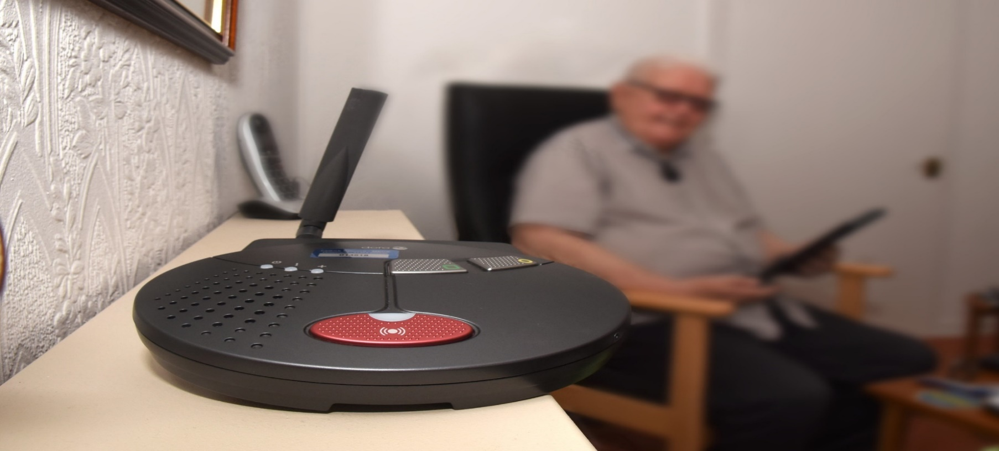

### Outcome 8:

People who work in health and social care services feel engaged with the work they do and are supported to continuously improve the information, support, care and treatment they provide

Our workforce remains the single most important resource in delivering high quality services and the transformation required to ensure the delivery of health and social care integration. This has remained a key priority during 2020/2021.

### Supporting our workforce

Putting learning at the heart of transformational change

We continue to aspire to be recognised as a Learning Organisation and this shapes and influences our approach to training, learning and development. We strive to follow the five golden rules in this respect:

1. encouraging experimentation
2. thrive on change
3. reward learning
4. facilitate employees to learn from one another
5. encourage learning from our surroundings

Many challenges have been faced in continuing to provide effective and responsive health and social services within the restrictions imposed by a global pandemic. Supporting the workforce to feel skilled, confident, and competent through the provision of essential and core learning and development opportunities has remained constant.

Those challenges have presented opportunities for innovative thinking, testing out new and different ways of doing things, such as induction and approaches to learning. Including, learning from each other, often in unplanned circumstances with unintended benefits, for example, extending our contact and relationships with communities and members of the wider workforce. This has also led to a greater appreciation of the roles and responsibilities of essential key workers and their impact upon vulnerable people accessing services.

The Partnership supports workforce development opportunities in a range of different ways:

Developing a digitally literate and connected workforce

Over the past year, our plans for significant investment in digital technology received increased and focussed attention. This has assisted us in achieving our priority to make better use of technology to support the delivery of health and social care services. Not only to maintain service delivery, but also to ensure that the workforce had access to necessary high-quality training, learning and development opportunities whilst adhering to government guidance on social distancing and where possible, remote working.

Plans to upskill the workforce in using digital technology were fast tracked and workforce development staff responded creatively to the changing and unpredictable environment.

Our approach to training, learning and development delivery has become adaptive, ahead of schedule. We have been utilising a blend of traditional face to face, self-directed, guided, webinar, and range of digital delivery. This has ensured our core scheduled programmes of training have continued to be delivered in some form and have continued to be coordinated to meet statutory and regulatory body requirements alongside responding to local identified needs.

Induction

The social work workforce development team has prioritised high quality induction training and ensured that it is accessible. Induction comprises face to face elements, following appropriate Covid 19 guidance, and via digital platforms, such as the Council’s eLearning platform, OLLE, and NHS Education for Scotland Turas platform.

Additional instructional videos are also accessed via You Tube and other digital platforms.

An example of one of the Induction & Training flowcharts can be accessed [here](https://blogs.glowscotland.org.uk/fa/public/GirfecFalkirk/uploads/sites/2017/2021/07/01155949/Induction-and-Training-Flowchart-Version-6.pdf). The flowchart includes linked documents to assist staff and their line managers to track and record progress through the induction process.

Home Care Services

Monthly induction sessions for Home Care services have been running throughout the pandemic. The increase in volume of induction training has been necessary to:

* address issues related to staffing capacity and retention
* adhere to restrictions on the number of staff who can attend the face-to-face elements of induction to maintain social distancing.

Arrangements have been made for all staff to access IT equipment that has enabled them to complete a wide range of online learning such as, Dementia Awareness, Understanding Epilepsy, and Delivering Reablement Services that promote independence.

Adult Care Homes

At the outset of the pandemic mandatory training required to be transferred to the online environment. Some of this was developed in-house and some sourced and commissioned. This included moving and handling theory, safe administration of medication and Behavioural Support Strategies courses.

Falkirk Council is registered with the Restraint Reduction Network as an affiliate provider of Behavioural Support Strategies training. The council require adherence to the Restraint Reduction Network training standards in their delivery of Behavioural Support Strategies training. The courses focus mainly on workers using proactive approaches in supporting individuals who challenge services, reducing the need for physical interventions. An open dialogue has been maintained with the Restraint Reduction Network throughout the pandemic to ensure practice is consistent with standards.

Training needs have been identified in relation to:

* embedding our Reablement ethos and approach.
* upskilling Social Care Officers in assessing for and the use of small pieces of equipment to support independence and self-management and,
* building confidence with sensory awareness.

Moving and Handling (M&H)

At the outset of the pandemic, the Social Work Workforce Development team developed and produced film resources on M&H techniques and managing continence care to support blended and flexible learning. These resources were made available to staff both on OLLE and via YouTube. These clips are being during induction and are included in moving and handling refresher activities. Staff have evaluated them as useful as they can be revisited in full or in part at any time to refresh knowledge.

Practical M&H training resumed in February 2021 with restricted numbers due to the 2-metre social distancing control measure. Health and Safety colleagues supported the training team to complete a risk assessment and to assist in taking this through the consultation process and sign of. The risk assessment incorporated many control measures that needed to be applied at the venue to minimise risk of Covid-19 transmission.

In order to build capacity in the provision of M&H refresher training opportunities, there has been focussed efforts to increase the number of Moving and Handling Liaison Workers. This has been expanded to include additional Occupational Therapists. Steps are being taken to recognise this commitment and upskill Liaison Workers through access to an ‘Intro to Trainers’ City and Guilds certified course. This will in turn support their continuing professional development and provide them with a range of transferable skills.

Planning is underway to have Falkirk Council registered with the Scottish Manual Handling Passport scheme. This is a joint venture for adult and children’s services delivering M&H training to direct care workers. This will enable consistency and transferability of M&H training being provided within and across the services.

Face Fit Mask Testing

Our workforce has access to appropriate PPE including fluid resistant face masks. There may be occasions however where it is required for them to wear a FFP3 face mask. This is identified through clinical assessment and is worn to provide protection from respiratory borne pathogens. The Partnership invested in the purchased of a Portacount machine which is used to carry out the face fit testing for the FFP3 face masks. Three members of Social Work Workforce Development team have been trained as Face Fit Testers.

To date, Face Fit Testing has been carried out within seven residential care homes, two of which were local authority provision. 51 workers have now had successful face fit tests undertaken. These numbers will increase as the team continue to respond to face fit testing requests.

Public Protection Training

Essential public protection training has been adapted for digital delivery using the Microsoft Teams platform. Flexibility and innovation have been key in developing a growing raft of digitally delivered adult and child protection related training and making this accessible to staff across the HSCP. New eLearning packages have been or are being developed with ongoing work continuing to make the Council’s eLearning platform accessible to partner agencies, particularly within the third sector.

The training plan is located on the re-developed Practitioner Pages, available to all partner agencies across the Forth Valley. The plan can be accessed [here](https://blogs.glowscotland.org.uk/fa/public/GirfecFalkirk/uploads/sites/2017/2021/07/12100901/2021-Training-Plan-Practitioners-V4.pdf).

Falkirk Council Social Services Assessment Centre

Virtually on your doorstep!

The Centre has continued to support employee candidates and modern apprentices to achieve Scottish Qualification Awards (SQA) to meet either registration requirements as outlined by the Scottish Social Services Council or as required as part of the Modern Apprenticeship programme.

The pandemic has impacted on candidates in different ways. For candidates shielding and self-isolating, opportunities have been taken to increase time spent on reflection and producing evidence for portfolios. For others, awards were put on hold or deadlines extended for evidence submission supporting candidates to prioritise essential service delivery.

In addition to their roles as assessors and verifiers, Centre team members have supported the recruitment and induction of new and redeployed staff into essential frontline services. They adopted a key mentoring role working closely with service-based mentors to address challenges in delivering comprehensive induction and flexible support online and in the workplace.

Student Social Worker Placements throughout the pandemic

In Falkirk, we have been able to rely on colleagues working within locality Adult Services to make sure that we fulfil our commitment to social work education and assist our local University. We have provided 8 placements since February 2021, and another 2 being offered later in the year.

Students have reported that “I have felt very lucky to have been able to get into the office a couple of times per week during Covid-19”.

They have all said that they felt very supported by their teams with all team members making the effort to welcome them in difficult circumstances.

One team manager commented “As a Social Worker and manager I am extremely committed to supporting Social Work students on placement and supporting existing staff to undertake link worker / practice teacher training. It’s great that we can work together on this”.

This kind of support and effort has made placements possible during this time. It’s a positive view that encourages the student placement practice assessor / co-ordinator to build on this to create the learning organisation that we can be proud of with the help of such committed colleagues.

Students appreciate our efforts with one offering excellent feedback to the team which included: “My placement experience within the East locality community care team was exceptional. The practical experience I

gained provided me with a platform to explore and develop a deeper understanding of my University learning. It was an opportunity to build my confidence, to be able to learn from a wide range of professionals and identify future areas of development. I observed first-hand the benefits of teamwork, and I was continuously impressed by the level of support and knowledge sharing within the team”.

Newly Qualified Social Workers (NQSWs)

24 NQSWs were supported over the last year. Several are moving into their second year; however, the majority are in their first year with some starting as recently as March 2021.

NQSWs were based in both adult and children’s services bringing opportunities for learning across the life span. This supported our commitment to shift siloed thinking and practice in recognition that the people we work with live in families and will often have needs and experiences that cross service remits.

With practice learning being restricted and limited opportunity for peer support from their teams, we worked with the Team Managers and Seniors to lead practice learning sessions on practice areas identified by the NQSWs e.g.

* Duty – Process and expectations
* Chronologies/Child’s Plan documentation
* Parent Capacity Assessment

As more learning and development became available online the NQSWs had the opportunity to attend virtual training which included Significant Case Review practice learning sessions, online e-modules, Safe & Together Core training and Risk Assessment training.

Team Managers also created regular informal meeting forums for members of their team to meet regularly to support the development of peer relationships.

### Outcome 9:

Resources are used effectively and efficiently in the provision of health and social care services

### Best Value

As a public body, the IJB has a duty to make arrangements to secure Best Value. As defined by Audit Scotland, Best Value is concerned with “*good governance and effective management of resources with a focus on improvement to deliver the best possible outcomes for the public*”.

With this in mind, the IJB’s governance framework is intended to support continuous improvement and better outcomes, whilst striking an appropriate balance between quality and cost.

The key features of the IJB’s governance framework which were in place during 2020/21 to support best value are outlined below:

### Vision and Leadership

A key statutory duty of the IJB is to develop a 3-year Strategic Plan which reflects the national health and wellbeing outcomes framework and delivery of agreed local priorities. The Strategic Plan is now set against a backdrop of the Covid-19 pandemic which has resulted in a significant and rapid change in the configuration of health and social care services across Scotland.

It is recognised that the long-term impact and unintended consequences arising from the pandemic are uncertain and may require development of new services and enhanced support for existing services such as mental health and various local community initiatives. At the same time, demand linked to ongoing demographic change, is increasing as people are living longer into old age, often with multiple long-term conditions which require more complex multidisciplinary care and support.

Similarly, the age profile of our workforce is also rising (and this is more prominent in certain staff groups e.g. District Nursing) which presents a number of risks in terms of succession planning and our ability to provide sustainable services. This is also exacerbated by ongoing recruitment and retention difficulties particularly in relation to Social Work services (where staff turnover is in the region of 7.9%).

In order to respond to these challenges (combined with the impact of growth in general price inflation and advances in new technology and medical treatments), it is clear that major reform and transformation of health and social care services is essential in order to deliver better care, better health and better value.

Our detailed Delivery Plan is underpinned by an integrated whole systems approach, which identifies the specific work streams and actions required to progress our strategic priorities. The Delivery Plan has recently been reviewed to ensure it is fit for purpose in a post Covid-19 context and remains aligned with our pandemic response in terms of the current remobilisation, recovery and redesign of services.

The IJB is confident that the Delivery Plan continues to reflect the appropriate direction of travel for Adult Health and Social Care Services in Falkirk and notwithstanding the operational disruption and financial risks arising from Covid-19, it is recognised that the pandemic presents a unique opportunity to accelerate key elements of our Delivery Plan.

### Governance and accountability

Falkirk IJB has responsibility for the strategic planning and commissioning of delegated health and social care functions. NHS Forth Valley and Falkirk Council delegate budgets to the IJB, which decides how resources are used to achieve the objectives of the Strategic Plan. The IJB then directs the partners, through the HSCP, to deliver services in line with this plan. The IJB controls an annual budget of approximately £257m.

The governance framework includes the Integration Scheme, IJB Standing Orders, Risk Management and Clinical and Care Governance. These frameworks set out the rules and practices by which the IJB ensures that decision making is accountable, transparent and carried out with integrity. The IJB has legal responsibilities and obligations to its stakeholders, staff and residents of the Falkirk Council area.

The range of IJB Board members has enabled informed decision-making through the insightful contributions from different perspectives. The voice of service users and carers in particular, has been of importance and value to the Board. During 2020-2021, all meetings have continued online.

### Effective use of resources

The National Health and Wellbeing Outcomes Framework requires the IJB is to demonstrate that *“resources are used effectively and efficiently in the provision of health and social care services”.* As part of this requirement, an overview of 2020/21 financial performance is provided below, including consideration of the financial outlook for 2021/22.

2020/21 Financial Performance (from Unaudited Accounts 2020/21)

The IJB reported total income of £256.989m for financial year 2020/21 (an increase of £22.322m compared to 2019-20) and total expenditure of £245.575m incurred during the year (an increase of £10.586m relative to 2019-20). As a result, a surplus of £11.414m was reported in the unaudited Comprehensive Income and Expenditure Statement as at 31 March 2021.

The reported surplus reflects delays in planned expenditure during the year, receipt of late funding allocations and unused Covid-19 funding which required to be carried forward to 2021/22 in line with Scottish Government guidance. The overall surplus does, however, mask a number of key financial pressures which were experienced during the year including:

**Large Hospital Services/Set Aside** – ongoing pay pressures within A&E and various inpatient specialties reflects the ongoing use of locums and agency staff to cover key vacancies. This position was offset by lower than expected non-pay costs (e.g. surgical sundries, lab supplies and drugs) linked to lower overall hospital activity levels as a result of Covid-19.

**Social Care** – ongoing pressures within home care resulted in a 10% increase in costs compared to the previous year. This was offset by savings reported against residential care services (reflecting continued low occupancy rates compared to pre-Covid-19 levels), respite services, housing aids and adaptations and the assessment and care planning team due to delays in recruitment to vacancies.

**Primary Healthcare** – key areas of overspend within General Medical Services related to Golden Hello payments and reimbursement of locum cover costs in respect of non-Covid-19 related sickness absence and maternity/paternity leave claims from independent GP Practices. With respect to Primary Care Prescribing, increased concession prices in respect of drugs in short supply combined with delays in delivering efficiency savings (in terms of both local savings initiatives and agreed national tariff reductions) contributed to the overspend position.

**Community Healthcare** – continued pay pressures within Falkirk Community Hospital relating to unfunded posts and use of temporary staff to cover non-Covid-19 related sickness absence and maternity leave. In addition, the impact of high cost out of area care packages within the complex care service remains a significant risk. These pressures were offset by fortuitous savings in other budget areas arising from vacancies within several services.

The vast majority (72%) of IJB expenditure incurred during 2020/21 related to Primary Healthcare and Social Care Services as outlined in the table below:

|  |  |  |  |  |
| --- | --- | --- | --- | --- |
| **Total Expenditure** | **2020/21** | **2019/20** | **2018/19** | **2017/18** |
| Large Hospital Services | 29,629 | 27,741 | 26,026 | 25,207 |
| Primary Care Services | 83,284 | 81,941 | 75,816 | 70,734 |
| Social Care Services | 93,952 | 88,259 | 83,694 | 78,297 |
| Community Healthcare Services | 38,241 | 36,604 | 35,422 | 36,785 |
| IJB Running Costs | 469 | 444 | 410 | 351 |
| **Total** | **245,575** | **234,989** | **221,368** | **211,374** |
|  |  |  |  |  |
| Set Aside | 29,629 | 27,741 | 26,026 | 25,207 |
| Integrated Budget | 215,946 | 207,248 | 195,342 | 186,167 |
| **Total** | **245,575** | **234,989** | **221,368** | **211,374** |

Table 17

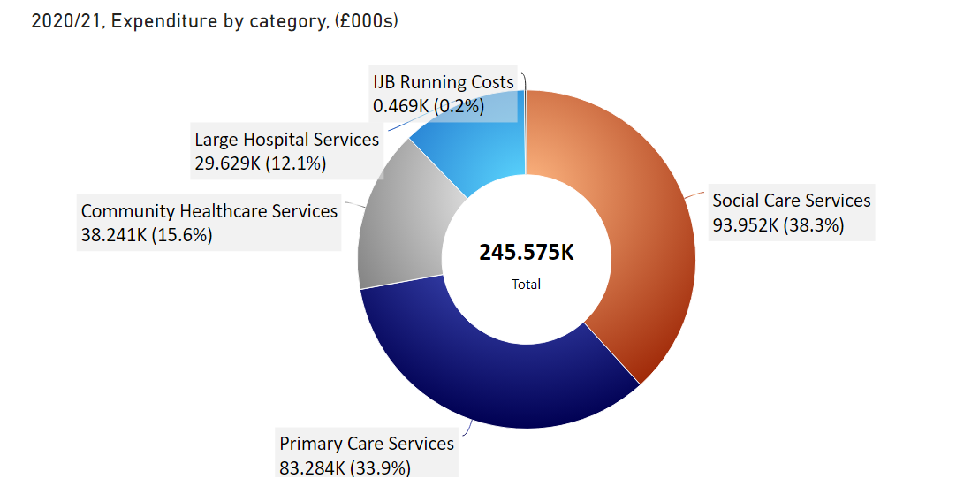

Covid-19 financial implications

During the course of the year the Scottish Government provided £16.098m of funding to meet all additional costs and unachieved savings associated with the pandemic. This reflected the funding originally requested through the IJB’s Local Mobilisation Plan submission (£13.066m) together with a further £3.032m confirmed by the Scottish Government in February in respect of winter planning and ongoing Covid-19 related cost pressures.

Expenditure of £7.902m was incurred during the year, leaving a balance of £8.196m to be transferred to reserves (£6.397m in relation to Covid-19 plus £1.799m for winter planning) to meet ongoing costs during 2021-22.

Forward look 2021/22 and beyond

It is clear that remobilisation, recovery and redesign of services will continue to be a key feature of financial year 2021-22 as we work to suppress Covid-19 through sustainable Public Health measures (such as “test and protect”, surveillance and response) combined with an effective national vaccination programme.

The initial estimate of the potential cost impact of Covid-19 in 2021-22 is in the region of £6.750m (excluding unachieved savings). In line with the previous year, we will continue to work closely with the Scottish Government to refine our local cost estimates and associated funding requirements. In the meantime, the current financial planning assumption is that all additional Covid-19 related costs will be fully funded in 2021-22 via a combination of earmarked Covid-19 reserves and additional Scottish Government funding. As part of the forthcoming review of the IJB’s Medium Term Financial Plan consideration will require to be given to the potential recurring cost impact of the pandemic in terms of long Covid-19, increased demand for mental health services and the longer-term implications for the wider economy in terms of the impact on future funding settlements.

Sustainability

Adult Social Work services are included in Falkirk Council’s Carbon Management Plan. The target for the IJB is to achieve a 68% reduction in its 2019/20 carbon emissions from vehicle fuel, gas and electricity consumption by 2030.

Adult Social Work accounted for 1,427 tonnes CO2e in 2020/21 which is 4% of Council’s overall carbon footprint of 38,862 tCO2e. The breakdown per emissions sector is as follows:

* Gas – 826 tCO2e
* Electricity – 378 tCO2e (30 tCO2e of this was transmission and distribution losses)
* Vehicle fuel – 149 tCO2e
* Business mileage – 69 tCO2e
* Water – 4 tCO2e

Work is underway to identify how to reduce carbon emissions, especially from travel and energy use in buildings.

The NHS Forth Valley Sustainability Strategy 2019-24 sets out how the key elements of sustainability can come together to actively support and enable efficient and effective healthcare delivery. The Strategy recognises that NHS Forth Valley needs to address health challenges as a result of climate change as well as reducing its own environmental impact.

FAIRNESS AND EQUALITYWe know that there can be significant differences in people’s health depending on where they live, whether they are socially excluded or whether they share certain characteristics (such as sex, ethnicity or disability). The impact of such health inequalities are explained in the [Joint Strategic Needs Assessment](https://falkirkhscp.org/wp-content/uploads/sites/9/2018/01/HSCP-SNA-Appendix-1.pdf).

Promoting fairness and equality to help tackle health inequalities underpins the priorities of the Strategic Plan. We aim to work with partners to prevent and reduce the impact of poverty and promote equality of access as part of our priority to ‘Deliver local health and social care services including Primary Care, through enabled communities and workforce’.

Our priority to ‘Focus on early intervention, prevention and harm reduction’ also recognises that there are unfair and avoidable differences in people’s health and social care between different population groups.

The [Equality Outcome and Mainstreaming Report 2017-21](https://falkirkhscp.org/wp-content/uploads/sites/9/2018/01/Equality-Outcomes-and-Mainstreaming-Report.pdf) explains what Falkirk IJB will do to address inequality in greater detail. The report defines six IJB equality outcomes and describes how equality will be built into the way that the IJB works.

One of the key mechanisms for ensuring that equality is mainstreamed into IJB decisions is the Equality & Poverty Impact Assessment. During 2020/21, we conducted Equality & Poverty Impact Assessments on the following areas:

* The establishment of Living Well centres in East and West localities
* Review of Existing Care Package: Younger Adults
* Relocation of Community Day Care service users to a new base at Burnbrae and Grahamston House
* MECS Operations Dispersed Alarm Replacement Programme.

Building confidence with Sensory Awareness

The British Sign Language (Scotland) Act 2015 and the British Sign Language National Plan 2017 - 2023 required public bodies in Scotland to publish local action plans by October 2018 and on a six-yearly basis, thereafter, showing how they will promote and support British Sign Language (BSL).

Our local action plan commits to raising awareness for workers who support individuals with sensory impairment. Sessions have been developed aimed at increasing workforce confidence about sensory impairment issues with the following learning outcomes:

* how to interact with someone who has a sensory impairment
* how a sensory impairment can affect someone’s communication, access to information and mobility
* how to adapt working practice to meet the needs of those with a sensory impairment and keep a positive attitude
* learn about the wide range of services within Falkirk Health and Social Care Partnership that are available to support those with a sensory impairment.

### Partnerships and collaborative working

the third sector’s response to Covid-19 in Falkirk

The response to the Covid-19 crisis in Falkirk took a multi-agency approach that garnered the skills, resources and commitment of individuals, communities, third sector organisations, local businesses and the partner agencies to provide access to food, medicines and essential services to meet the needs of the people and communities of Falkirk.

Arrivo Consulting (a partner of Evaluation Support Scotland) were commissioned to conduct a review into to third sector response to Covid-19, which was published in [December 2020](https://www.cvsfalkirk.org.uk/wp-content/uploads/2020/12/FALKIRK-Eval-of-3-sector-response-FINAL.pdf). The review found that overall, third sector organisations were very successful at scaling up to meet the needs of the community. Critical success factors included:

* Focussing on needs of service users, being driven by ‘what we can do’ rather than ‘what we can’t do’
* Speedy adaption of technology
* Strategic leadership and collaboration, which helped to avoid duplication and maximise the use of resources

The review also highlighted a number of challenges and identified what partners could learn from these challenges.

Our evaluation framework for community-led interventions

The HSCP commissioned Evaluation Support Scotland to co-design an evaluation framework with partners who are involved in the design and delivery of community-based health and social care services. Partners agreed the new framework needed to focus upon the measurement of meaningful outcomes for people. It should also help community practitioners build evaluation into their day-to-day work and support reflective practice and improvement.

The group initially developed a logic model for community-led initiatives which relates directly to the Partnership’s Strategic Plan priorities. The logic model is shown below. The group then created a new reporting template and developed guidance on evaluation methods.

The IJB approved the evaluation framework in June 2021. The framework is now being implemented across all community based and led services supported by the Partnership.

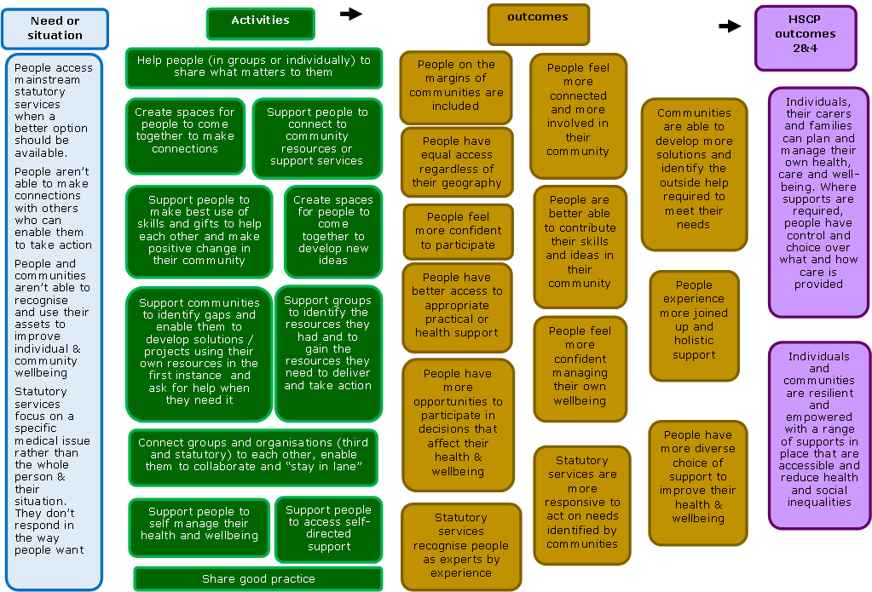

Figure 5

Falkirk’s Stronger Communities Group – working together to build resilient communities

The Stronger Communities Group was formed to help build stronger, more resilient, communities by bringing together disparate community health and wellbeing initiatives in the Falkirk area. The Group is jointly chaired by the Falkirk HSCP and the local third sector interface, CVS Falkirk. Its membership includes representatives from social work, housing services, Community Learning & Development, Community Planning, the Carers Centre, Strathcarron Hospice, and most importantly, service user and carers representatives.

Over the past 18 months, the group’s achievements include:

* Initiating a culture change by tackling traditional silo working
* Reducing duplication
* Promoting early intervention through community-based support
* Providing new strategic oversight which allows co-ordinated commissioning and action.
* Co-ordinating a wide range of responses to support our most vulnerable citizens and communities through the pandemic

People have traditionally faced lengthy waiting lists for social care services with little support or signposting to direct people to access alternative services which may meet their needs in a timely way. The Group have worked to address this issue by co-designing a new framework which challenges traditional approaches to assessment and providing support. The revised approach focuses on encouraging early intervention and prevention before input from formal statutory services is required.

The new approach encouraged a cultural change within services, switching from a focus on addressing what people cannot do to a ‘good conversation’ assessment. This assessment method concentrates on what matters to people and how they can use the assets around them to improve their outcomes.

Through investment in shared resources, the Stronger Communities Group have also focussed on reducing duplication of work between partners and identifying gaps and commissioning opportunities. New shared resources and joint working include:

* Funding three Community Link Workers (one in each Falkirk locality), connecting people with resources following initial GP consultation. This resource provides support to people with multiple issues impacting their health and wellbeing, leading to a more effective use of GP appointments and workload.
* Living Well Falkirk provides online assessment and advice for people experiencing a decline in their functional ability and / or mobility. It also provides signposting to community organisations. This is further supported by Community Learning and Development staff, who have in-depth knowledge of local community services and work with communities to develop resilience and capacity.
* Prior to the pandemic, Community Hubs were planned as part of Community-Led Support in Falkirk to provide new integrated first point of contact. Social Work and third sector partners will have a ‘good conversation’ with people and help them to make links to relevant supports in the community. Adapting to a post-pandemic environment, the service is currently introducing video consultations.

The emergence of this new model enabled community groups to reach families and individuals who were previously unknown to services. The immediate assistance provided during the pandemic brought services directly to the doorstep of households in need.

Community groups received training through Adult Support and Protection Services to help identify support needs based on their observations and contact within the community. This successfully led to around 190 referrals being made between May 2020 and April 2021.

The IJB works closely with a range of stakeholders including Falkirk Community Planning Partnership (to ensure service developments are consistent with their Local Outcomes Improvement Plan) and Falkirk Council Housing Services to determine and influence housing requirements at locality level. The IJB also consults and maintains established forums with carers and the third and independent sectors.

How We WORK with Housing Services

Housing has a key role for people to stay at home, in accommodation that meets their needs, in their communities. The contribution of Falkirk Council housing services and Registered Social Landlord’s (RSL’s) is key to delivery of the Partnership’s Strategic Plan.

Our Housing Contribution Statement (HCS) 2019 – 2022 includes the following priorities that form an essential link with the Strategic Plan and the Local Housing Strategy:

1. Make the best use of technology to help people stay in their communities for as long as possible

2. Recognise the importance of well-being and connectedness

3. Make the most of the built environment

4. Improve access to housing

5. Provide housing options for homeless people

Covid-19 has delayed progress towards some of the actions that support these priorities while other actions remain ongoing. Actions that have already been achieved include:

* Explore with developers incentives to provide accessible housing
* Explore key workers as a priority in the new Affordable Housing Policy where income and other priorities have been considered
* Increase priority for Affordable Housing Supply grant funding to projects which provide the greatest percentage wheelchair housing

Of the 22 actions:

* 10 are ongoing
* 3 are to be considered in the Local Housing Strategy Update 2021
* 3 are delayed by Covid-19
* 3 are under review
* 3 have been achieved

Working in partnership with the Independent Sector

The Independent Sector is committed to improving the sustainability of care provision in Falkirk and is a key partner in the delivery of integrated health and social care services in the area.

During the Covid-19 pandemic the independent sector lead has continued to support the Care Home Managers Support Network and the Care at Home Providers Network. These networks were well established before the pandemic and ensured continuity of support during this challenging period. The role also extended to proactively supporting the partnership through membership of the Care Home Improvement Team and the Care Home Oversight Group. This has ensured vital and regular communication with the independent sector providers and the Partnership.

Partnership Funding 2020-2021

Falkirk HSCP has operated a partnership funding programme during the period 2018-2021. The programme has provided an opportunity for partners to establish, test, transform and accelerate the delivery of integrated services, in line with local priorities.

During the investment period, 2018-2021, the IJB committed to shifting the balance of care towards integrated services and projects in the community. This was a change to traditional models of health and social care, which have largely focussed on statutory services within centralised and/or institutional settings. The IJB also agreed that that ongoing investment to support discharge or avoid admission should be via re-distribution of current allocations, rather than significant new investment. One of our challenges is to shift the balance of care to develop a range of community-based supports to develop supportive communities to enable more people to live at home longer.

The distribution of partnership funding is shown in Figure 6. and demonstrates the shift in investment to increase funding for community-based supports and carers.

|  |  |  |  |
| --- | --- | --- | --- |
|  | | | |
| Key: | | | |
| Avoiding Delayed Discharge/Admission to Hospital | Support for Carers | Community based support | Infrastructure |

Figure 6

During 2020-2021 all funded initiatives and services were impacted by Covid-19. The Partnership provided reassurance to partners that funding could be used flexibly to respond to the challenges of the pandemic and to continue to provide support to services users and carers. Partners were able to re-direct funds to provide services remotely, mostly online or by phone. Some services were completely halted for a period of time.

In September 2020, the IJB agreed that funding to initiatives impacted by the pandemic would be continued for a period of up to one year from April 2021

Partnership Funding Investment Plan 2021-2024

During this period 2018-2021, Partnership Funding encompassed only four funds; Main Programme, Leadership Fund, Carers Fund and Dementia Innovation Fund.

The IJB agreed that a single partnership investment plan should be developed to provide oversight of investment, governance, and evaluation of impact for all strands of funding available to the Partnership to support in-scope services. The Partnership Funding Investment Plan 2021-2024 developed in collaboration with partners during 2020-2021 and was approved by the IJB in June 2021.

**CASE STUDY: PEN GROUP – HEALTH ISSUES IN THE COMMUNITY (HIIC)**

**Example of Community-Led Support**

HIIC explores a social model of health, using discussion-based activities driven by the lived experience of participants to generate community led solutions to health inequalities. Work with PEN, a group for adults with additional support needs, to develop an understanding of what affects their own health and the health of their community, using the HIIC framework as a model for delivery.

Due to Covid-19 restrictions, this activity is being delivered online and the group have been supported to take part by application to Connecting Scotland for iPads and connectivity, and the provision of digital learning opportunities in online platforms. PEN members have learned to use digital platforms to participate in online group learning activities, and have been supported by Mates & Dates to access online social activities

At the start of the project, members of the group were anxious about taking part. They were worried they would not be able to fully understand the community issues surrounding health. They were also concerned they would not have the confidence to speak about their own issues, and if they did, then they would not be taken seriously. It was vital that session discussions and activities reflected these concerns and recognised the challenges faced by the members when articulating their needs in relation to their wellbeing.

By creating a space where people feel safe and valued, the group are progressing well. They realise that not only can they understand the issues being discussed, but more importantly, they feel confident enough to participate without fear of judgement or ridicule, “… decision makers need to realise how things affect us.” The group are now exploring the different ways to think about health and wellbeing and discovering the number of social issues that impact on their own.

As the group reach the halfway point of the project, they are beginning to think about the changes they would like to see and what could be done to make this happen, “I can make myself feel better, not just my doctor.”

# Our Governance

Inspection of Falkirk HSCP Registered Services

The Care Inspectorate is responsible for the regulation of care standards in Scotland. In consultation with the social care sector, the Care Inspectorate has developed a self-evaluation and quality framework model based on the Scottish Government’s Health and Social Care Standards. Inspectors use the quality framework to evaluate the quality of care during inspections and improvement planning.

Care Inspectorate Quality Assessment Framework

The Quality Assessment Framework sets out Key Questions about the difference a care service makes to people’s wellbeing, and the quality of the services that contribute to that. During 2020 the Care Inspectorate created an additional new theme of “How good is our care and support during Covid-19 pandemic?”

|  |  |
| --- | --- |
| ***Key Question 1*** | How well do we support people’s wellbeing? |
| ***Key Question 2*** | How good is our leadership? |
| ***Key Question 3*** | How good is our staff team? |
| ***Key Question 4*** | How good is our setting? |
| ***Key Question 5*** | How well is our care and support planned? |
| ***Key Question 6*** | What is the overall capacity for improvement? |
| **Key Question 7** | How good is our care & support during the pandemic? |

Residential Care Homes (Older People)

The Care Inspectorate carried out a full inspection of Burnbrae Care Home on 5 March 2021. This looked at areas of previous requirements and recommendations from their inspection of the service on 5 August 2019 when this was graded at a 2 (weak).

The Care Inspectorate have continued to grade the service at a 2 as five of the six requirements had not been met since 2019. The Inspectors spoke with residents and families and were assured with all the care in place to support individual outcomes for residents. This included the use of IT whereby residents were supported by staff to keep in regular contact with family members during national restrictions.

The Care Inspectorate observed that systems of record keeping, and auditing needed to be more robust and evidenced. They also acknowledged that the last 12 months had been a difficult time for the delivery of care during a pandemic but felt that the grades must remain unchanged at this time.

At the end of the 2020/21 financial year the percentage scores from all Homes in the Falkirk Council area were as follows:

|  |  |  |  |
| --- | --- | --- | --- |
|  | **Good/Very Good/Excellent** | **Unsatisfactory/**  **Weak/**  **Adequate** | **Not inspected** |
| **KQ1** | 86% | 14% | 0% |
| **KQ2** | 34% | 14% | 52% |
| **KQ3** | 38% | 10% | 52% |
| **KQ4** | 34% | 14% | 52% |
| **KQ5** | 71% | 24% | 5% |
| **KQ6** | 5% | 0% | 95% |
| **KQ7** | 5% | 10% | 85% |

Table 18

Residential Care Homes (Younger Adults)

11 out of the 12 care homes continue to be assessed under the new Quality Assessment Framework described in the section above. At the end of the 2020/21 financial year the percentage scores from for the 11 care homes in the Falkirk Council area inspected under the new framework were as follows, with only one care home been inspected during this financial year.

|  |  |  |  |
| --- | --- | --- | --- |
|  | **Good/Very Good/Excellent** | **Unsatisfactory/**  **Weak/**  **Adequate** | **Not inspected** |
| **KQ1** | 73% | 27% | 0% |
| **KQ2** | 27% | 9% | 64% |
| **KQ3** | 18% | 18% | 64% |
| **KQ4** | 27% | 9% | 64% |
| **KQ5** | 82% | 18% | 0% |
| **KQ6** | not graded | not graded | not graded |
| **KQ7** | 9% | 0% | 91% |

Table 19

One care home continues to be assessed under the old inspection regime and was graded 100% in good, very good and excellent and 0% in weak or unsatisfactory.

Care at Home and Housing Support Services

During inspection year 2020-21, inspection activity across all care and home and housing support services reduced to create capacity to respond to the Covid-19 pandemic. As a result of this only 1 service was inspected in the Falkirk area between April 2020 and March 2021.

Inspections are now being remobilised and as part of our continued partnership working with the Care Inspectorate, they will be attending a future provider forum to share information on the new Quality Framework for Care at Home and Housing Support Services.

Inspection of Forth Valley Royal Hospital

An unannounced visit by Healthcare Improvement Scotland (HIS) took place on 2 February 2021 at Forth Valley Royal Hospital (FVRH). The inspection focused upon the factors that contribute to the risk of Covid-19 (or any other infections). The report notes areas where NHS FV is performing well and where they could do better, including the following:

* The person-centred team provided a range of resources to support patients and their relatives
* Staff were kept up to date and were well supported during the Covid-19 pandemic
* Staff must observe physical distancing in clinical and non-clinical areas where possible
* Personal protective equipment (gloves) should be appropriately worn by all staff.

The inspection resulted in four areas of good practice and two requirements. An improvement action plan has been developed by the NHS Forth Valley to meet the two requirements.

# Our Performance

## National Integration Indicators

The IJB fulfils its ongoing responsibility to ensure effective monitoring and reporting on the delivery of services, relevant targets, and measures which are set out in the Strategic Plan and integration functions. The Partnership reports progress against the suite of 23 national integration indicators. This enables us to understand how well our services are meeting the needs of the people who use them.

Indicators 1-9 are populated by the bi-annual Health and Care Experience (HACE) Survey. The most recently available data for these indicators is for 2019/20. Indicators 11-20 are in the main populated from the Scottish Morbidity Records (SMRs) which are submitted from local Health Boards to Public Health Scotland (PHS). As the records are generated on discharge, PHS has recommended using calendar year 2020 instead of financial year 2020/21 for some indicators in order to avoid under reporting.

In previous years the analyses of the National Indicators has included a focus on direction of travel and whether performance had improved, deteriorated or the position had been maintained. Due to various changes in the 2019/20 HACE survey wording, indicators 2, 3, 4, 5, 7 and 9 are no longer directly comparable to previous years. The impact of Covid-19 means comparisons to previous years are also more challenging for other indicators. For the reasons outlined the annual performance report will focus on comparison to the national average.

Our performance for 2020 - 2021 is set out in the following ‘Performance at a Glance’, with more detailed tables below. The summary shows that for 13 out of the 19 (68.4%) indicators for which data are available Falkirk compares either well or similar to the National average.

## Performance at a Glance

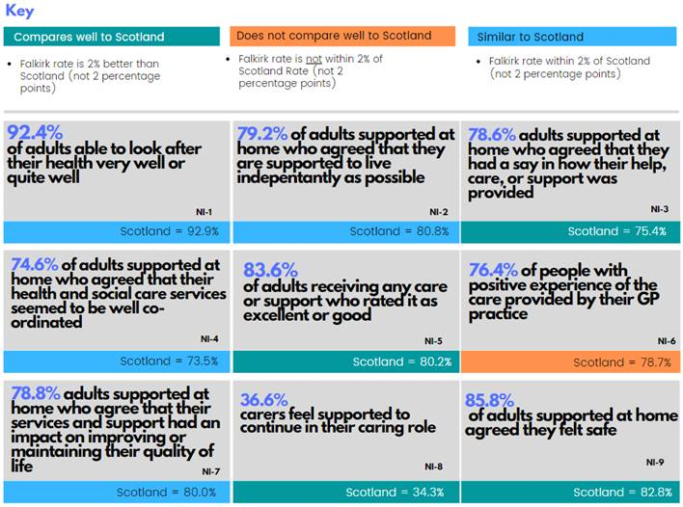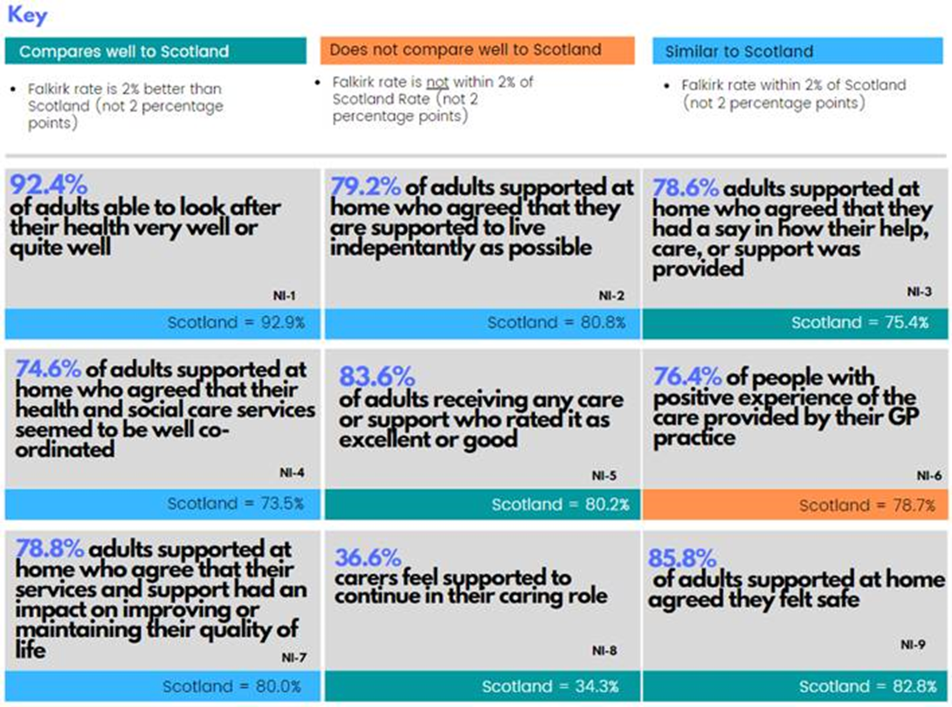

Figure 7

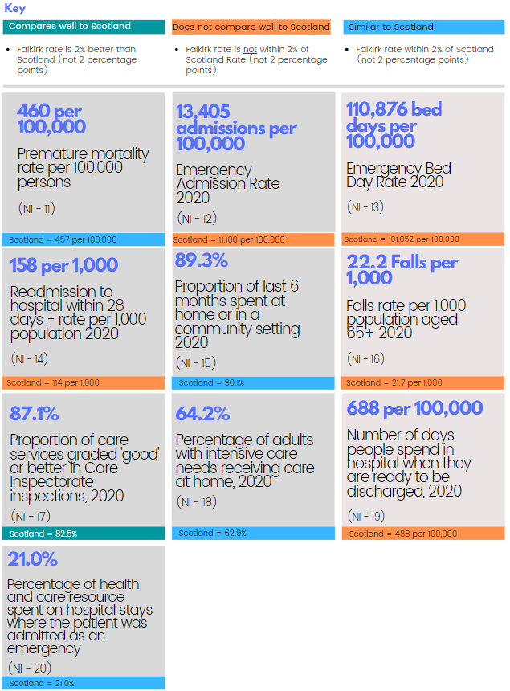 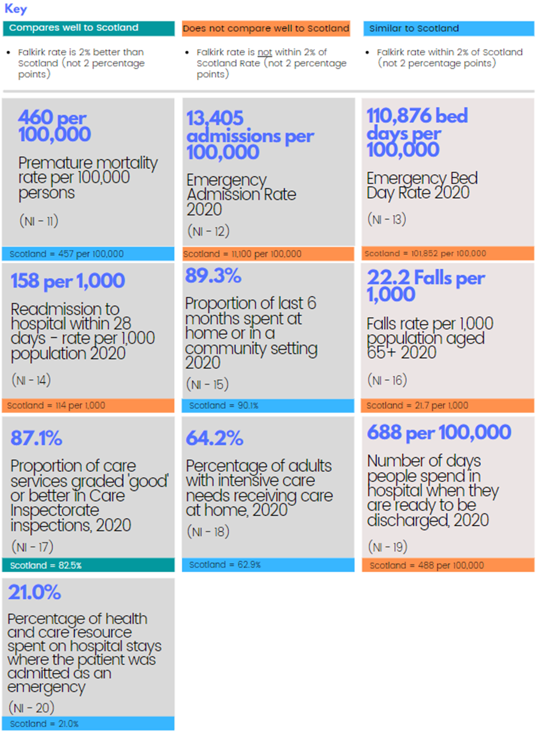

Figure 8

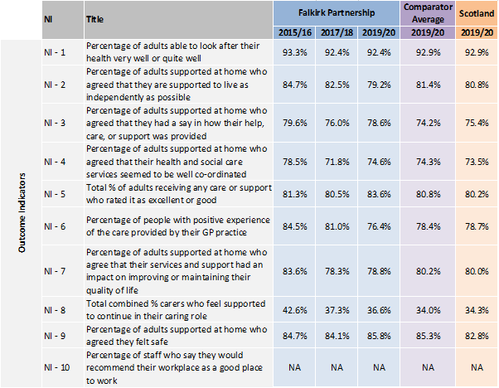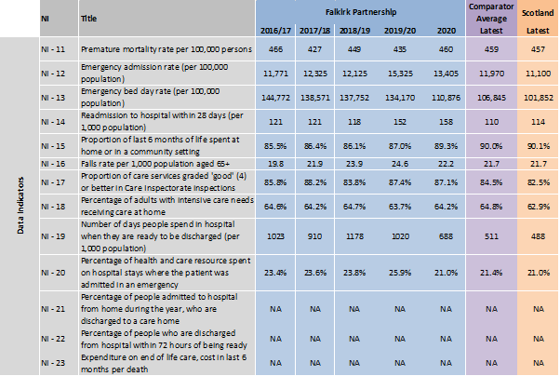

Source: Public Health Scotland

Notes:

1. NA indicates where data is not yet available.

2. NI 1 – 9: Data are presented on financial year file and 2019/20 is the most recent data available. The figures presented for the Core Suite of Integration Indicators may differ from those published due to changes in the underlying methodology. Historic figures will also not be comparable due to a change in methodology.

3. NI 12 – 16, 18 and 20: Calendar year 2020 is used here as a proxy for 2020/21 due to the national data for 2020/21 being incomplete. We have done this following guidance from Public Health Scotland and to improve consistency between our report and those for other Health and Social Care Partnerships. Please note that figures presented will not take into account the full impact of Covid-19 during 2020/21.

4. NI 17 and 19 are presented on financial year with the latest available data being from 2020/21.

5. NI 1 – 9, 11 and 17: for these indicators the data available for each Council Area in the Comparators group is a percentage or a rate only. So, the ‘Comparator Average’ is the average of the percentages or rates for each indicator, rather than a true weighted average.

6. NI 12 – 16 and 18 – 20: for these indicators, the ‘Comparator Average’ is a true weighted average.

7. Since moving to TrakCare in April 2019 Combined Assessment Unit (CAU) activity has been recorded in SMR01 under significant facility 11 whereas previously it was recorded in SMR00. This has contributed to an increase in the total number of emergency admissions (indicator 12) in Forth Valley areas from 2019/20 onwards. This will also have had an impact on Indicator 14.

Comparators: Includes members of Family Group 3: Clackmannanshire, Dumfries & Galloway, Fife, Renfrewshire, South Ayrshire, South Lanarkshire and West Lothian: <http://www.improvementservice.org.uk/benchmarking/how-do-we-compare-councils.html>

# Looking Forward

The Partnership, with support from a range of partners, has made good progress despite the pandemic, and remains committed to continue to improve the services available to people.

Our Delivery Plan, agreed by the IJB in December 2019, remains relevant and we have developed a transformation programme to help us achieve our ambitions. We will also implement the Falkirk HSCP Remobilise, Recover, Redesign plan, which outlines the key elements for recovery from Covid and the potential opportunities for redesign, within the context of the delivery of the National Framework, the IJB Strategic Plan and national policy and guidance.

Key areas of work for 2021/22 include:

* Reopen Adult Day Services
* Implement the redesign of Home Care service
* Implement the redesign of Day Opportunities
* Develop the Falkirk Community Hospital Masterplan
* Extending the programme of Community Led Support
* Planning for Winter pressures
* Adult Support & Protection Joint Inspection
* Refreshing the local Dementia Strategy
* Develop local Technology Enabled Care Strategy

# Glossary

|  |  |
| --- | --- |
| A&E | Accident and Emergency Department (casualty) |
| Acute | Acute Care is a branch of health care where people receive active but short-term treatment for a severe injury or episode or illness, an urgent medical condition, or during recovery from surgery. Acute care services are generally provided in a formal hospital setting. |
| Adaptations | Adaptations can help older people and people with disability to live independently in their own homes. They can reduce the risk of falls and other accidents in the home and also reduce the need for home care or long-term admission to a care home. A wide variety of aids and equipment is available to help with daily living tasks. This ranges from simple adapted cutlery to telecare alarms, specialist seating and beds. Common examples of adaptations include replacing a bath with a level access shower or making it easier to get in and out of the home by widening doors or installing a ramp. |
| Admitted / Admission  (to hospital) | Being taken into hospital |
| Advocacy | Advocacy means getting support from another person to help someone express their views and wishes, and to help make sure their voice is heard. Someone who helps in this way is called an advocate. In the Standards, we are referring to formal advocacy provided by an organisation to someone using care. |
| Adult support and protection (ASP) | Things we can do to identify, support and protect adults who may be at risk of harm or neglect and who may not be able to protect themselves |
| Alcohol and Drug Partnership (ADP) | ADPs are multi agency partnerships established to implement and respond to the national strategies on alcohol, drugs, tobacco and volatile substances across the whole population. ADPs also have a responsibility to develop a local substance strategy which addresses prevention. This must ensure that the range of treatment options that are required to promote recovery from substance use problems are provided for and available at point of need. |
| Anticipatory Care Plans (ACPs) | A plan prepared by a person with health/care needs along with a professional. The plan lays out what the person would prefer if/when their condition changes. |
| Assessment | Process used to identify the needs of a person so that appropriate services can be planned for them |
| Avoidable admission | An admission to a bed that may be regarded as unnecessary had other more appropriate services been available |
| Balance of care | How much care is given in the community compared to how much is given in hospitals etc |
| Bed based services | Those services such as inpatient wards in a hospital where people are cared for overnight |
| Bed days | The number of days that beds in hospital are occupied by someone |
| Capacity | Capacity refers to an individual’s ability to make decisions about their wellbeing. This may change over time and may refer to different aspects of their life. For people who have been medically assessed as lacking capacity there is legislation to protect their wellbeing. |
| Care home | A care service providing 24-hour care and support with premises, usually as someone’s permanent home. |
| Care Plan | A Care Plan is the plan of treatment or actions agreed with a service user, their carer and family, following an assessment of need by a health or care agency. |
| Carer | A carer is a person, of any age, who looks after family, partners, or friends in need of help, because they are ill, frail or have a disability and need support to live independently. This care is unpaid however the carer may be in receipt of carers allowance but this is not considered to be payment. |
| Chief Officer | Chief Officer of the Integration Joint Board was appointed to provide a single point of management for the integrated budget and integrated service delivery. They are accountable to the Integration Joint Board and to the Chief Executives of their Health Board and Local Authority for the delivery of the integrated services. |
| Choice and control | Choice and control is about shaping services to meet people’s needs, rather than allocating people to fit around services |
| Adult Carer Support Plan | An assessment to find out what a carer (unpaid, informal carer) needs (such as respite, short breaks etc) and how services can support them better |
| Clinical and Care Governance | Clinical and care governance is a systematic approach to maintain and improve care in a health and social care system. This will provide assurance to the IJB on the systems for delivery of safe, effective, person centred care in line with the IJB’s statutory duty for the quality of health and care services. |
| Commission (a service) | Buying a service from another to meet the needs of a population |
| Community Based Support | Services that are delivered within community settings, sometimes within a person’s home. Community based support is provided by NHS Forth Valley, Falkirk Council and also by voluntary and community organisations. |
| Community Planning Partnership (CPP) | Where public agencies work together with the community to plan and deliver better services which make a difference to people’s lives |
| Covid-19 | An acute respiratory illness in humans caused by the coronavirus, which can cause severe symptoms and in some cases death. Originally identified in China in 2019 which became a pandemic in 2020. |
| Daily living | Tasks that people carry out to look after their home, themselves and when taking part in work, social and leisure activities |
| Delayed discharge | Where someone is unable to leave hospital because the appropriate care and/or support is not yet available for them at home |
| Delegated function | A service that HSCP partnership will be responsible for |
| Delivering (a service) | Carrying out a service |
| Demographic change / workforce challenges | Changes in population (e.g. more older people) that mean we have to change how we provide our services |
| Direct payments | Means-tested payments made to service users in place of services they have been assessed as needing. This allows people to have greater choice in their care |
| Early intervention | Giving support, care and/or treatment as early as possible |
| End of Life Care | End of life care addresses medical, social and emotional, spiritual and accommodation needs of people thought to have less than one year to live. It often involves a range of health and social care services for those with advanced conditions who are nearing the end of life. |
| Engagement | Having meaningful contact with communities e.g. involving them in decisions that affect them |
| Facilitate/facilitator | Making a process easy or easier |
| Front line staff | Staff who work directly with users of a service |
| Governance | The way that an organisation is run |
| Health and Social Care Integration | In the UK, Health and Social Care (often abbreviated to HSC or H&SC) is a term that relates to services that are available from health and social care providers. This is a generic term used to refer to integrating/bringing together the whole of the health and social care provision infrastructure, public and private sector, including the Third sector. |
| Health inequalities | The gap that exists between the health of different population groups such as the well-off compared to poorer communities or people with different ethnic backgrounds |
| Home First | The Home First team support people to avoid delay in their discharge from hospital, they working with the person, their carer / relatives to agree how to support them to get home. |
| Housing Contribution Statement (HCS) | The HCS sets out the arrangements for carrying out the housing functions delegated to the Integration Authority under the Public Bodies (Joint Working) (Scotland) Act 2014 |
| Independent sector | This includes voluntary, not for profit, and private profit making organisations. It also includes housing associations |
| Integration | The term used to describe the partnership working between health and social care services as outlined in the Public Bodies (Joint Working) (Scotland) Act 2014 |
| Integration Joint Board (IJB) | The IJB is responsible for running the partnership and has members from Falkirk Council and NHS Forth Valley, staff representatives, the Third Sector and the public |
| Integration Scheme | The detail of our model of integration is laid out within our Integration Scheme. This scheme sets out a robust and transparent framework for the governance and operation of the Falkirk Health and Social Care Partnership. This includes detail such a financial arrangements, governance arrangements, data sharing, liability and dispute resolution. |
| Intermediate Care | Intermediate Care services support people to improve their independence and aim to provide a range of enabling, rehabilitative and treatment services in community and residential settings. The term has been defined as a "range of integrated services to promote faster recovery from illness, prevent unnecessary acute hospital admission, support timely discharge and maximise independent living"(NSF for Older People, DOH, June 02). |
| Joint working | Different teams and organisations working together |
| Long term conditions | Long-term conditions are conditions that last a year or longer, impact on many aspects of a person’s life, and may require ongoing care and support. The definition does not relate to any one condition, care group or age category. It covers adults and older people as well as children and those with physical and mental health issues. Common long-term conditions include epilepsy, diabetes, some mental health problems, heart disease, chronic pain, arthritis, inflammatory bowel disease, asthma and chronic obstructive pulmonary disease. |
| Multidisciplinary | Where several different professionals work together in the interests of service users and carers |
| Palliative care / Palliative and End of Life Care | Palliative care aims to improve the quality of life of people, and their families, with life-threatening illness that can’t be cured. It helps to prevent and relieve the problems associated with their condition, through early identification and assessment of their needs, care planning to address any symptoms and pain and address any social, psychological or spiritual needs. |
| Partnership | A partnership refers to two or more individuals or organisations working together to achieve a shared aim. Within the context of health and social care integration, the Partnership consists of Falkirk Council, NHS Forth Valley, Third and Independent sectors working together to provide effective, joined up service. |
| Personal outcomes | The changes or improvements that have taken place during the time someone has been receiving support |
| Person centred | Putting the needs and aspirations of the individual service user at the centre of our work |
| Priorities | Things we think are important to do |
| Proactive | Creating or controlling a situation rather than just responding once it’s happened. |
| Public Bodies | NHS Forth Valley and Falkirk Council are both public bodies. A public body is democratically accountable at either national or local level. They have specific functions and requirements generally driven by legislation, which they must undertake. The Public Bodies (Joint Working) (Scotland) Act requires the integration of health and social care, and is an example of legislation. |
| Readmission | Being taken back into hospital shortly after having been discharged |
| Recruitment and retention | Being able to recruit and keep staff |
| Reablement | Reablement service will begin at the point of assessment and have a focus on independence through the delivery of a short-term person centred approach by a multidisciplinary team of well-trained staff working |
| Resilience | Being able to cope with and recover from difficult situations |
| Redesign | Redesign within the context of health and social care integration, relates to services may be changed and improved. Redesign is based on evaluation and review of existing services and will often include listening to service users, their carers and families about what services are important to them. |
| Rehabilitation | Rehabilitation entails restoring someone to health or normal life through guidance and therapy after addiction, or illness. |
| Remobilise, Recover, Redesign | An overview of the HSCP mobilisation response to the Covid-19 pandemic, and the key elements for recovery and the potential for redesign |
| Risk management | The process of identifying, quantifying, and managing the risks that an organisation faces |
| Self-management | Where people take responsibility for and manage their own care. Encouraging people with health and social care needs to stay well, learn about their condition and remain in control of their own health |
| Self-directed support | When the person who needs services directs their own care and has choice when it comes to their support |
| Social Care | Any form of support or help given to someone to help them take their place in society |
| Stakeholders | Stakeholders include any person or group with a vested interest in the outcome of a project or plan. |
| Strategic Commissioning | This is the process that informs the Integration Authorities Strategic Plan. Strategic Commissioning is a way to describe all the activities involved in:   * assessing and forecasting needs * linking investment to agreed desired outcomes * planning the nature, range and quality of future services; and * working in partnership to put these in place. |
| Strategic Plan | The plan that describes what the partnership aims to do and the local and national outcomes used to measure our progress |
| Sustainable | Can be maintained at a certain level or rate |
| Technology | Specialised devices that helps people in their day to day life, such as telecare, telehealth or telemedicine, alarm call system, remote support and advice or mobility aids |
| Third sector | Voluntary and community groups, social enterprises, charities |
| Transformational change | A complete change in an organisation, designed to bring big improvements. |
| Transition | Used to describe a significant change for someone, such as starting to use a new care service or a change in life stage (eg becoming an adult). |

