Falkirk Health and Social Care Partnership

Framework for Local Eligibility Criteria for Unpaid Carers

Table of Contents

1. Background to the Framework for Local Eligibility Criteria for Unpaid Carers 3
2. Explaining the process 6
3. Outlining the Framework 7
4. Eligibility thresholds: where eligibility sits in relation to carer support as a whole 8
5. Eligibility Criteria: Determining the Impact of the caring role and associated risk 10
6. Table of Indicators 11
7. Case Studies 16

1. Background to the Framework for Local Eligibility Criteria for Unpaid Carers

Carers (Scotland) Act 2016

The Carers Act places a duty on local authorities to set out local eligibility criteria for carers. These criteria are a set of rules which determine whether the local authority has a duty under the Act to either directly provide support or to ensure carers have access to support in the community. Local authorities must consult and involve carers and representative organisations in developing criteria for their area.

When setting their criteria, local authorities must also have regard to matters specified by Scottish Ministers in regulation. These national matters may include ensuring that the criteria encourage a preventative approach to supporting carers to continue in their caring role.

The National Carer Organisations developed a ‘best practice’ framework for Eligibility Criteria in response to views, expressed by carers, that eligibility criteria for carer support should be designed and tested by the National Carer Organisations.¹ The framework was developed during the progress of the Carers Bill (through Parliament) in 2015 and published in December 2016. The Falkirk Health and Social Care Partnership has worked jointly with Falkirk and Clackmannanshire Carers Centre staff and local carers to revise this Framework document for local use in Falkirk.

Focus of the Framework

There are three aspects to eligibility: the criteria that determine it, the thresholds that must be passed to trigger it, and the support and/or services that follow it. This framework sets out best practice for the first two aspects only. It does not attempt to define the support services or type and amount of support service a carer would be entitled to. This is because each carer’s situation is different and support must be tailored to each individual. The Scottish Government draft Guidance advises the local authority to consider the carer’s own strengths and capabilities and how public services and community supports might help them.

It embraces prevention

Although other Scottish Government policy supports preventative work, Local Authority (LA) budgets and practice often focus on critical care. This document identifies thresholds for different levels of need, but it also aims to ensure that preventative support is embraced and embedded in policy and practice.

It supports a rights based approach

- The right of every carer to have an Adult Carer Support Plan, which aims to support their health and wellbeing by identifying their

- The Coalition of Carers in Scotland Y Submission to the Health and Sport Committee’s call for views on the Carers (Scotland) Bill

personal needs and outcomes.

- The right, through an Adult Carer Support Plan to access an appropriate balance of information, advice and support to meet these needs and achieve personal outcomes.

- The right to have eligible needs met.

It is outcomes focused

The Carers (Scotland) Act 2016 defines personal outcomes in relation to the caring role and makes provisions for subsequent regulations about personal outcomes. This framework allows for outcomes to be defined at all levels of support for carers, so that the benefits of accessing both preventative and more intensive support are clear and measurable.

It is applicable to any carer

The document was not written with young carers specifically in mind. Young carers are entitled to be children first and foremost, so frameworks like ‘Getting it Right for Every Child’ are likely to be more relevant to them. However, there is nothing in this framework document that could not apply to young carers and it is generic enough to be used in a range of situations.

2. Explaining the process

Through the Carers (Scotland) Act 2016, commencing in April 2018, Local Authorities have a duty to support carers who meet local eligibility criteria, this is in addition to the power they currently have to support all carers. Determining eligibility for support can be broken down into four steps from assessment to the carer accessing support that is appropriate for them.

Step One

A carer who wishes to access support will need to have an Adult Carer Support Plan completed. This will involve an assessment to decide the carer’s needs, and how they can best achieve their personal outcomes. Not all carers who undertake an Adult Carer Support Plan will have an eligible need, or a right to support. However, it is likely that they will still have needs which can be met through access to support in the community (universal services and preventative), and support that helps them to continue in their caring role and have a life outside of caring.

Step Two

Once the carer’s outcomes have been identified through their support plan, the local authority will need to determine if any of their needs meet eligibility criteria for funded support or support in the community. This document sets out a framework for eligibility criteria to enable local authorities to determine if carers meet the eligibility threshold, meaning they have a duty to support them.

Step Three

If a carer meets the eligibility threshold, the Health and Social Care Partnership (HSCP)/local authority will need to decide what level of support they are entitled to. The support they are entitled do will be decided on an individual basis and will be discussed with the carer. The level of available support will be determined by the eligible needs of the carer and available resources.

Step Four

Once the level of support and the available budget support has been agreed, the carer will then decide how they would like their support to be arranged and will be entitled to choose from the four self-directed support options available. There may be local variation in the services which are available to support carers in each HSCP/local authority area. Falkirk Health and Social Care Partnership will work with local organisations to ensure there is a choice of services available that respond to varying needs and the local environment.

3. Outlining the Framework

The two diagrams on the following pages set out our eligibility framework for carers. This consists of:

1. Eligibility thresholds i.e. where eligibility sits in relation to carer support as a whole

This diagram explains the process for working out eligibility and where the eligibility threshold sits. It also illustrates the role of preventative and universal services in supporting carers who do not meet the eligibility threshold for funded support. This includes some possible examples of services to support carers, which are not intended to be exhaustive or prescriptive.

2. A model framework of criteria – determining the impact of the caring role and associated risk

This diagram illustrates the different areas of a person’s life where their caring role may have an impact. This includes their health, finances, life balance and relationships, feeling valued, living environment, future planning and employment/education. It sets out the different categories of risk, with the red circle indicating where the highest risk and therefore the eligibility threshold sits.

The diagrams are followed by a table of indicators that are intended to show the impact of the caring role and the subsequent risk to the carer in relation to eight carer outcomes.

The diagrams and table of indicators are based on the following elements:

Universal, preventative support (such as information and advice). This is the foundation for helping carers manage their caring responsibilities. This in turn reduces the number of carers requiring a higher level of support, or crisis interventions and reduces demand on statutory (public) services.

Eligibility thresholds that show at what point the power to support carers becomes a duty to support carers. The diagrams do not attempt to describe which services carers should receive at any of the levels shown. Instead, they give examples of the types of support that could be given.

4. Eligibility thresholds: where eligibility sits in relation to carer support as a whole
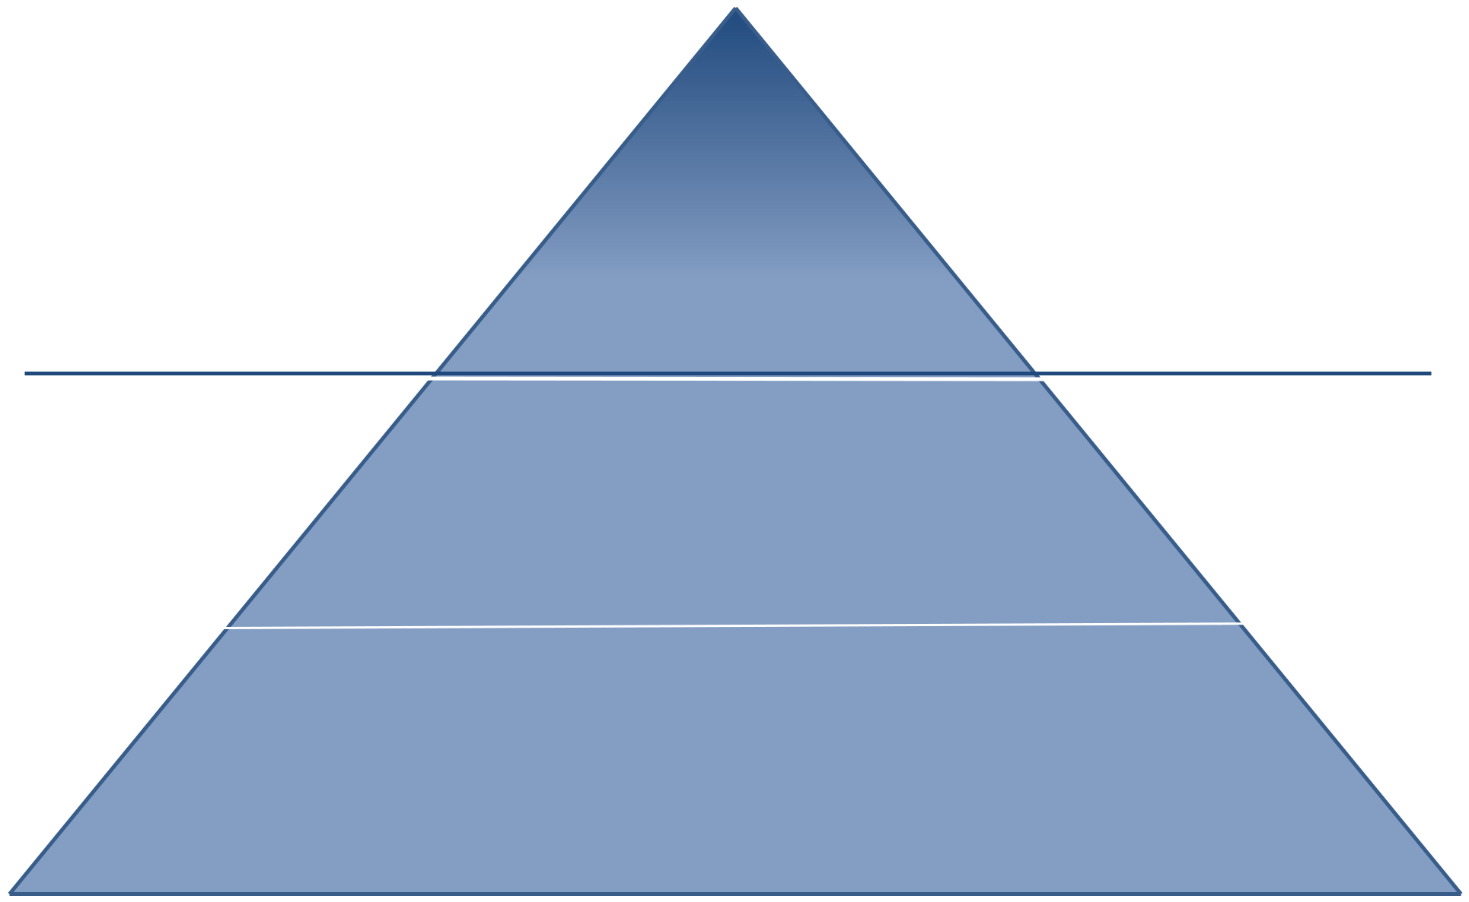

Stage 3: Post assessment support

Local Authority duty
To support eligible carers

LA and NHS will provide more specialist support.

Carer chooses delivery mechanism (self-directed support),

including the examples below

Eligibility threshold

Stage 2: Assessment, Adult Carer Support Plan

Local Authority power to support carers

1:1 assessment and outcomes-based conversation

LA and NHS will commission community supports (including examples below and other

carer services such as breaks from caring, respite care, advocacy, counselling)

Stage 1: Pre-assessment – Universal support

Local Authority power to support carers

LA and NHS will support infrastructure of information and advice, preventative and community support (e.g. registering with a GP, social prescribing, access to carer centre (online and/or in person), peer support, training, supported self-care, sign-posting to social and leisure opportunities)
Promote the Adult Carer Support Plan.

5. Eligibility Criteria: Determining the Impact of the caring role and associated risk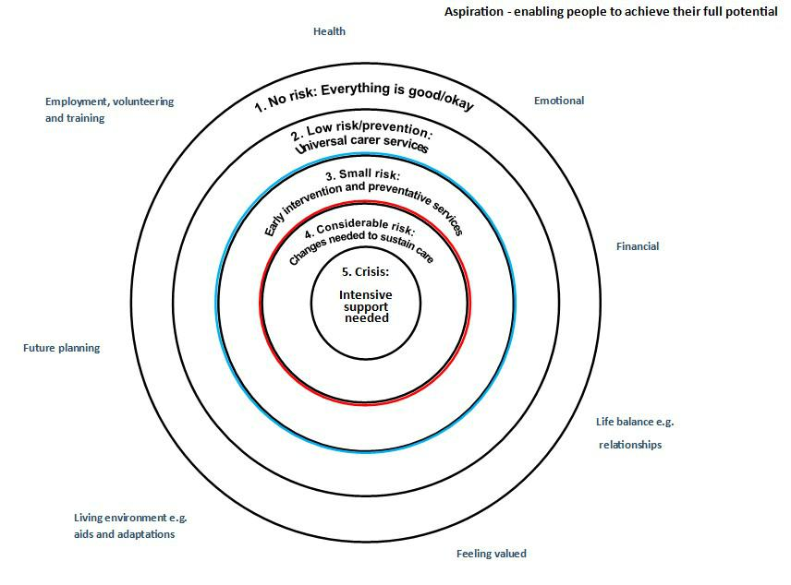

6. Table of Indicators

 | Stage 1: Universal Support | Stage 1: Universal Support | Stage 2: Assessment & Carer Support Plan | Stage 3: Post-assessment, duty to support | Stage 3: Post-assessment, duty to support
 | 1- Care has no impact / no risk | 2 - Caring has low impact/ risk prevention | 3 - Caring has clear impact/ moderate risk. Response needed | 4 – Caring has substantial impact / high risk | 5 – Evidence of critical impact / crisis
Physical health | Carer in good health | Carer’s health beginning to be affected | Carer’s health at risk without support | Carer has health need that requires attention | Carer’s health is significantly/seriously affected
Emotional Wellbeing | Carer emotional wellbeing is good | Caring role is beginning to have an impact on emotional wellbeing | Some impact on carer’s emotional wellbeing | Significant impact on carer’s emotional wellbeing | Carer’s emotional wellbeing is seriously affected
Life Balances | Carer has regular opportunities to achieve the balance they want in their life This includes a broad choice of breaks and activities which promote physical, mental and emotional wellbeing | Carer has opportunities to achieve the balance they want in their life They have access to a choice of breaks and activities which promote physical, mental and emotional wellbeing | Due to their caring role the carer has limited opportunities to achieve the balance they want in their life They have access to a few breaks and activities which promote physical, mental and emotional wellbeing | Due to their caring role the carer has few and irregular opportunities to achieve the balance they want in their life They have little access to breaks and activities which promote physical, mental and emotional wellbeing | Due to their caring role the carer has no regular opportunities to achieve the balance they want in their life They have no access to breaks and activities which promote physical, mental and emotional wellbeing
Finances | Caring is not causing financial hardship[ e.g. carer can afford housing costs and utilities | Caring is causing a risk of financial hardship e.g. some difficulty meeting housing costs and utilities | Caring is causing some impact on finances e.g. difficulty meeting either housing costs or utilities | Caring is having a significant impact on finances e.g. difficulty meeting housing costs and utilities | Caring is causing severe financial hardship e.g. carer cannot afford household essentials and utilities/not meeting housing payments
Feeling valued | Carer feels their knowledge and expertise is always valued by health and social care and others and they therefore feel included and empowered | Carer feels their knowledge and expertise is sometimes valued by health and social care and others and they generally feel included and empowered | Carer increasingly feels their knowledge and expertise is not always valued by health and social care and others and they sometimes feel excluded and disempowered | Carer often feels their knowledge and expertise is not valued by health and social care and others and they often feel excluded and disempowered | Carer feels their knowledge and expertise is never valued by health and social care and others and they always feel excluded and disempowered
Relationships | Relationship with the cared-for person is good Important relationships with other people are good | Risk of negative impact on relationship with cared-for person Risk of negative impact on relationships with other people | Some negative impact on relationship with cared-for person Some negative impact on relationships with other people | Relationship with cared-for person is significantly affected Relationships with other people are significantly affected | Relationship with cared-for person is seriously affected Relationships with other people are seriously affected
Living environment | Carer’s living environment is suitable, posing no risk to the physical health and safety of the carer and carer for person | Carer’s living environment is mostly suitable, but could pose a risk to the physical health and safety of the carer and carer for person in the longer term | Carer’s living environment is unsuitable, but poses no immediate risk to the carer or the cared for person | Carer’s living environment is unsuitable, and poses a significant risk to the physical health and safety of the carer and/or carer for person in the longer term | Carer’s living environment is unsuitable, and poses an immediate risk to the physical health and safety of the carer and/or carer for person in the longer term
Employment/training | Carer has no difficulty managing caring and employment and/or education OR Carer does not want to be in paid work or education | Carer has some difficulty managing caring and employment and/or education and there is a risk to sustaining this in the long term OR Carer is not in paid work or education but would like to be in the long term | Carer has difficulty managing caring and employment and/or education and there is a risk to sustaining this in the medium term OR Carer is not in paid work or education but would like to be in the medium term | Carer has some difficulty managing caring and employment and/or education and there is a risk to sustaining this in the long term OR Carer is not in paid work or education but would like to be soon | Carer has significant difficulty managing caring and employment and/or education and there is an imminent risk of giving up work or education OR Carer is not in paid work or education but would like to be now
Future plan | Carer is confident about the future and has no concerns | Carer is largely confident about the future but has minor concerns | Carer is not confident about the future and has some concerns | Carer is anxious about the future and has significant concerns | Carer is very anxious about the future and has severe concerns

7. Case Studies

Case Study 1 – Bill

Bill is 70 and cares for his mother Phyllis. Phyllis is 92 and is frail and elderly but lives independently. She manages fairly well and Bill visits daily to help her with housework, shopping, getting out and about. She receives some help from the social work department to cook her meals and has a community alarm for emergencies. Bill asks for an Adult Carer Support Plan. Overall he is managing his caring role well and his health and wellbeing are generally good. However, he identifies that he has some concerns about the future (if anything was to happen to him) and he is a bit lonely as he doesn’t really have anyone to talk to about his caring role.

Using the model criteria

All of Bill’s needs fall into universal or preventative support, which could be provided by a local carer support worker at Carers Centre. For example, they could arrange for him to join their male carers group to meet fellow carers. In addition, the person responsible for the Adult Carer Support Plan could help him develop an emergency plan so that if anything happened to Bill, the plan would take effect

Case Study 2 – Frances

Frances is 20 and cares for her mum who has cancer. She provides continuous care, although they have some help from the local hospice. She had to give up her college course and has no income. She is exhausted and depressed and has no idea how she will continue to cope. The hospital support worker contacts the Carers Centre to arrange for her to have an Adult Carer Support Plan which identifies that:

- Caring is causing significant impacts on her mental health.

- She is exhausted and wants to be able to have a break from caring and spend time with her friends.

- She wants to return to education but does not know how she will be able to manage education and caring.

- She is really worried about finances. Although her Mum gets ESA, she does not receive any other benefits.

Using the model criteria

- Frances’s health is at significant risk of breaking down.

- She has few opportunities to have a break.

- She has no opportunities for education.

- Her finances are precarious.

She meets the high threshold on this model across a number of areas and therefore the local authority has a duty to support her. This could include providing a regular break, maximising her income and helping her plan to return to education.

Case Study 3 – Fran

Fran cares for her husband John who has MS. She works full time. Although she has up to now managed the caring role, John’s disability is progressing and he needs more help to get up in the morning which she is finding more difficult. Fran requests an Adult Carer Support Plan. During the discussion about the outcomes the following is identified:

- Caring is causing some impacts on her health – she is stressed and has some back pain.

- Financially there are few problems as her job is well paid. Her husband is receiving DLA. However, were she to lose her job they would have significant financial difficulty, including paying the mortgage.

- Their housing is suitable and has all the adaptations they need.

- She feels her quality of life is good and despite her husband’s disability, they are able to enjoy activities together and apart.

- She is somewhat worried about the future and how they will cope as her husband’s condition progresses.

- She is keen to keep her job but it is significantly at risk as she is coming in late as she has to get her husband up and ready every morning. Her employer is concerned about her late arrivals and is threatening disciplinary action.

Using the model criteria

Fran is in the preventative/universal section for all areas of her life apart from two. This can be met with a referral to the Carers Centre , for example, with access to complementary therapies and some moving and handling training.

However, employment and (potentially) finance are of concern. In this instance, she meets the highest threshold where the local authority will have a duty to provide support to ensure that she continues to be able to manage work and caring. She is at imminent risk of losing her job and there are concerns about the associated impact that would have on their finances. Some help in the mornings would prevent this happening.

