Carers Challenge Fund
Application guidance: November 2022

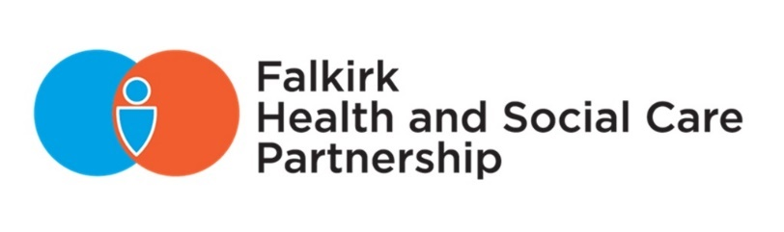

In this guide:
Application Guidance 2
Basic Eligibility Criteria 3
Monitoring and Evaluation 4
Application Process 4
Application Deadlines 4
How to Apply 4

Background

Falkirk Health and Social Care Partnership delivers adult community health and social care services – serving a local population of over 160,000 across rural and urban communities.

The Partnership is run by its Integration Joint Board, made up of representatives from Falkirk Council, NHS Forth Valley, the third sector, service users and carers.

Jointly developed by the Partnership, Falkirk Council Children’s Services, CVS Falkirk, and the Falkirk and Clackmannanshire Carers Centre, a Falkirk Carers Strategy was produced covering 2019 – 2022, due for renewal this year.

The £500,000 Carers Challenge Fund has been made available to local organisations to help address the areas of need identified within the Carers Strategy, delivering positive outcomes for carers and their families.

Carers Challenge Fund projects will complement the wide range of services and support in pace across Falkirk. As always, carers and their cared-for individuals will be engaged to ensure the advice, information, and support available is designed to make a difference.

Application Guidance
Proposals may be evaluated against 5 criteria listed below:

- The 2019-2022 Falkirk Carers Strategy identified priority areas for development, and each proposal must relate to at least one of these priorities:
- Reducing Impact of Caring on Health & Wellbeing
- Carers Employability (Carer Positive)
- Developing Community Support
- Breaks from Caring
- Emergency Planning
- Carer Involvement in Hospital Discharge
- Preventative Support
- Identifying hidden carers
- Transport – (as part of a wider proposal)

- We encourage proposals to represent at least one of these outcomes which support health and wellbeing for carers and enables them to continue in their caring role:
- Carers are informed and have access to information which enables them to feel supported and valued
- Carers are able to pursue their own interests and time for themselves out-with their caring role
- Carers are empowered and able to access support when needed
- Carers are supported to maintain their own physical and mental health
- Carers can control their finances, having information and access to support if needed
- Carers are enabled to continue to work as far as possible (if they wish to do so)
- Carers emotional wellbeing is prioritised by making sure their views and opinions are taken into account.
- Carers are able to plan for the future and emergency situations.

- We welcome proposals which minimise the impact of Covid-19 and support the recovery of carers and those they care for in terms of wellbeing and impact of financial crisis, though this is not an essential component of each proposal.

- We ask that proposals contain achievable delivery outcomes, and must ensure that your organisation can deliver on these.

- We may consider whether your proposal meets value for money.

Depending on the suitability of information within proposals, the Carers Strategy Group may respond seeking clarification.

Basic Eligibility Criteria
Funding is available for 2 years from January 2023.

Eligible organisations can apply for up to £35k per annum for an initial year. Continuation of funding will be dependent on the delivery of outcomes and the available budget.

We will accept proposals from community, third sector groups and statutory organisations. Funding can support children, young people and/or adults.

To qualify, organisations must:
- Be a registered charity or a constituted organisation that has only charitable purpose(s) and delivers public benefit.
- have an adequate governance structure, tied to a committee or board.

Unincorporated organisations will be restricted to £10k per annum.

We will accept proposals for 100% funding. Consideration should be given to how the project can continue beyond the term of funding.

We may consider awarding greater amounts where there are exceptional circumstances; this will be subject to availability of remaining funds.

Funds should not be used to replace or continue existing project funding. (although it can be used to add value to existing provision where a specific or short-term need has been identified).

Funds cannot be used:
- for the sole benefit of one individual;
- by private companies or sole traders;
- for activities promoting religious or political beliefs;
- for activities supporting people not resident in the Falkirk Local Authority area.

Monitoring and Evaluation
As a condition of your award, you are required to monitor and report on how the funding has been spent and the impact that it has had.

Monitoring will include what difference the funding has made to the carers and progress made in achieving the outcomes as set out within your proposal.

Evaluation will include information about the number and types of people who benefited but will mostly concentrate on qualitative information including snapshots or case studies.

Projects will be required to submit a quarterly or bi-annual report based on the scale of the project. The volume of information requested may change between first and second year, acknowledging that ‘year one’ includes project set up.

Projects must begin within 6 months of funding being agreed. Projects must be complete within the timescale for the grant, unless otherwise agreed with the Carers Strategy Group.

Application Process
Funding proposals will be assessed by the Carers Strategy Group, a multi-agency group consisting of Falkirk Health and Social Care Partnership, Falkirk Council, and representatives from Carers and the local third sector.

The panel will make funding recommendations to Falkirk Health and Social Care Partnership’s Senior Leadership, who will make final award decisions.

All eligible applications submitted by the deadlines set will be assessed on own merit, regardless of applicant i.e. no priority will be applied to either statutory or third sector applications.

In addition to open calls for proposals, the Senior Leadership Team may commission specific projects or services during the funding period. This will be based on needs identified within locality profiles or other strategic needs assessments.

Application Deadlines
We will accept applications until Friday 23 December 2022.

How to Apply
Please complete the application form and submit your proposal along with any supporting documents via email to carers@falkirk.gov.uk.

