

Integration Joint Board

Risk Management Strategy

|  |  |
| --- | --- |
| Date of first issue: | Sept 2022 |
| Approval status: | Approved by IJB Audit Committee on 23 Sept 2022 |
| Current issue date: | Sept 2022 |
| Available at: | [www.falkirkhscp.org/publications/](http://www.falkirkhscp.org/publications/) |
| Contact: | [integration@falkirk.gov.uk](mailto:integration@falkirk.gov.uk) |

Contents

**1.** **Introduction** 2

**1.1.** **What is a Risk?** 3

**1.2.** **What is Risk Management?** 3

**1.3.** **Why do we need Risk Management?** 3

**1.4.** **Risk Classification** 4

**1.5** **Partnership** **Risk Management Arrangements** 5

**2.** **Risk Architecture** 6

**2.1.** **Governance and Reporting** 7

**2.2.** **Roles and Responsibilities** 9

**3.** **Risk Appetite** 11

**3.1** **Risk Appetite Levels** 12

**4.** **Approach to Risk Management** 16

**4.1** **Risk Management Process – ISO31000** 16

**4.2** **Step 1: Establish Context** 16

**4.3** **Step 2: Identify Risks** 17

**4.4** **Step 3: Analyse Risks** 17

**4.5** **Step 4: Assess Risks** 18

**4.6** **Step 5: Manage Risks** 20

**4.7** **Monitor and Review** 21

**4.8** **Communicate and Consult** 22

**4.9**  **Assurance** 23

**5.** **Training, Learning and Development** 24

# **Introduction**

The Risk Management Strategy sets out the principles and approaches to risk management which are to be followed by the Integration Joint Board and staff within the Health and Social Care Partnership. Its objective is to achieve a consistent and effective application of risk management and enable it to be embedded into all core processes, forming part of day-to-day management activity and supporting the delivery of Strategic and Commissioning plans. Risk Management, when deployed effectively, should add value by supporting day-to-day activities as opposed to being seen as a separate, self-contained process and this Strategy supports this approach.

# **What is a Risk?**

A risk can be defined as ‘the effect of uncertainty on objectives’(*ISO31000)*. It is essentially any uncertain event which can have an impact upon the achievement of an organisation’s objectives – either reducing the likelihood of achievement or stopping it altogether.

Not every perceived problem or adverse event is a risk. An important distinction must be made between what is a risk and what is an issue – or in other words, an uncertainty, and a certainty. A risk is an event that may or may not happen. An issue or adverse event is something that is currently happening or has already happened. Issues and adverse events should therefore not be recorded and treated as risks – we want to adopt a proactive rather than reactive stance. However, we should consider whether identified issues impact on the risks currently identified, or indeed create new risks.

It is important that decision makers are “risk aware” rather than “risk averse,” meaning that risk is not a bad thing and does not need to be avoided (indeed it will often be impossible for us to avoid risk). Therefore, risk should be considered, and decisions made on risks v benefits.

# **What is Risk Management?**

Risk management is a systematic way of dealing with that uncertainty which involves the identification, analysis, control, and monitoring of risk. Risk Management activities are designed to achieve the best possible outcomes and reduce the uncertainty. An effective system of risk management will draw together all types of risks and enable an interrelated view of the organisation’s risk profile.

# **Why do we need Risk Management?**

An effective system of risk management will deliver a range of outputs:

* Ensuring that decision making is informed and risk-based, to maximise the likelihood of achieving key strategic objectives and effective prioritisation of resources
* Ensuring compliance with legislation, regulations, and other mandatory obligations
* Providing assurance to internal and external governance groups that risks are being effectively controlled
* Supporting organisational resilience and helping avert high profile failures
* Empowering all staff to make sound judgements and decisions concerning the management of risk and risk taking – fostering the “risk aware” rather than “risk averse” culture
* Achievement of effective and efficient processes throughout the organisation
* Anticipating and responding to changing political, environmental, social, technology and legislative requirements and / or opportunities
* Preventing injury and / or harm, damage, and losses
* Supporting Public Confidence in the Integration Joint Board

Effective risk management will be achieved by:

* Clearly defining roles, responsibilities, and governance arrangements
* Incorporating risk management in all Executive Leadership Team, Health Board, Integration Joint Board and Assurance Committee reports and when taking decisions
* Maintaining risk registers that are linked to the IJB’s Strategic Plans or delivery of delegated services
* Staff at all levels understanding risk management principles, and consistently applying them through their everyday activities, confidently identifying risks and taking actions to bring them down to an acceptable level for the organisation
* Establishing communication channels which support sharing of risk information through all areas of the IJB
* Monitoring and reviewing risk management arrangements on a regular basis
* Seeking assurance that controls relied on to mitigate risks are effective
* Developing a positive Risk Culture through the principles of Leadership, Involvement, Learning, Accountability and Communication, and by ensuring that all relevant partner Risk Management Strategies are consistent with their organisation’s values

# **Risk Classification**

**Strategic Risks**

Strategic risks represent the potential for the IJB to achieve (opportunity) or fail to meet (threat) its desired outcomes and objectives as set out within their Strategic Plans, and typically these risks will be long term and require strategic leadership in the development of activities and application of controls to manage the risk.

Risk identification for the Strategic Risk Register is facilitated through annual horizon scanning involving the Board and the SLT, alongside the review of the IJB Strategic Plan, and review of the risk section of board papers to assess whether amendment or addition to the Strategic Risk Register is required.

Risks are not automatically escalated/de-escalated from lower-level risk registers to the Strategic Risk Register. If a risk increases in severity to the extent that it requires strategic leadership/management and Board oversight, then the risk should be re-framed to reflect that and added as a new Strategic risk. If an existing Strategic risk decreases in severity and no longer requires strategic leadership/management or Board oversight, then consideration should be given to closing the risk, and creating relevant operational risks. For example, the UK’s exit from the European Union created Strategic risk. As mitigation plans progressed and the UK formally left the EU, the risk no longer needed the Strategic oversight, but there were pockets of residual operational risks, for example in relation to impacts on supply chains.

**Operational Risks**

Operational risks represent the potential for impact within or arising from the operational services delivered by the health and social care partnership (HSCP), as commissioned through the Strategic Commissioning Plan and Directions by the IJB. These risks will be managed within the respective risk management frameworks of the Local Authority and the Health Board, through integrated management teams, with relevant risk specialists working together to ensure consistent practice, and that the respective Risk Management strategies are aligned.

**Clinical Risks**

Clinical risks represent the risk of harm or negative consequences to a patient or service user, or capability of causing an adverse event. It is the degree to which a foreseeable harm (risk) can be managed by an individual practitioner and requires that person to have an open duty of care for an individual. It is closely aligned to safe staffing, levels of competence and compliance with professional standards of practice.

**Project Risks**

Project risks represent the risks to the delivery of a project to time, budget, and specification. These will be managed by the appropriate working group or Project Board and/or Transformation Board which oversees all projects and programmes of work.

# **1.5** **Partnership** **Risk Management Arrangements**

In order to ensure strong risk management partnership arrangements, it will be necessary to agree how some risks have an impact on more than one partner at a strategic level. Risks will be discussed and agreed across partners, with particular focus on:

* Where the risk was first identified
* Date of identification
* Nature of risk
* Impact areas (e.g. service delivery, performance, strategic commissioning intentions etc)
* Mitigation required

Risks with the potential to impact more than one partner will be identified for inclusion in one or more of the following risk registers:

* NHS Forth Valley Strategic Risk Register
* Clackmannanshire and Stirling IJB Strategic Risk Register
* Falkirk IJB Strategic Risk Register

Any such emerging risks will be submitted to the HSCP Senior Leadership Team for approval for inclusion on the Strategic Risk Register

# **Risk Architecture**

The arrangements for communication, governance, reporting, roles and responsibilities forms the organisation’s overarching risk architecture. Defining a consistent approach to how and where risk information is communicated is essential to developing a positive risk culture and to ensuring risk management is appropriately implemented to support the activities of the Integration Joint Board.

Risks, once identified, will be captured on risk registers (which may be managed using a Risk Management Information System such as Pentana or Safeguard). Each service team/specialty will hold a risk register, with risks owned by Heads of Service/Service Senior Management Teams. This forms the bottom layer of the risk register hierarchy.

Risk escalation is a process that ensures significant risks that cannot be managed by a local team, department or specialty are escalated appropriately following the risk register hierarchy and line management arrangements, to the groups/committees who require the information for direction of action and/or assurance purposes. The following questions should be asked when deciding whether to escalate a risk:

* Does the risk present a significant threat to the achievement of Government objectives and/or standards?
* Is the risk score assessed to be intolerable or beyond the IJB’s risk appetite?
* Does the risk have a widespread impact beyond a local area, e.g. does it affect multiple Service Teams, or does it have dependencies on multiple Service Teams/Departments or Directorates to mitigate?
* Does the risk present a significant cost/decision making beyond the scope of the budget holder, or require change driven at an organisational level?

Risk score and organisational risk appetite should be key considerations when recommending risks for escalation. If a risk is out of appetite and falls within the tolerance range, this indicates that close monitoring and corrective action is required to bring the risk back within appetite. A risk with a current score out with the tolerance range requires escalation and immediate corrective action.

When a risk is escalated, the ownership of the risk will also escalate to the relevant member of the HSCP Senior Leadership Team.

The process is summarised in the Diagram 1 below:

**Diagram 1:**

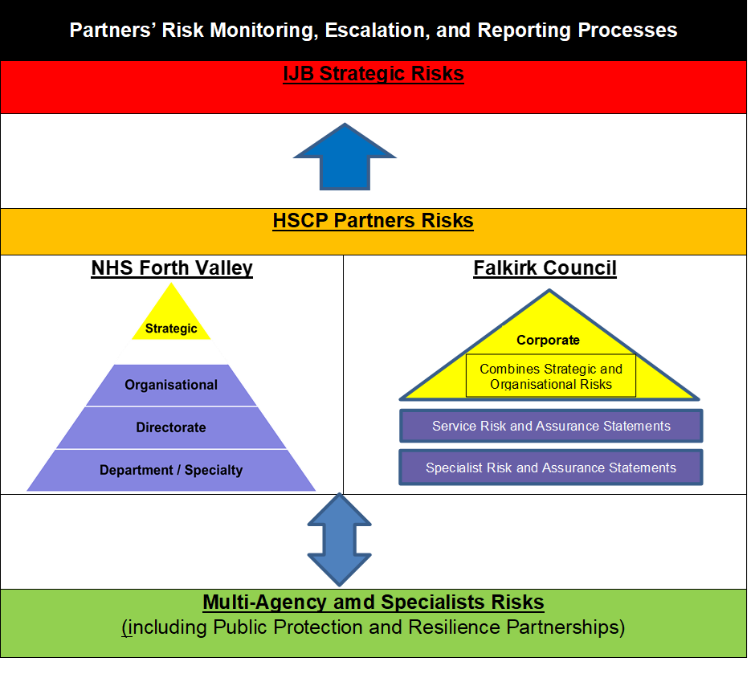

# **Governance and Reporting**

The IJB is responsible for the risk management arrangements and for ensuring that significant risks are adequately controlled. The IJB Audit Committee support the Board by providing independent assurance of the Risk Management arrangements, receiving quarterly risk management updates and reports and an annual report. The IJB and Audit Committee take assurances from the HSCP Senior Leadership Team.

Diagram 2 illustrates the Falkirk IJB Risk and Assurance Reporting Framework.

**Diagram 2:**

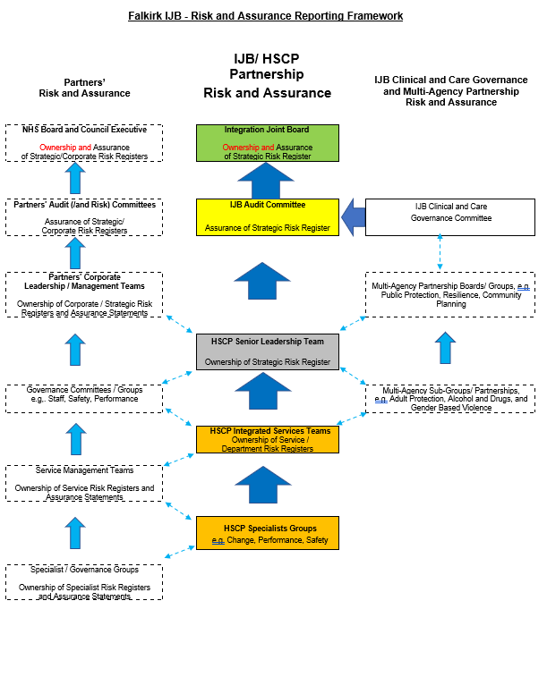

# **2.2. Roles and Responsibilities**

|  |
| --- |
| Risk Management Roles and Responsibilities |
| Integration Joint Board and/or delegated Committee |
| Members of the Integration Joint Board, including as members of the appropriate delegated Committee are responsible for:   * Oversight of the IJB’s risk management arrangements including seeking assurance that these are effective. * Receipt, review and scrutiny of reports on strategic risks and any key operational risks that require to be brought to the IJB’s attention; and * Ensuring that all IJB Board and Standing Committee papers adequately explain associated risks and overtly refer to the IJB Risk Register where relevant * Approve Risk Appetite for the IJB |
| Chief Officer |
| The Chief Officer has overall responsibility for:   * Ensuring the IJB has a risk management and assurance framework in place. * Ensuring that suitable and effective arrangements are in place to manage the risks relating to the functions within the scope of the IJB. * Keeping the Chief Executives of the IJB partner bodies (Council and Health) informed of any significant existing or emerging risks that could seriously impact the IJB’s ability to deliver the outcomes of their Strategic Plans, and vice versa; and * Production of a Risk Management Annual Report. |
| Chief Financial Officer |
| On behalf of the Chief Officer, the Chief Financial Officer will be responsible for:   * Ensuring risks are identified and mitigating actions identified for the consideration of the IJB and delegated Committees as appropriate. |
| IJB Audit Committee |
| The Audit Committee’s purpose is to provide independent assurance of the risk management framework, and is responsible for:   * Ensuring existence of and compliance with an appropriate Risk Management strategy. * Reviewing risk management arrangements. * Receiving regular risk management updates and reports, including an annual report which confirms that the risk management arrangements were adequate and effective throughout the year; and * Confirming the risk management activities support the wider governance and assurance framework. |
| HSCP Senior LeadershipTeam |
| Members of the Senior Leadership Team are responsible (either collectively, or by nominating a specific member of the team) for:   * Supporting the Chief Officer in fulfilling their risk management responsibilities * Arranging professional risk management support, guidance and training from partner bodies. * Ownership of the Strategic Risk Register * Set Risk Appetite for the IJB * Receipt and review of regular risk reports and assurances on strategic, shared key operational risks and escalating any matters of concern to the IJB Chief Officer; and * Ensuring that the processes outlined in this strategy are actively promoted across their teams and within their areas of responsibility. |
| Risk Owners |
| Risk Owners are those accountable for ensuring the effective management of a risk and providing assurance that key controls are operating effectively. For Strategic risks and escalated operational risks, this will be the relevant member of the HSCP SLT. |
| Risk Leads |
| Risk Leads are responsible for managing a risk on a day-to-day basis. Risk leads are likely to be those with management or supervision duties, and are responsible for:   * Clearly defining and articulating risks, and effectively analysed to identify the causes and impacts of the risk. * Assessing the risk score for probability and impact using the risk assessment matrix. * Formulating a management plan with controls which are proportionate to the level of risk and that are effectively applied in practice. * Recording the details using the relevant risk management system. * Reviewing the risk on a regular basis, taking into account any changes in context, and considering the impact of controls on the scoring of the risk; and * Identifying sources and levels of assurance regarding control effectiveness, to allow risk owners to provide assurance |
| Chief Social Work Officer (CSWO) |
| The Chief Social Work Officer (CSWO) has responsibility for:   * Performance Management and identification and management of corporate risk as it relates to the delivery of social work services; and * Ensuring all social services workers meet the requirements of the SSSC Codes of Practice. |

|  |
| --- |
| Other Persons with a Professional and/or Statutory Role |
| Designated Officers responsibilities in relation to provision of assurance and promotion of good governance, including Risk Management activities, should ensure that they discharge their risk management responsibilities in line with their job descriptions, and relevant legislation and Professional Standards. |
| All Persons Working Under the Direction of the IJB within the HSCP |
| Risk Management should be integrated into daily activities with everyone involved in identifying risks related to their working practices and service areas. Everyone is therefore required to:   * Understand the risks related to their roles and activities. * Understand how their actions relate to their own safety, and that of their patients, service users/clients and the wider public. * Understand their accountability for particular risks and how they can manage them. * Feed into the provision of assurance by the Risk Leads. * Understand the importance of reporting incidents and/or near misses to allow lessons to be learned and contribute to ongoing improvement of risk management arrangements; and * Understand that good risk management is a key part of the IJB’s culture |
| Partner Bodies |
| Risk professionals from partner bodies will provide risk management support to the IJB, and are responsible for:   * Regularly liaising with the IJB and other partners to have structured discussions around how risks will be treated as they arise, and how assurances will be obtained and provided. * Providing advice and support in relation to technical developments such as risk appetite and training. * Support risk identification, including facilitating workshops and horizon scanning; and * Reviewing the risk management process itself to ensure that it is adding value to the activities of the IJB and supports the Strategic Commissioning objectives |

# 

# **Risk Appetite**

Utilising risk appetite principles can help the IJB identify and set appropriate thresholds for its strategic risks, whereby the Board establishes the level of risk impact they are willing and able to absorb in pursuit of objectives.

The delivery of public services can be inherently high risk and the concept of applying risk appetite can be challenging. However, the application of risk appetite, particularly in a resource-finite environment, is essential to avoid over or under management of risk. Deployed effectively, risk appetite can act as an enabler to the delivery of key services.

**Risk Appetite:**

The amount and type of risk the IJB is willing to seek or accept in the pursuit of objectives.

Key considerations when applying risk appetite:

* It is not always possible to manage every risk down to the minimum or most desirable level and maintain service delivery
* It is not always financially affordable or manageable to fully remove risk and uncertainty from decision making and service delivery
* Risk management is concerned with balancing risk and opportunity (or downside risk and upside risk)

When a risk increases to a point where it is no longer within appetite, it may initially fall within a range which is not desirable, but the organisation has the capacity to tolerate. This is known as the risk tolerance range.

**Risk Tolerance:**

The maximum level of risk the organisation can tolerate regarding each type of risk before it is significantly impacted.

If a risk is out of appetite and falls within the tolerance range, this indicates that close monitoring and corrective action is required to bring the risk back within appetite. A risk with a current score out with the tolerance range requires escalation and immediate corrective action.

There are benefits to the practical application of Risk Appetite:

* supports decision making (resources can be allocated to risks further away from the desired appetite level)
* allows further prioritisation (if you have several risks with the same score, mitigate those further from appetite first)
* subjectivity is taken away from the setting of target scores (the appetite range becomes the target score)

Risk appetite is also useful when budget setting or considering approval of business cases, such as those relating to innovation activity. Identifying associated risks and their appetite levels allows focus on activities which mitigate the risks furthest from the organisation’s desired risk appetite/tolerance levels. **For that reason, all decision papers should overtly reference risk and any links to the IJB Strategic Risk Register.**

Partner bodies will also have a defined risk appetite acting as a trigger point for escalation. While partner bodies will seek to ensure that their respective approaches to risk appetite are aligned, it is recognised that partners may not have the same appetite levels for all types of risk. These variances will be taken into consideration when the risks are being managed, escalated and reported.

# **3.1 Risk Appetite Levels**

There are four levels of risk appetite which the IJB will use. Each risk category in the risk assessment matrix is assigned one of the risk appetite levels described below. The risk appetite levels and their application to each risk category is set and approved by the IJB, following development and consultation by key stakeholders and subject matter experts. Risk appetite may vary depending on internal and external circumstances; therefore, the levels will be reviewed on an annual basis.

**Averse:**

* Very little appetite for this type of risk
* Avoidance of risk and uncertainty is a key organisational objective
* Exceptional circumstances are required for any acceptance of risk

**Cautious:**

* Minimal appetite for this type of risk.
* Preference for ultra-safe delivery options that have a low degree of inherent risk and only reward limited potential.

**Moderate:**

* Acceptance that a level of risk will be required to pursue objectives, or that a greater level of risk must be tolerated in this area.
* Preference for safe delivery options that have a low degree of inherent risk and may only have limited potential reward.

**Open:**

* Acceptance that risk must be more actively taken in the pursuit of transformation or that a high level of risk must be tolerated.
* Willing to consider all potential delivery options and choose the one most likely to result in successful delivery while also providing an acceptable level of reward (and Value for Money).
* Eager to be innovative and confident in setting high level of risk appetite as controls are robust.

Each risk appetite level correlates with risk score levels on our risk assessment matrix as shown below. Refer to the NHS Forth Valley Risk Appetite Statement for details on risk appetite levels for each risk category.

### Risk appetite matrix

Likelihood

|  |  |  |  |  |  |
| --- | --- | --- | --- | --- | --- |
| 5 | 5 | 10 | 15 | 20 | 25 |
| 4 | 4 | 8 | 12 | 16 | 20 |
| 3 | 3 | 6 | 9 | 12 | 15 |
| 2 | 2 | 4 | 6 | 8 | 10 |
| 1 | 1 | 2 | 3 | 4 | 5 |
|  | 1 | 2 | 3 | 4 | 5 |

Impact

|  |  |  |
| --- | --- | --- |
| Score | Appetite |  |
| 1 - 3 | Averse | Demonstrates that if the risk appetite is ‘Averse’, a risk score of between 1-3 and the range of associated outcomes is within appetite |
| 4 - 9 | Cautious | Demonstrates that if the risk appetite is ‘Cautious’, a risk score of between 4-9 and the range of associated outcomes is within appetite |
| 10 - 16 | Moderate | Demonstrates that if the risk appetite is ‘Moderate’, a risk score of between 10-16 and the range of associated outcomes is within appetite |
| 20 - 25 | Open | Demonstrates that if the risk appetite is ‘Open’, a risk score of between 20-25 and the range of associated outcomes is within appetite |

# **Approach to Risk Management**

# **4.1 Risk Management Process – ISO31000**

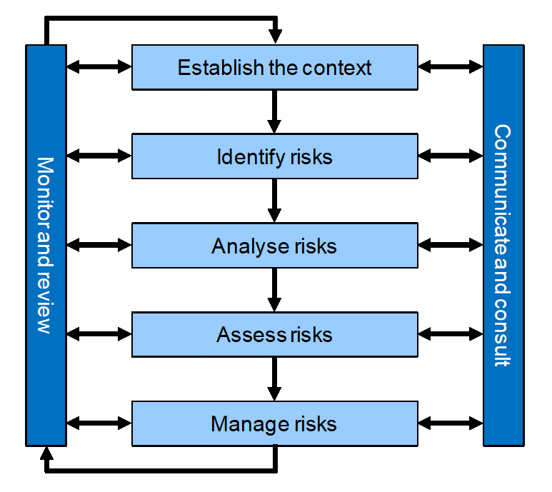

The above diagram demonstrates the whole process and cycle of risk management under the international standard ISO 31000.

The standard as outlined above makes clear that risk management is a dynamic process, with frequent review of existing risks and monitoring of the environment necessary to ensure the risks captured represent the current profile of the organisation.

Continual communication of risks within the organisation is essential to allow for informed decision-making. Communication to the Health Board and other stakeholders is also imperative to allow effective scrutiny and provide assurance that our risk profile is being effectively managed. It is also imperative to consult with and receive information from other departments within the organisation and our stakeholders to inform the management of our risks.

# **4.2 Step 1: Establish Context**

The purpose of establishing context is to customise the risk management process, enabling effective risk analysis and appropriate risk treatment. In order to identify risks, we need to understand what we are assessing risk *against.* We must set risks within the context of the team, specialty, department and overall organisation. In addition, we need to recognise the internal and external drivers that could create risk.

Risks should be set against what we are trying to achieve as an organisation – our strategic objectives. In this stage it is important to ensure there is a common understanding of what those objectives mean at a team, specialty, department and organisational level in order that risk identification is not based on an inconsistent set of assumptions.

# **4.3 Step 2: Identify Risks**

Once a clear, common set of objectives are agreed, the next step of the process is to identify potential risks that will prevent us from achieving them.

A range of techniques can be used for risk identification. Some prompts to consider:

* What might impact on your ability to deliver your objectives
* What does your performance data tell you?
* What do our audit and scrutiny reports and external reviews tell us?
* Do you have experience in this area? Do you know or do you need to involve others?
* Should you involve partners or specialists in your risk identification?
* Lessons learned – what happened before?

Risk can be identified in a multitude of ways, through focused identification sessions or as a product of other work:

|  |  |
| --- | --- |
| Focused Identification Methods | Other Identification Opportunities |
| * Risk Identification Workshops * Risk Questionnaires * Review & refresh of existing risk registers * Interviews | * Horizon scanning * Board meetings / working groups / management meetings * Audit & scrutiny reports * Performance data * Risk Management training |

The Risk Management function facilitates risk identification workshops with Departments to direct an in-depth review of new or emerging risks.

It is important to note that just because a risk cannot be fully mitigated by the organisation alone does not mean that it should not be captured. If the risk exists to the organisation, then it should be captured, managed as far as practicable and then monitored. Ongoing management of the risk may well be in conjunction with partner agencies or influence can be exerted over those capable of mitigating the risk to within an acceptable level.

# **4.4 Step 3: Analyse Risks**

Once a risk has been identified it must be described in a certain way in order to effectively understand, manage and mitigate it. The risk description should contain three essential components:

Diagram reads: Cause + Risk Event + Impact = Risk


These three components can be included within the description as follows:

**“If** [insert cause here], **there is a risk that**

[a certain event that may happen]**, resulting in**

[describe impact this will have if it manifests]**”**

An example of an effective risk description might be:

*If there is insufficient external funding and continued uncertainty over our cost base there is a risk that NHS FV will be unable to achieve financial sustainability, resulting in Scottish Government intervention and a detrimental impact on service delivery.*

Without understanding the underlying causes of the risk and all the potential impacts, it would be very difficult to design and implement effective controls.

# **4.5 Step 4: Assess Risks**

The assessment, or scoring, of risk allows for prioritisation by severity. Determining the likelihood and impact of a risk and utilising a standardised assessment criteria to assign a score based on these factors allows us to understand and prioritise which risks to mitigate first. Three scores must be assigned to cover the full trajectory and lifespan of the risk:

**Untreated Score**

This is the inherent risk score, that is the score with no controls applied. This score represents the “worst case scenario” for the risk. If there were no controls, mitigation or contingency plans in place, how likely is it the risk would materialise and what would the impact be?

**Current Score**

Considering any controls that are currently in place to manage the risk, how does the risk score compare to the untreated score? This is the current score. Current risk score is assessed on a regular basis to establish the effectiveness of the controls applied to the risk. It is also the current score that is the key indicator used to determine if the risk should be considered for escalation.

**Target Score**

The target risk score is the optimum position for the risk. Once all controls have been adequately implemented, what will the residual risk score be? Target risk scores should reflect the organisation’s risk appetite and align with the amount and type of risk the IJB is willing to accept (refer to section 3 on Risk Appetite). Risk controls should be designed to actively reduce the risk score towards the target level.

**Risk Assessment Matrix**

It has been agreed that staff within the IJB/HSCP will utilise the NHS Forth Valley Risk Assessment matrix to support consistency in the risk assessments.

The risk assessment matrix is a 5x5 scoring mechanism which will identify a score between 1 (1x1) at the lowest and 25 (5x5) at the highest possible score.

When utilising the impact criteria on the assessment matrix, a score must be applied for every category of impact applicable to that risk. For example, one risk may have a financial impact, an impact to patient experience and reputational/public confidence implications. The impact category with the highest scoring criteria will identify the overall impact score for that risk.

Assessment of likelihood is considered on a sliding scale from 1 to 5, with 1 representing ‘very unlikely’ and 5 ‘very likely.’

Once both scores have been identified, they are multiplied giving the overall score at *untreated, current* and *target* levels.

The risk assessment matrix is summarised below, and a full copy included at

Appendix A.



**Categorisation**

All risks, once identified, must be categorised into one of the recognised impact categories in order to understand the overall risk profile for the organisation. Categorisation of a risk is based upon the impact score, with the impact category which has the highest scoring criteria for that particular risk determining the risk category.

For example, a risk scoring a 3 for impact in Patient Experience but scoring a 5 in Finance will categorise that risk as Finance overall. Risk categories outlined in the risk assessment matrix:

* Patient Experience
* Objectives / Project
* Injury / Illness (physical and psychological) to patient / staff / visitors
* Complaints / claims
* Service / Business interruption
* Staffing and competence
* Financial (including damage / loss / theft / fraud)
* Inspection / audit
* Public Confidence

Where more than one category has the same impact score, select the category which has the lower risk appetite level. For example, if Patient Experience and Finance both score 5, but Patient Experience has an averse appetite but Finance has a cautious appetite, select Patient Experience. If both categories have the same risk appetite level, use professional judgement.

# **4.6 Step 5: Manage Risks**

The purpose of this step is to select and implement the appropriate action to respond to the risk. There are four broad ways we can respond to risk, known as the 4 Ts:

* Tolerate: this is the decision to accept the risk at its current level (usually after treatment). The ability to do anything may be limited, or the cost of taking action may be disproportionate to the benefit gained. Generally, it is risks that are within appetite that are tolerated.
* Treat: this is the decision to retain the activity or process creating the risk and to take action to implement risk controls that reduce either the likelihood of the risk occurring or minimising the impact. Risks which are out of appetite or tolerance will have to be treated.
* Transfer: this is the decision to transfer the impact of the risk either in full, or in part, to a third party. The most common form of risk transfer is insurance.
* Terminate: this is the decision to stop doing the activity associated with the risk. This may not always be possible and may create risks elsewhere as a result.

**Risk Controls**

Risk controls are management measures put in place to effectively manage a risk to within acceptable levels (i.e. to target score range). It is essential that the controls put in place to manage a risk are effective. The identification of effective controls is the most important part of the whole risk management process as without this element we would simply be identifying risks and doing nothing to manage them.

To assess whether the controls we identify are or will be effective, it is important to consider the following:

* What do you already have in place to manage the cause and / or impact of the risk? e.g. policies, procedures, projects, training courses, business continuity plans etc
* Do they work and what evidence do you have of the effectiveness? A policy which is in place but never complied with is not an effective one.
* Are there any gaps in your controls?
* Do you have all the information that you need about this risk or do you need to find out more?
* What more should you do?
* If several activities are required to manage the risk, how will you prioritise these?
* Are these controls within the remit of your department? If not, you will need to liaise with stakeholders to ensure that appropriate controls are put in place.

If you implement the controls you have identified, will this manage the risk to within acceptable levels for that risk category? If the answer is no, further controls are required. There are two main types of control measure that can be put in place to manage a risk:

* *Preventative Controls:* These are mitigating actions which will work to control the cause of the risk and prevent it happening in the first place
* *Contingency Controls:* These are actions that can be put in place to reduce the impact of the risk if it does materialise. Contingency controls are often aligned to the business continuity plans of an organisation.

As an example, consider fire safety measures. Segregation of flammable materials and sources of ignition is a control which prevents the risk of fire. Smoke detectors, sprinkler systems and fire evacuation plans are contingency controls should the risk of fire materialise.

If a risk has been effectively analysed (see section 4.4), it will be much easier to identify appropriate preventative and/or contingency controls.

# **4.7 Monitor and Review**

**Risk Review**

Once the process of identifying, analysing and assessing a risk are complete, it is imperative that it is subject to regular review. Ongoing management and review of a risk is the most important part of the process, as maintaining or reducing the risk score to within an acceptable level assures the overall management of the organisation’s risk profile.

Required risk review timescales are outlined below:

|  |  |
| --- | --- |
| Very High (20-25) | Monthly |
| High (10-16) | Monthly |
| Medium (4-9) | Quarterly |
| Low (1-3) | Quarterly |

During a risk review, the risk score must be re-assessed. If it is identified that the risk continues to exist, the list of current controls and further controls required must be checked and added to where necessary. On the basis of progress with controls and an assessment of the risk environment (i.e. are there any significant changes to the internal/external context), a re-assessment of the current score must be made using the risk assessment matrix. This will show whether the risk is decreasing, increasing or remaining static. Depending on its escalation level, a change to risk score will be reported at the appropriate assurance committee.

**Review of the Risk Management Process**

In addition to review of the risks themselves by risk leads/owners, the Risk Management lead from the IJB (currently the Chief Financial Officer) will review the whole system of risk management on behalf of the Chief Officer, supported by partner agency risk leads. This review will consider:

* are the right risks being escalated at the right time?
* Are the tools we provide sufficient to allow staff to effectively identify, analyse, assess and manage their risks?

This enables learning and improvement and ensures that risk management adds value to the organisation’s activities. This activity will align with the production of the Annual Report and review of risk appetite statements and will be subject to approval by the Audit Committee.

# **4.8 Communicate and Consult**

Communication at all levels is important to allow for informed decision making, and provision of assurance that our risk profile is effectively managed – this is achieved through risk reporting.

**Risk Reporting**

The IJB Strategic Risk Register is reviewed and updated by the HSCP Senior Leadership Team (SLT) and Audit Committee on a quarterly basis and is presented to the IJB biannually.

The Senior Leadership Team acts as the Risk Management Steering Group and provides recommendations to the IJB Audit Committee and the Board on the status of strategic level risks. HSCP Integrated Services Teams and Specialist Groups are expected to carry out regular review, monitoring and reporting on their risk registers (supported by the relevant risk management function) to ensure that risks are identified and escalated to the appropriate level at an early stage.

An annual report on risk management is also produced for the IJB.

Risks to delegated services which are hosted by one organisation on behalf of both IJBs will require to be communicated across partner organisations with clear responsibilities, ownership and timescales, and with mechanisms to ensure that assurance can be provided to the relevant Boards. Risk specialists from all parties will work together to ensure that Risk Management strategies are aligned to facilitate effective escalation of risks and provision of assurance.

# **4.9 Assurance**

**Assurance**

A fundamental component of any risk management framework is the expert and objective assessment of risk controls to ensure they are well designed and operate effectively. Implementing a process to critically review risk controls provides the Board with assurance on the effective management of key strategic risks. To facilitate the provision of assurance, the IJB will utilise the “three lines of defence” model.

Operating as the first line, operational management has ownership, responsibility and accountability for directly assessing, controlling and mitigating risks, understanding what the key controls are, and how effectively and consistently those controls are operating, in order to provide assurance to the Board. The second line is provided by governance/compliance functions such as Risk Management, who will assist the first line in developing an approach to fulfilling their assurance responsibilities. Internal Audit forms the third line, (providing independent assurance, and checking that the risk management process and framework are effective and efficient).

The levels of assurance and associated system and control descriptors are shown below:

### OVERALL RISK ASSURANCE ASSESSMENT

|  |  |  |
| --- | --- | --- |
| Level of Assurance | System Adequacy | Controls |
| Substantial Assurance | A sound system of governance, risk management and control, with internal controls operating effectively and being consistently applied to support the achievement of objectives. | Controls are applied continuously or with only minor lapses |
| Reasonable Assurance | There is a generally sound system of governance, risk management and control in place. Some issues, non-compliance or scope for improvement identified which may put at risk the achievement of objectives. | Controls are applied frequently but with evidence of non-compliance |
| Limited Assurance | Significant gaps, weaknesses or non-compliance identified. Improvement is required to the system of governance, risk management and control to effectively manage risks to the achievement of objectives. | Controls are applied but with some significant lapses |
| No Assurance | Immediate action is required to address fundamental gaps, weaknesses or non-compliance. The system of governance, risk management and control is inadequate to effectively manage risks to the achievement of objectives. | Significant breakdown in the application of controls |

Assurance should be provided to the relevant committees for their consideration on an ongoing basis. Any papers submitted as a source of assurance for the committee should explicitly reference the related strategic risk and should provide a conclusion as to whether performance indicates that controls are operating effectively and as intended. At the start of the year, assurance mapping principles will be used to determine the assurance requirements, and this will be set out in the committee assurance workplan. Assurance provision over the course of the financial year will be tracked and managed utilising the Pentana system, or an equivalent system.

Risks on the strategic risk register are subject to a programme of ‘deep dives’ managed by the relevant assurance committee. Deep dive reviews are facilitated by the Risk Owner with support from partner risk management functions and provide expert, objective assessment of the following key areas:

* Comparison of current risk score and target risk score
* Requirements to achieve the target risk score – success criteria for managing the risk
* Assessing the importance and effectiveness of implemented controls
* Assessing the proportionality of further controls required – i.e. will they help to achieve target score?
* Reviewing the assurance activity aligned to the risk controls in order to establish an overall assurance statement for the risk

Reciprocal assurances on the operation of the Risk Management arrangements and of the adequacy and effectiveness of key controls will be provided to/from partners. Receipt/provision of assurance will be facilitated by risk specialists from partner bodies, who will attend regular meetings to discuss risks and provide relevant advice.

# **Training, Learning and Development**

A key part of developing a positive risk management culture across the activities under the direction of the IJBs, in support of improving the overall risk maturity, is the delivery of risk management training.

The Senior Management Teams will carry out a training needs analysis to identify risk management training and development needs, and source the required training and development opportunities through respective partner bodies.

Risk Management training will be delivered using resources already available to the IJB through partner body risk management functions.

**APPENDIX A**

In using the matrix (overleaf) you should consider the potential areas of impact that your risk presents to Falkirk IJB and score appropriately. The final assessment of the impact of your risk is not an aggregation of your scores - it is based on your highest score in any one of the following categories. They are provided as a guide and professional assessment will determine the most applicable impact score. The highest scoring impact will determine the risk category and target score for the risk.

**Impact – What could happen if the risk occurred?** Assess for each category and use the highest score identified.

The impact scale is from an organisational level perspective. It reflects the key areas that if impacted could prevent the organisation achieving its priorities and objectives. The scale is a guide and cannot cover every type of impact therefore judgement is required.

| Category | Negligible  (1) | Minor  (2) | Moderate  (3) | Major  (4) | Extreme  (5) |
| --- | --- | --- | --- | --- | --- |
| Patient or Service user Experience | Reduced quality patient experience/clinical outcome not directly related to delivery of clinical care | Unsatisfactory patient experience/clinical outcome directly related to care provision – readily resolvable | Unsatisfactory patient experience/ clinical outcome, short term effects – expect recovery less than 1wk  Increased level of care/stay less than 7 days | Unsatisfactory patient experience /clinical outcome, long term effects - expect recovery over more than 1week  Increased level of care/stay 7 -15 days | Unsatisfactory patient experience/clinical outcome, continued ongoing long term effects |
| Objectives/ Project | Barely noticeable reduction in scope/quality/ schedule | Minor reduction in scope/quality/ schedule | Reduction in scope/quality/project objectives or schedule | Significant project over-run | Inability to meet project/corporate objectives, reputation of the organisation seriously damaged |
| Injury /illness  (physical and psychological) to patient/service user/visitor/staff/carer | Adverse event leading to minor injury not requiring first aid  No staff absence | Minor injury or illness, first aid treatment required  Up to 3 days staff absence | Agency reportable, e.g. Police (violent and aggressive acts)  Significant injury requiring medical treatment and/or counselling  RIDDOR over 7- day absence due to injury/dangerous occurrences | Major injuries/long term incapacity /disability (e.g. loss of limb), requiring, medical treatment and/or counselling  RIDDOR over 7- day absence due to major injury/dangerous occurrences | Incident leading to death(s) or major permanent incapacity |
| Complaints/Claims | Locally resolved verbal complaint | Justified written complaint peripheral to clinical care | Below excess claim.  Justified complaint involving lack of appropriate care | Claim above excess level.  Multiple justified complaints | Multiple claims or single major claim  Complex Justified complaint |
| Service/ Business Interruption | Interruption in a service which does not impact on the delivery of patient care or the ability to continue to provide service | Short term disruption to service with minor impact on patient care/service provision | Some disruption in service with unacceptable impact on patient care  Temporary loss of ability to provide service  Resources stretched  Potentially impaired operating capability  Pressure on service provision | Sustained loss of service which has serious impact on delivery of patient care resulting in major contingency plans being invoked  Potentially impaired operating capability  Temp service closure | Permanent loss of core service/ facility  Disruption to facility leading to significant “knock on” effect --  Inability to function |
| Staffing and Competence | Short term low staffing level temporarily reduces service quality (less than 1 day)  Short term low staffing level (>1 day), where there is no disruption to patient care | Ongoing low staffing level reduces service quality  Minor errordue to lack of/ ineffective training/ implementation of training | Late delivery of key objective/service /care due to lack of staff  Moderate error due to lack of/ ineffective training / implementation of training  Ongoing problems with staffing levels | Uncertain delivery of key objective/service/care due to lack of staff  Major error due to lack of/ ineffective training / implementation of training | Non-delivery of key objective/ service/care due to lack of staff.  Loss of key staff  Critical error due to lack of/ ineffective training/ implementation of training |
| Financial (including  Damage/Loss/Theft/ Fraud | Negligible organisational/  personal financial loss up to £100k | Minor organisational/  personal financial loss of £100k - £250K | Significant organisational/personal  financial loss of £250k - £500k | Major organisational/personal financial loss of £500k - £1m | Severe organisational financial loss of more than £1m |
| Inspection/  Audit | Small number of recommendations which focus on minor quality improvement issues | Recommendations made which can be addressed by low level of management action | Challenging recommendations that can be addressed with appropriate action plan  Improvement Notice | Enforcement/prohibition action  Low Rating  Critical report | Prosecution  Zero rating  Severely critical report |
| Adverse Publicity/ Reputation | Rumours, no media coverage  Little effect on staff morale | Local media coverage – short term  Some public embarrassment  Minor effect on staff morale/public attitudes | Local media - long-term adverse publicity  Significant effect on staff morale/public perception of the organisation  Local MSP/SEHD interest | National media adverse publicity less than 3 days  Public confidence in the organisation undermined  Use of services affected | National/International media/ adverse publicity, more than 3 days  MSP/MP/SEHD concern (Questions in Parliament)  Court Enforcement/Public Enquiry/FAI |

**Likelihood – What is the likelihood of the risk occurring? Assess using the criteria below.**

|  |  |  |  |  |
| --- | --- | --- | --- | --- |
| **Rare**  **(1)** | **Unlikely**  **(2)** | **Possible**  **(3)** | **Likely**  **(4)** | **Almost Certain**  **(5)** |
| **It is assessed that the risk is very unlikely to ever happen.** | **It is assessed that the risk is not likely to happen**. | **It is assessed that the risk may happen.** | **It is assessed that the risk is likely to happen**. | **It is assessed that the risk is very likely to happen.** |
| **Will only occur in exceptional circumstances** | **Unlikely to occur but potential exists** | **Reasonable chance of occurring - has happened before on occasions** | **Likely to occur - strong possibility** | **The event will occur in most circumstances** |

**Risk Assessment Table – Multiply likelihood score by impact score to determine the risk rating (score).**



**Review Timescales –** When a risk rating has been assigned the criteria below should be used to assess the review timescales.

|  |  |
| --- | --- |
| **RATING** | **TIMESCALE** |
| Very High or High | Requires monthly monitoring and updates. |
| Medium | Requires quarterly monitoring and updates. |
| Low | Requires 6 monthly monitoring and updates. |