Annual Performance Report
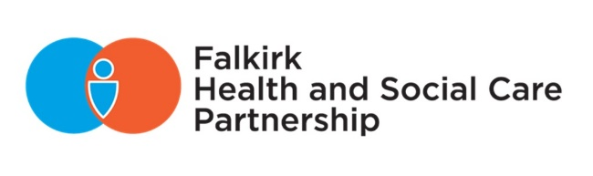
2023/2024

contents

Foreword 2
About Falkirk Health and Social Care Partnership 3
Priority 1 - Support and strengthen community-based services 8
Priority 2 - Ensure people can access the right care at the right time, in the right place 14
Priority 3 - Focus on prevention, early intervention, and minimising harm 18
Priority 4 - Ensure carers are supported in their caring role 23
Our Workforce 27
Communication and Engagement 33
Technology Enabled Care 36
Partnership Working 39
Equalities and Sustainability 42
Financial Performance and Best Value 45
Governance and Performance 51
Looking Forward 65

Foreword

Our 2023/24 annual report illustrates yet another rewarding year for those working in our local health and social care services.

The achievements of our hardworking colleagues across local authority, NHS, care organisations, community and voluntary groups are to be highly commended. Their daily efforts and long-term commitment to deliver high quality support throughout our communities ensures that people in Falkirk can live as well as possible.

This year, our Partnership has continued to grow with the addition of Primary Care, Prison Healthcare, Out of Hours Services, and Health Improvement Service being welcomed into the fold. By further integrating services, we have helped teams work closer together to benefit the people they support.

To name a few milestone moments over the past 12 months, we’ve celebrated the relaunch of our Short Breaks service for people with learning disabilities at Thornton Gardens; created new career paths within social work by introducing new roles and mentoring opportunities; launched a new online feedback platform for local services; received praise as the best place in Scotland to grow old as result of our high Care Inspectorate ratings for care homes; and last but not least – begun the implementation of our new 3-year strategic plan.

We hope this report provides a comprehensive snapshot of the many reasons to be proud of our Partnership. While there will be both expected and unseen difficulties ahead, we should keep these achievements in mind – as we already know we are up to the challenge.

Thank you,

Gail Woodcock
Chief Officer
Falkirk Health and Social Care Partnership

Councillor Fiona Collie
Chair
Integration Joint Board



About Falkirk Health and Social Care Partnership

Our Partnership

Falkirk Health and Social Care Partnership (HSCP) delivers adult social care services and community health services in the Falkirk area.

Key services that the Partnership provides includes:
- Community health services – District Nursing, Mental Health, and Learning Disability services
- Contracted health services – GPs, Pharmacies
- Adult social care services
- Elements of housing services for aids and adaptations and gardening aid
- Aspects of acute services (hospitals) relating to unscheduled care
The integration of these services is about ensuring those who use health and social care services get the right care and support whatever their needs. This should be at the right time and in the right setting at any point in their care journey, with a focus on community-based and preventative care.

Our Communities

The development of three localities within the Falkirk Council area is rooted within the integration legislation – the Public Bodies (Joint Working) (Scotland) Act 2014.

For service planning and delivery purposes, the three identified localities for the Partnership are West, Central and East (illustrated in Figure 1).

Locality Managers have begun to progress work to develop locality plans that reflect the needs of the communities and our strategic priorities.

Figure 1: Falkirk Localities Map

Our Challenges

- Population Projections
Anticipated 80% increase in the 75+ population by 2043 and an expected decrease in working age population – potential increased demand with a limited workforce.

- Inequalities
The difference of life expectancy between the most and least deprived areas is 10 years for men and 8 years for women, and the early death rate has increased by 50% in the most deprived areas.

- Demand
Some services have struggled to manage increase in demand due to a multitude of factors such as Covid-19 restrictions, staff fatigue, and workforce challenges.

- Workforce
We have an aging workforce with a sizable proportion of staff potentially nearing retirement as well as ongoing issues around recruitment and retention.

- Mental Health
Primary care data shows depression is the 2nd most prevalent long-term condition, and Scotland has the second highest rate of suicide deaths of all UK countries.

- Behavioural Factors
In the last five years, alcohol-related hospital admissions have been rising, and the drugs deaths rate increased by 234% between 2010 to 2020 from 10 to 33 annual deaths in Falkirk.

Our Localities

Households
Central - 21,952 East - 31,754 West - 21,520

% that live with a long-term health condition
Central - 20% East - 19% West - 18%

% that live in the most deprived SIMD quintile
Central - 22% East - 12% West - 7%

Our Vision and Leadership

A key statutory duty of the Integration Joint Board (IJB) is to develop a three-year Strategic Plan which reflects the national health and wellbeing outcomes framework and delivery of agreed local priorities.

The HSCP Strategic Plan (2023-2026) sets out the Partnership’s vision, local outcomes, and priorities that will help improve the lives of people in the Falkirk area and outlines how we will deliver adult health and social care services in Falkirk over three years.

Our vision:
“To enable people in Falkirk HSCP area to live full and positive lives within supportive and inclusive communities."

The following priority areas have been identified for the next three years:
- Support and strengthen community-based services
- Ensure people can access the right care at the right time, in the right place
- Focus on prevention, early intervention, and minimising harm
- Ensure carers are supported in their caring role

These priorities will be driven by three workstreams – Workforce, Technology, and Communication and Engagement.

The Delivery Plan was developed in February 2023 which provides high-level actions and timescales about how the HSCP will progress towards meeting the strategic and cross-cutting priorities.

The IJB is committed to delivering transformational change over the coming years to ensure financial sustainability. The Transformation Board meet regularly to review and approve transformation initiatives that will drive forward the changes needed to ensure services that are fit for the future can be delivered in a sustainable way.

The Falkirk HSCP Workforce Plan 2022-2025 outlines how the Partnership will support and develop the local workforce to deliver the vision for Falkirk, and support and improve the wellbeing of our communities. Work has started on an updated plan which is due to be published before the start of 2025/26.

National Health and Wellbeing Outcomes

The Scottish Government has nine National Health and Wellbeing outcomes to improve the quality and consistency of services for individuals, carers, and their families, and those who work within health and social care. This report sets out progress made towards our Strategic Plan and the National Health and Wellbeing Outcomes during 2023/2024.

National Health and Wellbeing Outcomes | Strategic Plan Priorities
- People are able to look after and improve their own health and wellbeing and live in good health for longer. | Priority 1 - 4
- People, including those with disabilities or long-term conditions, or who are frail, are able to live, as far as reasonably practicable, independently and at home or in a homely setting in their community. | Priority 1 - 4
- People who use health and social care services have positive experiences of those services, and have their dignity respected. | Priority 1 - 4
- Health and social care services are centred on helping to maintain or improve the quality of life of people who use those services. | Priority 1 - 4
- Health and social care service contribute to reducing health inequalities. | Priority 1, 2, and 4
- People who provide unpaid care are supported to look after their own health and wellbeing, including to reduce any negative impact of their caring role on their own health and well-being. | Priority 1 - 4
- People who use health and social care services are safe from harm. | Priority 1, 2, and 4
- People who work in health and social care services feel engaged with the work they do and are supported to continuously improve the information, support, care, and treatment they provide. | Priority 1 - 4
- Resources are used effectively and efficiently in the provision of health and social care services. | Priority 1 - 4
Table 1: Association between the priorities of the Falkirk HSCP Strategic Plan and National Health and Wellbeing Outcomes

Priority 1 - Support and strengthen community-based services

Falkirk Older People’s Day
Falkirk’s Older People’s Network is a coalition of local organisations working year-round to help individuals make the most of their later years, offering support, and raising awareness about available options for planning their futures.

Older People’s Day (17 October 2023) is a collaborative initiative driven by local charities, community groups, and organisations dedicated to combatting social isolation and promoting the richness of later life. The event is organised by the Falkirk Older People’s Network together with Falkirk HSCP, Solicitors for Older People Scotland, and Falkirk Delivers.

As we age, life continues to offer new opportunities, whether they are rediscovering long-lost passions or embarking on entirely new adventures. Falkirk’s Older People’s Day aims to make these opportunities more accessible to everyone, bringing the community together to discover new interests, access support, and forge new connections.

Dementia Friendly Denny
The Dementia Friendly Denny Group meet every six weeks to bring together professionals, community groups, local businesses, schools, and people living with dementia and their families to challenge stigma and raise awareness of dementia and brain health.

A resource pack includes information, tools, and activities as well as support and interaction with the schools from our professionals. The Joint Dementia Initiative (JDI) service offers opportunities for pupils to volunteer, providing experience and skills for future work opportunities. The pack also includes tools to help communicate with and care for a person living with dementia. This will be implemented across the Falkirk area.

Cunningham House transition
Grangemouth’s Cunningham House has completed a successful transition from a residential care home for people with dementia to offering stays of 6-12 months for people with physical reablement needs – creating a completely new type of rehabilitation support in the Falkirk area.

The 20-bed home now supports people leaving hospital who are beginning their rehabilitation journey following an accident or illness. The new option offers community-based support in a homely setting, rather than within a hospital.

For its existing residents, Cunningham has remained their home for as long as they need it. The process allowed residents to benefit from new co-located services and support options before anyone utilising the new physical rehabilitation service came to stay.

Cunningham’s existing staff team has grown to include a range of other Allied Health Professions, including physiotherapy and occupational therapy. While creating additional jobs and adding new services to benefit long-term residents, the integrated staff team has helped people with dementia improve their daily lives and now offers people a homely setting to begin their onward recovery journey from hospital.

Alongside this project, the Partnership made additional investment in supporting local care homes to increase overall capacity for dementia care, acknowledging the future needs of residential dementia care.

Home From Hospital Partnership
The Home from Hospital Partnership provides services to support patients being discharged from Forth Valley Royal Hospital, local community hospitals, and other intermediate care facilities.

Patients using the service are offered immediate support that helps them to be discharged safely from hospital and ongoing long-term support that helps them maintain their independence. The service has supported 1,578 service users in 2023/24.

Snapshot:
“I now have opportunity to become more social, as before I was sitting indoors and was very depressed… I am disabled and cannot work, but [Community Link Worker] did not ever make me feel that way. If it wasn’t for her, I don’t know how I would have survived at home.”

Stay Connected transport service
Falkirk HSCP funded Dial-a-Journey to deliver the Stay Connected Transport Service, a membership-based service to help vulnerable people attend community groups and social activities in the Falkirk area, combating loneliness and isolation at no cost to the individual.

The pilot service aimed to help people who are unable to access transport due to mobility requirements, cost, or those who rely solely on others to access transport, providing a break for carers. The Stay Connected service has supported 33 service users on 1,246 journeys across the Falkirk area, which has saved service users a total of £6,350 in fares or on average £192 per person.

Thornton Gardens
Thornton Gardens offers breaks and holidays of up to two weeks for adults living with a learning disability. The team have adapted and decorated the home to create a lively and welcoming place for guests and their carers to have a break.

Thornton Gardens now has six themed ensuite bedrooms, a dedicated arts and crafts room, sensory den, American style diner space, therapy room, cosy lounge, and a new games room. This was the result of the team’s fundraising efforts of more than £1,000 at the Thornton Garden’s open day.

The recent service transformation has been recognised by the latest Care Inspectorate report, which scored the service ‘Very Good’ in all assessed areas. It noted efforts made by staff and management to move away from the clinical feel of a care home to create homely and comfortable surroundings.

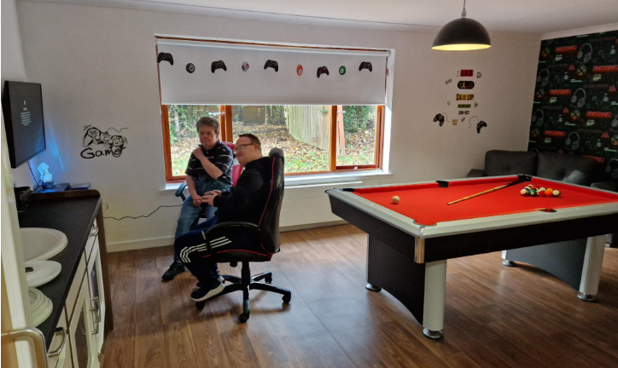

Snapshot (Care Opinion):
“The place is so cheery and welcoming with a sensory room and a separate craft and games room… My son enjoyed his time so much he didn’t want to come home, he wanted to stay longer.” It means more than you could imagine (13/07/2023)

Dundas Resource Centre
Dundas Resource Centre supports its service users to get involved in fun and engaging developmental outings and activities to increase self-confidence, engagement with others, and enjoyment of life.

Activities include:
- Barbara Bryceland singing at the Big Summer Bonanza Day
- Christmas Party at Leapark Hotel
- Christmas coffee morning with family and friends and the Zetland Nursery Class singing Christmas songs
- Boccia Competition (service users won 2 Golds and a Bronze)
- Burns Day Celebration

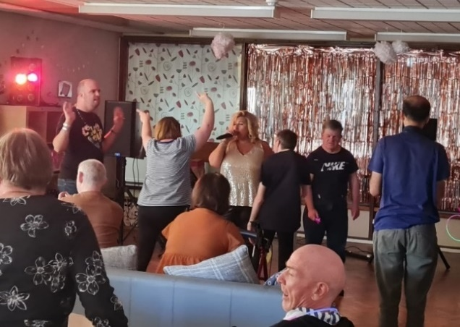

Snapshot:
Female diagnosed with Dysphasia and Ataxia referred to Dundas Resource Centre as condition deteriorated. After joining the service, her “life has dramatically improved for the better. I am never judged at the service and although I struggle with my speech I am provided with the time and support to communicate.”

Caledonia Service
The Caledonia Service has developed a new community-based partnership working with Forestry Land and Scotland, Helix Park Rangers, Falkirk Library, and Forth Environment Link. This has increased social inclusion and participation opportunities in local communities.

Creating a referral pathway with Bellsdyke Psychiatric Wards is supporting patients to feel more informed and confident in accessing a community-based service during their hospital transition. This pathway has improved the appropriateness of referrals, decreased the time between referral and induction date, increased awareness of the service to NHS staff, and improved communication and relationships with staff and patients on the ward. This is resulting in a smoother transition from inpatient to community care.

Snapshot:
“During the last year, I’ve had two traumatic family experiences to deal with while still trying to manage my own mental health. I’m so grateful for the support I’ve received from Caledonia Service, from the chats and advice to giving me some structure and a feeling of hope. I’m not too sure how I would have managed without them.”

Live Your Life
The Live Your Life service offers direct access to Strathcarron Hospice support for people with life-limiting illness and their carers. It emerged during Covid-19 as an alternative to day care. The team take a “start with what’s strong, not what’s wrong” approach to help people navigate uncertainty, chat through challenges, and together find ways for people to get on with living their life in their community.

Key outcomes:
- Early contact with hospice care when people choose.
- Help people explore what support is available and to plan ahead.
- Enable access to wider hospice services if needed.
- Connect people back into community where they can find people and purpose.

We now reach more people and at an earlier stage in their illness. The greatest challenge is raising awareness that most hospice support is provided in people’s homes and focuses on living life well.

Public Living Room
Strathcarron Hospice set up a Public Living Room in its Stenhousemuir Charity Shop in July 2023. This is a free public space open to all, seven days a week. Based on Camerados Principles, there is comfortable seating and free hot drinks and biscuits for anyone to sit and “have a blether.” The seating area was designed by Larbert High School students using upcycled materials.

Spaces, like the public living room, create social connection which plays an important role in sustaining mental health and wellbeing, reducing isolation and reliance on medical intervention. Some people have become shop volunteers for work experience or to help. In the first nine months, 5,148 free coffees were dispensed and shared between members of the public.

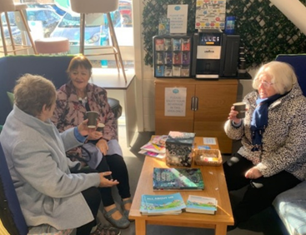

Snapshot:
A regular visitor enjoys the experience so much she is now considering volunteering with the shop. Attending the public living room means a lot to others who look forward to meeting her.



Priority 2 - Ensure people can access the right care at the right time, in the right place

Improving Primary Care
Primary Care services often act as the first point of contact for patients to access other services. This year significant work has been done in key areas.

Gathered data to better understand GP capacity across Forth Valley and plan for local demand and availability:
- An estimated 6,081 appointments delivered each day (urgent, routine, and house calls).
- 42 Practices carry out more than 50% of routine appointments face to face.
- In a typical 8,500 patient Practice, 212 patient results and clinical communications are dealt with daily with 123 results requiring clinical input.
- Each clinician sees an average of 23 patients per day.

In optometry and dental services, the statutory requirements for inspections have been maintained and provided valuable quality assurance on services to patients. Changes to community pharmacies following the withdrawal of Lloyds Pharmacy and all but one of their Forth Valley sites transferring to another Community Pharmacy contract holder. National dental reforms were introduced in November 2023 by Scottish Government to support dentists to maintain NHS services and local projects to support sustainability.

Other projects include the pilot implementation of Annual Reviews for Adults with Learning Disabilities, re-instatement of in person Protected Learning Time events for Practice staff, and continuation of routine and ad hoc inspections and support visits for Dental, Optometry, and Community Pharmacy.

Key challenges include:
- Recruitment and retention - a series of proposals to support General Practice are being progressed.
- Enhanced Services, additional to the General Medical Services contract, are under review with a focus on longer term sustainability.
- Support given to all Clinical Practitioners required to be listed/registered to work in Forth Valley.
- Financial pressures on the Primary Care Improvement Plan have presented a challenge in our ability to fully meet the commitments of the MOU from Scottish Government. Lack of additional funding necessitates service review to ensure delivery within the allocation.
- Providing services in rural areas remains a priority.

Patient communications has been developed to improve awareness of the range of activities carried out in General Practice. This also illustrates the significant volumes of daily activities to help show why services are under pressure.

Forth Valley Long Covid Service
The new Forth Valley Long Covid Service provides a range of advice and specialist support to help people manage their symptoms and improve their health and wellbeing. It offers a range of one-to-one clinics and group sessions where people can access support from a wide range of healthcare professionals. People can be referred by their local GP, practice nurse, or other healthcare professionals involved in their care and the service will continue to work closely with a Long Covid Support Group to develop and improve local services.

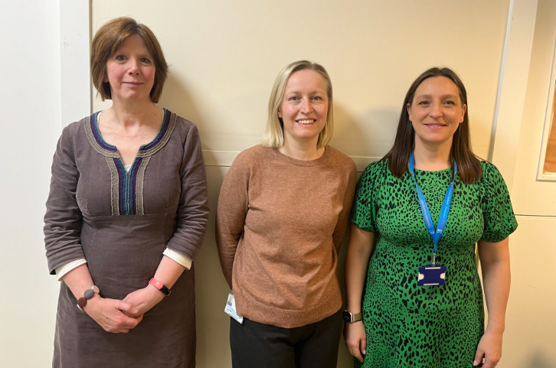

NHS Forth Valley Whole System Reset
Between 13 November and 1 December 2023, a ‘whole system reset’ aimed to improve flow across services. Targeted plans focused on reducing the number of contingency beds in use in Forth Valley Royal Hospital to reduce the number of patients being delayed in their discharge or transfer from local hospitals as well as preventing hospital admissions. This aimed to relieve current service pressures, return occupancy levels back to a more manageable level, improve the experience of people using our services across the whole system, and reduce pressure on staff.

As a result, improvements included the number of patients who had been in hospital over 14 days, the discharge profile within the acute hospital, and some reduction in the number of patients not in speciality beds.

Short Term housing lets
To reduce unnecessary hospital delays, the Partnership are facilitating the rental of two tenancies from Falkirk Council Housing by NHS Forth Valley. These tenancies will be used by people who are unable to return home until works have been undertaken on their homes, following a hospital admission.

It will support people to retain or regain independent living skills while freeing up hospital beds for people who require in-patient care. This is one initiative to improve capacity, improve the flow of patients through the system, reduce hospital length of stay, and help alleviate delays.

Change Champions Team
The Change Champions team was created in response to the actions identified within the Scottish Government ‘Coming Home Implementation Report’ and focuses on the creation and maintenance of the Dynamic Support Register. The purpose of the team is to review and (where possible) reduce the number of adults with learning disabilities who are inappropriately placed out of area, delayed discharged in hospital, or who are at risk of placement breakdown in their current environment.

New Transitions Team
The Transitions team was created to improve the experiences of young adults with additional support needs who are in transition from Children’s to Adult Services. This pilot team have focused on improving pathways and connectedness between services, guided by the Principles of Good Transitions (ARC Scotland).


Priority 3 - Focus on prevention, early intervention, and minimising harm

Alcohol and Drug Partnership

Falkirk Alcohol and Drug Partnership (ADPs) is responsible for the planning of local support services in partnership with Falkirk Council, NHS Forth Valley, Police, Fire, and Third Sector colleagues.

ADP EXECUTIVE AND GOVERNANCE
A new ADP Executive Committee has been created to replace the previous ADP Committee. The new structure will ensure the operational and strategic membership are best represented and the workstreams are efficiently managed. This will include developing several subgroups to focus on specific areas of work as well as a Lived Experience Panel so that the voice of lived experience is central to the decision-making process of the ADP.

MAT STANDARDS IMPLEMENTATION
The Scottish Government published the Drug Deaths Taskforce’s recommendations for the Medication Assisted Treatment (MAT) Standards in May 2021 to help reduce drug related deaths, and other harms and to promote recovery.

Work to implement the MAT Standards with partners across Forth Valley is ongoing. This has presented unique challenges and a fundamental systemic change in the way we deliver drug treatment services. This has created opportunities to develop new models of care to support, enable, and empower people to address their substance use.

RESIDENTIAL REHAB PATHWAY SELF-ASSESSMENT
During 2023, the ADP worked in partnership with Healthcare Improvement Scotland to map out existing pathways to residential rehab for people living in Falkirk. This work helped the ADP to better understand the changes needed to improve access for everyone and ensure that recovery was seen as a viable option for people who may not have considered it previously.

WHOLE FAMILY APPROACH
A new contract was developed with Scottish Families Affected by Alcohol and Drugs (SFAAD) to deliver services and support to people who are affected by a loved one’s substance use. This offers increased opportunities for people to find the support they need at the time they need it.

DRUG DEATH REVIEW GROUP
In partnership with NHS Forth Valley and Public Health, the ADP has worked to understand reasons for local drug-related deaths and a group has been developed to review all deaths which have occurred. This has enabled systems and services to be scrutinised and potential systemic changes to be made with the intention of reducing future deaths.

Trauma Champions Steering Group
The Trauma Champions Steering Group includes representatives from NHS Forth Valley, both HSCP’s, and all three Councils. In Falkirk, we have employed a Trauma Informed Policy Officer who is working with the three Trauma Champions to consider how each organisation would embed trauma informed practice. This work is fed into the Trauma Champions Steering Group and shared across the Trauma Champions to ensure consistency and equity across Forth Valley and identify any gaps or barriers.

As part of the National Trauma Training Programme (NTTP), the Scottish Government asked organisational leaders to commit to a leadership pledge supporting a trauma-informed and trauma-responsive workforce and services across Scotland. Falkirk HSCP supports the pledge from the Forth Valley Trauma Champion Steering Group.

Annual reviews for adults with learning disabilities
A local Implementation Group comprising of Learning Disability Nurses, GP Clinical Leads, Primary Care Managers, the Keep Well Nursing team, and GPs have established a pilot project to develop models of delivery and inform future delivery plans to address the known inequalities this client group experience.

Patients from five Practices have been invited to participate with over 120 reviews carried out or underway. This has included patients within residential facilities and those who do not regularly attend their GP Practice. Bespoke methods of invitation, data gathering tools and patient evaluation methods have been developed as well as recording proformas.

Key outcomes for patients include the time spent with a clinician (between an hour and 90 minutes) and access to other services as needed (34% have required an onwards referral). There are financial challenges to mainstreaming the service as well as data recording within the existing GP IT systems. The GP IT re-provisioning project is well underway so efforts to improve recording has paused until we better understand the new system.

Due to the current demand for services and the time taken to carry out each review, a hybrid model will continue into 2024/25.

Developing Healthy Relationships
Falkirk Learning Disability Team are supporting people with a learning disability to develop healthy relationships. Launching an 8-week course and forming a Healthy Relationships Group, the team have raised the standards of services available and introduced suitable sexual health and relationship education for people with learning disabilities.

The new healthy relationship support uses interactive games and peer-to-peer learning in a safe and relaxed environment, helping people to understand complex and sensitive concepts in an accessible way. The team’s work is rooted in strong evidence, working with sexual health nursing, local organisations who support gender-based violence survivors, and NHS Scotland to produce guidance for practitioners.

Protecting vulnerable adults in Falkirk from harm
This year’s National Adult Support and Protect Awareness Day (20 February 2024) highlighted the emerging and growing issue of ‘sextortion’ scams, which involve fraudsters using the threat of sharing sexual information, photos, or videos to demand money or pressure people into sending further information.

Teams across Falkirk HSCP, Police Scotland, Falkirk Council, Scottish Fire and Rescue, and third sector organisations encouraged people to say something if they see something that isn’t right.

Mobile Emergency Care Services (MECS)
The existing call handling system for MECS/telecare hardware could no longer be supported using the current supplier. An upgrade to utilise cloud technology, in line with Falkirk Council’s Digital Strategy, had to be sourced.

All data migrated from the existing system in December 2023. This process is ongoing, and it is hoped that all service users will be migrated to the new system by summer 2024.

Performance in 2023/24:
- 34 staff in team
- 3,500 service users
- Approximately 1,200 visits per month
- 1,210 referrals
- 4,500 pieces of equipment

Living Well Falkirk
In April 2023, the Living Well Falkirk service appointed 1.5 Social Care Officers to two new temporary posts. We can now offer Living Well Falkirk Centre appointments five days a week. The updated website provides local information and pathways that allow the site to match people’s assessment answers to suitable local activities.

Individuals take ownership of their assessments and feel empowered as the experts in their own abilities and needs. Rather than wait for a home visit from locality social work teams, people can get help from Living Well Falkirk staff at face-to-face centre appointments, via Near Me video calling, and by telephone.

Between April 2023 and March 2024, Living Well Falkirk staff supported people to complete 359 LifeCurveTM and 477 Area of Need (a specific everyday task such as going to the toilet) assessments. People’s waiting times for support with simple daily living tasks has reduced from many months to typically one or two weeks.

Often people are not aware there are things they can do to improve their ageing journey. Many believe their only options are equipment, house adaptations, or carer’s help to compensate for lost abilities. In 2024, we will build on ways to engage people to set goals and act now so they can keep doing the things that are important to them.

Mental Health Training
By delivering the following training courses to 152 people, we are building capacity, knowledge, and confidence across the workforce and within communities to support mental health.

- 2x Ask Tell Respond
- 5x Scotland’s Mental Health First Aid
- 2x Applied Suicide Intervention Skills Training

Participants report an increase in knowledge and confidence to respond to mental and emotional distress and crisis, increased confidence to speak openly and honestly about suicide, and increased ability to guide a person to appropriate help and support.

Step on Stress
Step on Stress is a 3-week stress management intervention for people aged 16 and over with mild to moderate stress levels. It aims to increase self-management and reduce the strain on primary healthcare and mental health services. We’ve delivered 11 live-streamed courses and one in-house with attendees generally reporting a reduction in stress. We are now working to extend the reach across groups experiencing inequalities.

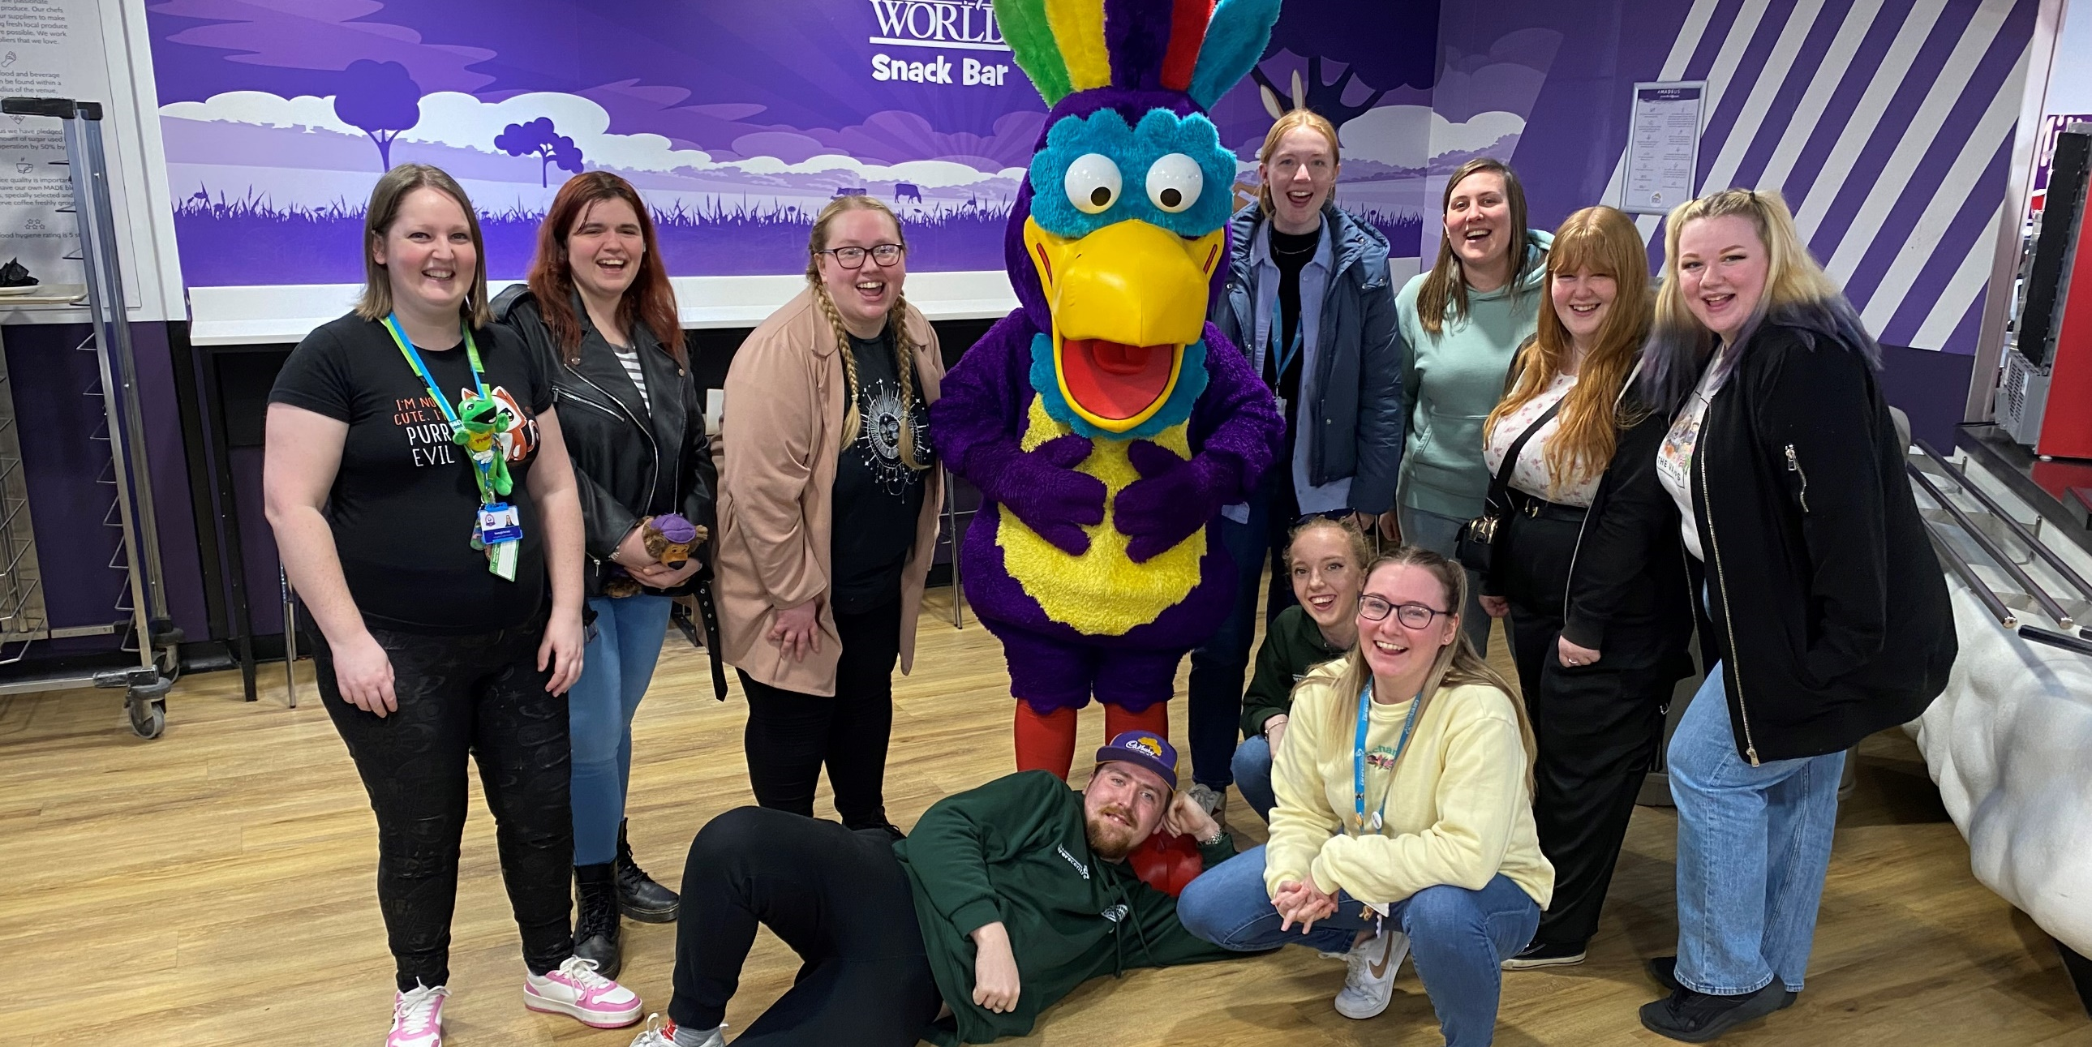

Priority 4 - Ensure carers are supported in their caring role

Supporting Carers
Falkirk HSCP works with carers and carer organisations to implement the Carer’s (Scotland) Act 2016.

Key outcomes include:
- Falkirk Carers Strategy 2023-26 was published in April 2023.
- Falkirk Short Breaks Services Statement was approved in March 2024.
- There has been an increase in the number of carers accessing flexible respite budgets to directly support them in their caring role – increased availability of respite options from providers to meet demand.
- Supported gradual return to regular respite options following significant impact of the Covid-19 pandemic.
- Increased partnership working with organisations funded via the Carers Challenge Fund, which has improved access to BAME carers and those affected by substance use.
- Funded organisations are working together to share best practice to increase impact of carer support and reduce duplication.
- Recruited a Social Care Officer to support carers to access short breaks quickly and minimise risk of carers reaching crisis stage.
- Established a Young Carers workstream to focus on improving support for young carers.

Falkirk & Clackmannanshire Carers Centre provides a range of support services to carers of all ages.

During 2023/24:
- 2,738 carers have accessed the service.
- 579 Adult Carer Support Plans (ACSP) completed.
- 419 Adult Carer Support Plan (ACSP) reviews completed.
- 118 Young Carer Statements (YCS) completed.
- 53 Young Carer groups with 626 people attending.
- 408 short breaks grants provided.
- 118 Care with Confidence sessions with 959 people attending.

Supporting Young Carers:
- An increase in partnership working with Education Services has led to an increase in referrals to the service and more young carers are receiving support and have improved outcomes.
- 60% more Young Carer Statements (YCS) were completed compared to the previous year.
- The Carers Trust and The Big Lottery have funded a Young Adult Carer Development Worker and a Young Carers Involvement Worker.
- Partnership working with LGBT Youth Scotland has built a pathway for referrals, signposting, and future support opportunities.

Snapshot:
“I’ve always been able to rely on the project to help with mental health and be able to talk about what it’s like being a young carer and now a young adult carer.”

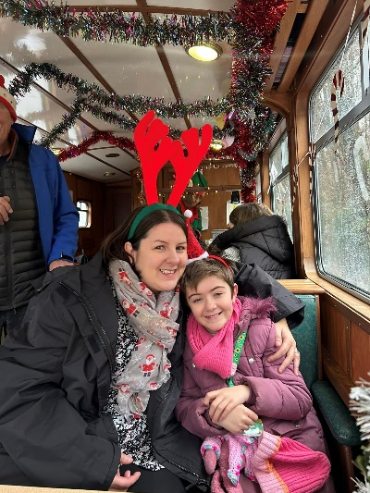

Supporting Adult Carers:
- Carer Support Workers and Telephone Support Workers have supported carers to improve their physical and emotional health and wellbeing and increased their confidence to continue caring and ability to enjoy a life outside caring.
- 2,089 adult carers accessed individual support including:
  - Help to complete an Adult Carer Support Plan (ACSP)
  - A short breaks grant and access to other short break opportunities
  - 1-1 emotional support from a telephone support worker
- Digital and system developments outside the Centre have reached more carers and increased capacity to provide information and preventative support.
- Challenges include a high number of carers requesting or being referred for an Adult Carer Support Plan (ACSP) which has led to a waiting list of 345 carers.

A programme of ‘Care with Confidence’ sessions covered topics to help carers in their caring role. Carers report that the sessions have:
- Improved their health and wellbeing.
- Increased their confidence in their caring role.
- Allowed them to spend time outside of caring.
- Improved their relationships with the person they care for and other family members.
- Enabled them to have a say.

Snapshot:
“I would gladly attend all sessions. Up till now everything was very helpful and topics that are on the list now might be the most important for me and my family.”

Self-Directed Support
The Self-Directed Support (SDS) team support staff, service users, and carers to understand how self-directed support can empower them to have more choice and control over how their support is provided.

The Covid-19 pandemic had a lasting impact on support, including availability of provision, and people’s confidence in engaging with support options and their community. The team is working with social care staff and SDS Forth Valley to support and encourage individuals and carers to consider options on how support can be accessed to meet agreed outcomes.

A SDS Steering Group supports further progress with implementation and considers the revised Statutory Guidance and the SDS Improvement Plan. This group will develop a local improvement plan and evaluate progress.

A snap poll of staff identified support and training needs, including identifying SDS champions. As a result, training sessions have been provided to social work staff. Individual support is being provided to staff, where required, to process SDS options and contracts. There are plans to embed the team within social work to provide direct support where needed while also raising the profile of SDS. The newly published Social Work Scotland SDS Toolkit can support staff with gaining confidence around supporting service users to explore SDS options.

Work continues to support service users and carers in accessing the different SDS options in line with their preference and the outcomes they want to achieve. This includes close partnership working with SDS Forth Valley, who have received funding to provide additional support to carers to help them identify support for their caring role.

A month of action is currently being planned for May 2024 to highlight self-directed support options within social work. This will include a range of publicity, video stories, and case studies.

Snapshot:
“My son has learning disabilities and cannot read, write, or fully look after himself but he is very sociable… It was important [SDS] met his needs but also was enjoyable and something to look forward to in the morning. He now has a mix of activities during the week, works on Newlands Farm at Muiravonside Park and has a good network of friends. Our SDS (Option 1) package gives me the confidence we can make changes to his weekly rota and look ahead as he grows older and support needs evolve.”

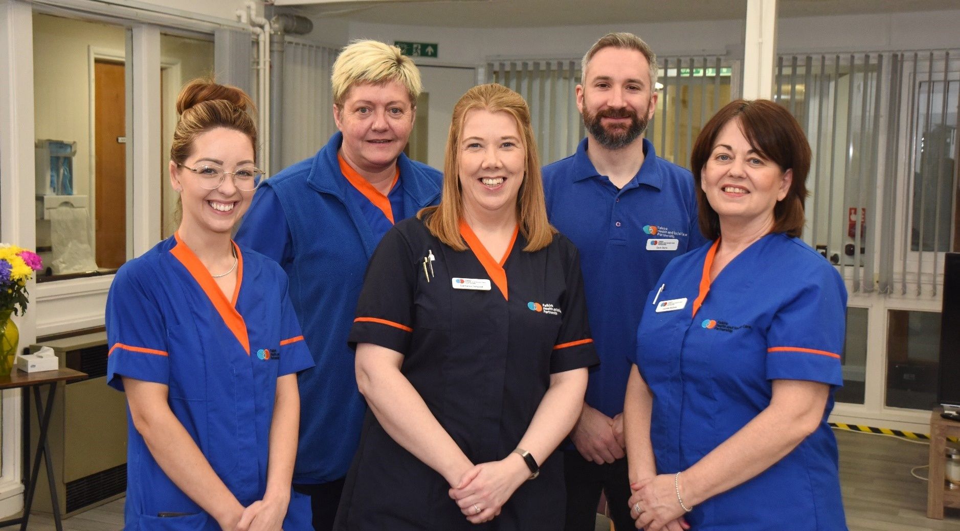
Our Workforce

Integration of Services
The Partnership has welcomed new colleagues into its workforce following the integration of additional services, including Primary Care, Prison Healthcare, Out of Hours Care and the Healthcare Improvement Service.

Work has also begun to consider the integration of Justice Services and Children’s Social Work Services into the Partnership.

The expanded remit of the Partnership provides new opportunities for the workforce, and an improved experience for people accessing support across the local health and social care system.

The Health and Care (Staffing) (Scotland) Act 2019
The Safer Staffing legislation came into effect on 1 April 2024. This includes the establishment of three layers of governance with HSCP partners and commissioned services – Safe Staffing Legislation Implementation Oversight Group, Operational Group, and Working Group. These groups involve appropriate representation across services and membership includes senior leaders and Directors.

Scottish Social Services Awards
The Joint Dementia Initiative and Caledonia Service were awarded Excellence within Mental Health Services, while Falkirk Council’s Women’s Justice Service was awarded Excellence in Justice Services category. The finalists gathered at the ceremony in Glasgow on 23 November 2023 to showcase and celebrate best practice within Scotland’s social service sector. The Falkirk Learning Disability Team (FLDT) was also a finalist within the Excellence in Disability Services category.

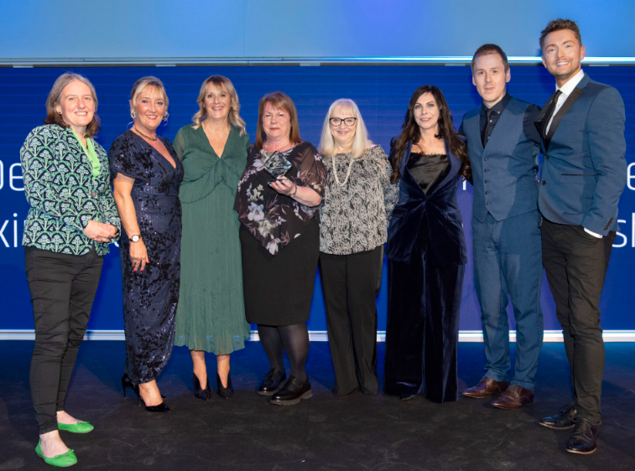

Royal College of Nursing Awards
Senior charge nurse, Laura McCann has been awarded the Learning Disability Nursing Award at the 2023 Nurse of the Year Awards. The awards, run by the Royal College of Nursing Scotland, shine a spotlight on the best of nursing, to recognise, highlight and celebrate the dedication and outstanding professional care of nursing staff across Scotland.

Laura was one of seven Forth Valley finalists across five other categories in the RCN Scotland Awards, including the Unit 5 team at Falkirk Community Hospital (Runner up for the Nursing Team of the Year Award)



New home for the Partnership
Desk-based staff in Falkirk HSCP moved to Falkirk Stadium, providing new, modern, and fit-for-purpose office spaces meeting the new flexible and hybrid way of working.

The move to Falkirk Stadium also marked the closure of Denny Town House, which colleagues have known as the base for Falkirk’s social care services for many years. With a growing team covering planning, policy, performance, and communications, Falkirk HSCP has outgrown its accommodation at Denny Town House, which provided dated, cellular layouts and are no longer suitable for modern working.

Also, the Social Work team within Meadowbank moved to the Grangemouth Social Work office, bringing together adult community care colleagues with social work teams covering children and family support.

Permanent Redeployment of Staff
All community hospital staff have been supported through temporary to permanent redeployment and have been moved into new positions within Forth Valley Royal Hospital. Many staff have developed further skills within their new posts, and staff report that they have felt supported throughout this difficult process. As a result, staffing levels remain excellent throughout community hospitals and we are retaining staff as well as recruiting to any natural waste positions.

Health and Wellbeing Funding – Home Care Teams
Staff in Falkirk’s Care and Support at Home teams were asked via an internal survey how funding could better support staff health and wellbeing. Feedback helped shape a ‘Wellbeing Grab Bag’, which included wellbeing vouchers for use at Falkirk Leisure gyms and Callendar House tearoom, branded water bottles, stress ball, and smart health fitness tracker watch, and useful leaflets and support information for mental health, better sleep, and managing menopause.

Bags were available for all staff working in Care and Support at Home teams, who secured funding from Inspire Scotland to purchase bags and contents.

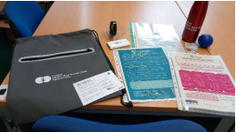

Recruitment and Retention Working Group
The group’s remit is to identify, implement, and evaluate strategies focused on the recruitment and retention of qualified Social Workers and Occupational Therapists.

Two new roles were introduced across all Social Work Services: Assistant Team Manager and Advanced Practitioner. These roles provide a clear career pathway for employees recognising an ambition for some to progress towards management and others to remain in practice. These posts have been successfully recruited.

We continue to face challenges in recruiting and retaining qualified Occupational Therapists and Mental Health Officers in line with the national position. We are currently sponsoring three Social Workers to complete a postgraduate Mental Health Officer Award.

An established ‘Grow our Own’ programme of sponsored employees accessing undergraduate and postgraduate Social Work programmes with Open University provides a more flexible and affordable route to career development for employees. We have six sponsored employees, with our first due to graduate in summer 2024.

We’ve agreed with NHS Forth Valley to share placements for Occupational Therapist students to provide experience of practice within Social Work and Health settings. However, we face challenges building capacity to support students because of vacancies.

improving Falkirk’s Social Work Service
Over 100 colleagues took part in a snap poll about working within Falkirk’s social work teams, sharing their thoughts to help improve local services and attract new colleagues. The survey asked social work staff what attracted them to work for Falkirk and what will keep them working for Falkirk Council. Over 70% of the 120 responses shared positive experiences of working within the Falkirk area and for the local authority.

The attraction to Falkirk included location and community, role and career development, and team and colleague relationships whilst retention factors included competitive employment conditions, team spirit, stronger leadership, and career progression.

Social Work Services Continuous Professional Development (CPD) Manager Online System
In April 2023, we launched a new online CPD Manager system across all Social Work Services. This provides an efficient system for managing the promotion of, booking, authorising, recording, evaluating, and reporting on training, learning and development activities.

We have 950 employees logged onto the system. A series of engagement sessions have been facilitated and easy read guidance developed. During spring 2024, we will be running a campaign linked to the first-year anniversary of the new system to support culture and practice change.

Challenges include supporting staff, especially those who are not office based, to create habits of routinely logging on and actively using the system.

Trauma Informed and Responsive Services
In support of Scottish Government’s ambition to have all services trauma informed and responses, we have created a Trauma Informed Policy Officer post and appointed three Senior Managers as Trauma Champions.

We are working to develop a strategy and tiered training framework for Falkirk Community Planning Partnership services. This involves working collaboratively with people with lived experience in the development and review of policies, processes, and delivery of workforce development.

A range of training resources have been developed and delivered to staff. This has included developing trauma skilled e-modules on both OLLE and TURAS learning platforms to promote staff accessing these resources. A trauma “Community of Practice” has also been established to support ongoing learning and application into practice.

Staff have increased their understanding of the prevalence and impact of trauma and increased their confidence and skills working with those affected by trauma. However, there are ongoing challenges with capacity of staff to attend training.

Adult Support and Protection Learning and Development Programme
We continue to develop and deliver a comprehensive single and multi-agency Learning and Development Programme for Adult Protection across the HSCP.

Training is offered across various workforce levels in line with both the National Child Protection Framework and the National Trauma Transformations Programme, Knowledge and Skills Framework. Links are also maintained with the National Adult Support and Protection Learning and Development Network facilitated by the National Adult Support and Protection Coordinator.

Learning and development activities are delivered in person and online to maximise access to training and flexibility for provider agencies. Access to all Adult Support and Protection (ASP) related training can be achieved via the web-based Practitioner Pages, an information resource that can be accessed by all HSCP partners, including independent and third sector partners. Adult, Children and Justice Services staff employed by Falkirk Council can also access all ASP related training using the CPD Manager System.

Between 1 April 2023 and 29 February 2024, a total of 42 courses have been delivered. These have varied in duration from one half day to two full days. A total of 417 staff have attended these courses:
- Third, private, and voluntary sector staff – 211
- Falkirk Council staff - 206

Courses continue to evaluate highly from all staff across Falkirk Council and other sectors. We continue to expand our range of ASP related training in line with any learning and development needs identified by the Adult Protection Committee and the HSCP.

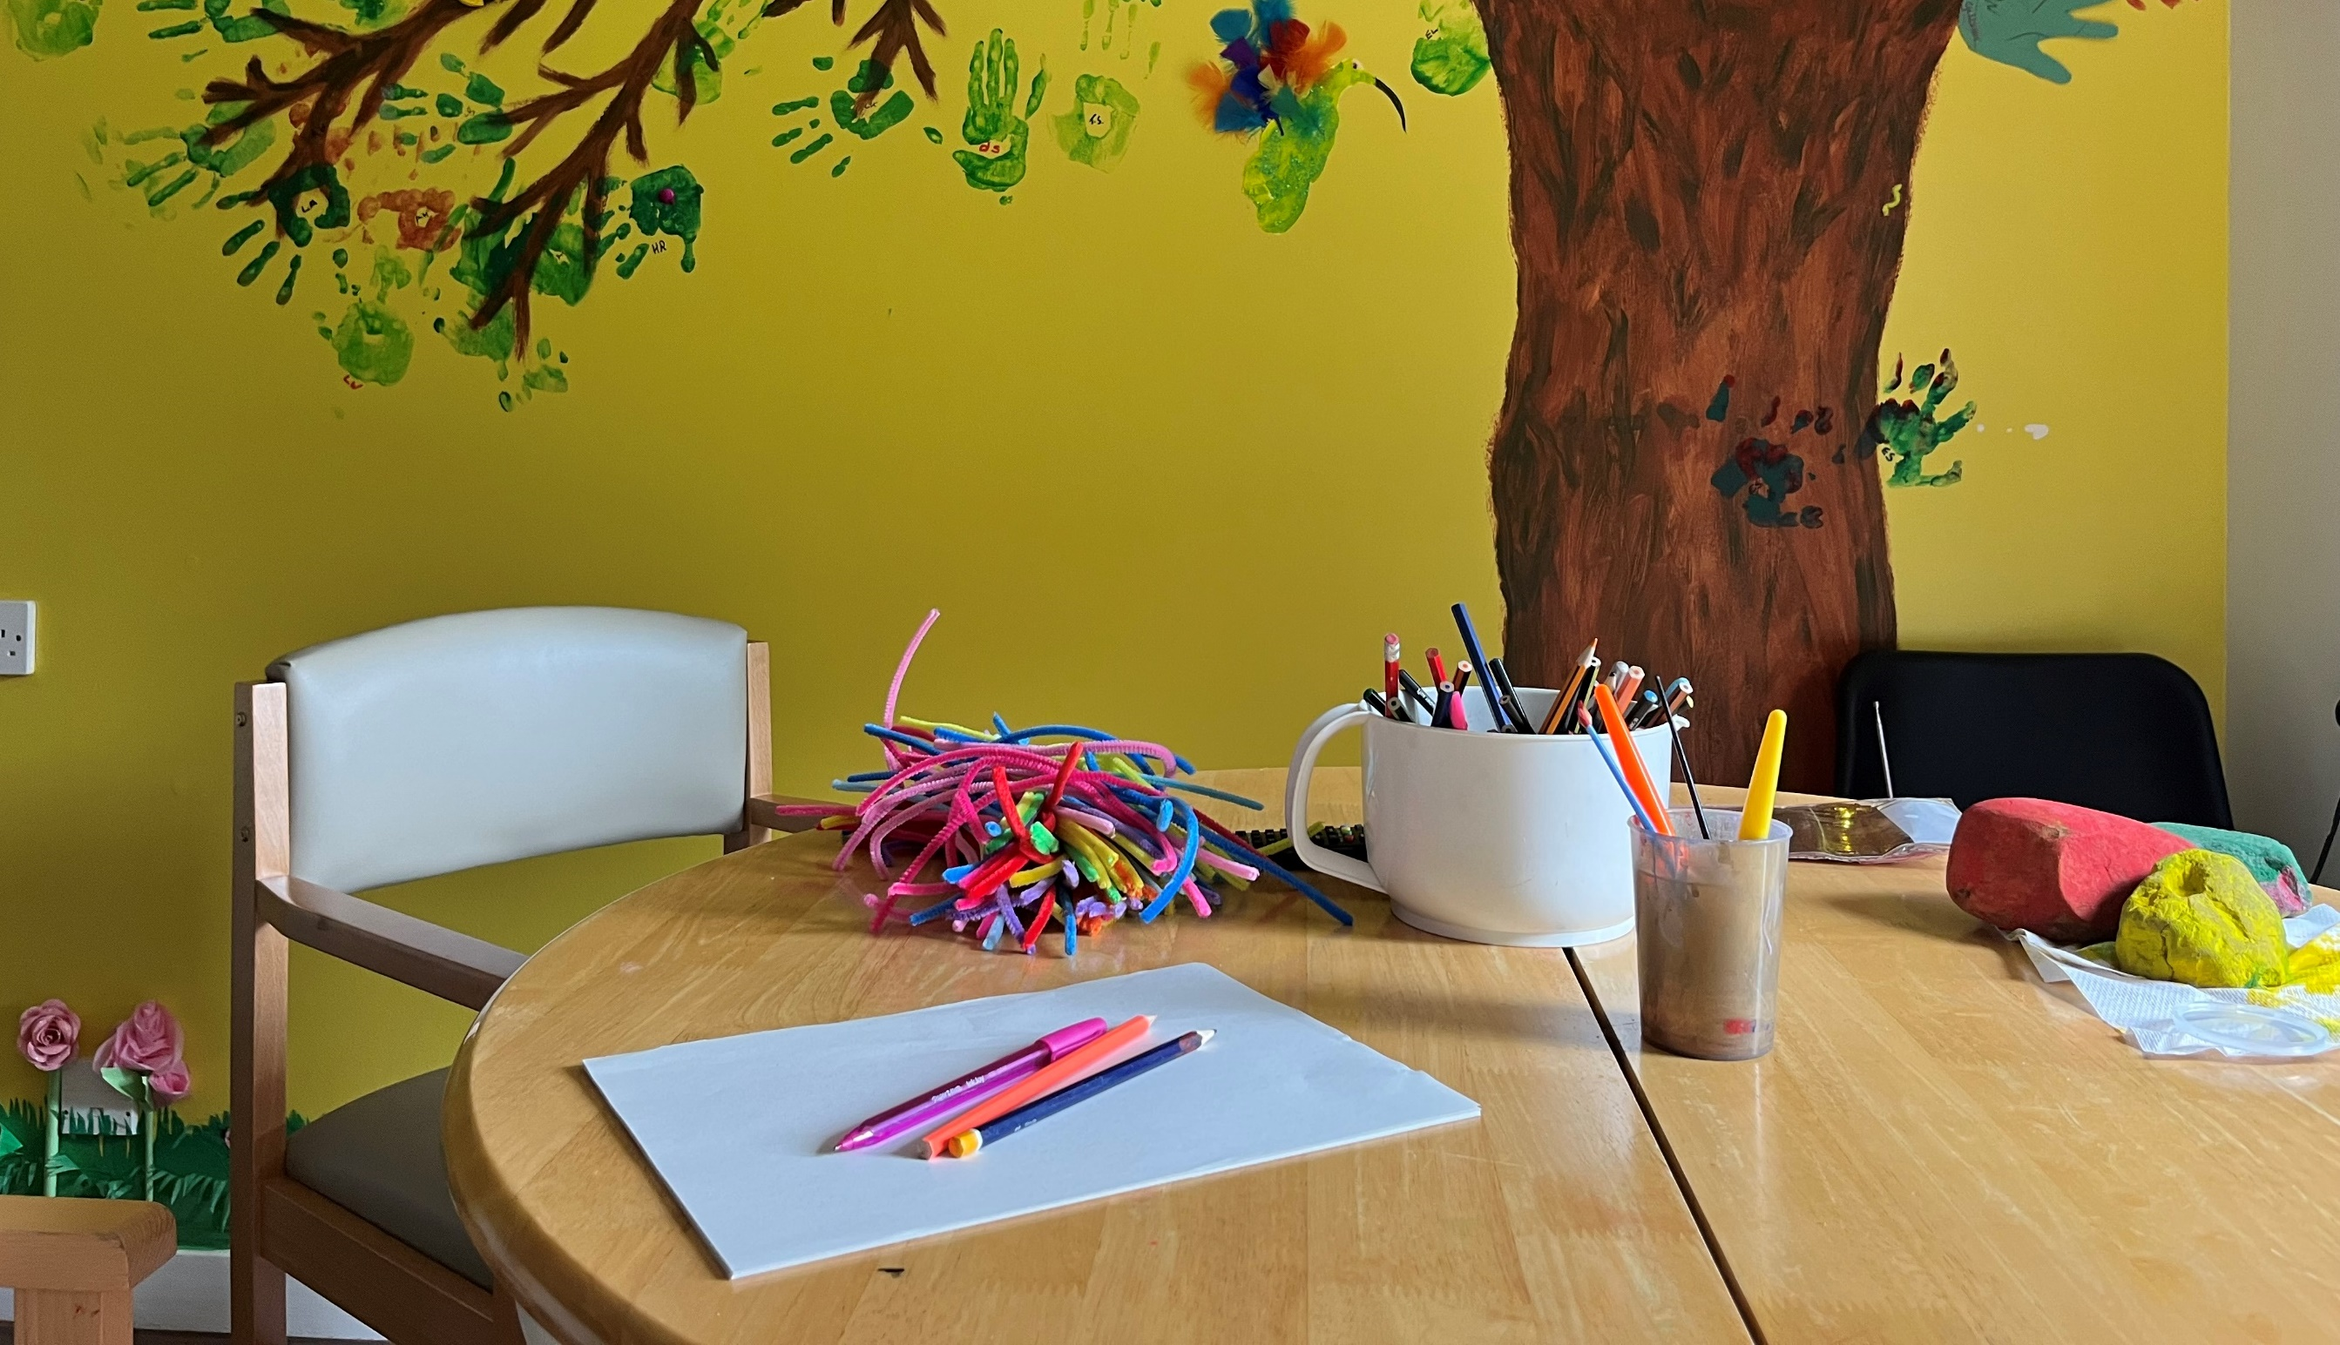

Communication and Engagement

Strategy Development
We have refreshed our Communication and Participation and Engagement Strategies as well as developed a combined action plan to support the implementation of each strategy. The strategies were approved by the Integration Joint Board (IJB) in June 2024.

careers and recruitment
The Partnership’s ‘Careers that Care’ recruitment campaign promotes a wide range of roles and opportunities. This year, we produced a new entry-level career booklet, outlining career options across the Partnership. We hosted over 20 of our partner home care organisations to our social care recruitment events in April and November, and hosted a Social Work and OT recruitment event in October to launch the new Advanced Practitioner and Assistant Team Manager roles.

Winter health Communications Group
The national winter health communications group, chaired by the Scottish Government, met fortnightly throughout the winter period to share updates and challenges facing services. The group continues to meet beyond the winter period, at a reduced frequency, allowing a space for collaboration and shared learning.

Care Home Framework for Adults Consultation
A consultation ran from 10 May – 23 June 2023 to develop a Care Home Framework for Adults with either a learning disability, autism, mental health needs, physical disability, and/or complex care needs. Easy read versions of the survey were made available to the local care homes, carers, and advocacy centre. In person visits supported people in care homes to complete the easy read survey or use Talking Mats to support communication and engagement. The feedback supported the development of the framework, so the support people receive is suited to their needs and wants.

Equality Outcomes Consultation
Between September and November 2023, we asked for feedback on two new equality outcomes, which focused on both older people and people from BME communities with the support of local community groups and organisations.

We improved the representation of BME people participating in public consultations, which included translating the survey into five languages. As a result, 35.5% of survey responses were received by people from BME communities. From January to March 2024, we carried out further engagement work to agree actions to be progressed to achieve our agreed outcomes.

Care Opinion
On 3 April 2023, the HSCP launched Care Opinion, an online feedback platform where people can safely share their experiences of any health service or Care Inspectorate-registered provider of adult social care service.

In its first year of launching, the Falkirk HSCP have received 54 stories. Table 2 provides an overview of Care Opinion stories.

Service Area | Total no. of stories | % of stories responded to by staff | % of positive stories
Falkirk HSCP | 54 | 76% | 93%
Adult Health Services | 35 | 63% | 89%
Adult Social Work Services | 18 | 100% | 100%
Commissioned Services | 1 | 100% | 100%
Table 2: Overview of Care Opinion Stories

Snapshot:
Carer is happy with her daughter attending Thornton Gardens for respite. “The staff are great with my daughter, she gets lots of hugs and she’s happy to tell me who they are. I’ve never seen her come out of her shell so much… I can go away for my wee break knowing she’s getting well looked after.” My disabled daughter’s respite (15/08/2023)
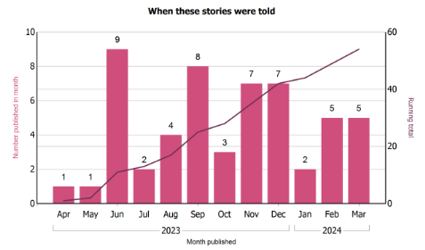
Figure 1: Stories Published by Month

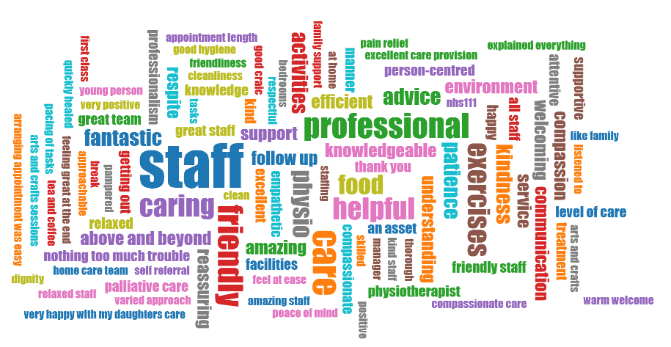
Figure 2: Story Word Cloud – What Was Good?

A full summary report of Care Opinion for 2023/2024 can be found on the HSCP website.

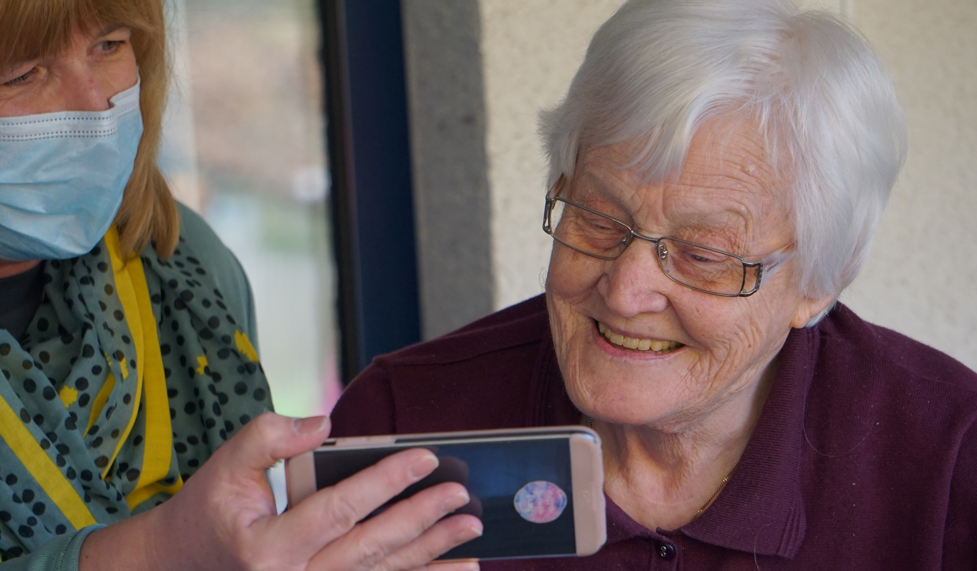

Technology Enabled Care

Digital Health and Care Programme
Launched in March 2023, the Digital Health and Care Programme was established to make better use of technology to deliver the Partnership’s strategic priorities. The Programme includes a range of activities to enhance our services through the effective use of digital health and care technologies.

The Digital Health and Care Programme Board provides governance to progress appropriate digital health and care initiatives whilst ensuring their continued alignment to HSCP strategy. It combines the expertise and resources of stakeholders from across our services and coordinates with Falkirk Council and NHS Forth Valley ICT services and Information Governance.

A Delivery Plan is being developed around key priorities that were identified throughout the Strategic Plan’s consultation and development. The programme will support activities to widen access to services and strengthen care co-ordination. It will prioritise opportunities to reduce demand for services by empowering individuals and encouraging independence through the appropriate use of technology. Planning around digital initiatives will also include consideration of digital exclusion factors to ensure individuals who are unable to engage with technology are not left behind and support arrangement will be built into programme activities.

Digital Health and Care Fund
The Board will oversee the Digital Health and Care Fund, a non-recurring budget of £250k which will be targeted towards improving the use and availability of digital health and care technologies within Falkirk.

Medication Management Technologies
The Digital Health and Care Programme is exploring ways in which technology could support individuals to manage their medication schedule. This could be built into the Medication Policy. We will explore the safe integration of advanced medication management technologies such as video prompting and digital dispensing devices.

Supporting Individuals with technology
A new Care Technologist role has been piloted by Scottish Care, funded by TEC Scotland. The Care Technologist role works with services to provide person-led digital evaluation and support to deliver assistive technology, devices, and tools to service users. This role aims to improve independence, increase safety, and grow confidence with technology. A Short Life Working Group is exploring how to apply the learning from this pilot role to Falkirk.

Access to Digital Health and Care Resources
We’ve created a single source of information on various digital health and care technologies and their applications to address the challenge of creating awareness of digital health and care technologies and to promote them to our service users, communities, and workforce.

Work is now underway to develop an online area within the Falkirk HSCP website with reliable information on digital health and care technologies and material for community activities and events.

Near Me Video Appointments
Near Me is a secure form of video consulting approved for use by the Scottish Government and NHS Scotland. The platform is being used by Falkirk HSCP and NHS Forth Valley services including health appointments, to support anti-smoking initiatives, deliver Living Well Falkirk appointments, and for ad hoc Social Work appointments.

Familiarisation sessions have been held to promote the platform. Possible other uses of Near Me will be considered in the future. The platform enables individuals to attend health and care appointments remotely and securely, saving the need to travel.

Care at Home Systems
The Care at Home Electronic Time Recording and Scheduling system, CallConfirmLive! plays a crucial role in the coordination of care activity. Every week, the system schedules 8,000-9,000 visits for the in-house Care at Home service. Visit details are shared securely with a remote workforce of over 250 staff via the CM mobile app to ensure they have the information they need to deliver a high standard of care.

Over the past months, automation has been built into reporting processes, making it easier to generate and access essential information promptly. This streamlined process contributes to management and statutory reporting, has informed the Care at Home Redesign, and strengthened decision making in the Care at Home service.



Partnership Working

The Independent Sector
The Independent Sector supports the sustainability of care provision in Falkirk and is a key partner in the delivery of integrated health and social care services in the area. During 2023/24, the Independent Sector Lead (ISL) has continued to engage in all activities within the Falkirk HSCP.

Activities have included:
- Hosted weekly provider forums to discuss local and national activities.
- Supported staff training.
- Hosted webinars on topics such as overseas recruitment, Anne’s Law, care home activities, Infection Prevention and Control, etc.
- Supported development of Adult Care Homes for Under 65s framework, including the consultation, draft procurement strategy, and setting up a ‘Training Consortium’ for providers.
- Supported engagement with pre-registration students at Robert Gordon University with presentation on nursing in care homes.
- Share all new/current information and changes in legislation, processes, and contracts, etc. with providers.

The Third Sector
During 2023/24, CVS Falkirk recruited a new Partnership Development Manager who works with partners, encourages third sector engagement, and represents the wider third sector with statutory partners to influence the strategic development of services in the Falkirk area.

Activities have included:
- Further developed third sector forums and networks, including the Health and Wellbeing Forum.
- Supported local groups to secure funding via the Community Mental Health and Wellbeing Fund – investment of circa £430k.
- Provided advice and guidance on the development of the HSCP Volunteer Policy.
- Participated in 2023 Recovery Olympics with Falkirk Mental Health Planning Team.
- Joined the ADP Executive Committee as the Third Sector Representative.
- Developed and delivered annual Wellness in Winter initiative to promote good health and wellbeing.
- Delivered Falkirk Funders Fayre in March 2024 with 23 funders available to meet with local groups.

Housing Services

Housing has a key role for people to stay at home, in accommodation that meets their needs, in their communities. The Housing Contribution Statement (HCS) is a bridge between the HSCP Strategic Plan and Falkirk Council Housing Strategy 2023-2028.

 | 2022/23 | 2023/24
Achieved | 6 | 10
Ongoing | 11 | 7
Carried forward | 4 | 4
Table 3: Summary of Housing Contribution Statement Actions

New Housing Contribution Statement
The Falkirk Housing Need and Demand Assessment (HNDA) has informed the development of the new Housing Contribution Statement. It identified:
- More affordable housing
- Larger properties
- Wheelchair properties including homes for families with multiple physical disabilities.
- Homes for people with complex care needs
- Support provision for people who have experienced domestic violence and abuse and people with alcohol and drug use who require specific support to sustain tenancies.

From 2024/25, the Strategic Planning Group will have representation from Registered Social Landlords.

Scottish Government
Getting it right for everyone (GIRFE) is a Scottish Government led programme and a multi-agency approach to developing health and social care support and services from young adulthood to end of life care. It will inform the future practice model of all health and social care professionals in Scotland and shape the design and delivery of services, ensuring that people’s needs are met.

The benefits to Falkirk HSCP by joining the GIRFE programme as a Partner, include:
- We can influence the design of national service models.
- By learning about the service design process, we can repeat this process for other service development activities.
- We can apply insights from the GIRFE process to develop our existing services.

The GIRFE programme is developing several prototypes to be tested with a range of service users in different areas. For example, digital resources, apps, new roles, and different approaches to improve the way care is coordinated. In collaboration with colleagues from HSCPs across Scotland, Falkirk HSCP have contributed to the design, development, and testing prototypes of new service models.



Equalities and Sustainability

Equalities
We must report on our progress every two years, which will now be done through our Annual Performance Reports. This is in recognition of the role equalities has in our work across the Partnership. Although we have set new Equality Outcomes for 2024 – 2028, we are still required to report on our previous Equality Outcomes for a final time. Future progress reports will be on the Equality Outcomes for 2024 – 2028.

Equality Outcomes | Progress in 2023/24 (links to sections within report)
Outcome 1: People within the relevant protected characteristic groups or who experience other forms of discrimination or disadvantage are able to be themselves and can achieve their full potential. | Priority 1; Priority 2; Priority 3; Priority 4
Outcome 2: Service users are equal partners in planning, developing and monitoring their care through informed choice and personal responsibility. | Caledonia Service; Living Well Falkirk; MECS; Supporting Carers; Self-Directed Support
Outcome 3: Our approach to engagement and participation will give a voice to our diverse communities. | Communication and Engagement; Care Opinion
Outcome 4: People who experience mental health problems and/or learning disabilities will be supported to live fulfilled lives without stigma. | Developing Healthy Relationships; Change Champions Team; New Transitions Team; Thornton Gardens; Dundas Resource Centre; Caledonia Service; Annual Reviews for People with Learning Disabilities;
Outcome 5: Access to our services will be improved by understanding and reducing barriers. | Technology Enabled Care; Ensure people can access the right care at the right time, in the right place
Outcome 6: Within NHS Forth Valley, people from the ‘LGBTi’ community will not experience barriers to accessing or receiving end of life care.
Table 4: Progress against equality outcomes

For more information on our Duties and general information about equalities, please visit the HSCP website.

During the past year, we’ve improved compliance with the Public Sector Equality Duty (PSED) to impact assess our policies and procedures. We’ve developed guidance to assist the completion of EPIAs and officers have received one-to-one support. The HSCP website equalities page has been refreshed and more completed EPIAs have been published on the site.

Following a successful consultation, we’ve developed a new set of Equality Outcomes for the 2024-2028 period:
- Older people who experience barriers to accessing internet-based health and social care services have alternative ways to access services.
- People from Black & Minority Ethnic backgrounds with cultural and language differences have improved experiences accessing health and social care services.

The Equality Outcomes and Mainstreaming Report 2024-2028 was approved by the IJB in March 2024.

Sustainability
Adult Social Work accounted for 977 tonnes CO2e in 2023/24, which is a 3% increase compared to last year (not including vehicle fuel data as it was unavailable in 22/23). This is partly due to a slight increase in consumption and an increase in electricity emissions factors in 2023. The emissions factors for electricity have increased by 7% due to an increase in natural gas usage for electricity generation and decrease in renewable generation.

Source | Tonnes CO2e
Electricity | 239
Electricity transmission and distribution loses | 21
Gas | 711
Water | 6
Vehicle fuel (petrol and diesel) | 150
Total | 1,127
Table 5: Breakdown per emissions sector

Work is underway to reduce energy consumption and emissions of the following buildings via installation of energy saving products such as LED lighting, Solar PV, Air source heat pumps (ASHP), and cavity wall installation.

Building | Estimated Savings | Estimated Reduction
Burnbrae Home | 65.5 tonnes CO2e | 62% reduction
Dorrator Court | 3.8 tonnes CO2e | 10% reduction
Dundas Resource Centre | 57 tonnes CO2e | 59% reduction
Table 6: Estimated energy savings and reduction in energy consumption



Financial Performance and Best Value

Best Value
As defined by Audit Scotland, Best Value is concerned with “good governance and effective management of resources with a focus on improvement to deliver the best possible outcomes for the public.”

The IJB’s governance framework supports continuous improvement and better outcomes, whilst striking an appropriate balance between quality and care. The key features of the IJB’s governance framework which were in place during 2023/24 to support best value are outlined below.

GOVERNANCE AND ACCOUNTABILITY
Falkirk IJB has responsibility for the strategic planning and commissioning of delegated health and social care functions. NHS Forth Valley and Falkirk Council delegate budgets to the IJB, which decides how resources are used to achieve the objectives of the Strategic Plan. The IJB then directs the partners through the HSCP, to deliver services in line with this plan. The IJB controls an annual budget of approximately £300m.

The IJB has legal responsibilities and obligations to its stakeholders, staff, and residents of the Falkirk Council area. The following governance frameworks set out the rules and practices by which the IJB ensures that decision making is accountable, transparent, and carried out with integrity:
- The Integration Scheme
- IJB Standing Orders
- Risk Management
- Clinical and Care Governance

The range of IJB Board members has enabled informed decision-making through the insightful contributions from different perspectives. The voice of service users and carers have been of importance and value to the Board. During 2023/24, a hybrid approach to meetings continued with some still taking place online.

EFFECTIVE USE OF RESOURCES
National Health and Wellbeing Outcome 9 requires the IJB to demonstrate that “resources are used effectively and efficiently in the provision of health and social care services.” As part of this requirement, an overview of 2023/24 financial performance is provided below, including consideration of the financial outlook for 2024/25.

Financial Performance 2023/24 (from unaudited accounts)
The IJB reported total income of £299.200m for financial year 2023/24 and total expenditure of £306.768m incurred during the year. As a result, a deficit of £7.568m was reported in the unaudited Comprehensive Income and Expenditure Statement on 31 March 2024.

As a result of the 2023/24 net overspend position of £2.606m of brought forward IJB reserves were used to achieve break even within the integrated budget.

The key pressure areas affecting 2023/24 financial performance are detailed below:

Large Hospital Services/Set Aside
Overspend pressures continued to be reported within A&E, General, Geriatric, Rehab and Specialist Mental Health Services. This was mainly relating to ongoing significant expenditure on bank and agency staffing, linked to staff absence/vacancies and acuity of care, increased demand, and case mix complexity/length of stay, together with additional costs to maintain safe staffing levels. Similar short staffing challenges also continued to impact on this.

It is important to recognise that the overspend pressure is met by NHS Forth Valley.

Social Care
Social Care cost pressures continued to rise throughout the year. There was a significant increase in demand for Care at Home services and within Residential Care an ongoing requirement for agency staff along with continuing high demand. These pressures were partly offset by underspends in Assessment & Care Planning mainly due to staff vacancies and within Day Care Services with the ongoing closure of Oswald Avenue. A review of Day Care Services is currently being carried out and is expected to be completed in early 2024/25 which will determine the future plans for Oswald Avenue.

Primary Healthcare
Large overspends were incurred, mainly due to prescribing pressures as a result of increased volumes, high inflation and Buvidal no longer being funded by the Scottish Government. The overspend was partly offset by underspends on GP OOH Services and Primary Medical Services GMS Contract.

Community Healthcare
A favourable financial position was largely due to development funding not yet being fully utilised, plus vacancies and staff turnover savings across a variety of services including Community Mental Health, Community Based AHP and Community Learning Disability. The favourable position masked ongoing pressures within the Joint Loan Equipment Store and Complex Care services.

An analysis of IJB expenditure incurred during 2023/24 is outlined in the table below:

Total Expenditure | 2023/24 | 2022/23 | 2021/22 | 2020/21 | 2019/20
Large Hospital Services | 42,952 | 39,844 | 31,079 | 29,629 | 27,741
Primary Care Services | 92,745 | 86,130 | 81,474 | 83,284 | 81,941
Social Care Services | 123,369 | 110,820 | 99,102 | 93,952 | 88,259
Community Healthcare Services | 47,159 | 44,331 | 21,956 | 38,241 | 36,604
IJB Running Costs | 543 | 470 | 454 | 469 | 444
Total | 306,768 | 281,595 | 234,066 | 245,575 | 234,989
Set Aside | 42,952 | 39,844 | 31,079 | 29,629 | 27,741
Integrated Budget | 263,817 | 241,751 | 202,987 | 215,946 | 207,248
Total | 306,768 | 281,595 | 234,066 | 245,575 | 234,989
Table 7: Total Expenditure 2023/24

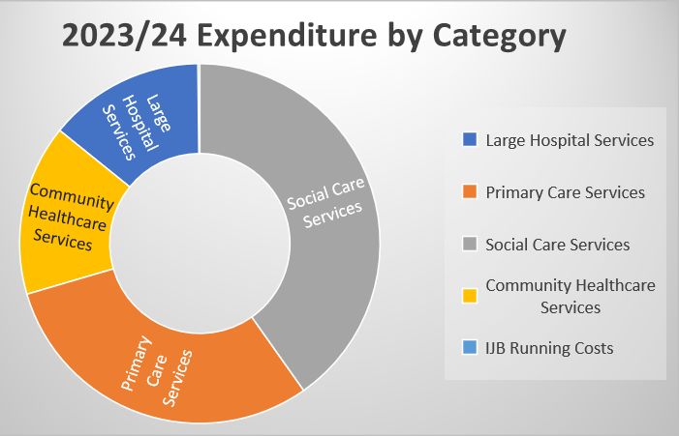
Figure 3: 2023/2024 Expenditure by Category
FORWARD LOOK 2024/25 AND BEYOND
The IJB is committed to delivering transformational change over the coming years to ensure financial sustainability. Transformation of services will therefore continue to be a key feature in financial year 2024/25 with the Transformation Board meeting regularly to review and approve transformation initiatives that will drive forward transformation programmes and projects in line with the Strategic Plan.

The updated Medium Term Financial Plan (MTFP) was approved on 22 March 2024 covering financial years 2024/25 to 2027/28. The plan details an expected funding gap throughout this period, the expected ongoing financial pressures, and the proposed savings delivery in order to achieve a balanced budget.

The expected funding gap before savings delivery is set out in the table below:

Projections | 2024/25 £m | 2025/26 £m | 2026/27 £m | 2027/28 £m
Expenditure | 307.562 | 312.603 | 317.078 | 321.925
Funding | 289.133 | 290.633 | 292.164 | 293.725
Shortfall before savings | 18.429 | 21.970 | 24.914 | 28.200
Impact of savings achievement | 0.000 | 18.429 | 21.970 | 24.914
Shortfall after prior years savings achieved | 18.429 | 3.541 | 2.944 | 3.286
Table 8: Expected Funding Gap

A number of assumptions have been used in the projections, including pay and social care provider uplifts, inflation rates and expected demographical changes.

It’s clear from the table that Falkirk IJB is facing an extremely challenging financial future with funding not increasing at the same pace as the demand for services and increased costs.

A savings programme has been identified for financial year 2024/25 which includes the use of £4.090m non-recurring funds. As non-recurring savings provide only a short-term solution, longer term solutions will require to be developed and work is continuing to identify service delivery changes that will deliver a sustainable financial position over the coming years.

Partnership Funding Programme
Falkirk HSCP has operated a Partnership Funding programme since 2018. The benefits of operating a Partnership Funding Programme include the ability to:
- Respond to emerging needs across the system on a flexible manner.
- Effectively and transparently allocate, monitor, and evaluate funds, using a collaborative commissioning approach.
- Include people with lived experience in design and decision-making processes.
- Shift resources from crisis support to earlier intervention and prevention.

The table below lists opening budgets for all funds included in the Partnership Funding Programme for 2023/24 along with lead commissioning groups.

Budget (£M 23/24)
Fund Name | Recurring | Non-recurring | Commissioning Group
Partnership Fund  (Main Programme) | 1.479 | 1.75 | Partnership Funding Group
Carers Fund | 1.632 | 3.147 | Carers Strategy Group
Carers Challenge Fund | 0.500 |  | Carers Strategy Group
Dementia Innovation Fund | 0.100 | 0.461 | Dementia Strategy Group
Health Inequalities & Wellbeing Fund |  | 0.544 | Health Inequalities & Wellbeing Panel
Locality Funds |  | 0.060 | TBC
TEC Innovation Fund |  | 0.250 | Digital Health & Care Programme Board
Ideas & Innovation  (Spend to Save) |  | 0.238 | Transformation Board
Falkirk Suicide Prevention Fund (Previously Choose Life) | 0.024 | 0.109 | Mental Health & Wellbeing Planning Group
Services for Survivors | 0.098 | 0.053 | Mental Health & Wellbeing Planning Group
Mental Health Recovery & Renewal Fund (Phase 2) | 0.100 | 0.118 | Dementia Strategy Group
Total | 3.933 | 6.155
Table 9: Partnership Funding 2023/24

The Partnership Funding Investment Plan 2021-2024 supported 38 organisations and 72 projects through 11 funds with a total of £10.1m. The next three-year Investment Plan was approved by the IJB in March 2024 and outlines how we will invest over £18m across 13 funds over the next three years.

FALKIRK SUICIDE PREVENTION FUND
Falkirk Suicide Prevention Fund (formally Choose Life) targets suicide prevention and harm reduction in Falkirk. This fund programme launched in February 2023 and has funded five projects with a total grant value of £55,989.

Snapshot:
Female, on waiting list for NHS secondary care support, is a long-term survivor of domestic abuse and became suicidal after a traumatic event. She was referred to the new ‘Keep in Touch’ Suicide Prevention service. By attending sessions, goals have been set and she has been taught coping strategies and techniques, the need for self-care, and assertiveness training. – Keep In Touch Service, Cyrenians

HEALTH INEQUALITIES AND WELLBEING FUND
The Health Inequalities and Wellbeing Fund aimed to develop community-based services and projects that minimise health and social inequalities and improve people’s health and wellbeing. This fund programme ran from April 2022 to March 2024 and funded 23 projects with a total grant value of £741,266.50.

Snapshot:
Elderly male has impaired sight and his wife had recently died. He couldn’t cook for himself but was keen to learn. With advice from NHS colleagues, KLSB Community Group contacted Forth Valley Sensory Centre to set up cookery lessons with the sight impaired chef to allow the service user to cook. – KLSB Community Group

CARERS CHALLENGE FUND
In 2022, the Falkirk Carers Strategy Group introduced the Carers Challenge Fund – an annually protected amount of £500k drawn from the Carers Fund, allowing service providers to propose projects which meet key carer outcomes. In 2023/24, the Carers Challenge Fund provided funding for four projects with a total grant value of £132,725.75.



Governance and Performance

Governance

The Care Inspectorate is responsible for the regulation of care standards in Scotland. The Quality Assessment Framework, which inspectors use to evaluate the quality of care during inspections and improvement planning, sets out Key Questions about the quality and difference a care service makes to people’s wellbeing.

KQ 1 How well do we support people’s wellbeing?
KQ 2 How good is our leadership?
KQ 3 How good is our staff team?
KQ 4 How good is our setting?
KQ 5 How well is our care and support planned?
KQ 6 What is the overall capacity for improvement?

RESIDENTIAL CARE HOMES (OLDER PEOPLE)
All 20 local care homes were inspected this year. The findings were as follows:

Key Questions | Good/  Very Good/  Excellent | Unsatisfactory/  Weak/  Adequate | Not Inspected
KQ 1 | 75% | 10% | 15%
KQ 2 | 75% | 10% | 15%
KQ 3 | 35% | 5% | 60%
KQ 4 | 25% | 10% | 65%
KQ 5 | 35% | 10% | 55%
KQ 6 | 0% | 0% | 100%
Table 10: Residential Care Homes (Older People)
The Care Inspectorate upheld seven complaints from January to December 2023, compared to eight during the same period in 2022.

RESIDENTIAL CARE HOMES (ADULTS)
10 of the 11 local care homes were inspected this year. The findings were as follows:

Key Questions | Good/  Very Good/  Excellent | Unsatisfactory/  Weak/  Adequate | Not Inspected
KQ 1 | 100% | 0% | 0%
KQ 2 | 100% | 0% | 0%
KQ 3 | 64% | 0% | 36%
KQ 4 | 55% | 9% | 36%
KQ 5 | 91% | 0% | 9%
KQ 6 | N/A | N/A | N/A
Table 11: Residential Care Homes (Adults)

The Care Inspectorate upheld two complaints from January to December 2023, compared to three during the same period in 2022.

INSPECTION REPORTS
There have been 11 Care Inspectorate inspection reports and 7 Mental Welfare Commission visit reports published in 2023/24.

Inspection Date | Inspection
07-09/06/2023 | NHS Forth Valley Community Residential Resources Housing Support Service
01/06/2023 | Dorrator Court
11/07/2023 | Cunningham House
13/04/2023 | Forth Valley Royal Hospital Ward 2
09/05/2023 | Forth Valley Royal Hospital Ward 3
27/03/2023 | Forth Valley Royal Hospital Ward 4
19/07/2023 | Burnbrae House
04/09/2023 | Summerford House
06 & 11/09/2023 | Thornton Gardens
07, 11, & 12/09/2023 | Grahamston House
05/10/2023 | Woodlands Resource Centre
11/10/2023 | Forth Valley Royal Hospital Ward 1 IPCU
31/10/2023 | Forth Valley Royal Hospital Ward 5
05/12/2023 | Bellsdyke Hospital – Hope House
11/01/2024 | Grahamston House Care Home
13/03/2024 | Housing Support Service - West Locality
13/03/2024 | Housing Support Service - Central Locality
13/03/2024 | Housing Support Service - East Locality
Table 12: Inspections in 2023/24

THORNTON GARDENS – CHANGE IN REGISTRATION
From 1 June 2023, Thornton Gardens reverted to the original registration to provide short breaks and respite care service to a maximum of six adults with a learning disability. Two of these places will be for emergency placements. Older people accessing this service will now be supported through other resources.

COMMUNITY RESIDENTIAL RESOURCES AND HOUSING SUPPORT SERVICE
NHS Forth Valley’s Community Residential Resources and Housing Support Service, which helps people across Forth Valley, currently support 27 people. The Care Inspectorate scored the service straight 6s equating to excellent in every section appraised, which is almost unheard of.

The Inspectorate commented that the service works in a truly person-centred way, using best practice as standard, delivered by staff who are motivated and committed to people. During the visit, the inspector spoke to 17 staff, spent time with 23 people using the service, observed practice and daily life, reviewed documents, and spoke with visiting professionals.

SUNDAY TIMES CARE HOME LEAGUE TABLE
Falkirk has been named as the best place to grow old in Scotland if you need residential care, following analysis of Care Inspectorate reports by the Sunday Times Care Home League Table.

The Sunday Times found that homes for older people in Falkirk scored an average of 4.35 out of 6 in all categories – higher than any other council area. 79.5% of homes in the area were graded good or better, compared to a national average of 75.2%.

ADULT CARE HOMES UNDER 65 FRAMEWORK
There were no national or local frameworks in place which covered all client categories in care homes for adults under 65. During 2023/24, a framework has been developed to provide flexibility for Falkirk HSCP to meet the requirements of people in their local area.

The framework aims to:
- Maximise the number of providers capable of delivering high-quality residential care to Falkirk residents.
- Stimulate further market interest in this area and create more capacity.
- Increase choice and control and improve lifestyles for all care groups.
- Ensure sufficient quality and value for money.

The new framework came into effect on 1 April 2024.

CARE HOME ASSURANCE REVIEW TEAM (CHART)
The social care CHART team work collaboratively with other clinical health teams to consider the priorities and deliverables in support of care homes, residents, and staff. The team support quality assurance, monitoring in care homes and improvement of outcomes for adults who live in care homes.

A person-centred review supports providers and obtains assurance regarding care standards. The team manage complexities within the review process such as review of legal orders, resident deterioration and change in outcomes as well as the investigation of concerns and complaints. A robust and flexible plan for review completion allows the team to respond to external factors such as a large-scale investigation and ensure reviews are actioned if risk levels increase, or early indicators of concern are identified.

Activities in 2023/24 included:
- Reviewing activity has reduced number of overdue reviews from 227 in September 2023 to 113 by March 2024.
- Contributed to the support and monitoring activity of two care homes subject to a Large-Scale Investigation.
- Focused review, support, and monitoring activity on multiple care homes where grades have gone down following Care Inspectorate activity.
- Contributed to regular Collaborative Care Home support group meetings and the HSCP Early Indicator of Concern group.
- Development sessions focused on processes, procedures, and development plans to improve efficiency following confirmed permanence of team.
- Recruitment challenges have impacted on team capacity with agency workers used. However, recruitment for permanent workers is ongoing.

CARE AND SUPPORT AT HOME CONTRACT REVIEW
The Partnership is developing a Falkirk Framework for Care and Support at Home, with a view to move away from Scotland Excel (SXL) to a Falkirk specific framework. This new contract will support the HSCP to ensure continuity and smooth transition from the current arrangements, introduce greater transparency around costs, and support commissioners to achieve improved value for money. It should also increase understanding of the nature of specific service provision and help further develop the relationships with providers.

Local Performance
The most recent Performance Monitoring Report was submitted to the IJB in June 2024.

KEY:
Direction of travel relates to previously reported position
▲ | Improvement in period
◄► | Position maintained
▼ | Deterioration in period
▬ | No comparative data

PRIORITY 1 – SUPPORT AND STRENGTHEN COMMUNITY-BASED SERVICES
Ref | Measure | 2015/16 | 2018/19 | 2020/21 | 2021/22 | 2022/23 | Direction of travel
86 | Proportion of last six months of life spent at home or in a community setting | 86% | 86% | 89.1% | 88.4% | 88.1% | ◄►

PRIORITY 2 – ENSURE PEOPLE CAN ACCESS THE RIGHT CARE AT THE RIGHT TIME, IN THE RIGHT PLACE
Ref | Measure | Dec-18 | Dec-19 | Dec-20 | Dec-21 | Dec-22 | Dec-23 | Direction of travel
25 | Emergency department 4 hour wait Falkirk (ED+MIU) | 72.3% | 85.7% | 89.2% | 61.9% | 47.7% | 46.4% | ▼
27 | Emergency department attendances per 100,000 Falkirk | 1,968 | 2,201 | 1,278 | 1,593 | 1,770 | 1,752 | ◄►
29 | Emergency admission rate per 100,000 Falkirk population | 970 | 1,302 | 1,072 | 1,165 | 1,160 | 1,168 | ◄►
31 | Acute emergency bed days per 1,000 Falkirk population | 865.8*  *Nov 18 | 763 | 339 | 647*  *Aug 21 | 820 | 836 | ◄►
33 | Number of patients with an Anticipatory Care Plan in Falkirk | 6,952*  *Nov 18 | 8,329*  *Sep 19 | 32,051*  *Sep 20 | 29,050 | 28,734 | 26,710 | ▼
43 | Readmission rate within 28 days per 1,000 admissions Falkirk | 1.23 | 1.37 | 2.09 | 1.88 | 53.9 | 55.2 | ▼

Ref | Measure | Dec-18 | Dec-19 | Apr-20 | Dec-21 | Dec-22 | Dec-23 | Direction of travel
54 | Standard delayed discharges | 32 | 38 | 7 | 38 | 44 | 48 | ▼
55 | Standard delayed discharges over 2 weeks | 26 | 21 | 1 | 14 | 23 | 36 | ▼
56 | Bed days occupied by delayed discharges | 1,050 | 1,112 | 128 | 761 | 1,406 | 2,037 | ▼
57 | Number of code 9 delays, including guardianship | 10 | 15 | 11 | 22 | 26 | 25 | ▲
58 | Number of code 100 delays | 3 | 5 | 0 | 6 | 3 | 2 | ▲
59 | Delays - including Code 9 and Guardianship | 42 | 53 | 18 | 60 | 70 | 73 | ▼

PRIORITY 3 – FOCUS ON PREVENTION, EARLY INTERVENTION, AND MINIMISING HARM
Ref | Measure | 2019/20 to Q3 | 2020/21 to Q3 | 2021/22 to Q3 | 2022/23 to Q3 | 2023/24 to Q3 | Direction of travel
45 | Number of Adult Protection Referrals (data only) | 440 | 561 | 833 | 706 | 742 | -
46 | Number of Adult Protection Inquiries Using Investigative Powers (data only) | 48 | 120 | 52 | 39 | 60 | -
 | % of protection referrals that result in an investigation | - | 11% | 4% | 5.5% | 8.1% | -
47 | Number of Adult Protection Support Plans at end of period (data only) | 14  (30/09/19) | 19  (31/12/20) | 20  (30/12/21) | 10  (31/12/22) | 16  (31/12/23) | -

Ref | Measure | 2018/19 | 2019/20 | 2020/21 | 2021/22 | 2022/23 | Direction of travel
48 | The total number of people with community alarms at the end of period (data only) | 4,173  (30/9/18) | 4,087  (31/03/20) | 3,989  (31/03/21) | 3,811  (31/03/22) | 3,705  (31/03/23) | -

Ref | Measure | Dec-18 | Dec-19 | Mar-20 | Mar-21 | Sep-21 | Sep-22 | Sep-23 | Direction of travel
68a | Substance Use – Percentage of patients that commence treatment within 3 weeks of referral – Forth Valley ADP (90% target) | 98.3% | 97.9% | 95.9% | 97.2% | 92.9% | 89% | 82.6% | ▼
68b | Substance Use – Percentage of patients that commence treatment within 3 weeks of referral – Forth Valley Prisons (90% target) | 99.6% | 86.4% | 87.8% | 100% | 100% | 100% | 100% | -

Ref | Measure | Dec-18 | Dec-19 | Dec-20 | Dec-21 | Dec-22 | Dec-23 | Direction of travel
69 | Access to Psychological Therapies – Percentage of people that commenced treatment within 18 weeks of referral | 58.7% | 63.9% | 57.4% | 67.8% | 77.2% | 74.6% | ▼

PRIORITY 4 – ENSURE CARERS ARE SUPPORTED IN THEIR CARING ROLE

Ref | Measure | 2018/19 | 2019/20 | 2020/21 | 2021/22 | 2022/23 | Direction of travel
37 | SDS Option 1: Direct payments (data only) | 35  (0.7%) | 27  (0.6%) | 29  (0.7%) | 25  (0.5%) | 55  (1.4%) | -
38 | SDS Option 2: Directing the available resource (data only) | 192  (4.5%) | 101  (2.2%) | 17  (0.4%) | 96  (2.0%) | 63  (1.6%) | -
39 | SDS Option 3: Local Authority arranged (data only) | 3,875  (90.1%) | 4,009  (88.8%) | 4,128 (92.7% | 4,525  (94.6%) | 3,674  (95.7%) | -
40 | SDS Option 4: Mix of options (data only) | 197  (4.6%) | 376  (8.3%) | 279 (6.3%) | 135  (2.8%) | 49  (1.3%) | -

National Integration Indicators
The Integration Joint Board (IJB) fulfils its ongoing responsibility to ensure effective monitoring and reporting on the delivery of services, relevant targets, and measures which are set out in the Strategic Plan and integration functions. The Partnership reports progress against the suite of national integration indicators. This enables us to understand how well our services are meeting the needs of people who use our services and communities.

Indicators 1-9 are populated by the bi-annual Health and Care Experience (HACE) Survey. The most recently available data for these indicators is for 2023/24. Indicators 11-20 are in the main populated from the Scottish Morbidity Records (SMRs) which are submitted from local Health Boards to Public Health Scotland (PHS). For indicators 12-16, the latest available data is 2023 calendar year due to data completeness issues in some health board areas.

Our latest performance is set out in the following ‘Performance at a Glance’, with more detailed tables on the following pages.

Performance at a Glance
From the 17 indicators updated this year:
- 3 indicators where Falkirk compares well to Scotland.
- 5 indicators where Falkirk is similar to Scotland.
- 9 indicators where Falkirk does not compare well to national average.

Overall performance for the latest year has increased.
- 12/17 (71%) of indicators have improved year on year*

*Please note – Indicator 11 was not updated so has been excluded from the above summary. Indicators 2, 3, 4, 5, 7, 9 featured small changes to methodology meaning comparisons may not be fully like for like.

Key
Compares Well to Scotland
Similar to Scotland
Does not compare well to Scotland
NI | Indicators 1-9 | Falkirk | Scotland
NI - 1 | Percentage of adults able to look after their health very well or quite well | 91.0% | 90.7%
NI - 2 | Percentage of adults supported at home who agreed that they are supported to live as independently as possible | 67.6% | 72.4%
NI - 3 | Percentage of adults supported at home who agreed that they had a say in how their help, care, or support was provided | 59.7% | 59.6%
NI - 4 | Percentage of adults supported at home who agreed that their health and social care services seemed to be well co-ordinated | 53.9% | 61.4%
NI - 5 | Percentage of adults receiving any care or support who rated it as excellent or good | 73.1% | 70.0%
NI - 6 | Percentage of people with positive experience of the care provided by their GP practice | 69.4% | 68.5%
NI - 7 | Percentage of adults supported at home who agree that their services and support had an impact on improving or maintaining their quality of life | 61.4% | 69.8%
NI - 8 | Percentage of carers who feel supported to continue in their caring role | 30.7% | 31.2%
NI - 9 | Percentage of adults supported at home who agreed they felt safe | 69.5% | 72.7%

Notes on Indicators 1-9
Indicators 1-9 have been updated to the latest available data from the Health and Care Experience Survey (HACE) for 2023/24.

Due to changes in the HACE survey wording, the 2023/24 results for indicators 2, 3, 4, 5, 7 and 9 are not fully comparable to the same indicators for previous years. This is due to: People receiving support in their caring role no longer being included in this section, while people who receive peer/emotional support are now included (Q27). In addition, the options available under the question "Who funds your help or support with everyday living?" have changed i.e. "Council" and "NHS" have been replaced by "The State/Local Government" (Q28).

NI | Indicators 11-19 | Falkirk | Scotland
NI-11 | Premature mortality rate per 100,000 persons* | 473 | 442
NI - 12 | Emergency admission rate (per 100,000 population) | 14,440 | 11,707
NI - 13 | Emergency bed day rate (per 100,000 population) | 124,142 | 112,883
NI - 14 | Readmission to hospital within 28 days (per 1,000 population) | 136 | 104
NI - 15 | Proportion of last 6 months of life spent at home or in a community setting | 87.7% | 89.1%
NI - 16 | Falls rate per 1,000 population aged 65+ | 24.4 | 23.0
NI - 17 | Proportion of care services graded 'good' (4) or better in Care Inspectorate inspections | 86.9% | 77.0%
NI - 18 | Percentage of adults with intensive care needs receiving care at home | 67.8% | 64.8%
NI - 19 | Number of days people aged 75+ spend in hospital when they are ready to be discharged (per 1,000 population) | 1,283 | 902

Notes:
Indicator 11
The latest available data for indicator 11 is 2022 calendar year so there is no update on the figure used in last year’s APR.

Indicators 12-16
For indicators 12-16 the latest available data is 2023 calendar year due to data completeness issues in some health board areas for 2023/24 data. We have done this following guidance issued by Public Health Scotland to all Health and Social Care Partnerships.

Indicator 17 and 19
These indicators have been updated to financial year 2023/24.

Indicator 18
Indicator 18 (percentage of adults with intensive care needs receiving care at home) has been updated to calendar year 2023.

Comparisons
Compares well is defined as Falkirk rate is 2% better than Scotland. Does not compare well is defined as Falkirk rate is not within 2% of Scotland rate. Similar is defined as Falkirk rate within 2% of Scotland rate.

indicators 1-9 – including past years and comparator average

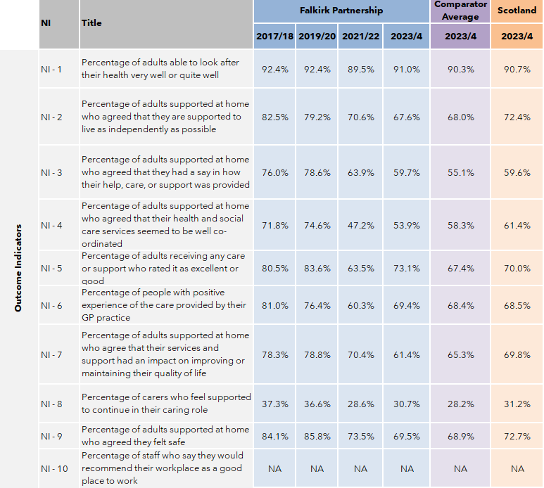
indicators 11-20 – including past years and comparator average
Please note – for indicators 11-20 the “Latest” column has the latest available data for each indicator. The footnotes below provide details on the latest year of data for each indicator.

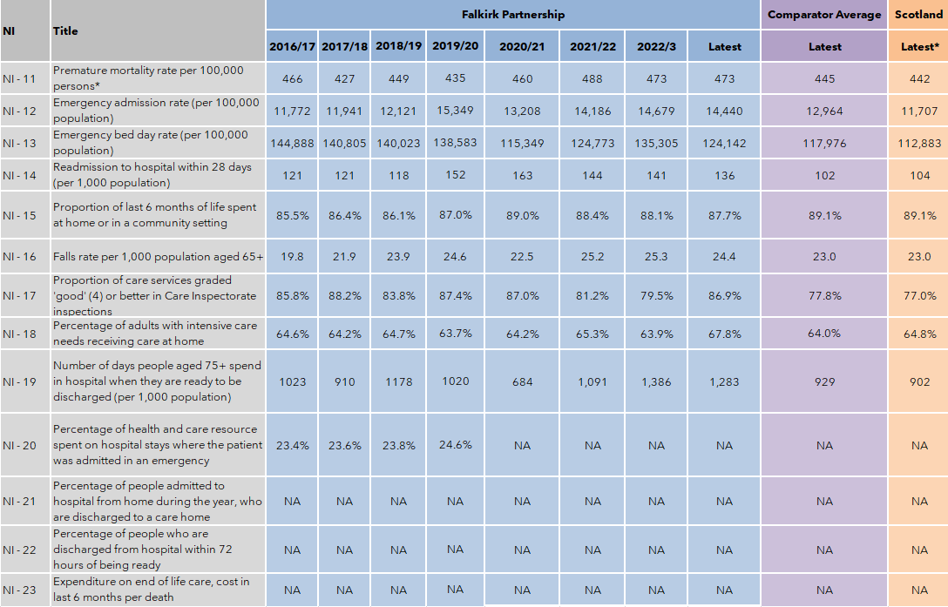
Source: Public Health Scotland

Notes:
1. NA indicates where data is not yet available.
2. NI 1 – 9: Data are presented on financial year file and 2023/24 is the most recent data available. Please note results for indicators 2, 3, 4, 5, 7 and 9 for 2023/24 are not fully comparable to previous years due to changes in survey wording. Also results for 2019/20 and 2021/22 for indicators 2, 3, 4, 5, 7 and 9 are comparable to each other, but not directly comparable to figures in previous years due to changes in survey wording and methodology.
3. NI 11 and 18 are presented as calendar year. 2022 is the most recent data available for NI 11 and 2023 is the most recent data for NI 18.
4. NI 12 – 16: Calendar year 2023 is used here as a proxy for 2023/24 due to data from Jan-Mar 2024 being incomplete for some boards. We have done this following guidance from Public Health Scotland and to improve consistency between our report and those for other Health and Social Care Partnerships.
5. NI 17 is presented on financial year with the latest available data being from 2023/24.
6. NI 1 – 9, 11 and 17: for these indicators the data available for each Council Area in the Comparators group is a percentage or a rate only. So, the ‘Comparator Average’ is the average of the percentages or rates for each indicator, rather than a true weighted average.
7. NI 12 – 16 and 18 – 20: for these indicators, the ‘Comparator Average’ is a true weighted average.
8. Since moving to TrakCare in April 2019 Combined Assessment Unit (CAU) activity has been recorded in SMR01 under significant facility 11 whereas previously it was recorded in SMR00. This has contributed to an increase in the total number of emergency admissions (indicator 12) in Forth Valley areas from 2019/20 onwards. This will also have had an impact on Indicator 14.

Looking Forward

The Partnership begins the 2024/25 year with the opportunities of fresh leadership, following the appointments of a new Chief Officer, Chief Finance Officer, and an interim Head of Integration to the team.

A key focus of the senior team is to ensure we have a strong financial footing to ensure services are sustainable - now and into the future.

To lead us through any period of change, we need bold, effective leadership. We will be reviewing the structure of our leadership team to ensure the right skills and support is in the right place for our teams. With supportive leadership in place across our services, we can continue our journey to progress whole system transformation and enable the long-term sustainability of local health and social care services.

A further priority this year will be to support the development of locality planning through the establishment of Locality Delivery Groups, working collaboratively with our partners across the community and within third sector organisations.

A new programme board has been convened to consider the integration of Falkirk Council’s Children and Families Social Work Services and Justice Social Work Services into the Partnership. Wide consultation and engagement work is being undertaken to inform a final decision by Falkirk Council and the Integration Joint Board later in the year.

We will continue to explore the use of new technology and digital approaches within service delivery and focus on the preventative and early intervention measures which help people live well for longer and help deliver services as efficiently as possible.

To improve service delivery and outcomes for people accessing our support, we will continue to collaborate with our partners and involve those with lived experience. This collaborative approach will be applied to our strategic planning, with the following areas identified within the upcoming year: dementia support; learning disabilities; digital health and care; alcohol and drugs support; palliative and end of life care; mental health; the Falkirk Alcohol and Drugs Partnership Lived Experience Panel; and locality planning.

Work will be progressed to increase the involvement of people with lived experience to create and deliver person-centred services. People who access our services, their carers, and the local community will be engaged through a new training programme which aims to help those become meaningfully involved in decision-making opportunities at all levels.

We will continue to focus on key whole system priorities - including reducing the number of people delayed in hospital; reducing inequalities; and supporting our workforce through the delivery of our Integrated Workforce Plan.

Our transformation programme will be further developed to ensure it manages finite resources efficiently and continues to progress the priorities of our Strategic Plan.

Glossary
A glossary of common terms and acronyms used within health and social care can be found at FalkirkHSCP.org/glossary

