Community Opportunities

resource pack
contents
Introduction 2
Health and Safety 3
Volunteering Information 5
Health and safety & Risk Assessment/ Management Information 8
Resources 10
Sample Volunteering Policy 11
Sample Volunteer Induction Checklist 15
Sample Health and Safety Policy 17
Blank Risk Assessment Template 19
Risk Assessment (First Aid) 21
Risk Assessment (Accidents, Incidents & Near Misses) 26
Risk Assessment (Training Induction) 30
Risk Assessment (COSHH) 35
Sample Safeguarding Adults Policy 38
Useful Links 43

Document information
Date of issue: | August 2023
Approval status: | Policy and Planning Team
Review date: | N/A
Available from: | falkirkhscp.org/publications
Key contact: | HSCPComms@falkirk.gov.uk
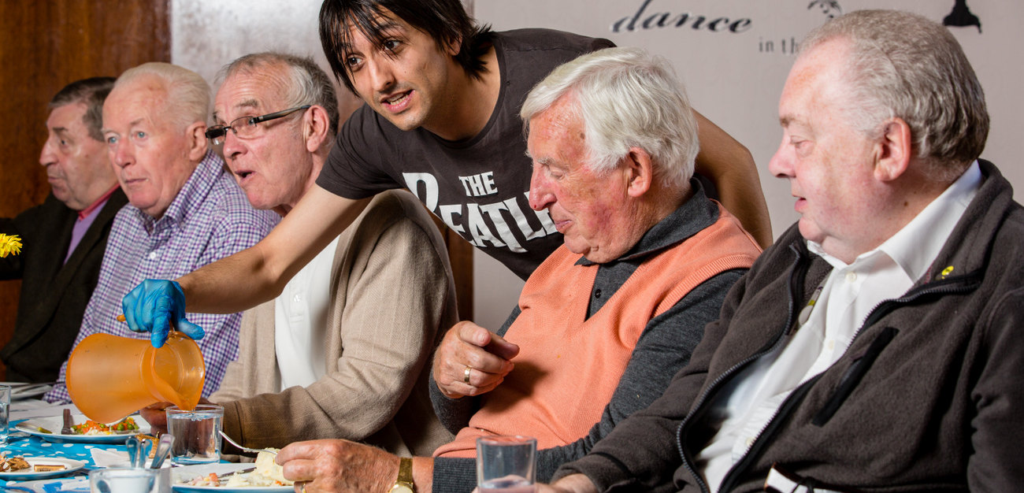

Introduction
Falkirk Health and Social Care Partnership (HSCP) delivers adult social care services and community health services in the Falkirk area. Our vision, as set out in the Strategic Plan, is “to enable people in the Falkirk HSCP area to live full and positive lives within supportive and inclusive communities.”

We are committed to ensuring people who need support have a range of options available to them so they can decide which is the best fit for their circumstances, needs, and wishes. We know that for many people they prefer receiving informal support within their own community. This type of community-led support can take many forms and is likely taking place in a community centre or church hall near you.

Community-led support projects might be called lunch clubs, social clubs, Darby and Joan clubs, or they might be centred around a specific theme like taking part in an exercise class, enjoying a meal, listening to live music, or playing bingo together. Often these services will cater for older people, but that is not always the case.

These provide opportunity to socialize and take part in regular enjoyable and meaningful activities. Many of these projects and services are entirely volunteer-led and often begin with someone seeing a need in their own community and feeling compelled to take action to meet that need.

We want it to be straight forward for people to get involved in leading and delivering community-led support options for the benefit of others in your area. We know it’s a lot of work to run community services and projects and we want to support you as much as we can. This resource pack is intended to give you the information, tools, and resources to get started.
To promote and facilitate a rich and varied landscape of community-led support options in the Falkirk area, Falkirk HSCP has put together this resource pack to provide a guide to the areas of service delivery that the HSCP expect groups or organisations to be aware of. This guide is particularly important for groups in receipt of funding or considering applying for funding.

While the legal status and expectations of community-led projects and settings differ from more formal, regulated services, there is still a need to ensure that they meet an acceptable standard that minimizes the risk of harm to the vulnerable people who participate and all others involved, such as volunteers or group committee members.

We do not expect everyone to be an expert, but we do expect a commitment to the areas noted below. The resources available in this pack will support you to achieve this.

Health and Safety
Groups and organisations providing a service or activity for community members must take steps to ensure the health and safety of everyone involved. A Health and Safety Policy is a good way to state your commitment to this and to set out how you will safely deliver your service. You can also highlight what you will do to make sure you are reducing the risk of harm, as much as is reasonably practicable.

Regular risk assessments should also be completed on the areas of your work that would warrant an assessment, so that the controls put in place to reduce the risks present in your service are proactive, current, and effective.

SAFEGUARDING
The Scottish Council for Voluntary Organisations (SCVO) tell us that “Safeguarding basically means ensuring that there are measures in place to make sure that beneficiaries and others who come into contact with your organisation are protected from harm.”

Where your group or organisation provides services for people who are vulnerable, safeguarding merits some extra attention as vulnerable people are often at increased risk of harm. Your service and your volunteers can be an important part of identifying someone who is being harmed, or is at risk of harm, and it is essential that any information or concerns that can help the individual to receive the support they need, is passed on to the right person(s).

A good Safeguarding Policy will state your commitment to making sure all people involved with your organisation are kept safe and include the steps that should be taken when there are concerns that someone is being harmed or is at risk of being harmed. Having a clear process in place helps to give everyone the confidence to act on any concerns they have, in an appropriate way.

REPORTING AND EVALUATION
It is important for all groups and organisations to evaluate and report on the work they do. This allows everyone involved to understand more about the services you provide. It allows you to plan effectively as you’ll know what is working well and where improvements could be made, and it demonstrates that you value the thoughts and opinions of those that use your service.

Good reporting and evaluation will help you to celebrate and promote the good work that you do and show funders the difference you are making in your community. It will highlight the supportive environment you are providing, the positive relationships developed by your volunteers and service users, and the enjoyable experiences your service users are having.

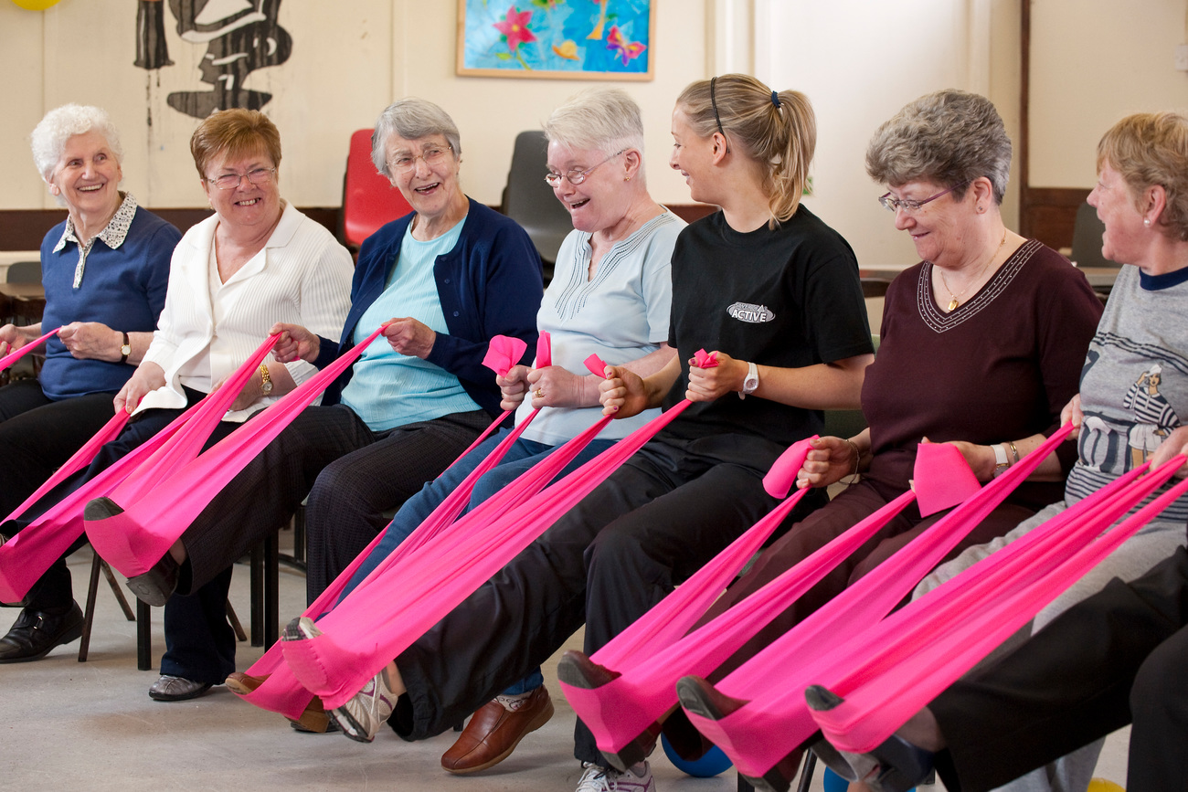

Volunteering Information
Many community-led support projects and services are entirely volunteer-led. This includes volunteers on the Board or Committee of Third Sector groups or organisations, as well as the volunteers who help to deliver services.

Volunteers who are part of a Board or Committee help to oversee the affairs and activities of their group or organisation and provide strategic direction. Some of them might take on a special role, such as Chair, Vice Chair, Secretary or Treasurer. Other volunteers can help with practical tasks such as welcoming people who attend the service and making sure they are adequately supported to participate, helping with preparing and serving food and drink, and helping with cleaning and tidying up the premises.

FREE RESOURCES
There are plenty of free resources available to help you recruit, manage, and work well with volunteers in your community. For support and guidance on volunteering, we recommend visiting CVS Falkirk, Volunteer Falkirk, and Volunteer Scotland. See Useful Links page for further information.

CVS Falkirk and Volunteer Falkirk are the Third Sector Interface (TSI) for the Falkirk area. They are funded by Scottish Government and Falkirk Council to provide services and support for the third sector who operate in communities across our Local Authority area. This includes third sector groups and organisations who deliver community-led support.

Volunteer Scotland is a national body dedicated to supporting volunteer-involving organisations (VIO) across Scotland, they also provide a service allowing VIOs to access PVG checks for their volunteers when needed, free of charge.

PVG MEMBERSHIP SCHEME
The Protecting Vulnerable Groups (PVG) membership scheme exists to help ensure that people whose behaviour makes them unsuitable to do what is called ‘regulated work’ with children and/or vulnerable adults don’t take up either volunteer or paid roles.

For volunteers, Volunteer Scotland can offer free PVG checks for third sector groups and organisations where the volunteer’s role falls into the category of ‘regulated work’ with children and/or vulnerable adults. To access these free PVG checks the group or organisation must first register with Volunteer Scotland. This is called Enrolling an Organisation. Volunteer Scotland does provide step-by-step instructions on their website, but support is also available via CVS Falkirk to help you go through this process, for help enrolling your group or organisation, or with any other aspect of completing PVG checks for your volunteers. Contact CVS Falkirk by email: info@cvsfalkirk.org.uk.

Not every volunteer role is considered ‘regulated work’, but it is likely, when providing a service for older or vulnerable people in your community, that some of your volunteers will require a PVG check to be carried out.

YOUR VOLUNTEER PROGRAMME
Creating a Volunteer Policy shows your commitment to working well with your volunteers and informs everyone of what they can expect when volunteering with your group or organisation.

When planning how you’d like your volunteer programme to operate, it can be helpful to break down the experience volunteers have with your group or organisation into three parts: before, during, and after.

‘Before’ includes the time from the volunteer learning about the opportunity, getting in touch with your organisation, and starting to volunteer. Some helpful questions to consider are:

- How will volunteers find out about the opportunity to help? Will you have a social media presence? Will you ask CVS Falkirk to help promote your volunteer roles?
- What happens when volunteers get in touch to offer their help? Is there a specific person who will deal with these enquiries? Will you have a standard ‘volunteer information’ pack or document you can send to them so they can find out more about you?
- Will they complete an application form? Will you ask for references? Which roles require a PVG check to be completed? Who will take the decision that the individual is a good fit for the volunteer role and should begin helping you?
‘During’ includes the time that your volunteer is actively involved in helping your group or organisation, from their first day to their last. Some questions to consider are:

- How will you provide each volunteer with an induction when they begin? Who will welcome the volunteer in the first instance and make sure they have all the information they need to safely complete their role? Will you complete a risk assessment with respect to any individual volunteers to improve their experience, for example where they are a wheelchair user or an inexperienced young person?
- Will volunteers need any specific training to undertake their role? Who will arrange for this training to be completed?
- Who will act as a contact point for volunteers so if they have any questions or concerns, they know who to bring these to and how to contact them? If any questions or concerns are raised about a volunteer, who will address these?
- What can you put in place to ensure that the volunteer receives regular contact with their volunteer contact, or another person who acts in a supervisory role, so that they can both give and receive feedback about their volunteer experience? How will you ensure that you regularly thank your volunteers, celebrate their contributions and the impact they have, and make sure they feel like a valued part of your group or organisation?
- Will your volunteer receive expenses for travel or other costs incurred in their volunteer role? If they will, how will you expect them to give you the information you need to pay these and what proof will you ask for, for example receipts or bus tickets?
‘After’ includes the time after the volunteer has stopped helping. Volunteers need to end their volunteering experience for many reasons and ensuring you end this relationship well can bring many benefits. Some questions to consider are:

- What can you learn from taking the time to end a volunteer’s experience well? Will you complete an ‘exit interview’ so you can get helpful feedback about their experience? Could you ask the volunteer’s permission to share information about their experience that could be included in your reporting and evaluation – a ‘case study’?
- If a volunteer feeds back that some of their experience has not been positive, or wants to make some suggestions for improvement, who will investigate how this feedback can be used to improve the volunteer experience in future?

Health and safety & Risk Assessment/ Management Information
Health and safety, and risk assessment and management, are an important part of providing any service. This doesn’t need to be too complicated, and many groups and organisations will have their own health and safety policy alongside risk assessments to cover areas where the risk of harm must be addressed, such as fire safety.

There are lots of resources available online that provide information and resources on the topic of health and safety. We recommend becoming familiar with the websites of the Health and Safety Executive (HSE) and Healthy Working Lives (HWL). These are trusted sources of information and contain helpful material about health and safety and risk management.

Both HSE and HWL provide guidance, tools, and templates on creating a health and safety policy that are free to use.

As both resources note, a health and safety policy should cover the following points:
- The intent or purpose of the policy,
- The responsible person for health and safety within your group or organisation, and
- Information that tells the reader how your group or organisation manages health and safety.

By including these areas, the policy will let everyone understand what they need to know about health and safety in the environment they are working or volunteering in, as well as providing a point of contact so if they have any questions or issues, they are able to bring these to the attention of the appropriate person easily.

The following document is a sample health and safety policy that you are free to use. It is a basic policy that can be adopted by a range of different groups and organisations to add and adapt it to fit their own needs.

Below are some tips to guide you in creating an environment with a level of health and safety awareness that is likely to be a good fit for a community-led support project or service:
- You must have the appropriate level and type of insurance cover for your needs. There are some insurers who specialise in third sector groups and organisations and you can have a conversation with them to discuss the most suitable option for your needs. See Useful Links page for a list of insurance providers.
- Fire safety is an important part of your health and safety considerations. If people with varied mobility needs use your service, their needs with respect to fire safety merit some special attention. It is likely to require extra coordination to safely evacuate a group of people when some of them use mobility aids or move more slowly than able-bodied participants.
- If your service provides a light meal and refreshments, storing and serving food and drink items requires a risk assessment to protect everyone from common issues.

Resources
The remainder of this pack contains sample policies and templates to support your group or organisation to get started.

You can amend these templates as required for your organisation’s needs.

If you require a paper copy of this resource pack, please contact: integration@falkirk.gov.uk

CONTENTS
Sample Volunteering Policy
Sample Volunteering Induction Checklist
Health and Safety and Risk Assessment/Management Information
Sample Health and Safety Policy
Blank Risk Assessment Template
Pre-Populated Risk Assessment Templates
Sample Safeguarding Adults Policy
Useful Links

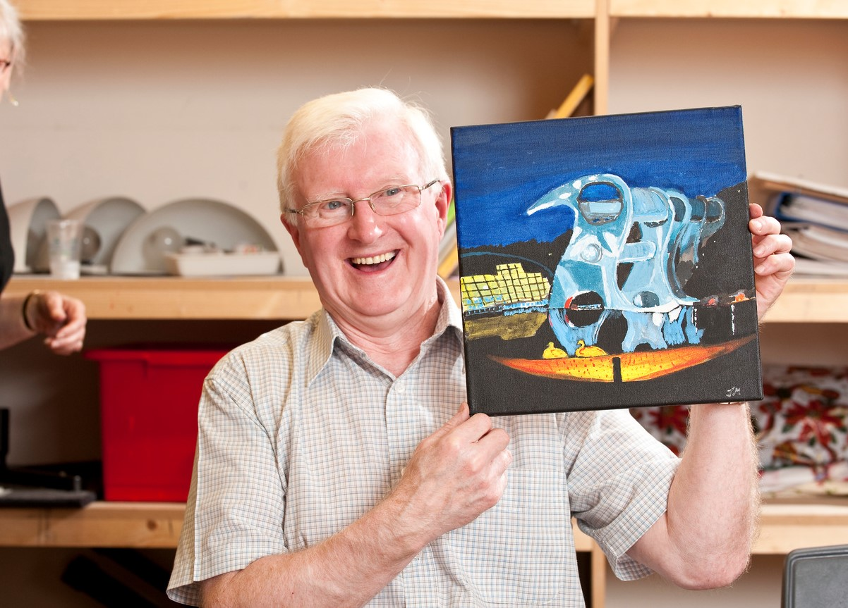

Sample Volunteering Policy

Introduction
In line with our organisational mission, aims and objectives, we seek to involve volunteers to:
- Assist us in carrying out the services that we offer
- Expand the skills, experience, and diversity within the organisation
- Provide wider perspectives to inform the direction of our work
- Maintain a link to the communities in which we work

Principles
- We will seek to involve volunteers as inclusively as we can, wherever practical and as allowed by available resources and in the interests of our services.

- We will seek to always be clear with our volunteers as to the nature of their role with us, the duties they are given responsibility for as a volunteer and the procedures and methods that should be observed.

- We will ensure that all volunteers are offered training of relevance to their role to improve their ability to carry out that role.

- We will ensure that adequate regard is given to the health and safety of all volunteers working with us, that appropriate measures are put in place to reasonably assure this, and that volunteers have all the equipment, support and guidance needed to carry out their role safely.

- We will provide adequate opportunities to volunteers for supervisory support, as well as advice and guidance in their roles, and opportunities for emotional support as appropriate.

- We will involve our volunteers in contributing to the ongoing development of our service and the development of good practice within that. As far as is reasonable and practical, their views and opinions will also contribute to the direction of our organisational strategy.

- We will ensure that all appropriate and relevant expenses incurred by volunteers in the proper execution of assigned duties are reimbursed to the volunteer.

- We expect all members of our organisation to value the contributions of volunteers, and work alongside them in a positive and encouraging way.

- We will ensure that our organisational procedures for volunteer involvement are regularly checked for effectiveness, efficiency, and clarity.

- We recognise that responsibility for volunteer management requires designated roles within the organisation, and particular skills and training. We will support staff and volunteers undertaking such roles appropriately.

Guidelines: Recruitment and selection of volunteers
Volunteers will ideally be recruited from a wide cross-section of the community, and we will seek to ensure that our volunteers represent the community we operate in.

Volunteers expressing interest in involvement with the organisation will normally be invited for an informal meeting to discuss the role(s) that they may be interested in and their suitability for them. They will be given an information pack which will include clear role profiles of any relevant volunteer roles, and any relevant supporting information or background data to support the volunteer to make an informed choice.

All volunteers wishing to proceed in applying for a role will be asked to complete a standard application form and provide detailed contact information and any information requested by the role profile.

Where a post involves contact with Vulnerable Groups or entails positions of trust, a volunteer may be asked to complete a Disclosure application so that we can complete a PVG check to ensure their suitability

Induction and Training
Each volunteer will be given a copy of the role profile for the volunteer role(s) they agree to undertake. This will clearly outline the duties and responsibilities involved, and any requirements, training and/or equipment needed. All documents will clearly state that there is no intention to create a contract with volunteers or any relationship of employment.

We will ensure that any relevant training or equipment is provided. Where training is essential to enable the volunteer to carry out their role, this will always be provided by the organisation or paid for if being provided externally.

When starting a new role with the organisation, all volunteers will be given an induction which will include relevant training, as well as an introduction to the organisation and the area of work they will be participating in, introduction to staff and volunteers they may be working with, and details of where they can seek advice or support as part of their volunteering experience.

All volunteers will have a named person(s) as a point of contact, volunteer management and support, as well as details of whom to contact in the event of a problem arising that they are unable to raise with their primary contact(s).

We will provide volunteers with a supportive environment. They will feel able to raise any issues at the earliest opportunity so their concerns can be addressed.

Expenses
We will have a clear and transparent policy for the reimbursement or paying by the organisation of any relevant and reasonably incurred volunteer expenses (such as travel costs from the volunteer’s home to their place of volunteering, reasonable subsistence during period of volunteering away from home, etc).

Only expenses that have been reasonably incurred and have been authorised by the appropriate volunteer supervisor or manager shall be paid.

At no time will any arrangement of payment for expenses be entered into which could create an effective benefit to the volunteer and lead to a potential impression of an employment relationship.

Health and Safety
All volunteers are covered by a Health and Safety policy and risk assessment procedure and are required to understand it and abide by it.

Volunteers will be made aware of the risk assessments for their roles, any action they are required to take to enhance health and safety, and any safety equipment that must be used.

All volunteers will be covered by appropriate insurance by the organisation while engaged in activities relating to organisation work and relevant to their role descriptions.

Volunteers will be made aware of the nature of the insurance cover and any requirements placed upon them to remain covered by it.

Volunteers driving their own private vehicles during volunteer work will be required to take steps to ensure they are insured to do so and provide evidence of this to the organisation.

Confidentiality
Volunteers are entitled to confidentiality with respect to any personal information they share with our organisation for the purpose of their volunteering and where volunteers may come into possession of confidential information about the organisation, staff, other volunteers, or any service users of the organisation, they are required to treat that information with respect and maintain its confidentiality.

Exit Interviews
When a volunteer leaves the organisation, we will generally seek to hold an exit interview. The purpose of the exit interview is to capture any learning for the organisation, as a chance to recognise the effort that has been given to the organisation by the volunteer, and to allow us to help volunteers to recognise what they have gained in terms of personal development from their time with us.

Sample Volunteer Induction Checklist

Volunteer Name |  | Volunteer Role
Start Date |  | Induction Completed

 | Welcome to the organisation | Date | Inductor Initials
1 | Tour of the building
2 | Background information about the organisation including name, brand, and legal status
3 | Introduced to staff/volunteers in the organisation and their roles explained
4 | Knows who is responsible for health and safety and knows their own role in terms of health and safety
5 | Emergency Fire Action Plan (alarm activation, exits, extinguisher location and action notice) including signing in/out board.
6 | Accident, Incident and Near Miss Policy and Reporting
7 | First Aid Kit and First Aiders identified
8 | Knows what to do in the event of an emergency – who to speak to, what action to take etc.
9 | Housekeeping Rules
10 | Accessibility, including parking, lift, toilets, and reasonable adjustments.
 | Your role | Date | Inductor Initials
11 | Your role within the organisation
12 | Engaging with clients
13 | Guidelines to fulfilling your role
14 | Contacting your Volunteer Supervisor
15 | Completing timesheets
16 | Reimbursement of expenses
17 | Understands how to request time off
18 | Organisation Policies and Procedures: access to and understand the details
19 | Dress Code
20 | Received a copy of the Volunteer Information pack
 | Personal Details | Date | Inductor Initials
22 | Personal Details form
23 | Emergency Contact form
25 | PVG membership/record update (if required)
26 | Documents required for reimbursement of travel expenses
27 | Date for initial review meeting

On completion of induction: 1 copy to the volunteer, 1 copy in organisation’s file

Volunteer Signature |  | Date

Sample Health and Safety Policy
The Health and Safety policy of organisation name sets out how we will take all steps that are reasonable and practical to ensure the health and safety of our volunteers and all others involved in the services we deliver, including participants/service users.

This policy is intended to be a working document that is freely available to all volunteers and will be reviewed at regular intervals, ideally once a year, and more regularly where the operating environment and/or other factors dictate that this is appropriate.

Organisation name is committed to the following in respect to health and safety, and risk management, in all our activities:

- To assess and provide adequate control of the health and safety risks arising from our activities.
- To regularly complete risk assessments on the aspects of our work which warrant this.
- To make this policy and associated risk assessments available to all volunteers, in a format that meets their needs.
- To consult with our volunteers on matters affecting their health and safety.
- To ensure all volunteers can undertake their roles safely, and to give them the training, guidance and support they need to do so.

Within organisation name, the following person takes overall responsibility for health and safety, and risk management. Any queries or concerns about this are of work should be directed to them in the first instance:

Name:
Position:
Contact info:
Signed:
Date:

It is the responsibility of all volunteers and representatives of organisation name to co-operate with this policy and the actions dictated by the associated risk assessments. Whilst named person and organisation name take overall responsibility for health and safety, it is wholly necessary that all persons involved adhere to the instructions and guidance given, to avoid harm to themselves and others.

Please find below guidance on the management of health and safety in respect to these aspects of our service delivery:
- Reporting accidents, near misses and ill health
- First Aid arrangements
- Fire Safety
- Control of Substances Hazardous to Health (COSHH)
- Food Hygiene and Safety
- Induction and Training

Blank Risk Assessment Template

Rating | Likelihood (L) | Severity (S)
1 | Extremely unlikely | Minor injury or disease, no time lost
2 | Unlikely | Injury or disease with up to 3 days lost
3 | Likely | Reportable injury or disease more the 3 days lost
4 | Very Likely | Major injury with long term absence
5 | Extremely likely | Almost certain death

Multiply the ratings for Likelihood (L) and Severity (S) (see below):

 | Severity (S)
Likelihood (L) | 1 | 2 | 3 | 4 | 5
1 | 1 | 2 | 3 | 4 | 5
2 | 2 | 4 | 6 | 8 | 10
3 | 3 | 6 | 9 | 12 | 15
4 | 4 | 8 | 12 | 16 | 20
5 | 5 | 10 | 15 | 20 | 25

If the risk multiplication lies above the step mark, it is adequate for the action to be recorded on the Health and Safety Risk Assessment Record.

If the risk multiplication is beneath the step mark, then the action shall be either:
The basis of, or be included in, a standing instruction procedure
Modification to the existing installation, or the procurement of equipment, training, or specific supervision to combat the hazard

Location | The organisation’s premises | Date of Assessment |  | Date of  Last Assessment
Work Activity |  |  |  | Assessment  Record Number

Operation or Process | Significant Risk or Hazard | Who is at Risk | Likelihood | Severity | Risk Classification | Preventative/ Control Measures | Final Risk Classification

Assessment carried out by |  | Signed
Date |  | Review assessment before

Risk Assessment (First Aid)

Rating | Likelihood (L) | Severity (S)
1 | Extremely unlikely | Minor injury or disease, no time lost
2 | Unlikely | Injury or disease with up to 3 days lost
3 | Likely | Reportable injury or disease more the 3 days lost
4 | Very Likely | Major injury with long term absence
5 | Extremely likely | Almost certain death

Multiply the ratings for Likelihood (L) and Severity (S) (see below):

 | Severity (S)
Likelihood (L) | 1 | 2 | 3 | 4 | 5
1 | 1 | 2 | 3 | 4 | 5
2 | 2 | 4 | 6 | 8 | 10
3 | 3 | 6 | 9 | 12 | 15
4 | 4 | 8 | 12 | 16 | 20
5 | 5 | 10 | 15 | 20 | 25

If the risk multiplication lies above the step mark, it is adequate for the action to be recorded on the Health and Safety Risk Assessment Record.

If the risk multiplication is beneath the step mark, then the action shall be either:
The basis of, or be included in, a standing instruction procedure
Modification to the existing installation, or the procurement of equipment, training, or specific supervision to combat the hazard

Location | The organisation’s premises | Date of Assessment |  | Date of  Last Assessment
Work Activity |  |  |  | Assessment  Record Number

 | Operation or Process | Significant Risk or Hazard | Who is at Risk? | Likelihood | Severity | Risk Classification | Preventative/ Control Measures | Final Risk Classification
1 | Operating our group name at premises for client group | Risk of injury, harm or illness that would benefit from first aid provision | Every person involved in operations –staff, volunteer, service users/participants, and any others visiting the premises for any reason (for example, trades people) | 3 | 3 | 9 | The organisation takes all reasonably practicable steps to ensure the health and safety of all participants, staff and volunteers but understand that illness, injury, or harm can still occur, and that no environment is entirely risk-free. Where illness, injury or harm that takes place can benefit from first aid provision we have the following in place to ensure we can provide this help in a safe and appropriate way  A fully stocked, regularly checked, and maintained first aid kit is available at location within premises – person’s name is responsible for the maintenance and upkeep of this kit, including replacing items that are used when first aid is applied at group name.  The organisation ensures that first aid training is available to an adequate number of staff/volunteers so that during each session of group name there will be a person with first aid training present, the following staff/volunteers have current first aid training:  person’s name  person’s name  person’s name  All incidences where first aid is applied at group name will be recorded for our records as well as to ensure that steps can be taken to prevent further injury or harm where possible.  All staff and volunteers will be made aware of the location and purpose of the accident book, and their responsibilities in relation to this, during their induction. | 6

Assessment carried out by |  | Signed
Date |  | Review assessment before

Risk Assessment (Accidents, Incidents & Near Misses)

Rating | Likelihood (L) | Severity (S)
1 | Extremely unlikely | Minor injury or disease, no time lost
2 | Unlikely | Injury or disease with up to 3 days lost
3 | Likely | Reportable injury or disease more the 3 days lost
4 | Very Likely | Major injury with long term absence
5 | Extremely likely | Almost certain death

Multiply the ratings for Likelihood (L) and Severity (S) (see below):

 | Severity (S)
Likelihood (L) | 1 | 2 | 3 | 4 | 5
1 | 1 | 2 | 3 | 4 | 5
2 | 2 | 4 | 6 | 8 | 10
3 | 3 | 6 | 9 | 12 | 15
4 | 4 | 8 | 12 | 16 | 20
5 | 5 | 10 | 15 | 20 | 25

If the risk multiplication lies above the step mark, it is adequate for the action to be recorded on the Health and Safety Risk Assessment Record.

If the risk multiplication is beneath the step mark, then the action shall be either:
The basis of, or be included in, a standing instruction procedure
Modification to the existing installation, or the procurement of equipment, training, or specific supervision to combat the hazard

Location | The organisation’s premises | Date of Assessment |  | Date of  Last Assessment
Work Activity |  |  |  | Assessment  Record Number

 | Operation or Process | Significant Risk or Hazard | Who is at Risk? | Likelihood | Severity | Risk Classification | Preventative/ Control Measures | Final Risk Classification
1 | Operating our group name at premises for client group | Details of accidents, incidents and near misses go unrecorded, this presents a risk to the organisation where this information may be needed in future (for example for insurance purposes) as well as not allowing for learning to take place and improvements to health and safety based on this to be made | Every person involved in operations –staff, volunteer, service users/participants, and any others visiting the premises for any reason (for example, trades people) | 3 | 3 | 9 | The organisation takes all reasonably practicable steps to ensure the health and safety of all participants, staff and volunteers but understand that illness, injury, or harm can still occur, and that no environment is entirely risk-free. For our own records and to ensure continued learning and improvement around health and safety we record all accidents, incidents and near misses in our accident book which is available at location within premises.  Person’s name, who takes overall responsibility for health and safety within the organisation, is responsible for the ongoing review of the contents of the accident book and for risk assessment and subsequent implementation of controls identified through information gathered about accidents, incidents and near misses  All staff and volunteers will be made aware of the location and purpose of the accident book, and their responsibilities in relation to this, during their induction. | 6

Assessment carried out by |  | Signed
Date |  | Review assessment before

Risk Assessment (Training Induction)

Rating | Likelihood (L) | Severity (S)
1 | Extremely unlikely | Minor injury or disease, no time lost
2 | Unlikely | Injury or disease with up to 3 days lost
3 | Likely | Reportable injury or disease more the 3 days lost
4 | Very Likely | Major injury with long term absence
5 | Extremely likely | Almost certain death

Multiply the ratings for Likelihood (L) and Severity (S) (see below):

 | Severity (S)
Likelihood (L) | 1 | 2 | 3 | 4 | 5
1 | 1 | 2 | 3 | 4 | 5
2 | 2 | 4 | 6 | 8 | 10
3 | 3 | 6 | 9 | 12 | 15
4 | 4 | 8 | 12 | 16 | 20
5 | 5 | 10 | 15 | 20 | 25

If the risk multiplication lies above the step mark, it is adequate for the action to be recorded on the Health and Safety Risk Assessment Record.

If the risk multiplication is beneath the step mark, then the action shall be either:
The basis of, or be included in, a standing instruction procedure
Modification to the existing installation, or the procurement of equipment, training, or specific supervision to combat the hazard

Location | The organisation’s premises | Date of Assessment |  | Date of  Last Assessment
Work Activity |  |  |  | Assessment  Record Number

 | Operation or Process | Significant Risk or Hazard | Who is at Risk? | Likelihood | Severity | Risk Classification | Preventative/ Control Measures | Final Risk Classification
1 | Staff and volunteers staffing group name at the premises | Staff and volunteers receiving no, or inadequate, induction and training to allow them to carry out their role safely and competently. | Every person involved in operations –staff, volunteer, service users/participants, and any others visiting the premises for any reason (for example, trades people) | 3 | 3 | 9 | The organisation understands that each staff member and volunteer who helps with the delivery of group name must have an appropriate induction process before they begin their role and undertake any relevant training, so they are supported to carry out their role safely and feel confident in doing so.  It is the responsibility of person’s name, to ensure an induction is carried out before a new staff member or volunteer begins their role, and for continuity each induction process will be recorded using the organisation name induction checklist, this will be signed by both parties on completion.  Where it is necessary person’s name will ensure the staff member or volunteer is able to access any relevant training promptly, and they will confirm the completion of same.  Each staff member or volunteer will have a clearly defined point of contact for any questions or issues (a line manager or volunteer supervisor) and they will have the information they need to contact this person when they need to. Volunteers and staff are encouraged to highlight any training needs or concerns so this can be remedied.  Volunteers and staff will have regular support and supervision sessions with their line manager or volunteer supervisor during which there will be opportunity to discuss training needs and both parties can share their ideas about how other forms of training or support can help them carry out their role to the best of their ability. | 6

Assessment carried out by |  | Signed
Date |  | Review assessment before

Risk Assessment (COSHH)

Rating | Likelihood (L) | Severity (S)
1 | Extremely unlikely | Minor injury or disease, no time lost
2 | Unlikely | Injury or disease with up to 3 days lost
3 | Likely | Reportable injury or disease more the 3 days lost
4 | Very Likely | Major injury with long term absence
5 | Extremely likely | Almost certain death

Multiply the ratings for Likelihood (L) and Severity (S) (see below):

 | Severity (S)
Likelihood (L) | 1 | 2 | 3 | 4 | 5
1 | 1 | 2 | 3 | 4 | 5
2 | 2 | 4 | 6 | 8 | 10
3 | 3 | 6 | 9 | 12 | 15
4 | 4 | 8 | 12 | 16 | 20
5 | 5 | 10 | 15 | 20 | 25

If the risk multiplication lies above the step mark, it is adequate for the action to be recorded on the Health and Safety Risk Assessment Record.

If the risk multiplication is beneath the step mark, then the action shall be either:
- The basis of, or be included in, a standing instruction procedure
- Modification to the existing installation, or the procurement of equipment, training, or specific supervision to combat the hazard

Location | The organisation’s premises | Date of Assessment |  | Date of  Last Assessment
Work Activity |  |  |  | Assessment  Record Number

 | Operation or Process | Significant Risk or Hazard | Who is at Risk | Likelihood | Severity | Risk Classification | Preventative/ Control Measures | Final Risk Classification
1 | Staff, volunteers, or others within the organisation being exposed to and/or using substances which can be described as ‘hazardous to health’ and are subject to COSHH (control of substances hazardous to health) for the purpose of keeping the premises clean | These substances causing a range of harms through, for example, skin contact, ingestion, inhalation | Every person who uses or comes into contact with and/or uses these substances – others who could gain access to them when they shouldn’t (for example children or others who may not know to take necessary precautions) | 2 | 4 | 8 | The organisation takes all reasonably practicable steps to ensure that any staff, volunteers, or others are protected from the risk of harm inherent in using some substances that could be hazardous to their health. In the context of group name the substances are cleaning products. It is not possible nor appropriate for us to avoid the use of these and so the following controls are in place to minimise the risk of harm:  Cleaning products such as bleaches, floor cleaners and anti-bacterial sprays are kept in location which has a door that can be locked to keep these out of the way and restricts access to only those who need to use them for their role. Person’s name is the keyholder for this space  The organisation makes single-use protective gloves available for all staff and volunteers to use to protect them from irritation and damage to the skin through contact with cleaning materials  All staff and volunteers should ensure that adequate ventilation is enabled during the use of cleaning products, we do this at the premises by opening the windows during periods of cleaning, before/after group name.  All staff and volunteers are aware of this risk assessment and feedback is both asked for and encouraged so we can improve same – where any staff member or volunteer feels that they are being adversely impacted by the use of cleaning products (such as dry or sore skin, or exacerbation of dermatitis, or of asthma with being exposed to fumes) the organisation, as a priority, will review their role and make adjustments with their health and safety in mind | 4

Assessment carried out by |  | Signed
Date |  | Review assessment before

Sample Safeguarding Adults Policy
Introduction
Adult safeguarding describes how individuals and organisations should work together to identify, prevent, and end abuse and neglect. Adult abuse can occur in many different settings and situations and staff, trustees and volunteers need to be aware of situations which may put a vulnerable adult at risk.

For older people getting this right is critical, as those aged 65 and over are at the greatest risk of abuse and neglect. organisation name believes in protecting an adult’s right to live safely, free from abuse and neglect.

This policy ensures that organisation name has all the right things in place to protect and safeguard adults. It also sets out the roles and responsibilities of organisation name in working together in promoting the adult’s welfare and safeguarding them from abuse and neglect.

This policy and related procedures are applicable to the Chief Executive Officer, trustees, staff, and volunteers of organisation name. It applies to all aspects of our work and will promote and safeguard the welfare of adults at risk. Failure to comply with the policy and related procedures will be addressed without delay and may ultimately result in dismissal/exclusion from the organisation.

Roles and Responsibilities
Everyone has a responsibility to safeguard and promote the welfare of adults at risk and all staff and volunteers must be clear about the actions they must take if they have concerns about adults at risk.

The purpose of this policy is:
- to safeguard and protect adults at risk who receive organisation name services,
- promote good practice for safeguarding adults at risk, and
- to ensure that everyone understands their responsibilities and allow all staff and volunteers to make informed and confident responses to specific issues.

Key Principles of Adult Safeguarding
In Scotland, The Adult Support and Protection (Scotland) Act 2007 exists to protect adults from harm, including physical, financial, sexual, and psychological abuse, neglect, and discrimination.

An Adult at Risk is defined by the Act as an adult aged 16 or over who is:
- unable to protect themselves from someone harming them, or from exploitation and neglect or safeguard their own well-being, property, rights, or other interests,
- is at risk of harm, and
- are affected by disability, mental disorder, illness or physical or mental infirmity, so they are more vulnerable to being harmed than adults who are not so affected.

All three of these criteria must be met.

Designated Safeguarding Lead
Person’s name is the Designated Safeguarding Lead at organisation name and can be contacted on contact details.

The main responsibilities of the designated professional for safeguarding include providing support and guidance to colleagues as well as making sure that all staff and volunteers:
- know how to raise safeguarding concerns
- understand the symptoms of abuse and neglect
- know how and where to refer any concerns

Recognising the signs of abuse
Staff, trustees, and volunteers are well-placed to identify abuse as the adult may say or do things that let you know something is wrong. It may come in the form of a disclosure, complaint, or an expression of concern. Everyone within the organisation should understand what to do, and where to go to get help, support, and advice.

Types of Abuse
These are not exhaustive but are a guide to behaviour that may lead to a safeguarding enquiry. This includes:
- Physical abuse
- Domestic Violence or Abuse
- Exploitation
- Sexual abuse
- Psychological abuse
- Financial or material abuse
- Modern slavery
- Discriminatory abuse
- Organisational abuse
- Neglect and acts of omission
- Self-neglect

Reporting Concerns
Any staff member, trustee or volunteer who becomes aware that an adult is or is at risk of, being abused must raise the matter immediately with the organisation’s designated safeguarding lead. Early sharing of information is the key to providing an effective response where there are emerging concerns. If the adult requires immediate protection from harm, contact the police and Social Work Adult Services.

All staff and volunteers who work with adults at risk are expected to report their concerns if they believe an adult is at risk. To ensure effective safeguarding arrangements no one should assume that someone else will do it.

Recording and Record Keeping
A written record must be kept about any concern regarding an adult with safeguarding needs. This must include details of the person involved, the nature of the concern and the actions taken, decision made and why they were made.

All records must be signed and dated. All records must be securely and confidentially stored in line with General Data Protection Regulations (GDPR).

Describe your organisation’s requirements for recordings details about the incident. Explain where the information should be recorded, in what format, and who should have access to the information. For example, many organisations have an incident form or a log of safeguarding concerns, which is kept by the organisation’s designated safeguarding lead. Records should be written at the time of the event, dated and signed. Keep records about safeguarding concerns confidential and in a location where the alleged abuser will not have access to the record. Access should not be given to any unauthorised personnel for accessing confidential information including the sharing of passwords. Include a link to your organisation’s Privacy Policy.

Incidents of abuse may be one-off or multiple and may affect one person or more. Staff and volunteers should look beyond single incidents to identify patterns of harm. Accurate recording of information will also assist in recognising any patterns.

Confidentiality and Information Sharing
organisation name expects all staff, volunteers, and trustees to maintain confidentiality. Information will only be shared in line with the General Data Protection Regulations (GDPR) and Data Protection.

However, information should be shared with Social Work Adult Services if an adult is deemed to be at risk of harm or contact the police if they are in immediate danger, or a crime has been committed.

Safe Recruitment & Selection
organisation name is committed to safe employment and safe recruitment practices, that reduce the risk of harm to adults with care and support needs from people unsuitable to work with them.

Safe recruitment practices, such as Protecting Vulnerable Groups (PVG) scheme reduce the risk of exposing adults with care and support needs to people unsuitable to work with them. We will check whether the roles we offer should be subject to PVG membership and where appropriate we will use these checks to help us assess the suitability of staff or volunteers to fill those roles.

Disclosure Scotland checks and shares information about people’s criminal records. This will help us to make safer recruitment decisions and prevent unsuitable people from working with vulnerable groups.

We will provide an induction for all new staff and volunteers and provide appropriate training to enable all personnel to undertake their roles safely and confidently. We will also provide ongoing training as benefits the personal and professional development of individuals and of our organisation.

Training and Awareness
organisation name will ensure that all staff, trustees, and volunteers receive basic awareness training on safeguarding adults as they may come across adults with care and support needs who may be at risk of abuse. Those adults may report things of concern to staff or volunteers who should be equipped with the basic knowledge around safeguarding adults and be confident to identify that abuse is taking place and action is required. All staff, trustees, and volunteers should be clear about the core values of organisation name and commitment to safeguarding adults.

Reporting Concerns about a Colleague
If the behaviour of a member of staff or volunteer towards adults causes concern this must be reported. Do not dismiss your concerns, do not confront the person about whom you have concerns, and your concerns must be discussed with the designated safeguarding lead.

organisation name assures that it will fully support and protect anyone, who in good faith reports their concerns that a colleague may or may not be abusing a vulnerable person.

When allegations of abuse are made against a member of staff or volunteer, whether the abuse is happening currently or has happened in the past, the matter will be reported to the Local Authority to investigate.

Reporting a Concern
Anyone who has a concern regarding the safety of an adult at risk, or the behaviour of an adult at risk should contact Social Work Adult Services immediately.

Monday to Friday, 9am to 5pm, call: 01324 506070
All other times, call: 01786 470500 or email: asp@falkirk.gov.uk

If it’s an emergency, always dial 999

If it is not an emergency, you can contact Police Scotland on 101

Useful Links

RESOURCES
CVS Falkirk
Home - Volunteer Falkirk
Volunteer Scotland | Help Make a Difference through Volunteering
Support & learning – SCVO
OSCR | Becoming a charity guidance

FUNDING
Falkirk HSCP Community-Led Support and Funding Opportunities
Falkirk Council Community Funding
CVS Falkirk Funding Portal
National Lottery Funding Scotland

HEALTH AND SAFETY
Health and safety policy - Healthy Working Lives
Prepare a health and safety policy: How to write your policy - HSE

RISK ASSESSMENTS
Fire Safety Risk Assessment - Healthy Working Lives
Food Hygiene Risk Assessment Example - HSE
Food Hygiene for your business – Food Standards Agency
Food Hygiene Covid-19 Risk Assessment – Food Standards Scotland

PRIVACY POLICY
Make your own privacy notice | ICO

INSURANCE
keegan & Pennykid Insurance Brokers | Charity insurance for UK Charities (keegan-pennykid.com)
Care Insurance | Insurance for Care Homes - Bollington Insurance Brokers
Public Liability Insurance Quote | Zurich Charity Insurance
Charity Insurance | Organisations | Ecclesiastical Insurance
Charity, Not-for-Profit and Faith Insurance - Ansvar

TRAINING
St Andrew's First Aid - Scotland's Dedicated First Aid Charity
Food Hygiene Certificate | Online Food Safety Training Courses

LUNCH CLUB EXAMPLES
Lunch Club Hints and Tips – Eat Well Age Well
Scotland’s Lunch Clubs Case Studies – Community Food and Health
Food Services for Older People – Community Food and Health

