Falkirk Strategic Needs Assessment

February 2023

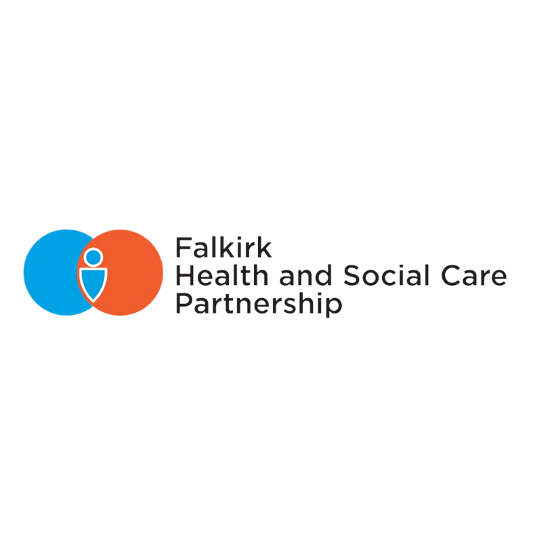

Contents

Executive Summary 4

1. Introduction 6

1.1 Background 6

1.2 Joint Strategic Needs Assessment 6

1.3 COVID-19 Impact 7

2. Geography 8

2.1 Overview 8

2.2 Locality Profiling 8

2.3 Outdoor and Leisure 9

2.4 Air Quality 10

3. Population 11

3.1 Current Population 11

3.2 Population and Deprivation 12

3.3 Dependency Ratio 14

3.4 Changing Population 14

3.5 Intermediate Zones of Note 15

4. Housing 17

4.1 Housing Demand 17

4.2 Housing Support – Adaptations 19

4.3 Single Adult Dwellings 20

4.4 Homelessness 20

4.5 Fuel Poverty 23

5. Economy, Employment and Deprivation 25

5.1 Children Living in Poverty 27

5.2 Department of Work and Pensions (DWP) Benefits 27

5.3 Employment and Economic Measures 29

5.4 Childcare Costs/Support 30

5.5 Summary 31

6. Behavioural Factors 32

6.1 Drugs and Alcohol 32

6.2 Smoking 35

6.3 Healthy Weight, Diet, and Physical Activity 36

6.4 Violent crime 38

7. Health 40

7.1 Health Inequalities: Life expectancy & Mortality 40

7.2 Diseases & Long-term Conditions 45

7.3 Cancer 50

7.4 Diabetes 54

7.5 Dementia 54

7.6 Disability 55

8. Mental Health & Wellbeing 57

8.1 Overview and Definitions 57

8.2 Community Engagement 59

8.3 Data Landscape 60

8.4 Local Services Data 61

8.5 Anxiety and Depression 62

8.6 Social Isolation & Loneliness 64

8.7 Psychiatric Hospitalisations 67

8.8 Deaths by Suicide 68

9. Community Prescribing 70

10. Unscheduled Care 72

10.1 Accident and Emergency Attendances 72

10.2 Emergency Admissions 74

10.3 GP Out of Hours 77

10.4 Delayed Discharges 78

11. Social Care Service Use 82

11.1 Care at Home 83

11.2 Personal Care 87

11.3 Care Homes 87

11.4 Telecare 91

11.5 Self-Directed Support (SDS) 91

11.6 Summary 92

12. Unpaid Carers 93

12.1 Identifying Unpaid Carers 93

12.2 Characteristics of Unpaid Carers 95

12.3 The Experience of Unpaid Carers 97

12.4 Support for Carers 98

13. Workforce 99

13.1 Primary Care - Expanded General Practice Team 99

13.2 Numbers of GPs 101

13.3 Community Link Workers 101

13.4 Social Care Workforce 101

13.5 Social Care staff Recruitment and Retention challenges 104

Appendix 1 - Falkirk’s datazones by simd quintile 107

Appendix 2 health and socio-economic measures by intermediate zone 108

DOCUMENT INFORMATION

|  |  |
| --- | --- |
| Date of issue | May 2023 |
| Available from | [www.falkirkhscp.org/publications](http://www.falkirkhscp.org/publications) |
| Key contact: | [Integration@falkirk.gov.uk](mailto:Integration@falkirk.gov.uk) |

# Executive Summary

This needs assessment provides a comprehensive description of health and social care data relevant to Falkirk Health & Social Care Partnership.

The following key issues have emerged from the needs assessment:

Population projections anticipate an 80% increase in the 75+ population between 2018-2043 at the same time as the proportion of working age people is decreasing. Older people are generally high users of services. This means that at the same time as demand for services could be increasing it could be more challenging to employ the workforce to meet this demand.

Inequalities - analysis of the available data has evidenced poorer outcomes for those living in the most deprived areas. Deprivation is associated with increased harm from alcohol and drug misuse, lower uptake of cancer screenings, increased likelihood of hospitalisation and death from various long term health conditions, poorer mental health and a greater number of deaths by suicide. Both male and female life expectancy is less for those living in the most deprived areas compared to those living in the least deprived - over ten years for men and eight years for women. Over the past decade the death rate for 15-44 years olds has been increasing and while it has increased by 50% in the most deprived areas (quintile 1) it has actually decreased by 40% in the least deprived (quintile 5). In short, poorer outcomes are experienced by people living in the most deprived areas and while it may not be within the gift of the health and social care partnership to influence all the underlying causes of inequalities, the HSCP is a position where it can target support to those most in need and contribute to reducing inequalities.

Current Demand Since COVID some services have struggled to manage demand due to unrelenting pressures. A lack of respite for exhausted staff following the periods of COVID restrictions, combined with recruitment challenges and considerable pent-up demand has meant that key services such as Care at Home, Emergency Department and Hospital Discharge Teams have struggled to keep up with sustained high levels of demand.

Unpaid Carers – During the COVID pandemic unpaid carers were heavily relied upon to provide necessary care when care packages or respite services were stopped. In the most recent national Carers Census reports the main impacts of being an unpaid carer have been on their health, employment and living environment. It is essential supports are provided to unpaid carers to ensure they are able to sustain their caring roles at a time when social care services are already experiencing high levels of demand.

Workforce - Across the health and social care services in Falkirk there is an aging workforce with a sizeable proportion of staff potentially nearing retirement. The COVID-19 pandemic and subsequent increased levels of demand have exacerbated the issue by adding additional pressures. Recent evidence shows that there has been a reduction in care home and, in particular, housing support and care home staff. In addition, the level of demand and complexity of care has changed and on the horizon is an increasing older population. Long-term workforce planning will be essential to ensure future services are sustainable.

Mental health - Determining the level of need for mental health services remains a challenge, but the evidence suggests that mental health should remain a priority for the strategic plan. Data from GP practices shows that depression is the second most prevalent long-term condition in Falkirk. Since primary care data does not explicitly record anxiety and other common mental health diagnoses, it is still difficult to estimate the overall prevalence of mental health issues in Falkirk. Scottish Burden of Disease data show that mental health issues have the highest burden in terms of the number of years that a person lives with their disability. Whilst the burden measured in terms of the years of life lost is not as high, the alarming rise in suicides in Falkirk in the last 20 years also highlights the need for action.

Behavioural Factors - Alcohol and drugs remain a challenge in Falkirk. In the last five years alcohol-related hospital admissions have been rising, and while these were historically below the national average in 2020/21 Falkirk rates were very similar to Scotland. It is worth noting that this trend seems to be driven by rates in Falkirk Central locality, which is the only locality with rates higher than Scotland. Similarly, it is also the only area with drug-related hospital admissions above the national average, although these have been consistently increasing across all areas over the past decade. In Falkirk, the number of drug-related deaths has more than tripled between 2010 and 2020.

# 1. Introduction

## 1.1 Background

This needs assessment represents the third iteration of a joint strategic needs assessment carried out by the Falkirk Health and Social Care Partnership. The previous strategic needs assessments (2016 & 2018) are available to view at the link below:

<https://falkirkhscp.org/publications/>

## 1.2 Joint Strategic Needs Assessment

In order for the partnership to produce a detailed strategic plan that best meets the needs of its local population we first require a clear understanding of the health and care needs of the population.

Need is the discrepancy between “what is” and “what should be”. This document aims to bring together the available data to describe the current pattern and level of supply of these services and where possible identify the extent of the gap between need and supply. This JSNA document is a technical document containing both qualitative and quantitative information to give an overall assessment of the needs of the local population. It will also allow for forecasting of possible changes in level of need in the coming years.

The most current data available were used to inform this needs assessment but due to the nature of how the various data publications are released at different times across the year, some data may appear out of date even if it was the most up to date available during the preparation of this document. In terms of specific data sources, of particular note is the national Census which was last undertaken in 2011 having been postponed in 2021. Data taken from the census will ultimately be quite dated but is unfortunately the only source for this information. 2022 Census data is expected to be published roughly one year after collection which like means the summer of 2023.

Locality level information has been provided where possible to aid local planning, however this is not intended to replace Locality profiles which are also available on the Falkirk HSCP website (*direct links to the profiles are provided in section 2.2 below*).

Key Reference Documents

A number of other key documents compliment the strategic needs assessment and include more in-depth detail on a number of topics.

The documents may be referenced in topic sections below but a list of web links are included here where available:

* [Falkirk Housing Need & Demand Assessment](https://www.falkirk.gov.uk/services/homes-property/policies-strategies/housing-need-and-demand-assessment.aspx)
* Forth Valley Alcohol and Drugs Partnership Needs assessment
* [Falkirk HSCP Workforce Plan 2022 - 2025](https://www.falkirk.gov.uk/coins/viewSelectedDocument.asp?c=e%97%9Dc%90my%8A)
* [NHS Forth Valley Workforce Plan 2022-2027](https://nhsforthvalley.com/wp-content/uploads/2022/09/NHS-Forth-Valley-Workforce-Plan-2022-2025.pdf)

## 1.3 COVID-19 Impact

The COVID-19 Pandemic caused significant and widespread challenges for the delivery of health and social care. While COVID-19 restrictions are ending in Scotland at the time of writing the full and lasting impacts are likely to be seen for some time. As such this needs assessment will consider COVID-19 to be a developing situation and will refrain from making any definitive conclusions, however the intention is to review and update this document over the course of 2022 as data becomes available for the whole of 2020 and 2021.

Where relevant this document will make use of available data to evaluate the impact of COVID-19 on both the Falkirk population and the health and social care services. Analysis of the impact of COVID-19, where possible will consider the challenges of providing health and social care services in the two years since the emergence of the virus and what the likely long-term implications are going to be.

# 2. Geography

## 2.1 Overview

Falkirk is located in central Scotland midway between Edinburgh and Glasgow. The area is home to 160,560 people (NRS, 2020) making it the 11th largest council area in Scotland by population. The Falkirk council area is relatively compact with most settlements within 10 miles of the town centre and is well served with excellent motorway and rail links. Falkirk falls within the NHS Forth Valley Health Board region with neighbouring Clackmannanshire & Stirling. The map below shows the 3 health a social care locality areas used for planning purposes.

Figure 2.1: Map of Localities

Map detailing Falkirk HSCP localities


## 2.2 Locality Profiling

Locality profiling supports us to make better informed decisions about the population in the locality area and ensure services are designed and delivered accordingly, as such profiles are updated regularly for the three Falkirk health and social care localities. This strategic needs assessment provides a picture of the current need and demand in the Falkirk area and the locality profiles provide a similar picture for each of the locality areas. As there are already locality profiles this SNA will not cover a full assessment of health and social care need at locality level, however there may be a focus on certain topics where locality information is pertinent.

Key Points from the latest locality profiles:

* Falkirk Central Locality has a greater proportion of people living in deprived areas **-** 54.4%of Falkirk Central live in the 2 most deprived quintiles, compared to 35.3% in Falkirk East and 28.7% in Falkirk West.
* Early mortality (Deaths aged 15-44) is considerably higher in Falkirk central locality compared to the other two localities and Scotland – the rate has also been increasing over the past 10 years.
* The most recent population estimates suggest an increase in males aged 85+ by approximately 23% in the past 5 years in the West Locality (2014-2019) alongside a reduction in females aged 0-4 years.
* Comparison of the 2016 vs 2020 SIMD deprivation categorisation for Falkirk East highlighted a reduction of 7% of the population living in the two most deprived quintiles.
* Female life expectancy is 81.3 years in Falkirk East,making it the highest of the 3 locality areas.

Links to the latest profiles on the Falkirk HSCP website are below:

East - <https://falkirkhscp.org/wp-content/uploads/sites/9/2020/12/PUBLIC-Falkirk-East-Locality-Profile.pdf>

West – <https://falkirkhscp.org/wp-content/uploads/sites/9/2020/12/PUBLIC-Falkirk-West-Locality-Profile.pdf>

Central - <https://falkirkhscp.org/wp-content/uploads/sites/9/2020/12/PUBLIC-Falkirk-Central-Locality-Profile.pdf>

## 2.3 Outdoor and Leisure

Parks and outdoor spaces are vital to our physical and mental health, the quality of our environment and provide valuable habitat for wildlife. Falkirk has an abundance of parks and open spaces covering over 24 square kilometres on 632 individual sites.

Falkirk council has committed to ensuring that every household is within an 800m walk of an open space containing a play space.

<https://www.falkirk.gov.uk/services/sport-leisure-culture/parks-outdoors/>

Over the past 9 years, sports, heritage and leisure facilities/locations in Falkirk were managed by Falkirk Community trust. As of 1st April 2022, Falkirk council assumed responsibility for management and operation of a range of community-facing sport, recreation, arts, heritage and library services.

The Falkirk Community trust reported the following achievements in the most recent annual report (2020/21):

* Muiravonside Country Park visitors increased by 40% - an extra 48,500 visitors.
* More than 4,200 participants accessed our live streaming fitness sessions and over 6,000 viewed our On Demand digital fitness classes
* Self-guided holiday themed walking trails were accessed by more than 5,000 people.

[Our Performance | Falkirk Council (falkirkleisureandculture.org)](https://www.falkirkleisureandculture.org/about-us/falkirk-community-trust-performance/)

## 2.4 Air Quality

Air quality is considered to be the greatest environmental health risk in Europe and the International Agency for Research on Cancer considers outdoor air pollution (and separately particulate matter air pollution) to be carcinogenic in Humans[1]. Exposure to air pollution in the long term can have an impact on multiple organs within the body and exacerbate long term conditions.

Air pollution can exacerbate common respiratory conditions such as Asthma, COPD and in the long term could lead to lung cancer. Furthermore it is understood that air pollution can for example also impact on the central nervous system and lead to cardiovascular problems.[2]

While Falkirk HSCP is made up of smaller villages and townships, and therefore will not see the same levels of air pollution as major cities, it is still worth due consideration for its impact on Falkirk residents in certain areas. In 2020 Falkirk air quality on the whole was rated as "Good" and there was no reported exceedances of the National Air Quality Strategy objectives.

Falkirk Council has roadside air quality monitoring stations around the council area and the two monitors which recorded highest concentrations of particulate matter (PM10 & PM2.5) were the Main street in Bainsford and the area near to the M80 motorway junction in Haggs.

The Falkirk Town Centre Air Quality Management Action Plan (AQAP) was approved in June 2015 and focuses on long-term key point actions to reduce air pollution in the area rather than short-term fixes. Key measures outlined in the plan include:

* Reducing emissions from individual vehicles.
* Promoting the ECOStars Fleet Recognition Scheme.
* Promoting alternative and sustainable modes of transport.
* To educate and inform the public on air quality issues.

In 2020 Falkirk council installed 39 electric vehicle charging points and has plans in place for over 60 more. In addition to this the largest Electric vehicle park opened in August 2020 at Falkirk Football stadium and has chargers for 26 vehicles.

# 3. Population

## 3.1 Current Population

The size and age of a population will have a large impact on the demands placed upon many health and social care services.

The table below illustrates the population size of Falkirk and the distribution of this population across selected age groupings.

Falkirk has an estimated population of 160,560 as of 2020, with 78,645 (49%) males and 81,915 (51%) females.

Table 3.1: Falkirk Population Profiles, 2020

|  |  |  |  |  |  |  |  |  |
| --- | --- | --- | --- | --- | --- | --- | --- | --- |
|  | Falkirk |  |  |  | Scotland |  |  |  |
| Age Group | Population | % of Total | Male | Female | Population | % of Total | Male | Female |
| 0 to 15 | 27,886 | 17.37 | 14,402 | 13,484 | 916,783 | 16.77 | 470,007 | 446,776 |
| 16 to 49 | 66,965 | 41.71 | 33,164 | 33,801 | 234,8111 | 42.96 | 1,166,000 | 1,182,111 |
| 50 to 64 | 35,054 | 21.83 | 17,216 | 17,838 | 1,145,026 | 20.95 | 553,404 | 591,622 |
| 65 to 74 | 17,320 | 10.79 | 82,45 | 9,075 | 586,263 | 10.73 | 280,439 | 305,824 |
| 75+ | 13,335 | 8.31 | 56,18 | 7,717 | 469,817 | 8.6 | 195,362 | 274,455 |
| Total | 160,560 | 100 | 78,645 | 81,915 | 5,466,000 | 100 | 2,665,212 | 2,800,788 |

Source: National Records of Scotland (NRS) mid-year population estimates 2020

Falkirk has a broadly similar distribution between the age bands as Scotland, with only slightly higher proportions of 0 to 15 year olds, 50 to 64 year olds and a slightly lower proportion of 16 to 49 year olds. There are slightly more males aged zero to 15, but from 65 upwards there are markedly

more females in Falkirk.

Figure 3.1: Falkirk population by sex and age groupings, 2020

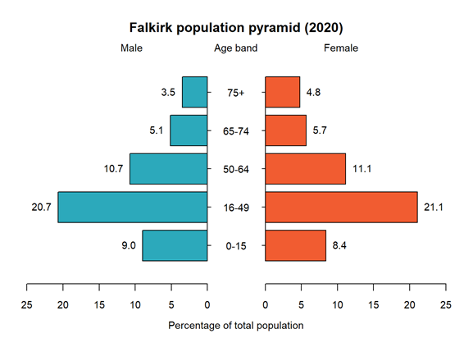

This figure shows the proportion of the population accounted for by each age band in either sex. We can see that the distribution of males and females across age bands is broadly similar though a higher proportion of the older population (65+) is female.

The Equality Act 2010 covers everyone in Britain and protects people from discrimination, harassment and victimisation. There are nine protected characteristics including age, disability, gender reassignment, marriage and civil partnership, pregnancy and maternity, race, religion or belief, sex and sexual orientation. Information on these is often not routinely collected and the first Strategic Needs Assessment drew from information collected from the 2011 Scotland Census. Due to the impact of the COVID-19 pandemic Scotland’s Census was moved from 2021 to 2022 and information is due to be published from 2023 onwards. This will allow for further detailed analysis and support our understanding of the needs of these populations.

## 3.2 Population and Deprivation

Deprivation is defined as the range of problems that arise due to lack of resources or opportunities, covering health, safety, education, employment, housing and access to services, as well as poverty.

The Scottish Index of Multiple Deprivation (SIMD) is the Scottish Government's official tool for identifying those places in Scotland suffering from deprivation. It incorporates several different aspects of, combining them into a single index. It divides Scotland into 6,976 small areas, called data zones, each containing around 350 households and a mean of 800 people. The Index provides a relative ranking for each data zone, from 1 (most deprived) to 6,976 (least deprived). By identifying small areas where there are concentrations of multiple deprivation, the SIMD can be used to target policies and resources at the places with greatest need.

One way we can use these is to divide all data zones into 5 equal deprivation quintiles. For the quintiles, 1 is the most deprived and 5 is the least deprived.

In Scotland as a whole, each of the five SIMD quintiles contains 20% of the population (as calculated by PHS). By looking at the distribution of the population across SIMD quintiles in Falkirk, we can see whether levels of deprivation across the area are higher or lower than in the rest of the nation.

Table 3.2: Population Distribution Across SIMS Quintiles in Falkirk, 2020

|  |  |  |
| --- | --- | --- |
| SIMD Quintile | Population | % of population |
| 1 | 25,930 | 16.1 |
| 2 | 36,055 | 22.4 |
| 3 | 39,920 | 24.8 |
| 4 | 28,003 | 17.4 |
| 5 | 30,982 | 19.3 |
| Total | 160,890 | 100 |

Source: Public Health Scotland (PHS) Scottish Index of Multiple Deprivation (SIMD) data 2020

Falkirk has a higher proportion of its population in SIMD three. It has below the national average in SIMD five (the least deprived areas), but it also has a lower proportion in the areas of highest deprivation. These distributions can also be compared to Forth Valley as a whole and neighbouring local authorities within the health board.

Figure 3.2: Percentage Population by Deprivation Quintile, Forth Valley Health Board Areas, 2020

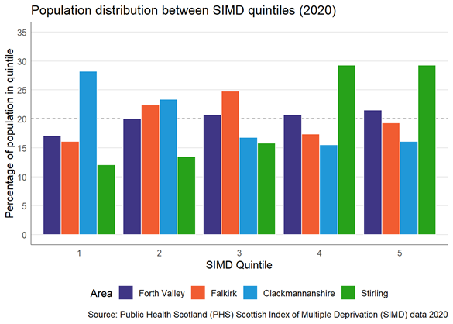

Least Deprived

Most Deprived

Falkirk has a deprivation profile more like Forth Valley as a whole than the other two local authority areas. It has an overrepresentation of SIMD two and three (nearly 50% of the population) and a slightly smaller proportion than seen nationally in the most deprived quintile of SIMD one. However with a large proportion of the population being in quintile 2&3 this also means that there is a smaller proportion of the population in the two least deprived quintiles compared to Scotland. Having a larger proportion of the population at the more deprived end of the scale could suggest a greater level of need in comparison to the national average.

## 3.3 Dependency Ratio

The dependency ratio is a measure of the proportion of the population seen as economically 'dependant' upon the working age population. The definition generally used in Scotland is 'those aged under 16 or of state pensionable age, per 100 working age population'.

The table below shows an increase in the dependency ratio over the next 25 years. In 2043 it is estimated that a quarter of the population (24%) will be of pensionable age.

Increases in dependency ratio signify a reduction in the economically active working age group and therefore a smaller population to recruit into health and social care jobs. If we combine this longer term impact with the more immediate effects of the COVID-19 pandemic on the health and social care workforce, there is much to consider in terms of workforce sustainability.

Table 3.3: Dependency Ratio in Falkirk based on 2018-based population projections

|  |  |  |  |  |  |  |
| --- | --- | --- | --- | --- | --- | --- |
| 2018 | 2020 | 2023 | 2028 | 2033 | 2038 | 2043 |
| 57.4% | 55.0% | 55.1% | 53.0% | 56.6% | 61.0% | 63.2% |

*Dependency ratio is the rate of dependent population (children and those of pensionable age) to working age population, expressed as a percentage.

Source: National Records of Scotland (NRS) 2018-based population projections.

## 3.4 Changing Population

As we have seen above, the population make-up in Falkirk has been changing over the years.

The mid-year estimates show a steady increase in 65+ age groups, with an acceleration in the increase of the 75+ age groups predicted from 2020 onwards by the projections. The mid-year estimates also show a steady decrease in the 16 to 49 age group from 2011 to 2020, the projections then predict an increase in this group from around 2025 to 2035 before decreasing again until 2043.

Table 3.4: 25-year projections - percentage change in population by age groups for given years in Falkirk

|  |  |  |  |  |  |
| --- | --- | --- | --- | --- | --- |
| Year  (% change from - to) | All Ages | Children | Working Age | Pensionable Age | 75+ |
| 2008 - 2033 | 13.00 | 1.00 | 10.00 | 35.00 | 93.00 |
| 2010 - 2035 | 10.05 | 1.3 | 6.24 | 30.41 | 91.82 |
| 2012 - 2037 | 10.41 | 4.74 | 4.63 | 34.41 | 97.8 |
| 2014 - 2039 | 8.36 | -0.62 | 2.17 | 36.51 | 93.54 |
| 2016 - 2041 | 8.06 | -2.88 | 2.94 | 34.77 | 90.01 |
| 2018 - 2043 | 6.00 | -9.05 | 2.22 | 32.78 | 80.34 |

Source: National Records of Scotland (NRS) population projections

The table shows that the 25-year projection published in 2008 predicted a 93% increase in the population aged 75 and over. The revised 25-year projection in 2018 predicted an 80.3% increase in those aged 75 and over. As new population projections are published, figures are revised and often the predicted rate of increase is not as high as previously projected. While there does seem to be a general trend towards an ageing population, this appears to be happening at a rate below that projected previously. The difference from previous projections is due to lower fertility rates and life expectancy increasing at a slower rate.   
  
Regardless of more cautious projections of population change there is expected to be a large increase in pensionable age and 75+ populations relative to the increase in working age population. It is important to consider the implications of this, namely the increase in demand for health and social care services because of a larger older population without the required increase in workforce to deliver these services.

## 3.5 Intermediate Zones of Note

In Falkirk, there are some intermediate zones whose make-up of population is markedly different from the rest of the local authority. These differences are marked out as significantly above or below the average percentage of the population in a given age band. Population proportion breakdown by age band can be seen above, in the Falkirk Population Profiles table (Table 3.1).

Table 3.5: Intermediate zone areas in Falkirk where the percentage of population in a certain age band is significantly above average

|  |  |  |
| --- | --- | --- |
| Intermediate Zone | Outlying Age Band | % of Population |
| Town Centre and Callendar Park | 65 to 74 | 18.41 |
| Town Centre and Callendar Park | 75+ | 20.24 |
| Polmont | 65 to 74 | 18.07 |
| Reddingmuirhead and Overton | 0 to 15 | 23.62 |
| Reddingmuirhead and Overton | 16 to 49 | 52.42 |

Table 3.6: Intermediate zone areas in Falkirk where the percentage of population in a certain age band is significantly below average

|  |  |  |
| --- | --- | --- |
| Intermediate Zone | Outlying Age Band | % of Population |
| Town Centre and Callendar Park | 0 to 15 | 8.64 |
| Town Centre and Callendar Park | 16 to 49 | 32.60 |
| Reddingmuirhead and Overton | 50 to 64 | 16.16 |
| Reddingmuirhead and Overton | 65 to 74 | 5.04 |
| Reddingmuirhead and Overton | 75+ | 2.76 |

In Falkirk Town Centre and Callendar Park, the proportion of those aged under 50 (40%) is lower than Falkirk as a whole, while the nearly 40% of the population is over 65. This can be attributed to a high number of high-rise tower blocks, some of which provide supported living.

In Reddingmuirhead and Overton, there is a very low proportion of those in the 50 to 64, 65 to 74 and 75-plus age bands since more than three quarters of the population in this area are under 50 years. New housing developments bringing young families to the area is a key contributor to the relatively young population.

It is important for the HSCP to look at population make up in small areas for the effective planning and delivery of services at a local level. In the case of the Town Centre and Callendar park intermediate zone, identifying the disproportionate 65+ population allows for planning of the optimum arrangement and quantity for service delivery in that area.

# 4. Housing

Housing plays a pivotal role in the health and wellbeing of the population, and it is imperative that the Strategic Plan reflects the need to provide sufficient quality housing provision to those who need it. The World Health Organisation (WHO) considers “physical environment” to be one of the 3 determinants of health, alongside the social and economic environment, and the person’s individual characteristics and behaviours. It is argued that these factors have a greater impact on the health of the population than commonly considered factors such as access to health and care services.1

Though Housing is not under the remit of the health and social care partnership it is responsible for creating a housing contribution statement (HCS) to accompany the Strategic Plan. The HCS provides an overarching strategic statement on how the housing sector will support the work of the IJB to achieve national and local outcomes for health and social care.

<https://falkirkhscp.org/wp-content/uploads/sites/9/2018/01/Final-HCS-10-12-19.pdf>

#### Housing Need & Demand Assessment (HDNA)

It is a statutory requirement that estimates be made on the future numbers of additional homes required to meet existing and future demand - the report for Falkirk is available at the link below:

<http://www.falkirk.gov.uk/services/homes-property/policies-strategies/docs/hnda/01%20Housing%20Need%20and%20Demand%20Assessment.pdf?v=201612051407>

The HNDA identified the number of households in the Falkirk area will increase over the next 20 years. In terms of population the biggest increase is projected to take place in people over retirement age. This means an increase in demand for additional housing, including affordable and specialist housing for people with a disability or mobility issues.

## 4.1 Housing Demand

National Records for Scotland population projections for Falkirk estimate a 6% population increase by 2043 (based on 2018 mid-year population). This increase is expected to be primarily driven by migration since the death rate over the next 25 years is anticipated to be higher than the birth rate (26% more deaths than births). The population increase in Falkirk is projected to be greater than for Scotland over the next 25 years with most migration to the Falkirk area from other parts of Scotland.

Table 4.1: Falkirk components of population change 2018-2043 (2018-based)

|  |  |
| --- | --- |
| Component change | 2018-2043 |
| Estimated population at 30 June 2018 | 160,340 |
| Births | 38,106 |
| Deaths | 48,092 |
| Natural change | -9,986 |
| Estimated net migration | 19,163 |
| Other changes | 445 |
| Population mid-2043 | 169,962 |
| Population change Number | 9,622 |
| Population change % | 6% |

Source: National Records of Scotland

While section 3.4 noted that more recent population projections have projected a lower increase in the older population than in previous years the 75+ population is still expected to increase substantially over the next 25 years and as such it is important to consider the housing and supported provision stocks required.

To enable people to live independently for as long as possible a combination of appropriate housing and care services will be required to serve the increasing older population. The Falkirk Housing Needs Assessment 2022 considers the housing aspects of this in detail:

1. **Property Needs** – this includes accessible and adapted housing, wheelchair housing
2. **Care and Support Needs** – supported provision such as care homes and sheltered housing, and care and support services provided at home to enable independent living

Household projections by National Records for Scotland estimate that there will be over 8,000 more households in Falkirk with residents aged 75+ by 2043 (compared to 2018 basis). While the increase over the next 5 years is not as significant, projections suggest an increase of 1,500 households in Falkirk with residents aged 75+ between 2022 and 2027.

This increase could bring considerable challenges in terms of service delivery for health and social care services such as Home Care and district nursing.

Figure 4.1: Projected number of households with residents aged 75+ 2018-2043 (2018-based)

Source: National Records for Scotland

## 4.2 Housing Support – Adaptations

For people who experience functional difficulties due to health or mobility problems there are several options to support continued independence. Options include equipment to facilitate independence, minor or major adaptations, or even moving to a more suitable property.

Basic adaptations could consist of things like internal/external grab rails, banister rails, lever taps or relocation of difficult to reach plug sockets. For more complicated major adaptations, it will be necessary to complete a formal assessment through social work.

Most recent estimates from the Scottish House Condition Survey suggests that Falkirk has a similar level of households reporting a need for disabled adaptations.

Table 4.2: Proportion of households reporting need for Disabled Adaptations

|  |  |  |
| --- | --- | --- |
|  | Falkirk | Scotland |
| % Household’s reporting requiring adaptation | 3% | 3% |
| Equivalent number of households | 2,000 | 82, 000 |

Source: Scottish House Condition Survey 2017-2019

## 4.3 Single Adult Dwellings

Figure 4.2: Single adult dwellings in Falkirk localities, council area and Scotland in 2020

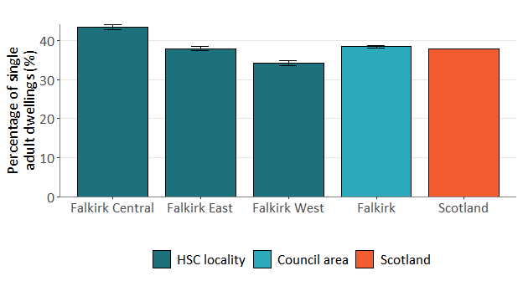

Source: ScotPHO

In Falkirk, more than a third (38.5%) of dwellings were occupied by a single person in 2020. This is similar to the rest of Scotland, although there are differences when looking at locality level, as shown in figure 4.2. Falkirk Central has the highest proportion of people living alone (43.4%).

Living alone can increase a person’s social isolation and loneliness, a topic covered in more detail in section 8.5. Furthermore, there is evidence that older adults living alone are more likely to go to A&E and be admitted to hospital, and more likely to visit their GP.[3]

## 4.4 Homelessness

Homelessness is defined as not having a home. It does not mean living on the street but could involve a number of situations.

You might be defined as homeless if you are:

* sleeping on the streets
* staying with friends or family
* staying in a hostel or bed and breakfast hotel
* living in overcrowded conditions
* at risk of violence in your home
* living in poor conditions that affect your health
* living in a house that is not suitable for you because you are sick or disabled.

The Scottish Government releases annual reports on homelessness in Scotland with some analysis broken down by Local Authority area. The data collected records homeless application information such as age, sex, family compliment and reason for homelessness. Use of temporary accommodation is also recorded.

The number of people presenting as homeless in Falkirk has remained relatively consistent over the last few years. In 2020-21, 1,072 applications were made for assistance (down 92 on the previous year). Falkirk Council considered that 823 (77%) of those who applied for support were found to be homeless or threatened with homelessness.

Figure 4.3: Number of applications under the Homeless Persons legislation and Homeless or Potentially Homeless cases in Falkirk 2011-2021

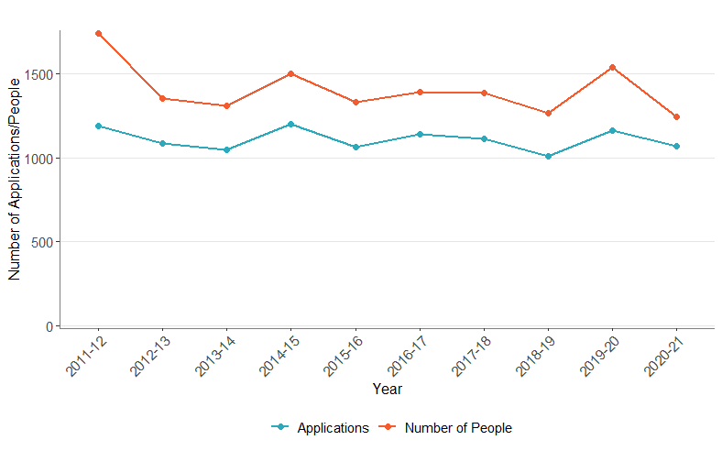

Source: Scottish Government – Homelessness in Scotland 2020-21

The gap between the number of people involved, and the number of applications highlights that while most applications are single person (at Scotland level in 2021, 46% single male, 22% single female) there are a proportion of applications which involve families with children. In Scotland in 2021 just over a fifth of applications involved a single parent with children.

The following chart shows the average time between a homelessness application and assessment in Falkirk with 2020/21 being the lowest in the past decade at 16 days although there is but limited deviation in the past 9 years.

Figure 4.5 shows the housing outcome for homeless people assessed as having a statutory duty for housing. The vast majority (62%) moved into council housing and collectively 82% secured a form of settled accommodation (compared to 80% in Scotland).

Figure 4.4: Average time from application to homelessness assessment in Falkirk, 2011/12 to 2020/21 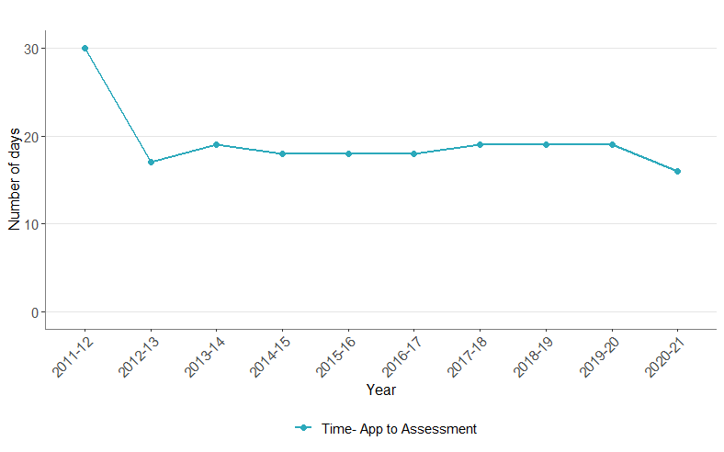Source: Scottish Government – Homelessness in Scotland 2020-21

Figure 4.5: Outcomes for households assessed as unintentionally homeless or threatened with homelessness, Falkirk, 2020-21

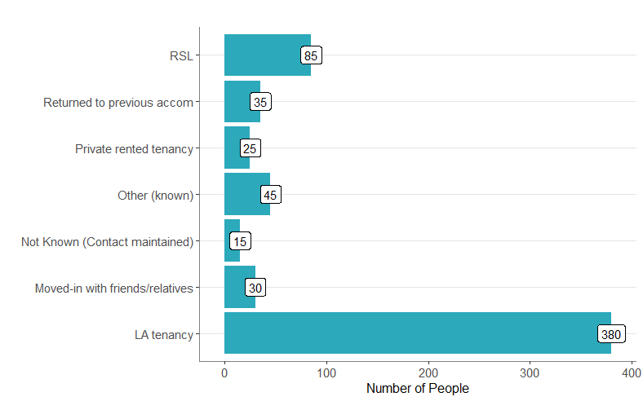

Source: Scottish Government – Homelessness in Scotland 2020-21

 *RSL – Registered social Landlord

## 4.5 Fuel Poverty

Fuel poverty is defined by the Scottish Government as any household spending more than 10% of their income on energy - after housing costs have been deducted.

The reason for considering fuel poverty in this needs assessment is because of the link between fuel poverty and health. This is based upon the health implications of living in cold, damp homes – certain respiratory conditions are exacerbated by the cold and people living in cold homes are more likely to suffer colds, flu, bronchitis, and pneumonia. Hypothermia is caused by long term exposure to cold and those who are chronically sick, disabled or with limited mobility are at particular risk.[4] At temperatures below 12 degrees Celsius, blood thickens, and this can result in increased likelihood of stroke/heart attack.

Those who are fuel poor are more likely to be forced to turn their heating down below the level tolerable for their well-being, and potentially more likely to live in energy inefficient homes.

In December 2020 it was estimated that 22% of the Falkirk households were in Fuel Poverty (Scotland Average = 24%). Due to increased volatility in the wholesale energy markets during 2021/22 a revised price cap was announced from April 2022 which would see average energy bills increase by £700 to £2000 a year. As such the Scottish Government released further estimates in February 2022 (based on April price cap) which estimated that nearly 1 in 3 of households (31%) in Falkirk will be in fuel poverty[5].

More recent estimates from a UK Parliament Briefing (August 2022) suggests even greater cost increases as further price caps are expected in October 2022 and January 2023[6]. The briefing note estim**ated “that it would cost the poorest 20% of households an additional £1,800-2,000, and pensioner households an additional £2,400, to use as much energy in 2022-23 as they did in 2020-21.” Fuel price will have a disproportionate impact on the health and wellbeing of the most vulnerable households who may struggle to heat their homes.**

Excess winter deaths data is not available at local authority level and due to the COVID-19 pandemic which was the underlying cause of almost two-thirds of additional winter deaths in 2019/20 (and likely similar in 2020/21) it would be difficult to draw conclusions about the overall impact of fuel poverty in the past two winters. Due to the increased estimate that nearly 1 in 3 homes in Falkirk are living in Fuel Poverty (April 2022), this is an area that should be monitored as increased numbers of vulnerable people living in inadequate cold conditions could ultimately result in increased hospital admissions and excess winter deaths.

To go some way to addressing the immediate challenges associated with fuel cost increases affecting households, the Health and Social Care partnership should work with local public health teams and local community planning partners to help identify those at increased risk of poor health associated with fuel poverty. Several supports are available to people in receipt of benefits, namely the Warm Home Discount Scheme which is automatically paid (£150) to those who are on benefits, and the Winter Fuel Payment which is paid to those of Pension Age.

# 5. Economy, Employment and Deprivation

Falkirk is an area where 16% of its residents live in the 20% most deprived areas of Scotland. Deprived does not just mean ‘low income’ but also that people have fewer health and education outcomes, opportunities, and access to services.

The link between economic and employment opportunities and deprivation is well known and all contribute to poorer health outcomes and the ability to lead a fulfilled and successful life. It will be important to understand this landscape in Falkirk to get a better understanding of the needs of its population and the drivers of service demand.

Within Falkirk’s three localities Central is considered as having the highest proportion of its population living in the most deprived quintile – 32% compared to 12% in Falkirk East and 7% in Falkirk West.

Figure 5.1: Percentage of locality living in each SIMD Quintile

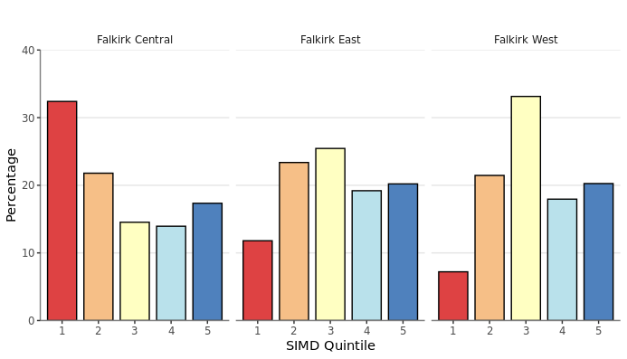

Source: Scottish Index of Multiple Deprivation (SIMD), Public Health Scotland

There are pockets of higher deprivation with 16 datazones falling within the top 10% most deprived areas in Scotland – four of which are in in Bainsford and Langlees, five are in Grangemouth and two are in Camelon East.

Of Falkirk’s 214 datazones the lowest ranked in terms of deprivation was Bainsford and Langlees-01 (39th) and the highest was Bo’ness-Newton-05 (6,948). A map of Falkirk’s datazones coloured by SIMD quintile can be found in Appendix 1. Datazones are quite small and so looking at intermediate zones allows us to see more clearly areas of deprivation.

The chart below presents Falkirk’s current population by intermediate zone and SIMD quintile. It is ordered by the percentage of the population in SIMD quintile 1 (most deprived) with those with none in alphabetical order to the right. It shows two things. Firstly, the size of the population in each intermediate zone varies, from Shieldhill up to Larbert North Broomage & Inches. Secondly, the deprivation profile varies. In some intermediates zones everyone is considered as living in the most deprived areas (quintile 1 and 2) or the least deprived areas (quintiles 4 and 5) while in others deprivation varies across several or all quintiles. It is important to understand the profile of an area to help understand the needs of its population and the drivers of demand.

Figure 5.2: Falkirk’s 2020 population by Intermediate Zone and SIMD Quintile, ordered by the proportion of the population in SIMD Quintile 1

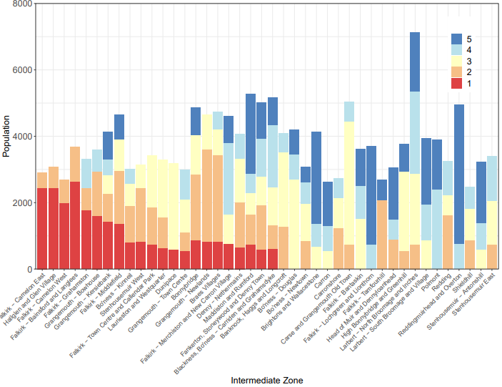

Source: Scottish Index of Multiple Deprivation (SIMD), Public Health Scotland

Extensive research exists on the links between deprivation and health but one of the succinct relationships is described as the ‘Social Gradient’. The social gradient in health is a term used to describe the phenomenon whereby people who are disadvantaged in terms of their socioeconomic position have worse health outcomes than those in the most advantaged socioeconomic positions [7].

## 5.1 Children Living in Poverty

In Falkirk, the percentage of children in low-income families has risen in the past few years and is similar to Scotland. In 2019/20 19% of children were living in poverty but across Falkirk’s Intermediate Zones this ranged from 5.5% in Lochgreen and Lionthorn to 36.1% in Camelon West.

Figure 5.3: Percentage of children living in poverty

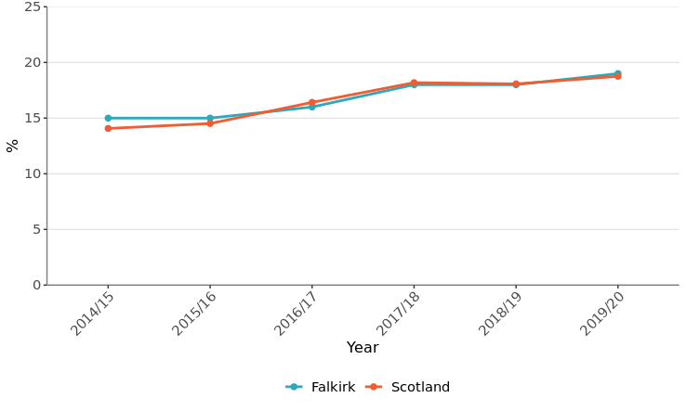

Source: Improvement Service

## 5.2 Department of Work and Pensions (DWP) Benefits

The chart below provides an overview of the number of people claiming Department of Work and Pensions (DWP) benefits at August 2021. This does not include State Pension Claimants. The top three benefits were Universal Credit, Personal Independence Payment and Housing Benefit. Personal Independence Payment (PIP) is a benefit which aims to help with some of the extra costs caused by long-term disability, ill-health or terminal ill-health and Housing Benefit aims to help claimants pay rent if they are on a low income.

Figure 5.4: DWP Benefits by Number of Claimants, August 2021

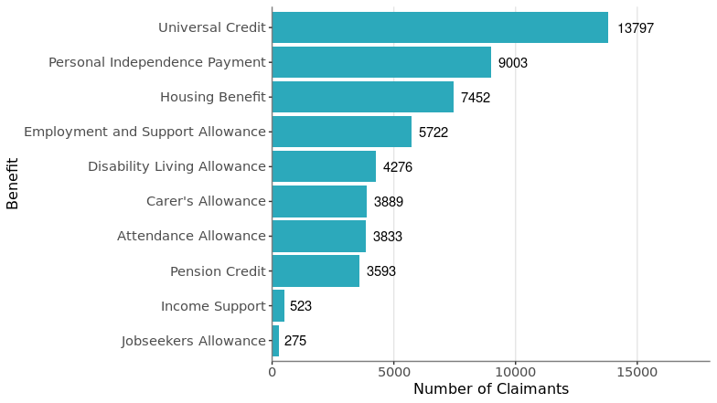

Source: DWP Stat- Xplore

### 5.3.1 UNIVERSAL CREDIT

The chart above shows that Universal Credit had the highest number of claimants, 13,797 claimants at August 2021. Universal Credit is a single payment to help with living costs for those on a low income or out of work. It is replacing six benefits including income-based Jobseekers Allowance, Income-related Employment and Support Allowance, Income Support, Working Tax Credit and Housing Benefit. Not all benefit and tax credit claimants have moved onto Universal Credit and increases in Universal Credit should be interpreted with this in mind.

In response to the COVID-19 pandemic and to support households, temporary changes were made to Universal Credit (e.g. changes to the eligibility criteria, open cases and requirements for payment). As a result, there has been a marked increase in the number of claims for Universal Credit. From March 2020 to February 2022 the number of claimants rose by 64%. While the rate of Universal Credit claimants in February 2022 was similar in Falkirk to the national average (101.5 and 99.6 per 1,000 16 plus population, respectively) this ranged from 16.4 in Lochgreen and Lionthorn up to 219.4 per 1,000 population (16+) in Bainsford and Langlees. Falkirk Central had the highest rate, 123.1 per 1,000 16+ population compared to 98 in Falkirk East and 86.3 in Falkirk West. Bainsford and Langlees is an area of high deprivation with almost three quarters of the population living in SIMD quintile 1 and within Falkirk’s three localities Central has the highest proportion of its population living in the most deprived quintile.

Figure 5.5: Claimants entitled to Universal Credit

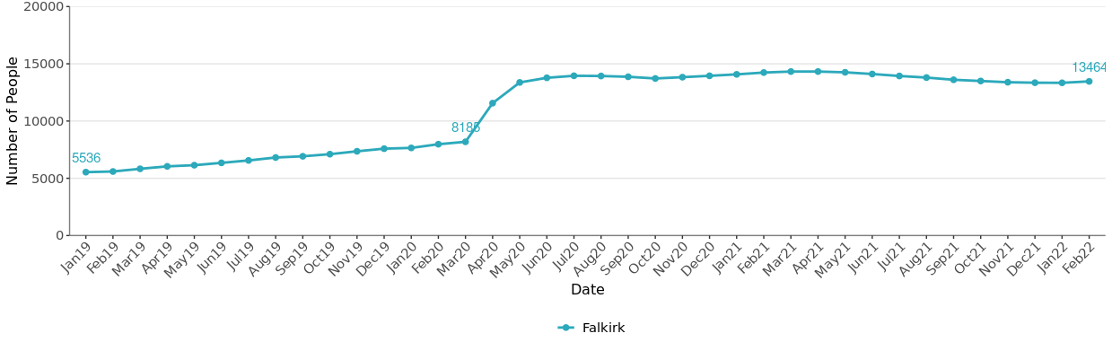

Source: DWP Stat- Xplore

*February 2022 data is provisional. Figures are a count of the number of people on Universal Credit on the second Thursday of each month.

### 5.3.2 Carers Allowance

Carer’s allowance is paid to carers aged 16 and older who look after a severely disabled person for at least 35 hours a week. The number of claimants entitled to carers allowance in Falkirk has been relatively stable over the past couple of years and was 3,889 in August 2021. While the rate of Carer’s Allowance claimants in August 2021 was slightly higher in Falkirk than the national average (29.3 vs 26.6 per 1,000 16 plus population, respectively) this ranged from 11.3 in Lochgreen and Lionthorn up to 55.9 per 1,000 population (16+) in Bainsford and Langlees. Falkirk Central locality had the highest rate, 31.5 per 1,000 16+ population, compared with 29.2 in Falkirk East and 27.0 in Falkirk West.

Figure 5.6: Claimants entitled to Carers Allowance - Falkirk

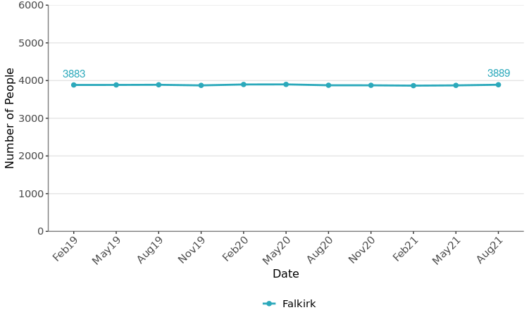

Source: DWP Stat- Xplore

## 5.3 Employment and Economic Measures

In 2020, 63.5% of Falkirk’s population was of working age. It had around 71, 000 jobs with the job density (the ratio of total jobs to population aged 16-64) being lower than Scotland (0.70 vs 0.80). A higher proportion of employee jobs were in the Manufacturing and Transportation and Storage industries than nationally.

The table below illustrates that on several economic and employment measures Falkirk is similar to the national average. It has a similar working age population, employment rate, population on out of work benefits and population economically active and unemployed. Where it differs is on gender pay. While the gender pay gap in Falkirk was narrower than that nationally this is due to the male median gross weekly earnings for full time workers being less and the females being slightly more than the national average. It should be noted however that this relates to a period where many people would have been furloughed. In the UK the gender pay gap has been declining slowly over time and it is much higher for people aged 40 and over than under.

Table 5.1: Overview of Economic and Employment Measures

|  |  |  |  |
| --- | --- | --- | --- |
| **Measure** | **Year** | **Falkirk** | **Scotland** |
| Employment Rate (%) 1 | 2019/20 | 75.0 | 74.4 |
| Enterprise Survival 1 | 2019/20 | 54.8 | 56.5 |
| Working Age population Employment Deprived (%) 2 | 2017 | 9.01 | 9.29 |
| Out of Work Benefits (%)1 | May-20 | 15.5 | 15.7 |
| Working age population (16-64)3 | 2020 | 63.5 | 63.9 |
| Median Gross Weekly Earnings for Full Time Workers - Men3 | 2021 | 602.5 | 650.4 |
| Median Gross Weekly Earnings for Full Time Workers - Female3 | 2021 | 584.7 | 577.3 |
| Economically Active (%)3 | Oct 20-Sept 21 | 77.0 | 76.1 |
| Unemployed, model-based (%)3 | Oct 20-Sept 21 | 3.9 | 4.2 |
| Coronavirus Job Retention Scheme (CJRS) cumulative total jobs4 | To 30 June 2021 | 27,300 | - |

Sources: 1. Improvement Service 2. ScotPHO 3. NOMIS

The Coronavirus Job Retention Scheme (CJRS) was announced on 20 March 2020 and has supported employers in paying their employees the COVID-19 pandemic. Up to 30 June 2021 a cumulative total of 27,300 jobs of Falkirk’s residents have been supported by the scheme at various points. This is a considerable number of people who have been living on a reduced income and not working at some point during this time.

## 5.4 Childcare Costs/Support

Since August 2021, all three and four year olds in Scotland can get up to 1,140 hours of funded early learning and childcare a year (around 30 hours a week in term time). It is available for 2-year-olds if the parent is on certain benefits or the child is looked after by the local authority, in kinship care or have been appointed a guardian. The introduction of funded early learning and childcare has greatly reduced costs for families however recent Research by Coram Family and Child Care[8] shows that the cost of childcare has continued to rise steadily.

Table 5.2: Childcare costs in Scotland

|  |  |  |  |  |
| --- | --- | --- | --- | --- |
| Prices for Child Care for Under 3s | Nursery Under two | Nursery Two | Childminder Under two | Childminder Two |
| Part-time (25 hours a week) | £108.62 | £106.62 | £119.17 | £117.77 |
| Full-time (50 hours a week) | £212.99 | £206.85 | £238.35 | £235.89 |
| School age childcare | **After school club** |  | **Childminder to 6pm** |  |
| Weekly price for children aged 5-11 | £66.75 |  | £72.86 |  |

Source: [Childcare Survey 2022](https://www.coram.org.uk/sites/default/files/resource_files/Coram%20Childcare%20Survey%20-%202022.pdf), Coram Family and Childcare

The National Living Wage and National Minimum Wage are set by the UK Government. From 01/04/22 the National Living Wage increased to £9.50 an hour for those aged 23 and over. For those under 23 the national minimum wage is £9.18 for 21-22 year olds, £6.83 for 18-20 year olds and £4.81 for under 18s.)

## 5.5 Summary

Living in deprivation with low income and little opportunities hugely impacts on life, from day to day living to the longer-term impact on physical and mental health. Within Falkirk there are pockets of higher deprivation where people have less income, are more reliant on benefits and more children are living in poverty. The Covid-19 pandemic for many has meant living on reduced pay, being more reliant on benefits, being more socially isolated, at a time where costs are rising. How much the COVID-19 pandemic has exacerbated existing problems we still do not know but with the continuing increase in daily basic living costs the stress for many, and the impact that this will have on people and need, is likely to grow.

The Inverse Care Law implies that ‘the availability of good medical care tends to vary inversely with the need for it in the population served’[9] and this has been well evidenced in Scotland and the UK. In short, the Inverse Care Law suggests that those in deprived areas, and potentially in most need of health and care services, are the population less likely to receive the appropriate level of care. While there is several health factors out with the control of the Health and Social Care Partnership, such as income, environment and lifestyle, the HSCP should utilise the data available to ensure that there is appropriate access to quality care in areas which need it most. The Kings Fund[10] has carried out a review of how Health and Social care can have an impact on Poverty’s impact on health, and how health and social care partners must share data better and take socio-economic circumstances into account when making planning decisions.

# 6. Behavioural Factors

## 6.1 Drugs and Alcohol

### 6.1.1 ADP Report Findings

The Forth Valley Alcohol and Drugs partnership (ADP) recently reviewed the available data for its alcohol and drugs needs assessment in 2021. This should be considered a more comprehensive needs assessment on this topic area and as such this section will summarise the main points with respect to Falkirk (updating with latest data where possible).

The Forth Valley ADP also set out a 4 year Delivery Plan (2020-2023) for Falkirk which reflects up to date national policy surrounding alcohol and drug support services.

<https://adp.nhsforthvalley.com/wp-content/uploads/sites/13/2020/10/Falkirk-ADP-Delivery-Plan-Final.pdf>

Key Points:

* The percentage of individuals adhering to weekly drinking advice regarding moderate drinking in 2017 was 40% for Males and 62% for Females in Falkirk.
* In Scotland those in the most deprived 20% of areas are most likely to exceed the recommended 14 units per week
* The drug deaths rate for Falkirk increased by 234% between 2006-10 to 2016-20 (5-year average rates) from 10 to 33 annual deaths
* Opiates were involved in 9 out of 10 drug deaths in Falkirk in 2020.
* The Scottish drug misuse Database 2020/21 report released by PHS in May 2022[11] reported 243 individuals registered using illicit drugs. An important consideration for strategic planning is that 54% of those on the register first used illicit drugs under the age of 20. The median age was 16 years.
* Of the 243 individuals on the Scottish drug misuse database, 85 (35%) reported consuming alcohol every day.
* Roughly 50% of individuals in Falkirk on the Scottish drug misuse database are unemployed and over 40% reported living alone.

Some additional locality level analysis on alcohol and drug-related hospital admissions has been added below where data was available.

### 6.1.2 Alcohol and Drug-Related Hospitalisations

Figure 6.1: Alcohol-related hospital admissions in Falkirk, its localities, and Scotland

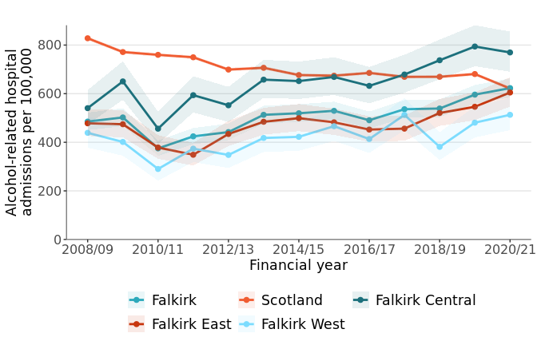

Source: ScotPHO

Figures 6.1 and 6.2 show that rates for both alcohol and drug-related hospital admissions have been increasing in Falkirk in the last few years. The increasing trends are particularly worrying in Falkirk Central, in both cases surpassing the Scotland average.

Figure 6.2: Drug-related hospital admissions in Falkirk, its localities and Scotland

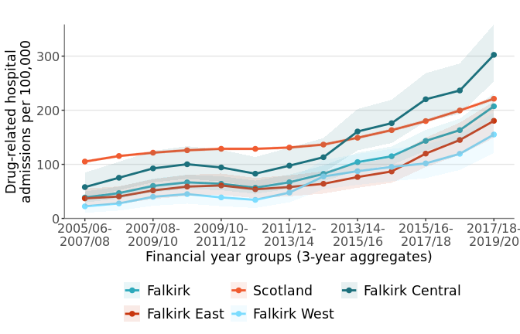

Source: ScotPHO

As shown in figure 6.2, drug-related hospital admissions have seen an alarming increase in all three localities and Scotland. It is worth noting that data recording improvements may have played a part in this.

Links to deprivation: Alcohol and drug-related harms are more severe in areas of higher deprivation. In Falkirk, for the latest time periods available through ScotPHO, the most deprived areas had 110% more alcohol-related hospital admissions and 132% more drug-related hospital admissions than the overall average. In addition to this, there were 87% more alcohol-specific deaths and 144% more drug-related deaths in SIMD 1 than SIMD 5. To put things into context, we can look at specific intermediate zones. Lochgreen & Lionthorn has 80% of its population living in the top SIMD quintile, and a rate of 73.4 alcohol-related hospitalisations per 100,000 population per year. On the other hand, Bainsford & Langlees, which has 100% of its population in the bottom two SIMD quintiles, has a rate over 25 times higher with 1854.1 hospitalisations per 100,000.[12]

## 6.2 Smoking

Smoking is a significant public health issue in Scotland and a leading cause of preventable ill health, premature death and disability. As shown in figures 6.3a and 6.3b, both smoking prevalence and smoking attributable deaths have been steadily declining in Scotland and Falkirk.

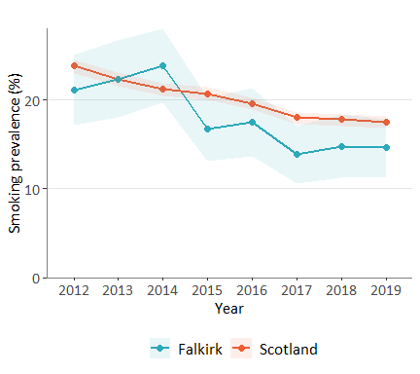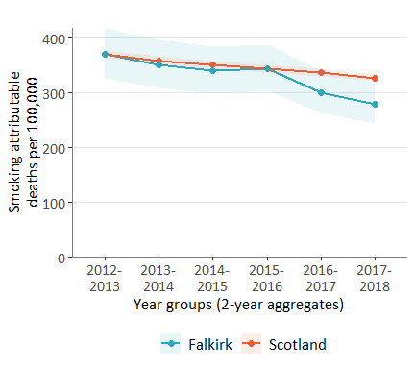

Source: ScotPHO

Figure 6.3a: Smoking prevalence in Falkirk and Scotland

Figure 6.3b: Smoking attributable deaths in Falkirk and Scotland

In 2019, smoking prevalence was 14.6% in Falkirk compared to 17.5% nationally. The latest estimate for smoking attributable deaths was also lower in Falkirk than Scotland (280 deaths per 100,000 compared to 327 deaths). also suggest that Falkirk's smoking prevalence and deaths are lower than the national average.

In Falkirk, 18.5% of people aged 35-64 are smokers, more than double the prevalence for older adults aged over 65 (8.3%).

Figure 6.4: Smoking prevalence by age group in 2019 in Falkirk and Scotland

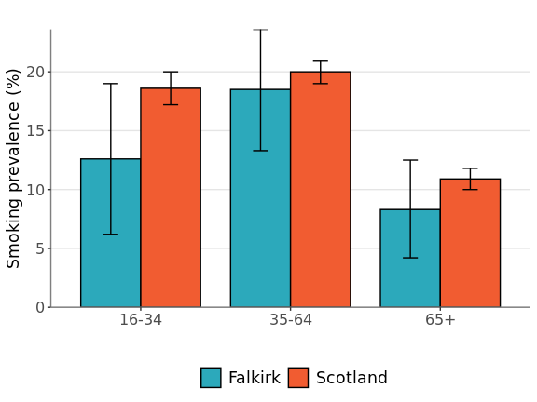

Source: ScotPHO

Links to deprivation: Smoking is linked to socioeconomic inequality, with prevalence rates being higher in more deprived areas. Across Scotland in 2019, 34% of adults living in SIMD 1 reported being current smokers compared to 6% in SIMD 5.[13]

## 6.3 Healthy Weight, Diet, and Physical Activity

One of Scotland's public health priorities is to promote having a healthy diet and being physically active, as this plays an important role in maintaining a healthy weight and brings a wide range of benefits for both physical and mental health.

### 6.3.1 Healthy Weight

The latest estimates from the Scottish Health Survey (2021) found that in Falkirk, around two thirds of adults do not have a healthy weight, and nearly a third (30%) are classed as obese. A healthy weight is defined by having a body mass index (BMI) between 18.5 and 25, and obesity represents a BMI greater than 30.

Figure 6.5: Rates of obesity between 2016 and 2019 in Falkirk and Scotland by sex.

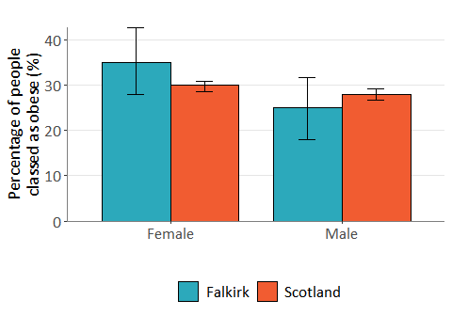

Source: Scottish Health Survey

Although these estimates are similar to the national average, there is variance between Falkirk and Scotland in terms of gender differences. Figure 6.5 shows that obesity among females in Falkirk is much greater than males. In 2016-2019, approximately 35% of females in Falkirk were obese compared to 25% of males. Whilst this pattern is present in the rest of Scotland, the difference is not as marked (30% of females classed as obese and 28% of males).

### 6.3.2 Diet

One of the ways to maintain a healthy weight is good nutrition. Eating a healthy diet also reduces the risk of various diseases, including cardiovascular diseases such as coronary heart disease and stroke[14], which have a much higher burden in Falkirk compared to the rest of Scotland (see section 7.2.2).

According to the Scottish Health Survey, people in Falkirk eat an average of 3.2 portions of fruit and vegetable each day, against a recommendation of 5. Less than a quarter (22%) of Falkirk’s population meet the recommended guidelines for fruit and vegetable consumption, and 1 in 10 people do not eat any fruit or vegetables at all.

Links to deprivation: It is more expensive to eat a healthy diet than to eat a less healthy diet, making it more difficult for people on lower incomes to eat well. In 2019, the Scottish Health Survey found that across Scotland, people living in the most deprived areas of Scotland were less likely to consume 5 portions of fruit and vegetables a day than those in the least deprived areas.

### 6.3.3 Physical activity

Part of the Scottish Government's national outcomes is to work towards a more active Scotland, as physical activity can improve people's health and wellbeing in various ways. COSLA's paper on "The Positive Contribution of Physical Activity and Sport to Scotland" outlines ways in which changes can be made locally to support this, such as making physical activity part of routine healthcare, or care providers embedding physical activity into the daily lives of those they support.

The latest findings from the Scottish Health Survey for the time period 2016-2019 were that 58% of females and 73% of males in Falkirk met the recommended guidelines for activity levels. It is possible that this difference in physical activity between sexes plays a role in obesity rates being higher among females than males. It is also worth noting that the proportion of people meeting their recommended activity levels has increased from 53% for females and 68% for males since 2012-2015. Despite the gender gap remaining the same, physical activity in Falkirk seems to be going in the right direction.

Links to deprivation: Levels of physical activity are lower in more deprived areas compared to less deprived areas. In 2019, 74% of those living in the least deprived SIMD quintile met recommended activity levels compared to 54% in the most deprived SIMD quintile. Similarly, the Scottish Household Survey found that in 2019, whilst 90% of people in SIMD 1 reported having engaged in a physical activity (including walking) in the 4 weeks prior to the survey, this was only 70% for those in SIMD 5.

## 6.4 Violent crime

Crime has an impact on the health and wellbeing of the victims and on the local community. Both the nature and frequency of crimes occurring in an area will have an influence on how safe residents feel and could impact how people go about their daily life.   
It is widely acknowledged that not all crimes are recorded so available figures are considered to be an understatement of true levels of crime.

Figure 6.6 shows that while levels of violent crime dropped between 2004/5 and 2013/14 in Falkirk, the rate of violent crimes has been increasing since then in Falkirk, mirroring a trend seen nationally. It is important to note that while the trend has been similar in Scotland and Falkirk in the past 5 years, Falkirk previously had considerably lower levels of violent crime compared to Scotland.

Figure 6.6: Violent crime in Falkirk HSCP and Scotland

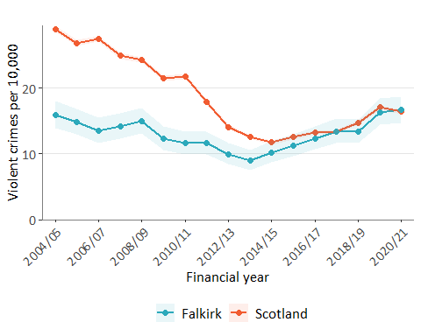

Source: ScotPHO

# 7. Health

According to the latest estimates from the Scottish Health Survey (2021), 69% of Falkirk's population describe their health as "Good" or "Very good" between 2016 and 2019. This is slightly lower than the national average (72%). This section delves deeper into the health of Falkirk's population, expanding on topics of health inequalities, disease and disability, and mental health.

## 7.1 Health Inequalities: Life expectancy & Mortality

One of the key objectives of the strategic planning process should be to make informed decisions which help to reduce health inequalities. Health inequalities shouldn't exist, but figures suggest that there are still significant health inequalities across all of Scotland dependant on where a person is born. A number of health inequality indicators have been developed focusing on life expectancy at birth and mortality.

### 7.1.1 Life Expectancy

In Falkirk, men can expect to live up to 76.6 years on average and women up to 80.4 years. Table 7.1 shows that life expectancy among males is similar to the rest of Scotland, whilst female estimates are slightly below the national average.

Table 7.1: Life expectancy at birth in most recent estimate (2018-2020 for Falkirk HSCP and Scotland, 2016-2020 for localities)

|  |  |  |  |  |  |
| --- | --- | --- | --- | --- | --- |
|  | Falkirk HSCP | Falkirk Central | Falkirk East | Falkirk West | Scotland |
| Female | 80.4 | 79.1 | 81.1 | 80.8 | 81.0 |
| Male | 76.6 | 75.5 | 77.4 | 77.4 | 76.8 |

Source: ScotPHO

The locality breakdown in table 7.1 also highlights inequalities across Falkirk. Falkirk Central locality has the lowest life expectancy for both men and women of the three localities. Figure 7.1 looks at life expectancy at birth by sex and level of deprivation in Falkirk. On average, life expectancy among people living in the least deprived quintile is 8.3 years higher among females and 10.5 years higher among males than those living in the most deprived quintile. Since Falkirk Central has more people living in deprived areas (54.4% living in the two most deprived quintiles compared to 35.3% and 28.7% in Falkirk East and West, respectively), the lower life expectancy could be partially attributed to higher deprivation.

Figure 7.1: Life expectancy by sex and SIMD in Falkirk, 2016-2020

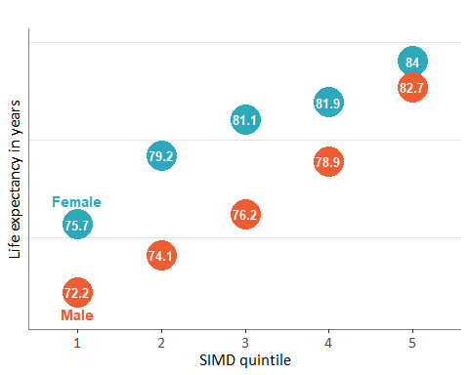

Source: Scottish Government (statistics.gov.scot)

These disparities are apparent on a small scale. For example, Camelon East is one of the most deprived areas of Falkirk with 83.4% of its population living in the most deprived SIMD quintile (the Falkirk average is 16%). It also has the lowest female life expectancy and second lowest male life expectancy. On the other hand, the Lochgreen and Lionthorn intermediate zone is one of the least deprived areas and has both the highest female and male life expectancy. As shown in figure 7.2, these areas are relatively close to one another and are in the same secondary school catchment area. Two students may both be going to Falkirk High school, yet the data shows that the student living in Lochgreen & Lionthorn may live 13 years longer than the one living in Camelon East if they are female, and almost 18 years longer if they are male.

Figure 7.2: Map of Camelon East and Lochgreen & Lionthorn

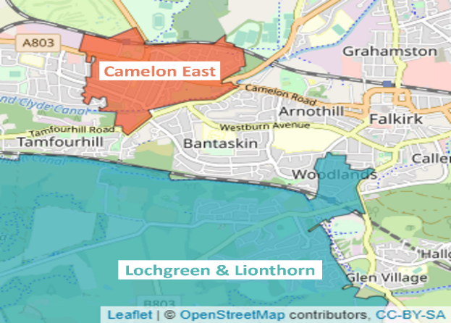

### 7.1.2 Healthy Life Expectancy

While life expectancy is an estimate of how many years a person might be expected to live, healthy life expectancy is an estimate of how many years they might live in a ‘healthy’ state. In Falkirk, although women are expected to live longer lives compared with men, they tend to live less years of their life in good health (an estimated 1.3 years less). As shown in table 7.2, this contrasts with patterns at national level. Furthermore, both female life expectancy and healthy life expectancy at birth are lower in Falkirk than Scotland, whereas male estimates are similar.

Table 7.2: Healthy life expectancy at birth in Falkirk and Scotland, 2018-2020

|  |  |  |
| --- | --- | --- |
|  | Falkirk HSCP | Scotland |
| Female | 59.5 | 61.8 |
| Male | 60.8 | 60.9 |

Source: ScotPHO

Healthy life expectancy also has evident inequalities linked to deprivation. In Scotland, those living in areas of higher deprivation have shorter healthy lives than those living in areas of lower deprivation. It is not possible to break this data down to Falkirk HSCP level, but the pattern experienced at Scotland level is expected be representative of what happens in Falkirk. For both males and females in 2018-2020, there was a difference of over 21 years in healthy life expectancy between those living in the least deprived and most deprived areas.

### 7.1.3 Mortality among 15-44 year olds

All-cause mortality among 15-44 year olds is defined by the number of deaths from all causes of people between 15 and 44 years of age. As figure 7.3 shows, in both Falkirk and Scotland this has been increasing since 2012-2014. In 2019, there were 119.8 deaths among 15-44 year olds per 100,000. Although information on the cause of deaths among 15-44 year olds in Falkirk is limited, in Scotland in 2020, almost one-third (32%) of deaths were drug-related, and 17% were probable suicides.[15]

Figure 7.3: Deaths aged 15-44 in Falkirk HSCP and Scotland

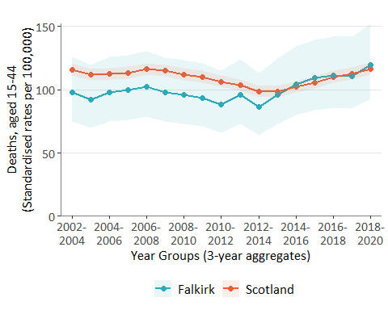

Source: ScotPHO

As seen with life and healthy life expectancy, there is a large gap in the rate of deaths among 15-44 year olds between the most and least deprived areas of Falkirk. Figures 7.4a and 7.4b below illustrate not only that these health inequalities exist, but they are also widening.

Figure 7.4a: Differences in deaths aged 15-44 years between deprivation groups for 2018-2020 in Falkirk

Figure 7.4b: Percentage change in deaths aged 15-44 years from 2002-2004 to 2018-2020 in Falkirk

Source: ScotPHO

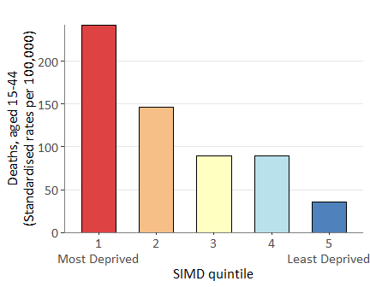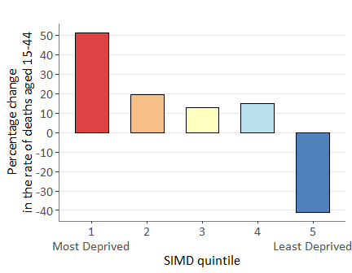

COVID-19 impact: The pandemic has disproportionately affected populations living in higher levels of deprivation. In Scotland, mortality related to COVID-19 has been twice as high for people living in the most deprived SIMD quintile compared to those living in the least deprived quintile[16]. Furthermore, there is emerging evidence that COVID-19 has heightened pre-existing inequalities and exacerbated the effect of deprivation on health outcomes. Although estimates for Falkirk are not recent enough to draw any concrete conclusions, the full effect of the pandemic on health inequalities is likely to be reflected in future estimates.

### 7.1.4 Health and socio-economic measures by intermediate zone

We have seen that life expectancy and mortality among 15-44 years olds varies widely across the Partnership. Factors that shape our lives (e.g. education, work, housing) influence our health and so it is important to understand how these vary across the Partnership too. Appendix 2 provides an overview of a select range of health and socio-economic measures by Intermediate Zone. Each chart is a scatterplot where each Intermediate zone is a dot which has been coloured by whether a quarter or more (red) or less than a quarter (blue) of the population is in considered to be in SIMD Quintile 1. The values for Falkirk and Scotland have also been included as a comparison. To illustrate the range the values for Bainsford & Langlees and Lochgreen & Lionthorn have been labelled as being representative of those areas in both local authorities where either a high proportion or none of the population is considered to live in the most deprived areas in Scotland (SIMD Quintile 1). The charts include the following measures: life expectancy, the older population, the environment, housing, the economy, mortality, ill health and children and young people.

With the caveat that the charts do not include confidence intervals, they highlight:

* The wide range across the Partnership and that while there are some areas that are worse than Scotland there are many that are better.
* Other than a higher rate of emergency hospitalisations and a lower rate of alcohol-related admissions, Falkirk generally performs similarly to Scotland.
* Areas of higher deprivation generally perform poorer across all measures than less deprived areas.
* Bainsford and Langlees consistently has one of the poorest outcomes across all measures and Lochgreen and Lionthorn one of the better outcomes.
* Importantly, they highlight the interconnectedness of all aspects of our lives - how people in more deprived areas are more reliant on benefits, more likely to live in poverty, to live on their own, live for less years, have a younger population and have poorer health outcomes than those who live in less deprived areas.

## 7.2 Diseases & Long-term Conditions

A long-term illness is a physical or mental condition lasting at least one year and is defined as limiting if it limits a person's activities in any way. According to the 2021 Scottish Health Survey, 51% of Falkirk's population do not have a long-term illness, 14% have a non-limiting long-term illness, and 36% have a limiting long-term illness.

Figure 7.5 provides further information on those with limiting long-term illnesses in Falkirk and Scotland. The chart shows that in both Falkirk and Scotland, women are more likely to report having a limiting long-term condition, but the gap between males and females is wider in Falkirk (female percentage is 12 points higher than males in Falkirk, and 5 points higher in Scotland). These figures echo patterns in healthy life expectancy seen in section 7.1.2, again suggesting that women in Falkirk live in poorer health compared to men and women in the rest of Scotland.

Figure 7.5: Proportion of males and females who report having a limiting long-term illness between 2016 and 2019 in Falkirk and Scotland.

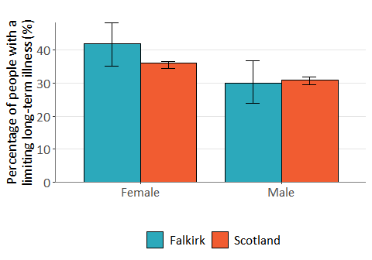

Source: Scottish Health Survey

### 7.2.1 Disease Prevalence

In June 2022, Public Health Scotland released disease prevalence data extracted from General Practices in Scotland through Scottish Primary Care Information Resource (SPIRE).[17] Data was available for all practices in Falkirk except one (Kersiebank from Forth Medical Group). Findings are summarised below, please refer to the official publication for methodologies as well as data visualisations at practice and cluster level.

Figure 7.6 shows prevalence of various diseases among the 156,614 people registered across Falkirk practices in 2021/22. The most prevalent conditions were hypertension (15.2%), depression (10.4%) and asthma (7.0%). Both hypertension and depression appear to be more prevalent in Falkirk than the rest of Scotland, with a 2.1%-point difference for hypertension, and 2.2%-point difference for depression.

Figure 7.6: Disease prevalence in Falkirk and Scotland, 2021/22

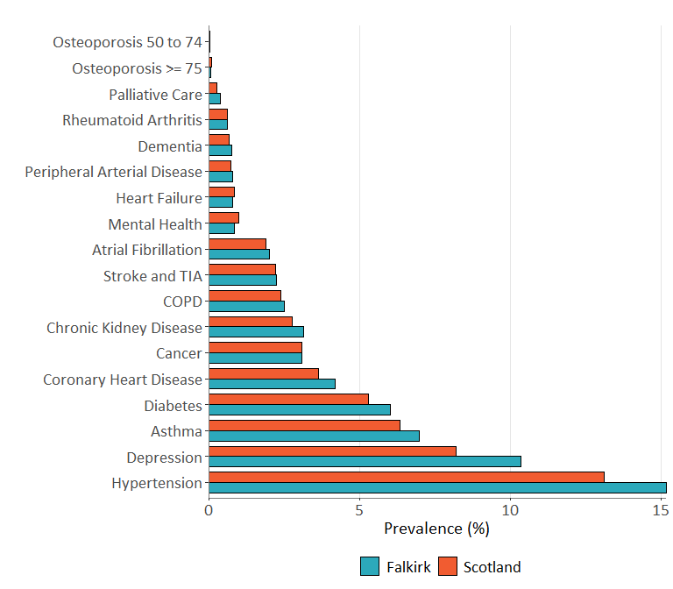

Source: Public Health Scotland

Note: Mental health in Figure 7.6 refers to patients with schizophrenia, bipolar affective disorder and other psychoses and other patients on lithium therapy.

### 7.2.2 Burden of disease

Burden of disease is a measure of the health of the population. It aims to quantify the difference between living to old age in good health, and the situation in which healthy life is shortened by illness, injury, disability and early death.

Burden of disease studies use a single measure which combines fatal burden [i.e. years lost because of early death - years of life lost (YLL)] and non-fatal burden [i.e. years lost because they are lived in less than ideal health - years lived with disability (YLD)]. The measure used to describe the overall burden of disease is called the disability-adjusted life year (DALY) and was calculated by adding together the YLL (fatal burden) and YLD (non-fatal burden) for each disease, condition, or injury.

Figure 7.7: What is a DALY?

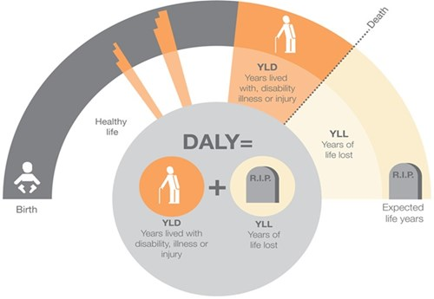

Source: Public Health England

Figure 7.8 shows the overall burden each group of conditions has in Falkirk and Scotland. Cancers and cardiovascular diseases are by far the conditions with the most important burden in Falkirk. Although Falkirk and Scotland have similar DALY rates for most conditions, cardiovascular diseases appear to have a higher burden in Falkirk than Scotland.

Figure 7.8 shows the overall burden of each category of disease or disorder as it sums the YLL (fatal burden) and YLD (non-fatal burden). However, the distinction between these two measures is important. As shown in Table 7.3, cancers are the biggest cause of years of life lost, whereas mental health conditions are responsible for the most years lived with a disorder or disease. The fatal and non-fatal burden of diseases is similar in both Falkirk and Scotland, with the exception of YLL for cardiovascular diseases and chronic respiratory disorders, where the burden is much higher in Falkirk (18.4% and 22.1% higher, respectively).

Figure 7.8: Disability-Adjusted Life Years (DALYs) in Falkirk and Scotland in 2019

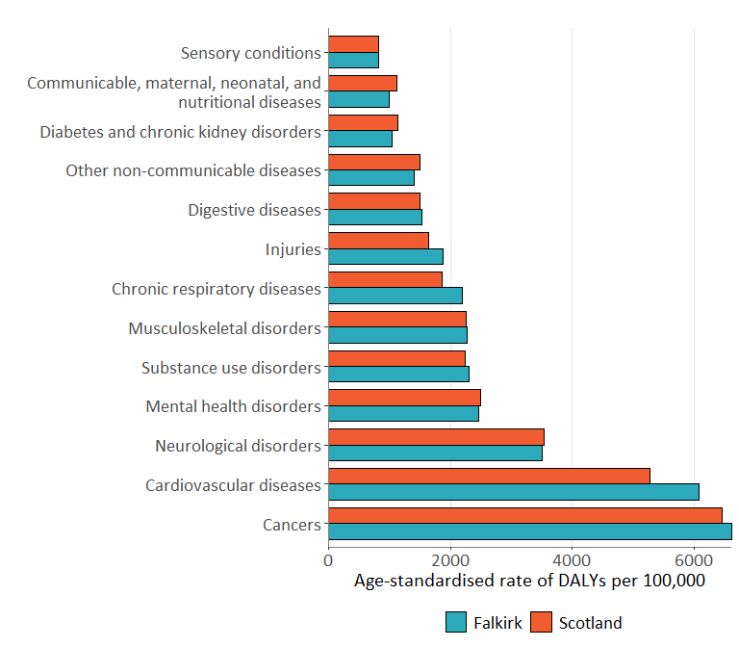

Source: ScotPHO

Table 7.3: Top 5 condition groups with highest YLL and YLD rates in Falkirk in 2019.

|  |  |  |  |  |  |
| --- | --- | --- | --- | --- | --- |
|  | Top 5 condition groups with highest YLL rate in Falkirk | Difference with Scotland |  | Top 5 condition groups with highest YLD rate in Falkirk | Difference with Scotland |
| 1 | Cancers (6,312 YLLs per 100,000) | + 2.7% |  | Mental health disorders (2,467 YLDs per 100,000) | - 0.57% |
| 2 | Cardiovascular diseases (5,162) | + 18.4% |  | Musculoskeletal disorders (2,174) | + 0.92% |
| 3 | Neurological disorders (2,031) | - 2.0% |  | Neurological disorders (1,481) | + 1.4% |
| 4 | Chronic respiratory disorders (1,747) | + 22.1% |  | Other non-communicable diseases (1,005) | + 0.68% |
| 5 | Substance use disorders (1,645) | + 5.6% |  | Cardiovascular diseases (924) | + 0.52% |

Source: ScotPHO

As well as using Burden of Disease, the impact of certain health conditions can be measured by looking at hospitalisations and early deaths associated with them. This is covered in the next two sections.

### 7.2.3 Hospitalisations linked to disease

Data on hospitalisations is available for asthma, CHD, and COPD. Compared to Scotland, asthma and COPD hospitalisation rates are lower, but CHD hospitalisation rates are higher.

Table 7.4: Hospitalisations per 100,000 by medical condition for 2019/20-2020/21 (3 financial year aggregates).

|  |  |  |
| --- | --- | --- |
| Condition | Falkirk HSCP | Scotland |
| Asthma | 67.7 | 75.8 |
| Coronary Heart Disease (CHD) | 365.1 | 354.8 |
| Chronic obstructive pulmonary disease (COPD) | 202.7 | 230.9 |

Source: ScotPHO

Links to deprivation:In areas of higher deprivation, hospitalisation rates are higher for all the above conditions. In Falkirk, in 2016/17-2018/19, the most deprived areas had 30% more CHD patients than average, 46% more asthma patients, and 82% more COPD patients. Taking examples on a smaller scale, Polmont has 100% of its population living in the top 2 SIMD quintiles, and a rate of 77.5 COPD hospitalisations per 100,000 population per year. On the other hand, Camelon West, which has 74% of its population in the most deprived SIMD quintile, has a rate roughly 6 times higher with 472 hospitalisations per 100,000.[18]

### 7.2.4 Deaths linked to disease

Figures 7.9a and 7.9b show early deaths, or deaths among population aged under 75, from cancer and CHD over time. Trends for both conditions show a decrease in deaths for Falkirk and Scotland since 2002-2004, although CHD deaths in Falkirk have remained similar since 2015-2017.

Figure 7.9a: Early deaths from cancer, aged <75 years in Falkirk and Scotland

Figure 7.9b: Early deaths from CHD, aged <75 years in Falkirk and Scotland

Source: ScotPHO

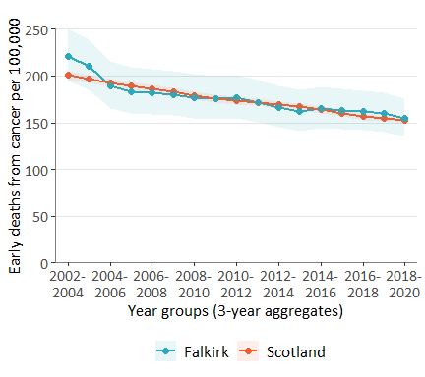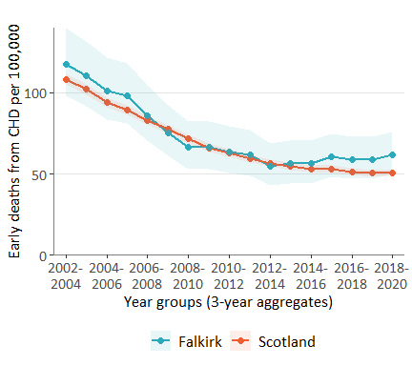

Links to deprivation: Rates of early deaths linked to cancer and CHD are higher in areas experiencing more deprivation. In Falkirk, in 2016-2018, the most deprived areas had 43% more deaths linked to cancer than average and 77% more deaths from CHD. Taking examples from specific areas, the intermediate zone of Lochgreen and Lionthorn, which has over 80% of its population living in SIMD 5, has a rate of early CHD deaths of 16.9 per 100,000. Conversely, Camelon East, the area with the highest proportion of its population in SIMD 1 (83.8%), also has the highest rate of premature mortality from CHD at 157.5 deaths per 100,000. It is important to note that there are exceptions to these patterns. For instance, Hallglen & Glen Village, which has 79.6% of its population living in the most deprived SIMD quintile, only has an estimated 14 early deaths from CHD per 100,000, lower than Lochgreen and Lionthorn.[19]

## 7.3 Cancer

### 7.3.1 Cancer Incidence

As shown in the previous section, early deaths from cancer have been decreasing in the last few years. Cancer registrations, on the other hand, have fluctuated over the years (see figure 7.10). The latest official statistics on the rates of cancer registrations at lower-level geographies are for the time period 2017-2019. These showed that Falkirk had a slightly lower rate of cancer registrations than the rest of Scotland (636 registrations per 100,000 compared to 643). The table below highlights differences at locality level, showing a gap of 55 registrations per 100,000 between Falkirk East and West. It should be noted though that confidence intervals are wide and overlapping across all areas.

Figure 7.10: Cancer registrations in Falkirk and Scotland

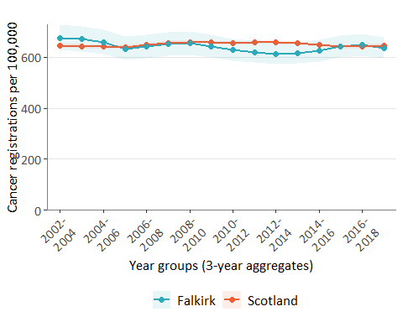

Source: ScotPHO

Table 7.5: Cancer registrations per 100,000 in 2017-2019 in different areas.

|  |  |  |  |  |
| --- | --- | --- | --- | --- |
| Falkirk HSCP | Falkirk Central | Falkirk East | Falkirk West | Scotland |
| 636.2 (CI: 597-678) | 645.2  (CI: 572-726) | 656.0  (CI: 594-531) | 601.3 (CI: 531-679) | 643.6 (CI: 636-650) |

Source: ScotPHO

COVID-19 Impact: Cancer services in Scotland were disrupted as a result of the coronavirus pandemic. The latest published figures on cancer incidence are only available at Health Board level, and show that in 2020, the age-sex standardised rate of cancer incidence for all types of cancer was 588.7 per 100,000. This is the lowest it has ever been since the earliest available figure in 1996. The next lowest figure was in 2000 with 599.2 incidences per 100,000.

The impact of COVID-19 can be further demonstrated if using the proxy measure of pathology samples detecting cancer, for which weekly figures at Health Board level are available for 2019, 2020 and 2021. Note that this method has limitations as it does not include patients newly diagnosed by other methods, and it may include those that are being followed-up from a pre-2019 diagnosis. As shown in figure 7.11, numbers in 2020 were similar to 2019 up until the first national lockdown in March, after which the weekly number of individuals who were found to have cancer via a pathology sample dropped. In both Forth Valley and Scotland overall, figures were approximately one third lower in the first quarter of 2020/21 compared to the same quarter in 2019/20. By 2021, numbers had returned closer to those seen in pre-pandemic years.

The reason for this drop could be for various reasons, such as individuals not wanting to burden the NHS or being anxious of the risk of infection. It is also likely that preventative and non-urgent care services were delayed due to lockdowns. Cancer registrations are a good example of how COVID-19 affected individuals’ health and use of health services. More information on the impact of COVID-19 on other types of services is available on the Public Health Scotland Wider Impacts Dashboard[20].

Figure 7.11: Total count of individuals in NHS Forth Valley having a cancer of type “All Malignant Neoplasms (Excl. C44)” confirmed on a pathological specimen in 2019, 2020 and 2021

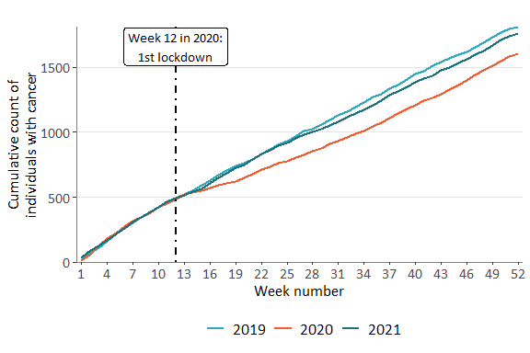

Source: Public Health Scotland – Wider

### 7.3.2 Cancer Screening

There are 3 programmes for cancer screening in Scotland: bowel, breast, and cervical. These programmes aim to detect early signs of cancer in order to diagnose and treat it as early as possible.

Data on breast and cervical screenings are only available at Health Board level. In 2017/18 to 2019/20, the average uptake for breast screening in NHS Forth Valley was 71.8%, comparable to Scotland (72.2%) and above the minimum standard of 70%. However, there is still some improvement needed to reach the target of 80% uptake. The latest estimate for cervical screenings showed that 73.2% of eligible women had had an adequate screening test in 2020/21, higher than the national average uptake of 69.3%.[21]

Bowel screening data shows that for the time period 2018-2020, uptake in Falkirk HSCP was at 64.0%, similar to the Scotland average of 64.2%.

The time trend (figure 7.12) illustrates that uptake in both Falkirk and Scotland has been steadily rising since 2015-2017.

Figure 7.12: Bowel screening uptake in Falkirk and Scotland

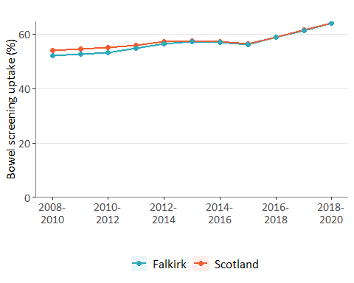

Source: ScotPHO

Links to deprivation: Although overall trends in bowel screening uptake are promising, it is important to note the disparities when comparing intermediate zones. As can be seen in table 7.6, which lists the 3 intermediate zones with the lowest and highest rates of uptake, there is a 27.2-point difference between the top and bottom ranked zones. Furthermore, those with the lowest uptake area some of the most deprived areas of Falkirk, and vice-versa. This pattern is also visible in cervical screening, as in 2019/20 it was found that uptake in the least deprived areas was 75.5% compared with 65.3% in the most deprived areas.

Increasing uptake in preventative care among deprived communities could have impact on health inequalities further down the line, such as reducing inequalities in early deaths linked to cancer (section 7.2.4), so it is important to consider these differences.

Table 7.6: Bowel screening uptake by intermediate zone in 2018-2020

|  |  |  |
| --- | --- | --- |
| Ranking (1 = highest uptake) | Intermediate Zone name | Bowel screening uptake (%) |
| 1 | Stenmuirhouse-Antonshill | 76.7 |
| 2 | Reddingmuirhead & Overton | 73.6 |
| 3 | Lochgreen & Lionthorn | 73.4 |
| 40 | Camelon East | 54.7 |
| 41 | Camelon West | 53.6 |
| 42 | Bainsford & Langlees | 49.5 |

## 7.4 Diabetes

Diabetes is a long-term condition characterized by elevated blood sugar levels. In 2021/22, the General Practice disease prevalence report found that 6% of the Falkirk population had diabetes, compared to 5.3% in Scotland overall. According to the Scottish Diabetes Survey (2017), it is estimated that around 88% of diabetes cases are type 2 diabetes. Unlike type 1 diabetes which is a chronic condition, type 2 is usually onset in adulthood, and the main modifiable risk factor is excess weight.

In 2018 the Scottish Government published a framework for prevention, early detection, and early intervention of type 2 diabetes.[22] The primary solution is the use of evidence-based weight management programmes, which can prevent and even reverse diagnoses of type 2 diabetes. This framework highlights the importance of making it easier to eat well and be physically active, discussed in section 6.3.

The table below provides recent figures on Type 1 and Type 2 prevalence in the Falkirk population from the SCI-diabetes system which is used in primary care services.

Table 7.7: Diabetes Rates in the Falkirk population at October 2022

|  |  |  |  |
| --- | --- | --- | --- |
| **Type** | **Falkirk (Number)** | **Falkirk Rate per 1,000** | **Proportion of total (%)** |
| Type 1 Diabetes | 1,020 | 6.4 | 10.4% |
| Type 2 Diabetes | 8,799 | 54.8 | 89.6% |
| Total | 9,819 | 61.2 | 100% |

Source: SCI-Diabetes (NHS Forth Valley)

Links to deprivation: Prevalence of type 2 diabetes is 40% higher in the most deprived areas compared to least deprived.[23] This is likely related to trends of self-reported physical activity and consumption of fresh fruit and vegetables being lower in adults living in areas of higher deprivation.

## 7.5 Dementia

There are an estimated 90,000 people with dementia in Scotland. Around two thirds are living at home with the remainder in acute or residential care. In the next 25 years it is predicted that the older adult population will rise. As a result, it is likely that the number of people with dementia will also rise. Data on dementia prevalence shows that there more women than men (most likely because women live longer), dementia risk increases with age and dementia rates are higher amongst people with a learning disability and onset is often younger.

In Falkirk in 2021/22, General Practice data suggested that 1,198 people registered had dementia (0.8%), but it is important to note that this figure is likely an undercount as it will only include those who have been registered with a diagnosis of Dementia. The 2016 Scottish Burden of Disease study estimated that there were 1,911 people with Alzheimer’s disease and other dementias in Falkirk – 65% female. This was a rate of 1,352.7 per 100,000 population for all ages and the rate increased with age and was higher for women. Assuming these rates remained the same and applying them to the 2018-based population shows that the estimated number of people with dementia in Falkirk is likely to increase by around 40% in the next 25 years. As the highest age range in the burden of disease study is 65 years and over these estimates are likely to be higher.

Figure 7.13: Estimated population with Alzheimer’s Disease and other Dementias in Falkirk, 2018-43

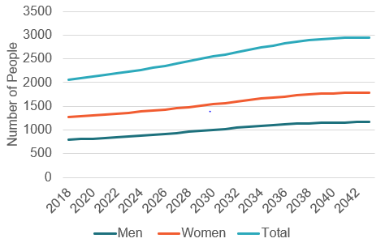

Source: Scottish Burden of Disease 2016 age-standardised rates for Alzheimer’s disease and other dementias in Falkirk, NRS 2018-based population projections.

## 7.6 Disability

### 7.6.1 Physical Disability

Information on people with a physical disability is limited. In the 2011 Census there were over 10,800 people in Falkirk recorded as having a physical disability, 7% of the total population. The proportion of those with a physical disability increased as people aged – 80% were aged over 50.

### 7.6.2 Sensory Impairment

Sensory impairment includes varying degrees of hearing loss, sight loss and loss of both of these senses. It can be a recognised sensory impairment; a risk of sensory loss or hidden and untreated sensory loss. The World Health Organization has recognised that children and adults with disabilities, including those with a sensory impairment, have poorer health outcomes, lower educational achievements, less economic participation and higher rates of poverty than people without a disability.[24]

Unfortunately, data on prevalence of sensory impairment is very limited. A register of blindness and partial sightedness (Registered Blind and Partially Sighted Statistics – Scottish Government) was collected at a local authority level until 2010 but has since been discontinued. In 2010, there were 3.1 registered blind people per 1,000 population in Falkirk, and 5.8 visually impaired per 1,000. The main caveat with this data source is that it is not compulsory to register with the local authority so only counts those who have come forward. It is thought that between a quarter and a third of those who are partially sighted are registered with their local authority.

Data on the population who are deaf or have a hearing impairment is even more limited. There is no national data collected on numbers of people who are deaf or have a hearing impairment. It is estimated that one in six people in Scotland suffer from hearing loss, and of those, 70% are over 70.

### 7.6.3 Learning Disability

According to the 2019 Learning Disability Scotland publication there were 691 adults with learning disabilities known to local authorities in Falkirk. This rate of 5.2 per 1,000 population is the same as the Scotland rate. It 2019 report showed that in Falkirk:

* There were more males than females - 63% were male.
* While the majority were younger adults (45% were under 35 years of age) there was a quarter that were aged 55 and over.
* A quarter (26%) were on the Autism Spectrum.
* 40% lived with a family carer.
* 3% were in employment, 6% were in education, 20% attended a day centre.

# 8. Mental Health & Wellbeing

## 8.1 Overview and Definitions

Mental health is an umbrella term used to encompass both mental health problems/illness and mental wellbeing. Mental Health problems or illnesses are clinically diagnosed symptoms which affect the way that a person thinks, feels or behaves. Mental wellbeing describes mood and how well a person can cope with day-to-day life. Someone with low mental wellbeing may struggle to cope with the stresses of daily life, to build and maintain relationships, to interact with the world around them and live and work productively. If a person experiences low mental wellbeing over a long period of time, they are more likely to develop a mental health problem[25]. However, it is important to note that it is possible to have poor mental wellbeing without a mental health illness – equally it is possible to have a diagnosed mental illness but still experience good mental wellbeing.

Life events such as bereavement, loneliness, loss of employment and money worries can all lead to low mental wellbeing. People who are socially excluded, who have a long-term condition, are homeless or living in poor housing, or socially disadvantaged are more vulnerable in terms of mental wellbeing, and consequently poor mental health in the long term. It is imperative that the health and social care partnership tackles inequalities not just in physical health, but also mental health and wellbeing as these go hand in hand. Poor physical health can negatively affect mental wellbeing, and conversely, poor mental wellbeing can negatively impact on physical health. Mental and physical health should both be considered when making key strategic decisions.

There is considerable debate as to the true prevalence of mental health disorders in Scotland, but here are some key points to recognise how widespread mental health issues are:

* The Scottish Government estimate that approximately 1 in 4 people will experience some form of mental health issue in their lifetime.
* According to the 2019 Scottish Health Survey, in 2018/19 17% of adults in Scotland had scores indicative of psychiatric disorders (scoring 4 or more on the General Health Questionnaire 12).
* Conditions related to mental health had the highest non-fatal burden of any condition group in 2019 (see table 7.3 in Burden of Disease section).

Societal stigma attached to mental ill health has meant that people with mental health problems have traditionally suffered discrimination in numerous aspects of their life[26]. This could be difficulties in getting and retaining employment, social isolation, difficulties maintaining decent housing, or being delayed access to the appropriate help and treatment. There is also a high likelihood that many people who are experiencing mental health issues will not interact with any services in their time of crisis. This means that a substantial proportion of the population may be dealing with mild to severe mental health issues at any one time with no professional or informal supports.

A number of national campaigns (such as SeeMeScotland.org) aim to challenge societal stereotypes and end stigma and discrimination against people with mental health problems. At the same time, the Scottish Government has made mental health one of its public health priorities and recently released a 10-year vision for mental health in Scotland (2017-2027)[27].

This document sets out 8 priorities for the new mental health strategy:

* Focus on prevention and early intervention for pregnant women and new mothers
* Focus on prevention and early intervention for infants, children and young people
* Introduce new models of supporting mental health in primary care
* Support people to manage their own mental health
* Improve access to mental health services and make them more efficient, effective and safe – which is also part of early intervention
* Improve the physical health of people with severe and enduring mental health problems to address premature mortality
* Focus on ‘All of Me’: Ensure parity between mental health and physical health
* Realise the human rights of people with mental health problems.

Links to deprivation: Socio-economic deprivation is associated with increased risk of developing a mental health disorder. Individuals from disadvantaged backgrounds may have higher exposure to stressful experiences and weaker support systems over the course of their lives, both of which play a role in mental wellbeing.[28] Responses to the Scottish Health Survey (2019), have shown that people living in the most deprived areas of Scotland have poorer mental wellbeing, scoring significantly lower on the Warwick-Edinburgh Mental Wellbeing Scale (WEMWS) than those living in in the least deprived areas.

COVID-19 impact: There is evidence that the pandemic has negatively affected the mental health of people living in the Scotland, particularly among people already experiencing inequalities (for example lone parents, Black And Minority Ethnic communities, refugees, and people with long term physical health conditions).[29] Between March 2020 and February 2021, suicidal thoughts and feelings of hopelessness and loneliness increased, and fewer people said they were coping well with the stress of the pandemic. However, in that same period, anxiety about the pandemic fell.[30] It is important to note that while these short-term effects of the pandemic on mental health are evident, long-term effects are still unknown.

In Falkirk, there is limited data to show the impact of COVID-19 on mental health. However, there is some evidence to suggest that people living in Falkirk may not have received the help they needed for their mental wellbeing in recent years. Whilst nation-wide research suggests mental health worsened due to the pandemic, in Falkirk the weekly average number of patients starting a new treatment course for selected mental health medicines was 13.5% less in 2020 and 16.9% less in 2021 compared to the weekly average in 2018 and 2019. [31]

## 8.2 Community Engagement

The Falkirk Community Planning Partnership strategic needs assessment[32] notes that community engagement with adults in Falkirk in 2020 (during lockdown) told us that their concerns are:

* Wellbeing and mental health concerns
* Worrying about their own or others’ futures
* How to support family or friends
* Social isolation/ loneliness
* Stress of working/ learning from home
* Worrying about health treatments needed and not getting these
* Job security/ furlough

While admittedly a number of these concerns are directly related to the restrictions on leaving home during lockdown, a number of these community concerns are still relevant and concerns about mental health and wellbeing, social isolation, job security/money worries will continue to have an impact on lives for years to come.

## 8.3 Data Landscape

While high quality mental health data exists for those patients who are hospitalised with a more serious mental health diagnosis, the vast majority of people who have mental health issues will not reach hospital, and many will not interact with any services. If people do not interact with services, there is no means of collecting information on this cohort, and as a result there is a significant gap in non-hospital Mental Health data. Without data, it is more difficult to plan & deliver services locally.

While people with common mental health issues are likely to interact with Primary care services, the data is not as accessible as secondary care data. Recent 2021/22 disease prevalence data from GPs does provide reliable estimates of the population in Falkirk suffering from depression, as well as schizophrenia, bipolar affective disorder and other psychoses. However, this excludes a range of other mental health problems, meaning it is still difficult to estimate the overall prevalence of mental health issues in Falkirk.

Priority number 7 of the Scottish Government’s 10-year vision for Mental Health states that there should be parity between mental and physical health. It is important that the partnership endeavours to improve collection of mental health data to a similar level as physical health data to help inform the planning and delivery of services.

In 2021/22 Public Health Scotland established a Mental Health Indicators project[33] to make relevant data more accessible to local and national users. These outputs support the use of data to improve population mental health through:

* more effective planning
* more efficient resource allocation
* consistently applying best practice
* more effective policies

Two sets of mental health indicators have been created, one set for adult mental health and one for children and young people. In each indicator set, indicators are grouped by type:

**Mental health outcomes** — mental wellbeing and common mental health problems

**Contextual Factors** — the determinants (risk factors and protective factors) of these outcomes

Some of these indicators use already existing data while some are aspirational indicators which will require development and new data collection. The health and social care partnership should keep well-informed of developments and how it can participate in strengthening the data and understanding of local mental health.

The following sections look at the data that is available around mental health and wellbeing.

## 8.4 Local Services Data

### 8.4.1 Primary Care MentAL HEalth NURSE Service

As part of the reform of primary care in Forth Valley a mental health nurse service was introduced in 2018. The introduction of this service aims to improve access for people with mild to moderate mental health needs to appropriate support in the most appropriate setting. The introduction of the service is in alignment with the Scottish Governments mental health strategy 2017-2027 which stated ambitions for "multi-disciplinary teams in primary care to ensure every GP practice has staff who can support and treat patients with mental health issues".

As of May 2022 a Primary Care mental health service was in place in 25 practices across Falkirk with staffing capacity adjusted according to practice population. While routine data collection for this service is still in development early studies suggest the service is currently offering in excess of 500 appointments per week across Falkirk and over 50,000 appointments annually across Forth Valley.

A number of studies were carried out to determine the service was operating as planned in 2019 & 2020. While these studies do not provide trend data to monitor over time, several observations from these studies provide insight into the mental health needs of the local population.

Insights:

* Age – The majority of patients accessing the primary care mental health service fall into the 18-44 age bracket.
* Gender **–** two thirds (66%) of patients are female. (Question of whether stigma around asking for help potentially reducing the proportion of men attending PCMHN service)
* Anxiety & Depression **–** consistently the two most common presenting problems (Anxiety ~47% of presentations, Depression ~56% of presentations)
* Other stress and Work-related stressare other common presenting problems.
* Self Help **–** was the most common appointment outcome (over 40% of recorded appointments mentioned this as an outcome)
* Medication **–** two thirds of patients attending primary care mental health service on at least one type of medication.

### 8.4.2 FDAMH: Falkirk’s Mental Health Association

The FDAMH (Falkirk Mental Health Association) Immediate help service exists to provide Falkirk residents with immediate help or support when they are in crisis. In 2020/21, 696 people attended one of their sessions, over half of which said they were in serious distress before finding support. As well as the immediate help service, FDAMH also offer counselling, groupwork courses, community and family support services, and mental health training. In 2020/21, 2,034 Falkirk residents received some form of support or training.

Over the course of 2020/21, people who reached out to FDAMH mostly presented issues of anxiety (87%) and low mood (85%), which will be explored further in the next section. Figure 8.1 illustrates common issues presented as well as contributing factors.

Figure 8.1: FDAMH Presenting Issue and Contributing Factor Summary

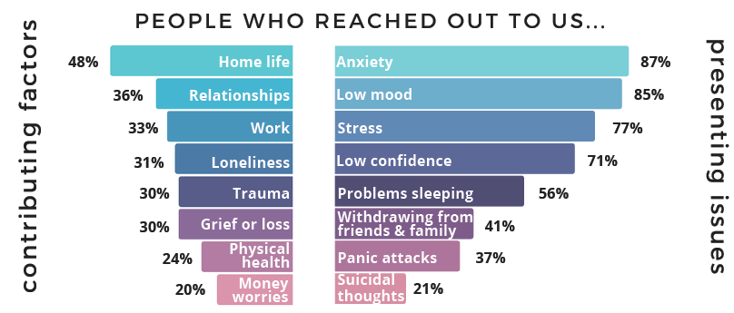

Source: FDAMH Annual Review 2021

## 8.5 Anxiety and Depression

Common mental health disorders include anxiety and depression. Depression is characterised by sadness, loss of interest in activities and by decreased energy. Anxiety is a broad category of conditions which share features of excessive anxiety and related behavioural disturbances.

In 2018/19, the Scottish Health Survey found that 12% of adults had reported experiencing several symptoms of depression, and 14% reported symptoms of anxiety. These figures have both increased from 9% in 2012/13, which is consistent with data on prescriptions for drugs to treat anxiety, depression, and psychosis. Figure 8.4 shows that prescription rates have been steadily increasing in both Falkirk and Scotland over the last decade, and the gap between both areas has widened. In 2019/20, 21.1% of the population in Falkirk were prescribed this medication, compared to 19.7% in all of Scotland.

Figure 8.4: Population prescribed drugs for anxiety, depression, and psychosis in Falkirk and Scotland

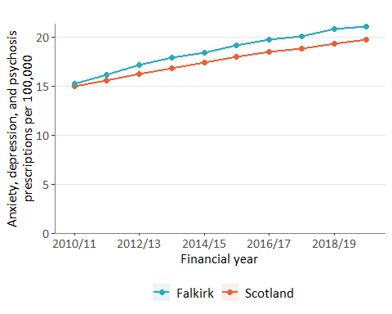

Source: ScotPHO

In 2021/22, information from General Practices suggested that around 10.4% of the Falkirk population had depression, compared to 8.2% in all of Scotland. The same publication reported much lower prevalence for mental health disorders of schizophrenia, bipolar affective disorder and other psychoses, and these are also less prevalent in Falkirk than Scotland (0.8% compared to 1.0%).

Figure 8.5 shows that the prevalence of depression has been increasing in the last few years, and that the difference between Falkirk and Scotland is widening, patterns which are similar to those found in figure 8.4.

Figure 8.5: Population with depression in Falkirk and Scotland 2017/18 to 2021/22

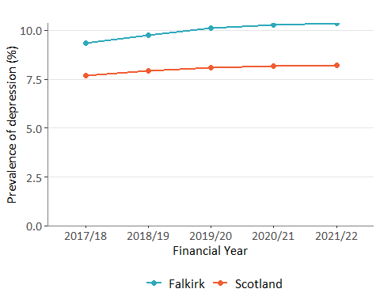

Source: Public Health Scotland

In Falkirk in 2019, depression and anxiety had the highest YLD rate of the mental health disorders covered in the Scottish Burden of Disease analysis. It is estimated that, per 100,000, a total of 1,237 years of life are lived with depression and 848 are lived with anxiety (compared to 210 for schizophrenia and 172 for other mental health disorders). Figure 8.6 shows that whilst men and women both experience similar non-fatal burden for depression, women tend to have a higher burden for anxiety. Similarly, Scottish Health Survey data has shown that women in Scotland have historically been more likely to display symptoms of anxiety (although that the difference between men and women in the latest year 2018/19, was not found to be significant).

Figure 8.6: Years lived with disability (YLDs) for anxiety and depression in Falkirk in 2019

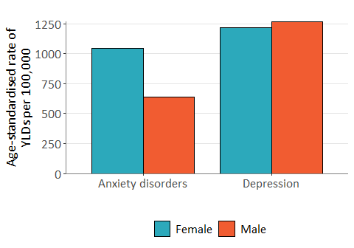

Source: ScotPHO

Links to deprivation: In Falkirk, the most deprived areas have 34% more people being prescribed drugs for anxiety, depression and psychosis than the overall average[34].

## 8.6 Social Isolation & Loneliness

Loneliness can be a contributing factor to a person’s mental health. Research from the Health Foundation found that people who reported feeling lonely often were more likely to have scores on the General Health Questionnaire (GHQ) indicative of distressed mental state.[35] Furthermore, as shown in figure 8.1, 31% of people who reached out to Falkirk’s Mental Health Association (FDAMH) in 2021 experienced loneliness.

Social isolation and loneliness are often discussed together. However, they are not necessarily connected as people are socially isolated may not feel lonely, and people who have many social connections may feel lonely. Social isolation refers to the quality and quantity of the social relationships a person has at individual, group, community and societal levels. Loneliness is a subjective feeling experienced when there is a difference between an individual’s felt and ideal levels of social relationships[36].

In 2018, the Scottish Household Survey included questions on social interactions and loneliness. Of the 210 respondents in Falkirk, 44.7% said that they had felt lonely at least some of the time in the week before taking the survey. This estimate is more than double the percentage from all 9,700 respondents across Scotland (21.3%), although it is difficult to determine significance due to the small sample for Falkirk. Figure 8.7 and table 8.1 provide further breakdowns of the responses to the survey question “How much of the time during the past week have you felt lonely?”.

Figure 8.7: Percentage of respondents who reported feeling lonely “Most, almost all or all of the time” in Falkirk and Scotland, 2018.

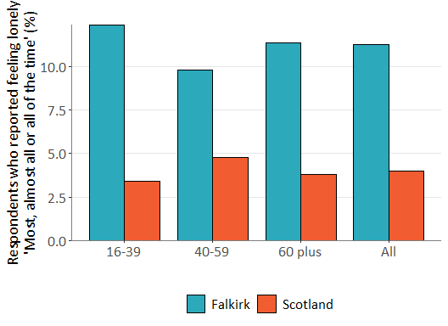

Source: Scottish Household Survey

Table 8.1: Frequency of responses to the question “How much of the time during the past week have you felt lonely?”

|  |  |  |  |  |  |
| --- | --- | --- | --- | --- | --- |
| Council | Age | N | None or almost none of the time (%) | Some of the time (%) | Most, almost all or all of the time (%) |
| Falkirk | All | 210 | 53.7 | 33.6 | 11.3 |
|  | 16-39 | 50 | 54.1 | 33.5 | 12.4 |
|  | 40-59 | 80 | 51 | 36.9 | 9.8 |
|  | 60+ | 90 | 56 | 30 | 11.4 |
| Scotland | All | 9,700 | 78 | 17.3 | 4 |
|  | 16-39 | 2,700 | 76.7 | 19 | 3.4 |
|  | 40-59 | 3,040 | 78.4 | 16.2 | 4.8 |
|  | 60+ | 3,970 | 79.1 | 16.5 | 3.8 |

Source: Scottish Household Survey

Note: Percentages do not add up to 100% due to category “Don’t know” not shown here.

Although self-reported loneliness was higher in Falkirk respondents than the rest of the cohort, there was no real difference in frequency of social interactions. In the 2018 Scottish Household Survey, 1.8% of Falkirk respondents reported never having any social interaction with relatives, friends, neighbours, or work colleagues, and 6.3% reported having such interactions very rarely or a few times a year (compared to 1.5% and 6.9% in the entire cohort, respectively). However, these figures do not provide any information on the quality of the social interactions and relationships the respondents have.

A range of services provided by the public sector, private sector, third sector and community and voluntary services may have the potential to impact on social isolation; even if it is not their primary aim.[37] Services like the FDAMH’s “Social spark” can directly help improve the quality of social interactions and relationships. The service aims to tackle the social isolation commonly experienced with mental health issues, providing small social groups and one-to-one support to help regain confidence and build connections. They help people both with and without a mental health diagnosis.

Links to deprivation: In Scotland, adults and children who are socio-economically disadvantaged and those experiencing poor physical and mental health are at risk of social isolation and loneliness, as are adults who are living alone, widowed or separated. Lack of access to transport can lead to social exclusion and poor social capital. In contrast, public and green spaces benefit health through promoting social interactions and physical activity[38].

COVID-19 impact: The Mental Health Foundation found that almost a quarter of Scottish adults have felt lonely during the pandemic.[39] The most affected were young people aged 18-24, 43% of whom reported feelings of loneliness. Although the survey found that loneliness was at its highest during periods of lockdown, it is worth considering possible long-term impacts of loneliness on mental health.

## 8.7 Psychiatric Hospitalisations

Psychiatric hospitalisations in Falkirk have fluctuated over the years but all localities seem to have been experiencing a downward trend in more recent estimates. In the time period 2017/18-2019/20, Falkirk had an average of 279 psychiatric hospital admissions per 100,000 population per year. This is slightly higher than the Scotland average at 254 admissions.

One important point to note is that this difference between Falkirk HSCP and Scotland is likely driven by the rate of admissions in Falkirk Central locality. As shown in figure 8.8, Falkirk East and West have similar rates to the national average, whereas Falkirk Central is higher at 340 psychiatric admissions per 100,000.

Figure 8.8: Psychiatric patient hospitalisations in Falkirk localities and Scotland

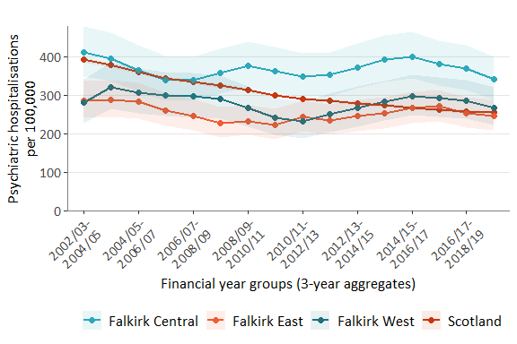

Source: ScotPHO

Links to deprivation: In Falkirk, the most deprived areas have 64% more psychiatric patient hospitalisations than the overall average.[40] This may explain in part why the rate of psychiatric admissions is higher in Falkirk Central, which also has more people living in deprived areas.

## 8.8 Deaths by Suicide

Suicide is a significant public health issue in Scotland and there are inequalities in suicide risk, with those in lower socio-economic positions at a higher risk. According to the 2021 report from the Scottish Suicide Information Database (ScotSID), between 2011 and 2019, 6,798 individuals aged 5+ years died from suicide in Scotland, 229 of which were in Falkirk. Figure 8.9 shows the age-standardised rates of deaths by suicide over time in Falkirk and Scotland. In Falkirk, the rate of suicide has increased from 11.3 deaths per 100,000 (CI: 6.8-18.6) in 2002-2006 to 17.5 (CI: 11.6-25.4) in 2015-2019.

Figure 8.9: Deaths from suicide in Falkirk and Scotland

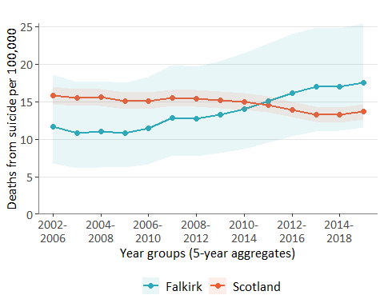

Source: ScotPHO

Figure 8.9 also shows that the overall rates are higher in Falkirk than Scotland in the latest estimate, however this difference is not statistically significant. Similarly, rates vary across Falkirk localities, with Falkirk Central having the highest rate (21 deaths by suicide per 100,000), but it is hard to determine significance of this due to confidence intervals being wide and overlapping.

Figure 8.10 shows that in both Falkirk and Scotland, the latest estimates of rates of suicide were higher in males than females. In fact, 73.2% of the entire ScotSID cohort from 2011 to 2019 was male. This pattern is present in many other high-income countries across the world, and there are many plausible explanations it, mostly related to social expectations and pressures on men.

Figure 8.10: Deaths from suicide by sex in Falkirk and Scotland in 2014-2018

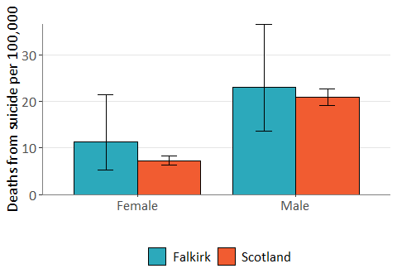

Source: ScotPHO

The 2021 ScotSID publication also provides insight into how people who completed suicide interact with services before their deaths. In Falkirk between 2011 and 2019:

* 21.1% had no previous contact with health services in the period before their death.
* 77.7% of had been in contact with one or more health services in the period before their death.
* Over half (58.5%) had received a mental health drug prescription in the 12 months before their death.

Links to deprivation: In the ScotSID cohort, the rate of suicide among those living in the most deprived SIMD quintile was 3 times that of the least deprived quintile. Research has also shown that the lower occupational social class position, the higher the suicide rate. This highlights the importance of recognising suicide as an issue of socio-economic inequality.

# 9. Community Prescribing

The total cost of items prescribed and dispensed in Falkirk in 2021/22 was over £32 million which is around 13% of the overall Health & Social Care Partnership expenditure (compared to 2020/21 expenditure).

The figure below shows the number of people prescribed items and the Gross Ingredient Cost in the past four years. From 2019/20 to 2020/21 there was a 7% reduction in the number of people prescribed items and a 4% reduction in Gross Ingredient Cost, reflecting the impact of the COVID-19 pandemic. This increased in 2021/22 and while the number of people prescribed items is still slightly below pre-pandemic levels the Gross Ingredient Cost increased to its highest level in the past five years.

Figure 9.1: Falkirk: Number of People Prescribed Items and Gross Ingredient Cost, 2017/18 to 2021/22

Source: Prescribing Information System, Public Health Scotland (extracted 20/07/2022)

The table below looks at the number of people prescribed items, total Cost and Cost per Person for the Partnership by BNF Chapter in 2021/22. Patients can be prescribed items from more than one BNF chapter and therefore the aggregate of patients in each BNF chapter will not match the overall total of patients in the previous chapter. Half of patients (50%) were prescribed items for the Central Nervous System which made up a fifth (20%) of the costs although this cost has decreased by 8% since 2019/20. Around a third of patients were prescribed items for the Gastro-Intestinal System (39% of patient and 7% of costs), the Cardiovascular System (37% of patients and 14% of costs) and for Infections (34% of patients and 4% of costs). Since 2019/20 costs have increased for the Gastro-Intestinal System (13% increase in costs, 0.3% decrease in patients, 14% increase in costs per patient) and the Cardiovascular System (7% increase in costs, 0.3% increase in patients, 7% increase in cost per patient).

Figure 9.2: Number of People Prescribed Items by BNF Chapter, 2021/22

|  |  |  |  |  |
| --- | --- | --- | --- | --- |
| Chapter Number | BNF Chapter Name | Number of Patients | Cost  (to nearest £) | Cost per Person (£) |
| 1 | GASTRO-INTESTINAL SYSTEM | 47,517 | 2,184,165 | 45.97 |
| 2 | CARDIOVASCULAR SYSTEM | 44,574 | 4,655,230 | 104.44 |
| 3 | RESPIRATORY SYSTEM | 32,980 | 3,740,274 | 113.41 |
| 4 | CENTRAL NERVOUS SYSTEM | 60,486 | 6,494,936 | 107.38 |
| 5 | INFECTIONS | 41,691 | 1,245,167 | 29.87 |
| 6 | ENDOCRINE SYSTEM | 26,326 | 3,931,692 | 149.35 |
| 7 | OBSTETRICS, GYNAECOLOGY AND URINARY-TRAC | 20,322 | 878,081 | 43.21 |
| 8 | MALIGNANT DISEASE AND IMMUNOSUPPRESSION | 2,243 | 1,041,019 | 464.12 |
| 9 | NUTRITION AND BLOOD | 20,947 | 1,432,499 | 68.39 |
| 10 | MUSCULOSKELETAL AND JOINT DISEASES | 27,101 | 880,140 | 32.48 |
| 11 | EYE | 10,091 | 354,265 | 35.11 |
| 12 | EAR, NOSE AND OROPHARYNX | 18,740 | 303,317 | 16.19 |
| 13 | SKIN | 34,738 | 962,769 | 27.72 |
| 14 | IMMUNOLOGICAL PRODUCTS AND VACCINES | 105 | 3,125 | 29.76 |
| 15 | ANAESTHESIA | 2,148 | 262,966 | 122.42 |
| 19 | OTHER DRUGS AND PREPARATIONS | 726 | 47,965 | 66.07 |
| 20 | DRESSINGS | 3,840 | 442,494 | 115.23 |
| 21 | APPLIANCES | 26,602 | 2,038,728 | 76.64 |
| 22 | INCONTINENCE APPLIANCES | 1,066 | 208,205 | 195.31 |
| 23 | STOMA APPLIANCES | 1,799 | 915,020 | 508.63 |
| NA | NA | 3,922 | 429,104 | 109.41 |

Source: Prescribing Information System, Public Health Scotland (extracted 20/07/2022).

*CHI completeness for Scotland is below 90% for chapters 5, 14, 20 and 22. BNF = British National Formulary.

# 10. Unscheduled Care

Unscheduled care refers to the unplanned treatment and care of a person usually because of an emergency or urgent event. Historically a considerable amount of attention is focused on unscheduled care primarily on accident and emergency attendances and emergency admissions to hospital. This is a key area of focus for both the Health and Social Care Partnerships across Scotland and the Scottish Government, with the aim to reduce the overall wait times in A&E and the number of emergency admissions.

## 10.1 Accident and Emergency Attendances

Since 2011, Falkirk, Clackmannanshire and Stirling have been served by a single Accident and Emergency department at Forth Valley Royal Hospital in Larbert with a minor injury unit at Stirling Community Hospital.

The chart below highlights fluctuations within the partnership’s A&E attendances over the past 5 years. In 2020 attendances decreased by 1523 between February and April, attendances did then return to January’s figures around July but again followed a similar pattern of decrease in 2021.

At the end of 2021, and the beginning of 2022, attendances increased to levels similar to 2018/19’s figures. It is clear to see that the COVID-19 lockdowns contributed towards notable decreases in Falkirk’s attendances, however either side of those lockdown periods attendance returned towards previous levels.

**Figure 10.1: Total monthly A&E attendances for Falkirk, Apr 2018 – Oct 2022**

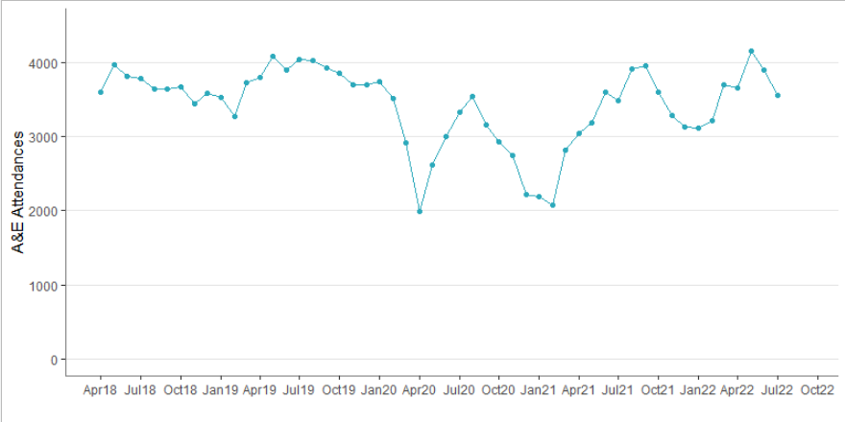

Source: SMR01, Public Health Scotland.

On the other hand, the proportion of patients seen within 4 hours, in Falkirk, has only hit the 95% target for 5 months during 2018 – 2022. From January 2019 Falkirk’s figures have been similar to Scotland’s, with a notable decrease in patients meeting the 4-hour goal nationally (and in Falkirk) during 2021. Whilst increasing briefly past the national level in April 2022, the partnership figure dropped to a low of 60.7% in June 2022.

**Figure 10.2: Percentage of A&E patients seen within 4 hours**

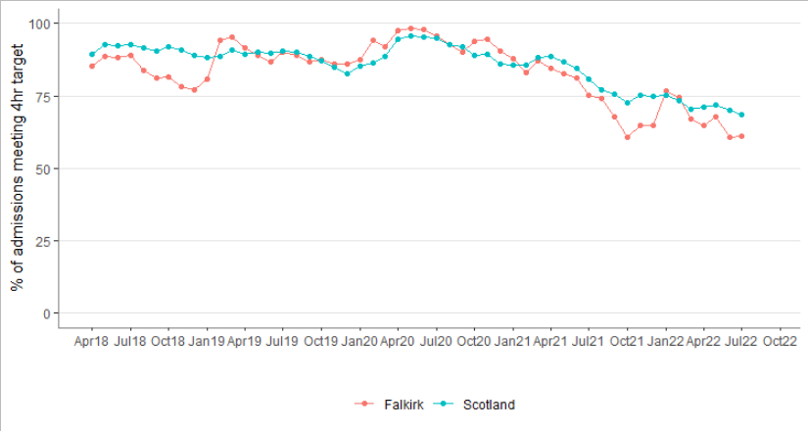

Source: SMR01, Public Health Scotland.

Figure 10.3 highlights the impact of the COVID-19 pandemic on A&E attendances by comparing average attendance figures from 2018/19 to attendances during 2020/21. Following the initial lockdown in March 2020 there was a sharp decrease in attendances, resulting in a large separation between 2020’s attendance figures and the prior years’ average attendance.

However, from April 2020 attendances have been slowly rising towards pre Covid-19 Levels, though 2022 attendance figures remain slightly below the pre-COVID seasonal averages. Ultimately, COVID-19 appears to have contributed to a lasting decrease in A&E attendance.

**Figure 10.3: Weekly A&E attendances in Falkirk in 2020-2022 compared to 2018-2019 average**

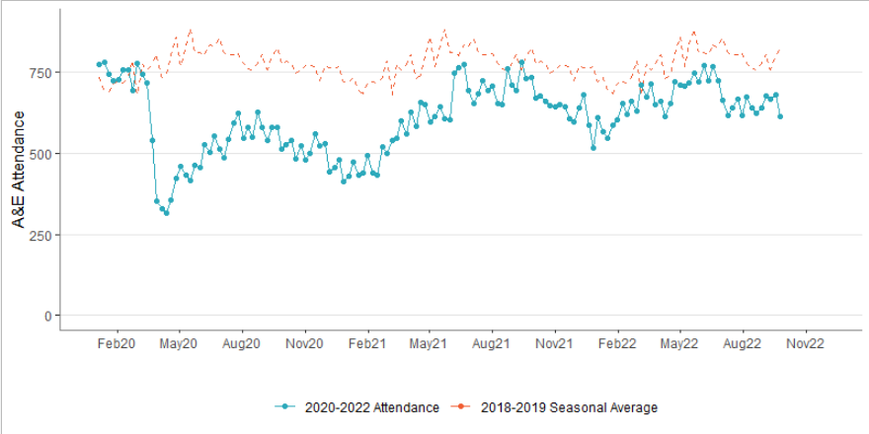

Source: RAPID Datamart, Public Health Scotland.

The chart below breaks down A&E attendance by age group, with the proportions shown for each age group in a given financial year.

If we take an average of the two years prior to COVID-19 and compare to the 2020/21 figures, we see that in 2020/21 there was a drop of 39% in under 18 attendances, a drop of 27% in 18-64 and a drop of 19% in the 65+ category. What is interesting is that while the 2021/22 attendance figures of the under 18 and 65+ categories have returned to similar level to the pre-covid average (2018/19 & 2019/20) the 18-64 attendances are still down by 13% (22,549 vs 25,449).

**Figure 10.4: Total A&E Attendance by Age Group and Financial Year**

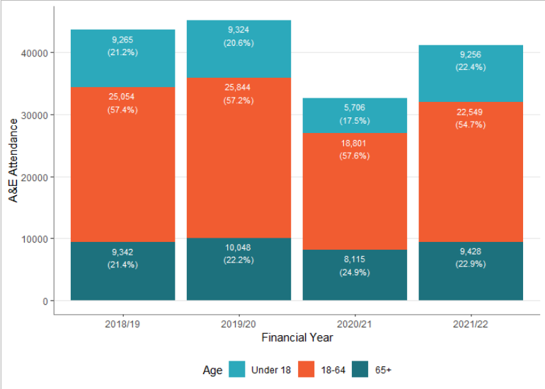

Source: SMR01, Public Health Scotland.

## 10.2 Emergency Admissions

The table and chart below show that there was an initial increase in emergency admissions to hospital in 2019 followed by a decrease in 2020, alongside the COVID-19 lockdown.

Table 10.1 highlights the rate of emergency admissions (per 100,000) in Scotland and Falkirk, across financial years. Although, the rates were similar for both Falkirk and Scotland in 2018/19, the Falkirk rate has been higher than Scotland in the past 3 financial years and in 2021/22 the Falkirk rate was 19% higher than the Scotland rate for 2021/22 and 15% higher than the 2018/19 Falkirk rate.

**Table 10.1: Yearly rate of emergency admissions per 100,000 population in Falkirk and Scotland**

|  |  |  |  |  |
| --- | --- | --- | --- | --- |
|  | 2018/19 | 2019/20 | 2020/21 | 2021/22 |
| Falkirk Rate | 10,808 | 13,338 | 10,858 | 12,416 |
| Scotland Rate | 10,950 | 11,284 | 9,365 | 10,431 |

Source: SMR01, Public Health Scotland.

**Figure 10.5: Number of Emergency Admissions to Hospital by month, Falkirk residents Apr 2018 to Apr 2022**

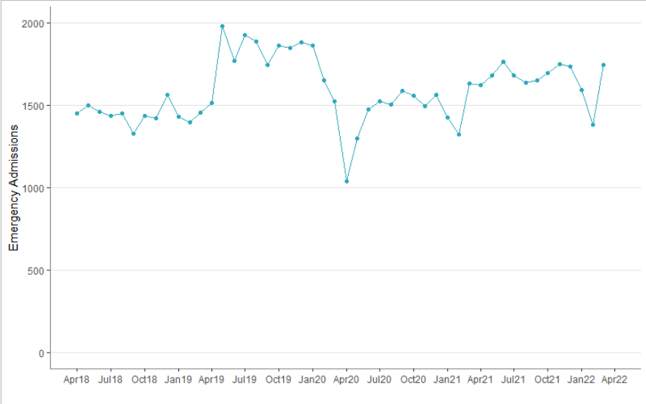

Source: SMR01, Public Health Scotland.

Figure 10.5 shows the change over time in the number of emergency admissions in Falkirk. Similarly, to A&E attendance there is a decrease in admissions around March 2020, following the initial lockdown.

However, admissions do increase back to 2018 levels around July 2020. This highlights that although the COVID-19 pandemic did contribute towards a decrease in emergency admissions the figure did return to pre-COVID levels quicker than A&E attendances. Through 2021 and early 2022 the emergency admission rate has been higher than in before the COVID-19 Pandemic.

Figure 10.6 shows a breakdown of admissions by age group and the 2021/22 figures show a comparatively large number of admissions for the under 18 group compared to the previous 3 years – in particular, a 68.1% increase compared to the previous (COVID-19 affected) year. The other age groups have seen a certain level of fluctuation over the 4 years with a notable drop in 2020/21, but on the whole proportions have remained relatively similar.

Figure 10.6: **Total Emergency Admission by Age Group and Financial Year**

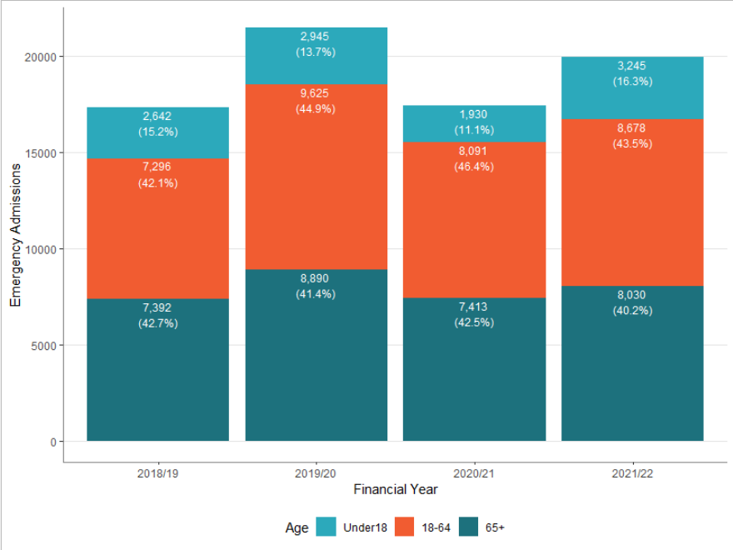

Source: SMR01, Public Health Scotland.

Figure 10.7 charts the rate of multiple emergency admissions (3 or more) in Scotland and Falkirk, per 100,000, have been increasing slowly since 2011/12, with Falkirk briefly matching the Scottish rate during 2014/15. Between 2018/19 and 2019/20 the rate in Falkirk sharply increased surpassing the national rate, and whilst in 2020/21 the rate decreased in both Falkirk and Scotland, Falkirk’s rate of multiple admission remains higher than the national level.

Whilst data for 2020/21 is provisional it does shows of those admitted as an emergency admission, around three quarters had one emergency admission (Falkirk 71.2%, and Scotland 74%), a smaller proportion had 2 emergency admissions (Falkirk 17.5%, and Scotland 16%) and one in ten had 3 or more emergency admissions (Falkirk 10.5%, Scotland 9%).

Emergency admissions are strongly related to patient age and deprivation. The most recent annual [**Public Health Scotland Acute Hospital NHS Bed information**](https://publichealthscotland.scot/publications/acute-hospital-activity-and-nhs-beds-information-annual/acute-hospital-activity-and-nhs-beds-information-annual-annual-year-ending-31-march-2021/) publication shows that the rate of emergency inpatient stays increase as age increases and also increases as deprivation increases, nationally and in Falkirk.

**Figure 10.7: Yearly rate of multiple emergency admissions (3+) per 100,000 in Falkirk and Scotland**.

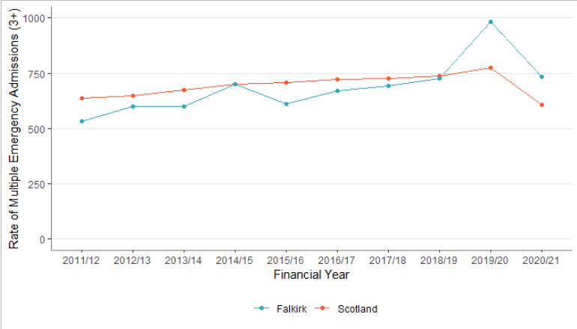

Source: SMR01, Public Health Scotland.

## 10.3 GP Out of Hours

The below figure compares the average, for GP Out of Hours (OOH) cases, in 2018/19 to 2020/21’s recorded figures.

There is an initial decrease in cases around March 2020 following the COVID-19 lockdown. Out of hours calls in 2020/21 were consistently lower than the historic average however in summer of 2022 cases started to increase to a level similar to the pre-COVID-19.

While cases dropped again below the 2018-19 seasonal average in the first half of 2022 calls began to increase dramatically to a level well above the pre-covid average and remained there since.

Figure 10.8: Weekly GP Out of Hours calls in Falkirk in 2020 - 2022 compared to 2018-2019 average

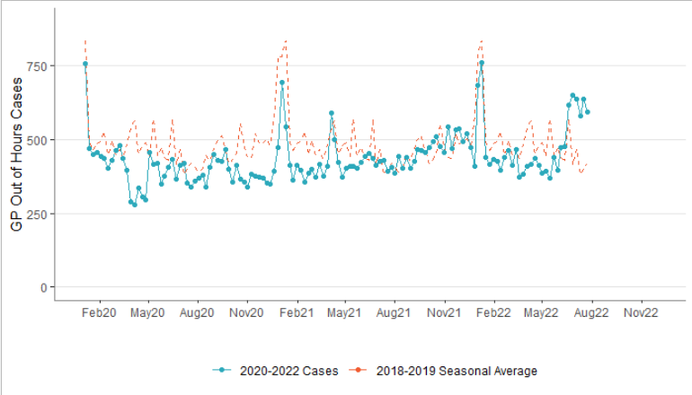

Source: GP OOH Datamart, Public Health Scotland.

## 10.4 Delayed Discharges

A delayed discharge is a hospital inpatient who is clinically ready for discharge from inpatient hospital care and who continues to occupy a hospital bed beyond the ready for discharge date. Delayed discharge could be a result of social care issues, healthcare issues or patient/carer/family-related issues.

Figure 10.9 charts delayed discharge bed days in Falkirk for the past four years. The chart shows a sharp decrease in bed days around the beginning of 2020, during the initial COVID-19 lockdown, followed by an increase afterwards going towards 2021. From there bed days, due to delayed discharge, have steadily increased and by the end of the year reached a higher level than what was seen pre-COVID.

COVID-19 contributed towards a decrease in delayed discharge in Falkirk, with a similar trajectory to emergency admissions presented previously. On the other hand, from April 2020 delayed discharges have been steadily increasing and throughout 2022 delayed discharges are higher than what’s been seen in the previous four years with the highest figure reported in July 2022 (2,531).

Figure 10.9: Total Delayed Discharge Bed Days in Falkirk, 2018-2022.

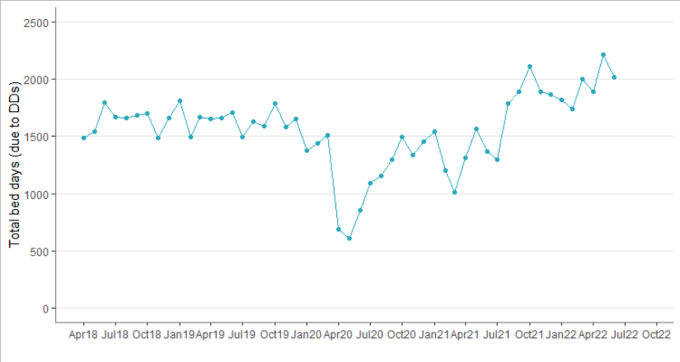

Source: Delayed Discharge, Public Health Scotland.

Figure 10.10 charts bed days, due to delayed discharge, across the past 4 financial years. Overall bed days during 2018/19 & 2019/20 remain relatively stable, bed days then decrease substantially due to COVID-19 impact on hospital use over 2020/21 (19,081 to 13,729). A large increase in 2021/22 (a percentage increase of 50.4% vs 2020/21) meant bed days are at their highest of the past 4 financial years.

Figure 10.10: Total Delayed Discharge Bed Days by Financial Year, Falkirk residents

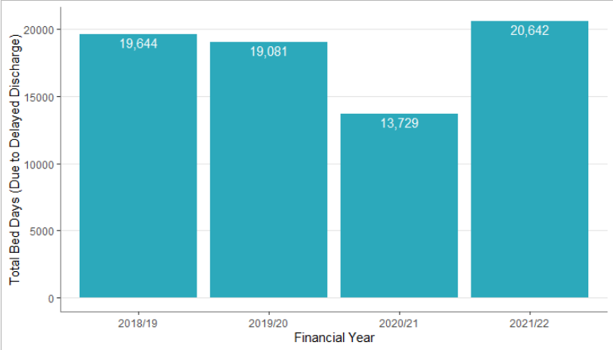

Source: Delayed Discharge, Public Health Scotland.

The chart below shows delayed discharge bed days in Falkirk broken down by age group & reason for delay in each of the past four financial years. It highlights that the majority of delayed discharge bed days for those aged 75+ were due to health and social care reasons. In the 18–74-year-old group health and social care delays do contribute to a smaller majority of delays in three of the four years below. However, it is the younger age group which has the highest proportion of Code 9 delays compared to health and social care delays.

The 2020/21 figure highlights a notable decrease in health and social care delays in the 75+ group (5,405 vs 9,783 in 2019/20). Although these types of delays then increase in 2021/22 to 9,068, a similar level to what was seen pre-pandemic, but code 9 delays also increased contributing to an overall increased number of bed days.

Ultimately, delayed discharge bed days decreased in the older cohort over 2020/21 and in 2022/22 increased to their highest level in four years.

Figure 10.11: Number of bed days by delay reason and age group in Falkirk, 2018-2022.

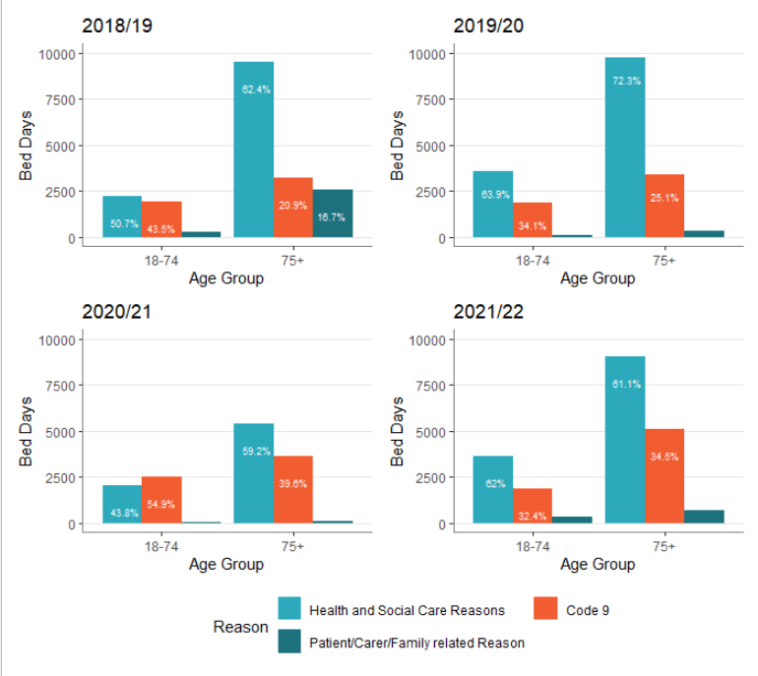

Source: Delayed Discharge, Public Health Scotland.

Table 10.2 looks at the proportion of bed days caused by specific types of delay. The most noticeable change over the 4 years is with delays due to patient/carer/family reasons which decreased in 2019/20 (by 11.9% as a proportion of the total bed days) and has stayed relatively low since (<5% delayed bed days). Delays due to health and social care reasons have fluctuated, increasing by 9.8% in 2019/20, then decreasing in 2020/21 and increasing again in 2021/22.

Code 9 delay bed days have increased year on year (2021/22 figure is up 37% compared to 2018/19) and made up a larger proportion of delays in 2020/21 & 2021/22 than in the previous years.

**Table 10.2 Bed Days caused by delayed discharge, by reason for delay**

|  |  |  |  |  |  |
| --- | --- | --- | --- | --- | --- |
| Year |  | Code 9 | Health & Social Care Reason | Patient/ Carer/Family | Total Bed days |
| 2018/19 | Bed Days | 5,099 | 11,745 | 2,800 | **19,644** |
|  | % | 26.0% | 59.8% | 14.3% |  |
| 2019/20 | Bed Days | 5,284 | 13,333 | 464 | **19,081** |
|  | % | 27.7% | 69.9% | 2.4% |  |
| 2020/21 | Bed Days | 6,145 | 7,423 | 161 | **13,729** |
|  | % | 44.8% | 54.1% | 1.2% |  |
| 2021/22 | Bed Days | 6,992 | 12,673 | 977 | **20,642** |
|  | % | 33.9% | 61.4% | 4.7% |  |

Source: Delayed Discharge, Public Health Scotland.

# 11. Social Care Service Use

Adult social care is all forms of personal and practical support for adults who need extra support and includes services such as care at home, care homes and telecare. Commissioning of social care services is the responsibility of integration authorities via health and social care partnerships. Local authorities though are responsible for procuring and contracting care from providers. In Scotland, social care services are accessed through Self-Directed Support which allows a person to control how their care is organised.

While there have been long standing challenges with social care provision including funding and staffing, the COVID-19 pandemic has had a profound effect on social care services. Services and staff have been under significant pressure, have had to respond and adapt quickly at the same time as people have taken extra precautions to protect their own health. Staffing has been a significant challenge and demand for some services has accelerated.

This section will look at social care support and services and the people who receive them.

#### People Receiving Social Care Services and Support

In 2020/21:

* 8,035 people were receiving social care support and services in Falkirk. Falkirk’s rate was higher than Scotland (estimated), 50 vs 42.4 per 1,000 population, and had been higher in the previous three years.
* While the majority of people were older adults (three quarters were of aged 65 and over and six out of ten were aged 75 and over) there was a high proportion of support provided to people of working age (23% were aged 18-84).
* Client profile and service/support provided differed dependent on age group.
  + The majority of those aged 65 and over were female (65%) which dropped to 48% for those aged 18-64 (61% were female overall).
  + People with physical and sensory disabilities were the biggest group receiving social care service and support. However, whereas it was over half of people aged 65+ this reduced to around a third of people of working age (18-64), with around third considered to have a learning disability.
* The service with the highest number of clients was Community Alarms/Telecare.

Figure 11.1: Number of People Receiving Social Care Services or Support by Age Group, Falkirk, 2020/21

Source: Insights in Social Care (PHS)

* People can receive more than one service/support.

## 11.1 Care at Home

Care at Home is an umbrella term for a range of supports delivered in your home with the aim of supporting people to live independently. It includes personal care and a wide range of practical support such as housework and shopping. Care at Home has been hugely impacted by the Covid-19 pandemic where the service and its staff have been under significant pressure and have faced significant challenges.

The chart below shows that in Falkirk there was a slight decrease in the number and people and hours following the first lockdown. In the past few years around 2,000 people have had home care in each quarter.

The most recent *Insights in Social Care* publication shows:

* In the last quarter of 2020/21 Falkirk Central had the highest rate, of Falkirk Localities, per 1,000 population receiving home care (16.3 compared to 11.2 in both Falkirk East and West).
* There is a relationship with deprivation with 27.1% of people receiving home care living in the most deprived areas (SIMD quintile 1) and 11.6% in the least deprived (SIMD quintile 5).
* Home care is delivered predominately to older adults - almost 9 out of ten people in each quarter of 2020/21 were aged 65 and over.
* Home care provision is mainly split between the Private Sector only and the Local Authority/HSCP/NHS Board sector only. Whereas in 2019/20 the split was closer to 50:50 in 2020/21 that balance has tipped slightly towards the Private Sector and in Q4 of 2020/21 58% of home care was provided by the Private Sector.
* A high proportion of people receiving home care had a physical/ sensory disability.
* The majority of people (74.2%) had lower levels of intensity of care (<10 hours a week) although just over a quarter (25.8%) that did receive 10 hours or more.
* The percentage of people receiving home care who have a community alarm has been rising over the past four years, particularly for those aged 18-64.
* Following the start of the Covid-19 pandemic the rate of A&E attendances, emergency admissions and emergency bed days of home care clients initially rose and then fell.

Figure 11.2: Care at Home - Number of people and hours, Falkirk

Start of the COVID-19 pandemic

Source: Insights in Social Care (PHS)

Figure 11.3: Percentage of people in each SIMD Quintile receiving home care, all ages, Falkirk, Q4 2020/21

Source: Insights in Social Care (PHS)

Figure 11.4: Percentage of home care clients categorised by level of service

Source: Insights in Social Care (PHS)

Figure 11.5: Percentage of people receiving home care who have a community alarm by age group, Falkirk

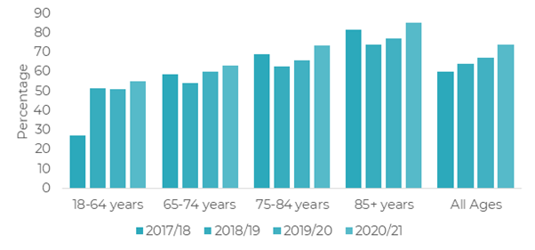

Figure 11.6: Rate per 1,000 people receiving home care who had emergency care, Falkirk, all ages

Start of the COVID-19 pandemic

Source: Insights in Social Care (PHS)

#### System Pressure

While the charts above tell us some of the overall stats up to the end of 2020/21, the data does not accurately depict the pressure on the Falkirk care at home service. The care at home teams have undoubtedly been one of the services most impacted by the pandemic:

* Diversion of clients from both hospitals and Care Homes due to outbreak
* Consistent staffing shortages due to shielding, COVID absence, other sickness absence (including work related stress) and staff moving into other roles
* Change in circumstances for many staff (e.g. home-schooling)

The care at home service is critical in the context of the whole health and care system, it prevents admission and enables discharge from hospital, it reduces need for care homes and enables more people to maintain independent living at home – so levels of unprecedented demand for home care services in 2020 and 2021 have resulted in long waiting lists which have knock-on impacts elsewhere. An efficient care at home service is essential in enabling timely discharge from hospital, and as such lack of care at home provision can have an impact on the hospital in the delayed discharges.

Equally care at home services enable people to maintain their independence at home so people in need of personal or non-personal care at home are at risk of hospital admission if such services cannot be provided. Since care at home services provide the means to keep people out of hospital and facilitate hospital discharge, it means system pressures felt in home care will have knock-on impacts elsewhere in the system.

Exceptional efforts were made by Falkirk care at home teams during the pandemic to maintain the required level of service, but in many cases this was unsustainable and as with other areas and health and social care sectors, staff health and wellbeing has been impacted with many staff facing burnout. The implications of this are considered in more detail in the workforce section (Chapter 14).

## 11.2 Personal Care

The most recent Insights in Social Care publication showed that almost everyone supported by home care also received personal care (99.8% in Q4 2021). The expansion of free personal care, which was previously only available to those aged over 65, came into force on 1st April 2019 and is often referred to as ‘Frank’s Law’. The chart below shows the considerable increase in people under 65 receiving personal care from the start of 2018/19 and that everyone under 65 supported by home care now also receives personal care.

Figure 11.7: Percentage of people supported by Home Care who also receive Personal Care by Age Group

Source: Insights in Social Care (PHS)

## 11.3 Care Homes

The Care Home Census includes all care homes for adults aged 18 ears and over in Scotland, including care homes for older people (65 year and over) and for those with learning disabilities, mental health problems, physical and sensory impairment, acquired brain injury, alcohol and drug problems and blood borne virus.

At the time of the 2022 Census there were 30 care homes for adults in Falkirk with 1,115 registered places. Estimated occupancy was at 83%, the majority were long stay residents and two thirds of the care homes were in the Private Sector (21 of the 30 care homes). It should be highlighted that in 2022 only 70% of care homes in Scotland submitted data with the data for the remaining 30% being estimated. In Falkirk 77% of care homes submitted data.

Table 11.1: Summary of Care Homes in Falkirk at 31st March 2022

|  |  |  |  |  |
| --- | --- | --- | --- | --- |
| Care Home Type: | Number of care homes | Patient Capacity | Current Residents  (Estimated) | Occupancy (%) (Estimated) |
| LA/NHS | 5 | 126 | 87 | 69 |
| Private | 21 | 932 | 791 | 85 |
| Voluntary | 4 | 57 | 49 | 86 |
| Total | **30** | **1115** | **927** | **83** |

Source: Public Health Scotland, Scottish Care Home Census 2022

Comparing 31st March 2022 to 31st March 2012 there are 6 care homes less (17% decrease) and while registered places has remained similar there has been a decrease in the number of residents (9% decrease, 927 from 1017).

Table 11.2: Care Homes for Adults, 31st March 2022 compared to 31st March 2012 (estimated % change)

|  |  |  |  |  |  |
| --- | --- | --- | --- | --- | --- |
| **Care Home Type:** | **No. of care homes** | **Registered Places** | **Residents (Est)** | **Long Stay Residents (Est)** | **Short Stay/**  **Respite Residents** (Est) |
| LA/NHS | 3 less | -32 | -41 | -49 | 88 |
| Private | 1 more | 9 | 1 | 2 | -26 |
| Voluntary | 4 less | -36 | -44 | -41 | -100 |
| **Total** | 6 less | -1 | -9 | -9 | -9 |

Source: PHS, Scottish Care Home Census 2022

In 2022 the number of long stay residents dropped but this may be the impact of the pandemic or the estimation of the data. With regards to care needs dementia and nursing care remain highest but what the table below illustrates is the increase in the proportion of residents with these needs. In the past ten years there has been an increase in the proportion of long stay residents with Medically Diagnosed Dementia and those requiring Nursing Care.

Table 11.3: Estimated Health Characteristics of long stay residents in all care homes in Falkirk for select years (years as at 31st March)

chart showing Estimated Health Characteristics of long stay residents in all care homes in Falkirk for select years (years as at 31st March)

Source: Scottish Care Home Census, 2022

*indicates values that have been suppressed due to the potential risk of disclosure and to help maintain resident confidentiality.

In 2022 of Long Stay residents:

* Gender:68% were female and 32% were males, similar to previous years.
* Estimated Age**:** The estimated mean age of residents was 80 (the median was 83), the estimated mean age at admission was 77 (the median was 81) and the estimated mean age at discharge was 84 (the median was 87). Apart from mean age at discharge, all have increased since 2012.
* Estimated Length of Stay**:** The estimated mean complete length of stay was 2.4 years while the estimated mean incomplete length of stay (for those still living at the care home at the time of the census) was 3.2 years.
* Estimated Cost**:** The estimated average gross weekly charge for fully or mainly self-funded long stay residents in Falkirk was £1,146 for nursing care and £1,047 without nursing care. Although estimated this signifies a 20% increase from the cost in 2019. In 2022, 24% of Falkirk’s long stay residents were estimated to be fully or mainly self-funded (although completeness in relation to this data was low and it was scaled up to 100%).

The Insights in Social Care publication collects and presents information on people supported in a care home at any point during the period January 2018 to 31 March 2021. It includes people where some or all of the care home fee is paid by the Partnership and so while it does not include anyone who is fully self-funded it does include out of area placements.

It showed that:

* There was a decrease in the number of people supported in care homes at the start of the COVID-19 pandemic, particularly for short stay/respite.
* In 2020/21 six out of ten long stay residents were female (64%) and almost three quarters were aged 75 and over.
* The median length of stay for long stay residents has increased in the past few years. For all ages it was 235 days in 2017/18, 300 in 2018/19, 520 in 2019/20 and 635 in 2020/21.
* While rates of A&E attendances and Emergency Admissions of long stay care home residents dropped following the first lockdown they have been increasing.

Figure 11.9: Number of Care Home Residents by Stay Type, Falkirk, All Ages

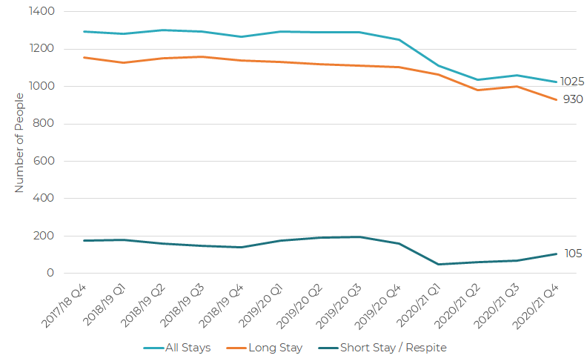 Source: Insights in Social Care (PHS)

Figure 11.10: Rates of Emergency Care for Long Stay Care Home Residents, Falkirk, All Ages

Source: Insights in Social Care (PHS)

## 11.4 Telecare

Telecare is a 24-hour remote monitoring system that uses a range of sensors and alarms to help people live safely and independently in their own home, with the reassurance that help is at hand in an emergency.

The recent Insights into Social Care publication showed that in 2020/21:

* There were 4,955 people in Falkirk with community alarms and/or telecare. This rate of 30.9 per 1,000 population is similar to previous years and compares with a rate of 23.8 per 1,000 for Scotland (estimated).
* 43.3% also received home care. People with community alarms/telecare were more likely to have home care also as they got older – 28.7% of clients aged 18-64 had home care also compared to 54% of clients aged 85+.
* There was a downward trend with regards to deprivation with 26.3% of people receiving community alarms/telecare living in the most deprived areas (SIMD quintile 1) and 12.1 % in the least deprived (SIMD quintile 5).

## 11.5 Self-Directed Support (SDS)

Self-directed support was introduced on the 1st April 2014 and means that people receiving social care support in Scotland have the right of choice, control and flexibility to meet their personal outcomes. Partnerships are required to ensure that people are offered a range of choices on how they receive their social care support. The options available are:

* Option 1: Taken as a Direct Payment
* Option 2: Allocated to an organisation that the person chooses and the person is in charge of how it is spent.
* Option 3: The person chooses to allow the council to arrange and determine their services.
* Option 4: The person can choose a mix of these options for different types of support.

In each year from 2017/18 to 2020/21, the majority of people in Falkirk with SDS choose for the council to arrange and determine their services (Option 3).

## 11.6 Summary

The past two years has been a particularly challenging time for social care services and the people they support. Services have had to adapt quickly in response to the Covid-19 pandemic, often having to do more with less resource. The section has highlighted that demand for social care provision comes predominately from older adults, although there is a large group of working age adults requiring support, predominately those with disabilities (physical, sensory and learning). Deprivation also seems to be a driver with a greater need coming from the most deprived areas. Evidence also shows multi-service provision with the greatest demand being for Community Alarms/Telecare. The evidence also lends support to services and staff dealing with an increase in complexity of care. With the older adult population predicted to increase significantly demand for social care provision is anticipated to increase too.

# 12. Unpaid Carers

A carer is ‘a person of any age who provides unpaid help and support to a relative, friend or neighbour who cannot manage to live independently without the carer’s help due to frailty, illness, disability or addiction (Scottish Government, 2016). The actual number of unpaid carers living in Scotland is not known but it was estimated that there were around 700,000 to 800,000 before the COVID-19 pandemic. A recent YouGov report [[1]](https://ukc-word-edit.officeapps.live.com/we/wordeditorframe.aspx?ui=en-gb&rs=en-gb&wopisrc=https%3A%2F%2Fscottish.sharepoint.com%2Fsites%2FFVLIST%2F_vti_bin%2Fwopi.ashx%2Ffiles%2Fd3ff4cb074eb48d88c25783fd6fc3022&wdenableroaming=1&mscc=1&hid=1394c14d-0446-ab2a-7fa1-590b86f85bd1-7287&uiembed=1&uih=teams&uihit=files&hhdr=1&dchat=1&sc=%7B%22pmo%22%3A%22https%3A%2F%2Fteams.microsoft.com%22%2C%22pmshare%22%3Atrue%2C%22surl%22%3A%22%22%2C%22curl%22%3A%22%22%2C%22vurl%22%3A%22%22%2C%22eurl%22%3A%22https%3A%2F%2Fteams.microsoft.com%2Ffiles%2Fapps%2Fcom.microsoft.teams.files%2Ffiles%2F1874176721%2Fopen%3Fagent%3Dpostmessage%26objectUrl%3Dhttps%253A%252F%252Fscottish.sharepoint.com%252Fsites%252FFVLIST%252FShared%2520Documents%252FSNA%252FSNA%2520Draft%25202022%2520-%2520WORKING%2520DOCUMENT.docx%26fileId%3Dd3ff4cb0-74eb-48d8-8c25-783fd6fc3022%26fileType%3Ddocx%26ctx%3Dfiles%26scenarioId%3D7287%26locale%3Den-gb%26theme%3Ddefault%26version%3D21120606800%26setting%3Dring.id%3Ageneral%26setting%3DcreatedTime%3A1650474197188%22%7D&wdorigin=TEAMS-ELECTRON.teams.files&wdhostclicktime=1650474196968&jsapi=1&jsapiver=v1&newsession=1&corrid=86ee810b-e5ff-4d65-9027-346f4d774682&usid=86ee810b-e5ff-4d65-9027-346f4d774682&sftc=1&sams=1&accloop=1&sdr=6&scnd=1&sat=1&hbcv=1&htv=1&hodflp=1&instantedit=1&wopicomplete=1&wdredirectionreason=Unified_SingleFlush&rct=Medium&ctp=LeastProtected#_ftn1) suggests that this could have since grown to over a million.

Anybody can become a carer at any time in their life and sometimes for more than one person at a time. They can be any age, from young children to the elderly. Some carers provide an intensive amount of support over a long period of time whilst for others it may be providing help for a shorter period of time and they do not need to be living with the person they care for to be considered a carer. Carers are not paid workers although some can receive payment for part of their time caring (e.g. through Carer’s Allowance). Many carers are ‘hidden’ and may not be accessing the support and services that they are entitled to.

Unpaid Carers are the largest group of care providers in Scotland, providing more than the NHS and Councils combined. The Valuing Carers 2015[[2]](https://ukc-word-edit.officeapps.live.com/we/wordeditorframe.aspx?ui=en-gb&rs=en-gb&wopisrc=https%3A%2F%2Fscottish.sharepoint.com%2Fsites%2FFVLIST%2F_vti_bin%2Fwopi.ashx%2Ffiles%2Fd3ff4cb074eb48d88c25783fd6fc3022&wdenableroaming=1&mscc=1&hid=1394c14d-0446-ab2a-7fa1-590b86f85bd1-7287&uiembed=1&uih=teams&uihit=files&hhdr=1&dchat=1&sc=%7B%22pmo%22%3A%22https%3A%2F%2Fteams.microsoft.com%22%2C%22pmshare%22%3Atrue%2C%22surl%22%3A%22%22%2C%22curl%22%3A%22%22%2C%22vurl%22%3A%22%22%2C%22eurl%22%3A%22https%3A%2F%2Fteams.microsoft.com%2Ffiles%2Fapps%2Fcom.microsoft.teams.files%2Ffiles%2F1874176721%2Fopen%3Fagent%3Dpostmessage%26objectUrl%3Dhttps%253A%252F%252Fscottish.sharepoint.com%252Fsites%252FFVLIST%252FShared%2520Documents%252FSNA%252FSNA%2520Draft%25202022%2520-%2520WORKING%2520DOCUMENT.docx%26fileId%3Dd3ff4cb0-74eb-48d8-8c25-783fd6fc3022%26fileType%3Ddocx%26ctx%3Dfiles%26scenarioId%3D7287%26locale%3Den-gb%26theme%3Ddefault%26version%3D21120606800%26setting%3Dring.id%3Ageneral%26setting%3DcreatedTime%3A1650474197188%22%7D&wdorigin=TEAMS-ELECTRON.teams.files&wdhostclicktime=1650474196968&jsapi=1&jsapiver=v1&newsession=1&corrid=86ee810b-e5ff-4d65-9027-346f4d774682&usid=86ee810b-e5ff-4d65-9027-346f4d774682&sftc=1&sams=1&accloop=1&sdr=6&scnd=1&sat=1&hbcv=1&htv=1&hodflp=1&instantedit=1&wopicomplete=1&wdredirectionreason=Unified_SingleFlush&rct=Medium&ctp=LeastProtected#_ftn2) report estimates the economic value of the contribution made by carers in Falkirk as £337 million per year. Research from Carers UK[[3]](https://ukc-word-edit.officeapps.live.com/we/wordeditorframe.aspx?ui=en-gb&rs=en-gb&wopisrc=https%3A%2F%2Fscottish.sharepoint.com%2Fsites%2FFVLIST%2F_vti_bin%2Fwopi.ashx%2Ffiles%2Fd3ff4cb074eb48d88c25783fd6fc3022&wdenableroaming=1&mscc=1&hid=1394c14d-0446-ab2a-7fa1-590b86f85bd1-7287&uiembed=1&uih=teams&uihit=files&hhdr=1&dchat=1&sc=%7B%22pmo%22%3A%22https%3A%2F%2Fteams.microsoft.com%22%2C%22pmshare%22%3Atrue%2C%22surl%22%3A%22%22%2C%22curl%22%3A%22%22%2C%22vurl%22%3A%22%22%2C%22eurl%22%3A%22https%3A%2F%2Fteams.microsoft.com%2Ffiles%2Fapps%2Fcom.microsoft.teams.files%2Ffiles%2F1874176721%2Fopen%3Fagent%3Dpostmessage%26objectUrl%3Dhttps%253A%252F%252Fscottish.sharepoint.com%252Fsites%252FFVLIST%252FShared%2520Documents%252FSNA%252FSNA%2520Draft%25202022%2520-%2520WORKING%2520DOCUMENT.docx%26fileId%3Dd3ff4cb0-74eb-48d8-8c25-783fd6fc3022%26fileType%3Ddocx%26ctx%3Dfiles%26scenarioId%3D7287%26locale%3Den-gb%26theme%3Ddefault%26version%3D21120606800%26setting%3Dring.id%3Ageneral%26setting%3DcreatedTime%3A1650474197188%22%7D&wdorigin=TEAMS-ELECTRON.teams.files&wdhostclicktime=1650474196968&jsapi=1&jsapiver=v1&newsession=1&corrid=86ee810b-e5ff-4d65-9027-346f4d774682&usid=86ee810b-e5ff-4d65-9027-346f4d774682&sftc=1&sams=1&accloop=1&sdr=6&scnd=1&sat=1&hbcv=1&htv=1&hodflp=1&instantedit=1&wopicomplete=1&wdredirectionreason=Unified_SingleFlush&rct=Medium&ctp=LeastProtected#_ftn3) suggest that three in five people will be carers at some point in their lives and it is important to consider the intensity of the caring role as well as the impact of caring on health and wellbeing among other factors. Caring can be a rewarding experience but can also have an impact on a person’s own health and wellbeing.

The Carer (Scotland) Act 2016 came into effect on 1st April 2018 and is designed to support carers’ health and wellbeing and help make the role of caring more sustainable. The Act aims to recognise and enhance the rights of carers and introduces the right to an Adult Carer Support Plan or Young Carer Statement based on each carer’s personal outcomes and needs for support. The [Falkirk Carer’s Strategy 2019-2022](https://www.falkirk.gov.uk/services/social-care/carers/docs/01%20Falkirk%20Carers%20Strategy%20-%20Getting%20it%20Right%20for%20Carers%20in%20Falkirk.pdf?v=201906271131) outlines how the Partnership will support carers and how it will meet its statutory requirements.

A dedicated unpaid carers needs assessment was undertaken in 2018 and provided a more in depth focus on the needs of unpaid carers in Falkirk. While this needs assessment is not current many of the key points in the document will be relevant today.

<https://falkirkhscp.org/wp-content/uploads/sites/9/2018/04/Unpaid-Carers-Needs-Assessment.pdf>

## 12.1 Identifying Unpaid Carers

The number of unpaid carers in the Partnership is difficult to identify exactly. Many carers do not recognise themselves as a carer, rather simply as family or a friend. Identifying yourself as a carer may only come when the intensity of the caring role increases or at key junctures such as giving up employment to care. Furthermore, there may be reluctance among some carers to identify themselves and make their needs known out of fear or anxiety, particularly for young carers and carers for people with, for example, mental health or drug and alcohol problems. The COVID-19 pandemic will also have resulted in more people taking up a caring role or increasing their caring responsibility with the health and social care system under significant pressure, services being reduced and people taking extra precautions to protect their own health.

Estimates of the number of unpaid carers in Scotland has changed over time. The Scotland’s Carers 2015 report considered 17% of the 16+ population as the best estimate of the number of carers in Scotland with the 2019 Scottish Health Survey subsequently estimating 14%. In 2020 the Scottish Health Survey ran a telephone survey and estimated 19% although this is not considered comparable due to methodological differences. A recent YouGov poll suggested that the number of unpaid carers in Scotland had grown due to the COVID-19 pandemic with 16% of the adult population saying they were already providing care before the coronavirus outbreak and a further 9% saying that they have started caring since the coronavirus outbreak. The Scottish Government have recently updated the headline figure of the Scotland’s Carer report and the subsequent 2019 update and estimate 15% of the 18+ population to be adult carers. Similarly, the initial young carers estimate of 4% of children aged 4-15 (Scottish Health Survey 2012/13 & 2019) has been updated with young carers now considered to be under 18 with different rates being applied to different age groups.

The table below provides an overview of estimates of the number of unpaid carers in Falkirk based on the different Scotland rates applied to Falkirk’s 2019 mid-year population estimates together with information on people entitled to carers allowance, carers known to the Carers Centre and the number of carers in the 2011 Census. While estimates may have changed over time they are all considerably higher than the number of carers counted via the 2011 census indicating that there may be thousands of ‘hidden’ carers. Estimates vary pre and during the pandemic indicating that there may be a growth in the number of people providing care. There is also a considerable difference in the estimated number of carers and those identified through services such as the Carers Centre or the Department of Work and Pensions (DWP). Many carers may feel that they do not require help or support or they may even be being supported by family and friends rather than statutory services. It may be that it is those without this network or those with more substantial caring responsibilities that seek support. Given the impact of the COVID-19 pandemic and the potential increase in not only the number of carers but also the hours of care provided there might be many more carers coming forward requiring support.

Table 12.1: Number of Carers Estimated and Known to Services

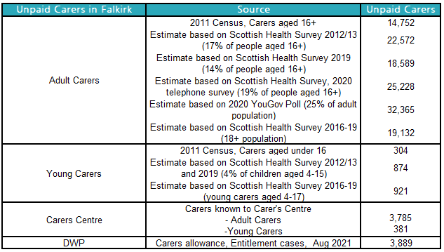

Source: Scottish Health Survey 2012/13, 2019 and 2020, Scotland Census 2011, Department of Work and Pensions (DWP), Falkirk Carers Centre

1. Estimates based on 2019 NRS Mid-Year Population Estimates
2. Number of carers known to the Carer’s Centre in June 2022.

## 12.2 Characteristics of Unpaid Carers

The 2011 Scotland Census and the most recent Scottish Health Surveys told us a lot about unpaid carers.

* Women were more likely to report being a carer than men.
* Caring prevalence varies by age. The latest figures from the Scottish Health Survey 2016-19 showed that people in Scotland are more likely to provide unpaid care in their later working years, especially females.
* A lot of carers provide a substantial amount of unpaid care.
  + In the 2011 Census over a third (35.7%) of carers in Falkirk provided over 35 hours or more care a week, equivalent to working full time. 29% of these people were aged 65 and over.
* Provision of unpaid care was higher among adults living in the most deprived areas compared with the least deprived areas (2018 Scottish Health Survey)
* Carers consider their health to be poorer than those who do not provide unpaid care and the health status of a carer deteriorates as the level of care provided increases (2011 Scotland Census).

While information from the 2019-20 and 2020-21 Carers Census’ is not currently considered robust due to completeness reasons and caution is advised when interpreting, the results for Scotland provide insight into carers known to services:

* Around 3 in 5 carers (62%) were working age (18-64) in 2020-21 compared to 57% in 2019-20. In 2020-21 adults aged 65+ accounted for roughly a quarter of carers identified (24%) and young carers (under 18) made up 14% which is higher than previous estimates of less than 5%.
* Around 7 in 10 carers were female – 71% in 2020-21 and 73% in 2019-20. This is higher than previous estimates suggesting that female carers are more likely to seek out support from services than male carers.
* There was a notable deprivation effect for young carers supported by local services. In 2020-21 14% of young carers living in the most deprived SIMD decile while 5% lived in the least.
* Over half of carers spent an average 50+ hours a week providing care (54% in 2020-21 and 59% in 2019-20) and around 15% spent less than 19 hours per week (17% in 2020-21 and 14% In 2019-20). This differs from that reported in the Scotland Carer’s report (27% and 56% respectively) reflecting the fact that people with more intense caring roles are more likely to seek support from local services. In 2020-21 66% of young carers spent less than 19 hours a week providing care compared to 11% of adults likely reflecting differences in the capacity for and appropriateness of, higher levels of caring between adult and young carers.
* The most commonly reported impact of providing unpaid care in both 2019-20 and 2020-21 was on carers' emotional well-being, followed by impact on carers’ life balance. In 2020-21 carers were more likely to experience impacts on their health, employment and living environment as the intensity of their caring roles increased.
* In 2020-21 20% of cared for people were children, 30% were working age adults and 41% were people aged 65+. Around 3 in 5 of the children were male.
* In 2020-21 the most common client group overall and for adult care for people, apart from ‘Other’, was Dementia followed by Physical Disability (14% and 12% of adult cared for people respectively). For children it was Autism Spectrum Disorder (21%).
* In 2020-21 around two-thirds were recorded as needing advice and information and just under half were recorded as needing short breaks or respite. The data suggest that support needs vary between adult carers and young carers with adult carers more like to need advice and information and practical support and young carers more likely to be recorded as peer or group support.

## 12.3 The Experience of Unpaid Carers

The Health and Care Experience Survey not only looks at the experience of care recipients but also the experience of those who provide unpaid care. The figure below provides a summary of responses from carers in Falkirk. The charts on the right show responses from the most recent survey and the bar charts under each question show how the percent of positive responses has changed over the past five surveys.

Figure 12.1: Summary of Carers Experiences in Falkirk, Number of responses 3,489, 26% response rate.

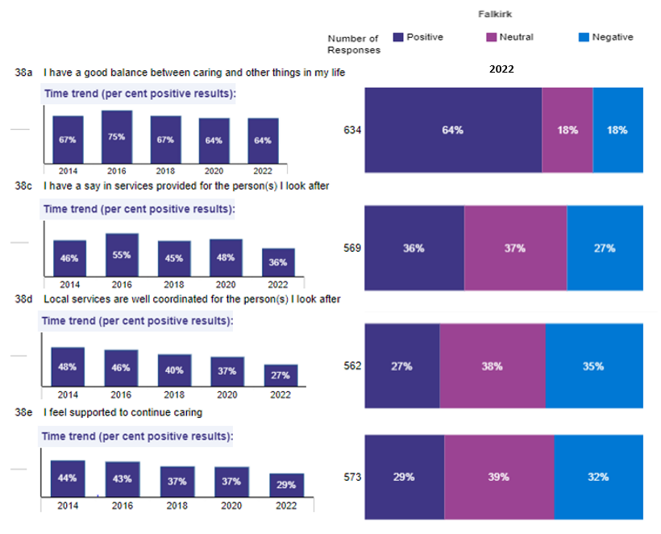

Source: Health and Care Experience Survey, 2021/22

They show that there is room for improvement particularly around local services being well coordinated and carers feeling supported. It is concerning that only 29% of carers feel supported to continue caring and even more concerning that this is a significant decrease from the previous survey. The percentage of positive responses has significantly decreased from the previous survey in three out of the four areas - having a say in service provision dropped from 48% and services being well co-ordinated dropped from 37%. This may reflect the impact that the COVID-19 pandemic has had on unpaid carers and on service provision.

## 12.4 Support for Carers

There are several support services available to carers in Falkirk.

The Falkirk Carer’s Centre provides information and support to carers of all ages living in Falkirk by a team of carer support workers and young carer workers. They provide a range of services including one to one support, group support and Adult Carer Support Plans/Young Carers Statements. There will have been a change in support as services have adapted to working during the pandemic. A feature of carer support during the pandemic was on the provision of information and support on how to keep themselves and the people they care for safe. In addition, a survey carried out by Falkirk Carer’s Centre staff in June 2020 showed that 78% of respondents had not been able to have a break from their caring role during the lockdown period. Despite the pandemic Falkirk Carers Centre has continued to provide support to carers including supporting new carers, completing Adult Carer Support plans, providing health and wellbeing sessions and grants to purchase short breaks, and delivering Care with Confidence sessions.

Carer’s allowance is paid to carers aged 16 and older who look after a severely disabled person for at least 35 hours a week and they get certain benefits. At present Carer’s Allowance is £69.70 a week. In Scotland you may also get Carer’s Allowance Supplement which is an extra payment (£245.70) for people who get Carer’s Allowance on a particular date and is paid twice a year. The number of claimants entitled to carers allowance in Falkirk has been relatively stable over the past couple of years and was 3,889 in August 2021.

# 13. Workforce

Since the last strategic needs assessment (2018/19) a number of significant events have changed the outlook in terms of workforce. In January 2020 the United Kingdom left the European Union, resulting in a reduced pool of skilled workers to recruit from. In March 2020 the COVID-19 pandemic arrived and suddenly realigned priorities for the Health and Social Care Partnership, bringing with it new challenges and exacerbating existing ones. In 2022, the war in Ukraine has resulted in a significant impact on fuel and energy supply, and therefore rising inflation and increases in cost of living. Many major trade unions have already taken to strike action to campaign for pay rises in line with inflation.

Falkirk HSCP has created a comprehensive workforce plan for the period of the new strategic plan (link below) and this report addresses the make-up of the current workforce, the challenges facing the partnership in terms of workforce and the objectives the HSCP has with view to developing a sustainable future workforce.

Listed below are some of the key challenges and drivers highlighted in the workforce plan:

Challenges and Drivers for Change:

* Ageing population and workforce
* Marked increase in substance use
* Mental wellbeing
* Finance – reduced funding with increased demand
* Recruitment skills shortages
* Technological and system improvements required
* Ageing estates and lack of suitable premises

Falkirk HSCP Workforce Plan 2022 - 2025 - [viewSelectedDocument.asp (falkirk.gov.uk)](https://www.falkirk.gov.uk/coins/viewSelectedDocument.asp?c=e%97%9Dc%90my%8A)

This section will not go into the detail contained in the workforce plan but will cover several considerations which will have an impact on how the HSCP can deliver the outcomes of the new strategic plan.

## 13.1 Primary Care - Expanded General Practice Team

NHS Forth Valley's 4-year primary care improvement plan 2018-2021[41] involves considerable transformational work to address and support sustainability challenges in Primary Care focusing on three key enablers of Premises, Information sharing agreements and Workforce. At full complement there will be almost 200 WTE equivalent of staff employed in principally new roles across varying specialties in Forth Valley, roughly half of those will be supporting the Falkirk GP practice population.

The agreed local priorities for a safe, effective, affordable and sustainable shift of workload and responsibilities from GPs to release capacity for their Expert Medical Generalist role are:

* Vaccination Transformation Programme
* Community Treatment and Care Services
* Pharmacotherapy Services
* Urgent Care (advanced practitioners)
* Additional Professional Roles (Primary Care Mental Health Nurse, Advanced Practice Physio)
* Community Link Workers

At March 2022 a total of 180 of the planned 197 posts (Forth Valley wide) were filled and all Falkirk practices were in receipt of either a full or partial service of the above professional roles. While the new services are now all operational across Forth Valley, there has been challenges to recruit and retain suitable staffing for all the new services because of competition from neighbouring boards who are also building similar teams.

Figure 13.1: Level of multi-disciplinary team capacity in place across Falkirk Practices May 2022.

Source: NHS Forth Valley

## 13.2 Numbers of GPs

In April 2022 there was a total of 140 GP registered working across the 25 GP practices in Falkirk. This compares to a headcount of 129 GPs in Falkirk in 2012. While this does represent an increase over the past decade, the available data does not reflect the whole time equivalent of the registered GPs in Falkirk, so we cannot account for how many are working on a part time basis.

Another consideration is that population changes over time can have an impact on the workload for general practice. For example, between 2011 and 2021 the 65+ patient population in Scotland increased by 21% and as alluded to in the population section of this needs assessment the projections are that Falkirk will see a substantial increase in the 75+ population. With increasing age comes increasing multimorbidity and therefore reliance on general practice services.

It is possible that GP numbers are not increasing sufficiently proportionate to the increasing demand.

## 13.3 cOMMUNITY lINK wORKERS

Part of the Forth Valley-wide Primary Care Transformation Programme, the Community Link Workers provide support for wellbeing, economic, and social factors which may be affecting the individual’s quality of life – and in turn, their health. As the link workers are integrated within GP Practices, the model also allows GPs to focus more of their time on medical issues.

Link workers take a ‘holistic’ approach to supporting people, using social prescribing to offer non-medical options to improve people’s health and wellbeing, including their mental health. Social prescribing is an approach used to support self-management.

At this time Falkirk has a total of 3 link workers in post across the 3 localities with each Link Worker hosted by a third sector organisation and aligned to GP Practices serving populations with highest levels of deprivation. This is due to expand in the coming year to provide a service to all GP practices in Falkirk.

## 13.4 Social Care Workforce

The Scottish Social Services Council collect and publish information on the social service sector workforce. Data comes from an annual return from all registered care services and an annual census of local authority social work staff. It includes information on all sectors and this section will provide an overview of information on the workforce in two sectors – Care Homes for Adults and Housing Support/Care at Home. Numbers are rounded to the nearest ten, counts of five and below appear as 0 and percentages are calculated on the aggregated total of that area rather than the overall total.

As at December 2021, there were 1,380 people working in Care Homes for Adults, a 9% decrease from 1,510 in 2020. From 2017-2020 the workforce had been relatively stable. The workforce is predominately female (88%), and the biggest employer was the Private Sector (80%). Over a quarter of staff were aged 55 and over and a large proportion worked part time (40%). Over half were considered a Class 2 Care Worker. Care Homes for Adults is the second biggest sector, 27% of the overall social service sector workforce.

Figure 13.2 – Care Home for Adults Workforce Age structure 2021, Falkirk

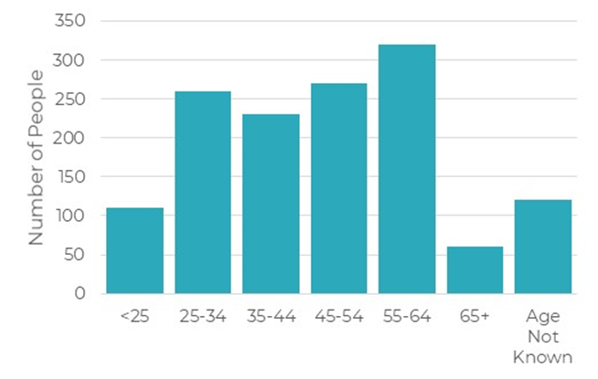

Source: Scottish Social Services Council

In December 2021, there were 1,630 people working in the Housing Support/Care at Home sector, a 25% decrease from 2,170 in 2020. Housing Support and Care at Home information is presented combined. The chart below shows that in the past few years the number of registered services and staff had been growing. However, in 2021 while there were only 2 services less the number of staff has decreased considerably. The workforce is predominately female (87%) and around a third are employed in each of the three sectors (Public 32%, Private 34% and Voluntary 34%). The number of staff working across the sectors has changed over the past few years. From 2019 to 2020 there was an increase in the number of staff in both the Private and Voluntary sectors and a decrease in the Public Sector. From 2020 to 2021 there has been a decrease in the number of staff in both the Private and Voluntary sectors and an increase in the Public Sector. Three out of ten staff were aged 55 and over and more people worked part-time than full-time (53%). The majority of staff were considered a Class 2 Care Worker (78%). Housing Support/Care at Home is the largest sector, 32% of the overall social service sector workforce.

Figure 13.3 - Housing Support/Care at Home Workforce Age structure 2021, Falkirk

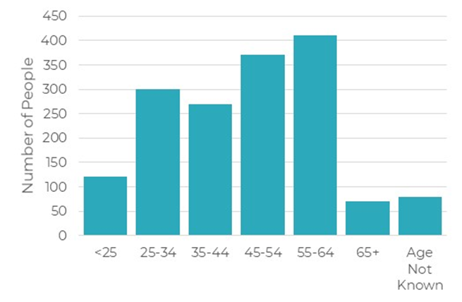

Source: Scottish Social Services Council

Figure 13.4 - Housing Support/Care at Home Headcount and Number of Services, Falkirk, 2010-2021

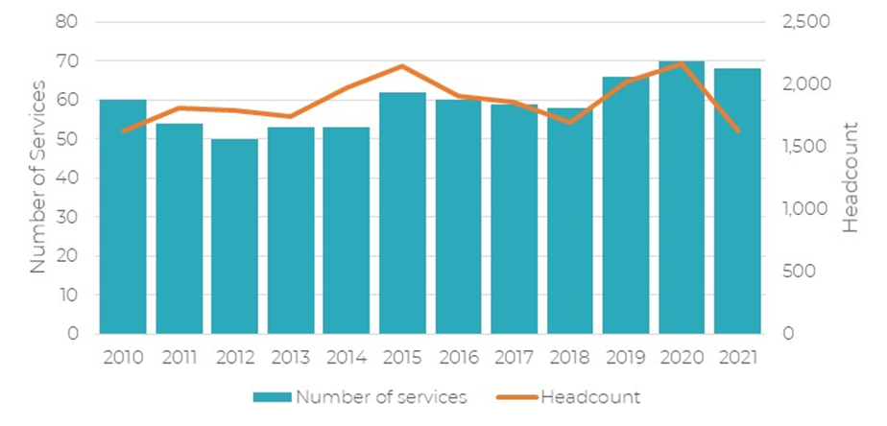

Source: Scottish Social Services Council

Both Care at Home/Housing Support and Adult Care Home staff are predominately female and employed by Private/Voluntary agencies. The COVID-19 pandemic has had a significant impact on staff in both sectors which a snapshot view does not fully reflect. Care at home teams have faced shifts in service delivery, consistent staff shortages, changes in personal circumstances and unprecedented levels of demand. Care home staff have faced similar challenges and it is unsurprising that staff health and wellbeing has been impacted. The latest SSSC workforce publication shows that while staffing levels in both services has decreased, they have decreased considerably for the Housing Support/Care at Home Service. As there has only been a small decrease in the number of services this may indicate the significant staffing, retention and recruitment challenges that this service has faced.

There is no recent information specifically restricted exclusively to staff employed by the Falkirk health and social care partnership however the Falkirk Council Equalities Outcome and Mainstreaming Report in 2021 looked at the overall council workforce structure and this is presented in the table below.

Table 13.1 - Workforce Age structure, Falkirk council

|  |  |  |  |  |
| --- | --- | --- | --- | --- |
| Indicator | 2017 | 2018 | 2019 | 2020 |
| Percentage of workforce who are 16-24 years | 4.3% | 4.9% | 5.3% | 5.7% |
| Percentage of workforce who are 25-34 years | 18.1% | 18.1% | 19.1% | 19.3% |
| Percentage of workforce who are 35-44 years | 21.5% | 21.2% | 20.9% | 21.5% |
| Percentage of workforce who are 45-54 years | 30.3% | 29.7% | 28.4% | 27.1% |
| Percentage of workforce who are 55-64 years | 23.3% | 23.6% | 23.6% | 23.3% |
| Percentage of workforce who are 65-74 years | 2.4% | 2.4% | 2.5% | 2.7% |
| Percentage of workforce who are 75+ | 0.1% | 0.1% | 0.2% | 0.2% |

The table below shows the Falkirk council workforce split by Gender and this reveals some clear trends. The percentage of female employees has been increasing since 2018 and in 2020 3 in every 4 Falkirk council employees were female. Conversely the percentage of males in the workforce has been decreasing and only a quarter of the workforce was male in 2020.

Table 13.2 - Workforce Gender Breakdown, Falkirk Council

|  |  |  |  |  |
| --- | --- | --- | --- | --- |
| Gender breakdown of overall workforce |  |  |  |  |
| Indicator | **2017** | **2018** | **2019** | **2020** |
| The percentage of employees in the workforce who are female | 73% | 73.5% | 75% | 75.1% |
| The percentage of employees in the workforce who are male | 27.0% | 26.5% | 26% | 24.9% |

<https://www.falkirk.gov.uk/services/council-democracy/policies-strategies/docs/equality/Equality%20Outcomes%20and%20Mainstreaming%20Report.pdf?v=201505061017>

## 13.5 Social Care staff Recruitment and Retention challenges

Falkirk, like many areas of Scotland is struggling to maintain levels of care staff. Several challenges exist in terms of recruiting and retaining people in social care worker roles.

**Competition** – the minimum wage for care workers (December 2021) is £10.02 per hour, but job opportunities in sectors such as supermarkets in the area are often preferable due to nature of work and higher wages. Cost of living increases in 2021/2022 are only likely to exacerbate the impact on social care services.

**Fuel costs** – unprecedented increases in the price of fuel combined with low wages means the job is not sustainable for some.

**Change of circumstances** - People who were employed in the care sector before the pandemic may have had to shield during 2020 and perhaps changed to a non-front line role that enabled home working. In these cases people may have chosen not to return to the front line role.

**Working demands –** with many services short staffed new staff will be subjected to considerable and perhaps stressful levels of demand which undoubtedly will impact on staff retention.

While there is a multitude of factors affecting the recruitment and retention of care staff, the crucial role that care staff play in keeping people supported in the community cannot be underestimated and a sustainable care workforce should be carefully considered in the strategic plan.

COVID-19 impact: The pandemic has undoubtedly had an impact on the wellbeing of much of the population but will have had a particular impact on the front line health and social care staff who had to continue to deliver essential services throughout. Many services will have will have had to introduce new safety measures for COVID-19 and change their ways of working, while managing unprecedented demand.

A number of surveys carried out in 2021 provide useful insight into what impact has been felt by health and care staff

Changes in personal circumstances

The iMatter 2021 NHS Staff Survey looked at whether staff have experienced changes in personal circumstances over the pandemic.

Of note are the following increases:

* School age children at home - increase **21%\***
* Providing support for a vulnerable relative - increase **21%\***
* Experienced physical or mental ill health (non-covid) - increase **21%\***
* Loss of a friend or relative - increase **19%\***
* Other household members furloughed - increase **11%\***
* I have tested positive for COVID-19 - increase **11%\***
* Worsening of financial situation - increase **11%\***

Source: <https://www.imatter.scot/media/1981/health-social-care-staff-experience-report-2021.pdf>

*Sept 2021 survey vs Sept 2020

**Social Care staff Burnout**

A UNISON report released in February 2022 looked at the impact of the pandemic on social care staff. The key findings of this report highlight the challenges facing social care services at this time:

* 96% of social care staff who participated in the survey said their employer is currently short staffed
* 90% said they are concerned about safe staffing levels
* Participants stated that the main causes of staff shortages are sickness (76%) and low pay (69%)
* The main reasons for people being off sick are stress and burnout (85% and 72% respectively)
* Nearly a quarter (24%) would consider leaving the care sector if pressures don't ease.

Source – UNISON survey <https://unison-scotland.org/wp-content/uploads/14.03.21-The-burnout-pandemic-final.pdf>

# Appendix 1 - Falkirk’s datazones by simd quintile

**West**

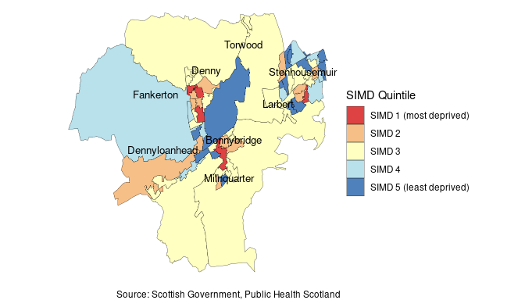

**East**

**Population: 7.2% in SIMD 1 20% in SIMD 5**

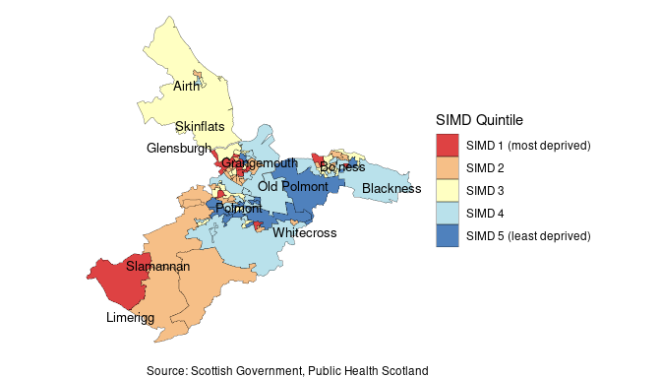

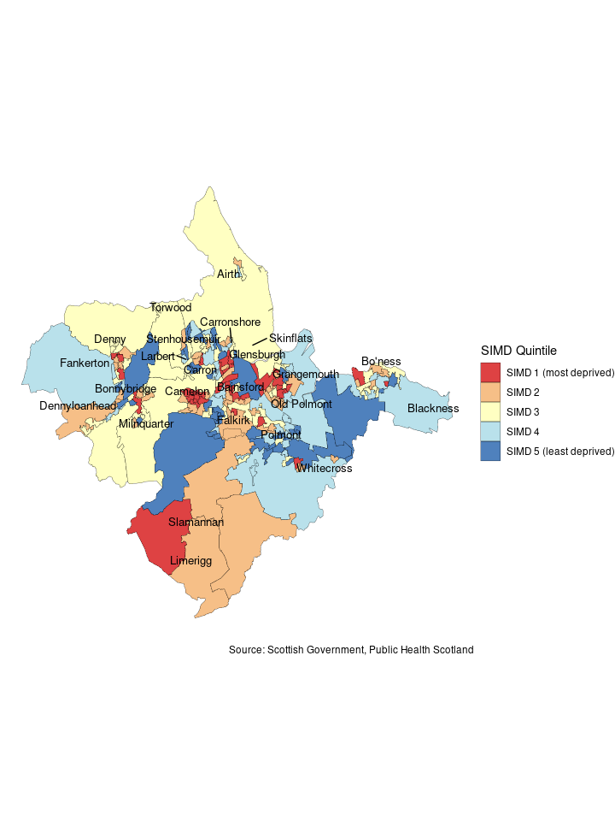

**Population: 32% in SIMD 1 17% in SIMD 5**

**Population: 12% in SIMD 1 20% in SIMD 5**

**Central**

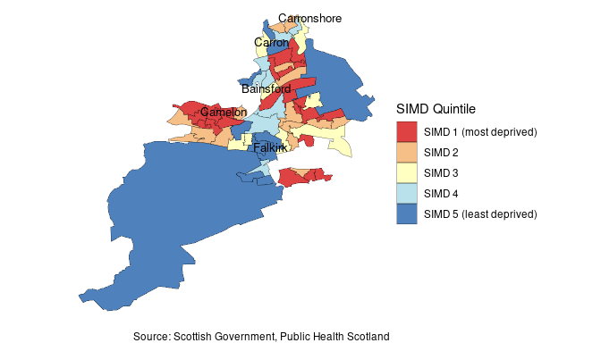

# Appendix 2 health and socio-economic measures by intermediate zone

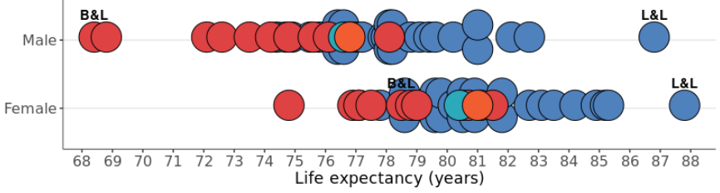

Life Expectancy

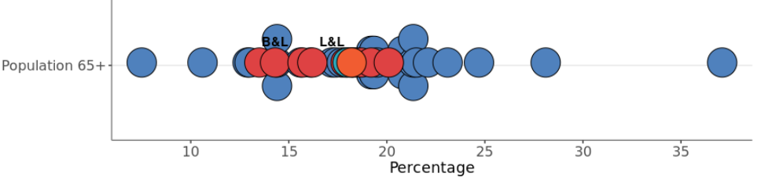

Population

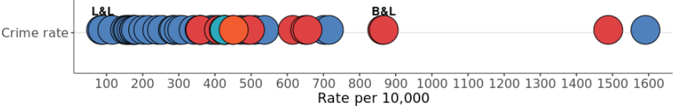

Environment

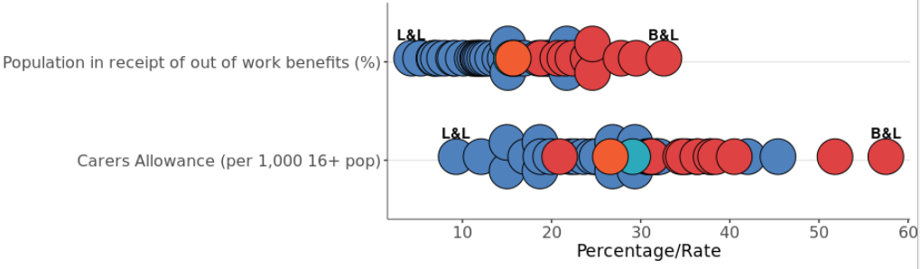

Economy



B&L – Bainsford & Langlees L&L - Lochgreen and Lionthorn

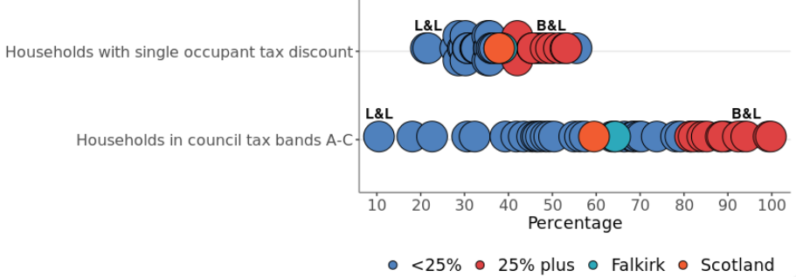

Housing

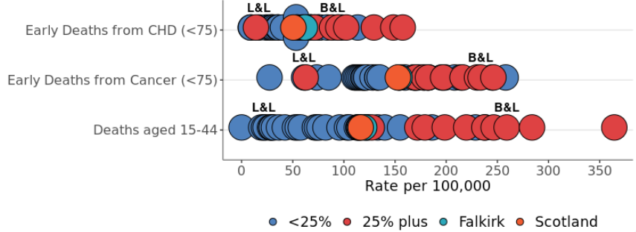

Deaths

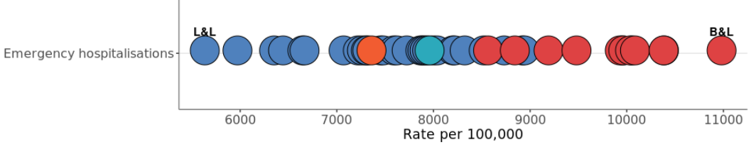

Ill Health and Behaviour

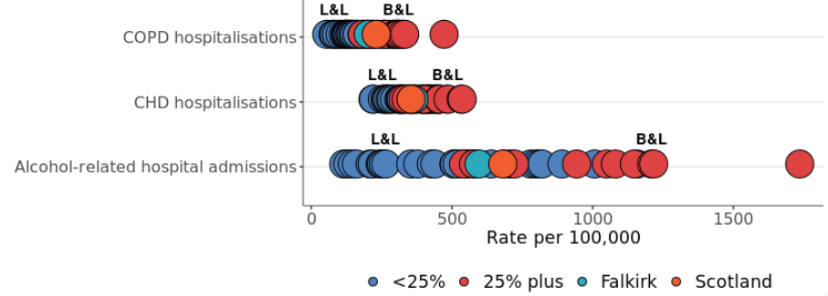

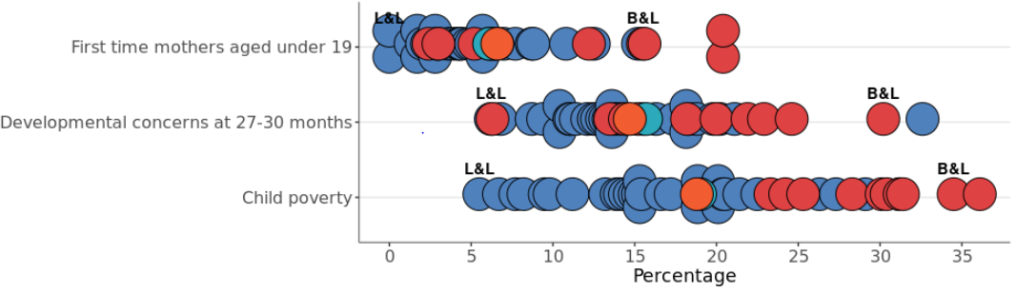

Children & Young People

Lochgreen and Lionthorn

Source: **ScotPHO** – Life Expectancy 2016-20, Deaths 2018-20 (Aged 15-44, early deaths from cancer and CHD), Hospitalisations (CHD & COPD 2018/19-2021, Emergency 2018-20, Alcohol-related 2019/20. **NRS 2020**–Population and Households (Single Occupant tax discount, Council tax bands), **Improvement Service**–Children living in poverty 2019/20, Pop in receipt of out of work benefits May 2020, Crime Rate 2019/20, **Scottish Government**-First time mothers aged under 19 2016/17-18/19. **DWP Stat-Xplore**-Carers Allowance Feb 21

1. https://www.iarc.who.int/wp-content/uploads/2018/07/pr221_E.pdf
2. https://www.eea.europa.eu/themes/air/health-impacts-of-air-pollution
3. Dreyer, K., Steventon, A., Fisher, R. *et al.* The association between living alone and health care utilisation in older adults: a retrospective cohort study of electronic health records from a London general practice. *BMC Geriatr*ics (2018). https://doi.org/10.1186/s12877-018-0939-4
4. <https://www.eas.org.uk/en/the-impact-of-cold-temperatures-on-health_50540/>
5. <https://www.eas.org.uk/en/fuel-poverty-set-to-break-the-50-barrier-in-parts-of-scotland_59652/>
6. <https://commonslibrary.parliament.uk/research-briefings/cbp-9491/>
7. https://www.who.int/news-room/questions-and-answers/item/social-determinants-of-health-key-concepts
8. [Childcare Survey 2022](https://www.coram.org.uk/sites/default/files/resource_files/Coram%20Childcare%20Survey%20-%202022.pdf), Coram Family and Childcare
9. <https://www.health.org.uk/funding-and-partnerships/programmes/responses-to-the-inverse-care-law-in-scotland-over-the-last-20-years>
10. <https://www.kingsfund.org.uk/publications/poverty-health-care-system-data-partnership>
11. <https://publichealthscotland.scot/publications/scottish-drug-misuse-database/scottish-drug-misuse-database-overview-of-initial-assessments-for-specialist-drug-treatment-202021/>
12. ScotPHO Online Profiles Tool - <https://scotland.shinyapps.io/ScotPHO_profiles_tool/>
13. Scottish Health Survey (2019)
14. WHO/FAO (2003) *Diet, Nutrition and the Prevention of Chronic Diseases*.
15. Long-term monitoring of health inequalities: March 2022 report - <https://www.gov.scot/publications/long-term-monitoring-health-inequalities-march-2022-report/>
16. The Impacts of COVID-19 on Equality in Scotland - <https://www.gov.scot/publications/the-impacts-of-covid-19-on-equality-in-scotland/>
17. [General practice disease prevalence data visualisation - General practice - disease prevalence data visualisation - Publications - Public Health Scotland](https://publichealthscotland.scot/publications/general-practice-disease-prevalence-data-visualisation/general-practice-disease-prevalence-data-visualisation/)
18. ScotPHO Online Profiles Tool - <https://scotland.shinyapps.io/ScotPHO_profiles_tool/>
19. ScotPHO Online Profiles Tool - <https://scotland.shinyapps.io/ScotPHO_profiles_tool/>
20. <https://scotland.shinyapps.io/phs-covid-wider-impact/>
21. Public Health Scotland
22. Scottish Government (2018) *A Healthier Future – a framework detailing action for the prevention, early detection and early intervention of type 2 diabetes.* 
23. Ibid.
24. World Report on Disability. World Health Organization, 2011. <http://www.who.int/disabilities/world_report/2011/report/en/>
25. Mind.org – Wellbeing - <https://www.mind.org.uk/information-support/tips-for-everyday-living/wellbeing/>
26. Mental Health Foundation - <https://www.mentalhealth.org.uk/a-to-z/s/stigma-and-discrimination>
27. Mental Health in Scotland – a 10 year vision - <https://consult.gov.scot/mental-health-unit/mental-health-in-scotland-a-10-year-vision/supporting_documents/mentalhealthstrategy.pdf>
28. World Health Organization and Calouste Gulbenkian Foundation. Social determinants of mental health. Geneva, World Health Organization, 2014.
29. COVID Response Programme in Scotland - <https://www.mentalhealth.org.uk/scotland/coronavirus/covid-response-programme>
30. Pandemic one year on: landmark mental health study reveals mixed picture in Scotland, as anxiety falls but loneliness rises - <https://www.mentalhealth.org.uk/news/pandemic-one-year-landmark-mental-health-study-reveals-mixed-picture-scotland-anxiety-falls>
31. Public Health Scotland Wider Impacts Dashboard - <https://scotland.shinyapps.io/phs-covid-wider-impact/>
32. Falkirk Community Planning partnership Joint Strategic Needs Assessment - <https://www.falkirk.gov.uk/services/people-communities/community-planning/docs/Falkirk%20JSNA.pdf?v=202105101227>
33. https://publichealthscotland.scot/media/12207/mental-health-indicators-process-paper.pdf
34. ScotPHO Online Profiles Tool - <https://scotland.shinyapps.io/ScotPHO_profiles_tool/>
35. Dearing, L. Exploring direct and indirect measures of loneliness. The Health Foundation; 2019. [The missing lonely (health.org.uk)](https://www.health.org.uk/news-and-comment/charts-and-infographics/the-missing-lonely)
36. Teuton J. Social isolation and loneliness in Scotland: a review of prevalence and trends. Edinburgh: NHS Health Scotland; 2018. <http://www.healthscotland.scot/media/1712/social-isolation-and-loneliness-in-scotland-a-review-of-prevalence-and-trends.pdf>
37. Reducing social isolation across the lifecourse. Public Health England; 2015. <https://assets.publishing.service.gov.uk/government/uploads/system/uploads/attachment_data/file/460708/3b_Reducing_social_isolation-Briefing.pdf>
38. S. Boniface, S., Scantlebury, R., Watkins, S.J. & Mindell, J.S. Health implications of transport: Evidence of effects of transport on social interactions. Journal of Transport & Health, 2015. <https://www.sciencedirect.com/science/article/pii/S2214140515002224>
39. Mental Health Foundation - [Almost a quarter of adults living under lockdown in Scotland have felt loneliness | Mental Health Foundation](https://www.mentalhealth.org.uk/news/almost-quarter-adults-living-under-lockdown-scotland-have-felt-loneliness)
40. ScotPHO Online Profiles Tool - <https://scotland.shinyapps.io/ScotPHO_profiles_tool/>
41. <https://nhsforthvalley.com/wp-content/uploads/2018/08/Forth-Valley-Primary-Care-Improvement-Plan-2018-2021.pdf>