Guidance for Equality and Poverty Impact Assessments

The purpose of this guidance is to assist in the effective completion of Equality and Poverty Impact Assessments.

An Equality and Poverty Impact Assessment (EPIA) is an important tool to assess the potential impact of policies, practices, and decisions on different groups within society.

The primary goal of EPIAs is to promote fairness, prevent discrimination, and advance equality. This should not be completed retrospectively. Whilst only one person can complete the EPIA on the system, the development of an EPIA should be a collaborative process. Colleagues can make use of the paper EPIA template to work on a shared file.

An impact assessment should be an effective way of improving policy development towards achieving strategic aims and delivering services by:

* Enabling organisations to identify the **IMPACT** of a decision or policy on a person or group of persons.
* Requiring organisations to collect **EVIDENCE** on what the potential impact may be.
* Requiring organisations to consider how that impact can be **AVOIDED OR MITIGATED**.

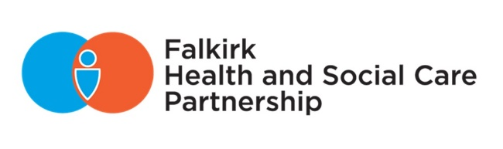

Contents

Why are Equality Impact Assessments important 3

Responsibilities 5

Where to begin 7

Technical Guidance 8

Getting Started 8

Registering a new EPIA 9

The EPIA Registers 10

The EPIA details screen 10

Initial EPIA 11

Creating a Full EPIA 14

Section 1: Essential Information 15

Section 2: Financial Information 17

Section 3: Evidence 18

Section 4: Engagement 20

Section 5: Assessing the Impact 22

Section 6: Partners/Other Stakeholders 25

Section 7: Action Planning 26

Section 8: Assessment Outcome 28

Section 9: Lead Officer Sign Off 29

Section 10: EPIA Task Group Use Only 30

Section 11: Chief Officer Sign Off 31

Once the EPIA is complete 31

Useful contacts 33

# Why are Equality Impact Assessments important

**The Equality Act (2010)** consolidated gender, disability and race legislation and extended protections to a further six characteristics. The nine characteristics protected under the Equality Act are age, disability, gender reassignment, marriage and civil partnership, pregnancy and maternity, race, religion or belief, sex, sexual orientation. The Scottish public sector is covered by the [**Equality Act 2010 (Specific Duties) (Scotland) Regulations 2012**](https://www.equalityhumanrights.com/guidance/public-sector-equality-duty/public-sector-equality-duty-specific-duties-scotland#how-to-comply-with-the-specific-duties) (as amended).

At present, the Duties require a Listed Authority (those public bodies which are subject to the Specific Duties under the 2012 regulations) to publish progress it has made in integrating the three needs of the General Equality Duty (GED) which are:

**The Fairer Scotland Duty** in addition to the Equality Act (2010) requires us to consider those affected by socio-economic disadvantage.

Furthermore, upholding **human rights** (also within UK legislation under the Human Rights Act 1998) ensures that, regardless of status or protected characteristics, we all have rights simply because we are human.

In Falkirk Council, equality impact assessments include ‘poverty’ in recognition of the rise of socio-economic inequalities and a commitment to tackle poverty within the district. Therefore, we refer to these as Equality and Poverty Impact Assessments (EPIAs). Reporting in this way allows the work relating to achieving equal outcomes to be presented in one place and to demonstrate accountability and transparency to their staff, stakeholders, and service users. The report must also be accessible to the public.

Apart from legal obligations, there are many other reasons to carry out these impact assessments:

Promoting Equal Opportunities

EPIAs are designed to help identify any potential discriminatory effects of policies or decisions, allowing the Council to adjust in order to improve equal opportunities for all individuals.

Enhancing Decision-Making

By regularly assessing the impact of decisions, policies, or practices, Falkirk Council can make more informed and equitable decisions. The analysis provided is aimed to avoid unintentional biases and ensure that decisions do not disproportionately disadvantage certain groups.

Engagement and Transparency

EPIAs involve consultation with affected groups, allowing organisations to engage with communities and stakeholders. This process fosters transparency and ensures that diverse perspectives are considered in decision-making.

Identifying Inequalities

An EPIA provides a framework for identifying existing inequalities and disparities within communities. This information is crucial for developing targeted interventions and policies that address specific needs and challenges faced by different groups.

Preventing Discrimination

By proactively assessing the potential impact of policies, organisations can identify and mitigate any discriminatory effects before they occur. This proactive approach is essential in preventing discrimination and addressing systemic biases.

Accountability and Monitoring

EPIAs help create a culture of accountability. Organisations can track the outcomes of policies over time, monitor progress, and adjust as needed to ensure that they are meeting their equality objectives.

Improved Public Services

Considering the diverse needs of the population through EPIAs helps develop more inclusive and responsive public services. This can lead to improved outcomes for individuals from different backgrounds.

Demonstrating Commitment to Equity

Conducting these assessments signals an organisation's commitment to promoting equity and diversity. It demonstrates a willingness to address potential biases and work towards creating a fair and inclusive environment.

Equality Impact Assessments are crucial for promoting fairness, preventing discrimination, and ensuring that policies and decisions benefit all members of society equitably. They contribute to the creation of inclusive and just organisations and help fulfil legal obligations related to equity and human rights.

# Responsibilities

This guidance is aimed to support those who are involved in strategic planning and decision making, such as lead officers, service managers, heads of departments and any other relevant people who are required to complete and Equality and Poverty Impact Assessment (EPIA).

***If the decision was to be challenged in a court of law, who would be held responsible?*** ***Where do you see yourself in the sequence?***

It is important to identify and remember where accountability lies in upholding the Public Sector Equality Duty (PSED) and the Fairer Scotland Duty, to understand the role everyone has and ensure the contributions are effectual.

An EPIA must be completed for any proposed change being made which could have a proportionate and relevant impact on people. This includes new or amended policies, proposed service reviews and redesigns etc. By proportionate we mean the number of people who could potentially be impacted by a decision. Relevance refers to where protected characteristics will be materially impacted by the proposals.

The target audience of an EPIA are the decision makers (i.e. Councillors), stakeholders and the public. Therefore, we need to ensure that the information provided can be published in an inclusive and accessible manner. Currently, EPIAs are automatically saved as a PDF and attached to a committee report. A summary of the EPIA outcome should be included within the report for ease of access to the central point(s). This will help decision makers retrieve the information in a simple and timely manner.

Falkirk Council has decided that:

* Reports with a decision (except for Appeals, Appointments and Regulatory bodies – Planning Committee, Civic Licensing Committee, and the Licensing Board) is where an initial EPIA must be carried out, then a full EPIA if required.
* Reports with no decision, i.e. for noting, consideration or where the process does not involve engagement, an initial/full EPIA is not required.

Falkirk Integration Joint Board (IJB) has decided that:

* All reports to the Board, its Committees and Senior Leadership Team must be subject to an initial screening. The initial EPIA will identify whether a full EPIA is required. This approach has been taken to eliminate errors in judgement and improve compliance. Some reports that are for noting/consideration may be part of a series of reports which require a decision at a future date, therefore work should have started on an EPIA and this should be reported, or; an update report on a decision already made, which may require an EPIA to be reviewed an updated. Please refer to HSCP specific guidance on EPIAs and report writing.

The demonstration of ‘Due Regard’ is a requirement through the Equality Act and the Fairer Scotland Duty, where active considerations must be explained, including that of participation and the proportionality of impact on vulnerable groups. This element should be reflected throughout the EPIA process, but also will need to be recorded in Section 5, when we are recording what considerations have been given to fulfilling the General Equality Duties (referred to on page 3).

Due regard does not mean there is an obligation to achieve a result. There may be a range of good reasons why it is not possible to reduce inequalities of outcome, therefore, it would be practical to outline the case in an EPIA.

However, if it is possible for public bodies to make changes to a programme, proposal, or decision to reduce inequalities of outcome, and there are no compelling reasons for not doing so, due regard would suggest that those changes should be made.

An EPIA is used to identify and record the impact of implementing a proposal on disadvantaged communities.

It should be focused on the outcomes of a decision.

# Where to begin

When writing a proposal, we identify the issue and potential solutions by providing objectives, outcomes, and activities to support an informed approach to make decisions. The information we need to complete an EPIA is similar to what facts/evidence we would need to support a position or provide alternatives (based on the evidence produced). Therefore, within the planning stage there are crucial factors to consider:

By answering these questions, we are also demonstrating ‘due regard’ as a requirement of the PSED and the Fairer Scotland Duty.

# Technical Guidance

### Getting Started

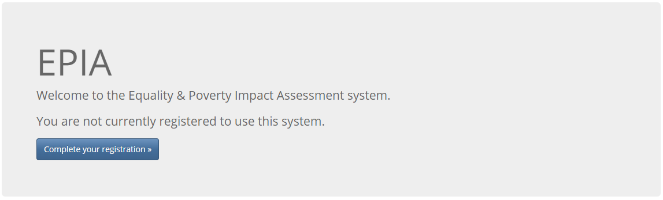You will need to make sure that you are registered on the system before you can register and complete any EPIAs.

The details you register allow the system to populate some areas of the EPIA for you. It also uses your email address to send alerts at different stages of the process. These emails will let you know if you need to do something in the system or are just for information.

Complete your details. The details will appear on the EPIA so choose which telephone number you are happy with being shown, i.e. extension or work mobile. If you use your own mobile, you must remember that we have a statutory requirement to publish full EPIAs and your own number will be shown.

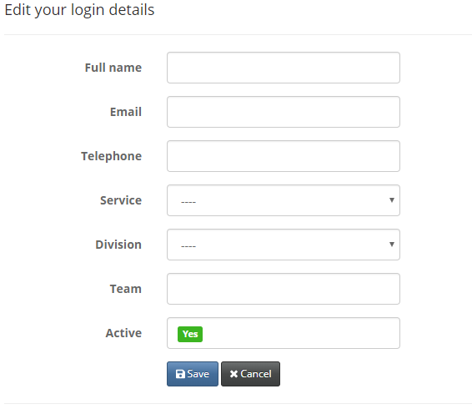

The system does not require the use of passwords. Once you are registered and you use the link / shortcut to the system, it will take you straight to the home screen.

Once completed, click on save. This will take you to the system home screen where you can start registering your EPIA.

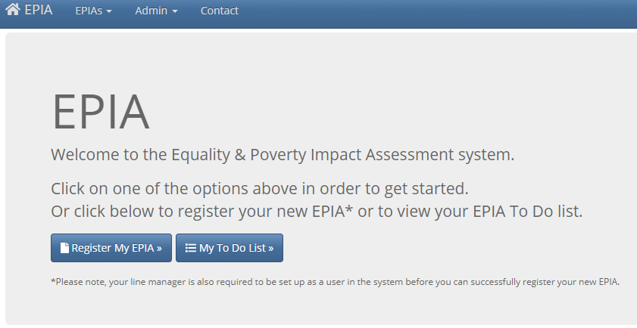This is the system home screen where you can access different registers and register a new EPIA.

This will show only the EPIAs you are connected with.

Useful contacts.

Start a new EPIA by clicking here to register the EPIA.

This button will only appear on those with administration rights to the system.

EPIAs, you have to action

All your EPIAs including those that need no action

Your completed EPIAs

Drop down menu:

Details of the drop down menu are shown: 
'My E.P.I.A. to do list'
'Current E.P.I.A. Register'
'Completed E.P.I.A. Register'

Home button - will always bring you back to this screen no matter where you are in the system.

### Registering a new EPIA

For registering a new EPIA, you will need to complete the basic details and workflow details.

The system will populate fields automatically (shown in grey) when the Lead Officer is added. This comes from the details when Officers registered on the system.

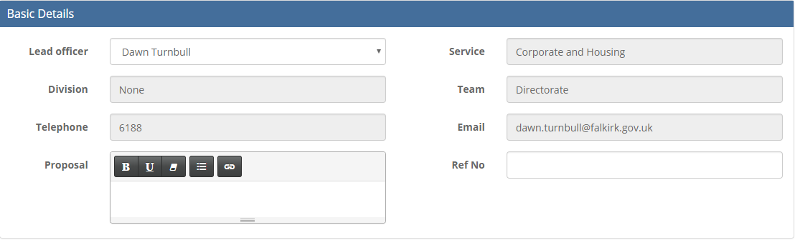

The proposal name should accurately reflect the proposal and any supporting options associated with the proposal.

This usually only applies to budget proposals and is the same as the reference used in the budget book.

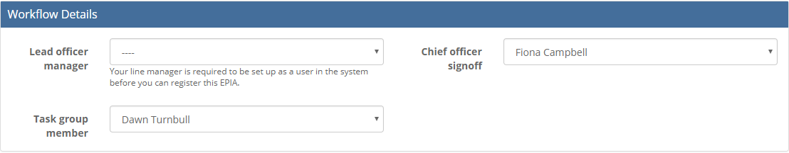



* Lead Officer Manager - This is a drop-down list. You should select your manager (or the person who has asked you to complete an EPIA). If their name isn’t on the list, you need to tell them to register on the system.
* Chief officer signoff - This is the person who will have final sign off on the EPIA and will be automatically populated as the Director of the Service of the Lead Officer. In their absence it can be changed to another Chief Officer.
* Task group member - This will be automatically populated depending on the Service of the Lead Officer.

You must click **Register EPIA button** to continue. This will only register your EPIA and is **not** the initial EPIA screening.

### The EPIA Registers

The following screen will be shown when you access the current or completed EPIA register.

Filters allow for a quick search.

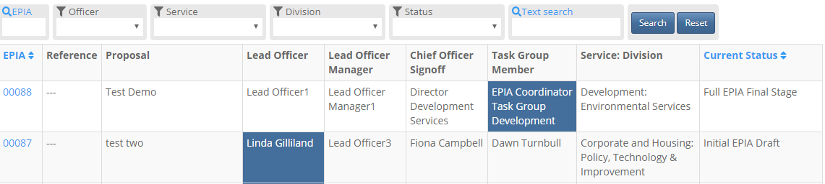

The names or titles that are highlighted indicate where EPIAs are in the workflow and who is required to take the next action. Click anywhere on the rows and it will take you to the EPIA details screen.

### The EPIA details screen

It is important to familiarise yourself with the different parts of the details screen, so you know where to obtain or check specific information.

Workflow information for the EPIA.

### Initial EPIA

A list of actions will be available as you go through the workflow of an EPIA.

The only option on this example is to create an initial EPIA as the current status shows the EPIA has only been registered.

These sections will have a link to view your initial and full EPIAs as you work through the system.

A button to allow editing of either the initial or full EPIA will also be displayed. In this example, there are no documents as they have not been created yet.

This shows the current status of the EPIA. This example shows that an EPIA has been registered.

EPIA reference number.

Once the EPIA has been registered, you are ready to create the initial EPIA. From the previous screenshot, in the ‘Actions’ section, you will be able to select the option of ‘Create Initial EPIA.’

The initial EPIA is a short assessment which determines whether you need to complete a full EPIA. This removes any uncertainty you may have regarding the need to impact assess your proposal. In addition, by requiring all proposals are subject to an initial screening, we can ensure a consistent approach to impact assessment. This should take you no more than 10 minutes.

When completing your initial EPIA you will be required to provide details of your proposal and you will be asked “does the proposal impact on people? If yes, a full EPIA will be required” In truth, most of our proposals will either have a direct or in-direct impact on people, so this test is a relatively low threshold. Therefore, we advise that you consider whether your proposal will have a proportionate and relevant impact on people; the number of people who will likely to be impacted and whether the protected characteristics are likely to be materially impact and how this related to the Equality Duty.

If you have determined that your proposal will ***not*** have a proportionate and relevant impact on people, you will need to provide a clear and convincing reason in the text box provided. All EPIAs are checked for sign off, including initial EPIAs. Therefore, if it is apparent that you have not applied the test of proportionality and relevance correctly, you will be asked to complete a full EPIA.

Some details will be pre-populated for you. You will need to complete the following sections:

1. Lead Officer
2. Proposal
3. Reference number (usually only applies to budget proposals and is the same as the reference used in the budget book).
4. Screening Question: Does the proposal impact on people?
5. If no, please explain why
6. Lead Officer Signature
7. Click on ‘Create’

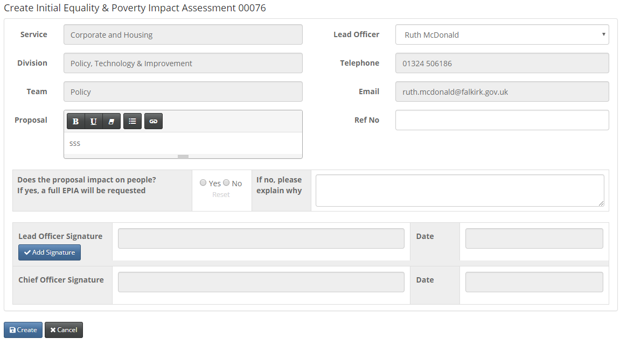The following screenshot is an example of the layout of the screen at this stage.

Once you have created the initial EPIA the system will take you back to the details screen. You will notice that the status has changed. Your EPIA is now in draft and can be edited if needed.

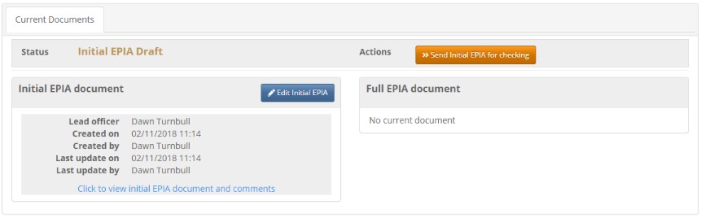

The action now available is to submit the initial EPIA for checking. This will be sent along the workflow to your Service’s representative on the EPIA Task Group.

You can view your initial EPIA and add comments. Comments are available for everyone with access to your EPIA to see. These are additional comments and do not appear in the EPIA. They could be questions throughout the workflow or just a comment to your thought process.

When you click to view initial EPIA document and comments, you will see the next screen. Remember, **EPIAs are public documents**. They are available upon request and full EPIAs are published on the website. You should be comfortable with what you have written at all stages of completing an EPIA.

If you have any queries you can discuss with your manager before sending for a check. You could also add a comment and your manager will get an alert.

View your EPIA as a PDF

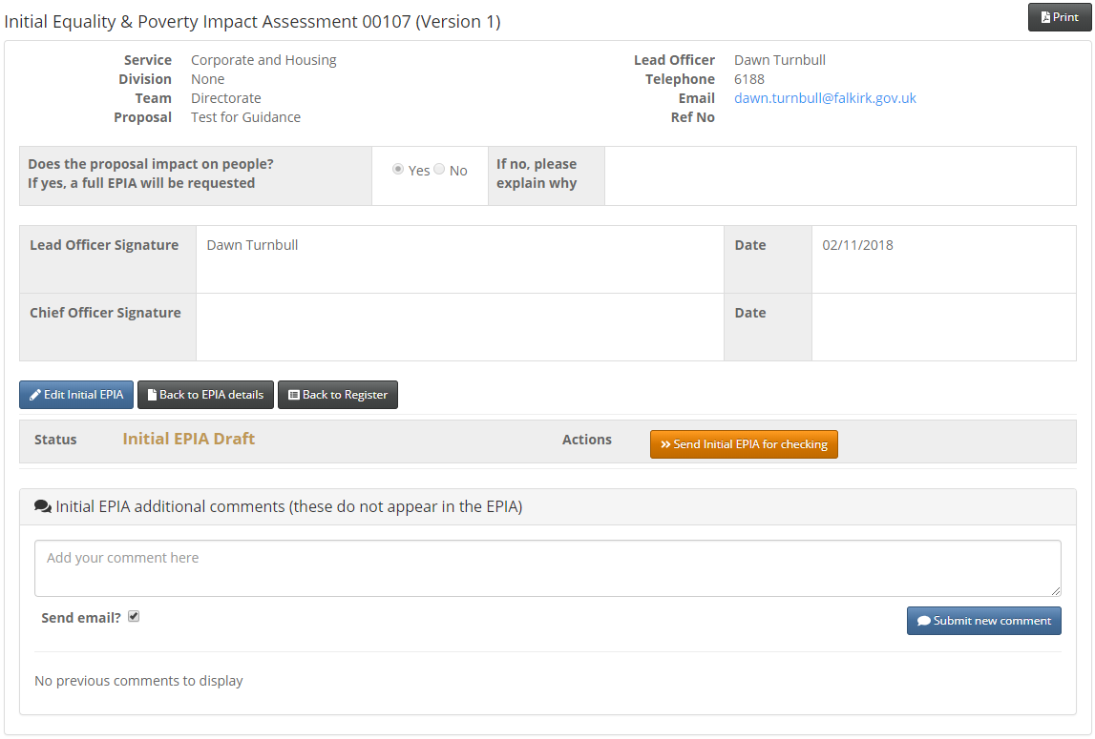

Send for checking.

This is where comments can be added and submitted. For this example, there have been no comments added.

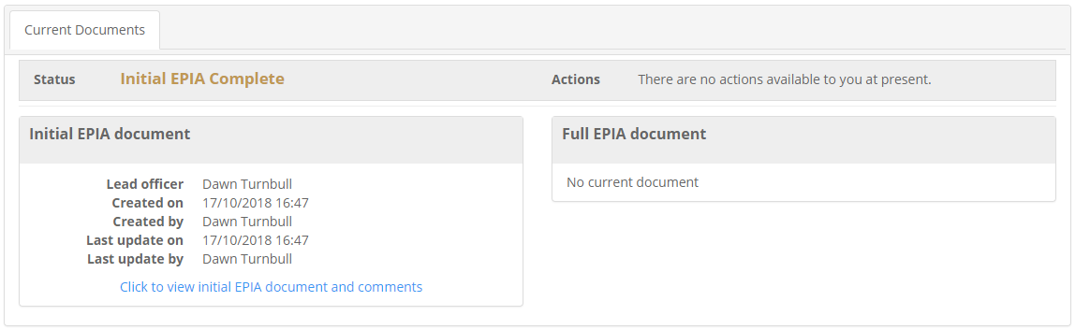Once the initial EPIA has been signed off by a Chief Officer your details screen will be updated. The status will have changed to Initial EPIA Complete. You will also get an email alert advising it is signed off.

As the initial EPIA is complete there are no actions available for you to take until the EPIA has been signed off. The details screen will be updated, and the status will have changed to ‘Initial EPIA Complete.’ You will also get an email alert advising it is signed off.

### Creating a Full EPIA

Your register will show the current status of your EPIA. This example shows that a full EPIA is required.

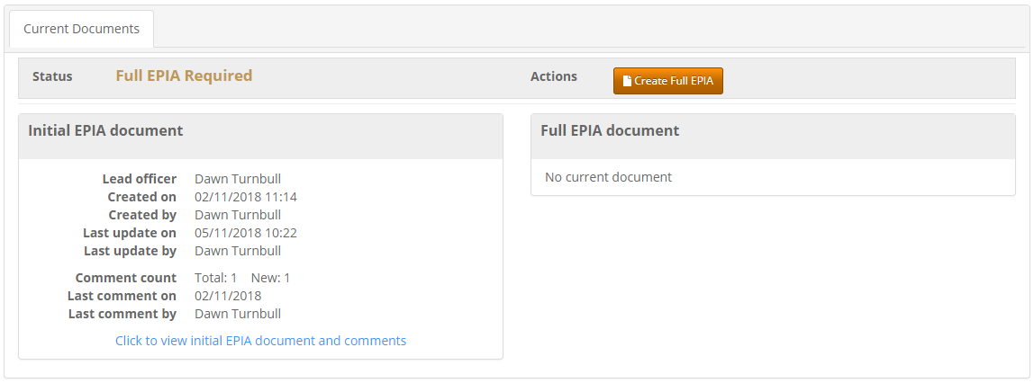

Click here to start your full EPIA.

### Section 1: Essential Information

The top part of section 1 is captured from the initial EPIA, so you do not need to populate.

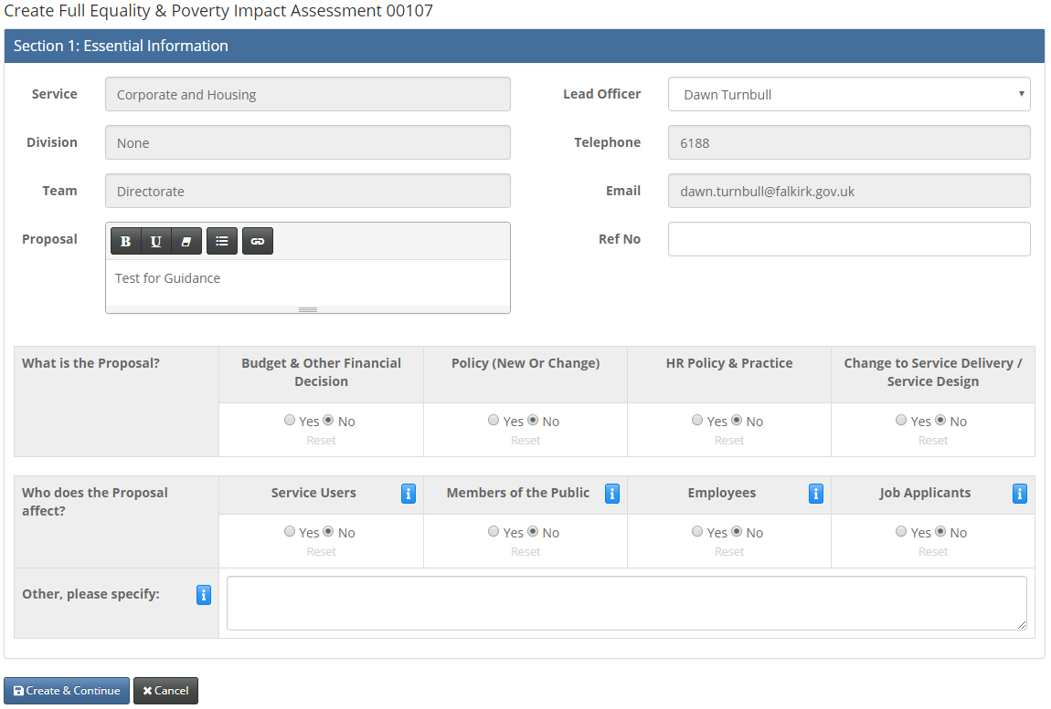

You must choose at least one option.

The system will not allow you to proceed until you choose what type of proposal it is.

This is the first stage of the process for you to consider the impact of your proposal. You are asked to provide details of your proposal, the nature of your proposal (whether it is a new policy/change to existing policy, or a change to service delivery/service design etc.), who will be affected by your proposal (service users, employees etc.) and to identify the main aims and projected outcomes of your proposal.

The system will not allow you to proceed until this section is completed. Click the blue button to continue.

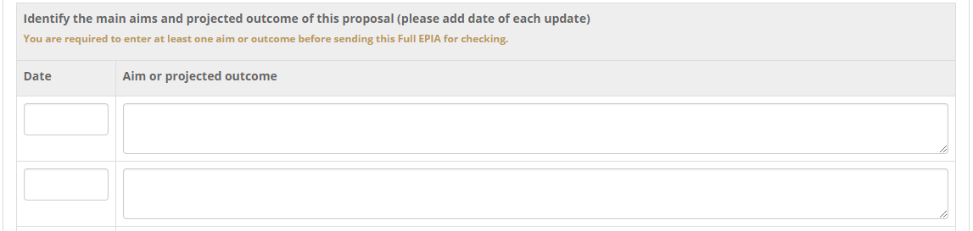The next screen will provide a section to complete the fields explaining the aims or projected outcome of the proposal. You should also keep adding to this section if there are any changes to the proposal (if there are significant changes further consultation and engagement may be required).



**Save** – Save each section as you move through the EPIA. You can move through sections without having to save each time but if you cancel at another section nothing will be saved.

**Save & close** – saves all changes and returns you to the details page. You can save and close and come back to the EPIA at a future time.

**Cancel** – does not save the work you have done at the current session. Anything input previously and saved will still be available.

|  |
| --- |
| **Good Practice:**   * The proposal is presented succinctly, and it clearly states the projected aims and outcomes that will be achieved. * The decision that is being proposed relates to the aim and intended outcomes and it is presented in a style which clearly outlines the ‘proposal’ and the ‘ask’ of the decision-makers. |
| **What to avoid:**   * The proposal is presented in one or two sentences without reference to the intended aims and outcomes. * It is not clear what is being asked of the decision-makers. |

### Section 2: Financial Information

If this is a decision that has a financial impact, and if the proposal is a cost saving measure, then we need to record what these are.

Benchmarking information should be included when the change applies to a charge or a concession and where evidence or information can be obtained from other local authorities or similar services. *Be specific and provide a reference where possible*.

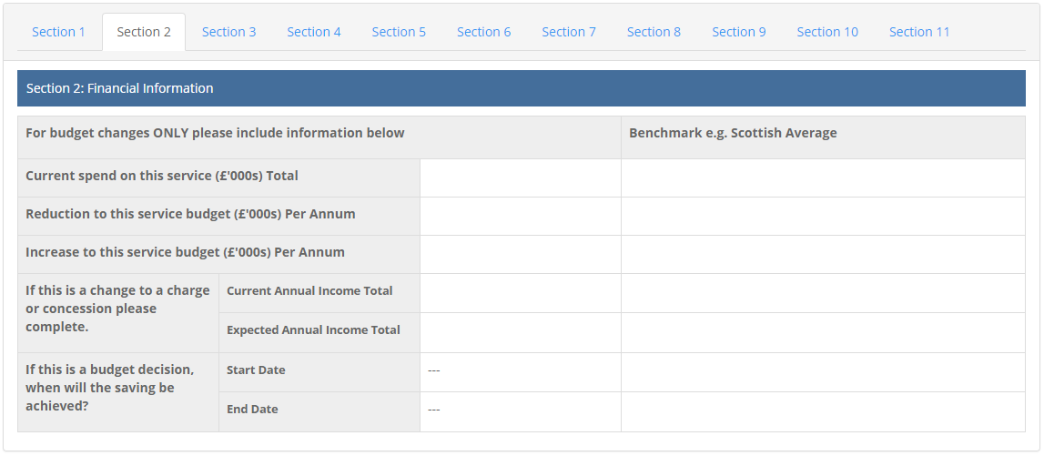

|  |
| --- |
| **Good Practice:**   * Accurate and agreed budgets/budgets changes have been provided. Attempts have been made to benchmark the budget. If there is a budget saving, a timeline has been provided for the saving being achieved. |
| **What to avoid:**   * The information provided is inaccurate and is not agreed. No attempt has been made to benchmark the budget. |

### Section 3: Evidence

It is important that your evidence shows how your proposal might impact on people with protected characteristics and those who experience socio-economic disadvantage. For example, what data do we have on those using the service, and is this data disaggregated into the protected groups? If you do not have this information you need to think about how it can be obtained to move on with your proposal. If you do not have evidence, you are unlikely to be able to determine the level of impact your proposal is likely to have.

It is also useful to refer to other sources such as statistics, surveys, research or evaluations from government departments, partner organisations, voluntary sector organisations, equality groups and networks, and academic and professional institutions. *The important thing to remember is you must clearly demonstrate how this relates to each of the Protected Characteristics*.

* Emphasis should be given to integrating equity into general consultation and engagement activities by monitoring the engagement of protected groups and ensuring that the data and information collected is disaggregated for each of the protected characteristics
* Involve people from protected groups to help with interpretation of existing evidence
* Where audits, surveys or separate evidence papers are referred to, links to these should be provided to aid transparency and accountability in terms of exactly what evidence was gathered and what was done with it
* Consider using evidence to benchmark performance and develop positive action measures which will address inequalities identified
* Identify evidence gaps and needs and develop a plan to fill them
* 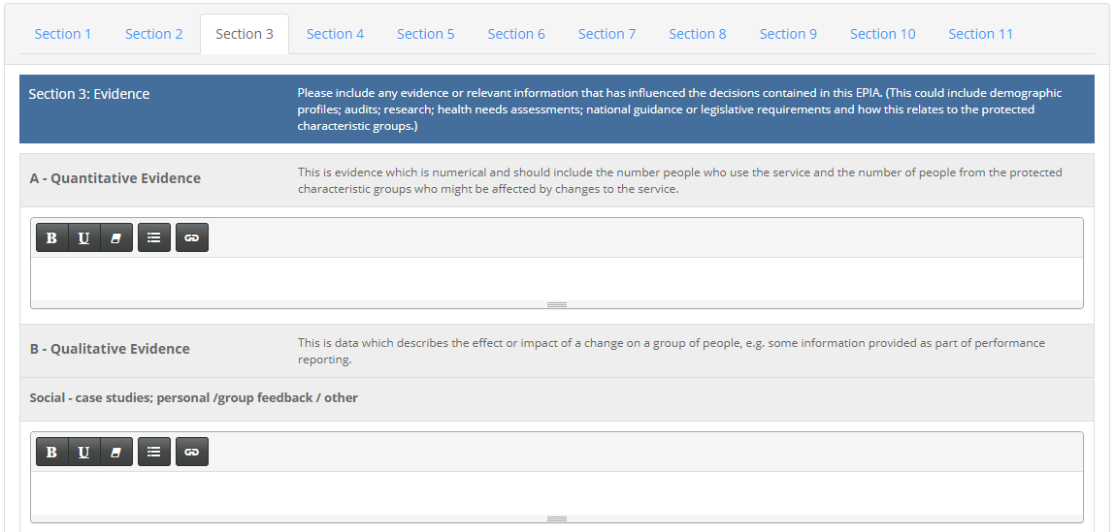Secondary reports should demonstrate analysis and use of data and information rather than continue to focus on process e.g. ‘plans are in place to capture more evidence’ or ‘regular surveys are carried out’

**Part A – Quantitative evidence** which is where numbers and statistics should be recorded.

**Part B – Qualitative evidence** where the data describes the effects or impact of a change on a group of people. This is often feedback that has been given, and views emerged from consultations/engagement of affected groups. This takes place in the form of pieces of text.

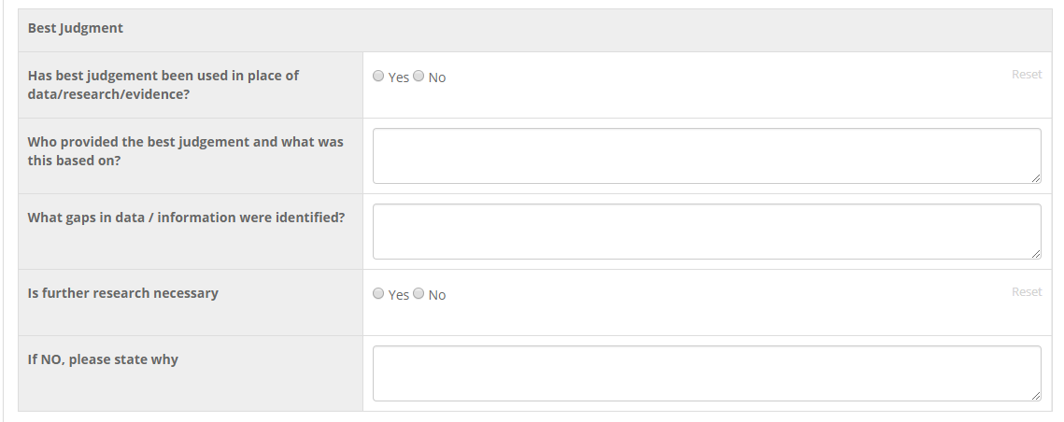**Best Judgement** – Officers can provide their judgement on a proposal based on their experiences and knowledge. Ideally to be used where we do not have other evidence and where it is based on experience and knowledge (which must also be recorded).

|  |
| --- |
| **Good Practice:**   * The evidence provided includes the number of service users/employees/members of the public who may be affected by the proposal. This information also includes demographic profiles of peoples’ Protected Characteristics. Reasonable effort has been made to obtain this information and data gaps are acknowledged with a plan for further research, as necessary. * A wide variety of sources is used, including primary information gathered through any engagement activity/case studies; information gathered through publications, research reports; national guidance and legislative requirements. The evidence included in this section is relevant to the Protected Characteristics. * The qualitative data describes the effect or impact on the Protected Characteristics. |
| **What to avoid:**   * The evidence provided includes the number of service users/employees who may be affected by the proposal. There are no demographic profiles and no information relating to Protected Characteristics. A reasonable effort has not been made to fill data gaps. * No consultation or engagement has been conducted were relevant or proportionate. There is limited to no research of secondary data source has been conducted. The evidence which is used is not relevant to the Protected Characteristics. * The qualitative data describes whether people agree or disagree with the proposal but does not describe the impact on the Protected Characteristics. |

### Section 4: Engagement

As part of the Fairer Scotland duty there is clear expectation that engagement will take place. When you are gathering information from your service users, you should also be asking for data about their protected characteristics and socio-economic background. We now have a standardised equalities monitoring form with questions used from the Scottish 2021 Census to use, accompanied with a guidance note on the relevance of when to ask for this information and what questions can be justified.

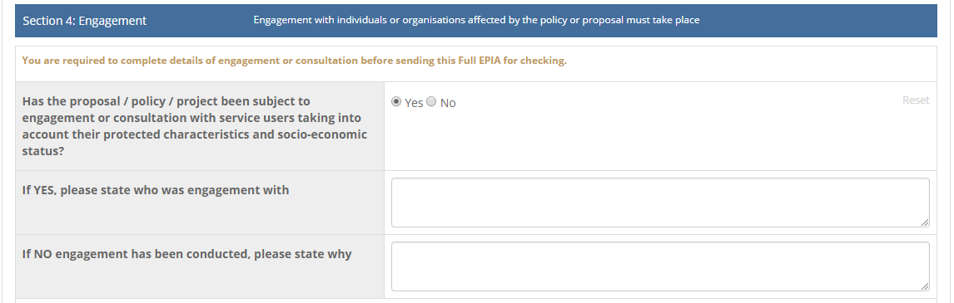If your proposal has limited scope and will therefore have a limited impact on people, then it may not be proportionate and relevant to consult with people. If this is the case, you may wish to consider using existing/previous consultation results as evidence so long as the evidence is relevant to your EPIA and is not out of date. Remember, people are at the heart of our decision-making and this process is about assessing the impact on people. Therefore, it is important that you apply this test of proportionality and relevance carefully.

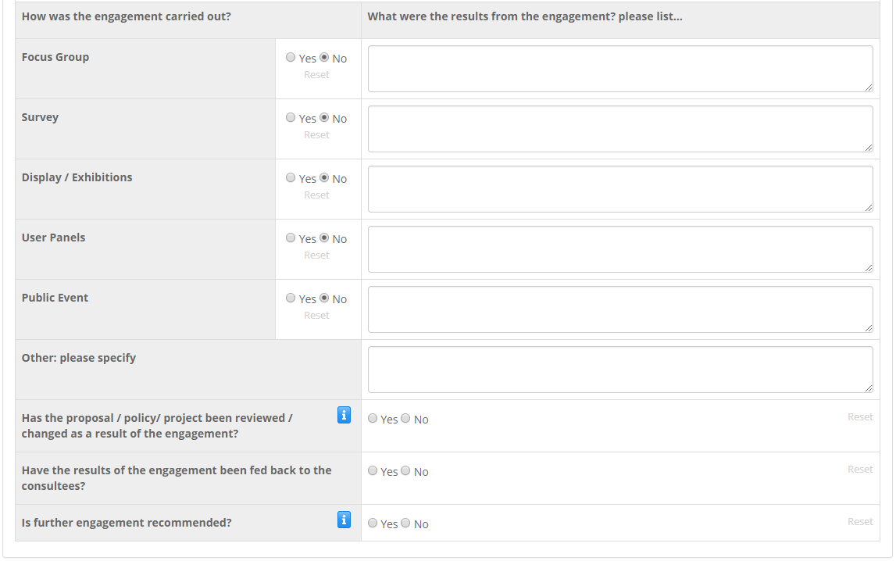Remember, when you are engaging with people you are not trying to find out whether they agree or disagree with your proposal; you want to find out what impact your proposal will have on the different Protected Characteristics. We need to record evidence of what engagement was carried out and what the outcomes were.

If you have decided to change your proposal, or mitigate the proposal in some way, you should record this in **section 1 of the EPIA – Essential Information**. You should also consider if you need to re-engage if the proposal is revised / changed or if you find the engagement is insufficient.

|  |
| --- |
| **Good Practice:**   * The proposal has considered and evidenced the views of service users/members of the public/employees taking account of their Protected Characteristics and socio-economic status. The engagement has influenced the content and considerations of the EPIA. The results of the consultation have been fed back to the participants and there is a demonstration of how the responses to the consultation have influenced the EPIA. * Where engagement has not been conducted, a test of proportionality and relevance has been applied carefully and there is sufficient evidence provided within Section 3 of the EPIA in lieu of any engagement with the relevant groups. A clear explanation is provided for engagement not being conducted. |
| **What to avoid:**   * There has been limited engagement with service users which has not taken account of their Protected Characteristics. The engagement has not influenced the EPIA, and the results have not been shared with the participants. * A test of proportionality and relevance has not been applied carefully. There is a lack of evidence in Section 3 to subsidise non-engagement. An explanation has not been provided detailing the reasons for not conducting a consultation/engagement. * Outcome from the engagement has not been recorded. |

### Section 5: Assessing the Impact

In this section, analysis of the evidence and the feedback given from the engagement will be used to determine if the proposal has a neutral, positive, or negative impact. It is important to explain why we have chosen one of these.

It is important to remember that people are not the same and that we all experience life differently because of our Protected Characteristics. Therefore, in this section, it may be helpful to consider each of the Protected Characteristics in isolation to provide focus to the specific impacts. However, when reviewing each of the Protected Characteristics individually, be mindful that the Characteristics relate to each other, and some impacts may overlap.

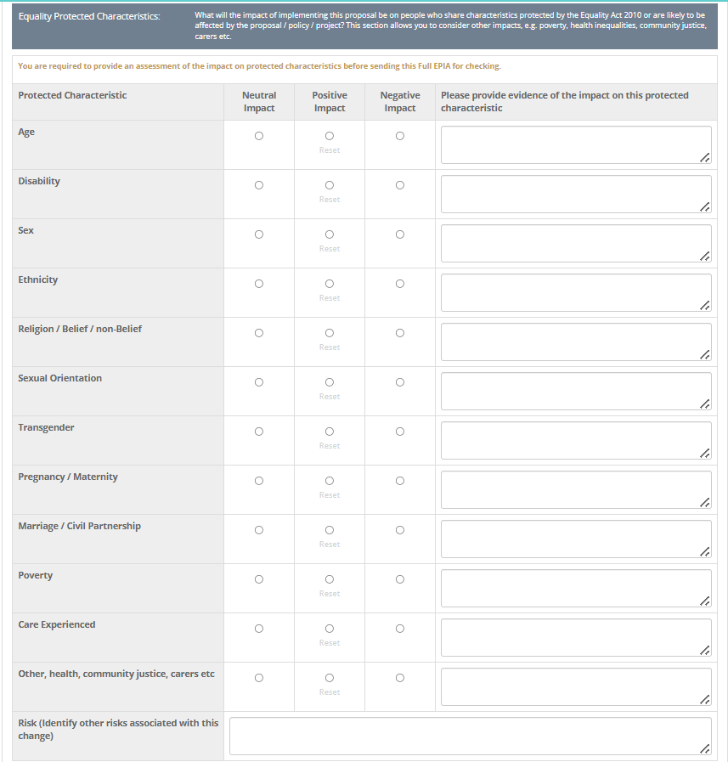

The proposal is likely to affect more than one protected characteristic. You can select an impact for more than one, but you do not need to refer to them all.

This refers to the  [Fairer Scotland Duty](https://www.gov.scot/publications/fairer-scotland-duty-guidance-public-bodies/pages/7/#:~:text=Fairer%20Scotland%20Duty%3A%20guidance%20for%20public%20bodies%2019,caused%20by%20socio-economic%20disadvantage%2C%20when%20making%20strategic%20decisions.) and impact on the socio-economic status of individuals or groups, including geographic communities.

Includes communities of interest that have high levels of disadvantage, e.g. looked after children, care leavers, carers or people involved with the criminal justice system.

This refers to other risks and any risk to the Council. Does the proposal result in a different risk, e.g. reputational, financial etc. For further advice you can contact the Council’s Corporate Risk Co-ordinator.

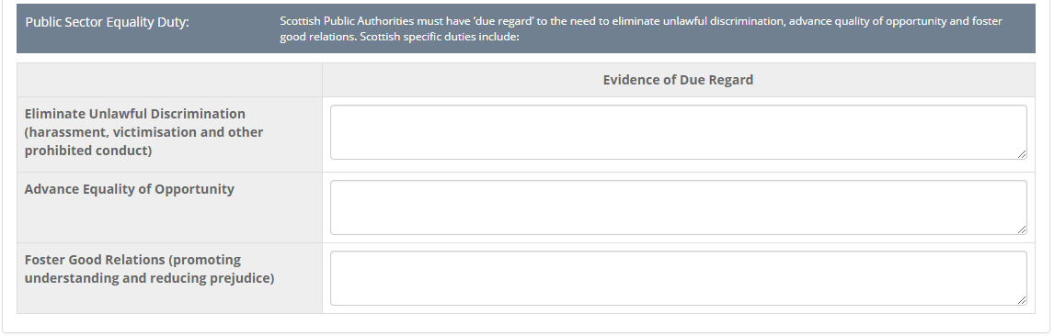The other part of this section refers to the Public Sector Equality Duty and what evidence we have about due regard. Due regard means that you need to document what consideration and attention has been given as part of the decision-making process, for example, any activities that took place to fulfil the Public Sector Equality Duty aims. This is recorded as evidence in relation to the three duties of eliminating unlawful discrimination, advancing equality of opportunity, and fostering good relations.

In more detail, the starting point for assessing impact is the three needs of the duty:

* ensuring that the policy does not discriminate unlawfully;
* considering how the policy might better advance equality of opportunity; and
* considering whether the policy will affect good relations between different groups.

|  |  |
| --- | --- |
| General Equality Duty | Evidence of Due Regard |
| Eliminate Unlawful Discrimination (harassment, victimisation, and other prohibited conduct) - *Eradicate unlawful discrimination, harassment and victimisation and other conduct that is prohibited by the Equality Act 2010.* | What activities/research/discussions (that are documented) have taken place to meet this requirement?  In considering whether the policy eliminates discrimination you should consider whether there is evidence to indicate that:  • the policy may result in less favourable treatment for particular groups;  • the policy may give rise to indirect discrimination;  • the policy may give rise to unlawful harassment or victimisation;  • the policy may lead to discrimination arising from disability;  • the policy builds in reasonable adjustments where these may be needed. |
| Advance Equality of Opportunity *- between people who share a relevant protected characteristic and those who do not.* | In determining how the policy contributes to advancing equality of opportunity (by focusing on equity), you should consider whether the proposal will help to:  • remove or minimise disadvantage;  • meet the needs of different groups;  • encourage increased participation of particular groups; and  • take account of disabled people’s impairments. |
| Foster Good Relations -*promoting understanding and reducing prejudice between people who share a protected characteristic and those who do not.* | Similarly, in determining how the policy will affect good relations, you should consider whether the proposal will help you to:  • tackle prejudice; and  • promote understanding. |

|  |
| --- |
| **Good Practice:**   * There is a clear understanding and demonstration of how each of the Protected Characteristics may be impacted differently by the proposals. Sufficient evidence is provided in assessing the impact. There is a strong understanding of any disproportionate impacts and an appreciation of the barriers and discrimination that people may experience because of their Protected Characteristic. * Where there is a lack of sufficient evidence, the impact is assessed as ‘neutral,’ and a clear explanation is given for the lack of evidence. * There is a careful consideration and interpretation of the Duty to give ‘due regard’ to the need to eliminate unlawful discrimination, advance quality of opportunity and foster good relations. There is evidence of ‘due regard’ and the aims of the proposal are clearly linked to the three aims of the General Equality Duty. |
| **What to avoid:**   * There is limited to no understanding of how the Protected Characteristics may be impacted differently by the proposals. There is a lack of evidence in the assessment of the impact. There is a poor understanding of the disproportionate impacts people may experience based on their Protected Characteristics. The same or a similar response is copied into each text box. * The impact is assessed as ‘positive’ or ‘negative’ despite there being a lack of evidence to suggest as such. There is little to no explanation of the lack of evidence. * ‘Due regard’ has not been given to the need to eliminate unlawful discrimination, advance quality of opportunity and foster good relations. There is no explanation for a lack of evidence and the aims of the proposal are not linked to the three aims of the General Equality Duty. * Any perceived positive impact for one group is applied to all. There is a lack of understanding of the differential experiences each Protected Characteristic has. It is highly unlikely that the proposal will universally benefit all Protected Characteristics, therefore this section should reflect those differences. |

### Section 6: Partners/Other Stakeholders

This section is to record any partner organisations or stakeholders will be affected by the proposal/policy/project.

The interest / affect must be added if you select a partner / other stakeholder. You will not be able to send your EPIA to the next stage without this information.

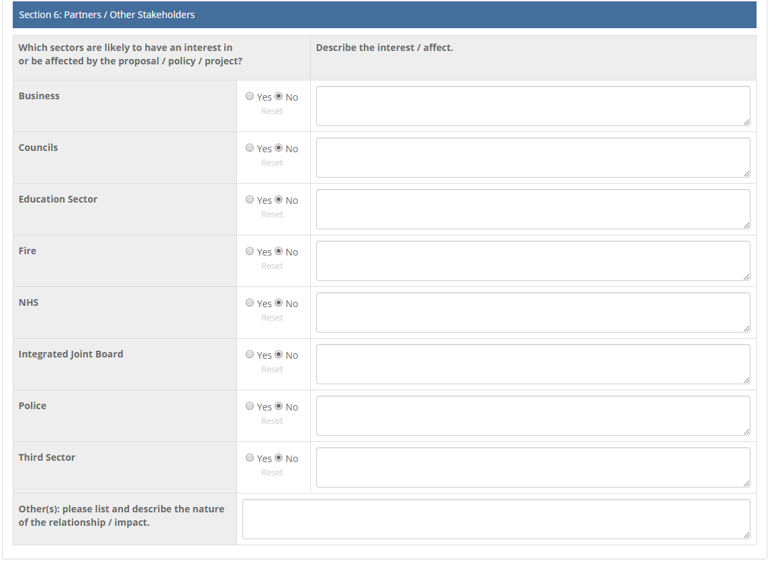

|  |
| --- |
| **Good Practice:**   * Clear thought has been given to the relationship this proposal has with other partners/stakeholders. There is an acknowledgement of the wider implications the proposal may have further other partners. |
| **What to avoid:**   * Limited to no information is provided. There is a lack of understanding of how the proposals relate to other partners/stakeholders. |

### Section 7: Action Planning

With reference to engagement and assessing the impact (sections 4 and 5 of the EPIA), you need to list the impacts identified on each of the protected characteristic groups and what the recommendations that need to be taken to mitigate the risk.

Once these actions are agreed they need to be implemented or the mitigation will not take effect. You will also run the risk of being challenged on the decision of the proposal if the mitigation does not take place.

If there are no mitigating actions identified, then this needs to be clarified in the section below. This will also include if there are negative impacts identified in section 5, but no mitigating actions will be taken, as you need to explain clearly why.

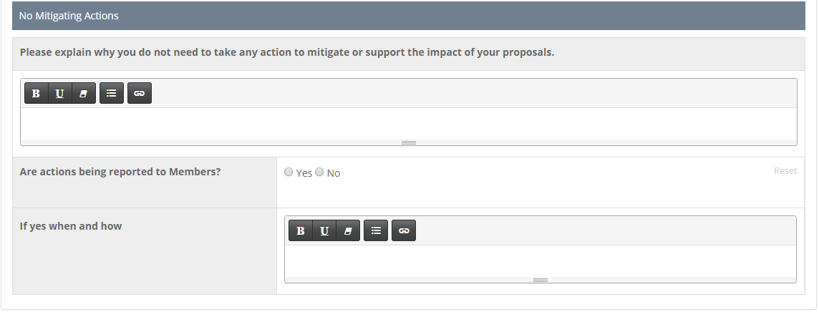You will need to record if the mitigating actions are being reported to members, when and how will this be reported i.e. through a committee report under the Equalities section.

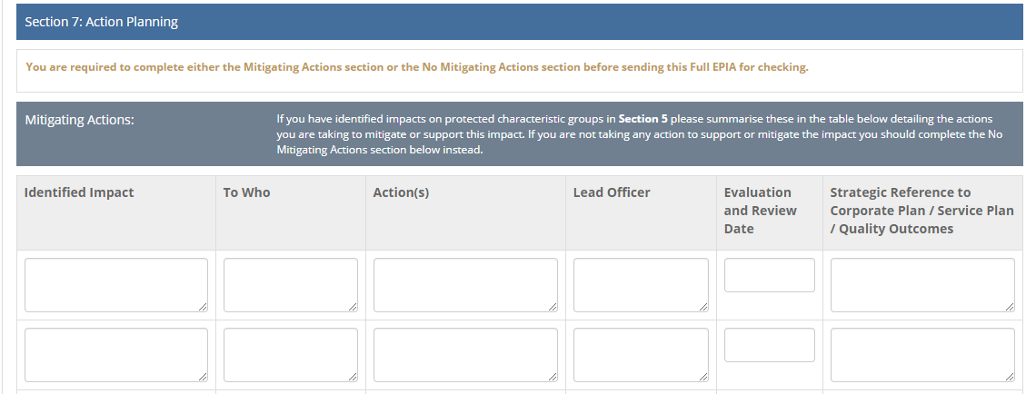

|  |
| --- |
| **Good Practice:**   * All negative impacts have been addressed in this section and there is an appropriate corresponding mitigation. Every reasonable effort has been made to develop sufficient mitigations. There is a sound understanding of the identified impact, who will be impacted and the appropriate measure to mitigate that impact. There is a clear line of accountability for leading on those mitigating actions and there is an agreed timeline for evaluating and reviewing them. * If the impacts have been assessed as ‘positive’ or ‘neutral,’ and no mitigating actions are required, a clear explanation is provided for why mitigating actions are not required. |
| **What to avoid:**   * Not all negative impacts have been addressed and the level of mitigation is not appropriate. There is a lack of accountability for leading on the mitigating actions and the timeline for evaluating and reviewing them is unclear. * This section has limited to no information; there is not a clear explanation of why mitigating actions are not required. |

### Section 8: Assessment Outcome

This section records a summary of the impact assessment and what the outcome of the proposal should be. There needs to be a justified reason to select the relevant statement.

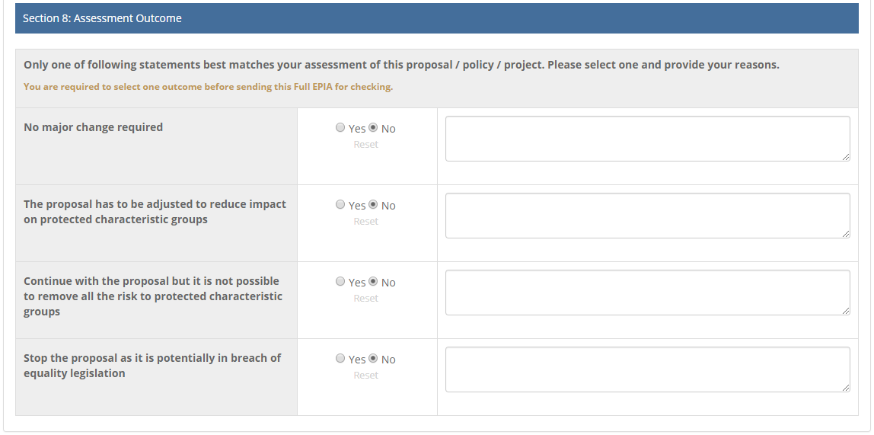

|  |
| --- |
| **Good Practice:**   * There may be no major change required if the assessment has not identified any potential for discrimination or adverse impact, and all opportunities to advance equality and foster good relations have been taken.   However, your proposal may need to be adjusted to remove barriers or disadvantages for particular equality groups, to better advance equality or to foster good relations.  You should make an informed judgement and the select the statement which best matches your assessment. |
| **What to avoid:**   * No reasons are provided for the selection and the statement is not the best match. |

### Section 9: Lead Officer Sign Off

This is the final section for the lead officer to complete. If you have not completed the “required” sections of the EPIA you will be unable to send for checking.

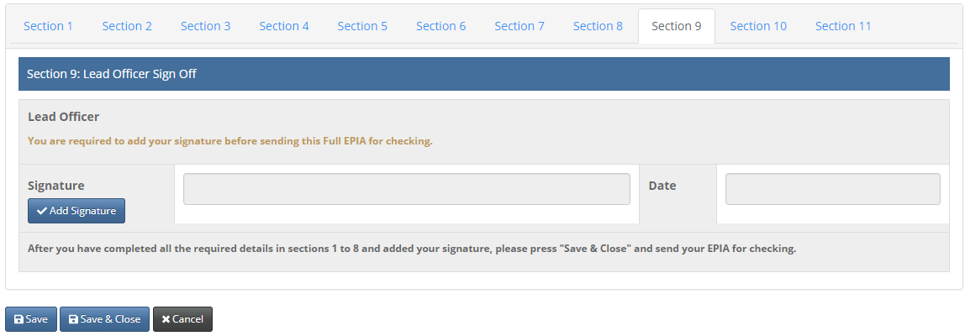Click to add your electronic signature. The date will populate automatically. Please make sure you have completed all the required sections then save & close.

Once you send the full EPIA for checking it goes to your service representative (Task Group Member). It will be returned to you if more information is required or needs clarified.

The EPIA then goes to the EPIA Co-ordinator for a review, and then to the Director, or another Chief Officer in their absence, for sign off.

Throughout the process email alerts are sent to either you, your line manager, your service representative, the EPIA Co-ordinator or your Director to advise if you have an action to take, if comments have been added, to advise where the EPIA is in the workflow or if the EPIA has been signed off.

Section 10: EPIA Task Group Use Only

This section is to be completed by the EPIA Task Group or the EPIA Co-Ordinator, who will provide feedback on the impact assessment and determine the risk level of the proposal. Any comments made must reference elements of the EPIA to provide justification for the answer selected.

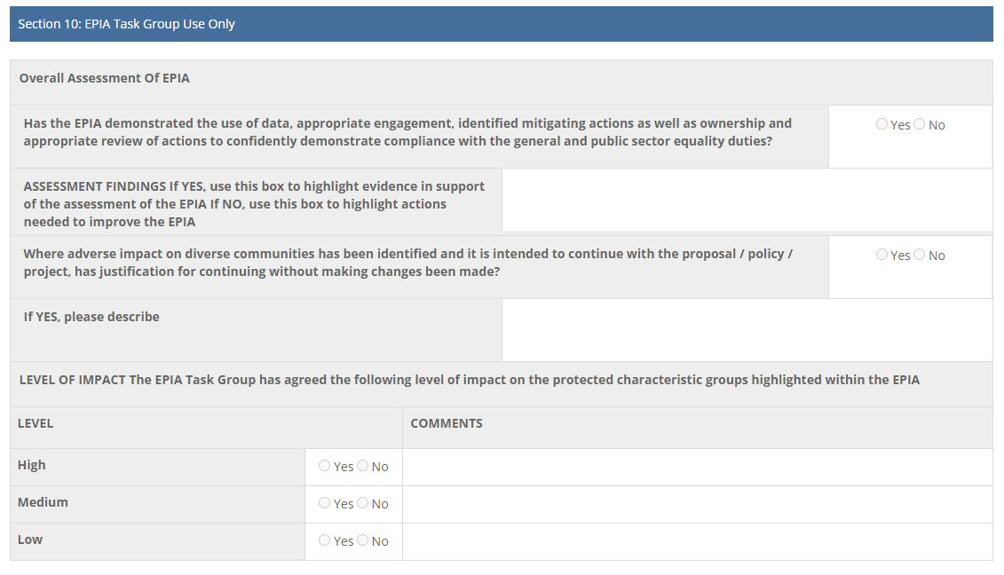

### Section 11: Chief Officer Sign Off

This section is to be completed by the Chief Officer, who are the directors of services.

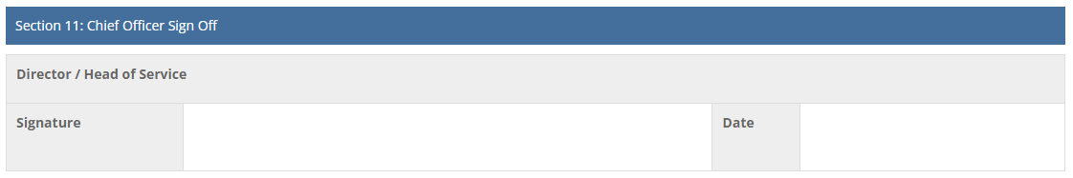

### Once the EPIA is complete

Once the EPIA has been signed off if should be provided to Members to assist in the decision-making process. You will need to provide a copy by selecting the ‘Print’ option on the top right-hand corner, where a PDF version will be generated.



Once you have completed your assessment, you can begin work on your report. Included in the report is an ‘Equalities Assessment’ section; **do not** simply write ‘an EPIA has been completed.’ The report needs to take account of the results and how the assessment has developed your proposals. In addition, it is your responsibility to ensure that the decision-makers have *due regard* to the results of the assessment when making the final decision about the proposal and its implementation.

Decision-makers have a scrutiny role in determining whether the EPIA has been robust enough and gives them sufficient information. You need to ensure you are satisfied that you:

* Understand the relevance of the needs in the Equality Duty to the decisions you are making
* Have sufficient information on the potential impact of the decision on people with relevant protected characteristics. If not, you will need to decide if further research or consultation is necessary.
* Have considered whether action can be taken to mitigate any identified potential adverse impact of the proposed policy.
* Have considered whether action can be taken to enable the proposed policy to advance equality of opportunity.

Besides, a lot of work can go into an EPIA - write about it! The decision-makers will recognise the hard work and effort you have applied to developing your proposal.

**Publish**

It is our Duty to publish all EPIAs on the Falkirk Council and HSCP website. Publishing EPIAs ensures openness and transparency in decision-making. The assessments are designed to be public documents. Therefore, it is important to keep this in mind when you are completing your EPIA. Make your EPIA as accessible as possible by writing in plain English.

**Monitor**

Once your proposal has been implemented, it is your responsibility to monitor its impact. When you are developing your proposal and completing your EPIA, it is important to consider the systems you could use to that will enable you to monitor impact. Remember, the three aims of the general Equality Duty (eliminate discrimination, equality of opportunity, foster good relations) still apply to your proposal once it has been implemented. Therefore, it is important you consider how your proposal continues to meet those aims on an ongoing basis.

As the implementation of your proposal progresses, you may learn of new ways in which people are impacted. Review your EPIA and update it with the relevant information. This means we will have an accurate record of the impact of your proposal and could provide evidence for other EPIAs.

### Useful contacts

For further information, you can contact your EPIA Task Group Member or EPIA Co-ordinator.

**Children’s Services**

* Paul Wilcox: [Paul.Wilcox@falkirk.gov.uk](mailto:Paul.Wilcox@falkirk.gov.uk)

**Transformation, Communities & Corporate Services**

* Dawn Turnbull: [Dawn.Turnbull@falkirk.gov.uk](mailto:Dawn.Turnbull@falkirk.gov.uk)

**Development Services**

* Ross Maclean: [Ross.Maclean@falkirk.gov.uk](mailto:Ross.Maclean@falkirk.gov.uk)

**Falkirk EPIA Co-ordinator**

* Farah Farzana [Farah.Farzana@falkirk.gov.uk](mailto:Farah.Farzana@falkirk.gov.uk)
* Mobile: 07484054904

**Social Work Adult Services**

* Tracey Reilly: [Tracey.Reilly@falkirk.gov.uk](mailto:Tracey.Reilly@falkirk.gov.uk)

**Falkirk Health and Social Care Partnership Co-ordinator**

* David Keenan: [david.keenan@falkirk.gov.uk](mailto:david.keenan@falkirk.gov.uk)