Participation and Engagement Strategy

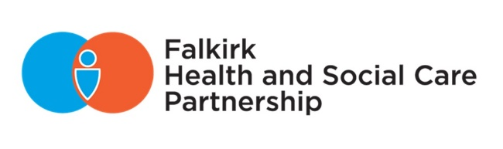

2024 - 2027

# Contents

Introduction 2

Legislative & Strategic Context 2

HSCP Strategic Context 3

How We Engage With People 5

Who We Engage With 10

Principles of Engagement 15

Inclusion 15

Support 17

Planning 17

Working Together 19

Methods 21

Communication 22

Impact 23

Appendix I. Community Engagement Toolkit 25

Appendix II. Participation Rights 26

|  |  |
| --- | --- |
| Document information |  |
| **Date of issue:** | **28/06/2024** |
| **Approval status:** | **Approved by IJB** |
| **Review date:** | **June 2027** |
| **Available from:** | **Partnership website** |
| **Key contact:** | **Policy and Research Officer** |

# Introduction

Community engagement aims to develop working relationships between Falkirk Health and Social Care Partnership and individuals or community groups. Community engagement can be used to create effective change, especially when it is embedded in our activities to improve service planning and delivery. Successful engagement is person-centred and places service users, carers, and staff at the core of how we deliver our services.

The HSCP Participation and Engagement Strategy 2024-2027 aims to achieve the following three outcomes:

1. The involvement of people and communities positively impacts on service change and strategy development to ensure that services meet people’s needs and develops trust with our communities.
2. Our approach to engagement is inclusive, meaningful and is evaluated to identify learning and improve how we deliver future engagement activities.
3. Staff have the necessary knowledge and skills required to deliver effective and meaningful community engagement.

To support the implementation of the Participation and Engagement Strategy as well as the Communication Strategy, an action plan has been co-produced. This action plan contains 17 actions supporting the Participation and Engagement Strategy and 21 actions supporting the Communication Strategy.

The action plan sets out what we’ll do to meet the above outcomes and the National Standards of Community Engagement, as outlined in this strategy, with the aim of improving how we deliver meaningful engagement. The outcomes and action plan are aligned with the [HIS Quality Framework for Community Engagement and Participation](https://www.hisengage.scot/quality-framework).

We will report our progress on the action plan to the Integration Joint Board (IJB) quarterly to ensure that we remain accountable and transparent about our engagement practices.

## Legislative & Strategic Context

The [Public Bodies (Joint Working) (Scotland) Act 2014](https://www.legislation.gov.uk/asp/2014/9/contents/enacted) requires each HSCP to produce a Participation and Engagement Strategy for the Integration Joint Board (IJB), which is the formal body with overall responsibility for the integration of health and social care. This plan forms part of Falkirk HSCP’s Strategic Plan.

The [Community Empowerment (Scotland) Act 2015](https://www.legislation.gov.uk/asp/2015/6/contents/enacted) requires public bodies to engage with communities and community organisations. The 2015 Act requires the Integration Joint Board (IJB) to put in place a participation process and to report on how engagement has shaped the delivery of local outcomes.

The [Carers (Scotland) Act 2016](https://www.legislation.gov.uk/asp/2016/9/contents/enacted) requires local authorities and health boards to involve carers and persons representative of carers in the services they provide. It ensures that carers are involved at a strategic level in the design and delivery of services.

The [Consumer Scotland Act 2020](https://www.legislation.gov.uk/asp/2020/11/contents) establishes a Consumer Duty on public bodies to improve the extent to which consumers are considered in strategic policy and decision-making. A key principle of the Duty will be to ensure all public bodies are working towards improving outcomes for consumers as part of their strategic decision-making process.

The [Independent Review of Adult Social Care (IRASC)](https://www.gov.scot/publications/independent-review-adult-social-care-scotland/) highlighted the importance of involving people with lived experience to improve service delivery to ensure they remain at the heart of provision. Recommendation 30 states “there must be a relentless focus on involving people who use services, their families and carers in developing new approaches at both a national and local level.”

With the introduction of the [National Care Service (Scotland)](https://www.gov.scot/policies/social-care/national-care-service/) Bill, the Scottish Government remains committed to involving people and local communities to help shape and co-design how the National Care Service is delivered.

The updated [Planning with People](https://www.gov.scot/binaries/content/documents/govscot/publications/advice-and-guidance/2023/04/planning-people-community-engagement-participation-guidance/documents/planning-people-community-engagement-participation-guidance/planning-people-community-engagement-participation-guidance/govscot%3Adocument/planning-people-community-engagement-participation-guidance.pdf) guidance supports NHS Boards, Integration Joint Boards, and Local Authorities to meaningfully involve people and communities when services are being planned or when changes to services are being considered.

## HSCP Strategic Context

The Participation and Engagement Strategy and the Communication Strategy promotes and supports how we carry out community engagement across the Partnership.

Both documents are part of a set of strategic documents that supports the implementation of the Partnership’s overall [Strategic Plan 2023 – 2026](https://falkirkhscp.org/publications/#strategicplan), with communication and engagement being identified as a supporting workstream that drives forward our strategic priorities.

Other relevant HSCP policies include the Volunteer Policy and Expenses Policy. These policies aim to provide opportunities for people to get involved and share their skills, make connections, and support the Partnership to achieve its vision. The Expenses Policy ensures that IJB carer and service user representatives are not out of pocket when carrying out their duties.

The Participation and Engagement Strategy also supports the development and implementation of other strategies such as the Falkirk Carers Strategy as well as our local dementia and learning disability strategies currently being developed in 2024.

Figure 1 below illustrates how legislation and national guidance as well as local plans and strategies support the development of the Participation and Engagement Strategy.

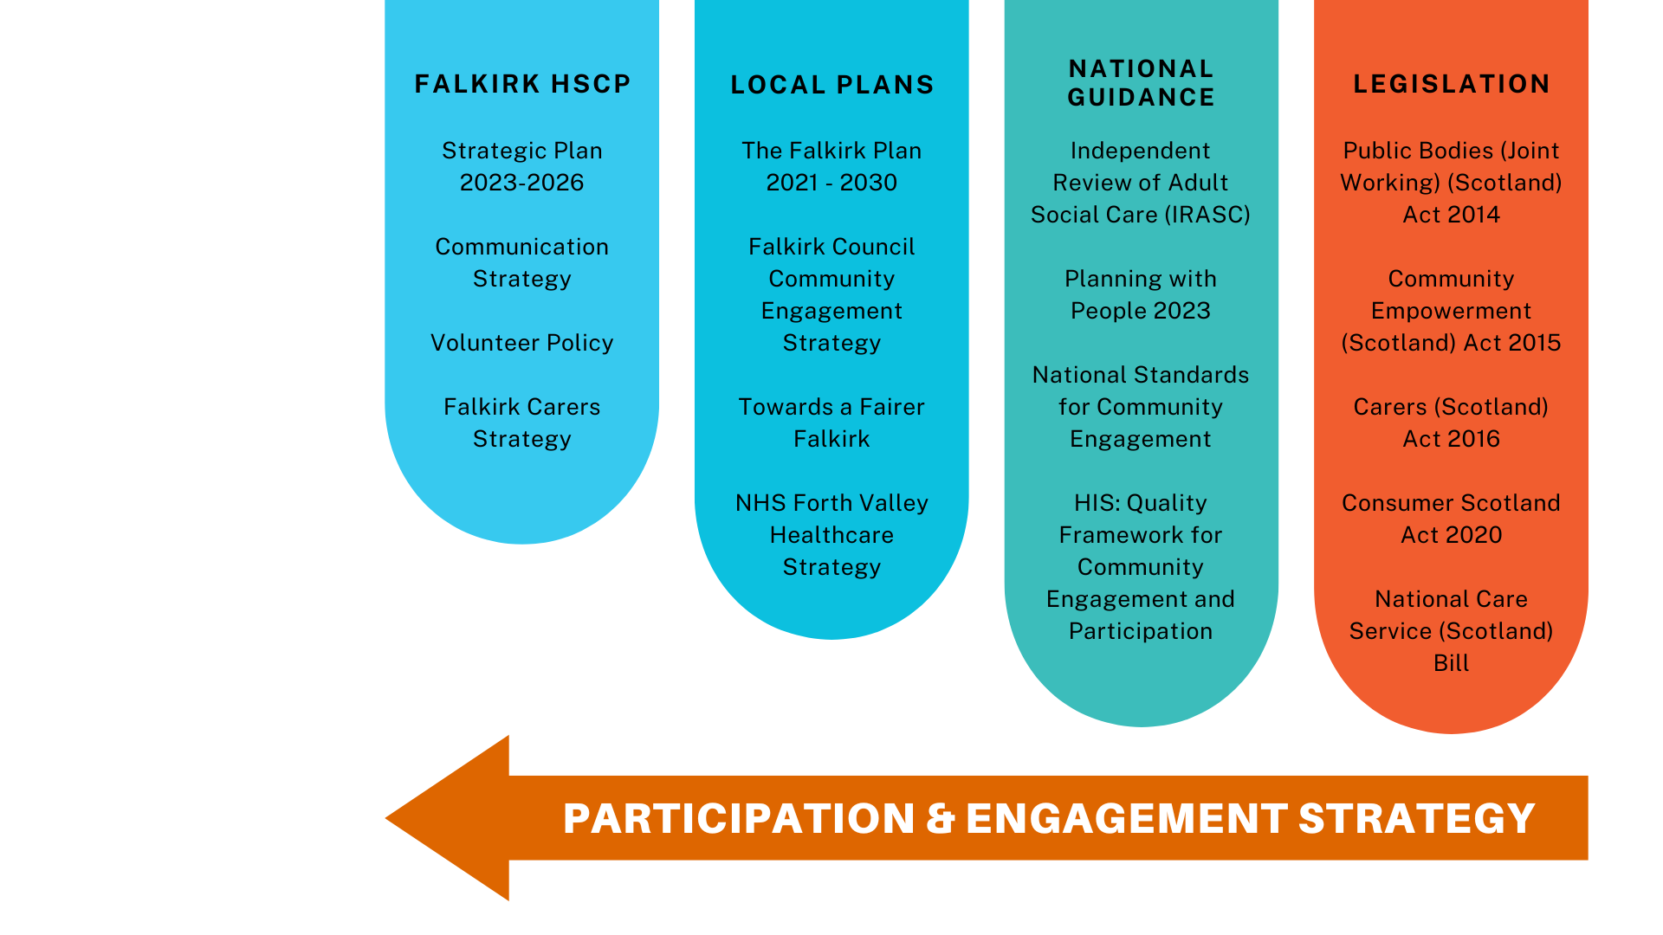

Figure 1. Legislative and Strategic Context

# How We Engage With People

The Falkirk HSCP actively engages with our service users, carers, and staff to review our services and develop key strategies that inform how we deliver our services.

Falkirk Collaborative

Working with Healthcare Improvement Scotland’s iHub and the New Models for Learning Disability Day Support Collaborative, the Falkirk Collaborative reviewed its local services and support options to improve outcomes and opportunities for adults with learning disabilities. The Scottish Approach to Service Design was used throughout this process.

Collaboration and co-design remained at the heart and soul of this work as the Falkirk Collaborative remained committed to listening to the service user and carer voice and worked alongside service users and carers to build on existing assets and create new opportunities.

Using a mix of easy read surveys and talking mats, the Collaborative gathered views from service users, carers, and staff working with people who access day opportunities. Feedback events held in person at Camelon Social Work Office and virtually via MS Teams shared what we’ve learned so far and explained the next steps and opportunities for 2023 Falkirk school leavers with a diagnosed learning disability who were transitioning from Children’s Services to Adult Social Work Services to take part in Big Planning sessions.

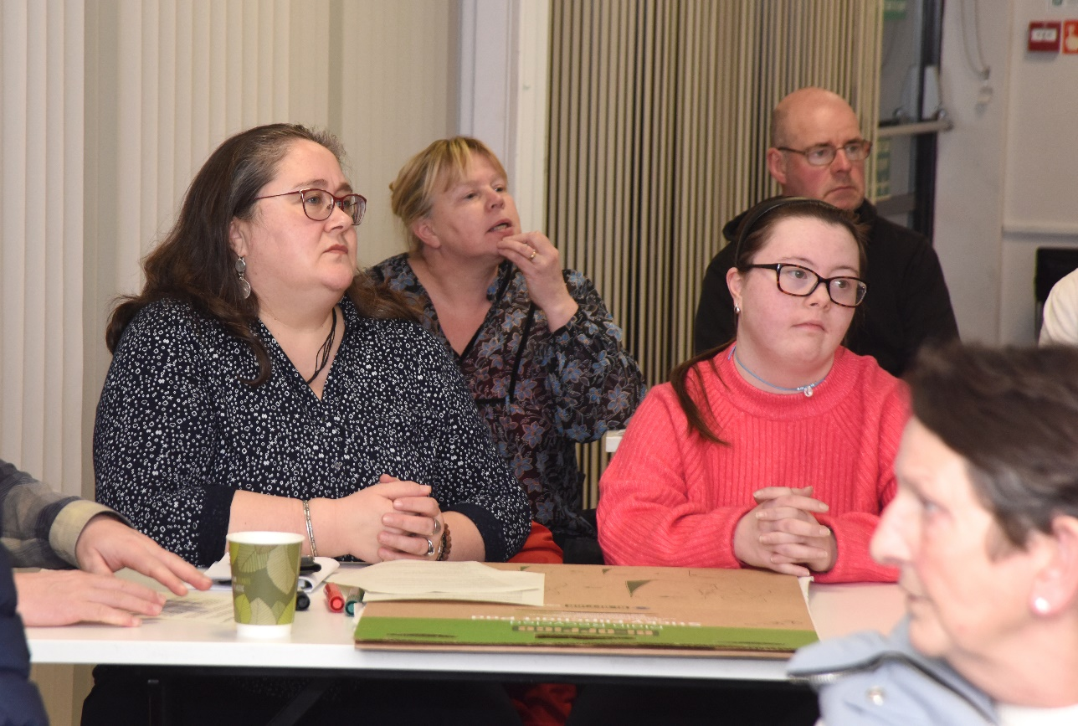

The Big Plan is a collaborative person-centred planning process that offers a unique opportunity for adults with a learning disability in transition from child services to adult services. The team hosted eight Big Planning sessions with an average of twenty-five people in attendance.

Joint Dementia Initiative (JDI) Service

The Joint Dementia Initiative service, which aims to help people with dementia to continue to live independently and within their own communities for as long as possible, continuously hosts engagement activities to improve the service. Throughout 2021, they engaged with staff as well as service users and carers to review the service, identify what was important to people, and establish partnership working to work towards creating a dementia-friendly Falkirk.

In 2023, JDI continued to host engagement events for service users and their families and carers of the ‘Home from Home’ service to discuss future development plans for the service, including change of venues for the service and potential changes to service times to be more flexible to meet the needs of service users and their families and carers.

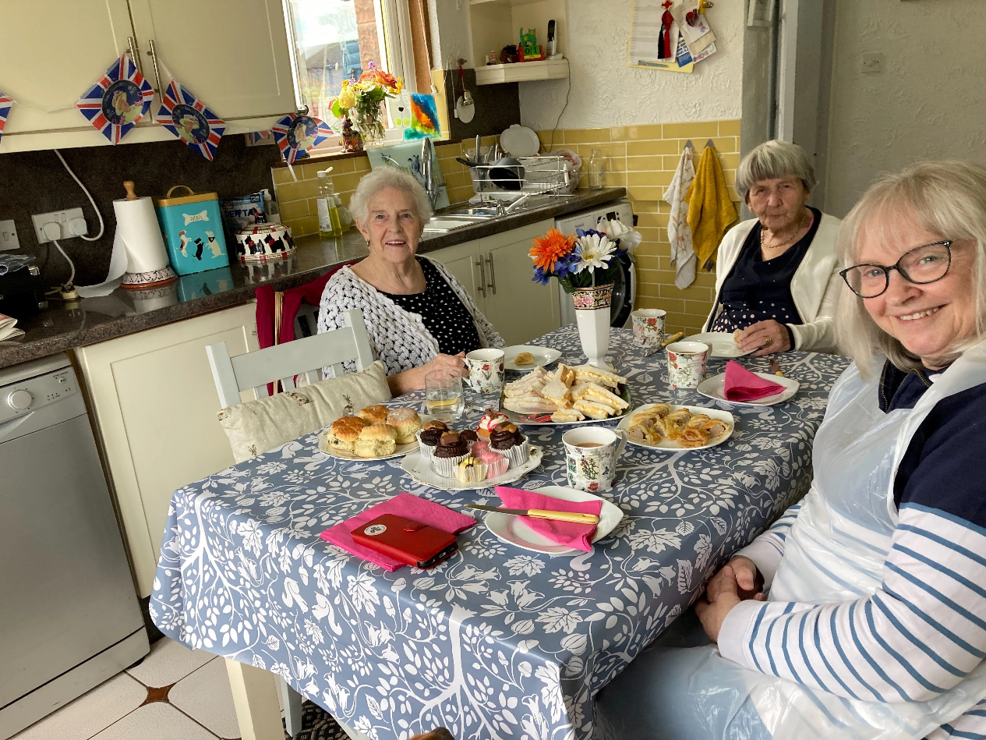

Technology Enabled Care (TEC)

Participation and engagement play a significant role in how the Partnership uses technology and digital solutions to transform the way we provide health and care services. Engaging in a meaningful way with stakeholders, such as service users, carers, communities, the workforce staff and other health and care professionals, the Partnership aims to ensure our digital health and care initiatives are in line with the needs and preferences of those we serve.

TEC presentations have been delivered at the Carers Centre to discuss the Partnership’s digital health and care solutions, including presentations on MECS, Living Well, Near Me, digital inclusion, and anticipated forthcoming projects. Carers views will contribute to the development of a Digital Health and Care Strategy.

Since the summer of 2022, a programme of weekly Tech Tea Parties, hosted by Falkirk HSCP and AbilityNet, in venues such as Dorrator Court, Summerford House, and Burnbrae. Residents were invited to bring along any technology they wanted to learn more about, and a tech-savvy volunteer supported them. These sessions have helped tackle digital exclusion and isolation.

Strategic Plan Consultation

To begin reviewing the Strategic Plan, the first series of consultation events were held in September and October 2022, so people could share their views on the main challenges and priorities within health and social care in Falkirk that should be outlined in the next Strategic Plan. The feedback from the first phase of consultation informed the draft Strategic Plan which went out for a second phase of consultation in January and February 2023.

Over 420 people were involved throughout the consultation period (approx. 326 people attended the in-person events and 99 people responded to the online consultations). Each consultation phase involved a Citizen Space survey, staff consultation events, and Strategic Planning Group workshops. Everyone’s contribution during each phase of consultation informed the Partnership’s new Strategic Plan which was published in April 2023.

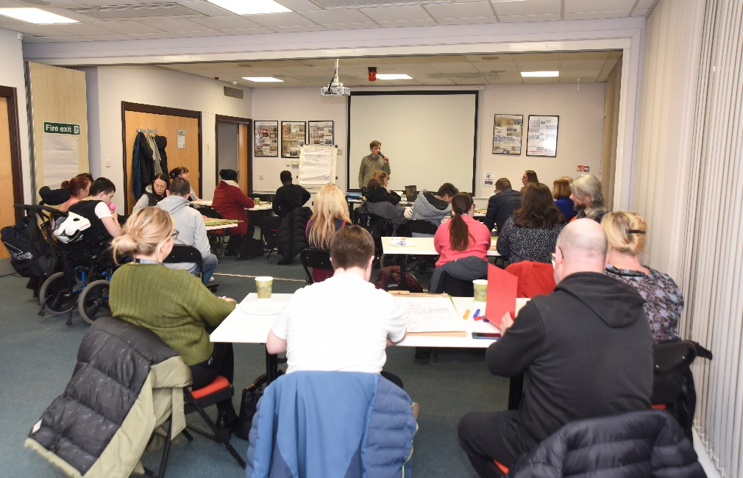

Carers Strategy Consultation

People in Falkirk who care for a family member, friend, or neighbour were asked for their views on the support they receive from health and social care services. Their feedback was used to shape the new Falkirk Carers Strategy 2023-2026. The HSCP was keen to hear from carers to help update the priorities within the strategy, acknowledging and addressing significant changes which have occurred since the previous 2019 strategy, such as the impact of the pandemic upon daily life and the current cost of living challenges facing local carers.

There were two consultations available for carers to complete: Young Carer and Young Adult Carers consultation and a wider Carers Strategy consultation. These consultations focused on what was important to each group of carers. We also gathered feedback from unpaid carers to the Carers Centre which highlighted two new areas of concern for carers: financial pressures, including financial impact of caring and the developing or changing relationship between an unpaid carer and the cared for person.

Equality Outcomes Consultation

Falkirk’s Integration Joint Board has a duty to publish a set of Equality Outcomes every four years, and report on its progress every two years. The Equality Outcomes consultation was the first HSCP engagement activity that used Falkirk Council’s new engagement platform Participate+ to invite people to complete a survey. In total, 76 responses were received for the online survey.

The focus of the engagement was on both older people and Black and Minority Ethnic (BME) communities with the support of local community groups and organisations. We held initial conversations with community groups to assess the best form of engagement with service users to ensure we received their feedback. We held engagement events with community groups throughout Falkirk to ensure we received feedback from those in the most and least deprived areas. This included coffee mornings and lunch clubs.

A significant amount of work was undertaken to improve the representation of BME communities participating in public consultations. This was particularly important as one of the proposed Equality Outcomes focuses on issues experienced by BME communities. In total, 35.5% of survey responses were received by people who identify as part of the BME community.

Throughout the engagement process, we have understood the importance of reaching people in community settings as opposed to organising centralised events where stakeholders approach us. This allowed us to build relationships with third sector partners and community groups and have open discussions.

By approaching people in community settings, we have been able to engage with a more diverse range of service users. In addition, we have sought to improve the accessibility of the consultation by translating the survey into five different languages.

Carer and Service User Involvement

Falkirk HSCP was one of five partnerships who participated in a pilot training programme with the Coalition of Carers in Scotland and Carers Scotland in March 2021. Following the successful training sessions to increase carer involvement, we collaborated with key organisations to develop a similar package of training for both carers and service users to enable them to participate meaningfully with the Partnership.

The training programme was held over three sessions in April and May 2022 and was designed and delivered in collaboration with the following key organisations: Coalition of Carers in Scotland (COCIS), Carers Scotland, Falkirk & Clackmannanshire Carers Centre, Inclusion Scotland, and Independent Living Association Forth Valley.

Following on from the training, we successfully recruited a new IJB Deputy Service User Representative. Having an additional representative allows the IJB Service User Representative to share the workload and time commitments required to prepare for and attend meetings. This reduces the demand on the same individual representatives to participate in activities and minimises the risk of engagement fatigue by ensuring people remain actively engaged in the Partnership. The Service User Representative has recently been asked to join the Strategic Planning Group.

Staff Facilitation Training

In collaboration with the Community Empowerment Team in Falkirk Council, we developed a pilot training package for staff to support and allow meaningful participation for people with lived experience in strategic and operational-level meetings.

The pilot training session was delivered on Monday 3 October 2022 to twelve staff members. The training was well-received with staff enjoying the session and finding it useful. Since it was a pilot training session, feedback from participations will inform how we review and deliver future sessions with wider HSCP staff.

# Who We Engage With

It is important for the Partnership to better understand who is participating in our engagement activities so we can identify under-represented groups and improve how we target participation from those groups.

The following data represents equalities information gathered from 332 participants across eight consultations during the period 2021-2023. Please note that this data is incomplete and does not represent every participant who has been involved in a consultation or engagement event since 2021. There are also inconsistencies in questions and response options asked since we currently do not have a consistent way to collect data. Another challenge is that most of this data has been compared to the 2011 local census data, where available, to identify gaps in representation.

Age

68% of participants are adults aged 16-64 and 24% are older adults aged 65+. This compares to 63% of adults aged 16-64 and 19% of older adults locally. 8% of our participants are under 16 and this would comprise of young carers who took part in our Carers Strategy consultation in 2022.

Gender

72% of participants are female and 26% are male. Locally, 51% of the Falkirk population is female and 49% are male. This suggests that there is an over-representation of women and an under-representation of men participating in our engagement events.

Sexual Orientation

90% of participants identify as Heterosexual/Straight which compares to 95% of the Scottish population. Please note that the 2011 census didn’t include a question regarding sexual orientation, but this was included in the 2022 census.

Ethnicity

89% of participants are white (including white British, white Scottish, or white Irish) and 4% are Asian or Asian British. This compares to 98% of the Falkirk population being white and 1.3% are Asian or Asian British. 0.6% of the local population is Other Ethnic Group which compares to 7% of our participants which includes Black, African, Caribbean, Black British, Mixed or Multiple Ethnic Groups and Other Ethnic Group.

Religion or Belief

52% of participants have no religion or belief, 34% are Christian, 8% are Muslim, and 1.9% are Roman Catholic. In Falkirk, 39% have no religion or belief, 36.5% are Christian, 0.9% are Muslim, and 12.3% are Roman Catholic.

Marital Status

62% of participants are married, 23% are single, 7% are divorced, and 3% are widowed. 49% of the Falkirk population are married, 31% are single, 9% are divorced, and 8% are widowed.

Employment Status

52% of participants are employed/self-employed, 17% are unemployed, and 31% are retired. Locally, 65% are employed/self-employed, 5% are unemployed, and 16% are retired. This suggests that people who are unemployed and retired have greater flexibility and more likely to engage and attend events during working hours than people who are employed/self-employed.

Caring Responsibilities

59% of participants have a caring responsibility and due to the Carers Strategy Consultation, we’ve been able to identify parent carers (17%) and young or young adult carers (14%). 41% of participants do not have a caring responsibility. In Falkirk, 9.6% of the population have a caring responsibility.

Disability or Long-Term Health Condition

49% of participants consider themselves to have a disability or long-term health condition and 51% do not. This compares to 30% of the local population that consider themselves to have a disability or long-term health condition and 70% do not.

Reduction in day-to-day activities

Of the participants that consider themselves to have a disability or long-term health condition, 81% experience a reduction in their day-to-day activities either a little or a lot. This compares to 20% of the Falkirk population.

The next steps, as outlined in the action plan, are to improve how we gather this data and embed data collection into engagement practices. This will involve developing a consistent set of equality questions and guidance for staff as well as multiple formats to collect this information. We will also explore options to store this data centrally along with local census data and data gathered from our service users and carers.

The aim is that this data will allow us to target the right people when planning engagement activities and ensure that they are representative of the local population and the people who access or are being supported by HSCP services.

# Principles of Engagement

The [National Standards for Community Engagement](https://www.scdc.org.uk/what/national-standards/) sets out seven principles of engagement: Inclusion, Support, Planning, Working Together, Methods, Communication, and Impact. These principles should serve as a baseline for measuring the quality and impact of our engagement activity.

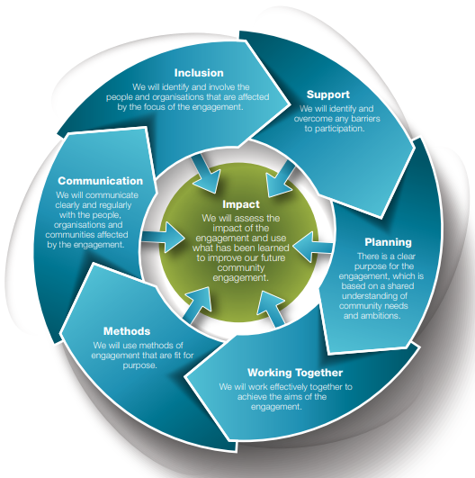

Figure 2. National Standards for Community Engagement (2016)

## Inclusion

The INCLUSION standard means we will identify and involve the people and organisations that are affected by the focus of the engagement.

The Partnership recognises that engagement with people is a critical aspect to service planning, service delivery and improvement. We aim to maintain effective and meaningful engagement with individuals, communities, staff, and partner and external agencies.

Communities can be typically defined as:

* Community of place – a group of people brought together by geographic boundaries, e.g., residents of Camelon.
* Community of identity – a group of people brought together by how they or society identifies them, e.g., people living with dementia.
* Community of interest – a group of people brought together who share the same interest or passion, e.g., a breastfeeding support group for new mothers.

People will often belong to or identify with more than one of these communities, and they can participate at different levels and stages of the decision-making process. People choose to participate for many reasons. They may have lived experience, and this has motivated them to participate, or they may have a general interest in the services delivered in their local area.

It is important to identify and involve people who might be particularly interested in a service change and encourage them to participate. It may be useful to involve community representatives in engagement planning so we can respond to the diverse needs of individuals and communities.

Ideally, engagement should take place where people are rather than expecting people to come to us. By going out into communities to engage with people, we can build trust, provide opportunities for collaboration, and highlight what is working well in our engagement practices.

How we will meet the INCLUSION standard:

* We will improve our understanding of who we are engaging with and proactively seek participation from under-represented groups to ensure participation represents our local population and the people who access or are supported by HSCP services.
* We will work with partners to regularly engage with local communities to ensure people are meaningfully engaged in decisions made on services which will affect them.
* We will ensure our engagement processes are accessible, inclusive and reflect the diversity of communities, and is informed by Equality and Poverty Impact Assessments (EPIA).
* We will undertake training and awareness raising with staff to support them to engage with people and communities.

We will know we have met the INCLUSION standard when:

* The people and groups who are affected by the focus of the engagement are involved at the earliest opportunity.
* Measures are taken to involve groups with protected characteristics and people who are excluded from participating due to disadvantage relating to social or economic factors.
* Participants in the community engagement process commit to continued two-way communication with the people they work with or represent.
* A wide range of opinions, including minority and opposing views, are valued in the engagement process.

|  |
| --- |
| Community Engagement Toolkit ([HSCP Colleague Hub](https://falkirkhscp.org/colleague-hub/)):  Inclusive Engagement Resource  Community Engagement Toolkit (External Resources):  [HIS – Inclusive engagement at a distance](https://www.hisengage.scot/equipping-professionals/engaging-differently/inclusive-engagement-at-a-distance/)  [Citizen Lab – Inclusive Community Engagement](https://www.citizenlab.co/blog/civic-engagement/6-good-practice-examples-for-inclusive-community-engagement-enuk/)  [DEEP – Involving People with Dementia](https://www.dementiavoices.org.uk/deep-resources/involving-people-with-dementia/) |

## Support

The SUPPORT standard means we will identify and overcome any potential barriers to participation.

There will be barriers to participation, and this can include (but is not limited to) participation anxiety, digital exclusion, travel expenses, the need for respite care, time of day, accessibility requirements, etc. It is our responsibility to consider and address these barriers when planning any engagement activity, and to hold ourselves accountable if we fail to engage with groups by not addressing barriers to their participation.

How we will meet the SUPPORT standard:

* We will meaningfully involve the people and groups who are affected by the focus of our engagement and provide support for people to get involved.
* We will support carers to be involved in the way HSCP services are provided for their cared for person(s) and the support they need in their caring role. We will evaluate their involvement and can show that their suggestions, feedback, and concerns have been considered and is having an impact in decision-making.

We will know we have met the SUPPORT standard when:

* An assessment of support needs is carried out, involving all participants.
* Action is taken to remove or reduce any practical barriers which make it difficult for people to take part in engagement activities.
* Access to impartial and independent development support is provided for groups involved in the community engagement process.

|  |
| --- |
| Community Engagement Toolkit (External Resources):  [HIS – Potential Barriers to Engagement](https://www.hisengage.scot/service-change/resources/potential-barriers-to-engagement/) |

## Planning

The PLANNING standard means there is a clear purpose for the engagement, which is based on a shared understanding of community needs and ambitions.

When planning engagement, consider the purpose of involving people and the goal of their participation. There are different levels of community engagement, with each level outlining a specific engagement goal. This is called the Public Participation Spectrum, which was developed by the International Association for Public Participation (IAP2).

It was developed to help clarify the role of the community in planning and decision-making, and how much influence the community has over planning and decision-making processes.

It identifies five levels of community engagement. The further to the right on the Spectrum, the more influence the community has over decisions, and each level can be appropriate depending on the context. It is important to recognise these are levels, not steps. For each level, it articulates the public participation goal and the promise to the public.

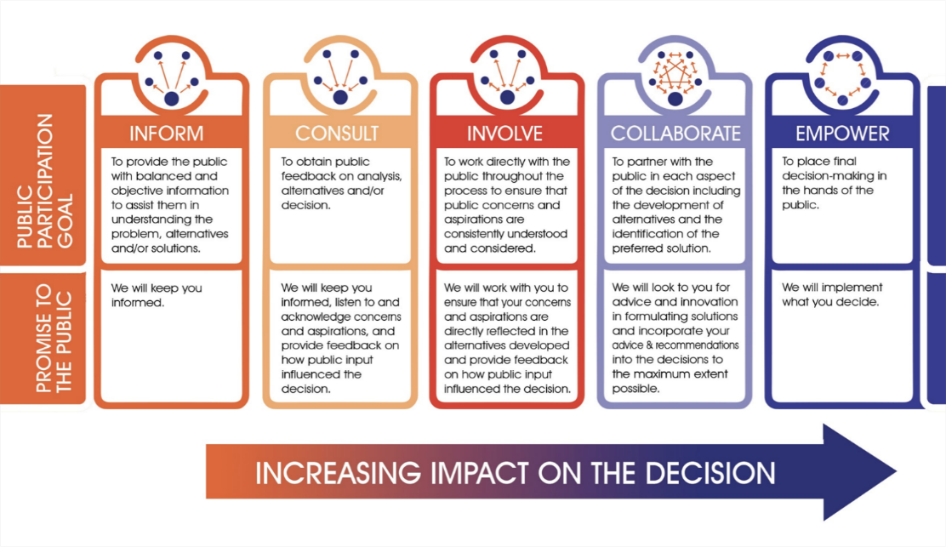

Figure 3. The Spectrum of Public Participation

When planning engagement, consider sufficient timescales to allow for high-quality engagement activities. Engagement is not a tick-box exercise and should not be rushed. It is best practice to allow at least six weeks for individuals and community organisations to respond to a formal consultation.

We also need to provide notice to community organisations and individuals to attend an engagement event. Notice periods of at least six weeks for community organisations and at least three weeks for individuals to attend an engagement event is required.

When we are considering the potential impact on people and communities of any major service changes to delegated health services, then we must involve Healthcare Improvement Scotland (HIS) as outlined in the [Planning with People](https://www.gov.scot/publications/planning-people-community-engagement-participation-guidance-updated-2024/pages/2/) guidance prior to carrying out community engagement activities. Proposals for major service changes to delegated health services must allow for three months of public consultation. Healthcare Improvement Scotland (HIS) have developed [flowcharts](https://www.hisengage.scot/service-change/resources/overview-of-engagement-process/) which outline the engagement processes for service change.

How we will meet the PLANNING standard:

* We will ensure that staff feel they have the knowledge, skills, and know where to seek advice, to plan and deliver meaningful engagement on behalf of the HSCP.

We will know we have met the PLANNING standard when:

* Partners are involved at the start of the process in identifying and defining the focus that the engagement will explore.
* A clear and agreed engagement plan is in place.
* All available information which can affect the engagement process has been shared and used to develop the community engagement plan.
* Partners agree what the outcomes of the engagement process should be, what indicators will be used to measure success, and what evidence will be gathered.

|  |
| --- |
| Community Engagement Toolkit ([HSCP Colleague Hub](https://falkirkhscp.org/colleague-hub/)):  Engagement Planning Tool  Engagement Session Planning Tool  Stakeholder Mapping Tool  Information Sheet template  Consent Form template  Community Engagement Toolkit (External Resources):  [Participate+](https://participateplus.falkirk.gov.uk/en-GB/)  [Community Empowerment Hub](https://intranet.falkirk.gov.uk/services/transformation-communities-corporate-services/communities/community-empowerment-hub/)  [HIS – How to Engage](https://www.hisengage.scot/equipping-professionals/how-to-engage/)  [HIS – Identifying and Understanding Stakeholders](https://www.hisengage.scot/service-change/resources/identifying-and-understanding-stakeholders/)  [HIS – Understanding the impact of changes](https://www.hisengage.scot/service-change/resources/understanding-the-impact-of-changes/)  [Involve – Context Checklist](https://www.involve.org.uk/resource/context-checklist) |

## Working Together

The WORKING TOGETHER standard means we will work effectively together to achieve the aims of the engagement.

The [Scottish Approach to Service Design (SAtSD)](https://www.gov.scot/publications/the-scottish-approach-to-service-design/) is a framework for designing user-centred services and to support people to actively participate in the design and delivery of public services. It is about helping people and the system learn to work together to understand the needs of the people who use and deliver services and to find solutions within the context of what is and is not possible.

The HSCP Integration Joint Board (IJB) is made up of representatives from Falkirk Council, NHS Forth Valley, Third Sector representatives, as well as Service User and Unpaid Carer representatives. The Partnership values the contributions of our IJB Service User and Carer representatives and supports them to get involved in key governance and decision-making structures and processes.

Involving people in service design and decision-making processes ensures that the needs of people with lived experience are accurately reflected in how we improve and deliver services. It is important that we increase our representation of people with lived experience and encourage them to get involved in a range of strategic and operational level meetings.

How we will meet the WORKING TOGETHER standard:

* We will make our decision-making processes transparent and clearly demonstrate how the views of communities have been considered and the reasons for decisions are explained.
* We will take a co-design approach to developing services and strategies, by involving people and communities from the start of any process through to decision-making.
* We will include representation of people with lived experience in strategic and operational groups and produce work which addresses the needs and meets the aspirations of people who access or are supported by HSCP services more fully.
* We will ensure that Carer and Service User Representatives are treated as equal and expert partners and feel confident in undertaking the responsibilities of their role.

We will know we have met the WORKING TOGETHER standard when:

* The roles and responsibilities of everyone involved are clear and understood.
* Decision-making processes and procedures are agreed and followed.
* The methods of communication used during the engagement process meet the needs of all participants.
* Information that is important to the engagement process is accessible and shared in time for all participants to properly read and understand it.
* Communication between all participants is open, honest, and clear.
* The community engagement process is based on trust and mutual respect.
* Participants are supported to develop their skills and confidence during the engagement.

|  |
| --- |
| Community Engagement Toolkit ([HSCP Colleague Hub](https://falkirkhscp.org/colleague-hub/)):  Facilitation and Session Planning Toolkit  Community Engagement Toolkit (External Resources):  [Scottish Approach to Service Design](https://www.gov.scot/publications/the-scottish-approach-to-service-design/)  [HIS – Tips for online meetings](https://www.hisengage.scot/equipping-professionals/engaging-differently/tips-for-online-meetings/)  [HIS – Ethical engagement cards](https://www.hisengage.scot/equipping-professionals/designing-person-centred-services/tool-directory/ethical-engagement-cards/)  [Involve – Facilitation Skills](https://www.involve.org.uk/resource/facilitation-skills)  [Involve – Facilitating Tricky Situations](https://www.involve.org.uk/resource/facilitating-tricky-situations) |

## Methods

The METHODS standard means we will use methods of engagement that are fit for purpose.

There are a variety of methods that can be used in our engagement activities, e.g., telephone calls, events (virtual or in person), email, social media, surveys, focus groups, interviews, etc. The engagement methods used will be relevant to the objective of the engagement activity and dependent on where the engagement sits on the Public Participation Spectrum. For example, focus groups would be inappropriate if the goal is to inform, but would be an effective method for involvement or collaboration.

There is no mainstream solution to community engagement as not all methods of engagement are going to be suitable for everyone. As such, engagement methods must be appropriate and tailored to meet the individual needs of each targeted group to minimise barriers to participation. They should be continually reviewed throughout the engagement process and changed or adapted based on feedback and evolving public participation goals.

How we will meet the METHODS standard:

* We will use a range of effective engagement methods to involve people in our engagement activities.

We will know we have met the METHODS standard when:

* The methods used are appropriate for the purpose of the engagement.
* The methods used are acceptable and accessible to participants.
* A variety of methods are used throughout the engagement to make sure that a wide range of voices is heard.
* Full use is made of creative methods which encourage maximum participation and effective dialogue.
* The methods used are evaluated and adapted, if necessary, in response to feedback from participants and partners.

|  |
| --- |
| Community Engagement Toolkit (External Resources):  [Care Opinion](https://www.careopinion.org.uk/services/s37000013)  [Outside the Box – Accessible Online Events](https://otbds.org/online-event-tips/)  [HIS – Participation Toolkit](https://www.hisengage.scot/equipping-professionals/participation-toolkit/)  [HIS – Dementia in Hospitals Improvement Toolkit](https://ihub.scot/project-toolkits/specialist-dementia-units-toolkit/dementia-in-hospitals-improvement-toolkit/using-people-s-experience-to-develop-improvement-priorities)  [Institute for Healthcare Improvement – Model for Improvement](https://www.ihi.org/resources/how-to-improve)  [Involve – Where do I start with digital engagement?](https://www.involve.org.uk/resource/where-do-i-start-digital-engagement)  [Involve - Resources](https://www.involve.org.uk/resources?category%5B55%5D=55) |

## Communication

The COMMUNICATION standard means we will communicate clearly and regularly with the people, organisations and communities affected by the engagement.

Our accompanying Communication Strategy 2024 – 2027 sets out the principles for inclusive communication, defining the characteristics of accessible, simple, and understandable communication.

How we will meet the COMMUNICATION standard:

* We will make communities aware of the opportunities they have to get involved.
* We will provide people timely and accessible information in a variety of formats that meets their needs (e.g., easy read documents, talking mats, large print, audio, Braille, different languages, induction loops, etc.)
* We will keep people and communities informed of progress during the engagement process and provide feedback on the outcome of the engagement.

We will know we have met the COMMUNICATION standard when:

* Information on the community engagement process, and what has happened as a result, is clear and easy to access and understand.
* Information is made available in appropriate formats.
* Without breaking confidentiality, participants have access to all information that is relevant to the engagement.
* Systems are in place to make sure the views of the wider community continuously help to shape the engagement process.
* Feedback is a true representation of the range of views expressed during the engagement process.
* Feedback includes information on the engagement process, the options which have been considered, and the decisions and actions that have been agreed, and the reasons why.

|  |
| --- |
| Community Engagement Toolkit ([HSCP Colleague Hub](https://falkirkhscp.org/colleague-hub/)):  Engagement Feedback Report template |

## Impact

The IMPACT standard means we will assess the impact of the engagement and use what we have learned to improve our future community engagement.

It is important that we provide feedback on all engagement activities to develop trust within communities. We need to inform participants how valuable their participation has been and demonstrate the impact of their participation by evidencing the action, where appropriate, that has been taken towards achieving local outcomes.

We must provide participants with regular updates and feedback on our progress towards achieving local outcomes. Engagement planning should identify how feedback will be provided and participants should be informed of when they can expect to receive this feedback.

To understand how well we are currently engaging, we need to integrate evaluation into the planning of all engagement activities. A benefit of monitoring our engagement activity is learning and sharing the lessons learned within our networks for the benefit of future engagement activity.

How we will meet the IMPACT standard:

* We will evaluate how effective ongoing engagement is to help to improve people’s experience of engagement and share this learning across the HSCP to inform future practice.
* We will actively seek out good practice and learning on community engagement from both within and outside the HSCP and share it with others.

We will know we have met the IMPACT standard when:

* The outcomes the engagement process intended to achieve are met.
* Decisions which are taken reflect the views of participants in the community engagement process.
* Local outcomes, or services, are improved because of the engagement process.
* Participants have improved skills, confidence, and ability to take part in community engagement in the future.
* Partners are involved in monitoring and reviewing the quality of the engagement process and what has happened as a result.
* Feedback is provided to the wider community on how the engagement process has influenced decisions and what has changed as a result.
* Learning and evaluation help to shape future community engagement processes.

|  |
| --- |
| Community Engagement Toolkit ([HSCP Colleague Hub](https://falkirkhscp.org/colleague-hub/)):  Engagement Evaluation Tool  Engagement Feedback Report template  Feedback Form  Community Engagement Toolkit (External Resources):  [HIS – Case Studies](https://www.hisengage.scot/sharing-practice/case-studies/)  [Involve – How to Feedback the Results](https://www.involve.org.uk/resource/how-feed-back-results) |

# Appendix I. Community Engagement Toolkit

[Internal - HSCP Colleague Hub](https://falkirkhscp.org/colleague-hub/)

* Engagement Planning tool
* Engagement Session Planning tool
* Engagement Self-Evaluation tool
* Stakeholders Mapping tool
* Facilitation and Session Planning toolkit
* Inclusive Engagement Resource
* Information Sheet template
* Consent Form template
* Engagement Feedback Report template
* Feedback Form

Internal - Falkirk Council

* [Community Empowerment Hub](https://intranet.falkirk.gov.uk/services/transformation-communities-corporate-services/communities/community-empowerment-hub/)
* [Participate+](https://participateplus.falkirk.gov.uk/en-GB/)

External - Healthcare Improvement Scotland

* [HIS – Ethical engagement cards](https://www.hisengage.scot/equipping-professionals/designing-person-centred-services/tool-directory/ethical-engagement-cards/)
* [Inclusive engagement at a distance](https://www.hisengage.scot/equipping-professionals/engaging-differently/inclusive-engagement-at-a-distance/)
* [Potential Barriers to Engagement](https://www.hisengage.scot/service-change/resources/potential-barriers-to-engagement/)
* [How to Engage](https://www.hisengage.scot/equipping-professionals/how-to-engage/)
* [Identifying and Understanding Stakeholders](https://www.hisengage.scot/service-change/resources/identifying-and-understanding-stakeholders/)
* [Understanding the impact of changes](https://www.hisengage.scot/service-change/resources/understanding-the-impact-of-changes/)
* [Tips for online meetings](https://www.hisengage.scot/equipping-professionals/engaging-differently/tips-for-online-meetings/)
* [Participation Toolkit](https://www.hisengage.scot/equipping-professionals/participation-toolkit/)
* [Dementia in Hospitals Improvement Toolkit](https://ihub.scot/project-toolkits/specialist-dementia-units-toolkit/dementia-in-hospitals-improvement-toolkit/using-people-s-experience-to-develop-improvement-priorities)
* [Case Studies](https://www.hisengage.scot/sharing-practice/case-studies/)

External - Involve

* [Context Checklist](https://www.involve.org.uk/resource/context-checklist)
* [Facilitation Skills](https://www.involve.org.uk/resource/facilitation-skills)
* [Facilitating Tricky Situations](https://www.involve.org.uk/resource/facilitating-tricky-situations)
* [Where do I start with digital engagement?](https://www.involve.org.uk/resource/where-do-i-start-digital-engagement)
* [Resources](https://www.involve.org.uk/resources?category%5B55%5D=55)
* [How to Feedback the Results](https://www.involve.org.uk/resource/how-feed-back-results)

External - Other

* [Citizen Lab – Inclusive Community Engagement](https://www.citizenlab.co/blog/civic-engagement/6-good-practice-examples-for-inclusive-community-engagement-enuk/)
* [Outside the Box – Accessible Online Events](https://otbds.org/online-event-tips/)
* [Institute for Healthcare Improvement – Model for Improvement](https://www.ihi.org/resources/how-to-improve)
* [DEEP – Involving People with Dementia](https://www.dementiavoices.org.uk/deep-resources/involving-people-with-dementia/)
* [Scottish Approach to Service Design](https://www.gov.scot/publications/the-scottish-approach-to-service-design/)
* [Care Opinion](https://www.careopinion.org.uk/services/s37000013)

# Appendix II. Participation Rights

Community Empowerment (Scotland) Act 2015

This Act places a duty on public authorities including the Council, NHS Health Board and HSCP to improve the quality of lives of people living in disadvantaged areas. Communities can make participation requests to public authorities to change the way a service is delivered. The public authority must agree unless there are reasonable grounds not to do so. Under the Act, community bodies can make asset transfer requests to lease or take ownership of a publicly owned building or piece of land. The Act gives local communities the right to buy abandoned or neglected land.

Communities must be engaged by the Community Planning Partnership (CPP) when Local Outcome Improvement Plans (i.e., strategic plans) and Locality Plans (i.e., Community Action Plans) are being developed. The CPP must also publish annually how it has engaged with communities and responded to participation requests and asset transfer requests. The Act states that communities should be given a direct say in allocation of public resources, e.g., participatory budgeting.

Equality Act 2010

This Act aims to prevent discrimination of nine “protected characteristics”. These are: age, disability, gender, gender reassignment, sexual orientation, marriage and civil partnership, pregnancy and maternity, race, and religion or belief.

Human Rights Act 1998

This Act gives people rights: to life, liberty, and security, to a fair trial, to marry and start a family, to education, and to participation in free elections. It also gives people freedoms: from torture and inhuman or degrading treatment, slavery and forced labour, of thought, belief and religion, or assembly and association. Public authorities must comply with the European Convention on Human Rights.

NHS Reform (Scotland) Act 2004

This Act places duties of public involvement and equal opportunities on NHS Health Boards. This led to the establishment of the Scottish Health Council (SHS) in 2005 to ensure that the NHS allows patients to participate as fully as possible.

Patient Rights (Scotland) Act 2011

The Act sets out health care principles and a Charter of Patients’ Rights. This includes allowing patients to participate as fully as possible in decisions relating to their health and wellbeing and have full access to the necessary information to do so. The Act provides a right to give feedback (both positive and negative), leave comments, or raise concerns or complaints about the health care they have received. The Act requires that Health Boards encourage, monitor, and learn from the feedback and comments they receive. Good Practice Guidance has been issued to NHS Boards setting out what is required and giving advice on how to handle and learn from feedback and complaints.

The Children and Young People (Scotland) Act 2014

This Act places a duty on Councils to undertake a survey or consultation with service users and parents to gauge views on the existing service provision and to offer the chance to provide comments or suggestions as to how the service could be improved.