Falkirk Evaluation Framework for Community-Led Interventions

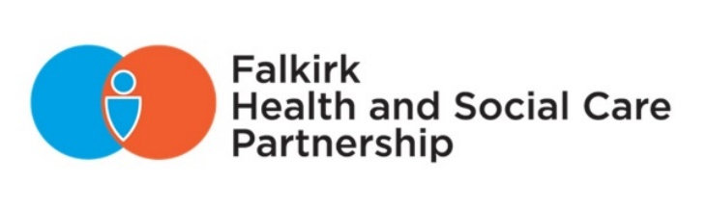

# contents

Introduction 2

Logic Model for Community-Led Initiatives in Falkirk 3

What is Evaluation? 5

Example Methods for Measuring Outcomes 6

Top Tips 7

Reporting Template for Partnership Funded Community-Led Projects 8

Annex: Example Indicators for Community-Led Outcomes. 11

Document information

|  |  |
| --- | --- |
| **Date of issue:** | **September 2024** |
| **Available from:** | **Partnership Website – Community Led Support page**  <falkirkhscp.org/community-led-support-and-funding> |
| **Key contact:** | [HSCPComms@falkirk.gov.uk](mailto:HSCPComms@falkirk.gov.uk) |

# Introduction

This framework is for people and organisations who are delivering **community-led interventions** funded by Falkirk Health and Social Care Partnership (HSCP).

The purpose of the framework is to help you:

* Identify meaningful **outcomes** for your work (the difference you want to make).
* Measure those outcomes using evaluation **methods** that are appropriate for community settings.
* **Report** on your impact and learning to **demonstrate** the value of community-led support and make it even **better**.

You should use this framework in a way that makes sense for you and the people you work with. The intention is to help you build evaluation into your day-to-day work and support reflective practice and improvement.

We have created a **logic model**. It sets out in broad terms:

* The **need** for community-led interventions.
* Common **activities** that are undertaken.
* **Outcomes**.
* The link to HSCP outcomes.

We do not expect you to be working to ALL the outcomes but there should be at least one that describes the difference you want to make with the people and communities you are working with.

The rest of the framework includes:

* A brief guide on how to evaluate.
* Example **methods** that are appropriate for evaluating different types of community-led interventions.
* Some tips.
* Example **reporting template**.

# Logic Model for Community-Led Initiatives in Falkirk

### Need or Situation

People access mainstream statutory services when a better option should be available. People can’t make connections with others who can enable them to take action. People and communities aren’t able to recognise and use their assets to improve individual and community wellbeing. Statutory services focus on a specific medical issue rather than the whole person and their situation. They don’t respond in the way people want.

### Activities

* Help people (in groups or individually) to share what matters to them.
* Create spaces for people to come together to make connections.
* Support people to connect to community resources or support services.
* Support people to make best use of skills and gifts to help each other and make positive change in their community.
* Create spaces for people to come together to develop new ideas.
* Support communities to identify gaps and enable them to develop solutions or projects using their own resources in the first instance and ask for help when they need it.
* Support groups to identify the resources they had and to gain the resources they need to deliver and act.
* Connect groups and organisations (third and statutory) to each other, enable them to collaborate and “stay in lane”.
* Support people to self-manage their health and wellbeing.
* Support people to access self-directed support.
* Share good practice.

### Outcomes

* People on the margins of communities are included.
* People have equal access regardless of their geography.
* People feel more confident to participate.
* People have better access to appropriate practical support or health support.
* People have more opportunities to participate in decisions that affect their health and wellbeing.
* People feel more connected and more involved in their community.
* People are better able to contribute their skills and ideas in their community.
* People feel more confident managing their own wellbeing.
* Statutory services recognise people as experts by experience.
* Statutory services are more responsive to act on needs identified by communities.
* Communities are able to develop more solutions and identify the outside help required to meet their needs.
* People experience more joined up and holistic support.
* People have more diverse choice of support to improve their health and wellbeing.

### HSCP Outcomes 2 and 4

* Individuals, their carers and families can plan and manage their own health, care, and wellbeing. Where supports are required, people have control and choice over what and how care is provided.
* Individuals and communities are resilient and empowered with a range of supports in place that are accessible and reduce health and social inequalities.

# What is Evaluation?

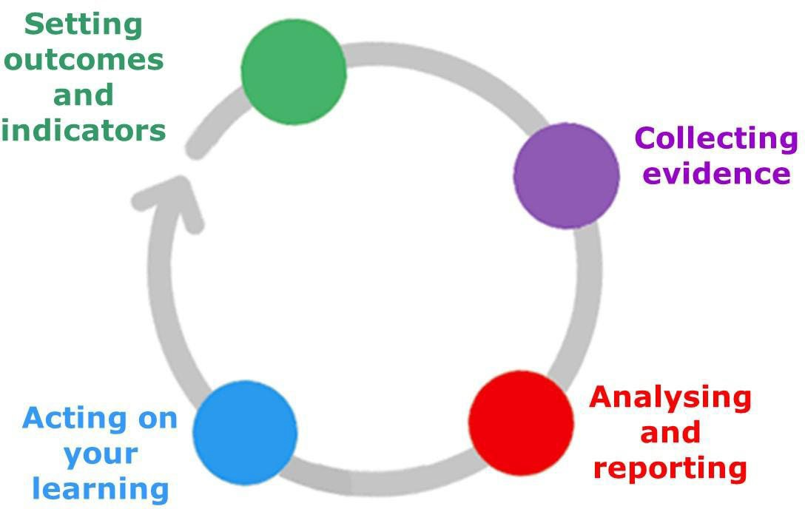Evaluation is a process of setting, measuring and reporting on the difference.

Image : Evaluation process

The process of evaluation includes:

* Setting outcomes and indicators.
* Collecting evidence.
* Analysing and reporting.
* Acting on your learning.

Evaluation should:

* Be about **outcomes** not just activities.
* Be **useful**.
* Help you **learn** what’s going well and **improve** if needed.
* **Fit** with how you do your work.
* Help the **people you work with** reflect on their achievements.

where to find evidence of your outcomes:

* Participant feedback.
* Third-party feedback.
* Internal records.
* Statistics.
* Awards and Standards.
* Observed Behaviour.

To evaluate you:

1. Agree on outcomes that are the difference that you want to make through your work.
2. Set indicators: indicators are specific things that show the outcome is happening.
3. Use appropriate methods to gather evidence of whether your activities are helping to achieve your planned outcomes and indicators – or not.

# Example Methods for Measuring Outcomes

### Distance travelled tools

* The key purpose is to show change over time in 1-1 work. A person-centred and visual approach enables the person you are working with to reflect on their own changes. It allows you to turn outcomes into numbers. For example, the number of people who have progressed.
* Outcome Star™, Clinical Outcomes, and Routine Evaluation (CORE) are examples but be aware what you need to pay for.

### Transformational Evaluation

* Whatever your colleague responds to the question, “What do you think has been the most significant change that has occurred for you?” Do not change their words. Instead, you can use this as a chance to reflect on what changes you saw, why you did work in that way, and share this with the person. This creates transparency. Once you’ve collected a significant number of stories from colleagues, you can look at the common themes to create organisational learning and identify common outcomes for improvement.

### Magic Moments

* If the person you work with, individually or in a group, identifies a positive change for them - it can be small but important to them. This is a magic moment that could be observed by the worker.

### Mind Maps

* A visual way of asking people to show connections between your work and other services, therefore, showing a “ripple effect”.

### Surveys

* This traditional evaluation tool is good for getting feedback from a lot of people and, if you do it electronically, you can easily analyse and report on the data. Make sure you ask questions that are relevant to your planned outcomes and indicators.

### Graphic Representation

* This is where an artist records visually a person or community’s story over time like a cartoon. It can tell a big story in a concise way and is both a collection tool and a report in one. To do it well, there is a cost, but it is not expensive.

### Photos

* Photos are a simple way of showing outcomes in action. For example, happiness or people working together. It is important to be clear about what the photo is showing and illustrating. Caution is needed regarding permission and any sensitivity or protection issues.

### Video

* Videos are a means of collecting evidence and can be a report. You can use a professional filmmaker, but it is possible for individuals to record their own video on a phone or laptop.

# Top Tips

1. Try to create a culture where the people you work with can tell their own story.
2. Honest and credible feedback can come in conversations so be ready to capture what people are telling you, as appropriate, in the moment.
3. If you are working with people and communities over time, try to capture evidence more than once to show change.
4. Collecting follow up data is ideal but not always appropriate. For example, if service users have gone through a traumatic experience and want to move on. Third-party feedback can be a way of getting around that.
5. Encourage honest feedback – ask appreciative questions like, “What could have made this even better?” to get around people’s reluctance to be negative. Another approach is to notice what they aren’t saying, the absence of data in relation to an outcome might tell you something.
6. Remember that if you tell your funder that everything was perfect and nothing went wrong, the funder won’t believe it and that might undermine the credibility of all your evaluation.

# Reporting template for partnership funded Community-Led Projects

|  |
| --- |
| Name of Funded Project: |
|  |

|  |
| --- |
| What did you do?  *Please summarise the main activities you delivered in this reporting period.* |
|  |

|  |
| --- |
| What difference did you make?  *Please pick a relevant outcome or outcomes from the framework outcomes that are detailed within your application form. Please summarise the evidence that shows that you are making progress towards that outcome or outcomes for the people you work with.* |
|  |

|  |
| --- |
| Snapshots  *Please provide up to 3 short snapshots that illustrate your work and the difference it makes.* |
|  |

|  |
| --- |
| Challenges and Changes  *Tell us of any problems you encountered that meant you had to adapt what you were doing or affected your ability to achieve your outcomes. For example, things that were changed or unexpected problems and what you did to address these.* |
|  |

|  |
| --- |
| Learning and development  *Tell us of any learning you have taken from the project. What worked well, are there any areas for improvements?* |
|  |

|  |
| --- |
| The numbers  *Please tell us about the number of people you worked with. Please do this in a way that makes sense to you and draws on your own monitoring systems. You don’t have to count every single person your project might have reached.* |
|  |

|  |  |
| --- | --- |
| Financial Reporting |  |
| Project Name: |  |
| Project Lead: |  |
| Approved Allocation 2020/2021: £ |  |
| Approved Carry forward 2019/2020: £0 |  |
| Total Funding Allocation: £ |  |
| Q1 Spend: |  |
| Q2 Spend: |  |
| Q3 Spend: |  |
| Q4 Spend: |  |
| Total Spend 2020/2021:  *Please explain any current or anticipated variations:* |  |

# Annex: Example indicators for community-led outcomes.

Indicators are what people say, do, or what you see that shows that **outcomes are happening.** It can be helpful to have an idea in advance what indicators you might look for. Or you might use indicators to shape questions you might ask the people you are working with to help them, and you reflect on change.

Some projects will already have indicators in place so this annex is simple some **example indicators** that you can pick from **if you want to,** to help you measure your outcomes.

|  |  |
| --- | --- |
| Outcomes | Example Indicators |
| * People on the margins of communities are included. * People have equal access regardless of their geography. | * Examples of specific resources that groups and communities have accessed. * Specific examples of people from marginalised groups being put in touch with the right support.   Statistics on numbers of people from different communities of place and interest being involved. |

|  |  |
| --- | --- |
| Outcomes | Example Indicators |
| * People feel more confident to participate. * People have more opportunities to participate in decisions that affect their health and wellbeing. * Statutory services recognise people as experts by experience. * Communities are able to develop more solutions and identify the outside help required to meet their needs. | * People voice their opinion. * People try new things. * There are new groups in place. * People say that barriers have reduced. * People say they are listened to. * People working in statutory services say that they are working with people. * The statistics on the number of people that are taking part. |

|  |  |
| --- | --- |
| Outcomes | Example Indicators |
| * People are more confident managing their own wellbeing | * People say they can cope. * People have self-management skills. * Examples of people NOT using statutory services (because they don’t need to). |
| Outcomes | Example Indicators |
| * People feel more connected and involved in their community. * People are better able to contribute their skills and ideas in their community. | People say:   * I feel I have something to offer. * I can use my skills. * I feel valued. * I feel part of my community. * I can lead a group. * I have confidence to use my skills. * I feel comfortable receiving help. * I know what I can do.   Workers see:   * People “discovering” their skills/ gifts and being confident to use them. * People leading or helping others. * People becoming volunteers. |

|  |  |
| --- | --- |
| Outcomes | Example Indicators |
| * Statutory services are more responsive to act on the needs identified by communities. * People have more diverse choice of support to improve their health and wellbeing. * People experience more joined-up and holistic support. | * People say there is something for me in my areas. * People say barriers have been reduced. * Examples of statutory services doing what people need and want. * Examples of people NOT using statutory services. |