Appendix 1

Falkirk Health & Social Care Partnership Locality Planning

Central Locality Plan 2025-2026

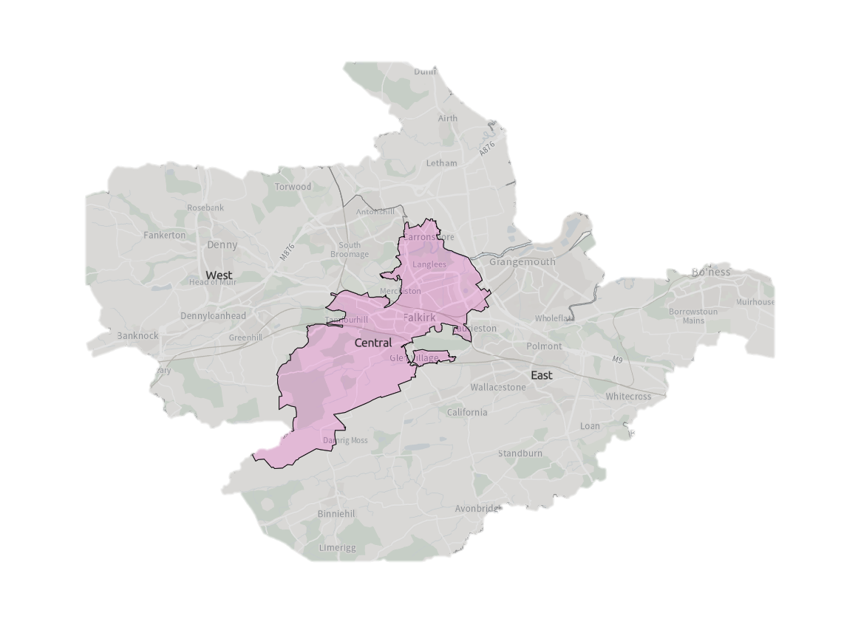



Contents

Introduction 1

Falkirk Health & Social Care Partnership 1

Locality Planning 1

Development of Falkirk Central Locality Plan 2

Strategic Context 4

About Falkirk Central Locality 5

Summary 5

Services In The Area 6

Third Sector & Communities 6

Local Support 6

Previous Consultation & Engagement Feedback 7

Challenges in Falkirk Central 8

Guiding Principles & Priorities 12

Consultation & Engagement 13

Finance & Resources 14

Measuring Progress 15

Next Steps 16

Appendix 1: Delivery Plan 17

Appendix 2: Services in the Area 22

Document information

|  |  |
| --- | --- |
| **Date of issue:** | **31/01/2025** |
| **Approval status:** | **Approved by IJB** |
| **Review date:** | **March 2026** |
| **Available from:** | **Partnership Website** |
| **Alternative formats:** |  |
| **Key contact:** | Policy & Research Officer |

# Introduction

## Falkirk Health & Social Care Partnership

Falkirk Health and Social Care Partnership (HSCP) is one of 31 integration bodies in Scotland, serving a population of over 160,000 across rural and urban communities. It aims to enable people in Falkirk to live full and positive lives within supportive and inclusive communities.

The Partnership’s workforce is employed by Falkirk Council, NHS Forth Valley, and its partners in the third and independent sectors. They work in local social work offices, health centres, GP Practices, community hospitals, care homes, intermediate care facilities, day centres, and communities across the Falkirk area.

Falkirk Health and Social Care Partnership delivers care and support for adults and older people with mental health problems, long term physical conditions, and substance misuse problems.

People who provide direct care for their loved ones, known as unpaid carers, are also supported by the Partnership through the [Falkirk and Clackmannanshire Carers Centre.](https://centralcarers.org/)

The Partnership is run by its [Integration Joint Board](https://falkirkhscp.org/falkirk-integration-board/)made up of representatives from Falkirk Council, NHS Forth Valley, the third sector, service users and carers.

The Board has responsibility for planning, resourcing and operating services, working to deliver the nine [National Health & Wellbeing Outcomes.](https://www.gov.scot/publications/national-health-wellbeing-outcomes-framework/)

## Locality Planning

The Partnership has identified three locality areas for service planning and delivery purposes. Our locality areas are aligned to GP ‘clusters’:

1. West: Denny, Bonnybridge, Larbert and Stenhousemuir
2. Central: Falkirk town, Camelon, Bainsford, Langlees, Hallglen
3. East: Grangemouth, Bo’ness and Braes

Working by locality provides the opportunity for the Partnership to design integrated services and realign resources to deliver the Falkirk HSCP Strategic Plan. This includes working alongside our partners and their plans such as the Community Planning Partnership’s [Falkirk Plan](https://www.falkirk.gov.uk/services/people-communities/community-planning/falkirk-plan.aspx) and [Community Action Plans](https://www.falkirk.gov.uk/services/people-communities/locality-planning/).

The Partnership is required to develop Locality Plans for each locality within the area. The plans should demonstrate how the Outcomes & Priorities of the Falkirk HSCP Strategic Plan are implemented at a local level to ensure services respond to the priorities, needs and challenges of communities.

**Falkirk HSCP Strategic Plan 2023-2026**

Our Strategic Plan, [Creating a Healthier Falkirk,](https://falkirkhscp.org/wp-content/uploads/sites/9/2023/04/Falkirk-HSCP-Strategic-Plan.pdf) sets out a vision and priorities for the three-year period between 2023 – 2026. The plan reflects the needs and aspirations of Falkirk’s communities and includes feedback from the public, our staff, and external partners.

Priorities within the Strategic Plan are:

* Support and Strengthen Community-Based Services
* Ensure People Can Access the Right Care, at the Right Time, in the Right Place
* Focus on Prevention, Early Intervention and Minimising Harm
* Ensure Carers are Supported in their Caring Role

These priorities are driven by three workstreams:

* Workforce
* Technology
* Communication and Engagement

**Falkirk Community Planning Partnership: Falkirk Plan 2021-2030**

The Partnership has collaborated in the development of the Falkirk Plan 2021-2030. The Plan has been developed by community planning partners and identifies six priority areas, or themes:

* Working in Partnership with Communities
* Poverty
* Mental Health and Wellbeing
* Substance Use
* Gender Based Violence
* Economic Recovery

Falkirk HSCP is represented on each priority area working group and chairs the Mental Health & Wellbeing and Substance Use groups.

## Development of Falkirk Central Locality Plan

Work started on the development of the Falkirk HSCP Central Locality Plan with a self-evaluation assessment conducted for the three locality areas. The assessment involved:

* A review of available data
* Previous consultation and engagement feedback
* Board reports
* Staff feedback

The evidence gathered highlighted the current position for the localities against five areas:

* Access & Information
* Assessment & Support Planning
* Care Co-ordination
* Prevention & Supporting Independent Living
* Systems & Processes

A Locality Planning Steering Group involving key stakeholders was established to act as an oversight group to drive development of Locality Plans.

A Central Locality Delivery Group was convened and involved key stakeholders and partners from across the locality area, including third sector and carer representation. The role of the Locality Delivery Group was to plan and co-ordinate delivery of the Central Locality Plan, identifying challenges within the Locality and priority areas to be addressed.

The Central Locality Delivery group will work with the Central Locality Team to support with implementation of the Locality Plan. Progress towards the delivery plan will be measured and reported back to the Locality Planning Steering Group. The Steering Group will then inform the Strategic Planning Group, Senior Leadership Team and the Integration Joint Board.

# Strategic Context

Figure 1: Locality Planning Development Process

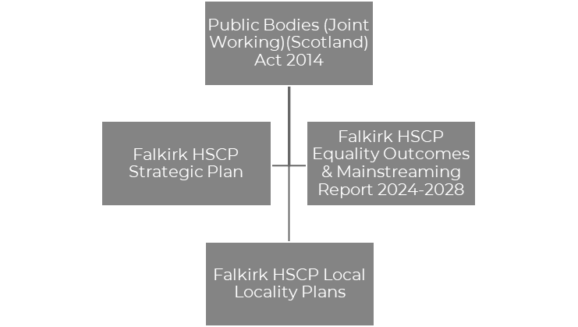

Figure 2: Strategic Context

The [Public Bodies (Joint Working) (Scotland) Act 2014](https://www.legislation.gov.uk/asp/2014/9/contents/enacted)is the government legislation that underpins integration and the development of Health & Social Care Partnerships across Scotland. The Act sets out nine national outcomes for health & wellbeing, the preparation of Strategic Plans, and the requirement for HSCPs to establish localities within its area.

The Falkirk HSCP Strategic Plan**,** [Creating a Healthier Falkirk,](https://falkirkhscp.org/wp-content/uploads/sites/9/2023/04/Falkirk-HSCP-Strategic-Plan.pdf)sets out a vision and priorities for the HSCP over a three-year period between 2023 – 2026. Locality Plans must demonstrate how the Strategic Plan will be implemented on a local level to ensure services respond to the priorities, needs and challenges of communities.

[Falkirk HSCP Equality Outcomes & Mainstreaming Report](https://view.officeapps.live.com/op/view.aspx?src=https%3A%2F%2Ffalkirkhscp.org%2Fwp-content%2Fuploads%2Fsites%2F9%2F2024%2F03%2FEquality-Outcomes-and-Mainstreaming-Report-2024-2028.docx&wdOrigin=BROWSELINK)supports the partnerships commitment to promoting fairness, dignity and respect while delivering services that provide equal opportunity for all in Falkirk. The report sets out Equality Outcomes which will support the Partnership to achieve this aim. Locality Planning will support with the implementation of the Outcomes on a local level.

Although Locality Planning follows the Strategic Context set above, it is important that other local strategies are acknowledged with collaboration and workstreams aligned where possible. This includes:

* [Falkirk HSCP Carers Strategy 2023-2026](https://view.officeapps.live.com/op/view.aspx?src=https%3A%2F%2Ffalkirkhscp.org%2Fwp-content%2Fuploads%2Fsites%2F9%2F2023%2F06%2FCarers-Strategy-2023-26.docx&wdOrigin=BROWSELINK)
* [Falkirk HSCP Participation & Engagement Strategy 2024-2027](https://view.officeapps.live.com/op/view.aspx?src=https%3A%2F%2Ffalkirkhscp.org%2Fwp-content%2Fuploads%2Fsites%2F9%2F2024%2F07%2FParticipation-and-Engagement-Strategy-2024-2027.docx&wdOrigin=BROWSELINK)
* [Falkirk Integrated Workforce Plan 2022-2025](https://falkirkhscp.org/publications/#workforce)
* [Falkirk Council Falkirk Plan & Community Action Plans](https://www.falkirk.gov.uk/services/people-communities/locality-planning/)
* [Falkirk ADP Delivery Plan 2020-2023](https://falkirkhscp.org/wp-content/uploads/sites/9/2023/05/Falkirk-ADP-Delivery-Plan-Final.pdf) *(New Plan in development)*
* Falkirk Learning Disability Strategy 2025-2030 *(Currently in Draft)*

# About Falkirk Central Locality

|  |  |
| --- | --- |
| **Population**  As of 2024, the population for Falkirk Central is 44,107. This is 27% of Falkirk’s overall population.  20% of the population are 65+. This is slightly higher than Falkirk at 19.6%.  Falkirk Central is the only Locality with a decrease in 5-17 age group. Furthermore, it has the highest decrease in 18-44 years and lowest increase for 45-64 years. | Source: National Records Scotland |
| Source: Scottish Government, Public Health Scotland | **Community**  Falkirk Central is the smallest of Falkirk’s three locality areas and contains 22,228 dwellings, 96.8% of which are occupied.  Health Outcomes are influenced by a variety of factors, including deprivation, access to health care and environmental conditions.  32% of people in Central live in neighbourhoods that fall within the most deprived 20% of Scotland. |
| **Health**  Health outcomes in Falkirk Central are worse than both the Scottish and Falkirk average on a number of key measures, including life expectancy, mortality rate, and individuals living with long-term conditions.  Furthermore, the Locality has a higher rate of both drug-related and alcohol-related admissions than Falkirk & Scotland.  A higher proportion of the population are also prescribed medication for anxiety, depression or psychosis than Scotland. | Source: ScotPHO  Source: ScotPHO |

## Summary

All data extracted from “Locality Profile: Falkirk Central Locality”

April 2024

## Services In The Area

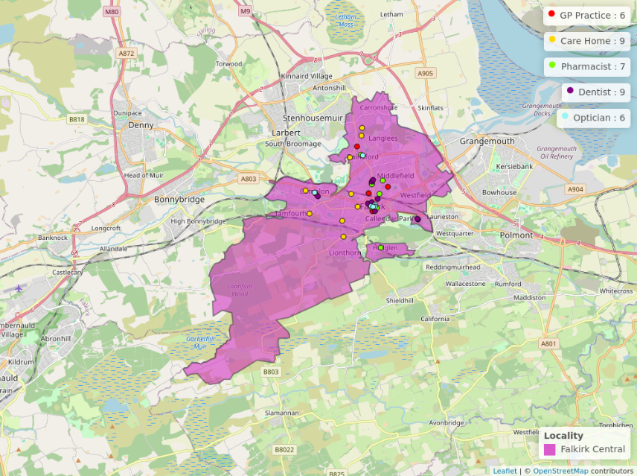

Further Information for health & wellbeing Services can be found at [NHS Inform](https://www.nhsinform.scot/scotlands-service-directory/). Details of services within the Figure 3 can be found at Appendix 2.

## Third Sector & Communities

CVS Falkirk & Districtare the Third Sector Interface for the Falkirk area and supports, promotes and develops the connection between the third sector and HSCP. They advocate for the role of the third sector within decision-making, strategic planning and redesign of health and social care services.

CVS Falkirk & District provided representation for the third sector and communities in the development of the Central Locality Plan. They have ensured communities have informed Locality Planning through a wide range of engagement that has included local forums and networks.

Our third sector and community organisations are vital assets in our communities and will be important partners in the implementation and delivery of the Central Locality Plan.

## Local Support

Falkirk Council have developed the [Our Falkirk- Local Services Map](https://www.falkirk.gov.uk/maps-local/local-support.aspx). It highlights support available within Falkirk Central Locality including provision for:

* Online access
* Food provision
* Money advice and support services
* Period Products
* Warm & Safe Welcoming Spaces

## Previous Consultation & Engagement Feedback

Over recent years, the Partnership has engaged with residents in Falkirk Central to assist with strategy development. Below is a summary of some of the key issues from previous engagement work and how the feedback has been represented within our various plans. It should be noted that although this has impacted Central Locality, most of the feedback have been area-wide.

|  |  |
| --- | --- |
| **What We Have Been Told** | **What We Are Doing** |
| “It is a postcode lottery for where you stay that depends on the support you will get.” | Two priorities have been added to the Strategic Plan to address the issues raised during the consultation to improve support within our communities and how individuals access services:   * ‘Support and Strengthen Community Based services’ * ‘Ensure people can access the right care, at the right time, from the right person’ |
| “Better communication between primary and secondary care would create better pathways between services.”  “Better local support in GP surgeries.” | ‘Communication & Engagement’ has been included in the Strategic Plan as a cross-cutting priority. We recognise the need for clear, accessible and inclusive information to ensure individuals know what support is available and how it can be accessed.  The partnership has recently developed a Participation & Engagement Strategy 2024-2027 to improve engagement and working relationships with our communities.  The Strategic Plan commits to the further development of multi-disciplinary teams in communities, bringing together different health and social care professionals. This will ensure communities can access a wider range of professionals and services within GP practices and closer to their home. |
| “It’s important that we recognise the need for people to live well, not just live longer.” | ‘Focus on prevention, early intervention and minimising harm’ is a priority in the current Strategic Plan as we recognise addressing issues before they escalate will help improve people’s wellbeing. |
| “Don’t know what alternative ways are to accessing services. Living on my own, no family to be shown what to do, nobody to ask for help.” | An Action has been added to the Equality Outcome & Mainstreaming Report:   * “We will communicate and promote traditional methods of accessing services with older people.” |
| “People like me should not be relying on the help of friends to translate when going to see a doctor.” | An Action has been added to the Equality Outcome & Mainstreaming Report:  “Work with staff to improve access to translation and interpretation services.” |
| “Third sector orgs coming together (let down by statutory services and needs partnership working to minimise waiting time and barriers to access).” | We will work closer with our Third Sector organisation and Community Groups as outlined in our Participation & Engagement Strategy. |
| “Dementia is 24/7.” | Development of a new evening and weekend support service within Dollar Park Dementia Service. |
| “We need to reduce drug use in the area.” | Community Substance Use Concerns is a theme within the Bainsford & Langlees Community Action Plan. The Falkirk Alcohol & Drug Partnership are currently conducting a Needs Assessment which will support development of their Delivery Plan which will look at substance use concerns in our communities. |

## Challenges in Falkirk Central

Below is a summary of the challenges identified within Falkirk Central Locality which have supported with identifying our key priority areas outlined on page 12. The challenges have been identified based on previous and current engagement work which has supported with the development of the plan. Evidence from available data, staff feedback and self-evaluation assessment reports has also been included. It is important to highlight that although some of the challenges have been identified in Falkirk Central, they are also area wide.

**Access to Services**

There is difficulty in making appointments with primary care services. Individuals face challenges accessing internet-based health and social care services and translation support. Feedback from respondents suggested it was difficult to access services outside the community they live in, with limited support available to help them. Limited wheelchair access was highlighted as an issue, particularly within the community around Hallglen. Furthermore, Falkirk Central currently has a lower uptake for bowel, breast and cervical cancer screenings than other locality areas.

**Access to Information**

Clear, accessible and easy-to-find information is not readily available. Individuals are unsure where to find or access information on support available within the locality area. Often, service users are presented with information that can become overwhelming and difficult to navigate.

**Anti-Social Behaviour**

During consultation, certain areas highlighted concerns with ongoing and increasing anti-social behaviour within their communities. Areas that expressed this concern included Hallglen, Callander Park high flats, Camelon and Bainsford & Langlees. This is impacting their health and wellbeing and causing negative feelings towards individuals within those communities.

**Unpaid Carers**

Some carers are unable to access the short break service and have difficulty finding information about support available to them. For example, some carers are not aware of advocacy and self-directed support options. Individuals are not aware they are an unpaid carer and do not access support they are entitled to. During the period 2023/2024, the carers centre received 699 referrals from individuals residing within the Central Locality, 45% were self-referrals and 19% from Social Work.

**Communication Between and from Services**

Individuals feel they receive insufficient communication from services about their care and are frustrated with having to repeat their story to multiple services. Staff have also acknowledged that communication between services and partnership working within the locality could be improved. Residents within Camelon expressed their frustration in meaningful engagement and the concern that it is just token gestures.

**Health Inequalities**

Falkirk Central has lower life expectancy for male and female than other Locality areas and 22.2% of Falkirk Central population have a long-term condition. The Central Locality has a large proportion of people living in deprived areas which means individuals will experience comparatively worse outcomes in terms of key health indicators. Individuals indicated that they would like to have access to appropriate information required to help them deal with their health & wellbeing.

**Local Support**

It is perceived more local support is needed that does not require use of transport or travelling out-with the area. A lack of community-based groups and services in the Central Locality means individuals have to leave the area to access support if they can afford it, for example in Grangemouth, Larbert & Denny.

**Mental Health & Wellbeing**

There are still issues with waiting times for mental health referrals, and respondents have expressed frustration with having to speak to a mental health nurse over the phone. There is an increased demand in dementia support and older adult mental health referrals within Central Locality. Central has a higher percentage of prescriptions for anxiety, depression and psychosis and carers shared the need for greater support with stress management.

**Respite**

Falkirk has nearly double the national average in respite provision, however during various engagement exercises carers reported being unable to access respite support. The Carers Voice Group shared concerns that the situation was becoming a crisis. Access to respite and improving support has been acknowledged within the Falkirk Learning Disability Strategy.

**Stigma**

Stigma is still an issue with regards to mental health, substance use, carers and disabilities. Stigma has also been highlighted as a main reason for individuals not engaging or dis engaging with services. Statutory services were highlighted as impacting on stigma as a result of previous experiences service users had endured.

**Substance Use**

There is a rise in alcohol-related admissions and drug-related hospital admissions from Falkirk Central. Substance use is recognised as a concern for local communities and the Bainsford & Langlees Community Action Plan has Substance Use Concerns as a priority area. Respondents to our consultation outlined that it was important that both mental health & wellbeing and substance use were prioritised together rather than in isolation.

**Transition**

Transitioning between children and adult services is regularly highlighted as an issue but equally challenging is older carers whose cared-for person is middle aged. There is concern around future planning and the uncertainty of what future support will be available for their cared-for person.

**Travel**

Travel is noted as a problem, particularly for accessing services out-with the area. This includes limited options available, accessibility to travel options and affordability. Some respondents also shared difficulty they have accessing their GP with some registered to surgeries out-with the locality area. Respondents expressed concerned that travel issues might lead to missed appointments. There are also issues accessing taxis within the town centre for individuals that require mobility support. Carers raised issues with transport and a request to review the local transport policy.

# Guiding Principles & Priorities

Below are the priority areas for Falkirk Central Locality. The priorities have been identified by the Locality Delivery Group and were finalised following public engagement and consultation work with the wider community.

The Delivery Plan within Appendix 1 sets out actions for each priority area. The Delivery Plan will be implemented by the Locality Team with the support of the Locality Delivery Group.

**Priority: Making it Easier to Manage Your Health & Wellbeing**

To support Individuals, their carers and families to plan, manage and understand their own health, care and wellbeing.

**Priority: Improved Access & Availability of Community-Based Resources**

Improvement in clear, accessible and inclusive communication to ensure service users are aware of what is available to them within their local area.

**Priority: Reducing Mental Health Harms and Supporting Recovery**

Capturing all aspects that impact mental health & wellbeing and ensuring adequate support for recovery is available. A high level of the population live in areas of deprivation and are at greater risk of developing a mental health disorder.

**Priority: Improved Partnership Working**

Improving partnership working and information sharing between services, resulting in improved experiences and outcome for service users.

**Addressing Health & Social** **Inequalities**

**Focus on Person-Centred Care**

**Improving Trauma Informed Approaches**

**Eliminate discrimination, advance equality of opportunity & foster good relations**

Guiding Principles

The priority areas will be supported by four guiding principles established by the Delivery Group. The guiding principles will be taken into account throughout each priority area and will underpin all work undertaken within the locality.

# Consultation & Engagement

The phase of consultation and engagement for development of the Central Locality Plan was undertaken from 16 October to 28 November 2024. The consultation involved:

* An online survey and Central Locality Summary document available via Falkirk Council’s [Participate+](https://participateplus.falkirk.gov.uk/en-GB/projects/falkirk-hscp-locality-plans) website.
* In-person meetings with local community groups and organisations.
* Attendance at local events such as Older Peoples Day & Camelon Action Plan Workshop.
* Drop-in event at Falkirk Central Library.

Consultation fatigue was highlighted as a concern to officers when conducting previous consultation work for the Partnership. Therefore, the Delivery Group also utilised data and feedback from previous engagement to identify challenges and priority areas to address in Falkirk Central.

The Consultation phase for the Central Locality Plan followed a collaborative approach with individuals to refine the challenges, priority areas and actions to be implemented. The engagement targeted particular service groups including older people, local community groups, carers and substance use services.

Overall, 38 individuals completed the online survey and over 100 people were consulted with at 14 in-person events. A consultation report is available on the Falkirk Council [Participate+](https://participateplus.falkirk.gov.uk/en-GB/projects/falkirk-hscp-locality-plans) platform. The report outlines feedback received during consultation and where respondents were instrumental in the decision-making of the Central Locality Plan.

# Finance & Resources

The Integration Joint Board is primarily funded for services through contributions from Falkirk Council and NHS Forth Valley and has a duty to set a balanced annual budget aligned to the Strategic Plan.

In September 2024, the IJB agreed a Budget Strategy setting out an approach to meet a £21.164m financial gap over the next three years. The budget process is ongoing at this time and a balanced budget requires to be approved on 21 March 2025.

The Medium-term Financial Plan outlines the overall resources available to the Partnership and ensures a robust approach to financial planning, allowing co-ordination between service redesign, transformation and annual budgets. An update on a [Business Case and Medium Term Financial Plan](https://www.falkirk.gov.uk/coins/viewSelectedDocument.asp?c=e%97%9Dc%93j%82%8C) was presented to the IJB in November 2024 and outlined a financial plan setting process in respect of the current position. The budget working group are preparing proposals to close the budget gap.

The Partnership’s financial planning will be challenging throughout the duration of this Locality Plan. This is consistent with the position for both Falkirk Council, NHS Forth Valley and the overall Partnership. Work is under way to establish some initial locality budgets at this time, with further development required for coming years to review each locality teams budget resources and responsibilities.

# Measuring Progress

The Central Locality Delivery Plan within Appendix 1 outlines how each action will be measured throughout the duration of the plan. Progress towards the actions will be reviewed by the Central Locality Delivery Group and reported to the Locality Planning Steering Group. The Steering Group will then inform the Strategic Planning Group, Senior Leadership Team and the Integration Joint Board.

The Partnership’s Integration Joint Board receives regular performance reports. These reports ensure the Board fulfils its ongoing responsibility to ensure effective monitoring and reporting on the delivery of services. Future reports will provide information on performance against targets and measures set out in the Central Locality Plan.

# Next Steps

The Locality Planning Steering Group will review and develop a process for the effective implementation of the Central Locality Plan. This will include connecting with ongoing groups and committees across the Partnership to provide connection and additional support towards implementation.

The Central Locality Delivery Group will review its membership to ensure important stakeholders continue to be involved. The group will expand to include members of the public in the Delivery Group process, and the feasibility of organising public meetings is currently under discussion.

The Central Locality Plan provides an important insight for the upcoming review of the Falkirk HSCP Strategic Plan, which will commence in 2025. The Central Locality Plan will be pivotal in shaping a new Strategic Plan that meet the priorities, needs and challenges currently faced in our communities.

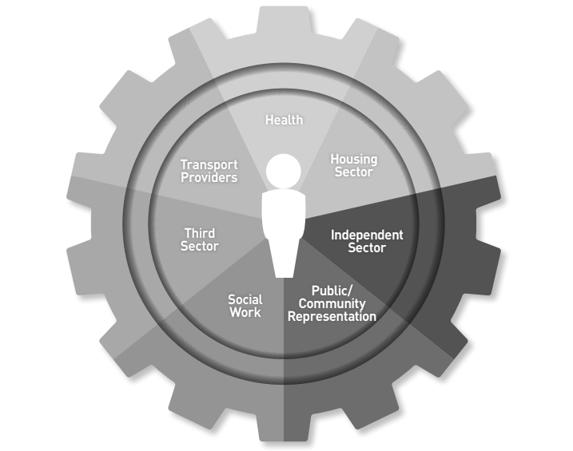

Figure 4: Locality Delivery Group Stakeholders

# Appendix 1: Delivery Plan

This Delivery Plan supports the implementation of the Partnership’s Central Locality Plan for 2025-2026. It has been developed by the Central Locality Delivery Group who will continue to review the plan and assist with its implementation. Progress will be reported to the Locality Planning Steering Group who will inform our Strategic Planning Group, Senior Leadership Team and Integration Joint Board. The Delivery Plan reflects related workstreams where applicable.

The Delivery Plan contains 19 actions, aligned to the four priorities:

|  |  |
| --- | --- |
| **Action** | **Priority** |
| 1-4 | Making it Easier to Manage Your Health & Wellbeing |
| 5-8 | Improved Access & Availability of Community-Based Resources |
| 9-14 | Reducing Mental Health Harms & Supporting Recovery |
| 15-19 | Improved Partnership Working |

Work will be progressing to implement actions within the Delivery Plan and timescales will be considered alongside the development of our East & West Locality Plans. This will take into account any synergies and duplicate actions between the plans including the upcoming review of the Strategic Plan and future operating model.

**Making it Easier to Manage your Health & Wellbeing**

|  |  |  |  |  |
| --- | --- | --- | --- | --- |
| **No.** | **Action** | **Measure** | **Lead** | **Related Workstreams** |
| 1 | People accessing services are provided with information that will help them, this could include appropriate signposting to additional services (e.g. Advocacy, Carers Centre, Translation services, SDS, Living Well etc) | Staff and service user Feedback  Review accessibility, uptake and referrals to services | Central Social Work Team  Access Team (in early 2025) | Falkirk HSCP Strategic Plan, Community Led Support Programme Board |
| 2 | Provide accessible training opportunities for all staff to complete such as Think Poverty training. This will support with Falkirk Councils focus on enabling people to maximise their income and reduce their living costs | Number of Staff completing Think Poverty Training | Locality Manager | Falkirk’s Anti-Poverty Strategy |
| 3 | Raise awareness of key public health messages and signpost to promote health information, self-management resources and supports | Key public health information has been reinforced and targeted to local needs and demographics | Communications  Health Improvement Service | Community Led Support Programme Board |
| 4 | Convene a Small Working Group to explore feasibility for developing forums across Central Locality, in partnership with local community groups and organisations, to increase awareness of services and support available. | Small working group convened and initial exploration underway | Locality Manager  Central Social Work Team |  |

**Outcomes:**

* There is an improvement in the wellbeing, quality of life, health and independence for individuals in Falkirk Central
* Individuals within Central Locality feel empowered and have resources to look after their own health & wellbeing

**Improved Access & Availability of Community-Based Resources**

|  |  |  |  |  |
| --- | --- | --- | --- | --- |
| **No.** | **Action** | **Measure** | **Lead** | **Related Workstreams** |
| 5 | Improve knowledge and awareness for staff and people accessing services about local support, services and helpful contacts within Falkirk Central Locality  (e.g. ALISS, Community Learning Development etc) | Staff meetings/Locality Delivery Group Meeting forums | Locality Manager |  |
| 6 | Work with Local Partners to find solutions towards the barriers for accessing services  (e.g. Travel, translation support, engagement with services, Sensory Impairment, online services) | Working group organised with relevant partners  Involvement in Partnership Discussions | Locality Manager  Central Social Work Team | Falkirk’s Anti-Poverty Strategy, Community Led Support Programme Board, Community Action Plans, Falkirk Learning Disability Strategy (Draft) |
| 7 | Work with local partners to remove barriers which prevent individuals from engaging with services and their readiness for change to improve this  (i.e building trust, consistency and transparency) | Community Led Support membership within the Delivery Group | Central Locality Delivery Group  Community-Led Support Programme Co-ordinator | Community Led Support Programme Board |
| 8 | Signpost carers to Falkirk & Clackmannanshire Carers Centre support, targeted to hidden carers | Dialogue with Carers Centre and referral uptake in Central Locality | Central Social Work Team | Falkirk HSCP Carers Strategy |

**Outcomes**:

* Individuals have awareness of the support available to help them access and engage with services.
* Individuals, such as Carers, have a place to feel heard/valued and are involved in shaping positive change, learning about the local support available in the community.

|  |  |  |  |  |
| --- | --- | --- | --- | --- |
| **No.** | **Action** | **Measure** | **Lead** | **Related Workstreams** |
| 9 | Support with development of the Falkirk ADP Delivery Plan in Central Locality and support with the needs assessment | Engage with development work | Central Social Work Team  Falkirk ADP Development Officers | Falkirk Alcohol & Drug Partnership Delivery Plan (In Development) |
| 10 | Support development and implementation of Forth Valley Mental Health Strategy | Engagement with development work | Central Social Work Team | Forth Valley Mental Health Strategy (In Development) |
| 11 | Staff are supported to access appropriate levels of trauma training required for their posts | Uptake of new training being rolled out. | Trauma Informed Policy Officer  Locality Manager | Trauma Informed & Responsive Services |
| 12 | Improve support to staff for managing their own mental health and wellbeing, including providing additional support where possible | Staff Meetings  1 to 1 meetings  Promoting update of enhanced trauma training to support staff awareness and self care | Locality Manager  Central Social Work Team | Falkirk HSCP Workforce Plan |
| 13 | Work closer with community-led organisations to plan, develop and deliver support that addresses local needs. | Further representation from local groups at delivery group meetings to discuss opportunities | Central Locality Delivery Group | Community Led Support Programme Board |
| 14 | Promote alternative support for mental health & wellbeing and recovery such as social prescribing and peer support | Referrals from Social work team to alternative supports available locally. | Central Social Work Team  Central Locality Delivery Group |  |

**Reducing Mental Health Harms & Supporting Recovery**

**Outcomes**

* There is an understanding and improvement made to the barriers which prevent individuals accessing support or recovery from substance use (stigma, trauma-informed spaces, follow-up engagement, increased referral pathways)
* Communities are aware of the impact & health inequalities associated with substance use

|  |  |  |  |  |
| --- | --- | --- | --- | --- |
| **No.** | **Action** | **Measure** | **Lead** | **Related Workstreams** |
| 15 | Further Develop the Locality Planning Delivery Group with a framework and expansion of members to include service user representation | Framework developed for Locality Delivery Group and regular meetings arranged. | Central Locality Delivery Group |  |
| 16 | Develop Locality forums to encourage sharing of knowledge and support across the Locality team.  (Similar to GP Liaison meetings and Asylum Seekers in Falkirk Multi-agency Forum) | STRIVE Weekly meetings for MDT engagement for harm reduction/escalating concerns. | Central Social Work Team  Lead ASP Officer |  |
| 17 | Improve communication and awareness of services within the locality to improve relationship and trust between the community and local services | STRIVE Weekly meetings for MDT engagement for harm reduction/escalating concerns. Currently in development at the data gathering stage | Central Social Work Team  Central Locality Delivery Group  Lead ASP Officer |  |
| 18 | Identify solutions to improve data & information sharing across the Locality | Initial discussions undertaken to identify where improvements can be made | Central Social Work Team  Central Locality Delivery Group | Community Led Support Programme Board |
| 19 | Encourage local organisations to collaborate on local projects and initiatives, developing shared resources, services and capabilities. | Further discussions and representation from local groups at delivery group meetings | Central Locality Delivery Group | Community Led Support Programme Board |

**Improved Partnership Working**

Outcome:

* There is clear joined-up approaches between services with an improvement in data & information sharing, reducing duplication of workload & resources

# Appendix 2: Services in the Area

Breakdown of services provided within figure 1, page 8.

**GP Practice**

|  |  |  |
| --- | --- | --- |
| **Practice** | **Address** | **Number** |
| Alba Medical Group | Westburn Avenue, Falkirk, FK1 5SU | 03301 289389 |
| Ark Medical Practice | 9 Booth Place, Falkirk, FK1 1BA | 01324 621113 |
| Camelon Medical Practice | 3 Baird Street, Camelon, Falkirk, FK1 4PP, FK2 7ES | 01324 622854 |
| Meeks Road Surgery | 10 Meeks Road, Falkirk, FK2 7ES | 01324 619930 |
| The Graeme Medical Centre | 1 Western Avenue, Falkirk, FK1 4PP | 01324 624437 |
| Wallace Medical Centre | 254 Thornhill Road, Falkirk, FK2 7AZ | 01324 622826 |

**Care Home**

|  |  |  |
| --- | --- | --- |
| **Name** | **Type** | **Address** |
| Burnbrae | Older People | Burnbrae Road, Falkrik FK1 5SD |
| Carrondale Nursing Home | Older People | Carron, Falkirk, FK2 8SN |
| Grahamston House | Older Popele | Mandela Avenue, Falkirk, FK1 7BD |
| Kinnaird Manor Care Home | Older People | Brown Street, Camelon, FK1 4QF |
| Newcarron Court Nursing Home | Older People | Newcarron Court, Falkirk, FK2 7TB |
| Summerford House | Older People | Summerford, Falkirk, FK1 5BT |
| Thorntree Mews | Older People | House Arnothill, Arnothill Mews, Falkirk, FK1 5RZ |
| Treddinoch | Learning Disabilities | 33 Slamannan Road, Falkirk, FK1 5NF |
| Willow Lodge | Mental health | Windsor Road, Falkirk, FK1 5EL |

**Pharmacist**

|  |  |  |
| --- | --- | --- |
| **Pharmacist** | **Address** | **Number** |
| Boots The Chemist | 79-91 High Street, Falkirk | 01324 620535 |
| Callander Pharmacy | 334 Thornhill Road, Falkirk | 01324 623688 |
| Tesco Pharmacy | Central Retail Park, Grahams Road, Falkirk | 0131 2892565 |
| Well | New Carron Village, 1 Ronades Road, Falkirk | 01324 612439 |
| Falkirk Pharmacy | 96-98 Grahams Road, Falkirk | 01324 635859 |
| Callendar Pharmacy | Hallglen Centre, New Hallglen Road, Hallglen, | 01324679732 |
| Hallglen Pharmacy | Hallglen Centre, New Hallglen Road, Hallglen | 01324 679732 |
| Right Medicine Pharmacy | 84-85 May Street, Laurieston | 01324 623454 |

**Dentist**

|  |  |  |
| --- | --- | --- |
| **Dentist** | **Address** | **Number** |
| Lint Riggs Dental Care | 16 Lint Riggs, Falkirk, FK1 1DG | 01324 623300 |
| Forth Valley Smile Design | 6 Weir Street, Falkirk, FK1 1RA | 01324 621495 |
| Clark & Watson | 27 Newmarket Steet, Falkirk, FK1 1JJ | 01324 623045 |
| Falkirk Courtyard Dental | Unit 4, Callander Business Park, Falkirk, FK1 | 01324 622392 |
| Dental Surgery Limited | 112 Grahams Road, Falkirk, FK2 7BZ | 01324 622338 |
| Lux Dental Care | 8 Union Road, Falkirk, FK1 4PG | 01324 623089 |
| Central Orthodontics | Unit 4, Callander Business Park, Falkirk, FK1 1XR | 01324 621130 |
| Falkirk Dental Care | 91 Grahams Road, Falkirk, FK2 7DD | 01324 671278 |
| Envisage Dental Health Falkirk | 54-58 Cow Wynd, Falkirk, FK1 1PU | 01324 624630 |

**Opticians**

|  |  |  |
| --- | --- | --- |
| **Optician** | **Address** | **Number** |
| Thomas McMahon | 83 Manor Street, Falkirk, FK1 1NU | 01324 626464 |
| Specsavers Falkirk | 128-130 High Street, Falkirk, FK1 1HB | 01324 638872 |
| Boots Professional Services | 79-91 High Street, Falkirk, FK1 1HB | 01324 636434 |
| Vision Express | 118 High Street, Falkirk, FK1 1NW | 01324 639240 |
| Firstform LTD T/A For Eyes | 340 Main Street, Camelon, Falkirk, FK1 4AR | 01324 635919 |
| Firstform LTD T/A For Eyes | 3 Carron Road, Bainsford, Falkirk, FK2 7RS | 01324 636213 |

**Third Sector & Communities**

* CVS Falkirk & District have a directory available on their website which lists groups and organisations that are members of CVS Falkirk & District within our communities: [Members Directory](https://www.cvsfalkirk.org.uk/members-directory/)
* ALISS is a national digital programme enabling people and professionals to find and share information on health and wellbeing resources, services, groups, and support in their local communities and online: [About ALISS | ALISS](https://www.aliss.org/about-aliss/)