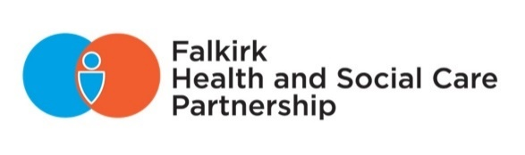**Briefing Note**



**FOR INTERNAL/EXTERNAL USE (delete as appropriate)**

Should not be shared external to Falkirk Council, NHS Forth Valley, or the Integration Joint Board.  Can be shared by officers who receive this with other officers. **(amend as appropriate)**

|  |  |
| --- | --- |
| **Service:** |  |
| **Officer:** |  |
| **To:** |  |
| **Date:** |  |
| **Subject:** |  |

Provide a short overview of the circumstances, issues arising, actions underway, and key contacts. Keep to 1-2 pages.