Annual Performance Report
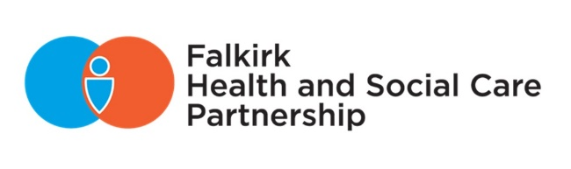
2024/2025

contents

Foreword 2
About Falkirk Health and Social Care Partnership 3
Priority 1 - Support and strengthen community-based services 11
Priority 2 - Ensure people can access the right care at the right time, in the right place 16
Priority 3 - Focus on prevention, early intervention, and minimising harm 22
Priority 4 - Ensure carers are supported in their caring role 27
Our Workforce 31
Communication and Engagement 35
Technology Enabled Care 39
Equality Outcomes 43
Housing and Sustainability 46
Financial Performance 48
Governance and Performance 54
Looking Ahead 2025/26 66

Foreword

If two words can summarise the past year for our Partnership – they are changes and challenges.

Like many other Integration Joint Boards and public bodies across Scotland, this year we have put considerable effort into addressing our financial challenges and positioning services for a sustainable future. This pressing challenge comes as we work to balance the resources we have available with an increasing demand for our services.

Setting out to address a £21m budget gap over the next three years, we started an open conversation about the decisions we face and our future outlook.

This led us to launch the widest reaching public consultation ever conducted by the Partnership, engaging with staff, partner organisations, and people in Falkirk who access services and support within their communities.

With service reform at the heart of our proposals, we heard a broad range of views and voices to help inform our next steps. This allowed us to set our annual budget and begin the process of transforming the way we deliver support in the community to help make services fit for the future, and ensure consistent support remains available to those most in need.
Our Partnership has also evolved this past year, introducing new service portfolios and embedding clear leadership across our complex mix of services.

We also prepared to welcome new colleagues from Children and Families Social Work and Justice Social Work Services, bringing us together and integrating services from 1 April 2025.

This wider Partnership presents opportunities for new ways of working and to achieve better outcomes for the people we support.

While changes and challenges can be difficult to navigate, it’s because of our dedicated, passionate, and hard-working local workforce that we can continue to develop and take advantage of our future opportunities.

This annual report is a snapshot of the achievements undertaken by our teams this year, and an example of the continued progress that is yet to come.

Gail Woodcock
Chief Officer, Falkirk Health & Social Care Partnership

Gordon Johnston
Chair, Integration Joint Board



About Falkirk Health and Social Care Partnership

Our Partnership

Falkirk Health and Social Care Partnership (HSCP) delivers adult social care services and community health services in the Falkirk area.

Key services that the Partnership provides includes:
- Community health services – District Nursing, Mental Health, and Learning Disability services
- Primary Care services – GPs, Pharmacies, Out of Hours Services
- Community Hospitals – Bo’ness and Falkirk
- Allied Health Professions: Physiotherapy, Occupational Therapy, Speech and Language Team, Podiatry, ReACH
- Intermediate care
- Health Improvement services
- Adult social work and social care services, including care homes and complex care
- Elements of housing services for aids and adaptations and gardening aid
- Prison healthcare services
- Alcohol and Drugs Partnership

The integration of these services is about ensuring those who use health and social care services get the right care and support whatever their needs. This should be at the right time and in the right setting at any point in their care journey, with a focus on community-based and preventative care.

Our COmmunities
The development of three localities within the Falkirk Council area is rooted within the integration legislation – the Public Bodies (Joint Working) (Scotland) Act 2014.

For service planning and delivery purposes, the three identified localities for the Partnership are West, Central and East (illustrated in Figure 1).

Figure 1: Falkirk Localities Map

Our Challenges
Population Projections
Anticipated 80% increase in the 75+ population by 2043 and an expected decrease in working age population – potential increased demand with a limited workforce.

Inequalities
The difference of life expectancy between the most and least deprived areas is 10 years for men and 8 years for women, and the early death rate has increased by 50% in the most deprived areas.

Financial Pressures
Significant savings are required over the coming years to balance the revenue budgets whilst demand on services continues to increase leading to a greater challenge in managing in year financial positions.

Workforce
We have an aging workforce with a sizable proportion of staff potentially nearing retirement as well as ongoing issues around recruitment and retention.

Mental Health
Primary care data shows depression is the 2nd most prevalent long-term condition, and Scotland has the second highest rate of suicide deaths of all UK countries.

Behavioural Factors
Analysis from our last Strategic Needs Assessment evidenced alcohol-related hospital admissions have been rising, and the drugs deaths rate increased by 234% between 2010 to 2020 from 10 to 33 annual deaths in Falkirk.

Our Localities

Households
Central – 22,228 East - 32,271 West - 21,680

% that live with a long-term health condition
Central – 22.2% East – 20.5% West – 20.1%

% that live in the most deprived SIMD quintile
Central – 32.2% East – 11.7% West – 7.1%

Our Vision and Leadership

A key statutory duty of the Integration Joint Board (IJB) is to develop a three-year Strategic Plan which reflects the national health and wellbeing outcomes framework and delivery of agreed local priorities.

The HSCP Strategic Plan (2023-2026) sets out the Partnership’s vision, local outcomes, and priorities that will help improve the lives of people in the Falkirk area and outlines how we will deliver adult health and social care services in Falkirk over three years.

Our vision:
“To enable people in Falkirk HSCP area to live full and positive lives within supportive and inclusive communities."

The following priority areas have been identified for 2023-2026:

- Support and strengthen community-based services
- Ensure people can access the right care at the right time, in the right place
- Focus on prevention, early intervention, and minimising harm
- Ensure carers are supported in their caring role

These priorities will be driven by three workstreams – Workforce, Technology, and Communication and Engagement.

The Partnership has been developing Locality Plans for each of its three locality areas (Central, East, and West). Central and East Locality Plans have been approved by the IJB with the development of the West Locality Plan ongoing. The plans support local development of services and implement the principles of the Scottish Government’s Localities Guidance.

The Locality Plans demonstrate how the outcomes and priorities of the HSCP Strategic Plan will be delivered on a local level by addressing the needs and challenges of its communities. Plans are co-produced through public and partner consultation with Locality Delivery Groups supporting the development and implementation of their respective plans.

The Falkirk HSCP Workforce Plan 2022-2025 outlines how the Partnership will support and develop the local workforce to deliver the vision for Falkirk, and support and improve the wellbeing of our communities.

The Integration Joint Board (IJB) has increased the frequency of its meetings to six meetings annually to allow for more timely and informed decision-making, addressing concerns that information is sometimes outdated by the time it reaches the IJB.

The newly established Performance, Audit, and Assurance Committee replaces the previous Audit Committee and Clinical and Care Governance Committee. This Committee has a wider remit, with an oversight of audit, risk management, performance as well as Clinical and Social Care Governance.

The Strategic Planning Group continues to meet regularly and will continue to have a key role to review the existing 2023-2026 Strategic Plan during 2025 and determine revisions or determine the need for a new plan, which would be developed over 2025/26.

The revision of the Integration Scheme is intended to improve governance and its understanding in relation to the functions of each Integration Joint Board as well as Falkirk, Clackmannanshire and Stirling Councils and NHS Forth Valley.

The revised Integration Scheme also includes the integration of Falkirk Council’s Children and Families Social Work Services and Justice Social Work Services. Preparatory work was done over 2024/25 and decision taken to transfer those services which formally became part of Falkirk HSCP from 1 April 2025.

The Scheme requires to be approved by Scottish Ministers, and if approved, the IJB will be responsible for planning, resourcing, and overseeing these new services, which is currently fulfilled by members of Falkirk Council. This will create opportunities for closer collaboration with other health and social care teams across the Falkirk area. There will be minimal immediate changes, but over time, we will explore how integration can enhance frontline services and improve service delivery.

Following a comprehensive co-production approach, a new leadership structure realigns the existing four Head of Service roles into refreshed service areas. These are:

- Chief Finance Officer (which includes Business and Governance functions for the HSCP)
- Head of Community Services
- Head of Specialist Services
- Head of Strategic Planning and Transformation

The structure intends to:
- Take a one team approach, based on integrity and compassionate leadership
- Bring together the right people and information to make safe, timely, and successful decisions
- Provide clear roles and lines of responsibility, accountability, and delegated authority
- Ensure financial responsibility and accountability is everyone’s role
- Support a whole-system approach, centred around people in our communities

The Transformation Board has overseen transformation initiatives. A new Strategic Planning and Transformation Board is being established to continue to drive forward the changes needed to ensure services that are fit for the future can be delivered in a sustainable way.

National Health and Wellbeing Outcomes

The Scottish Government has nine National Health and Wellbeing outcomes to improve the quality and consistency of services for individuals, carers, and their families, and those who work within health and social care. The table below outlines how our strategic priorities align to each of the nine National Health and Wellbeing Outcomes:

National Health and Wellbeing Outcomes | Strategic Plan Priorities
- People are able to look after and improve their own health and wellbeing and live in good health for longer. | Priority 1 - 4
- People, including those with disabilities or long-term conditions, or who are frail, are able to live, as far as reasonably practicable, independently and at home or in a homely setting in their community. | Priority 1 - 4
- People who use health and social care services have positive experiences of those services, and have their dignity respected. | Priority 1 - 4
- Health and social care services are centred on helping to maintain or improve the quality of life of people who use those services. | Priority 1 - 4
- Health and social care service contribute to reducing health inequalities. | Priority 1, 2, and 4
- People who provide unpaid care are supported to look after their own health and wellbeing, including to reduce any negative impact of their caring role on their own health and well-being. | Priority 1 - 4
- People who use health and social care services are safe from harm. | Priority 1, 2, and 4
- People who work in health and social care services feel engaged with the work they do and are supported to continuously improve the information, support, care, and treatment they provide. | Priority 1 - 4
- Resources are used effectively and efficiently in the provision of health and social care services. | Priority 1 - 4
Table 1: Association between the priorities of the Falkirk HSCP Strategic Plan and National Health and Wellbeing Outcomes

Falkirk HSCP Strategic Plan outlines four strategic priorities to help us achieve our local outcomes and the National Health and Wellbeing Outcomes.

- Priority 1: Support and strengthen community-based services
- Priority 2: Ensure people can access the right care, at the right time, in the right place
- Priority 3: Focus on prevention, early intervention, and minimising harm
- Priority 4: Ensure carers are supported in their caring role

These priorities are backed by three supporting workstreams that drive everything that we do:

- Workforce
- Technology
- Communication and Engagement

This report sets out progress made towards our Strategic Plan priorities, including the three supporting workstreams during 2024/25.

Priority 1 - Support and strengthen community-based services

Dollar Park Dementia Service
Previously known as the Joint Dementia Initiative, the Dollar Park Dementia Service relaunched on 31 July following a £128,000 investment in its building and staff. The creation of a new entrance and reception area in the Dollar Park base has made way for a refurbished day room for group activities and the creation of a new multi-use room for informal meetings, one to one support, or a quiet area away from distraction.

People who use the service and their families/carers are benefiting from the enhanced facilities and expanded opening hours, including a new evening and weekend service which launched in December.

We continue to provide a bespoke, trauma informed specialist service which is tailored to each individual, supporting service users and their families/carers. The new staff team are highly experienced and have been fully trained to create a stimulating environment to support cognitive decline, prevent social isolation, and alleviate carers stress.

Snapshot:
Mr A has benefited from accessing the evening and weekend service, and has settled in well, with the service improving his quality of life. He engages with everyone who attends, is a natural leader and offers support to others in the group. These sessions are the highlight of his week.

Dementia Friendly Logo
The new Dementia Friendly Falkirk initiative partnered with local schools to run a logo competition ahead of its launch across Falkirk. This partnership brings together local services, community groups, schools, and businesses to help foster a dementia friendly environment. The winning design, created by S1 Falkirk High pupil Amy, was chosen by the team at Dollar Park Dementia Service for its explanation of the positive difference felt by people accessing local support.

Getting It Right For everyone
In early 2024, the Partnership joined the Getting It Right For Everyone (GIRFE) programme as a partner. Throughout the year, we actively participated in co-design activities alongside the Scottish Government and various health and social care partnerships from across Scotland. This collaborative effort culminated in the creation of the ‘Team Around the Person’ toolkit, which aims to enhance the delivery of health and social care services in a more person-centred manner.

This toolkit comprises several innovative tools and service models designed to improve the way health and social care services are provided, ensuring they are tailored to individual needs. We plan to pilot some of these tools in 2025. The GIRFE programme’s service design approach has proven valuable, and we plan to apply it to other areas in the future.

Falkirk Sensory Team
The Falkirk Sensory Team reduces isolation by fostering greater social inclusion and community engagement. The team supports health and social care professionals to be better equipped to support individuals with sensory impairments. They also support people with access to assistive technologies and ensure carers receive the necessary resources to support their loved ones.

The team has responded innovatively to growing demand for services, particularly in under-served areas, resource limitations as well as staffing shortages in specialised roles.

Key achievements for 2024/25 include improved access to services through the provision of British Sign Language (BSL) interpreters and adaptive technologies, and greater integration of sensory support with community activities, which reduced isolation. The team also made progress in improving health outcomes by facilitating early interventions and coordinating care.

We’ve adapted to changes, including a shift towards more digital solutions to increase service accessibility. The team strengthened collaborations with local organisations, ensuring a more cohesive approach to service delivery. Overall, the sensory team made notable progress while adapting to evolving needs and aligning with national strategies such as the BSL Local Plan and See Hear Strategy.

Expanding Day Support For Adults with Disabilities
A new approach to delivering day activities and opportunities for adults with disabilities has been agreed following a collaborative process to co-design future support. Activities and support will be spread throughout the community and an almost £230,000 investment will be made to Grangemouth’s Dundas Resource Centre to allow people to gather in a single hub when needed.

The service at Dundas has also built strong links with the Dollar Park Dementia Service, with people often receiving support from both services. Resources are being reallocated from Oswald to redesign the service to support evening and weekend service provision at Dollar Park on a permanent basis, which was previously made possible through temporary grant funding.

Caledonia Service
The refurbishment at Dollar Park and the creation of a new multi-use room has provided the Caledonia Service opportunities to be more creative and utilise resources to better support service users. The room has become a more appropriate space to facilitate inductions and reviews for service users, providing a safe and relaxed space to provide emotional support dependent on individual need.

We have hosted information sessions, showcasing the work of our service to new health and social care staff, while also inviting other services, e.g., Welfare Benefit Team, to share their working practices and improve how we signpost to appropriate services for the benefit of service users.

Over the last year, we have successfully referred individuals to Fairer Falkirk to provide free SIM cards for service users experiencing poverty and inequalities. We’ve also worked in partnership with NHS Health Improvement Service to provide group sessions for service users participating in the Quit Your Way Falkirk Stop Smoking Service. As a result, over 50% of participants are now smoke free, which benefits the individual's health and, as evidence shows, plays an important role in the efficiency of medication to treat their illness.

Snapshot:
“I’ve smoked for over 25 years and have had several unsuccessful quit attempts over the years. However, through the encouragement and emotional support of my keyworker at Caledonia Service I attended the group support sessions with Quit Your Way Falkirk Stop Smoking Service, which gave me the tools to finally become smoke free and complete one of my life goals.”

Strathcarron Hospice
Strathcarron Hospice’s Compassionate Communities team delivers a wide range of activities for Falkirk communities to increase people’s confidence in discussing issues relating to illness, death, and grief in community settings, and to make connections resulting in more positive mental health and wellbeing.

The Bereavement Community Connector (BCC) role provides one-to-one support to people experiencing grief, but also increasingly works alongside community organisations to help them deliver their own support to people in the community.

The purpose of the service is to strengthen support for people experiencing grief by focusing on prevention, early intervention, and minimising harm. The Bereavement Community Connector encourages people to talk, seek support if needed, and share with family, friends, and peers in their own communities. This aims to improve mental health and wellbeing for individuals anticipating or experiencing grief and supports community organisations with greater capacity to support their members.

Snapshot:
Mrs B was referred to BCC following the sudden death of her husband. After several visits, she attended a Snowdrop Café where she felt welcomed and attends regularly. She has formed several new friendships and has also connected with a Compassionate Communities volunteer who helps her with household chores.

Burnbrae Care Home
Burnbrae Care Home hosted a ‘Gig in the Garden’ on Saturday 24 August to celebrate the service and raise funds to upgrade the courtyard garden. A local community group, Roots Bonnybridge, hosted outdoor activities, including tombola, bric-a-brac, bingo, and various children’s games.

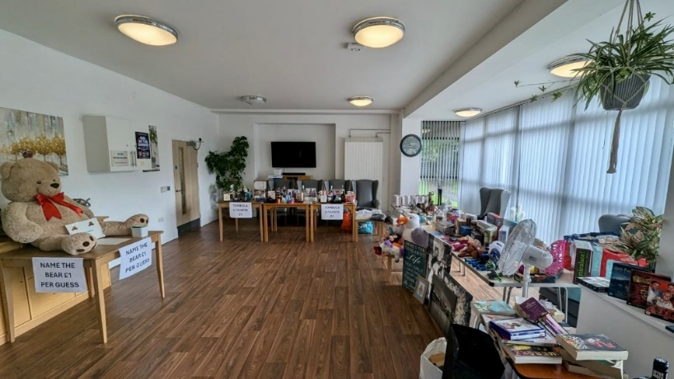
The team raised £1,358 to purchase garden furniture, planters, and plants. The space has become a well-used, relaxing area where residents, families, and staff can enjoy the benefits of being outdoors.

Through other fundraising efforts, Burnbrae purchased new furniture and decorative items, to create a more welcoming and comfortable environment for residents and visitors. The team also raised £1,505 at the Christmas Fayre for the Residents’ Comfort Fund, directly supporting meaningful activities and quality of life enhancements.



Priority 2 - Ensure people can access the right care at the right time, in the right place

Primary Care
Primary Care Services are Forth Valley wide, but Falkirk HSCP host the Contractual and Business Management role across Forth Valley. Primary Care services often act as the first point of contact for patients to access other services. This year significant work has been done in key areas.

We continue to use available data to understand GP capacity across Forth Valley and plan for local demand and availability:
- An estimated 5,471 appointments delivered each day (urgent, routine, and house calls)
- 37 Practices carry out more than 60% of routine appointments face to face with many Practices offering patients a choice of in person or telephone/virtual
- In a typical 8,500 patient Practice, 212 patient results and clinical communications are dealt with daily with 123 results requiring clinical input
- Each clinician sees an average of 23 patients per day

The Primary Care Improvement Plan supports 127 WTE multi-disciplinary professionals in General Practice with expanded Practice teams which now include mental health provision for young people and feet checks for patients with diabetes through the CTAC service.

Assurance and support visits have been made to all community pharmacies in the last year providing valuable guidance on systems and establishing effective joint working arrangements. National dental reforms have enabled more practices to accept NHS patients, and this continues to be monitored along with volumes of patients accessing the Public Dental Service.

Other projects include:
- Pilot implementation of Annual Reviews for Adults with Learning Disabilities
- In-person Protected Learning Time events for Practice staff
- Consultant Connect which enables GPs and their clinical teams to directly engage with secondary care specialists on individual patient care requirements
- Digital Dermatology project which provides a secure mechanism for sharing clinical information including images to facilitate quicker assessment and diagnosis of skin issues
- Early scoping of a community diagnostic hub proposal is underway
- Communication to raise patient awareness of priorities such as medicines wastage

A General Practice update session was provided for IJB members in January 2025 providing valuable insights into service priorities and ways of work.

A new Primary Care Governance Board has been approved and is in the process of being established by the Primary Care Management Team.

Advanced Physiotherapy Practitioners
Advanced Physiotherapy Practitioners (APP) work independently to assess, diagnose and plan the management of patients presenting in Primary Care with MSK conditions. The service aims to reduce GP workloads, promote self-management, and have a positive impact on the collective MSK system. In September 2024, the APP service reached full implementation in all assigned Practices, being one of the first Scottish Boards to achieve this.

Across Forth Valley during 2024/25:
- 3,000 appointments available every month
- Over 32,000 patients have accessed the service
- Less than 75% managed solely in Primary Care with knee and low back consultations being the most common
- More than 3% need a GP review
- 20% reduction in referrals to MSK Physiotherapy & Orthopaedics
- Less than 75% of GPs feel the APP service has eased their workload

Delayed Discharges
Being delayed from leaving hospital when there is no clinical reason for being there, has an adverse effect on individuals in terms of their diminishing fitness and confidence, at a point in which the initial impact of the need for being in hospital may have passed and it is hoped they can return as quicky as possible home. Consequently, it is a priority for us to reduce the delays people experience.

Performance has improved in this regard, with the number of people delayed in their discharge reducing by around 33% between May and end October 2024. This improvement has been the result of whole system improvements including changes in processes and systems. Feedback on the positive impact of the improvement activity has been shared with staff involved in this area of work. The commitment and valuable contribution from workers have been key to improving performance in delayed discharge.

Moving On Policy
A Moving On Policy supports a clear and consistent process to support discharge from hospital. It aims to provide a structure for all stakeholders when there is disagreement around the best way to meet an adult’s needs. It aims to establish clear and consistent protocols for all staff, patients and their families and carers for hospital discharge. The policy is anticipated to strengthen practice in delayed discharge and will support timelier discharge to a more appropriate setting, improving outcomes for the adult. This policy was approved by the IJB in March 2025.

Interim Placement Unit
In some instances, individuals are unable to be discharged timeously from Hospital due to the unavailability of an appropriate care home placement. This causes anxiety and distress for individuals and their family, is likely to have an adverse effect on their fitness levels as hospital are not ideal environments for improving mobility, and the knock-on effect of individuals not being able to move on affects the availability of beds within the hospital.

The Partnership has secured 16-beds within a dedicated section of a local care home, exclusively for adults delayed in hospital who are assessed as requiring a 24-hour residential or nursing placement.

The aim of the service is to support significant reduction in the number of adults delayed in their discharge from hospital under an interim arrangement while they are awaiting placement in care homes.

Review Workstream of Care and Support (Adult Services)
The review workstream is a pilot project tackling the backlog of reviews for care and support in Adult Services. It aims to ensure that reviews are carried out within timescale and that the care and support provided for individuals is consistent with service eligibility criteria. The pilot involves staff from each of the locality teams and care at home services and is managed through the East Locality Community Care Team.

The workstream has undertaken over 450 reviews, helping to tackle the backlog and resulting in significant savings of over £1M to the Partnership. Based on the outcomes of the pilot, the project will be funded for a further year.

We are learning from our experience of the pilot and will make changes to our review processes to ensure we address concerns of service users, families, and service providers and identify recruitment and retention of staff to the pilot.

Allied Health Professions
Forth Valley Orthotics department restructured their processes in January 2024. Improvement projects looked at the patient journey, referral vetting, scheduling practices, staff training, physical room allocations, scheduling maximisation and external relations with other teams and external vendors. As a result, the waiting list has reduced from 52 weeks to 11 weeks in 2024/25 with 5,790 patient contacts made area wide, and 2,800 new patient referrals received.

The Podiatry Service aims to provide an effective person-centred service, working together with other care providers and service users to promote patient wellbeing. Approximately 29,000 contacts were seen in 2024/25 with 5,500 new patients. This is an increase from previous years, as 28,000 contacts with 5,055 new patients in 2023/24 and 25,490 contacts with 4,234 new patients in 2022/23.

The Nutrition and Dietetic Service underwent a review to improve access, outcomes, and opportunities for early intervention for people living in Forth Valley with nutrition related problems. People can now access up-to-date evidence-based nutrition and dietary information online. Waiting times across the service have improved as 95% of patients are seen within 12 weeks of referral. Approximately, 8,413 people used the service, and 4,152 of them were seen within community settings, clinics, groups, or at home.

Joint Loan Equipment Service
The Joint Loan Equipment Service (JLES) buys, lends, maintains, collects, and recycles community equipment on behalf of Falkirk HSCP, NHS Forth Valley, and the Clackmannanshire and Stirling HSCP. Falkirk residents account for over 60% of equipment loans.

Demand for the service has risen by over 60% in the last five years and continues to increase, largely driven by an aging and increasingly frail population. Recycling of community equipment is beneficial financially and reduces environmental impacts.

We have designated drop off points at recycling centres for walking aids to be collected for refurbishment, cleaning and safety inspection followed by return to NHS Forth Valley to be used again by Physiotherapy departments. This fulfils 51% of walking aid orders by physiotherapy departments.

- 4,368 walking aids returned via recycling centres
- 3,539 walking aids fit for reuse to NHS Forth Valley
- 829 walking aids recycled
- 13 collections from local recycling centres yielding 1,080kg

As most equipment is provided on open-ended loan, the number of people who have JLES equipment increases each year. We have provided 28,000 equipment items to 8,500 unique addresses in the past five years. During 2024, 14,125 equipment items were provided to Falkirk citizens. Provision to Falkirk residents increased by 8% from 2023 to 2024 and continues to rise in 2025. In addition to the items supplied to individuals, regular deliveries were made to nine buffer stores within the Falkirk area.

Eligibility Criteria
Social care eligibility criteria refer to the set of guidelines or standards used to determine whether an adult or their carer requires a social care service. The eligibility criteria help ensure resources are allocated fairly and effectively, prioritising people with the greatest need or risk of harm.

A short-life working group was established to develop the policy. The policy promotes self-management, and an asset-based approach based on the principles of the Self-Directed Support (Scotland) Act 2013.

The aim of the policy is to allow fair allocation of available resources, prioritising those with the greatest need or risk. The policy was consulted on alongside the budget savings proposals and was approved by the IJB in March 2025.

Medication Policy
The Medication Policy for care at home services provided by the Partnership has been updated following review by a multidisciplinary working group to ensure it reflected good practice and supported consistency of approach. The policy clarified roles and responsibilities, streamlined the process and aims to strengthen the administration of medication support for both personal carers and clients. This policy was approved by the IJB in September 2024.

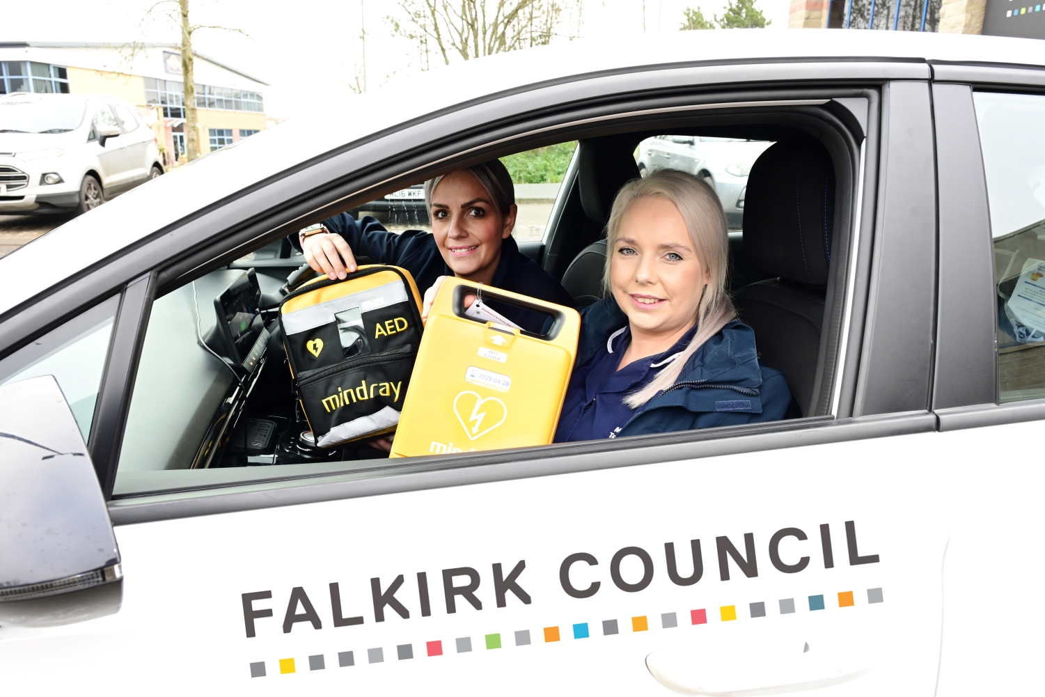

Priority 3 - Focus on prevention, early intervention, and minimising harm

Alcohol and Drug Partnership

Falkirk Alcohol and Drug Partnership (ADP) is responsible for the planning of local support services in partnership with Falkirk Council, NHS Forth Valley, Police, Fire, and Third Sector colleagues.

Work has continued to ensure the ADP is effectively connected to strategic partnership groups and associated groups across the Health and Social Care Partnership and NHS Forth Valley.

We recruited two new Development Officers to the ADP Support Team. Both Officers demonstrated considerable experience in the substance use sector and have already been an invaluable asset to the ADP.

The ADP Support Team have established several subgroups to focus on specific elements of ADP responsibility. A new Alcohol Harms Group has been developed, a Third Sector Managers Forum, and a Lived Experience Panel has also been established.

Plans to implement a Drug Related Harm subgroup are underway and the ADP Support Team is anticipating national guidance on this from Public Health Scotland. This group will also review local drug-related death data and near-fatal overdoses to better understand the drivers and how to respond and reduce occurrences.
Falkirk ADP is also exploring ways to involve young people with the development of its local strategic plan by scoping the potential to create a young person’s advisory panel.

In preparation for the new ADP Strategy development during 2025, a full needs assessment was commissioned by the ADP in November 2024. This work will provide an evidence base for the development of the new ADP strategy and commissioning plan. A range of themes have arisen from this work which the ADP is planning to take forward. These include ensuring services are:

- In the right place, at the right time, for the right people
- Have equity of access
- Co-located and multidisciplinary
- Non-stigmatising
- Prioritise workforce development
- Inclusive of families and friends

The ADP is planning to hold several stakeholder engagement events over the summer of 2025 to discuss this work further and develop an integrated, person-centred Recovery Oriented System of Care (ROSC) which is compliant with the Scottish Government’s policies and strategies including the Medication Assisted Treatment Standards.

Suicide Prevention Day Funding
CVS Falkirk & District supported Falkirk HSCP to introduce a small grants programme of up to £500 for community-based groups or organisations in Falkirk to mark World Suicide Prevention Day on Tuesday 10 September 2024.

Events and activities promoted the theme of awareness day which was “changing the narrative”, highlighting the shift needed to discuss and raise the understanding of this complex issue; shifting from a culture of silence and stigma to one of openness, understanding, and support.

Six local third sector groups were successful and were supported to deliver community-led events and activities raising awareness of World Suicide Prevention Day across the Falkirk area. This community-led approach aimed to make it easier for communities to talk about the importance of suicide prevention in meaningful and accessible ways.

Examples of funding:
- Central Wellbeing hosted an afternoon tea on 10 September for the local community to learn about local services and support available
- The Braveheart Association delivered wellbeing related activities across the Falkirk area with a series of sessions held including walks; community meals; yoga; mindfulness sessions; staff training; and workshops covering active listening and problem-solving skills
- Falkirk’s local branch of the Samaritans promoted the support they offer and their local Dawn Walk – a 5k sunrise walk to fundraise and support Samaritans activities.

Learning from the event has prompted future development opportunities to further normalise community conversations about mental health and suicide prevention. CVS Falkirk & District and Falkirk Health Improvement Service are working together to deliver a community-based suicide prevention training sessions for local representatives in May 2025.

National Adult Support & Protection Day Conference
In February 2025, Falkirk Adult Support & Protection and CVS Falkirk & District organised a cross-sector Partnership Conference to mark National Adult Support and Protection Day with an event focussed on shared learning, raising awareness of practical actions for recognising and reporting various forms of financial abuse. The Conference focused on financial harms affecting older adults, bringing together around 100 cross-sector colleagues.

Working together enabled a targeted partnership approach to organising and delivering a cross-sector Conference, facilitating important discussions and partnership opportunities to enhance the protection of vulnerable adults. Financial harm of older adults was recognised as a key local and national challenge. The Conference proved to be an effective method for sharing information and promoting an effective, collective approach to responding to this harm locally.

Making Choices, Keeping Safe - Relationships & Sexual Health
Falkirk Learning Disability Team Nurses developed an information resource for Falkirk residents to support education and skills development around the topics of sexual health and relationships for adults with a learning disability. The document provides extensive information on a broad range of topics including safe sex, pregnancy, sexuality and gender identity.

The aim of the resource is to equip parents/carers and professionals with the confidence to engage in open, healthy discussions and promote learning with the adults they support, with the hope of reducing the potential for risk of harm.

The key outcome is for service users to increase their knowledge and skills in managing relationships and dealing with matters of sex and sexuality. We also aim to reduce the number of referrals to the learning disability nursing service and adult protection service relating to social and sexual harm.
Pilot training will be delivered to a small group of support providers. The course will then be evaluated and amended as required, with a full roll out by end of 2025.

Community Falls Data Dashboard
The Health Improvement Service is working in partnership with key stakeholders to create a community falls data dashboard for the Falkirk area. It is expected, once complete, the dashboard will make community falls data more accessible for professionals and will allow for easier and more complete analyses to be carried out.

This will provide baseline measurements for quality improvement projects and help identify key places where community falls take place, allowing for more targeted prevention and early-intervention programmes.

Safer Together Collaborative
Grahamston House was commended for leading a Quality Improvement project as part of the Safer Together Collaborative which focused on reducing falls among residents. In partnership with physiotherapists, residents, families, and staff participated in a structured exercise program to build strength and flexibility. Early outcomes showed promising results and progress is being actively monitored.

Mobile Emergency Care Service (MECS)
The Mobile Emergency Care Service (MECS) provides round the clock monitoring and a response service to vulnerable people in Falkirk. MECS response teams now have access to mobile defibrillators throughout its fleet of vehicles, following a donation from Friends of Forth Valley First Responders.

The response teams attend more than 1,000 call outs each month in the local area and are first aid trained to provide immediate assistance ahead of further medical help arriving if needed.

Palliative and End of Life Care
Palliative and End of Life Care (PEOLC) is a key focus for improvement due to several challenges, including an ageing population, rising multi-morbidity, increased demand, and disparities in access. On 29 November, the Falkirk IJB approved a new Forth Valley-wide strategic commissioning plan for palliative and end of life care.

A new Commissioning Consortium group has been established. Membership includes HSCP and NHS staff across Forth Valley, third sector providers, and those with lived experience. A model of care will be developed in 2024/25. This will provide a framework for understanding financial needs and how any identified gaps in support can be met.

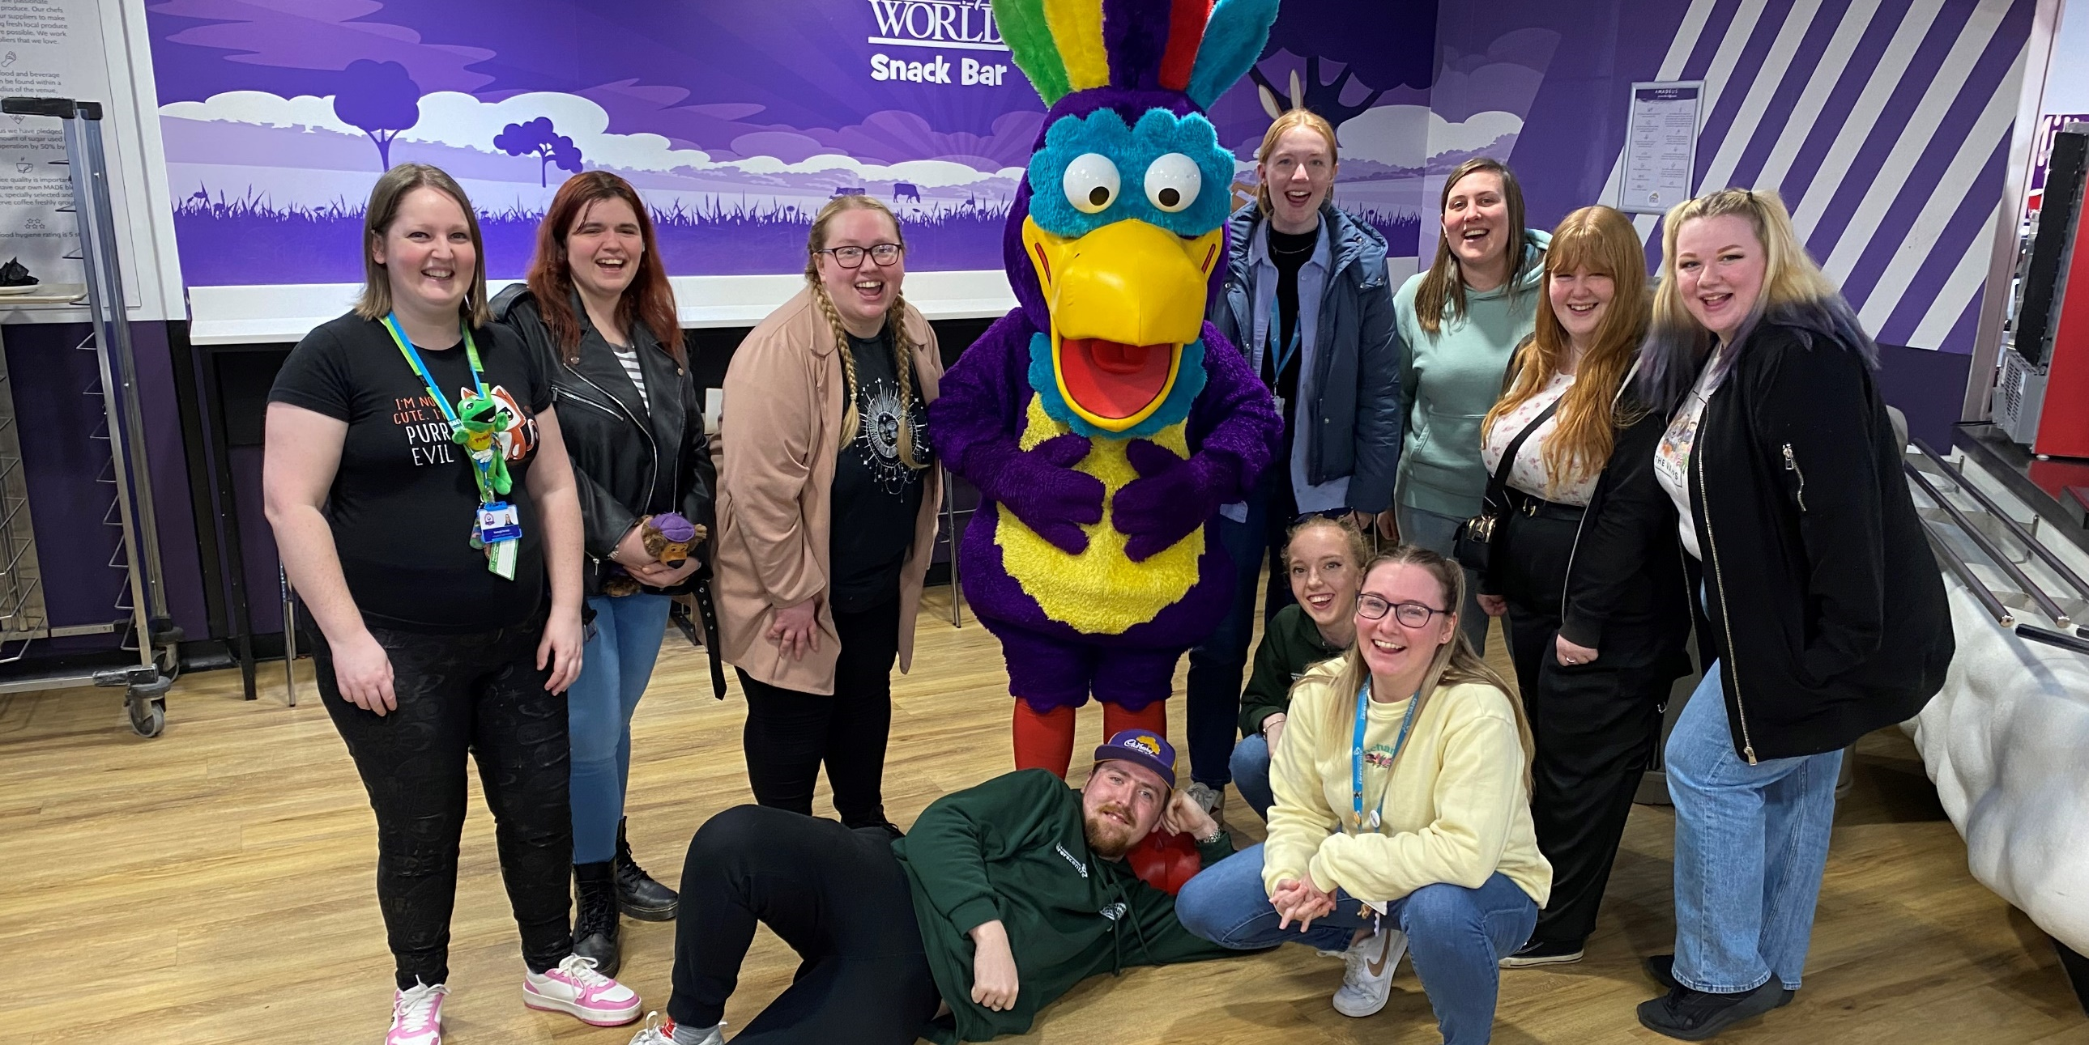

Priority 4 - Ensure carers are supported in their caring role

Supporting Carers
Falkirk Carers Strategy 2023-26 and associated Delivery Plan ensures delivery of the Carers (Scotland) Act 2016, and National Carers Strategy to support carers living in Falkirk.

We have progressed towards achieving an improved Carer Positive status for Falkirk Council and aim to fully achieve this in 2025/26. We have raised awareness of the risk of harm carers may experience from the people they care for, which has included a presentation to Adult Support and Protection teams.

We have held regular meetings to explore outcomes for young adult carers and young carers. Our Hospital Support and Discharge workstream now meets regularly and has recently gathered views from carers at an engagement event in February 2025.

Falkirk HSCP works with Falkirk & Clackmannanshire Carers Centre to provide a range of support services to carers of all ages. For adult carers, this also involves support to complete their Adult Carer Support Plan (ACSP).

During 2024/25:
- 2,747 carers have accessed the Carers Centre
- 554 ACSP completed
- 223 ACSP reviews completed
- 135 YCS completed
- 53 Young Carer groups with attendance of 509
- 365 short breaks grants provided
- 101 Care with Confidence sessions for 679 carers

Carer Support Workers provide information and support to individual carers. As a result, carers consistently report improvements in their:
- Physical and emotional health and wellbeing
- Confidence to continue caring
- Ability to enjoy a life outside of caring

Snapshot:
“Thank you very much for attending me today without an appointment and for offering so many resources which I didn’t know about, but especially for your kindness and empathy during such a delicate time for me and my family.”

2,067 adult carers accessed individual support including:
- Help to complete an Adult Carer Support Plan
- Short breaks grants and access to other short break opportunities
- One-to-one emotional support from a telephone support worker
- Support around hospital admissions and discharge
- Signposting and referrals to other appropriate organisations

Support from the Carers Centre have helped carers in their caring role and to improve their health and wellbeing. We have increased the range of short breaks opportunities delivered for carers including short breaks grants, Respitality breaks, and individual and group wellbeing activities. External funding allowed for group outings, including a carer retreat at Loch Lomond. We’ve started a monthly lunch group for carers and the person they care for, and carers continue to access a range of Care with Confidence sessions.

Challenges include low staffing capacity at certain times, an increase in requests/referrals for an ACSP, with the waiting list rising to 483 carers. The introduction of a new appointments booking system has increased efficiencies in triaging the waiting list, reducing admin time, and reducing the ACSP waiting list to 60 by the end of 2024/25.

Supporting young carers involves providing group support and one-to-one support, including support to complete a Young Carer Statement (YCS) or Young Adult Carer Support Plan (YACSP).

Key outcomes:
- Awareness raising, involvement and engagement opportunities have increased understanding among professionals of YC/YAC issues, thus increasing support
- YAC service has increased reach and engagement with YACs which is reflected in referral numbers, increased uptake for YACSPs, and wider engagement on social media
- Feedback has shown that YC/YACs feel better supported - “I feel better equipped to go to social work”

11% more YCS were completed compared to 2023/24, and an ACSP template specifically for YACs (YACSP) was designed and piloted and was showcased at the Scottish Young Carer Service Alliance Conference. This has been a major achievement and well received by other carer organisations across Scotland.

There have been challenges around delayed recruitment which has affected staff capacity and, as a result, the service was unable to participate in some opportunities and experiences. The YAC Service changed how social support was offered, making social groups more relatable to age and stage needs.

Short Breaks Bureau
The Short Breaks Bureau works to support short break/respite options for carers.

Key outcomes:
- 305 cared for people accessed a break
- Increased flexibility with respite options being offered – respite hours at home, care within a care home setting, or as part of a joint alternative/holiday type break
- New Carers Social Care Officer (SCO) role, funded from Carers Funding started in April 2024 - this preventative approach allows earlier intervention and quicker access to carer support and respite before reaching carer breakdown/crisis

Snapshot:
“It allowed us to get away for a break to recharge our batteries.”

Key achievements:
- The Carers SCO will help the partnership prepare for the ‘right to a break’ currently being legislated for under the new National Care Service legislation
- Survey responses from those who have used the Short Breaks Bureau showed that 90% of people were very satisfied with the service provided
- ACSP coming from the Carers Centre to social work are being actioned consistently
- Creation of a respite “tracker” in LAS which allows workers on other teams to access all respite dates and information

Key challenges include the increase in demand for respite as the number of unpaid carers also increase. Also, budget constraints are impacting on the processing of respite requests.

Self-Directed Support
The Self-Directed Support (SDS) team support staff, service users, and carers to understand how self-directed support can empower them to have more choice and control over how their support is provided.

In May 2024, we worked with colleagues on a Month of Action to raise awareness of SDS and Options 1 and 2. The SDS team is now working with locality and specialist social work teams once a month to provide support. We’ve also delivered briefing sessions to Homecare and Home First staff. We’ve also improved our resources for staff by updating information on intranet and practitioners pages, created new SDS information leaflets, and provided guidance for setting up Options 1 and 2.

We continue to work closely with local and national partners. SDS Forth Valley have delivered training sessions throughout the year. We’ve worked with Social Work Scotland, SDS Forth Valley, and the Carers Centre as a pilot area involved in the development of 13th Standard on the SDS Framework of Standards.

We will continue to develop our practice by updating our policy and procedures in line with best practice.

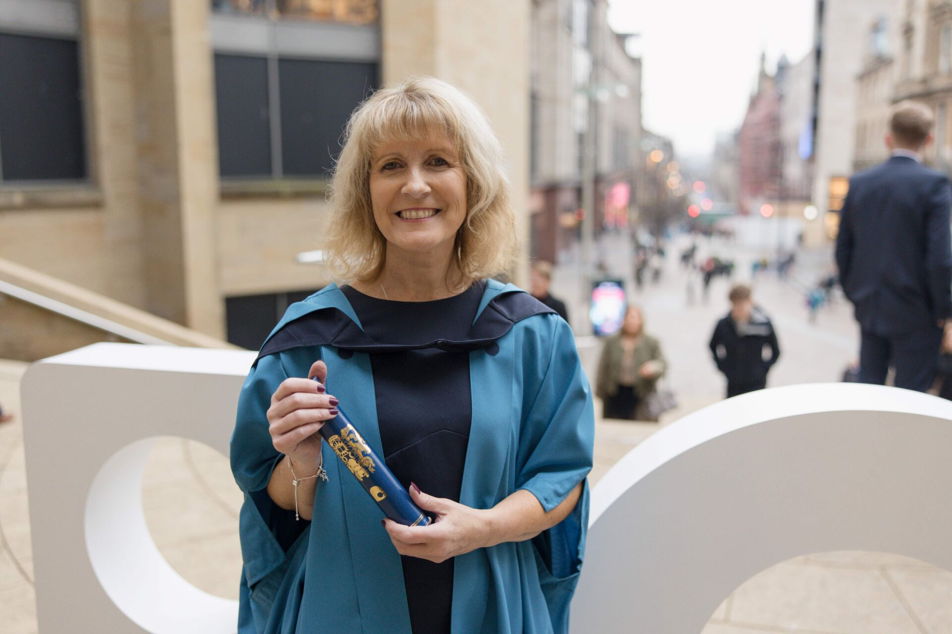

SUpporting Workstream: Our Workforce

Recruitment and Retention Working Group
The Working Group includes representatives from Adult, Children & Families and Justice Social Work Services, Workforce Development, Human Resources, and Communication leads. A reference group of frontline staff are consulted with regularly. The purpose of the group is to identify, implement, and evaluate strategies focused on the recruitment and retention of qualified Social Workers and Occupational Therapists.

We’ve reviewed the impact and implementation of new roles introduced across all Social Work Services: Assistant Team Manager and Advanced Practitioner. Two new posts have been established to build capacity within workforce development and support recruitment and retention of staff.

The Newly Qualified Social Worker (NQSW) Supported Year Coordinator is temporarily funded to focus on building capacity across social work services to implement the new Supported First Year Programme and develop sustainable approaches beyond the funded period. The SVQ and Career Pathways Manager brings capacity to promote a career in Health and Social Care and focuses on collaboration with partner agencies in Education and Higher Education alongside NHS and Employment Training Unit.

We continue to face challenges in recruiting Mental Health Officers. We are currently reviewing our sponsorship model and propose to introduce an in-house accredited programme of mental health training for Advanced Practitioners.

Snapshot:
Before completing a Falkirk Council-sponsored Postgraduate Diploma in Social Work, Gina had over 20 years’ experience as a social care officer in Falkirk’s social work services. Following her graduation, she is now a registered social worker.

“Studying has definitely impacted my career,” says Gina. “I was in adult social work for many years as a social care officer. Now I am a qualified social worker I can champion for people’s rights using legislation, frameworks and tools to evidence my practice and support that person throughout their journey. Initially my study was for personal goals and my career, but latterly it was to further my career.”

Gina was inspired by two people during her Diploma – “both my practice educators at the council were amazing and supported me well during my studies”.
While reflecting that it has not been an easy journey, and that transitioning into the role of a qualified social worker is taking time, Gina feels that she has grown as a person: “If you want to progress, do it! I can’t recommend it enough!”

Trauma Informed and Responsive services
Falkirk HSCP has been working with key partners across Forth Valley to ensure we collaborate and drive forward trauma-informed change. The Forth Valley Trauma Informed and Responsive Steering Group agreed a new vision and action plan. Development sessions are planned for the Implementation Group to further support the embedding of trauma informed and responsive practice, systems and processes throughout Falkirk.

This work is aligned to the Roadmap for Creating Trauma Informed and Responsive Change and will be key to providing ongoing strategic direction and ensuring the longer-term sustainability of trauma-informed approaches across Falkirk and Forth Valley. Learning and development opportunities are available for Falkirk HSCP staff and a “Community of Practice” has been established for participants who have engaged in the training.

Reablement – Maximising Independence Training
The Reablement-Maximising Independence training covered key topics such as the reablement approach, falls prevention, Living Well Falkirk, and use of small equipment to support a person’s independence at home. The first training events were delivered in autumn 2024. These sessions were designed to ensure that maximising independence, using a reablement approach, is the underpinning ethos for working with all people receiving our services. This training highlights to staff the range of support available in community settings that individuals and families can access themselves.

Safe & Together Training
The Safe&Together™ Model is an internationally recognised suite of tools and interventions designed to help professionals become domestic abuse informed. It highlights multiple pathways to harming children and adult survivors as the negative outcomes of domestic abuse for children and adult survivors can be enduring.

While the model has the benefit of being child-centred, the tools also provide a framework to enhance the safety and wellbeing of adult survivors. Falkirk’s continued investment in Safe&Together™ is aimed at improving cross system collaboration amongst children and adult services, improving staff competencies while improving outcomes for our communities. Adult Services workforce attendance at training has been steadily increasing with representation at each planned learning event during 2024/2025. Post training, attendees are encouraged to join a “Community of Practice” to provide opportunities for sharing learning and embedding practice change.

Developing the Workforce
Promoting social services and healthcare as a positive career choice to young people involves supporting the development of career pathways. By integrating students into professional settings early in their education via student placements, as employers we can engage with potential future employees, fostering a pipeline of skilled professionals who are already familiar with workplace expectations, culture, and standards.

During 2024/25:
- 11 school student work placements supported within Care Home services and Community Care Services
- 10 HNC Social Services and Healthcare and 3 Pathway to Health and Social Care – Level 6 college student placements provided in each Care Home Service and Community Care Services
- Supporting staff to become a student mentor and provide access to Forth Valley College mentorship training, ensuring students feel supported throughout their placements
- Continue to collaborate with Forth Valley College to increase the number of students offered placements as part of their college programmes
- Falkirk Social Services SVQ Assessment Centre has supported 55 candidates to successfully achieve SVQ awards
- The Assessment Centre was nominated for staff recognition as it’s maintained a 10-year high confidence inspection record by SQA External Verifiers

Adult Support and Protection Training
The Training Workforce Development Team continue to develop and deliver Adult Support and Protection/Public Protection training across the Council and HSCP. A multiagency focus continues with learning opportunities offered to third sector and statutory partners.

Key achievements during 2024/25:
- High quality responsive learning and development activities are being delivered across multiple agencies
- Delivered 60 Adult Support and Protection related courses with 646 participants attending from a wide range of partner agencies
- Responsive learning and development activities
- High levels of satisfaction are recording in training evaluations

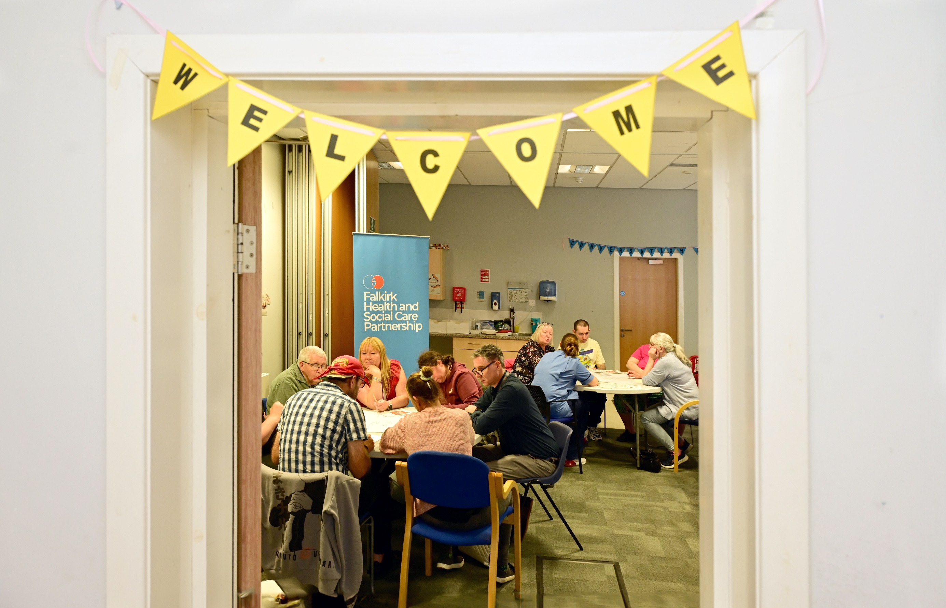

Supporting Workstream: Communication and Engagement

Overview of Engagement Activity
The Partnership continues to improve how we engage with our local communities. During 2024/25, we created opportunities for people to share their views across ten projects, including one-off engagement events. Over 440 people responded to online surveys available on Participate+. We actively promoted these surveys and gathered views from over 1,000 people across 58 engagement activities, ranging from drop-in sessions at local libraries and planned events to attending local community group meetings and staff sessions.

Timescale | Project | Total Survey Responses | Total Activities | Total Engaged via Activities
22 April - 31 May; 09 Aug - 22 Sep 2024 | Palliative and End of Life Care Strategy | 77 | 3 | <10
30 May 2024 | Alcohol and Drug Partnership Conversation Café | N/A | 1 | 20+
27 May - 21 June; 05 Aug - 18 Sep 2024 | Learning Disability Strategy | 42 | 8 | 143
22 July - 02 Sep 2024 | Digital Health and Care Programme Delivery Plan | 23 | 6 | 81
01 Aug – 05 Dec 2024 | Integration of Children’s Social Work and Justice Services | <10 | 11 | 120+
02 - 22 Sep 2024 | Independent Advocacy Plan | <10 | N/A | N/A
17 Oct - 28 Nov 2024 | Central Locality Plan | 38 | 16 | 138
03 December 2024 | Alcohol and Drug Partnership Stakeholder Workshop | N/A | 1 | 35
14 Jan - 25 Feb 2025 | Budget Consultation | 258 | 11 | 464
10 February 2025 | Hospital Support Discharge Carer Workshop | N/A | 1 | 16
 | Total | 440+ | 58 | 1,020+
Table 2: Overview of HSCP Engagement Activity 2024/25

Learning Disability Strategy
The Falkirk Learning Disability Team (FLDT) have been meeting regularly to develop a five-year strategy and delivery plan to improve outcomes for people living with learning disabilities in the Falkirk area. As part of this work, we engaged with people with learning disabilities, their carers and families, and staff to help inform the strategy and the development of local learning disability services. The new strategy will be presented for IJB approval in 2025.

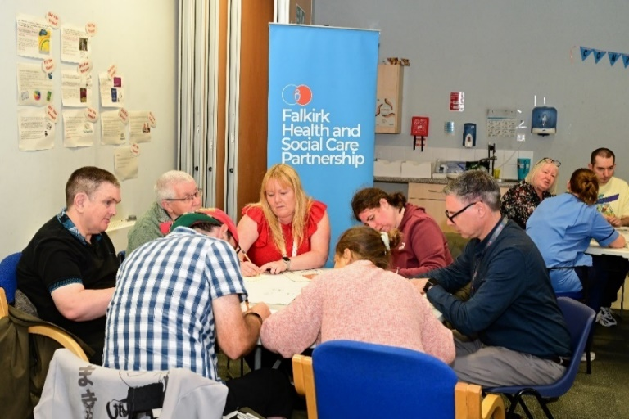

Budget Consultation
The consultation focused on a set of proposals to raise income, reform services, and help close a £21m budget gap over the next three years. The consultation has gathered views on a range of options, which involve changes to the way services are delivered, proposed increases to social care charges, and some changes to the level of support available. Alongside the proposals, the Partnership put forward a new set of eligibility criteria which outlines when social care support will be provided and what support will be available.

New IJB Carer Representatives
Local carers, Elaine and Sharon, have been appointed as new representatives on the Integration Joint Board (IJB). Following a collaborative recruitment process supported by Falkirk and Clackmannanshire Carers Centre and the Carers Voice Group, the Board appointed the new members during its meeting on Friday 31 January.

Our previous IJB Carer Representative, Carol Ann, played a key role in sharing carers views during meetings. Most notably, in raising the issue of hospital discharge and its importance to carers at the IJB, the Hospital Discharge Planning Group has been reinstated. Carol Ann will continue to represent carers at the Mental Health & Wellbeing Communities Group.

Carer Representative Programme
Working in partnership with Falkirk & Clackmannanshire Carers Centre, we have developed a programme to increase involvement of carer representatives in various strategic steering groups.

Since September 2024, we have successfully recruited ten carer representatives across seven groups at all levels of the decision-making process, ranging from the Integration Joint Board to the Digital Health and Care Programme Board and the Carers Strategy Group.

Snapshot:
“Before attending [the Carers Strategy Group] I felt I’d be classed as a carer and not listened to properly. However, I feel that every professional in the meeting listens to me. My confidence is growing slowly, and I now feel I can move on as I’m not worrying about feeling stupid. It’s good to have senior managers listening to me.”

Developing the Carer Representative Programme has involved:
- Delivered two training cohorts to provide unpaid carers with the information and skills they need to get started in the role
- Established a recruitment and induction process to match carers with the right opportunities
- Regular support and mentoring are available, depending on individual needs
- Created a digital lending library for carer representatives who may require digital support to attend online meetings

Next steps include developing training and guidance for staff, identifying further training opportunities for carer representatives, and ongoing monitoring and evaluation so we can demonstrate the impact of involving carer representatives.

Care Opinion
Care Opinion is an online feedback platform where people can safely share their experiences of any Falkirk HSCP service.

During 2024/25, 16 stories have been published about Falkirk HSCP services.

Service Area | Total no. of stories | % of stories responded to by staff | % of positive stories
Falkirk HSCP | 16 | 94% | 94%
Adult Health Services | 11 | 91% | 91%
Adult Social Work Services | 5 | 100% | 100%
Commissioned Services | - | - | -
Table 3: Overview of Care Opinion Stories

Snapshot:
“I was really impressed with the service. The physio helped me to start walking again, and now I go out every day. I can’t praise the care and attention enough.” ReACH (24/07/2024)

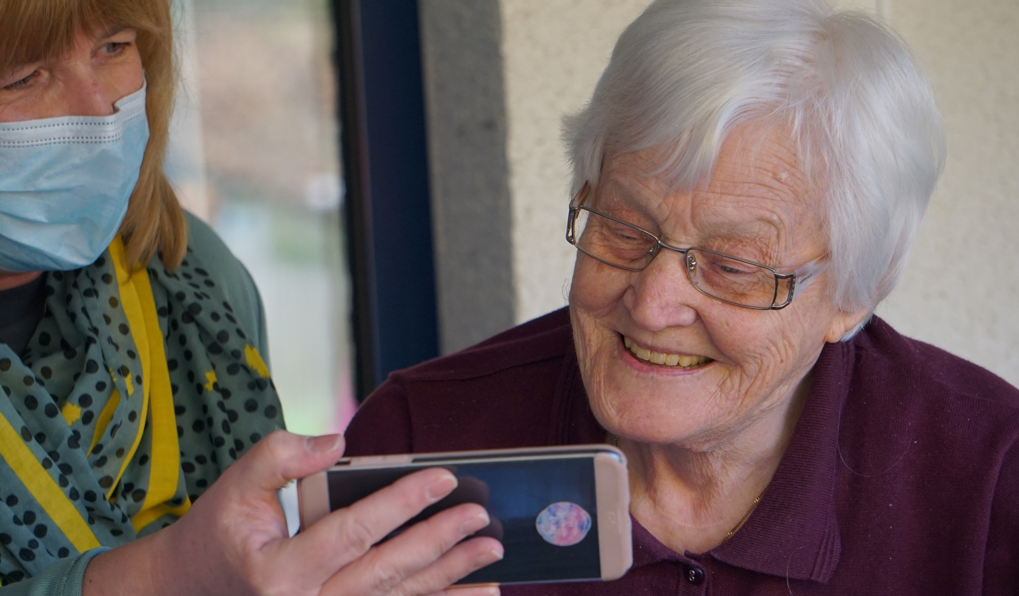

SUpporting Workstream: Technology Enabled Care

Our digital systems continue to support service delivery, workforce planning, and coordination across health and social care in Falkirk. These systems ensure staff have the right information, at the right time, improving decision-making, streamlining processes and ultimately, enhancing the experience of those using our systems.

Digital systems play a crucial role in ensuring safe, efficient and effective service delivery. They enable better communication across teams, provide real-time insights into service capacity and demand, supporting the coordination of care between different providers. Although many of these systems have been in place for some time, they continue to be developed in response to evolving needs.

Key outcomes:
- Improved service coordination and workforce efficiency
- Better real-time data for management decision-making
- Reduced administrative burden, enabling staff to focus on frontline care

Care At Home Service
We use a real-time electronic time recording and scheduling system that allocates visits to staff via a smartphone app. This enables them to access their schedules, confirm attendance, and update records instantly. The system also enables managers to monitor service delivery, assess staffing levels, and make informed decisions about the delivery of care to improve efficiency and service continuity.

Living Well Falkirk
The recently updated Living Well Falkirk platform, a healthy ageing self-assessment tool, provides advice and access to equipment, helping individuals manage their health and wellbeing more independently. This has been useful for those on waiting lists or who may not otherwise have access to services. To further support service users, we have introduced Near Me video appointments, enabling staff to provide guidance remotely and reducing the need for in-person visits where appropriate.



Liquid Logic
Our core social work system LiquidLogic provides a centralised digital platform for recording and managing social care information that enables staff to access and update case records ensuring the information is accurate and up to date.

The system supports co-ordination between teams enabling more effective communication and collaboration across services. It provides valuable insights into caseloads, service demand and workforce capacity helping managers to plan resources more effectively and ensure the staff are deployed where they are needed most.

Telecare
In telecare, our transition from an analogue to a digital alarm receiving centre has improved reliability and given us better insights into service demand and connectivity. This data helps us plan for future service user demands and workforce requirements by ensuring staff resources are allocated effectively.

Launch of eBrokerage System
Falkirk HSCP’s new eBrokerage web-based system for allocating packages of care launched in February. The system aims to significantly reduce the time taken to assess needs and identify a suitable care provider. It is expected to reduce the existing turnaround time from around 21 to 4 hours. This will make it easier for staff to match individual care needs with appropriate care providers, improving efficiency in workforce coordination, reducing administrative burden, and providing key management information.

Digital Health and Care Programme Board
The Digital Health and Care Programme Board is exploring new ways to use technology to support staff and service users, including the use of consumer technology and digital tools that help people remain independent.

Key outcomes:
- Improved collaboration between health and social care through better data-sharing solutions
- Expanding access to digital tools that support independent living, including engagement activities to provide information and resources with a focus on safe and effective digital inclusion, ensuring service users can engage with technology confidently
- The Board is actively overseeing and guiding the integration of digital health and care solutions, ensuring governance frameworks are robust and future trends are proactively identified and addressed
- Ensuring that digital initiatives remain focused on long-term service improvements

We are looking at how we can improve digital skills across the workforce to ensure that staff can confidently use new systems and technologies as they are introduced. For example, exploring how digital solutions can support medication management within services following the review of the Medication Policy.

Also, by working in collaboration with Falkirk Council and NHS Forth Valley, we are enabling staff, where appropriate, to securely access partner’s systems via a single laptop to improve efficiency, support integrated working and ensure staff have access to the right tools to deliver high-quality joined up care.

We are currently developing the Smart Properties Platform project, in partnership with the Scottish Government. which is exploring how Home Assistants can support individuals’ care needs.

Work is also underway to establish how best to resource the Digital Health and Care Programme, ensuring that funding supports sustainable, impactful digital developments. Despite this ongoing work, progress continues across existing systems and new initiatives, ensuring that digital solutions continue to support both workforce and service user needs.

Canary System Pilot
Canary system technology has been installed for three service users, where we place sensors in each room to monitory movement. This allows us to build a picture of regular movement and identify any deviation from this. It also allows us to virtually “pop in” to see if people have been moving around the property, usually overnight. For example, if someone has not returned to bed after getting up to use the bathroom and this is outside their “normal” times of bathroom visits then we could provide extra assistance during this time.

The equipment can be programmed to send text alerts for various reasons, such as texting shift staff when clients get out of bed overnight to attend and assist them back to bed to ensure their safety and comfort. Through this use of technology, we can monitor service user movements and identify if overnight assistance is required or if they can manage independently. We can also place a sensor by the stairs to alert staff if clients have attempted to climb the stairs to ensure their safety and prevent the possibility of fall and injury.



Equality Outcomes

Falkirk IJB has a duty to report progress made to achieve its Equality Outcomes at intervals of not more than two years, which is done through our Annual Performance Reports. This is in recognition of the role equalities has in our work across the Partnership.

Equality Outcome 1
Older people who experience barriers to accessing internet-based health and social care services have alternative ways to access services.

The key intended outputs for Equality Outcome 1 are:
- Communicate and promote traditional methods of accessing services with older people
- Involve older people in the design of future services to ensure they are fully accessible
- Work with our staff so that technology is appropriately used with our service users

During 2024/25, services have continued to engage with people using non-digital methods of communication. For example, Social Work Adult Services (Central Team) contact all adult service users via telephone and can send follow up letters. For Allied Health Professionals (AHP) such as Nutrition & Dietetics and Podiatry & Orthotic services, people can still self-refer via telephone or in person.

Where technology initiatives are being developed to make services more efficient, these are being tested with staff and service users. Living Well Falkirk is a digital based service; however, Social Work Duty accepts telephone referrals and colleagues from the Living Well team for individuals who cannot access internet-based services or people wishing to use the service can get support through Falkirk Council library staff.

Going forward, further work needs to be done to include older people in service design when we are designing digital services. Not all older people experience digital exclusion. However, for those that do use the internet, there are varying skill levels, and they rely on accessible and easy to navigate platforms. Through our engagement work, older people told us when we update and refresh digital platforms, they take longer to learn to use them and have expressed an interest in being involved in the design stage of digital platforms.

Equality Outcome 2
People from Minority Ethnic backgrounds with cultural and language differences have improved experiences accessing health and social care services.

The key intended outputs for Equality Outcome 2 are:
- Ensure that formal communication regarding health and care needs is provided in preferred formats
- Work with staff to improve access to translation and interpretation services
- Work closely with our Minority Ethnic communities to ensure our services understand and are responsive to different cultures

During 2024/25, the Nutrition & Dietetics service’s Early Detection Type 2 Diabetes Mellitus team have offered targeted interventions to ethnic minority groups who have not previously engaged with healthcare. Positive data has been received from this work. In recognition that having an interpreter will take more time for conversations to take place, some GPs offer longer appointments. However, it is important to note that GPs are independent contractors, so this won’t be consistent across Falkirk.

A significant amount of activity has taken place within the Health Improvement Service in particular. Below are some examples of work undertaken to date. This list is not exhaustive of all activity:

- Sexual Health Blood Borne Viruses Managed Clinical Network commissioned a service from Amazing Harmonies to work with African Communities across Forth Valley to promote HIV prevention and increase testing. Much of this is carried out by linking with African church groups via the pastors and connecting people through events, small group meet ups to promote and connect people to services. We meet with the worker every 6-8 weeks for updates and to link them into local activity and developments.
- Identify and engage with Minority Ethnic groups to promote the Smile4Life programme. In addition to providing bespoke culturally sensitive Smile4Life training to health and social care staff and facilitate access to local dental services.
- Engaged with Minority Ethnic groups and places of worship to disseminate oral health information resources and dental packs.
- Consulted with NHS Forth Valley Early Intervention Pre-Diabetes team to ensure that information about type 2 diabetes and treatment interventions are culturally responsive. The service helped the team to identify local Minority Ethnic groups to engage with.

A significant amount of work has already been undertaken to address language barriers. However, further work is required to understand and address cultural barriers across all services.



Housing and Sustainability

Housing
Housing has a key role for people to stay at home, in accommodation that meets their needs, in their communities. The Housing Contribution Statement (HCS) is a bridge between the HSCP Strategic Plan and Falkirk Council Housing Strategy 2023-2028. The table below outlines progress made towards the Housing Contribution Statement.

 | 2022/23 | 2023/24 | 2024/25
Achieved | 6 | 10 | 11
Ongoing | 11 | 7 | 61
Carried forward | 4 | 4 | 12
Table 4: Summary of Housing Contribution Statement Actions

Sustainability
Adult Social Work services are included in Falkirk Council’s Carbon Management Plan, and the NHS Forth Valley Sustainability Strategy 2019-2024 sets out how the key elements of sustainability can come together to actively support and enable efficient and effective healthcare delivery. The Strategy recognises that NHS Forth Valley needs to address health challenges due to climate change as well as reducing its own environmental impact.

Adult Social Work accounted for 1,040 tonnes CO2e in 2024/25, which is 87 tonnes less than the previous year.

Source | 2020/21 | 2021/22 | 2022/23 | 2023/24 | 2024/25
Electricity | 378 | 397 | 238 | 260 | 277
Gas | 826 | 772 | 707 | 711 | 759
Water (supply and treatment) | 4 | 4 | 5 | 6 | 4
Vehicle fuel (petrol and diesel) | 149 | 229 | - | 150 | -
Total | 1,357 | 1,402 | 950 | 1,127 | 1,040
Table 5: Breakdown per emissions sector (Tonnes CO2e)



Financial Performance

Best Value
As defined by Audit Scotland, Best Value is concerned with “good governance and effective management of resources with a focus on improvement to deliver the best possible outcomes for the public.”

The IJB’s governance framework supports continuous improvement and better outcomes, whilst striking an appropriate balance between quality and care. The key features of the IJB’s governance framework which were in place during 2023/24 to support best value are outlined below.

GOVERNANCE AND ACCOUNTABILITY
Falkirk IJB has responsibility for the strategic planning and commissioning of delegated health and social care functions. NHS Forth Valley and Falkirk Council delegate budgets to the IJB, which decides how resources are used to achieve the objectives of the Strategic Plan. The IJB then directs the partners through the HSCP, to deliver services in line with this plan. The IJB controls an annual budget of approximately £321m.

The IJB has legal responsibilities and obligations to its stakeholders, staff, and residents of the Falkirk Council area. The following governance frameworks set out the rules and practices by which the IJB ensures that decision making is accountable, transparent, and carried out with integrity:
- The Integration Scheme
- IJB Standing Orders
- Risk Management
- Clinical and Care Governance

The range of IJB Board members has enabled informed decision-making through the insightful contributions from different perspectives. The voice of service users and carers have been of importance and value to the Board.

During 2024/25, a review of the IJB Integration Scheme has been ongoing and a revised scheme has been approved by the IJB, Falkirk Council and NHS Forth Valley, and has been submitted for consideration to Scottish Ministers. At the time of publishing, feedback has been received, and some final amendments are being considered by partners. Key changes to the Integration Scheme include the integration of Falkirk Councils Children and Justice services from 2025/26, and an increase in voting members from each partner from three to four.

A review of IJB and associated committee governance arrangements has also been carried out. This included the approval of a new terms of reference and updated membership of the IJB (with voting members moving from three from each partner body to four) in line with the updated draft Integration Scheme.

The review also stood down the previous IJB Audit Committee and IJB Clinical and Care Governance Committee, which have now been replaced by our new IJB Performance, Audit and Assurance Committee, which held its first meeting on 17 January 2025.

EFFECTIVE USE OF RESOURCES
National Health and Wellbeing Outcome 9 requires the IJB to demonstrate that “resources are used effectively and efficiently in the provision of health and social care services.” As part of this requirement, an overview of 2024/25 financial performance is provided below, including consideration of the financial outlook for 2025/26 and for the medium term.

Financial Performance 2023/24 (from unaudited accounts)
The IJB reported total income of £319.822m for financial year 2024/25 and total expenditure of £325.368m incurred during the year. As a result, a deficit of £5.546m was reported in the unaudited Comprehensive Income and Expenditure Statement on 31 March 2024.

A number of budget recovery measures were implemented during the financial year including the in year use of some non-recurring reserves. A final draw on reserves of £5.037m was required to fund the final revenue overspend at the year end.

The key pressure areas affecting 2024/25 financial performance are detailed below:

Large Hospital Services/Set Aside
Overspend pressures continued to be reported within A&E, General, Geriatric, Rehab and Specialist Mental Health Services. This was mainly relating to ongoing significant expenditure on supplementary staffing, linked to staff absence/contingency beds/vacancies, although good progress has been made to reduce agency spend throughout the year. It is important to recognise that the overspend pressure is met by NHS Forth Valley.

Social Care
The main areas of overspend recorded during 2024/25 related to external care at home, external residential care and in house residential care. A budget recovery plan was approved by the IJB including use of non-recurring reserves and control measures were put in place including a vacancy panel, resource allocation panels and a two for one admissions approach to residential care. These measures, along with final draws on reserves of £5m we necessary to arrive at a final balanced position for the year.

Primary Healthcare
Large overspends were incurred, mainly due to prescribing pressures as a result of increased demand pressures, newer expensive drugs becoming available, the volatility of international markets for drug purchases and high inflation pressures. The prescribing position benefited from a one-off contribution from reserves of £3.5m during 2024/25, which has been addressed on a permanent basis via the 25/26 business case.

Community Healthcare
A favourable financial position was again largely due to development funding not being fully utilised, plus vacancies and staff turnover savings across a variety of services with the main variances within community mental health, district nursing, community hospitals and out of hours services. The favourable position masked ongoing pressures within the Joint Loan Equipment Store and Complex Care services.

Figure 2: 2024/2025 Expenditure by Category

An analysis of IJB expenditure incurred during 2024/25 is outlined in the table below:

Total Expenditure | 2024 / 2025 | 2023 / 2024 | 2022 / 2023 | 2021 / 2022 | 2020 / 2021
Large Hospital Services | 46,194 | 42,952 | 39,844 | 31,079 | 29,629
Primary Care Services | 94,676 | 92,745 | 86,130 | 81,474 | 83,284
Social Care Services | 132,728 | 123,369 | 110,820 | 99,102 | 93,952
Community Healthcare Services | 51,202 | 47,159 | 44,331 | 21,956 | 38,241
IJB Running Costs | 568 | 543 | 470 | 454 | 469
Total | 325,368 | 306,768 | 281,595 | 234,066 | 245,575
Set Aside | 46,194 | 42,952 | 39,844 | 31,079 | 29,629
Integrated Budget | 279,174 | 263,817 | 241,751 | 202,987 | 215,946
Total | 325,368 | 306,768 | 281,595 | 234,066 | 245,575
Table 6: Total Expenditure 2024/25

FORWARD LOOK 2025/26 AND BEYOND
The IJB is committed to delivering transformational change over the coming years to ensure financial sustainability. Transformation of services will therefore continue to be a key feature in financial year 2025/26.
The updated Medium Term Financial Plan (MTFP) was approved in March 2025 covering financial years 2025/26 to 2028/29. The plan detailed an expected funding gap throughout this period, the expected ongoing financial pressures, and the proposed transformation and efficiencies required in order to address the financial challenges over the medium term. For 2025/26 a shortfall of £3.962m was reported due to anticipated pressures outweighing the efficiency proposals brought forward.

Open and transparent discussions with our partners allowed a business case to be presented which provided assurances of non-recurring contributions towards the shortfall in 2025/26, with a commitment to minimising the burden during the financial year where possible.

The expected funding gap before savings delivery is set out in the table below:

Projections | 2025/26 £m | 2026/27 £m | 2027/28 £m
Expenditure | 333.629 | 342.498 | 351.886
Funding | 312.301 | 317.886 | 323.502
Shortfall before savings | 21.328 | 24.612 | 28.384
Impact of savings/transformation proposals | 17.366 | 22.624 | 27.226
Cumulative shortfall after prior years savings achieved | 3.962 | 1.988 | 1.158
Table 7: Expected Funding Gap

A number of assumptions have been used in the projections, including pay and social care provider uplifts, inflation rates and expected demographic changes.

It’s clear from the table that Falkirk IJB is facing a challenging financial future with funding not increasing at the same pace as the demand for services and increased costs.

A comprehensive efficiency and transformation programme has been identified for the medium term which aims to provide sustainability over the next three years of the plan, without the reliance on non-recurring reserves, with some further efficiencies required to close the overall budget gap in the medium term. Due to the reserves position now showing that, excluding future commitments the balance will be only slightly higher than the recommended contingency level, it is unsustainable to use these reserves as a mechanism to balance budgets moving forward.

A programme management approach is being taken to drive forward the transformation proposals and reviews, with greater accountability via the new Strategic Planning and Transformation and Finance Oversight Boards.

Partnership Funding Programme
In March 2024, a three-year Partnership Funds Investment Plan was agreed by the IJB which included the use of recurring budgets and non-recurring reserves balances.

The 2024/25 programme continued to fund a large number of early intervention and prevention activity including but not restricted to, support for dementia, unpaid carers, mental health, domestic abuse and substance misuse.

The 2025/26 Budget Strategy agreed by the IJB on 27 September 2024 included a review of both recurring and non-recurring reserves, including Partnership Funds. In view of the overall challenging financial position set out both during 2024/25 and in the medium term, a co design approach was adopted with our third and voluntary sector partners to arrive at an updated funding programme for 2025/26. There will also be a thematic review of partnership funds spend carried out next financial year to inform future investment proposals within available resources.



Governance and Performance

Governance

Seven inspection reports have been published which relate to Falkirk HSCP services during 2024/25.

Inspection Reports | Inspection Date
HMIPS of HMP YOI Stirling | 19 – 23 February 2024
Housing Support Service – West Locality | 05 – 13 March 2024
Housing Support Service – Central Locality | 05 – 13 March 2024
Housing Support Service – East Locality | 05 – 13 March 2024
Mobile Emergency Care Service | 26 – 28 March 2024
Housing with Care Service | 24 July 2024
Thornton Gardens | 14 January 2025
Table 8: Falkirk HSCP Inspection Reports 2024/25

RESIDENTIAL CARE HOMES (OLDER PEOPLE)
19 out of 20 local care homes were inspected this year. The findings were as follows:

Key Questions | Good/  Very Good/  Excellent | Unsatisfactory/  Weak/  Adequate | Not Inspected
KQ 1 | 85% | 15% | 0%
KQ 2 | 15% | 20% | 65%
KQ 3 | 70% | 20% | 10%
KQ 4 | 5% | 15% | 80%
KQ 5 | 10% | 5% | 85%
KQ 6 | 0% | 0% | 100%
Table 9: Residential Care Homes (Older People)

The Care Inspectorate upheld 15 complaints from January to December 2024, compared to seven during the same period in 2023.

RESIDENTIAL CARE HOMES (ADULTS)
8 of the 11 local care homes were inspected this year. One care home closed (Denovan in January 2025). The findings were as follows:

Key Questions | Good/  Very Good/  Excellent | Unsatisfactory/  Weak/  Adequate | Not Inspected
KQ 1 | 73% | 0% | 27%
KQ 2 | 0% | 0% | 100%
KQ 3 | 73% | 0% | 27%
KQ 4 | 0% | 0% | 100%
KQ 5 | 0% | 0% | 100%
Table 10: Residential Care Homes (Adults)

The Care Inspectorate upheld two complaints from April to March 2024/25, compared to one during the same period in 2024/25.

Local Performance

Direction of travel relates to previously reported position
▲ | Improvement in period
◄► | Position maintained
▼ | Deterioration in period
▬ | No comparative data

PRIORITY 1 – SUPPORT AND STRENGTHEN COMMUNITY-BASED SERVICES
Ref | Measure | 2015/16 | 2018/19 | 2020/21 | 2021/22 | 2022/23 | 2023/24 | Direction of travel
86 | Proportion of last six months of life spent at home or in a community setting | 86% | 86% | 89.1% | 88.4% | 88.1% | 87.7% | ▼

PRIORITY 2 – ENSURE PEOPLE CAN ACCESS THE RIGHT CARE AT THE RIGHT TIME, IN THE RIGHT PLACE
Ref | Measure | Dec-18 | Dec-19 | Dec-20 | Dec-21 | Dec-22 | Dec-23 | Dec-24 | Direction of travel
25 | Emergency department 4 hour wait Falkirk (ED+MIU) | 72.3% | 85.7% | 89.2% | 61.9% | 47.7% | 46.1% | 44.4% | ▼
27 | Emergency department attendances per 100,000 Falkirk | 1,968 | 2,201 | 1,278 | 1,593 | 1,770 | 1,818 | 1,781 | ▼
29 | Emergency admission rate per 100,000 Falkirk population | 970 | 1,302 | 1,072 | 1,165 | 1,160 | 1,179 | 1,193 | ▼
31 | Acute emergency bed days per 1,000 Falkirk population | 865.8*  *Nov 18 | 763 | 339 | 647*  *Aug 21 | 820 | 873 | 915 | ▼
33 | Number of patients with an Anticipatory Care Plan in Falkirk | 6,952*  *Nov 18 | 8,329*  *Sep 19 | 32,051*  *Sep 20 | 29,050 | 28,734 | 26,710 | 16,876 | ▼

Ref | Measure | Dec-18 | Dec-19 | Apr-20 | Dec-21 | Dec-22 | Dec-23 | Dec-24 | Direction of travel
54 | Standard delayed discharges | 32 | 38 | 7 | 38 | 44 | 48 | 61 | ▼
55 | Standard delayed discharges over 2 weeks | 26 | 21 | 1 | 14 | 23 | 36 | 32 | ▲
56 | Bed days occupied by delayed discharges | 1,050 | 1,112 | 128 | 761 | 1,406 | 2,037 | 1,568 | ▲
57 | Number of code 9 delays, including guardianship | 10 | 15 | 11 | 22 | 26 | 25 | 20 | ▲
58 | Number of code 100 delays | 3 | 5 | 0 | 6 | 3 | 2 | 1 | ▲
59 | Delays - including Code 9 and Guardianship | 42 | 53 | 18 | 60 | 70 | 73 | 81 | ▼

PRIORITY 3 – FOCUS ON PREVENTION, EARLY INTERVENTION, AND MINIMISING HARM
Ref | Measure | 2019/20 to Q3 | 2020/21 to Q3 | 2021/22 to Q3 | 2022/23 to Q3 | 2023/24 to Q3 | 2024/25 Q3 | Direction of travel
47 | Number of Adult Protection Support Plans at end of period (data only) | 14  (30/09/19) | 19  (31/12/20) | 20  (30/12/21) | 10  (31/12/22) | 16  (31/12/23) | 23 | -

Ref | Measure | 2018/19 | 2019/20 | 2020/21 | 2021/22 | 2022/23 | 2023/24 | Direction of travel
48 | The total number of people with community alarms at the end of period (data only) | 4,173  (30/9/18) | 4,087  (31/03/20) | 3,989  (31/03/21) | 3,811  (31/03/22) | 3,705  (31/03/23) | 3,865 (31/03/24) | -

Ref | Measure | Dec-18 | Dec-19 | Mar-20 | Mar-21 | Sep-21 | Sep-22 | Sep-23 | Sep-24 | Direction of travel
68a | Substance Use – Percentage of patients that commence treatment within 3 weeks of referral – Forth Valley ADP (90% target) | 98.3% | 97.9% | 95.9% | 97.2% | 92.9% | 89% | 82.6% | 99.5% | ▲
68b | Substance Use – Percentage of patients that commence treatment within 3 weeks of referral – Forth Valley Prisons (90% target) | 99.6% | 86.4% | 87.8% | 100% | 100% | 100% | 100% | 95.7% | -

Ref | Measure | Dec-18 | Dec-19 | Dec-20 | Dec-21 | Dec-22 | Dec-23 | Dec-24 | Direction of travel
69 | Access to Psychological Therapies – Percentage of people that commenced treatment within 18 weeks of referral | 58.7% | 63.9% | 57.4% | 67.8% | 77.2% | 74.6% | 76% | ▲

PRIORITY 4 – ENSURE CARERS ARE SUPPORTED IN THEIR CARING ROLE
Ref | Measure | 2018/19 | 2019/20 | 2020/21 | 2021/22 | 2022/23 | 2023/24 | Direction of travel
37 | SDS Option 1: Direct payments (data only) | 35  (0.7%) | 27  (0.6%) | 29  (0.7%) | 25  (0.5%) | 55  (1.4%) | 52  (1.3%) | -
38 | SDS Option 2: Directing the available resource (data only) | 192  (4.5%) | 101  (2.2%) | 17  (0.4%) | 96  (2.0%) | 63  (1.6%) | 68  (1.7%) | -
39 | SDS Option 3: Local Authority arranged (data only) | 3,875  (90.1%) | 4,009  (88.8%) | 4,128 (92.7% | 4,525  (94.6%) | 3,674  (95.7%) | 3,898  (95.0%) | -
40 | SDS Option 4: Mix of options (data only) | 197  (4.6%) | 376  (8.3%) | 279 (6.3%) | 135  (2.8%) | 49  (1.3%) | 84  (2.0%) | -

National Integration Indicators
The IJB fulfils its ongoing responsibility to ensure effective monitoring and reporting on the delivery of services, relevant targets, and measures which are set out in the Strategic Plan and integration functions.

The Partnership reports progress against the suite of national integration indicators. This enables us to understand how well our services are meeting the needs of people who use our services and communities.

Indicators 1-9 are populated by the bi-annual Health and Care Experience (HACE) Survey. The most recently available data for these indicators is for 2023/4 (as included in last year’s APR).

Indicators 11-20 are in the main populated from the Scottish Morbidity Records (SMRs) which are submitted from local Health Boards to Public Health Scotland (PHS). For indicators 12-16 the latest available data is 2024 calendar year. Indicator 11 has been updated to 2023 calendar year and Indicator 18 has been updated to 2024 calendar year. Indicators 17 and 19 have been updated to 2024/25 financial year.

Our latest performance is set out in the following ‘Performance at a Glance’, with more detailed tables on the following pages.

Performance at a Glance
- From the 9 indicators updated this year:
- 2 indicators where Falkirk compares well to Scotland
- 2 indicators where Falkirk is similar to Scotland
- 5 indicators where Falkirk does not compare well to Scotland
- 4/9 (44%) of indicators have improved

Key
Compares Well to Scotland
Similar to Scotland
Does not compare well to Scotland
NI | Indicators 1-9 | Falkirk | Scotland
NI - 1 | Percentage of adults able to look after their health very well or quite well | 91.0% | 90.7%
NI - 2 | Percentage of adults supported at home who agreed that they are supported to live as independently as possible | 67.6% | 72.4%
NI - 3 | Percentage of adults supported at home who agreed that they had a say in how their help, care, or support was provided | 59.7% | 59.6%
NI - 4 | Percentage of adults supported at home who agreed that their health and social care services seemed to be well co-ordinated | 53.9% | 61.4%
NI - 5 | Percentage of adults receiving any care or support who rated it as excellent or good | 73.1% | 70.0%
NI - 6 | Percentage of people with positive experience of the care provided by their GP practice | 69.4% | 68.5%
NI - 7 | Percentage of adults supported at home who agree that their services and support had an impact on improving or maintaining their quality of life | 61.4% | 69.8%
NI - 8 | Percentage of carers who feel supported to continue in their caring role | 30.7% | 31.2%
NI - 9 | Percentage of adults supported at home who agreed they felt safe | 69.5% | 72.7%

Notes on Indicators 1-9
Indicators 1-9 have been updated to the latest available data from the Health and Care Experience Survey (HACE) for 2023/4.
Due to changes in the HACE survey wording, the 2023/24 results for indicators 2, 3, 4, 5, 7 and 9 are not comparable to the same indicators for previous years. This is due to: People receiving support in their caring role no longer being included in this section, while people who receive peer/emotional support are now included (Q27). In addition, the options available under the question "Who funds your help or support with everyday living?" have changed i.e. "Council" and "NHS" have been replaced by "The State/Local Government" (Q28).

NI | Indicators 11-19 | Falkirk | Scotland
NI - 11 | Premature mortality rate per 100,000 persons | 447 | 442
NI - 12 | Emergency admission rate (per 100,000 population) | 15,478 | 11,559
NI - 13 | Emergency bed day rate (per 100,000 population) | 124,948 | 113,627
NI - 14 | Readmission to hospital within 28 days (per 1,000 population) | 141 | 103
NI - 15 | Proportion of last 6 months of life spent at home or in a community setting | 87.3% | 89.2%
NI - 16 | Falls rate per 1,000 population aged 65+ | 24.4 | 22.5
NI - 17 | Proportion of care services graded 'good' (4) or better in Care Inspectorate inspections | 89.9% | 81.9%
NI - 18 | Percentage of adults with intensive care needs receiving care at home | 69.6% | 64.7%
NI - 19 | Number of days people aged 75+ spend in hospital when they are ready to be discharged (per 1,000 population) | 1,480 | 952

Notes
Indicator 11
The latest available data for indicator 11 is 2023 calendar year.

Indicators 12-16
For indicators 12-16 the latest available data is 2024 calendar year.
*Normally the end of the reporting period would be 31 March however, due to data completeness issues which exist for hospital activity data between January to March 2025, PHS have advised Integration Authorities to report on calendar year 2024 rather than financial year ending 31 March 2025 for indicators 12, 13, 14, 15 and 16

Indicator 17 & 19
Indicators 17 & 19 have been updated to financial year 2024/25.

Indicator 18
Indicator 18 (percentage of adults with intensive care needs receiving care at home) has been updated to calendar year 2024.

Comparisons
Compares well is defined as Falkirk rate is 2% better than Scotland. Does not compare well is defined as Falkirk rate is not within 2% of Scotland rate. Similar is defined as Falkirk rate within 2% of Scotland rate.

indicators 1-9 – including past years and comparator average

NI # | Title | Falkirk  2017/18 | Falkirk  2019/20 | Falkirk  2021/22 | Falkirk  2023/24 | Comparator Average  2023/24 | Scotland  2023/24
NI – 1 | Percentage of adults able to look after their health very well or quite well | 92.4% | 92.4% | 89.5% | 91.0% | 90.03% | 90.7%
NI – 2 | Percentage of adults supported at home who agreed that they are supported to live as independently as possible | 82.5% | 79.2% | 70.6% | 67.6% | 68.0% | 72.4%
NI – 3 | Percentage of adults supported at home who agreed that they had a say in how their help, care, or support was provided | 76.0% | 78.6% | 63.9% | 59.7% | 55.1% | 59.6%
NI – 4 | Percentage of adults supported at home who agreed that their health and social care services seemed to be well co-ordinated | 71.8% | 74.6% | 47.2% | 53.9% | 58.3% | 61.4%
NI – 5 | Percentage of adults receiving any care or support who rated it as excellent or good | 80.5% | 83.6% | 63.5% | 73.1% | 67.4% | 70.0%
NI – 6 | Percentage of people with positive experience of the care provided by their GP practice | 81.0% | 76.4% | 60.3% | 69.4% | 68.4% | 68.5%
NI – 7 | Percentage of adults supported at home who agree that their services and support had an impact on improving or maintaining their quality of life | 78.3% | 78.8% | 70.4% | 61.4% | 65.3% | 69.8%
NI – 8 | Percentage of carers who feel supported to continue in their caring role | 37.3% | 36.6% | 28.6% | 30.7% | 28.2% | 31.2%
NI – 9 | Percentage of adults supported at home who agreed they felt safe | 84.1% | 85.8% | 73.5% | 69.5% | 68.9% | 72.7%
NI – 10 | Percentage of staff who say they would recommend their workplace as a good place to work | N/A | N/A | N/A | N/A | N/A | N/A

indicators 11-20 – including past years and comparator average
Please note – for indicators 11-20 the “Latest” column has the latest available data for each indicator. The footnotes below provide details on the latest year of data for each indicator.
NI | Title | Falkirk  2019/20 | Falkirk  2020/21 | Falkirk  2021/22 | Falkirk  2022/23 | Falkirk  2023/24 | Falkirk  Latest | Comparator Average  Latest | Scotland  Latest*
NI – 11 | Premature mortality rate per 100,000 | 438 | 463 | 491 | 479 | 447 | 447 | 443 | 442
NI – 12 | Emergency admission rate (per 100,000 population) | 15,358 | 13,205 | 14,190 | 14,867 | 14,994 | 15,478 | 12,837 | 11,559
NI – 13 | Emergency bed day rate (per 100,000 population) | 139,421 | 116,056 | 125,918 | 138,796 | 133,362 | 124,948 | 119,967 | 113,627
NI – 14 | Readmission to hospital within 28 days (per 1,000 population | 152 | 164 | 144 | 141 | 136 | 141 | 103 | 103
NI – 15 | Proportion of last 6 months of life spent at home or in a community setting | 87.0% | 89.0% | 88.4% | 88.1% | 87.8% | 87.3% | 89.0% | 89.2%
NI – 16 | Falls rate per 1,000 population aged 65+ | 24.6 | 22.5 | 25.2 | 25.3 | 24.6 | 24.4 | 23.6 | 22.5
NI – 17 | Proportion of care services graded ‘good’ (4) or better in Care Inspectorate inspections | 87.4% | 87.0% | 81.2% | 79.5% | 86.9% | 89.9% | 82.7% | 81.9%
NI – 18 | Percentage of adults with intensive care needs receiving care at home | 63.7% | 64.2% | 65.2% | 63.8% | 67.8% | 69.6% | 64.1% | 64.7%
NI – 19 | Number of days people aged 75+ spend in hospital when they are ready to be discharged (per 1,000 population) | 1,020 | 684 | 1,091 | 1,351 | 1,250 | 1,480 | 938 | 952
NI – 20 | Percentage of health and care resource spent on hospital stays where the patient was admitted in an emergency | 24.3% | N/A | N/A | N/A | N/A | N/A | N/A | N/A
NI – 21 | Percentage of people admitted to hospital from home during the year, who are discharged to a care home | N/A | N/A | N/A | N/A | N/A | N/A | N/A | N/A
NI – 22 | Percentage of people who are discharged from hospital within 72 hours of being ready | N/A | N/A | N/A | N/A | N/A | N/A | N/A | N/A
NI – 23 | Expenditure on end of life care, cost in last 6 months per death | N/A | N/A | N/A | N/A | N/A | N/A | N/A | N/A
Source: Public Health Scotland

Notes:
1. NA indicates where data is not yet available.
2. NI 1 – 9: Data are presented on financial year file and 2023/24 is the most recent data available. Please note results for indicators 2, 3, 4, 5, 7 and 9 for 2023/24 are not comparable to previous years due to changes in survey wording. Also results for 2019/20 and 2021/22 for indicators 2, 3, 4, 5, 7 and 9 are comparable to each other, but not directly comparable to figures in previous years due to changes in survey wording and methodology.
3. NI 11 and 18 are presented as calendar year. 2023 is the most recent data available for NI 11 and 2024 is the most recent data for NI 18.
4. NI 12 – 16: the latest available data as advised by PHS is Calendar year 2024.
5. NI 17 & 19 are presented as financial year with the latest available data being from 2024/25.
6. NI 1 – 9, 11 and 17: for these indicators the data available for each Council Area in the Comparators group is a percentage or a rate only. So, the ‘Comparator Average’ is the average of the percentages or rates for each indicator, rather than a true weighted average.
7. NI 12 – 16 and 18 – 20: for these indicators, the ‘Comparator Average’ is a true weighted average.
8. Since moving to TrakCare in April 2019 Combined Assessment Unit (CAU) activity has been recorded in SMR01 under significant facility 11 whereas previously it was recorded in SMR00. This has contributed to an increase in the total number of emergency admissions (indicator 12) in Forth Valley areas from 2019/20 onwards. This will also have had an impact on Indicator 14.

Complaints

The handling and reporting of Complaints comprise three elements (for the three complaints procedures we work with):

- The Council complaints procedure covers services delegated from the Council
- The NHS complaints procedure covers services delegated from the NHS and
- The IJB complaints procedure which is specific to the IJB itself.

Both the Council and NHS statutory reporting arrangements will be covered by the annual reports submitted by the Council and NHS FV respectively. Up until this report there has not been a channel to report complaints specifically directed to the IJB. This will now be included in subsequent APR.

There were no complaints submitted relating to the IJB within 2024/25.

Looking Ahead 2025/26

In 2025/26, our focus will be progressing our transformation plan including delivering the service changes and reviews, agreed by our Board in March 2024.

Through our efforts to place services on a sustainable footing, we will also ensure we maintain our performance against the national indicators, preserving good outcomes for people who access our services today and investing our skills to deliver healthier communities in the future.

This coming year presents several opportunities to realign our strategic direction. We are required to review our Strategic Commissioning Plan by mid-2026, and that process presents us with an opportunity to potentially agree the commissioning of a new Strategic Commissioning Plan. Such a new plan would enable us to fully re-state the IJB’s Strategic direction, utilising our now established co-production principle for strategic planning. The current co-production of new locality plans, with the Central Locality Plan having been approved by the IJB and the East Locality Plan currently being progressed towards the IJB, has laid the groundwork for our next Strategic Plan. We will also be establishing clarity in relation to the creation of a Future Operating Model which will describe our future delivery environment around which the New Strategic Plan will be shaped.

In addition, new strategic plans will be laid out for our approach to carers support, alcohol and drugs services, community-led support, and dementia services.

We will also begin to realise the benefits of closer alignment of services, as we bed in the newly integrated Children’s Social Work and Justice Social Work Services.

This integration development will present further opportunities for our Future Operating Model for local services in Falkirk, including wider ranging Tests of Change and greater convergence between younger people and adults in terms of Transition services.

To help us take the next steps, we’ll continue to engage frequently and meaningfully with our local communities, partners, and staff.

Continuing to value the experience of people accessing support, we’ll ensure the voices of people with lived experience are heard throughout the service design and decision-making process.

This demonstrates that communities and local perspectives are at the heart of everything we do, and will continue to be as we transform, adapt, and develop our services.

Glossary
A glossary of common terms and acronyms used within health and social care can be found at FalkirkHSCP.org/glossary

