Appendix 1

Falkirk Health & Social Care Partnership Locality Planning

Central Locality Plan 2025-2026

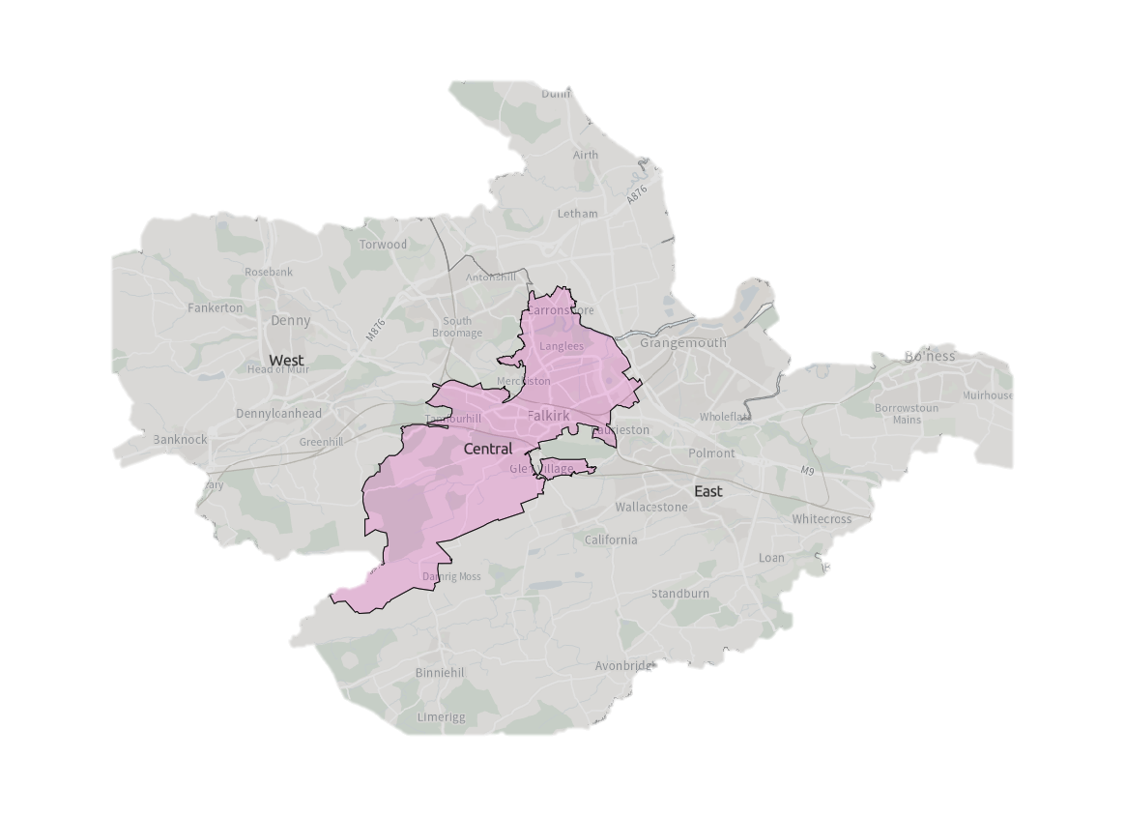





Contents

Introduction 3

Falkirk Health & Social Care Partnership 3

Locality Planning 3

Development of Falkirk East Locality Plan 3

Strategic Context 6

About Falkirk Central Locality 8

Summary 8

Services In The Area 9

Third Sector & Communities 9

Local Support 9

Previous Consultation & Engagement Feedback 10

Challenges in Falkirk Central 11

Guiding Principles & Priorities 15

Consultation & Engagement 16

Finance & Resources 17

Measuring Progress 18

Next Steps 19

Appendix 1: Delivery Plan 20

Appendix 2: Services in the Area 29

Document information

|  |  |
| --- | --- |
| **Date of issue:** | **31/01/2025** |
| **Approval status:** | **Approved by IJB** |
| **Review date:** | **March 2026** |
| **Available from:** | **Partnership Website** |
| **Alternative formats:** |  |
| **Key contact:** | Policy & Research Officer |

# Introduction

## Falkirk Health & Social Care Partnership

Falkirk Health and Social Care Partnership (HSCP) is one of 31 integration bodies in Scotland, serving a population of over 160,000 across rural and urban communities. It aims to enable people in Falkirk to live full and positive lives within supportive and inclusive communities.

The Partnership’s workforce is employed by Falkirk Council, NHS Forth Valley, and its partners in the third and independent sectors. They work in local social work offices, health centres, GP Practices, community hospitals, care homes, intermediate care facilities, day centres, and communities across the Falkirk area.

Falkirk Health and Social Care Partnership delivers care and support for adults and older people with mental health problems, long-term physical conditions, and substance misuse problems.

People who provide direct care for their loved ones, known as unpaid carers, are also supported by the Partnership through the [Falkirk and Clackmannanshire Carers Centre.](https://centralcarers.org/)

The Partnership is run by its [Integration Joint Board](https://falkirkhscp.org/falkirk-integration-board/)made up of representatives from Falkirk Council, NHS Forth Valley, the third sector, service users and carers.

The Board has responsibility for planning, resourcing and operating services, working to deliver the nine [National Health & Wellbeing Outcomes.](https://www.gov.scot/publications/national-health-wellbeing-outcomes-framework/)

## Locality Planning

The Partnership has identified three locality areas for service planning and delivery purposes. Our locality areas are aligned to GP ‘clusters’:

1. West: Denny, Bonnybridge, Larbert and Stenhousemuir
2. Central: Falkirk town, Camelon, Bainsford, Langlees, Hallglen
3. East: Grangemouth, Bo’ness, Braes Villages, Airth and Letham

Working by locality provides the opportunity for the Partnership to design integrated services and realign resources to deliver the [Falkirk HSCP Strategic Plan](https://falkirkhscp.org/wp-content/uploads/sites/9/2023/04/Falkirk-HSCP-Strategic-Plan.pdf). This includes working alongside our partners within the Community Planning Partnership and collaborating on [Falkirk Plan](https://www.falkirk.gov.uk/services/people-communities/community-planning/falkirk-plan.aspx) and [Community Action Plans](https://www.falkirk.gov.uk/services/people-communities/locality-planning/).

## Development of Falkirk East Locality Plan

Work started on the development of the Falkirk HSCP East Locality Plan with a self-evaluation assessment. The assessment involved:

* A review of available data
* Previous consultation and engagement feedback
* Board reports
* Staff feedback

The evidence gathered highlighted the current position of the localities in five areas:

* Access & Information
* Assessment & Support Planning
* Care Co-ordination
* Prevention & Supporting Independent Living
* Systems & Processes

A Locality Planning Steering Group involving key stakeholders was established to act as an oversight group and drive development for all three Locality Plans.

A Central Locality Delivery Group was convened and involved key stakeholders and partners from across the locality area, including third sector and carer representation. The role of the Locality Delivery Group was to plan and co-ordinate the development of the East Locality Plan, identifying challenges within the Locality and priority areas to be addressed. Development of the plan followed a bottom-up approach and was co-produced through an in-depth consultation & engagement process undertaken across the Locality.

The Central Locality Delivery group will work alongside partners and services within the Central Locality to support with implementation of the Locality Plan. Progress towards the delivery plan will be measured and reported back to the Strategic Planning Group.

Figure 1: Locality Planning Development Process

# Strategic Context

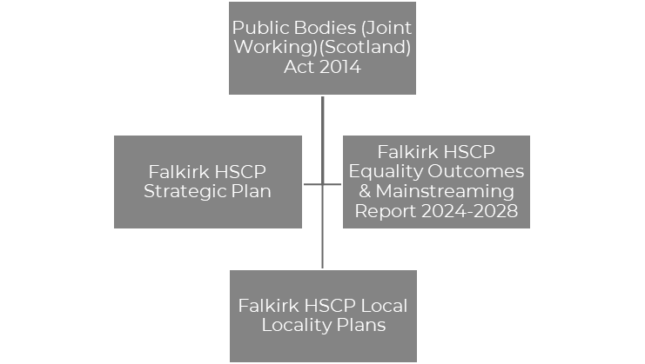

Figure 2: Strategic Context

**Public Bodies (Joint Working) (Scotland) Act 2014**

The [Public Bodies (Joint Working) (Scotland) Act 2014](https://www.legislation.gov.uk/asp/2014/9/contents/enacted)is the government legislation that underpins integration and the development of Health & Social Care Partnerships across Scotland. The Act sets out nine national outcomes for health & wellbeing, the preparation of Strategic Plans, and the requirement for HSCPs to establish localities within its area.

**Falkirk HSCP Strategic Plan**

Our Strategic Plan, [Creating a Healthier Falkirk,](https://falkirkhscp.org/wp-content/uploads/sites/9/2023/04/Falkirk-HSCP-Strategic-Plan.pdf) sets out the outcomes and priorities that we aim to deliver to help improve health and social care in Falkirk over a three year period between 2023 – 2026. The Strategic Plan sets out how the Integration Joint Board (IJB) will plan and deliver services for the Falkirk area, using the integrated budgets under our control.

Four Strategic priorities have been identified that the Partnership believe will make the biggest difference and helping us achieve our outcomes. The priorities are:

* Support and Strengthen Community-Based Services
* Ensure People Can Access the Right Care, at the Right Time, in the Right Place
* Focus on Prevention, Early Intervention and Minimising Harm
* Ensure Carers are Supported in their Caring Role

These priorities are driven by three workstreams:

* Workforce
* Technology
* Communication and Engagement

**Equality Outcomes & Mainstreaming Report**

[Falkirk HSCP Equality Outcomes & Mainstreaming Report](https://view.officeapps.live.com/op/view.aspx?src=https%3A%2F%2Ffalkirkhscp.org%2Fwp-content%2Fuploads%2Fsites%2F9%2F2024%2F03%2FEquality-Outcomes-and-Mainstreaming-Report-2024-2028.docx&wdOrigin=BROWSELINK)supports the partnerships commitment to promoting fairness, dignity and respect while delivering services that provide equal opportunity for all in Falkirk. The report sets out Equality Outcomes which will support the Partnership to achieve this aim. The Equality Outcomes are as follows:

* Equality Outcome 1: Older people who experience barriers to accessing internet-based health & social care services have alternative ways to access services
* Equality Outcome 2: People from Black and Minority Ethnic backgrounds who experience language and cultural barriers have improved access to services

**Falkirk HSCP Locality Plans**

The Partnership is required to develop Locality Plans for each locality within the area. The plans should demonstrate how the Outcomes & Priorities of the Falkirk HSCP Strategic Plan are implemented at a local level to ensure services respond to the priorities, needs and challenges of communities.

Although Locality Planning follows the Strategic Context set above, it is important that other local strategies are acknowledged with workstreams aligning where possible. This includes:

* [Falkirk HSCP Carers Strategy 2023-2026](https://view.officeapps.live.com/op/view.aspx?src=https%3A%2F%2Ffalkirkhscp.org%2Fwp-content%2Fuploads%2Fsites%2F9%2F2023%2F06%2FCarers-Strategy-2023-26.docx&wdOrigin=BROWSELINK)
* [Falkirk HSCP Participation & Engagement Strategy 2024-2027](https://view.officeapps.live.com/op/view.aspx?src=https%3A%2F%2Ffalkirkhscp.org%2Fwp-content%2Fuploads%2Fsites%2F9%2F2024%2F07%2FParticipation-and-Engagement-Strategy-2024-2027.docx&wdOrigin=BROWSELINK)
* [Falkirk Integrated Workforce Plan 2022-2025](https://falkirkhscp.org/publications/#workforce)
* [Falkirk Council Falkirk Plan & Community Action Plans](https://www.falkirk.gov.uk/services/people-communities/locality-planning/)

Additional HSCP Strategies and plans, including the Falkirk ADP Delivery Plan, Independent Advocacy Plan and Falkirk Learning Disability Strategy, are currently under development and will be integrated within Locality Planning going forward.

# About Falkirk Central Locality

## Summary

All data extracted from “Locality Profile: Falkirk Central Locality”

April 2024

and [ScotPHO Profiles](https://scotland.shinyapps.io/ScotPHO_profiles_tool/)

|  |  |
| --- | --- |
| **Population**  The projected population in Falkirk Central in 2024 is 44,107. This is 27% of Falkirk’s overall population.  20% of the population are 65+. This is slightly higher than Falkirk at 19.6%.  Falkirk Central has almost a 10% decrease in 0-4 years. Furthermore, it is the only Locality to not have a significant population change in females 85+. | Source: National Records Scotland |
| Source: Scottish Government, Public Health Scotland | **Community**  Falkirk Central is the smallest of Falkirk’s three locality areas.  Health Outcomes are influenced by a variety of factors, including deprivation, access to health care and environmental conditions.  32% of people in Central live in neighbourhoods that fall within the most deprived 20% of Scotland. |
| **Health**  Health outcomes in Falkirk Central are worse than both the Scottish and Falkirk average on a number of key measures, including life expectancy, mortality rate, and individuals living with long-term conditions.  Furthermore, the Locality has a higher rate of both drug-related and alcohol-related hospital admissions than Falkirk & Scotland.  A higher percentage of the population are prescribed medication for anxiety, depression or psychosis than in Scotland. | Life Expectancy in Falkirk Central  Mortality Rate in Falkirk Central  Source: ScotPHO  Source: ScotPHO |

## Services In The Area

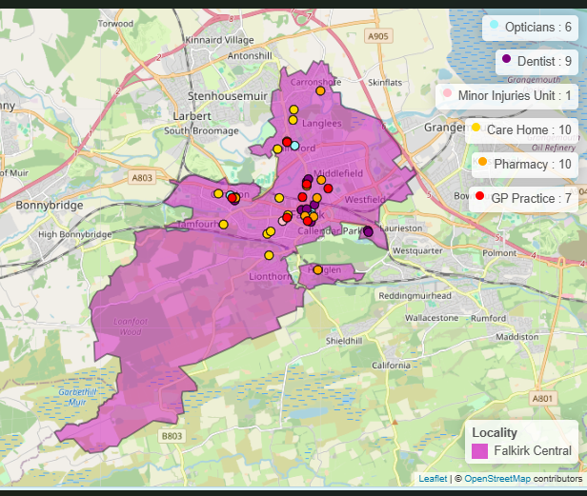

Figure 3 : Public Health Scotland

Further Information for health & wellbeing Services can be found at [NHS Inform](https://www.nhsinform.scot/scotlands-service-directory/). Details of services within the Figure 3 can be found at Appendix 2.

## Third Sector & Communities

CVS Falkirk & Districtare the Third Sector Interface for the Falkirk area and supports, promotes and develops the connection between the third sector and HSCP. They advocate for the role of the third sector within decision-making, strategic planning and redesign of health and social care services.

CVS Falkirk & District provided representation for the third sector and communities in the development of the Central Locality Plan. They have ensured communities have informed Locality Planning through a wide range of engagement that has included local forums and networks.

Our third sector and community organisations are vital assets in our communities and will be important partners in the implementation and delivery of the Central Locality Plan.

## Local Support

Falkirk Council have developed the [Our Falkirk- Local Services Map](https://www.falkirk.gov.uk/maps-local/local-support.aspx). It highlights support available within Falkirk Central Locality including provision for:

* Online access
* Food provision
* Money advice and support services
* Period Products
* Warm & Safe Welcoming Spaces

## Previous Consultation & Engagement Feedback

Over recent years, the Partnership has engaged with residents in Falkirk Central to assist with strategy development. Below is a summary of some of the key issues from previous engagement work and how the feedback has been represented within our various plans. It should be noted that although this has impacted Central Locality, most of the feedback has been Falkirk wide.

|  |  |
| --- | --- |
| **What We Have Been Told** | **What We Are Doing** |
| “It is a postcode lottery for where you stay that depends on the support you will get.” | Two priorities have been added to the Strategic Plan to address the issues raised during the consultation to improve support within our communities and how individuals access services:   * ‘Support and Strengthen Community-Based services.’ * ‘Ensure people can access the right care, at the right time, from the right person.’ |
| “Better communication between primary and secondary care would create better pathways between services.”  “Better local support in GP surgeries.” | ‘Communication & Engagement’ has been included in the Strategic Plan as a cross-cutting priority. We recognise the need for clear, accessible and inclusive information to ensure individuals know what support is available and how it can be accessed.  The partnership has recently developed a Participation & Engagement Strategy 2024-2027 to improve engagement and working relationships with our communities.  The Strategic Plan commits to the further development of multi-disciplinary teams in communities, bringing together different health and social care professionals. This will ensure communities can access a wider range of professionals and services within GP practices and closer to their home. |
| “It’s important that we recognise the need for people to live well, not just live longer.” | ‘Focus on prevention, early intervention and minimising harm’ is a priority in the current Strategic Plan as we recognise addressing issues before they escalate will help improve people’s wellbeing. |
| “Don’t know what alternative ways are to accessing services. Living on my own, no family to be shown what to do, nobody to ask for help.” | An Action has been added to the Equality Outcome & Mainstreaming Report:   * “We will communicate and promote traditional methods of accessing services with older people.” |
| “Third sector organisations coming together (let down by statutory services and needs partnership working to minimise waiting time and barriers to access).” | We will work closer with our Third Sector organisation and Community Groups as outlined in our Participation & Engagement Strategy. |
| “Dementia is 24/7.” | Development of a new evening and weekend support service within Dollar Park Dementia Service. |
| “We need to reduce drug use in the area.” | Community Substance Use Concerns is a theme within the Bainsford & Langlees Community Action Plan. The Falkirk Alcohol & Drug Partnership are currently conducting a Needs Assessment which will support the development of their Delivery Plan which will look at substance use concerns in our communities. |

## Challenges in Falkirk Central

Below is a summary of the challenges identified within Falkirk Central Locality which have supported with identifying our key priority areas outlined on page 12. The challenges have been identified based on previous and current engagement work which has supported the development of the plan. Evidence from available data, staff feedback and self-evaluation assessment reports has also been included. It is important to highlight that although some of the challenges have been identified in Falkirk Central, they are also Falkirk wide.

**Access to Services**

There is difficulty in making appointments with primary care services. Individuals face challenges accessing internet-based health and social care services and translation support. Feedback from respondents suggested it was difficult to access services outside the community they live in, with limited support available to help them. Limited wheelchair access was highlighted as an issue, particularly within the community around Hallglen. Furthermore, Falkirk Central currently has a lower uptake for bowel, breast and cervical cancer screenings than other locality areas.

**Access to Information**

Clear, accessible and easy-to-find information is not readily available. Individuals are unsure where to find or access information on support available within the locality area. Often, service users are presented with information that can become overwhelming and difficult to navigate.

**Anti-Social Behaviour**

During consultation, certain areas highlighted concerns with ongoing and increasing anti-social behaviour within their communities. Areas that expressed this concern included Hallglen, Callander Park high flats, Camelon and Bainsford & Langlees. This is impacting their health and wellbeing and causing negative feelings towards individuals within those communities.

**Unpaid Carers**

Some carers are unable to access the short break service and have difficulty finding information about support available to them. For example, some carers are not aware of advocacy and self-directed support options. Individuals are not aware they are unpaid carers and do not access the support they are entitled to. During the period 2023/2024, the carers centre received 699 referrals from individuals residing within the Central Locality, 45% were self-referrals and 19% from Social Work.

**Communication Between and from Services**

Individuals feel they receive insufficient communication from services about their care and are frustrated with having to repeat their stories to multiple services. Staff have also acknowledged that communication between services and partnership working within the locality could be improved. Residents within Camelon expressed their frustration in meaningful engagement and the concern that it is just token gestures.

**Health Inequalities**

Falkirk Central has a lower life expectancy for males and females than other Locality areas and around 22% of Falkirk Central population have a long-term condition. The Central Locality has a large proportion of people living in deprived areas which means individuals will experience comparatively worse outcomes in terms of key health indicators. Individuals indicated that they would like to have access to the appropriate information required to help them deal with their health & wellbeing.

**Local Support**

It is perceived more local support is needed that does not require use of transport or travelling out-with the area. A lack of community-based groups and services in the Central Locality means individuals have to leave the area to access support if they can afford it, for example in Grangemouth, Larbert & Denny.

**Mental Health & Wellbeing**

There are still issues with waiting times for mental health referrals, and respondents have expressed frustration with having to speak to a mental health nurse over the phone. There is an increased demand for dementia support and older adult mental health referrals within Central Locality. Central has a higher percentage of prescriptions for anxiety, depression and psychosis and carers shared the need for greater support with stress management.

**Respite**

Falkirk has nearly double the national average in respite provision, however during various engagement exercises carers reported being unable to access respite support. The Carers Voice Group shared concerns that the situation was becoming a crisis. Access to respite and improving support has been acknowledged within the Falkirk Learning Disability Strategy.

**Stigma**

Stigma is still an issue with regard to mental health, substance use, carers and disabilities. Stigma has also been highlighted as a main reason for individuals not engaging or disengaging with services. Statutory services were highlighted as impacting stigma as a result of previous experiences service users had endured.

**Substance Use**

There is a rise in alcohol-related admissions and drug-related hospital admissions from Falkirk Central. Substance use is recognised as a concern for local communities and the Bainsford & Langlees Community Action Plan has Substance Use Concerns as a priority area. Respondents to our consultation outlined that it was important that both mental health & wellbeing and substance use were prioritised together rather than in isolation.

**Transition**

Transitioning between children and adult services is regularly highlighted as an issue but equally challenging is older carers whose cared-for person is middle-aged. There is concern about future planning and the uncertainty of what future support will be available for their cared-for person.

**Travel**

Travel is noted as a problem, particularly for accessing services out-with the area. This includes limited options available, accessibility to travel options and affordability. Some respondents also shared the difficulty they have accessing their GP with some registered to surgeries out-with the locality area. Respondents expressed concern that travel issues might lead to missed appointments. There are also issues accessing taxis within the town centre for individuals who require mobility support. Carers raised issues with transport and a request to review the local transport policy.

# Guiding Principles & Priorities

Below are the priority areas for Falkirk Central Locality. The priorities have been identified by the Locality Delivery Group and were finalised following public engagement and consultation work with the wider community.

The Delivery Plan within Appendix 1 sets out actions for each priority area. The Delivery Plan will be implemented by the Locality Team with the support of the Locality Delivery Group.

**Priority: Making it Easier to Manage Your Health & Wellbeing**

To support individuals, their carers and families to plan, manage and understand their own health, care and wellbeing.

**Priority: Improved Access & Availability of Community-Based Resources**

Improvement in clear, accessible and inclusive communication to ensure service users are aware of what is available to them within their local area.

**Priority: Reducing Mental Health Harms and Supporting Recovery**

Capturing all aspects that impact mental health & wellbeing and ensuring adequate support for recovery is available. A high level of the population lives in areas of deprivation and is at greater risk of developing a mental health disorder.

**Priority: Improved Partnership Working**

Improving partnership working and information sharing between services, resulting in improved experiences and outcomes for service users.

**Addressing Health & Social** **Inequalities**

**Focus on Person-Centred Care**

**Improving Trauma Informed Approaches**

**Eliminate discrimination, advance equality of opportunity & foster good relations**

Guiding Principles

The priority areas will be supported by four guiding principles established by the Delivery Group. The guiding principles will be taken into account throughout each priority area and will underpin all work undertaken within the locality.

# Consultation & Engagement

The phase of consultation and engagement for the development of the Central Locality Plan was undertaken from 16 October to 28 November 2024. The consultation involved:

* An online survey and Central Locality Summary document are available via Falkirk Council’s [Participate+](https://participateplus.falkirk.gov.uk/en-GB/projects/falkirk-hscp-locality-plans) website.
* In-person meetings with local community groups and organisations.
* Attendance at local events such as Older Peoples Day & Camelon Action Plan Workshop.
* Drop-in event at Falkirk Central Library.

Consultation fatigue was highlighted as a concern to officers when conducting previous consultation work for the Partnership. Therefore, the Delivery Group also utilised data and feedback from previous engagements to identify challenges and priority areas to address in Falkirk Central.

The Consultation phase for the Central Locality Plan followed a collaborative approach with individuals to refine the challenges, priority areas and actions to be implemented. The engagement targeted particular service groups including older people, local community groups, carers and substance use services.

Overall, 38 individuals completed the online survey and over 100 people were consulted at 14 in-person events. A consultation report is available on the Falkirk Council [Participate+](https://participateplus.falkirk.gov.uk/en-GB/projects/falkirk-hscp-locality-plans) platform. The report outlines feedback received during consultation and where respondents were instrumental in the decision-making of the Central Locality Plan.

# Finance & Resources

The Integration Joint Board is primarily funded for services through contributions from Falkirk Council and NHS Forth Valley and has a duty to set a balanced annual budget aligned to the Strategic Plan.

In September 2024, the IJB agreed a Budget Strategy setting out an approach to meet a £21.164m financial gap over the next three years. The budget process is ongoing at this time and a balanced budget requires to be approved on 21 March 2025.

The Medium-term Financial Plan outlines the overall resources available to the Partnership and ensures a robust approach to financial planning, allowing co-ordination between service redesign, transformation and annual budgets. An update on a [Business Case and Medium Term Financial Plan](https://www.falkirk.gov.uk/coins/viewSelectedDocument.asp?c=e%97%9Dc%93j%82%8C) was presented to the IJB in November 2024 and outlined a financial plan setting process in respect of the current position. The budget working group are preparing proposals to close the budget gap.

The Partnership’s financial planning will be challenging throughout the duration of this Locality Plan. This is consistent with the position for both Falkirk Council, NHS Forth Valley and the overall Partnership. Work is under way to establish some initial locality budgets at this time, with further development required for coming years to review each locality teams budget resources and responsibilities.

# Measuring Progress

The Central Locality Delivery Plan within Appendix 1 outlines how each action will be measured throughout the duration of the plan. Progress towards the actions will be reviewed by the Central Locality Delivery Group and reported to the Locality Planning Steering Group. The Steering Group will then inform the Strategic Planning Group, Senior Leadership Team and the Integration Joint Board.

The Partnership’s Integration Joint Board receives regular performance reports. These reports ensure the Board fulfils its ongoing responsibility to ensure effective monitoring and reporting on the delivery of services. Future reports will provide information on performance against targets and measures set out in the Central Locality Plan.

# Next Steps

The Locality Planning Steering Group will review and develop a process for the effective implementation of the Central Locality Plan. This will include connecting with ongoing groups and committees across the Partnership to provide connection and additional support towards implementation.

The Central Locality Delivery Group will review its membership to ensure important stakeholders continue to be involved. The group will expand to include members of the public in the Delivery Group process, and the feasibility of organising public meetings is currently under discussion.

The Central Locality Plan provides an important insight for the upcoming review of the Falkirk HSCP Strategic Plan, which will commence in 2025. The Central Locality Plan will be pivotal in shaping a new Strategic Plan that meets the priorities, needs and challenges currently faced in our communities.

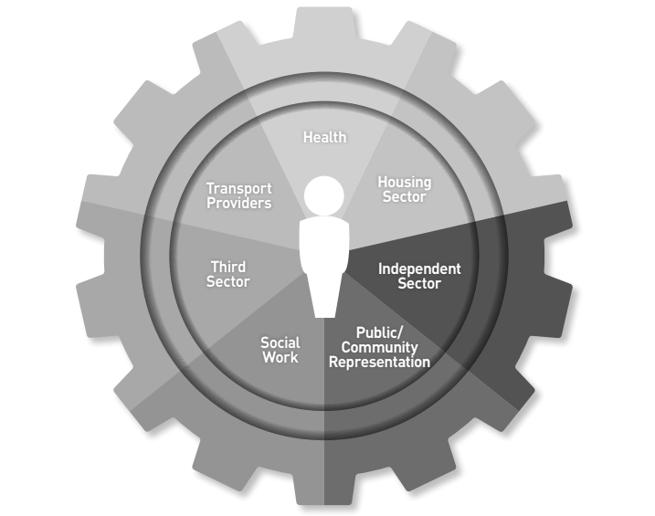

Figure 4: Locality Delivery Group Stakeholders

# Appendix 1: Delivery Plan

This Delivery Plan supports the implementation of the Partnership’s Central Locality Plan for 2025-2026. It has been developed by the Central Locality Delivery Group who will continue to review the plan and assist with its implementation. Progress will be reported to the Locality Planning Steering Group who will inform our Strategic Planning Group, Senior Leadership Team and Integration Joint Board. The Delivery Plan reflects related workstreams where applicable.

The Delivery Plan contains 15 actions, aligned with four priority areas:

|  |  |
| --- | --- |
| **Action** | **Priority** |
| 1-4 | Making it Easier to Manage Your Health & Wellbeing |
| 5-8 | Improved Access & Availability of Community-Based Resources |
| 9-12 | Reducing Mental Health Harms & Supporting Recovery |
| 13-15 | Improved Partnership Working |

Work will be progressing to implement actions within the Delivery Plan throughout the Locality Plans iteration. Synergies and duplicate actions between Localities will be reviewed as each plan progresses. Development of the Delivery Plan has considered the upcoming review of the HSCP Strategic Plan and future Falkirk HSCP operating model. Once the current Locality Plan iteration is complete, we will review priority areas, actions and timescales to align with the new Falkirk HSCP Strategic Plan.

## Priority Area: Making It Easier to Manage Your Health & Wellbeing

|  |  |  |  |  |
| --- | --- | --- | --- | --- |
| **No.** | **What we Want to Achieve**  **(Action)** | **How We Are Going to Achieve It**  **(Tasks/Measure)** | **Resources**  **(Lead)** | **Timescale** |
| 1 | Information and appropriate signposting are provided that can support individuals to manage their health & wellbeing | 1. Identify key community led support that staff can signpost or refer people to. 2. Develop a standardised process to follow when signposting or referring people to community led support. 3. Train staff on effective signposting and referrals. 4. Provide people requiring support with user-friendly information on available support. 5. Track how often and to which services people are referred, and gather feedback on whether the support meets their needs. | Community Led Support Co-ordinator | June 2026 |
| 2 | The workforce are poverty aware and recognise early intervention opportunities to signpost to relevant support services | 1. Staff who have access to Falkirk Councils OLLE training course have undertaken the Think Poverty module with number of completions provided by Fairer Falkirk team. 2. Think Poverty training sessions have been conducted initially with Adult Social Work Teams in line with Fairer Falkirk’s Action Plan. 3. Public Protection Webinars are available for the workforce to access and improve their understanding of the impact of poverty. 4. Services are updated with refreshed information to inform our communities on a Stay Safe, Well and Warm provision in a format that is accessible to them. | Locality Lead  With Support from:   * Fairer Falkirk * Public Protections Group | June 2026 |
| 3 | There is good visibility across the Central Locality highlighting pathways and support for individuals and families experiencing poverty. | 1. Identify current initiatives and uptake within the Central Locality for access to support services within Citizens advice Bureau and Community Advice Service. 2. Identify priority locations for displaying support service information, for example areas of multiple deprivation. | Citizen Advice Bureau  &  Community Advice Service | June 2026 |
| 4 | Empower people who live and work in the locality to be more aware of and informed about key health issues in the local community | 1. Increase in community assets (people, places, community) that have been supported to provide public and community health messaging, targeted towards known local locality needs. 2. Increase in people engaging with formal and informal learning on health behaviour change. | Community Development  With support from:   * Health Improvement Service * Public Health and Public Health Nutrition/Dietetics * Allied Health Professionals | June 2026 |

## Priority Area: Improve Access & Availability of Community-Based Resources

|  |  |  |  |  |
| --- | --- | --- | --- | --- |
| **No.** | **What we Want to Achieve**  **(Action)** | **How we are going to Achieve it**  **(Tasks/Measure)** | **Resources**  **(Lead)** | **Timescale** |
| 5 | Information and knowledge about local services and support are available and promoted | 1. Compile a list of key local support services, resources and contacts relevant to the Central Locality. 2. Create a user-friendly directory with information on support in a format that can be kept up to date. 3. Deliver information sessions and training to increase staff knowledge of support. 4. Promote awareness to the public. | Community-Led Support Co-ordinator | June 2026 |
| 6 | Work with partners to find solutions that will reduce practical barriers to accessing health and social care services | 1. Conduct a needs assessment to understand why individuals cannot access services. 2. Establish a working group of local partners to explore solutions. 3. Co-design initiatives with local partners to address barriers. 4. Pilot the initiatives. 5. Measure and evaluate. | Community-led Support Co-ordinator | September 2026 |
| 7 | Improve the experiences of individuals accessing and using services | 1. Staff are provided with learning and development opportunities to respond effectively to individuals’ circumstances and need at first point of contact. 2. Staff are supported to access the appropriate level of trauma training required for their post. 3. Services take a “trauma informed lens” to their service to consider practical changes they can make to embed trauma informed change. | Locality Lead  With support from   * Workforce Development * Trauma Informed Practice and Policy Development Officer | December 2025 |
| 8 | Identify and provide support to hidden and new carers within the Central Locality | 1. Track and monitor Carers accessing support from the Carers Centre for the first time and noting their supporting role. 2. Delivery of information sessions from the Carers Centre staff across the Locality to outline support they offer and how individuals can be signposted to the service. | Carer Participation Development Worker | December 2025 |

## Priority Area: Reduce Mental Health Harms & Supporting Recovery

|  |  |  |  |  |
| --- | --- | --- | --- | --- |
| **No.** | **What we Want to Achieve**  **(Action)** | **How we are going to Achieve it**  **(Task/Measure)** | **Resources**  **(Lead)** | **Timescale** |
| 9 | Support with development and implementation of Regional and Local Strategies currently under development which relate to the priority area. | 1. Falkirk ADP Delivery Plan. 2. Gender-Based Violence Strategy. 3. Forth Valley Mental Health & Wellbeing Strategic Plan. | Locality Lead  With support from:   * Falkirk ADP Development Officer * GBV Lead Officer * IMH | June 2026 |
| 10 | Staff are provided with additional support to help Manage their mental health & Wellbeing | 1. Wellbeing/Wellness pack developed and provided to all staff with information and support for managing their own mental health and wellbeing. 2. Connecting with an integrated Mental Health team to source additional support to be provided and promoted to staff. | Central Locality Team Manager Care and Support at Home  With support from:   * Health Improvement Service | September 2025 |
| 11 | Social work staff have Improved knowledge of substance use & referral pathways | 1. Deliver CREATE sessions with social work staff which will provide staff with knowledge and skills to understand the presentation of substance use and available recovery pathways. 2. Roll out of associated work that comes from CREATE sessions and continue to provide ongoing support to social work with this. | Falkirk ADP Development Officer | December 2025 |
| 12 | Explore opportunities to improve social prescribing and peer support | 1. Identify current support available for social prescribing and peer support within the Central Locality. 2. Work with partners to understand the need for improved support and how this could be provided. | Falkirk ADP Development Officer | December 2025 |

## Priority Area: Improved Partnership Working

|  |  |  |  |  |
| --- | --- | --- | --- | --- |
| **No.** | **What we Want to Achieve**  **(Action)** | **How we are going to Achieve it**  **(Tasks/Measure)** | **Resources**  **(Lead)** | **Timescale** |
| 13 | Delivery Group Set-up and Running to Support Locality Planning | 1. Further Develop the Locality Planning Delivery Group, implement Terms of Reference and framework to ensure functionality of the group. 2. Expansion of members to include further representation across the Locality, particular focus on Health colleagues and local community representation. | Falkirk HSCP Planning & Performance team  With support from:   * Central Locality Delivery Group Chairperson | December 2025 |
| 14 | Implement a Pilot on Safeguarding Through Rapid Intervention (STRIVE) fortnightly meetings within the Central Locality. | 1. STRIVE meetings will recognise the importance of suitable early intervention for adults who present at social work, police and NHS emergency departments. 2. A multi-agency approach with relevant services and partners in the Central Locality involved. 3. Individuals at risk are provided with effective support and signposting to prevent escalation in circumstances. | Central Locality Team Manager Community Care  With support from:   * ASP Lead Officer | December 2025 |
| 15 | Third Sector & Communities involved in Locality Planning Process | 1. Local communities and organisations involved in the Locality Planning process with representation on Locality Delivery Groups. 2. Local communities and organisations are supported to collaborate on local projects and initiatives that meet locality needs. | CVS Falkirk & District | June 2026 |

# Appendix 2: Services in the Area

Breakdown of services provided within figure 1, page 8.

**GP Practice**

|  |  |  |
| --- | --- | --- |
| **Practice** | **Address** | **Number** |
| Alba Medical Group | Westburn Avenue, Falkirk, FK1 5SU | 03301 289389 |
| Ark Medical Practice | 9 Booth Place, Falkirk, FK1 1BA | 01324 621113 |
| Camelon Medical Practice | 3 Baird Street, Camelon, Falkirk, FK1 4PP, FK2 7ES | 01324 622854 |
| Meeks Road Surgery | 10 Meeks Road, Falkirk, FK2 7ES | 01324 619930 |
| The Graeme Medical Centre | 1 Western Avenue, Falkirk, FK1 4PP | 01324 624437 |
| Wallace Medical Centre | 254 Thornhill Road, Falkirk, FK2 7AZ | 01324 622826 |

**Care Home**

|  |  |  |
| --- | --- | --- |
| **Name** | **Type** | **Address** |
| Burnbrae | Older People | Burnbrae Road, Falkrik FK1 5SD |
| Carrondale Nursing Home | Older People | Carron, Falkirk, FK2 8SN |
| Grahamston House | Older Popele | Mandela Avenue, Falkirk, FK1 7BD |
| Kinnaird Manor Care Home | Older People | Brown Street, Camelon, FK1 4QF |
| Newcarron Court Nursing Home | Older People | Newcarron Court, Falkirk, FK2 7TB |
| Summerford House | Older People | Summerford, Falkirk, FK1 5BT |
| Thorntree Mews | Older People | House Arnothill, Arnothill Mews, Falkirk, FK1 5RZ |
| Treddinoch | Learning Disabilities | 33 Slamannan Road, Falkirk, FK1 5NF |
| Willow Lodge | Mental health | Windsor Road, Falkirk, FK1 5EL |

**Pharmacist**

|  |  |  |
| --- | --- | --- |
| **Pharmacist** | **Address** | **Number** |
| Boots The Chemist | 79-91 High Street, Falkirk | 01324 620535 |
| Callander Pharmacy | 334 Thornhill Road, Falkirk | 01324 623688 |
| Tesco Pharmacy | Central Retail Park, Grahams Road, Falkirk | 0131 2892565 |
| Well | New Carron Village, 1 Ronades Road, Falkirk | 01324 612439 |
| Falkirk Pharmacy | 96-98 Grahams Road, Falkirk | 01324 635859 |
| Callendar Pharmacy | Hallglen Centre, New Hallglen Road, Hallglen, | 01324679732 |
| Hallglen Pharmacy | Hallglen Centre, New Hallglen Road, Hallglen | 01324 679732 |
| Right Medicine Pharmacy | 84-85 May Street, Laurieston | 01324 623454 |

**Dentist**

|  |  |  |
| --- | --- | --- |
| **Dentist** | **Address** | **Number** |
| Lint Riggs Dental Care | 16 Lint Riggs, Falkirk, FK1 1DG | 01324 623300 |
| Forth Valley Smile Design | 6 Weir Street, Falkirk, FK1 1RA | 01324 621495 |
| Clark & Watson | 27 Newmarket Steet, Falkirk, FK1 1JJ | 01324 623045 |
| Falkirk Courtyard Dental | Unit 4, Callander Business Park, Falkirk, FK1 | 01324 622392 |
| Dental Surgery Limited | 112 Grahams Road, Falkirk, FK2 7BZ | 01324 622338 |
| Lux Dental Care | 8 Union Road, Falkirk, FK1 4PG | 01324 623089 |
| Central Orthodontics | Unit 4, Callander Business Park, Falkirk, FK1 1XR | 01324 621130 |
| Falkirk Dental Care | 91 Grahams Road, Falkirk, FK2 7DD | 01324 671278 |
| Envisage Dental Health Falkirk | 54-58 Cow Wynd, Falkirk, FK1 1PU | 01324 624630 |

**Opticians**

|  |  |  |
| --- | --- | --- |
| **Optician** | **Address** | **Number** |
| Thomas McMahon | 83 Manor Street, Falkirk, FK1 1NU | 01324 626464 |
| Specsavers Falkirk | 128-130 High Street, Falkirk, FK1 1HB | 01324 638872 |
| Boots Professional Services | 79-91 High Street, Falkirk, FK1 1HB | 01324 636434 |
| Vision Express | 118 High Street, Falkirk, FK1 1NW | 01324 639240 |
| Firstform LTD T/A For Eyes | 340 Main Street, Camelon, Falkirk, FK1 4AR | 01324 635919 |
| Firstform LTD T/A For Eyes | 3 Carron Road, Bainsford, Falkirk, FK2 7RS | 01324 636213 |

**Third Sector & Communities**

* CVS Falkirk & District have a directory available on their website which lists groups and organisations that are members of CVS Falkirk & District within our communities: [Members Directory](https://www.cvsfalkirk.org.uk/members-directory/)
* ALISS is a national digital programme enabling people and professionals to find and share information on health and wellbeing resources, services, groups, and support in their local communities and online: [About ALISS | ALISS](https://www.aliss.org/about-aliss/)