Appendix 1

Falkirk Health & Social Care Partnership Locality Planning

East Locality Plan 2025-2026

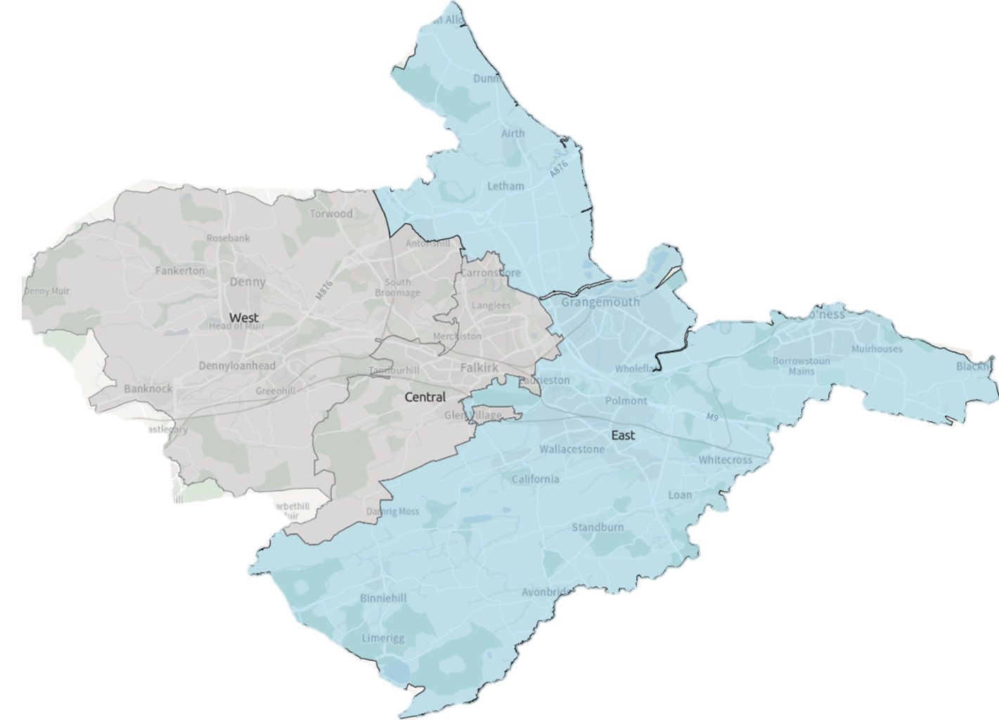



Contents

Introduction 3

Falkirk Health & Social Care Partnership 3

Locality Planning 3

Development of Falkirk East Locality Plan 4

Strategic Context 4

About Falkirk East Locality 7

Summary 7

Services In The Area 8

Primary Care Services 8

Third Sector & Communities 9

Community Learning and Development 9

Local Support 9

Previous Consultation & Engagement Feedback 10

Challenges in Falkirk East Locality 12

Guiding Principles & Priorities 17

Consultation & Engagement 18

Finance & Resources 19

Measuring Progress 20

Next Steps 21

Appendix 1: Strategy & Policy Context 22

Appendix 2: East Locality Delivery Plan 23

Appendix 3: Services in the Area 32

Document information

|  |  |
| --- | --- |
| **Date of issue:** | **20/06/2025** |
| **Approval status:** | **Approved by IJB** |
| **Review date:** | **June 2026** |
| **Available from:** | [falkirkhscp.org/publications](https://falkirkhscp.org/publications) |
| **Alternative formats:** | One page summary version |
| **Key contact:** | Policy & Research Officer |

# Introduction

## Falkirk Health & Social Care Partnership

Falkirk Health and Social Care Partnership (HSCP) is one of 31 integration bodies in Scotland, serving a population of over 160,000 across rural and urban communities. It aims to enable people in Falkirk to live full and positive lives within supportive and inclusive communities.

The Partnership’s workforce is employed by Falkirk Council, NHS Forth Valley, and its partners in the third and independent sectors. They work in local social work offices, health centres, GP Practices, community hospitals, care homes, intermediate care facilities, day centres, and communities across the Falkirk area.

Falkirk Health and Social Care Partnership delivers care and support for adults and older people with mental health problems, long-term physical conditions, and substance misuse problems.

People who provide direct care for their loved ones, known as unpaid carers, are also supported by the Partnership through the [Falkirk and Clackmannanshire Carers Centre.](https://centralcarers.org/)

The Partnership is run by its [Integration Joint Board](https://falkirkhscp.org/falkirk-integration-board/)made up of representatives from Falkirk Council, NHS Forth Valley, the third sector, service users and carers.

The Board has responsibility for planning, resourcing and operating services, working to deliver the nine [National Health & Wellbeing Outcomes.](https://www.gov.scot/publications/national-health-wellbeing-outcomes-framework/)

## Locality Planning

The Partnership has identified three locality areas for service planning and delivery purposes. Our locality areas are aligned to GP ‘clusters’:

1. West: Denny, Bonnybridge, Larbert and Stenhousemuir
2. Central: Falkirk town, Camelon, Bainsford, Langlees, Hallglen
3. East: Grangemouth, Bo’ness & Blackness, Braes Villages, Airth and Letham

Working by locality provides the opportunity for the Partnership to design integrated services and realign resources to deliver the [Falkirk HSCP Strategic Plan](https://falkirkhscp.org/wp-content/uploads/sites/9/2023/04/Falkirk-HSCP-Strategic-Plan.pdf). This includes working alongside our partners within the Community Planning Partnership and collaborating on [Falkirk Plan](https://www.falkirk.gov.uk/services/people-communities/community-planning/falkirk-plan.aspx) and [Community Action Plans](https://www.falkirk.gov.uk/services/people-communities/locality-planning/).

## Development of Falkirk East Locality Plan

Work started on the development of the Falkirk HSCP East Locality Plan with a self-evaluation assessment. The assessment involved:

* A review of available data
* Previous consultation and engagement feedback
* Board reports
* Staff feedback

The evidence gathered highlighted the current position of the localities in five areas:

* Access & Information
* Assessment & Support Planning
* Care Co-ordination
* Prevention & Supporting Independent Living
* Systems & Processes

A Locality Planning Steering Group involving key stakeholders was established to act as an oversight group and drive development for all three Locality Plans.

An East Locality Delivery Group was convened and involved key stakeholders and partners from across the locality area, including third sector and carer representation. The role of the Locality Delivery Group was to plan and co-ordinate the development of the East Locality Plan, identifying challenges within the Locality and priority areas to be addressed. The Locality Delivery Group meant the development of the plan followed a bottom-up approach and supported with co-production with communities in the Locality through a phase of public consultation & engagement.

The East Locality Delivery group will work alongside partners and services within the East Locality to support with implementation of the Locality Plan. Progress towards the delivery plan will be measured and reported back to the Strategic Planning Group.

# Strategic Context

Figure 1: Locality Planning Development Process

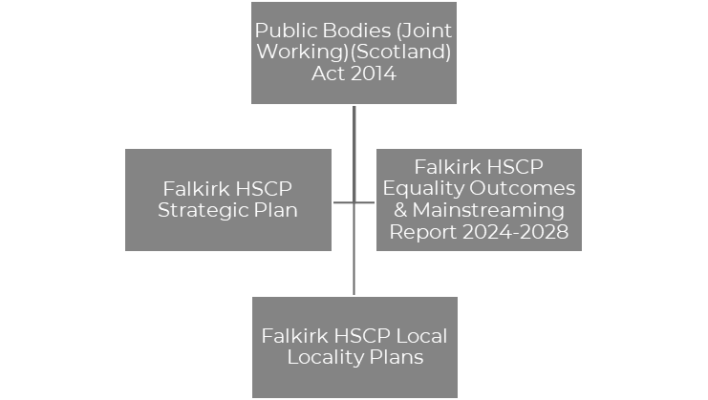

Figure 2: Strategic Context

**Public Bodies (Joint Working) (Scotland) Act 2014**

The [Public Bodies (Joint Working) (Scotland) Act 2014](https://www.legislation.gov.uk/asp/2014/9/contents/enacted)is the government legislation that underpins integration and the development of Health & Social Care Partnerships across Scotland. The Act sets out nine national outcomes for health & wellbeing, the preparation of Strategic Plans, and the requirement for HSCPs to establish localities within its area.

**Falkirk HSCP Strategic Plan**

Our Strategic Plan, [Creating a Healthier Falkirk,](https://falkirkhscp.org/wp-content/uploads/sites/9/2023/04/Falkirk-HSCP-Strategic-Plan.pdf) sets out the outcomes and priorities that we aim to deliver to help improve health and social care in Falkirk over a three-year period between 2023 – 2026. The Strategic Plan sets out how the Integration Joint Board (IJB) will plan and deliver services for the Falkirk area, using the integrated budgets under our control.

Four Strategic priorities have been identified that the Partnership believe will make the biggest difference and helping us achieve our outcomes. The priorities are:

* Support and Strengthen Community-Based Services
* Ensure People Can Access the Right Care, at the Right Time, in the Right Place
* Focus on Prevention, Early Intervention and Minimising Harm
* Ensure Carers are Supported in their Caring Role

These priorities are driven by three workstreams:

* Workforce
* Technology
* Communication and Engagement

**Equality Outcomes & Mainstreaming Report**

[Falkirk HSCP Equality Outcomes & Mainstreaming Report](https://view.officeapps.live.com/op/view.aspx?src=https%3A%2F%2Ffalkirkhscp.org%2Fwp-content%2Fuploads%2Fsites%2F9%2F2024%2F03%2FEquality-Outcomes-and-Mainstreaming-Report-2024-2028.docx&wdOrigin=BROWSELINK)supports the partnership’s commitment to promoting fairness, dignity and respect while delivering services that provide equal opportunity for all in Falkirk. The report sets out Equality Outcomes which will support the Partnership to achieve this aim. The Equality Outcomes are as follows:

* Equality Outcome 1: Older people who experience barriers to accessing internet-based health & social care services have alternative ways to access services
* Equality Outcome 2: People from Black and Minority Ethnic backgrounds who experience language and cultural barriers have improved access to services

**Falkirk HSCP Locality Plans**

The Partnership is required to develop Locality Plans for each locality within the area. The plans should demonstrate how the Outcomes & Priorities of the Falkirk HSCP Strategic Plan are implemented at a local level to ensure services respond to the priorities, needs and challenges of communities.

Although Locality Planning follows the Strategic Context set above, other strategies and workstreams within the HSCP and local partners must be aligned where possible. A list of all Strategies and plans connected to Locality Planning is outlined in Appendix 1. Alignment with plans will be reviewed as we further enhance our Locality Planning process.

As a result of the Just Transition work ongoing in Grangemouth, officers have had discussions with partners to ensure work undertaken from a national perspective has been considered within the Locality Planning approach.

# About Falkirk East Locality

## Summary

Information extracted from “Locality Profile: Falkirk East Locality,” April 2024

& [ScotPHO Profiles](https://scotland.shinyapps.io/ScotPHO_profiles_tool/)

|  |  |
| --- | --- |
| Population change for Falkirk East from 2016-2021**Population**  Falkirk East is the largest populated locality. In 2024, the projected population was 68,748.  Population growth for those aged 65+ is notable for both males and females, whereas in other localities it is more concentrated among males. Specifically, the population of 85+ is almost 10% for both genders is greater than in other localities. | Source: National Records Scotland |
| SIMD quintile zones in Falkirk East  Source: Scottish Government, Public Health Scotland | **Community**  Falkirk East is the largest of the Localities and covers multiple settlements in rural areas.  Health Outcomes are influenced by a variety of factors, including deprivation, access to health care and environmental conditions.  11.7% of the population live in the neighbourhoods that fall within the most deprived 20% in Scotland with access as the most common domain. |
| **Health**  Falkirk East has a greater life expectancy for females across the three locality areas. More people 85+ have at least one long-term health condition and it has the highest rate of delayed discharge from hospital for 65+.  People from deprived areas are 15.3 times more likely to die from drug use. Through the period 2019-2023, the Locality had a higher rate of alcohol-specific deaths per 100,000 across the three Localities.  In 2023/24, over 22.1% of the population are prescribed medication for depression, anxiety and psychosis. | Average life expectancy in Falkirk East  Source: ScotPHO  Alcohol-specific deaths in Falkirk East  Source: ScotPHO |

## Services In The Area

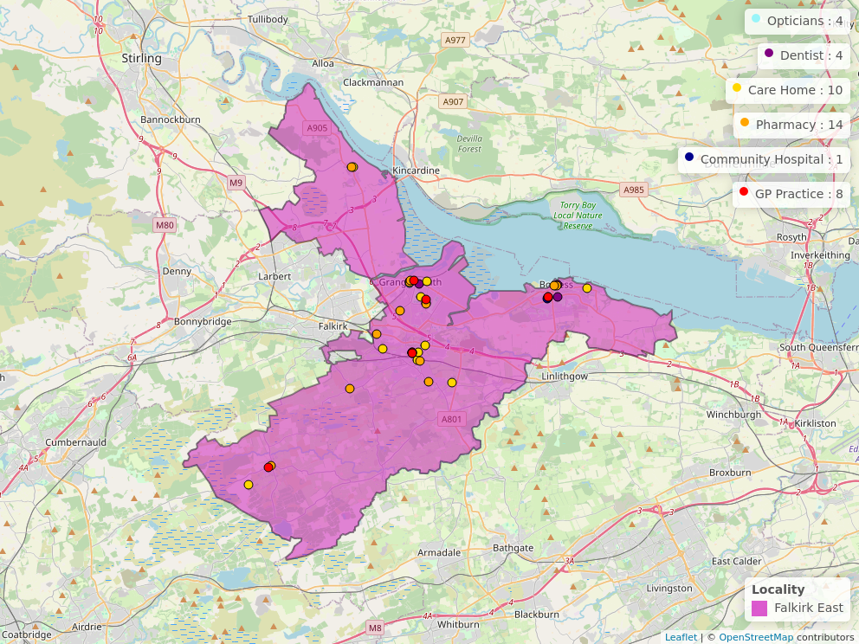

Figure 3: Public Health Scotland

Further Information for health & wellbeing Services can be found at [NHS Inform](https://www.nhsinform.scot/scotlands-service-directory/). Details of services within the Figure 3 can be found at Appendix 3.

## Primary Care Services

Capacity within GP practices were increased across Falkirk East as a result of the [Forth Valley Primary Care Improvement Plan 2018-2021](https://links.uk.defend.egress.com/Warning?crId=67cb64975750110ba7c41c32&Domain=falkirk.gov.uk&Threat=eNpzrShJLcpLzAEADmkDRA%3D%3D&Lang=en&Base64Url=eNoFwssJgDAMANBpck29aQURpBs4QYlRS7_YtOL28t4tUuqsFGWXKp42ePd4vHLH5lV3_O4cmIQPk6lFToK2lpUWBj2CNgR6iB9M2w_PBxk3&@OriginalLink=coins.falkirk.gov.uk). As a result, additional Healthcare professionals were recruited to support with service demand. This has led to additional pressures on the capacity of facilities where practices are located.

Practices are contracted by NHS Forth Valley to provide medical services under the 2018 Scottish General Medical Services (GMS) Contract. 90% of healthcare encounters take place in general practice, however many practices in Scotland do not have enough clinicians to meet the needs of their patients. This creates a capacity and demand imbalance which is resulting in a lack of sustainability in general practice.

The British Medical Association (Scotland) has produced [Safe Working Guidance for Practices](https://links.uk.defend.egress.com/Warning?crId=67cb64975750110ba7c41c32&Domain=falkirk.gov.uk&Threat=eNpzrShJLcpLzAEADmkDRA%3D%3D&Lang=en&Base64Url=eNo9zEEWwyAIANETIfvehmpCfTHAA6zXj6ssZxb_l2nxQVxrle9NRZ3LvJDav9cDSBrENFNPZANzqrl_4E1C3IVhqV9DqWHQebwFPHsj2cKpDmwBXSCq5tjiA8oAK4k%3D&@OriginalLink=www.bma.org.uk). The guidance provides GPs with advice on how to safely manage workload such as redirecting patients to more suitable NHS services, the number of patient contacts per day and appointment times*.*

Practices will follow the [Right Care, Right Place](https://www.nhsinform.scot/campaigns/right-care-right-place) guidance to signpost individuals to appropriate health care provider. This can include dentist, optician, physiotherapist, mental health nurse and the [Pharmacy First Scotland service.](https://www.nss.nhs.scot/pharmacy-services/pharmacy-services/nhs-pharmacy-first-scotland-pfs/) Practices will have their own systems in place to triage patients. This is supported by GP reception teams who may ask for a brief idea of patients symptoms to enable them to be directed to the most appropriate support.

## Third Sector & Communities

CVS Falkirk & Districtare the Third Sector Interface for the Falkirk area and supports, promotes and develops the connection between the third sector and HSCP.

CVS Falkirk & District provided representation for the third sector and communities in the development of the East Locality Plan. They have also supported the Scottish Government to engage with Communities in the development of the [Grangemouth Just Transition Plan](https://www.gov.scot/publications/grangemouth-industrial-cluster-transition-vision/).

Our third sector and community organisations are vital assets in our communities and will be important partners in the implementation and delivery of the East Locality Plan.

## Community Learning and Development

Community Learning and Development work within communities to facilitate and enable community and group leadership within the East Locality. They support with community development across the Locality and have ensure that local groups, particularly those providing low-level support have been engaged and involved in the Locality Planning process.

## Local Support

Falkirk Council have developed the [Our Falkirk- Local Services Map](https://www.falkirk.gov.uk/maps-local/local-support.aspx). It highlights support available within Falkirk East Locality including provision for:

* Online access
* Food provision
* Money advice and support services
* Period Products
* Warm & Safe Welcoming Spaces

## Previous Consultation & Engagement Feedback

Over recent years, the Partnership has engaged with residents in Falkirk East to assist with strategy development. Below is a summary of some of the key issues from previous engagement work and how the feedback has been represented within our various plans. It should be noted that although this has impacted East Locality, most of the feedback has been Falkirk wide.

|  |  |
| --- | --- |
| **What We Have Been Told** | **What We Are Doing** |
| “It is a postcode lottery for where you stay that depends on the support you will get.” | Two priorities have been added to the Strategic Plan to address the issues raised during the consultation to improve support within our communities and how individuals access services:   * ‘Support and Strengthen Community-Based services.’ * ‘Ensure people can access the right care, at the right time, from the right person.’ |
| “Better communication between primary and secondary care would create better pathways between services.”  “Better local support in GP surgeries.” | ‘Communication & Engagement’ has been included in the Strategic Plan as a cross-cutting priority. We recognise the need for clear, accessible and inclusive information to ensure individuals know what support is available and how it can be accessed.  The partnership has recently developed a Participation & Engagement Strategy 2024-2027 to improve engagement and working relationships with our communities.  The Strategic Plan commits to the further development of multi-disciplinary teams in communities, bringing together different health and social care professionals. This will ensure communities can access a wider range of professionals and services within GP practices and closer to their home.  Our Locality Plan has outlined guidelines that General Practices follow for managing and arranging appointments. |
| “It’s important that we recognise the need for people to live well, not just live longer.” | ‘Focus on prevention, early intervention and minimising harm’ is a priority in the current Strategic Plan as we recognise addressing issues before they escalate will help improve people’s wellbeing. |
| “Don’t know what alternative ways are to accessing services. Living on my own, no family to be shown what to do, nobody to ask for help.”  “The older population do not know how to access online services.” | An Action is included within the Equality Outcome & Mainstreaming Report:   * “We will communicate and promote traditional methods of accessing services with older people.”   As a result of the Action, some services are offering alternative appointment options which include telephone, in-person or face-to-face. |
| “Third sector organisations coming together (let down by statutory services and needs partnership working to minimise waiting time and barriers to access).” | We will work closer with our Third Sector organisation, Community Groups and Community Learning & Development Teams as outlined in our Participation & Engagement Strategy. |
| “Little support for people with addictions.”  “A lot of Drug problems”  “Drug problems- Leading to problems in housing.” | Social Wellbeing is a theme within Falkirk’s Community Planning Partnership’s Grangemouth Community Action Plan. Our Locality Plan will align with work undertaken by the Community Planning Partnership locally to ensure there is an integrated effort.  The Falkirk Alcohol & Drug Partnership are currently conducting a Needs Assessment to support the development of their Delivery Plan which will look at substance use concerns in our communities with a focus on provision within Localities. |

## Challenges in Falkirk East Locality

Below is a summary of the challenges identified within Falkirk East Locality which have supported with identifying our key priority areas outlined on page 16. The challenges have been identified based on anecdotal evidence received from previous and current engagement work, evidence from available data, staff feedback and self-evaluation assessment reports. It is important to highlight that although some of the challenges have been identified in Falkirk East, they are also Falkirk wide.

**Access to Primary Care Services**

Respondents have shared frustration with accessing Primary Care Services, Particularly GPs. One frustration is from the process undertaken for individuals to make an appointment and the waiting time to receive one. Particular concerns were raised with waiting times to meet Allied Health Professionals such as a Mental Health Nurse or Physiotherapist based in local practice. Respondents were also unclear on the procedure for being referred to alternative health care providers including the Pharmacy first protocol. The Locality Plan has included a section outlining guidance and procedures that the Primary Care Services undertake.

**Access to Services**

Access to internet-based health and social care services is a challenge highlighted by respondents, particularly for the older population. Community groups that provide provision for older people often find themselves providing additional support for individuals to access online services. Due to the rural landscape of the East Locality, some respondents understood why internet-based support was more suitable, however still expressed the need for alternatives to be in place.

Furthermore, accessing services out with the Locality area and main towns of Bo’ness and Grangemouth can be challenging, especially if public transport is required. Individuals within the braes villages spoke about opportunities for more outreach or drop-in provision in communities as an alternative means for access.

**Access to Information**

Clear, accessible and easy-to-find information is not readily available. Often, respondents are provided with information but are not clear what to do with this afterwards and can be left overwhelmed. The East Locality has a lot of grassroots community provision and resources where information could be distributed and opportunities for health and social care services to connect better with the community assets. Respondents were also unaware of some of the community provisions available and suggested it should be advertised better. Local Libraries across the East Locality provide support and information to service users where information for health and social care could be distributed.

East Locality has a large percentage of new settlers residing in local communities who are not clear on how the local health and social care systems work. Language barriers are also difficult for new settlers which can hold up the process for support. Work is currently ongoing through the Falkirk HSCP Equality Outcomes and Mainstreaming Report to improve those barriers to access and ensure information is shared within preferred formats.

**Ageing Population**

In 2023/24, 29.3% of the population in the East Locality over 65 had multiple long-term conditions. Furthermore, over 8 in 10 people over 85 had at least one Long-term condition. Ageing population, particularly in the rural communities is challenging where adaptations in the home are required and the individual’s family network provide caring responsibilities. Local Community resources provide provision specifically for older people which includes lunch clubs and support with transport.

**Communication Between and From Services**

Individuals feel they receive insufficient communication from services about their care and are frustrated with having to repeat their stories to multiple services. Staff have also acknowledged that communication between services and partnership working within the locality could be improved. Miscommunication was highlighted as a concern for both the individuals and their carers. It was suggested that services could involve carers and family more in the decision-making and care for their loved ones.

**Delayed Discharge From Hospital**  
For the period 2022/23 the East Locality had the highest rate of Delayed Discharge from hospital for over 65 than other Locality areas. Staff acknowledged that delayed discharge may be the result of the demographic of the population, in particular an ageing population living within rural communities. The provision of formal care and support can be challenging to source in rural areas. Older people feel comfortable and wish to remain in their homes and within their communities where their support network is local. It is acknowledged that not all properties are adaptable or meet a person's long-term needs.

Within Slamannan, it was highlighted through engagement that a lot of the older population own their own homes and do require adaptations. Through assessment, it may be determined that a property is no longer suitable.

**Diet & Nutrition**

Good food initiatives and promotion are being undertaken throughout the East Locality by Third Sector Organisations and the NHS Forth Valley Healthier Future Team within particular areas. Food knowledge and nutrition skills have been highlighted by both service users and staff as a gap within the East Locality and this contributes to poorer physical and mental health & wellbeing.

Dignified access to nutritional, affordable food is inequitable and the current economic situation is impacting further on food choices. There are opportunities within the East Locality to provide dignified access to emergency food provision such as pop-up community pantries. This has begun within East Locality supplying some food provision and meals for communities as an alternative to reliance on food banks.

**Economy & Cost of Living**

Energy costs in rural communities, such as Slamannan, are causing challenges for communities. Often, individuals have to make hard decisions financially at the detriment of their health. Cost of living and price increases have made it more difficult for individuals to prioritise. The Housing Contribution Statement within the Partnership has committed to working with individuals experiencing fuel poverty.

**Housing**

Challenges are posed within housing, particularly those in need of adaptations for individuals living rurally and the ageing population. There are also high levels of temporary and homeless accommodation in the East Locality and no Housing with Care complex. Through engagement, respondents suggested greater provision of support provided through housing, particularly for mental health & wellbeing and substance use. Change, Grow Live currently provides a drop-in and officers signpost people to support within temporary accommodation. There are outreach workers providing support for homeless people in the East Locality. Dean Court, a Housing complex with 33 flats providing accommodation to people over 60 years of age is due to close as a result of RAAC. This is impacting individuals and their families trying to relocate

An Action within the Community Planning Partnerships Grangemouth Community Action Plan plans is to establish links between health and support providers for housing. Our Locality Plan will work alongside the Community Action Plan towards this action going forward.

**Lack of Facilities & Community Spaces**

A lot of community provision, particularly within areas of deprivation and rural communities, is provided by local community groups. Often, individuals attending the community support are not known to service and utilise the community provision as a means of support. The greatest concern at the moment for communities is the impact of facilities closing and the lack of community spaces to accommodate groups. On top of this, funding opportunities for groups are becoming more difficult which could result in local grassroots groups and organisations having to close. This could leave little provision locally and have an impact on those individuals not known to service.

**Mental Health & Loneliness**

Local community and grassroots groups have started up to provide support specifically for mental health & wellbeing. This is due to a lack of provision provided and often the only support available is out with the Locality area. There has also been a need to provide support for those waiting for a mental health assessment. Pop-up community pantries and cafes have started in certain communities across the East Locality to not only provide nutritional meals but also an opportunity for socialising. Mental Health is also still a taboo subject with some groups in the East Locality which can impact individuals reaching out for support.

Poverty & Inequality, diet & nutrition have all been highlighted as having an impact on the mental health & wellbeing in the East Locality. Engagement during the Community Planning Partnership Grangemouth Action Plan identified mental health & wellbeing as having an impact on people and have included an action to review the support available locally.

**Unpaid Carers**

Unpaid carers are having difficulty with the changes to provision and finance provided in the current climate. There is current concern over the impact of recent efficiency savings and transformation proposals could have on them. Through engagement, it was highlighted that greater support is required for unpaid carers in rural areas. Often in rural communities family members support individuals and additional support to help them within their caring role is limited.

**Substance Use**

For the period 2019-2023, the East Locality had a higher rate of alcohol-specific deaths among all three localities. Respondents suggested that greater and more targeted support could be provided within the Locality. There was concern that some individuals do not have knowledge of the services available, or how they can support and it is often left to volunteers running local groups to provide support for those not known to services. There was also a request for further information to be shared within GPs, social work and housing for Substance use.

**Social Prescribing**

The engagement has highlighted opportunities available for both social prescribing and outreach programmes within the East Locality to utilise the local community assets (people, places, community) available. This could be targeted within certain areas and demographics depending on the needs of the community.

**Travel**

It had been mentioned through the engagement work that Falkirk had a higher bus fare among other local authorities. There is a scattered bus service throughout the East Locality and some areas are not connected to the main towns of Grangemouth & Bo’ness. Rural communities often only have a bus service running once a day or every hour. There are no local community groups available providing travel provision for cancer patients, unlike other Locality areas. Local community organisations are currently promoting active travel options within Grangemouth & Bo’ness and highlighting the benefits this can have on health & wellbeing.

# Guiding Principles & Priorities

Below are the priority areas for Falkirk East Locality. The priorities have been identified by the Locality Delivery Group and were finalised following public engagement and consultation work with the wider community.

The Delivery Plan within Appendix 2 sets out actions for each priority area. The Delivery Plan will be monitored by the Locality Delivery Group.

**Priority: Making it Easier to Manage Your Health & Wellbeing**

To support individuals, their carers and families to plan, manage and understand their own health, care and wellbeing.

**Priority: Improved Access & Availability of Community-Based Support**

Improvement in clear, accessible and inclusive support within the East Locality and ensure service users are aware of what is available and how it can be accessed.

**Priority: Reducing Mental Health Harms and Supporting Recovery**

Capturing all aspects that impact mental health & wellbeing, including substance use and ensuring adequate support for recovery is available

**Priority: Improved Partnership Working**

Improving partnership working and information sharing between services, resulting in improved experiences and outcomes for service users.

**Addressing Health & Social** **Inequalities**

**Focus on Person-Centred Care**

**Improving Trauma Informed Approaches**

**Eliminate discrimination, advance equality of opportunity & foster good relations**

Guiding Principles

The priority areas will be supported by four guiding principles established by the Delivery Group. The guiding principles will be taken into account throughout each priority area and will underpin all work undertaken within the locality.

# Consultation & Engagement

The phase of consultation and engagement for the development of the East Locality Plan was undertaken from 05 March to 23 April 2025. The consultation involved:

* An online survey including a summary document outlining the East Locality Planning process for the East Locality available via Falkirk Council’s [Participate+](https://participateplus.falkirk.gov.uk/en-GB/projects/falkirk-hscp-locality-plans) website.
* In-person meetings with local community groups and organisations.
* Drop-in event at Bo’ness, Grangemouth & Slamannan Library

Consultation fatigue was highlighted as a concern to officers when conducting previous consultation work for the Partnership. Therefore, the Delivery Group utilised data and feedback from previous engagement exercises to identify challenges and priority areas to address in Falkirk East.

The Consultation phase for the East Locality Plan followed a collaborative approach with individuals to refine the challenges, priority areas and actions to be implemented. This allowed the Plan to be co-produced by the communities and follow a bottoms-up approach. The engagement targeted particular underrepresented groups highlighted by members within the Locality Delivery Group.

Overall, 31 individuals completed the online survey and over 60 people were consulted at 17 in-person events. A consultation report is available on the Falkirk Council [Participate+](https://participateplus.falkirk.gov.uk/en-GB/projects/falkirk-hscp-locality-plans) platform. The report outlines feedback received during consultation and where respondents were instrumental in the decision-making of the East Locality Plan.

# Finance & Resources

The Integration Joint Board is primarily funded for services through contributions from Falkirk Council and NHS Forth Valley and has a duty to set a balanced annual budget aligned to the Strategic Plan.

In September 2024, the IJB agreed a Budget Strategy setting out an approach to meet a £21.164m financial gap over the next three years. In March 2025, a [Business Case and Medium Term Financial Plan](https://coins.falkirk.gov.uk/viewSelectedDocument.asp?c=e%97%9Dc%93n%7E%8E) was presented to IJB. This outlined the budget for the period 2025/26 at £312.301m. It also included efficiency and transformation proposals to close the overall funding gap which remains at £3.962m.

 The Partnership’s financial planning will be challenging throughout the duration of this Locality Plan. This is consistent with the position for both Falkirk Council, NHS Forth Valley and the overall Partnership. Work is under way to establish some initial locality budgets at this time, with further development required for coming years to review each locality teams budget resources and responsibilities.

# Measuring Progress

The East Locality Delivery Plan within Appendix 2 outlines the tasks and measures to be undertaken for each action within the Delivery Plan. Progress towards the actions will be reviewed and monitored by the East Locality Delivery Group on a quarterly basis and reported to the Strategic Planning Group. A monitoring framework has been developed to ensure updates are regularly provided.

The Partnership’s Integration Joint Board receives regular performance reports. These reports ensure the Board fulfils its ongoing responsibility to ensure effective monitoring and reporting on the delivery of services. Future reports will provide information on performance against targets and measures set out in the East Locality Plan.

# Next Steps

The East Locality Plan will move into its monitoring and implementation phase. This will begin with the East Locality Delivery Group membership being reviewed and a regular meeting schedule arranged. The review will will ensure important stakeholders are represented and working with our partners to expand community representation within the Locality Planning process. The Delivery Group will look to connect with ongoing groups and committees across the East Locality to provide connection and additional support towards implementation.

Discussions have begun with colleagues in the Community Planning Partnership to review the Locality Planning process and identify areas for alignment in Locality Planning work. Falkirk Councils Children and Families Social Work Services and Justice Social Work Services are now a part of the partnership. Over time, we will explore how integration can enhance and improve service delivery.

The East Locality Plan provides an important insight for the upcoming review of the Falkirk HSCP Strategic Plan, which is due to be reviewed in 2026. The East Locality Plan will be pivotal in shaping a new Strategic Plan that meet the priorities, needs and challenges currently faced in our communities.

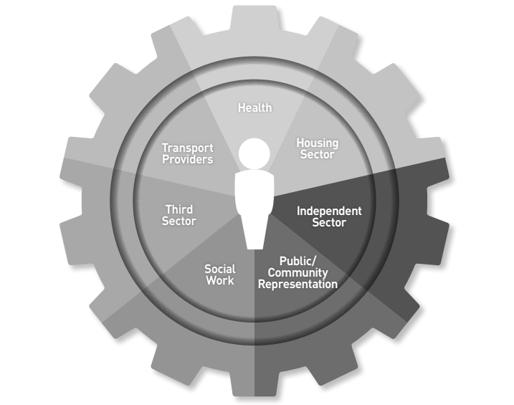

Figure 4: Locality Delivery Group Stakeholders

# Appendix 1: Strategy & Policy Context

Below is a list of local and partner Strategies that have supported the development of Falkirk HSCP East Locality Plans.

**Falkirk HSCP**

* [Falkirk HSCP Strategic Plan](https://falkirkhscp.org/wp-content/uploads/sites/9/2023/04/Falkirk-HSCP-Strategic-Plan.pdf)
* [Falkirk HSCP Participation & Engagement Strategy](https://view.officeapps.live.com/op/view.aspx?src=https%3A%2F%2Ffalkirkhscp.org%2Fwp-content%2Fuploads%2Fsites%2F9%2F2024%2F07%2FParticipation-and-Engagement-Strategy-2024-2027.docx&wdOrigin=BROWSELINK)
* [Falkirk HSCP Carers Strategy](https://view.officeapps.live.com/op/view.aspx?src=https%3A%2F%2Ffalkirkhscp.org%2Fwp-content%2Fuploads%2Fsites%2F9%2F2024%2F07%2FParticipation-and-Engagement-Strategy-2024-2027.docx&wdOrigin=BROWSELINK)
* [Falkirk HSCP Equalities Outcomes & Mainstreaming Report](https://view.officeapps.live.com/op/view.aspx?src=https%3A%2F%2Ffalkirkhscp.org%2Fwp-content%2Fuploads%2Fsites%2F9%2F2024%2F03%2FEquality-Outcomes-and-Mainstreaming-Report-2024-2028.docx&wdOrigin=BROWSELINK)
* [Housing Contribution Statement](https://view.officeapps.live.com/op/view.aspx?src=https%3A%2F%2Ffalkirkhscp.org%2Fwp-content%2Fuploads%2Fsites%2F9%2F2022%2F06%2FHousing-Contribution-Statement-2019-2022.docx&wdOrigin=BROWSELINK)

Data that supported the development of the plan was taken from:

* [Falkirk HSCP Joint Strategic Assessment 2023](https://view.officeapps.live.com/op/view.aspx?src=https%3A%2F%2Ffalkirkhscp.org%2Fwp-content%2Fuploads%2Fsites%2F9%2F2023%2F05%2FFalkirk-Joint-Strategic-Needs-Assessment-2023-1.docx&wdOrigin=BROWSELINK)
* [Falkirk HSCP East Locality Profile](https://falkirkhscp.org/wp-content/uploads/sites/9/2020/12/PUBLIC-Falkirk-East-Locality-Profile.pdf)

Current plans are under development that have also supported the plans development. This includes the Falkirk Alcohol & Drug Partnership Delivery Plan, Gender-Based Violence Strategy, Advocacy Plan and Falkirk HSCP Learning Disability Strategy.

**Falkirk Council**

* [The Falkirk Plan](https://www.falkirk.gov.uk/people-and-communities/the-falkirk-plan-2021-2030)
* [Grangemouth Community Action Plan](https://falkirkcommunityplanning.co.uk/wp-content/uploads/2022/11/Grangemouth-Community-Action-Plan.pdf)
* [Falkirk Anti-Poverty Strategy](https://www.falkirk.gov.uk/people-and-communities/building-a-fairer-falkirk-2024-2029)
* [Falkirk Local Housing Strategy](https://www.falkirk.gov.uk/people-and-communities/building-a-fairer-falkirk-2024-2029)

**NHS Forth Valley**

* [Population Health & Care Strategy](https://nhsforthvalley.com/publications/health-plans/population-health-care-strategy/)
* [Digital Health & Care Strategy](https://nhsforthvalley.com/publications/health-plans/population-health-care-strategy/)

The plan has also considered work ongoing within the delivery of the NHS Forth Valley Mental Health & Wellbeing Strategic Plan and Suicide Prevention Action Plan.

**National**

The [Draft Grangemouth Just Transition Plan](https://www.gov.scot/publications/grangemouth-industrial-transition-plan-supporting-fair-transition-scotlands-core-manufacturing-cluster-draft-consultation/documents/) was published in November 2024 and discussions have taken place with local partners that supported with its development. Throughout the iteration of the East Locality Plan dialogue will continue with partners to understand how the plan may impact the East Locality and this current East Locality Plan.

# Appendix 2: East Locality Delivery Plan

The Delivery Plan supports the implementation of the Partnership’s East Locality Plan for 2025-2026. It has been developed by the East Locality Delivery Group who will continue to review and monitor its implementation. Progress will be reported to the Locality Planning Steering Group who will inform our Strategic Planning Group, Senior Leadership Team and Integration Joint Board. The Delivery Plan reflects related workstreams where applicable.

The Delivery Plan contains 17 actions, aligned to the four priority areas:

|  |  |
| --- | --- |
| **Action** | **Priority** |
| 1-4 | Making it Easier to Manage Your Health & Wellbeing |
| 5-9 | Improved Access & Availability of Community-Based Resources |
| 10-14 | Reducing Mental Health Harms & Supporting Recovery |
| 15-17 | Improved Partnership Working |

Work will be in progress to implement actions within the Delivery Plan throughout the Locality Plans iteration. Synergies and duplicate actions between Localities will be reviewed as each individual plan progresses. Development of the Delivery Plan has considered the upcoming review of the HSCP Strategic Plan and future Falkirk HSCP operating model. Once the current Locality Plan iteration is complete we will review priority areas, actions and timescales to align with the new Falkirk HSCP Strategic Plan.

## Priority Area: Making It Easier to Manage Your Health & Wellbeing

|  |  |  |  |  |
| --- | --- | --- | --- | --- |
| **No** | **What We Want to Achieve**  **(Action)** | **How We Are Going to Achieve It**  **(Tasks/Measure)** | **Resources**  **(Lead)** | **Timescale** |
| 1 | Information and appropriate signposting are provided that can support individuals to manage their health & wellbeing. | 1. Identify key community-led support that staff can signpost or refer people to. 2. Develop a standardised process when signposting or referring people to community led support. 3. Identify what services need support and develop training for staff on effective conversations, signposting and referrals. 4. Provide people requiring support with user-friendly information on available support and embed a waiting well approach across services. 5. Track how often and to which services people are referred to and gather feedback on whether the support meets their needs. | Community Led Support Co-ordinator  With Support from:   * Health Improvement Service | June 2026 |
| 2 | The workforce is poverty aware and recognises early intervention opportunities to signpost to relevant support services. | 1. Staff who have access to the Falkirk Councils OLLE training course have undertaken the Think Poverty module, with the number of completions provided by the Fairer Falkirk team. 2. Think Poverty training sessions have been conducted initially with Adult Social Work Teams in line with Fairer Falkirk’s Action Plan. 3. Public Protection Webinars are available for the workforce to access and improve their understanding of the impact of poverty. 4. Services are updated with refreshed information to inform our communities on a Stay Safe, Well and Warm provision in a format that is accessible to them. | Locality Lead  With Support from:   * Fairer Falkirk * Public Protections Group | June 2026 |
| 3 | There is good visibility across the East Locality highlighting pathways and support for individuals and families experiencing poverty. | 1. Identify current initiatives and uptake within East locality for access to support services within Citizen’s Advice Bureau and Community Advice Service. 2. Identify priority locations for displaying support service information, for example areas of multiple deprivation. | Citizen Advice Bureau  &  Community Advice Service | June 2026 |
| 4 | Empower people who live and work in the locality to be more aware of and informed about key health issues in the local community. | 1. Increase in community assets (people, places, community) that have been supported to provide public and community health messaging, targeted towards known local locality needs. 2. Increase in people engaging with formal and informal learning on supporting health behaviour change and health and wellbeing issues. | Community Development  With Support from:   * Health Improvement Service, Public Health and Public Health Nutrition/Dietetics & Allied Health Professionals * CVS Falkirk & District | June 2026 |

## Priority Area: Improved Access and Availability of Community-Based Support

|  |  |  |  |  |
| --- | --- | --- | --- | --- |
| **No.** | **What we Want to Achieve**  **(Action)** | **How We Are Going to Achieve It**  **(Tasks/Measure)** | **Resources**  **(Lead)** | **Timescale** |
| 5 | Information and knowledge about local services and support are available and promoted. | 1. Compile a list of key local support services and resources, noting identified gaps in provision that the partnership can look to address within the locality. 2. Create a user-friendly directory with information on support services and resources in a format that can be kept up-to-date. 3. Deliver information sessions and training to increase staff knowledge of support. 4. Promote awareness to the public. | Community-Led Support Co-ordinator | June 2026 |
| 6 | Explore options to develop an Active Outreach Programme based on local needs. | 1. Conduct a needs assessment via CVS Falkirk & District’s Health and Wellbeing Forum to establish third sector capacity and desire to support the development of a local active outreach programme. 2. Produce a briefing paper to provide Locality Planning Delivery Groups with a mapped overview of community assets across localities, detailing their geographical locations, access times and availability; as well as a benchmark analysis of average hire costs for community spaces that charge for use. | CVS Falkirk & District  With Support from:   * HSCP Planning Team | December 2025 |
| 7 | Work with partners to find solutions that will build assets and reduce practical barriers to accessing health and social care services. This includes support for facilitating changing behaviours which can reduce barriers to access. | 1. Conduct a needs assessment to understand why individuals cannot access services. 2. Establish a working group of local partners and community representatives to explore solutions. 3. Co-design initiatives with local partners to address barriers. 4. Pilot the initiatives. 5. Measure and evaluate. | Community-led Support Co-ordinator | September 2026 |
| 8 | Identify and provide early and relevant support to hidden and new carers within the East Locality targeted towards rural locations. | 1. Carers Centre will undertake information sessions in connection with local community groups in rural communities within the East Locality to promote their services. Pilot sessions within the Slamannan community. 2. Track and monitor Carers accessing support from the Carers Centre for the first time noting their supporting role and identify any gaps in support provided. 3. Pilot consultation specifically with carers in rural communities to understand the impact their caring role has on their health & wellbeing. Determine actions that could be undertaken based on feedback and shared with participants in the consultation. | Carer Participation Development Worker  With support from:   * HSCP Carers Policy & Development Officer | December 2025 |
| 9 | Improve the experiences of individuals accessing and using services. | 1. The workforce is provided with learning and development opportunities to respond effectively to individuals’ circumstances and needs at the first point of contact. 2. Staff are supported to access the appropriate level of trauma training required for their post. 3. Services take a “trauma informed lens” to their service to consider practical changes they can make to embed trauma informed change. | Locality Lead  With support from   * Workforce Development * Trauma Informed Practice and Policy Development Officer | December 2025 |

## Priority Area: Reduce Mental Health Harms & Supporting Recovery

|  |  |  |  |  |
| --- | --- | --- | --- | --- |
| **No.** | **What we Want to Achieve**  **(Action)** | **How We Are Going to Achieve It**  **(Task/Measure)** | **Resources**  **(Lead)** | **Timescale** |
| 10 | Support with development and implementation of Local and Regional Strategies currently under development which relate to the priority area. | 1. Falkirk ADP Delivery Plan. 2. Gender-Based Violence Strategy. 3. Forth Valley Mental Health & Wellbeing Strategic Plan. 4. Forth Valley Population Health and Care Strategy | East Locality Delivery Group  With support from:   * Falkirk ADP Development Officer * Integrated Mental Health * GBV Lead Officer | June 2026 |
| 11 | Staff are provided with additional support to help manage their mental health & Wellbeing. | 1. Wellbeing/Wellness pack developed and provided to all staff with information and support for managing their own mental health and wellbeing. 2. Connecting with an Integrated Mental Health team to source additional support to be provided and promoted to staff. | Locality Delivery Group Chairperson  With Support from:   * Health Improvement Service | December 2025 |
| 12 | Social work staff have improved knowledge of substance use & referral pathways. | 1. Deliver CREATE sessions with social work staff which will provide staff with knowledge and skills to understand the presentation of substance use and available recovery pathways, particularly for alcohol. 2. Roll out of associated work that comes from CREATE sessions and continue to provide ongoing support to social work with this. | Falkirk ADP Development Officer | * March 2026 |
| 13 | Explore support provided within temporary and Homeless accommodation across the East Locality. | 1. Connect with Strategic Housing Group to explore work ongoing and develop links between social housing providers and health & support providers. 2. Identify support currently being provided by housing and opportunities to progress this based on local needs and community evidence. | Housing Strategy & Development Co-ordinator  Housing Support Co-ordinator | * June 2026 |
| 14 | Review substance Use, mental health and wellbeing support within East Locality and identify opportunities to facilitate behaviour change that empowers individuals and reduces the need for services. | 1. Connect with the Community Planning Partnership to identify work undertaken towards this Action within their local Community Action Plan. 2. Assess current support, identify gaps and review feasible improvement measures that can be taken to address gaps in provision. 3. Explore opportunities for the HSCP to take a proactive approach in highlighting and improving the support available. | Community Planning Policy Officer | June 2026 |

## Priority Area: Improved Partnership Working

|  |  |  |  |  |
| --- | --- | --- | --- | --- |
| **No.** | **What we Want to Achieve**  **(Action)** | **How we are going to Achieve it**  **(Tasks/Measure)** | **Resources**  **(Lead)** | **Timescale** |
| 15 | Locality Delivery Group Set-up and Running to Support with Locality Planning. | 1. Further Develop the Locality Planning Delivery Group and implement a framework to ensure the functionality of the group. 2. Expansion of members to include further representation across the Locality, particular focus on Health colleagues and local community representation. | East Locality Delivery Group Chairperson  With support from:   * Falkirk HSCP Planning & Performance team | * December 2025 |
| 16 | Improve relationship and communication between HSCP, local community groups and assets. | 1. Involvement from Community Assets increased in locality planning development with opportunities tailored to their needs. 2. Co-ordinate future engagement opportunities within the East Locality, connecting where possible with engagement ongoing in the Community Planning Partnership. 3. There is an uptake in engagement from the East Locality with individuals completing Participate+ surveys and hosting in-person engagement events. | Falkirk HSCP Planning & Performance Team.  With Support from:   * Community Learning & Development * CVS Falkirk & District | June 2026 |
| 17 | Explore opportunities for Locality Planning to connect with wider Primary Care Services in the East Locality. | 1. Identify opportunities to connect with East Locality GP Network and provide regular updates to GP Cluster meetings. 2. Look at opportunities to connect with wider primary care services. | HSCP Primary Care Lead  With support from:   * East Locality GP Representative | June 2026 |

# Appendix 3: Services in the Area

Breakdown of services provided within figure 3, page 7.

|  |  |  |
| --- | --- | --- |
| Optician | **Address** | **Number** |
| MJ Optical T/A for Eyes | 33 South Street, Bo’ness, EH51 9HE | 01506 823874 |
| Spectacle World | 9 York Arcade, Grangemouth, FK3 8BA | 01324 474344 |
| Specsavers Grangemouth | 52-58 La Porte Precinct, Grangemouth, FK3 8BG | 01324 483019 |
| MJ Optical LTD T/A for Eyes | 55 Charlotte Dundas Court, Grangemouth, FK3 9EE | 01324 472020 |

|  |  |  |
| --- | --- | --- |
| **Dentist** | **Address** | **Number** |
| Long & Gilmour | 83-93 Morth Street, Bo’ness, EH51 9ND | 01506 824231 |
| Rosemount Dental Practice | 52 Dean Road, Bo’ness EH51 9BB | 01506 822753 |
| Dundas Dental Practice | 18 La Porte Precinct, Grangemouth, FK3 8AS | 01324 482292 |
| The Practice | 72 Bo’ness Road, Grangemouth, FK3 8BL | 01234 482292 |

|  |  |  |
| --- | --- | --- |
| **Care Home** | **Type** | **Address** |
| Aithrey Care | Older People | Paul Drive, Airth, FK2 8LA |
| Barleystone | Older People | Westquarter Avenue, Westquarter, Falkirk, FK2 9RY |
| Care Visions- Westside | Children & Young People | Westide Farmhouse, Avinbridge, FK1 5RL |
| Ivybank House | Older People | Main Street, Polmont, FK2 0PS |
| Southfield House | Learning Disabilities | Southfield House, Falkirk, FK1 3BB |
| St Margarets Home | Older People | Buchanan Gardens, Polmont, Falkirk, FK2 0UP |
| Summerdale | Older People | Victoria Place, Brightons, Falkirk, FK2 0TZ |
| The Haining Nursing Home | Older People | The Haining, Maddiston, Falkirk, FK2 0BN |
| Tremanna | Children & Young People | 26-32 Rimlie, Slamannan, FK1 3HJ |
| Wallace Crescent Children’s Home | Children & Young People | 42A Wallace Crescent, Brightons, Falkirk, FK2 0LZ |

|  |  |  |
| --- | --- | --- |
| **Pharmacist** | **Address** | **Number** |
| Airth Pharmacy | 2 Shore Road, Airth, FK2 8LH | 01324 831063 |
| Rowlands Pharmacy | Richmond Terrace, Bo’ness, EH51 0DQ | 01506 824524 |
| Your Local Boots Pharmacy | 60 South Street, Bo’ness, EH51 9HA | 01506 822106 |
| Rowlands Pharmacy | 5 South Street, Bo’ness, EH51 0EA | 01506 822701 |
| Brightons Pharmacy | Pretoria Place, Brightons, FK2 0UF | 01324 712526 |
| Boots the Chemist | 32-32 La Porte Precinct, Grangemouth, FK3 8BG | 01324 482118 |
| Howard Pharmacy | 29 La Porte Precinct, Grangemouth, FK3 8AZ | 01324 482008 |
| Linsay & Gilmour Pharmacy | 123-125 Newlands Road, Grangemouth, FK3 8NU | 01324 482079 |
| Rowlands Pharmacy | 16 Charlotte Dundas Court, Grangemouth, FK3 9EA | 01324 484297 |
| Deans Pharmacy | 63 Main Road, Maddiston, FK2 0ZL | 01324 716555 |
| Meadowbank H.C Pharmacy | Health Centre, Salmon Inn Road, Polmont, FK2 0XF | 01324 717865 |
| Shieldhill Pharmacy | Crossbrae, Shieldhill, FK1 2EQ | 01324 624754 |
| Slamannan Pharmacy | 11-17 High Street, Slamannan, FK1 3EX | 01324 851265 |

|  |  |  |
| --- | --- | --- |
| **Community Hospital** | **Address** | **Number** |
| Bo’ness Community Hospital | 100 Dean Road, Bo’ness, EH51 0DH | 01506 829580 |

|  |  |  |
| --- | --- | --- |
| **GP Practice** | **Address** | **Number** |
| Bo’ness Road Medical Practice | 29-33 Bo’ness Road, Grangemouth, FK3 8AN | 01324482653 |
| Braesview Medical Group | 3 Salmon Inn Road, Polmont, Falkirk, FK2 0XF | 01324 715540 |
| Kersiebank Medical Group | Kersiebank Avenua, Grangemouth FK3 9EL | 0330 128 9389 |
| Kinneil Medical Practice | Gauze Road, Bo’ness, EH51 9UE | 01506 537054 |
| Parkhill Medical Practice | Salmon Inn Road, Polmont, Falkirk, FK2 0XF | 01324 715446 |
| Polmont Park Medical Practice | Salmon Inn Road, Polmont, FK2 0XF | 01324 715753 |
| Richmond Practice | Dean Road, Bo’ness, EH51 0DH | 01506 822665 |
| Slamannan Health Centre | Bank Street, Slamannan, Falkirk, FK1 3EZ | 01324 851288 |

**Third Sector & Communities**

* CVS Falkirk & District have a directory available on their website which lists groups and organisations that are members of CVS Falkirk & District within our communities: [Members Directory](https://www.cvsfalkirk.org.uk/members-directory/)
* ALISS is a national digital programme enabling people and professionals to find and share information on health and wellbeing resources, services, groups, and support in their local communities and online: <https://www.aliss.org/about-aliss/>

**Health Improvement Service**

[Forth Valley Health Improvement Service](https://nhsforthvalley.com/health-services/health-promotion/) works to enhance health & wellbeing while reducing inequalities across Forth Valley. The team provides training, resources and specialist advice to partners on key health topics, including nutrition, mental health, tobacco, substance use, oral health, physical activity, sexual health and blood borne viruses health inequalities and multi-agency collaborative working. It also delivers community interventions such as Step on Stress and the Quit Your Way Stop Smoking Service.

Below is a list of available resources and training brochure available for people living and working across Forth Valley:

* [Health Improvement Resource Service](https://www.canva.com/design/DAGkCyZrRHg/PQ8IkwkMRWp05nJ0pU1u3w/view?utm_content=DAGkCyZrRHg&utm_campaign=designshare&utm_medium=link2&utm_source=uniquelinks&utlId=hb167faab8a)
* [2025/26 Training brochure](https://www.canva.com/design/DAGkCyZrRHg/PQ8IkwkMRWp05nJ0pU1u3w/view?utm_content=DAGkCyZrRHg&utm_campaign=designshare&utm_medium=link2&utm_source=uniquelinks&utlId=hb167faab8a)

**Allied Health Professionals**

Allied Health Professionals (AHP) provide vital and valuable services alongside colleagues across the Falkirk Health & Social Care Partnership. AHPs focus on specific areas including:

* Physiotherapy
* Podiatry
* Dietetics
* Orthotics
* Occupational Therapy
* Speech and Language Therapy.

AHPs play a vital role in supporting individuals to manage and recover from conditions. They are located within GP Practices, hospitals and community settings, working closely with other health and social care professionals to provide holistic, person-centred care.

Below are useful link to some of the support available within the East Locality and wider Forth Valley area:

* [NHS Forth Valley – Community Rehabilitation Services](https://nhsforthvalley.com/health-services/az-of-services/rehab-care-group/)
* [NHS Forth Valley – Physiotherapy](https://nhsforthvalley.com/health-services/az-of-services/physiotherapy/)
* [NHS Forth Valley – Musculoskeletal (MSK)](https://nhsforthvalley.com/health-services/az-of-services/physiotherapy/musculoskeletal-msk/)
* [NHS Forth Valley – Podiatry](https://nhsforthvalley.com/health-services/az-of-services/podiatry/)
* [NHS Forth Valley – Dietetics](https://nhsforthvalley.com/health-services/az-of-services/dietetics/)
* [NHS Forth Valley – Nutrition](https://nhsforthvalley.com/health-services/health-promotion/nutrition/)
* [NHS Forth Valley – Orthotics](https://nhsforthvalley.com/health-services/az-of-services/orthotics/)
* [NHS Forth Valley – Occupational Therapy](https://nhsforthvalley.com/health-services/az-of-services/occupational-therapy/)
* [NHS Forth Valley – Speech and Language Therapy (SLT)](https://nhsforthvalley.com/health-services/az-of-services/speech-and-language-therapy/)