

Locality Profile

Falkirk West Locality

April 2025

Table of Contents

Notes for this profile 5

Demographics 6

Population 6

Deprivation 8

Services 11

Housing 12

General Health 14

Summary 14

Life Expectancy 14

Deaths, aged 15 to 44 15

Long-Term Physical Health Conditions and Multi-morbidity 17

Cancer 19

Hospitalisations by condition 21

Anxiety, Depression and Psychosis (ADP) prescriptions 21

Lifestyle and Risk Factors 23

Alcohol-related Hospital Admissions 23

Alcohol-Specific Deaths 24

Drug-related Hospital Admissions 25

Bowel Screening Uptake 27

Hospital and Community Care 29

Emergency Admissions 30

Unscheduled Acute Bed Days 32

A&E Attendances 34

Emergency Readmissions (28 days) 36

Delayed Discharge Bed Days 38

Emergency admissions from a fall 38

Potentially Preventable Admissions (PPAs) 40

Hospital Care (Mental Health Speciality) 41

Psychiatric patient hospitalisations 41

Footnotes 43

Appendices 44

Appendix 1: Indicator Definitions 44

Appendix 2: Date of Indicator Data Extractions 48

Appendix 3: Conditions included as Potentially Preventable Admissions (PPAs) 50

| **Demographic Indicators** | **Data Type** | **Time Period** | **Falkirk West Locality** | **Falkirk Central Locality** | **Falkirk East Locality** | **Falkirk HSCP** | **Scotland** |
| --- | --- | --- | --- | --- | --- | --- | --- |
| **Total population** | count | 2022 | 48,484 | 42,675 | 67,291 | 158,450 | 5,447,000 |
| **Ratio male to female** | ratio | 2022 | 1:1.05 | 1:1.05 | 1:1.06 | 1:1.06 | 1:1.06 |
| **Population over 65** | % | 2022 | 19.2 | 20 | 19.8 | 19.7 | 20.1 |
| **Population in the least deprived SIMD quintile** | % | 2020 | 20.3 | 18 | 20.4 | 19.7 | 20 |
| **Population in the most deprived SIMD quintile** | % | 2020 | 7.4 | 32.1 | 11.7 | 15.9 | 20 |
| **Housing Indicators** | **Data Type** | **Time Period** | **Falkirk West Locality** | **Falkirk Central Locality** | **Falkirk East Locality** | **Falkirk HSCP** | **Scotland** |
| **Total number of households** | count | 2023 | 22,013 | 22,262 | 32,414 | 76,689 | 2,721,139 |
| **Households with single occupant tax discount** | % | 2023 | 36.2 | 45.5 | 39.3 | 40.2 | 38.5 |
| **Households in Council Tax Band A-C** | % | 2023 | 56.2 | 72.1 | 62.8 | 63.6 | 58.7 |
| **Households in Council Tax Band F-H** | % | 2023 | 14.8 | 8.9 | 12.4 | 12 | 13.8 |
| **General Health Indicators** | **Data Type** | **Time Period** | **Falkirk West Locality** | **Falkirk Central Locality** | **Falkirk East Locality** | **Falkirk HSCP** | **Scotland** |
| **Male average life expectancy in years** | mean | 2019-2023* | 77.4 | 74.5 | 76.9 | 76.2 | 76.8 |
| **Female average life expectancy in years** | mean | 2019-2023* | 80.4 | 78.4 | 80.9 | 79.7 | 80.8 |
| **Deaths aged 15-44 per 100,000** | rate | 2021 - 2023 | 95.4 | 186.9 | 97.1 | 122 | 111.7 |
| **Population with long-term condition** | % | 2023/24 | 20.8 | 22.8 | 21 | 21.4 | 22.1 |
| **Cancer registrations per 100,000** | rate | 2020 - 2022 | 643.3 | 691.3 | 683.1 | 677.6 | 629.7 |
| **Anxiety, depression & psychosis prescriptions** | % | 2023/24 | 22 | 23.6 | 22.1 | 22.4 | 20.9 |

###### *At HSCP and Scotland level, the time period is a 3-year aggregate (2021-2023)

| **Lifestyle & Risk Factors Indicators** | **Data Type** | **Time Period** | **Falkirk West Locality** | **Falkirk Central Locality** | **Falkirk East Locality** | **Falkirk HSCP** | **Scotland** |
| --- | --- | --- | --- | --- | --- | --- | --- |
| **Alcohol-related hospital admissions per 100,000** | rate | 2022/23 | 449.4 | 800.5 | 477.9 | 557.5 | 532 |
| **Alcohol-specific mortality per 100,000** | rate | 2018 - 2022 | 18.8 | 21.7 | 19.9 | 20.2 | 21.4 |
| **Drug-related hospital admissions per 100,000** | rate | 2020/21 - 2022/23 | 151.4 | 329.9 | 170.3 | 211.3 | 201.8 |
| **Bowel screening uptake** | % | 2020 - 2022 | 68 | 63.2 | 66.9 | 66.2 | 66.2 |
| **Hospital & Community Care Indicators** | **Data Type** | **Time Period** | **Falkirk West Locality** | **Falkirk Central Locality** | **Falkirk East Locality** | **Falkirk HSCP** | **Scotland** |
| **Emergency admissions per 100,000** | rate | 2023/24 | 12,198 | 14,435 | 12,568 | 12,957 | 10,963 |
| **Unscheduled bed days per 100,000** | rate | 2023/24 | 71,056 | 94,887 | 82,241 | 82,225 | 77,702 |
| **A&E attendances per 100,000** | rate | 2023/24 | 23,051 | 27,672 | 22,450 | 24,040 | 27,227 |
| **Delayed discharges (65+) per 100,000** | rate | 2023/24 | 50,123 | 84,032 | 75,553 | 69,635 | 48,494 |
| **Potentially Preventable Admissions per 100,000** | rate | 2023/24 | 1,675 | 2,062 | 1,739 | 1,806 | 1,691 |
| **Hospital Care (Mental Health) Indicators** | **Data Type** | **Time Period** | **Falkirk West Locality** | **Falkirk Central Locality** | **Falkirk East Locality** | **Falkirk HSCP** | **Scotland** |
| **Psychiatric patient hospitalisations per 100,000** | rate | 2021/22 - 2023/24 | 214 | 300.3 | 194.4 | 229.4 | 216.1 |

##### Page break

## Notes for this profile

* All years shown are calendar years unless otherwise specified.
* Upper and lower 95% confidence intervals are shown throughout this document where available. In charts, these are displayed as shaded areas on either side of trend lines or as black error bars in bar charts. Confidence intervals show the range of possible values and a certainty that the true value falls within them.
* Definitions for the indicators shown are available in Appendix 1.
* Any zero figures for some indicators will indicate either suppression of small data or a complete lack of data available for this locality

##### Page break

## Demographics

**Summary**

For the most recent time period available, Falkirk West Locality had:

* A total population of **48,484** people, where **48.8%** were male, and **19.2%** were aged over 65.
* **20.3%** of people lived in the least deprived SIMD quintile, and **7.4%** lived in the most deprived quintile.

### Population

In 2022, the total population of Falkirk West locality was 48,484. The graph below shows the population distribution of the locality. Overall, **48.8%** of the population are male, and **51.2%** are female.

#### Figure 1: Population by age and sex.

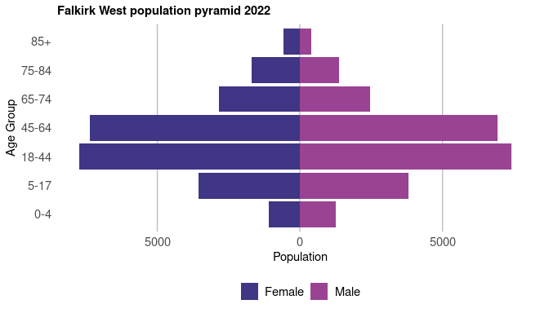

Figure 2 shows the historical population of Falkirk West, along with the NRS population projections. The population has been rising in general, however it has fallen since last year. The population in Falkirk West is estimated to increase by 1.3% from 2022 to 2027. *Please see the footnotes for more information on how the population projections were calculated1.*

##### Page break

#### Figure 2: Population time trend and projection.

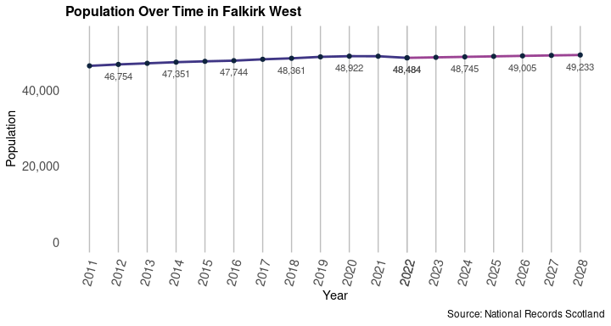

Figure 3 shows how the population structure has changed between 2017 and 2022.

#### Figure 3: Change in population structure over the last five years.

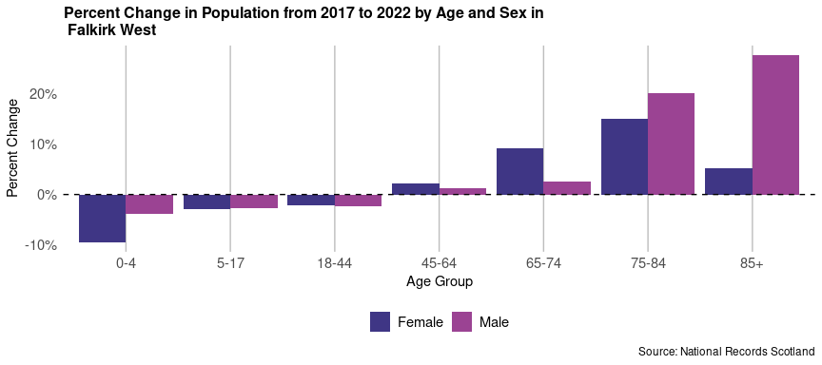

##### Page break

### Deprivation

The following section explores the deprivation structure of Falkirk West through the Scottish Index of Multiple Deprivation (SIMD). The SIMD ranks all datazones in Scotland by a number of factors; Access, Crime, Education, Employment, Health, Housing and Income. Based on these ranks, each datazone is then given an overall deprivation rank, which is used to split datazones into Deprivation Quintiles (Quintile 1 being the most deprived, and Quintile 5 the least). The most recent SIMD ranking was carried out in 2020. This section mainly focuses on the SIMD 2020 classifications, however, the 2016 classifications are used to assess how deprivation has changed in Falkirk West when compared to the rest of Scotland.

Of the 2022 population in Falkirk West, **7.4%** live in the most deprived Quintile (SIMD 1), and **20.3%** live in the least deprived Quintile (SIMD 5).

#### Figure 4: Map of Data Zones within Falkirk West coloured by SIMD quintiles.

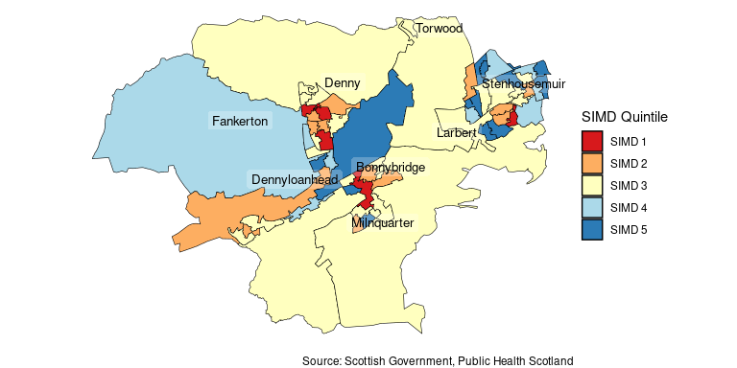

##### Page break

Table 1 details the percentage of the locality’s 2016 population living in the 2016 SIMD Quintiles, the percentage of the 2022 population living in the 2020 SIMD Quintiles, and their difference for comparison. Figure 5 then breaks down SIMD by domain in Falkirk West.

#### Table 1: Percentage of the Falkirk West population living in the 2016 and 2020 SIMD Datazone Quintiles in 2016 and 2022 respectively.

|  |  |  |  |
| --- | --- | --- | --- |
| Quintile | Percent of 2016 Population (SIMD 2016 Ranking) | Percent of 2022 Population (SIMD 2020 Ranking) | Difference |
| SIMD 1 | 5.4% | 7.4% | 2.0% |
| SIMD 2 | 29.6% | 21.7% | -7.9% |
| SIMD 3 | 24.5% | 33.3% | 8.8% |
| SIMD 4 | 17.9% | 17.3% | -0.7% |
| SIMD 5 | 22.6% | 20.3% | -2.3% |

Source: Scottish Government, Public Health Scotland, National Records Scotland.

#### Figure 5: Proportion of the population that reside in each 2020 SIMD quintile by domain in 2022.

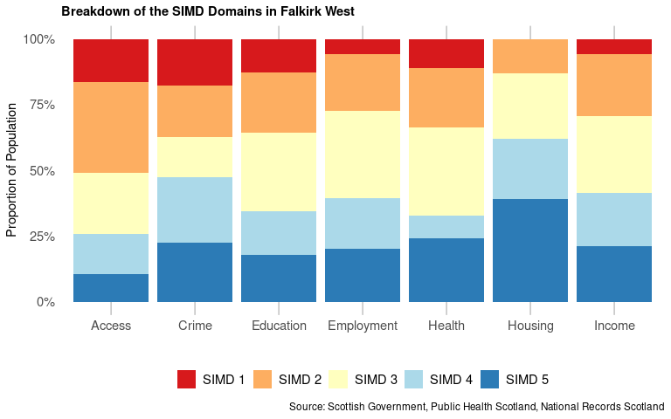

##### Page Break

Figure 6 presents a comparison between the 2016 SIMD ranking applied to 2016 population estimates, and the more recent 2020 SIMD ranking applied to 2022 population estimates. The percentages of the population living within each SIMD quintile by domain were calculated using the 2016 and 2020 SIMD datazone classifications respectively. The differences in these percentages are plotted in Figure 6. Negative values on the y-axis indicate a decrease in the percent of the population living within a quintile, while positive values indicate an increase in the percent of the population living within a quintile. **Please note that quintiles have been weighted by the Scottish population so, any local changes in SIMD quintile do not necessarily indicate a difference in deprivation, but rather a difference in deprivation in comparison to the rest of Scotland.**

#### Figure 6: Percentage of population in 2016 and 2022 living in the 2016 and the 2020 SIMD quintiles by domain.

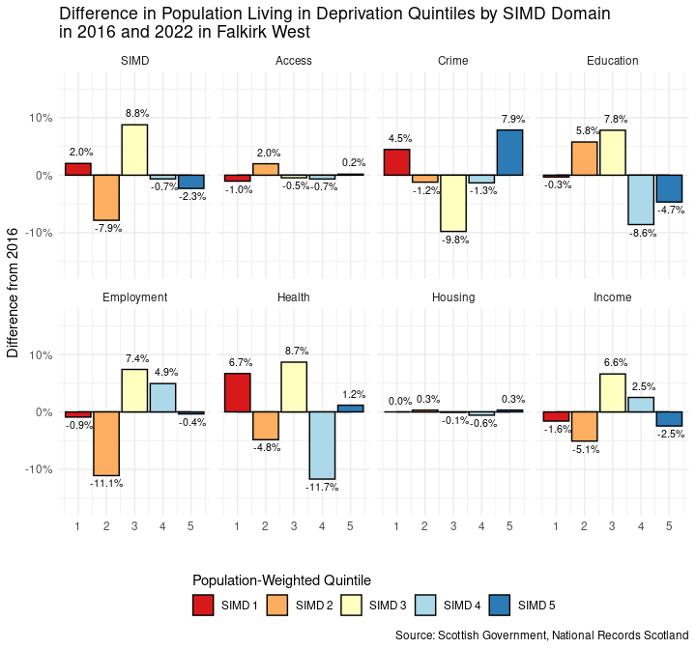

##### Page break

## Services

#### Figure 7: Map of services by locality in Falkirk HSCP2.

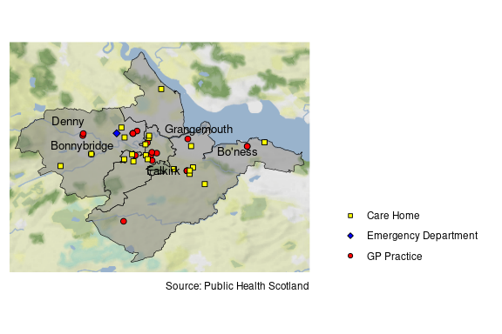

#### Table 2: Number of each type of service in Falkirk West Locality2.

|  |  |  |
| --- | --- | --- |
| Service Type | Service | Number |
| **Primary Care** | GP Practice | 9 |
| **A&E** | Emergency Department | 1 |
|  | Minor Injuries Unit | 0 |
| **Care Home** | Elderly Care | 5 |
|  | Other | 7 |

##### Page break

## Housing

**Summary**

For the most recent time period available, Falkirk West Locality had:

* **22,013** dwellings, of which: **97.8%** were occupied and **0.11%** were second homes.
* **36.2%** of dwellers received a single-occupant council tax discount, and **1.1%** were exempt from council tax entirely.
* **56.2%** of houses were within council tax bands A to C, and **14.8%** were in bands F to H.

The graph below shows the number of dwellings in Falkirk West from 2014 to 2023.

#### Figure 8: Number of dwellings time trend.

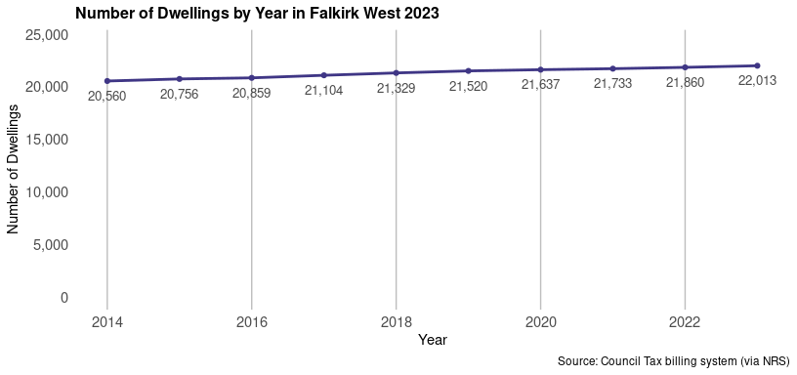

Of the total number of dwellings in 2023, 36.2% (7,979 households) were occupied by an individual receiving a single-occupant council tax discount. Furthermore, 1.1% (248 households) were occupied and exempt from council tax.

There were 25 dwellings classed as a second home in 2023, these dwellings made up 0.11% of the households in Falkirk West.

##### Page break

#### Table 3: Breakdown of dwelling types by year for Falkirk West locality.

|  |  |  |  |  |  |  |
| --- | --- | --- | --- | --- | --- | --- |
| Year | Total Dwellings | Occupied Dwellings | Vacant Dwellings | Single Occupant Tax Discount | Council Tax Exempt Dwellings | Second Homes |
| 2014 | 20,560 | 20,022 | 443 | 6,813 | 194 | 93 |
| 2015 | 20,756 | 20,235 | 422 | 6,918 | 202 | 99 |
| 2016 | 20,859 | 20,407 | 413 | 7,041 | 193 | 39 |
| 2017 | 21,104 | 20,677 | 405 | 7,172 | 171 | 26 |
| 2018 | 21,329 | 20,907 | 397 | 7,181 | 203 | 25 |
| 2019 | 21,520 | 21,094 | 401 | 7,319 | 230 | 25 |
| 2020 | 21,637 | 21,220 | 393 | 7,410 | 240 | 24 |
| 2021 | 21,733 | 21,340 | 369 | 7,707 | 241 | 24 |
| 2022 | 21,860 | 21,367 | 470 | 7,808 | 248 | 23 |
| 2023 | 22,013 | 21,528 | 460 | 7,979 | 248 | 25 |

Source: Scottish Assessors’ Association (via NRS)

The proportion of households within each council tax band are displayed in the chart below, figures are shown in Table 4.

#### Figure 9: Breakdown of households by council tax band for Falkirk West in 2023.

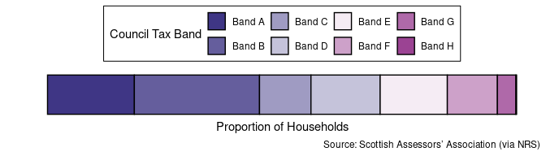

#### Table 4: Percentage of households by council tax band for Falkirk West in 2023.

|  |  |  |  |  |  |  |  |  |
| --- | --- | --- | --- | --- | --- | --- | --- | --- |
| Tax Band | A | B | C | D | E | F | G | H |
| Percent of households | 18.50% | 26.70% | 11.00% | 14.80% | 14.30% | 10.70% | 3.90% | 0.15% |

Source: Scottish Assessors’ Association (via NRS)

##### Page break

## General Health

### Summary

For the most recent time period available3, Falkirk West Locality had:

* An average life expectancy of **77.4** years for males and **80.4** years for females, compared to the national average of 76.8 and 80.8 years of age respectively.
* A death rate for ages 15 to 44 of **95.4** deaths per 100,000 age-sex standardised population. This is lower than Scotland (112 deaths per 100,000)4.
* **20.8%** of the locality’s population with at least one long-term physical health condition. This is lower than Scotland (22.1%).
* A cancer registration rate of **643** registrations per 100,000 age-sex standardised population (compared to 630 in Scotland), and an early death rate (<75 years) from cancer of **138** per 100,000 age-sex standardised population (compared to 145 in Scotland)4.
* **22%** of the population being prescribed medication for anxiety, depression, or psychosis. This is a larger proportion than Scotland (20.9%).

### Life Expectancy

In the latest time period available from 2019-2023 (5-year aggregate), the average life expectancy in Falkirk West locality was 77.4 years for men, and 80.4 years for women. A 10-year time trend can be seen in figure 10.

#### Figure 10: Average life expectancy in men and women over time.

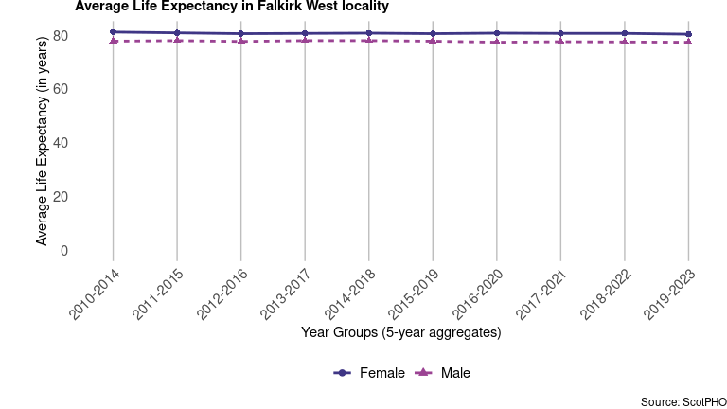

##### Page break

Table 5 provides the average life expectancy for men and women in different areas for the latest time period available.

#### Table 5: Average life expectancy in years for the latest time periods (2019-2023 aggregated years for the locality; 2021-2023 aggregated years for other areas).

|  |  |  |  |  |
| --- | --- | --- | --- | --- |
| Sex | Falkirk West | Falkirk | NHS Forth Valley | Scotland |
| Male | 77.4 | 76.2 | 76.7 | 76.8 |
| Female | 80.4 | 79.7 | 80.4 | 80.8 |

Source: ScotPHO

### Deaths, aged 15 to 44

The following chart shows a trend of death rates among people aged 15 to 44 per 100,000 age-sex standardised population4 by area. In the most recent aggregate time period available (2021 - 2023), the mortality rate in Falkirk West locality was **95.4** deaths per 100,000 population.

#### Figure 11: Deaths aged 15 to 44 years by geographical area and over time.

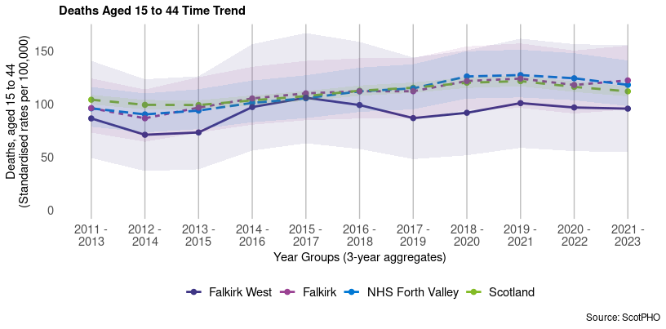

##### Page break

Figure 12 provides comparisons of deaths at ages 15 to 44 across all areas including other localities in Falkirk HSCP. In 2021 - 2023, Falkirk West had a lower rate than the rest of Scotland (95.4 compared to 112 deaths per 100,000).

#### Figure 12: Deaths at ages 15 to 44 by area for the latest time period available.

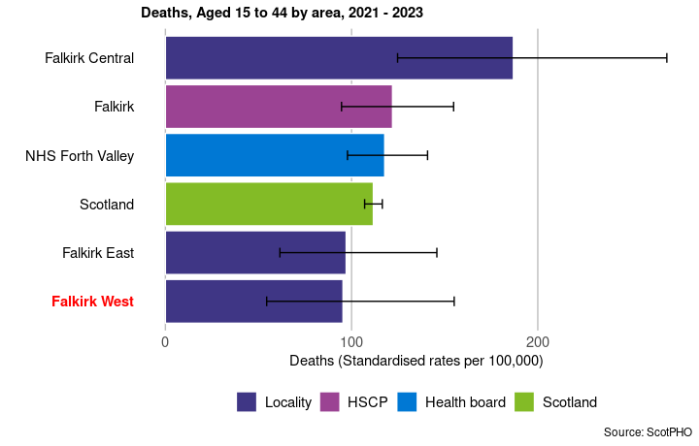

##### Page break

### Long-Term Physical Health Conditions and Multi-morbidity

In the financial year 2023/24, in Falkirk West Locality, it is estimated that **20.8%** of the population had at least one physical long-term condition (LTC). These include cardiovascular, neurodegenerative, and respiratory conditions, as well as other organ conditions (namely liver disease and renal failure), arthritis, cancer, diabetes, and epilepsy. *Please note that estimates for this section are based on people who had contact with NHS services - see footnotes for further information and caveats on identifying LTCs.5*

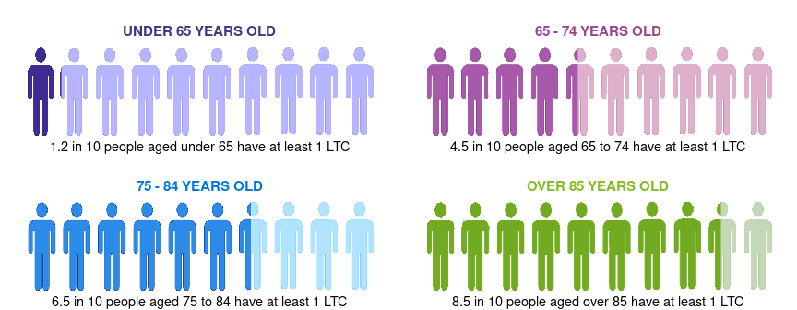

The co-occurrence of two or more conditions, known as multi-morbidity, is broken down in Table 6, distinguishing between age groups. Overall, **2.7**% of those under 65 have more than one LTC, compared to **29.1**% of those over 65.

#### Table 6: Multi-morbidity of physical long-term conditions by age group in 2023/24.

|  |  |  |
| --- | --- | --- |
|  | Percentage over 65 | Percentage under 65 |
| 1 LTC | 26.5 | 9.4 |
| 2 LTCs | 14.4 | 2.0 |
| 3 LTCs | 7.6 | 0.5 |
| 4 or more LTCs | 7.1 | 0.2 |

##### Page break

**Most common physical Long-Term Conditions (LTCs)**

Below is a breakdown of the physical LTCs, for the financial year 2023/24. Figure 13 shows the prevalence of different LTCs in each age group in Falkirk West locality, and Table 7 illustrates the five most common physical LTCs across all ages at the locality, partnership, and Scotland levels.

#### Figure 13: The percentage of people with each physical LTC *(based on hospital admissions with diagnosis of LTC since 1981)* by age group – 2023/24

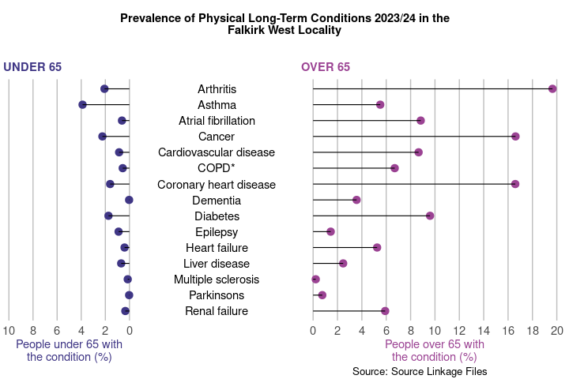

*COPD: Chronic Obstructive Pulmonary Disease

#### Table 7: The five most common physical LTCs *(based on hospital admissions with diagnosis of LTC since 1981)* as a percentage of the population across geographical areas (1 is the most common).

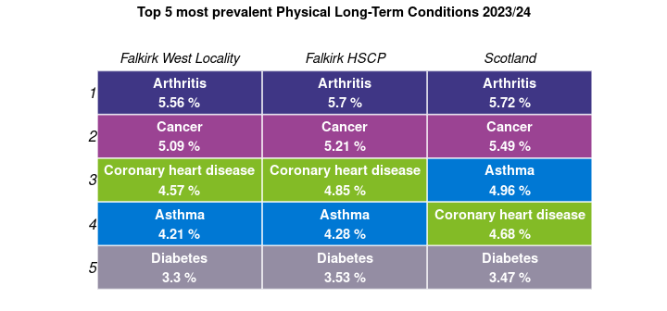

Source: Source Linkage Files

### Cancer

For the period 2020 - 2022, there were **308** new cancer registrations per year on average (a rate of **643** registrations per 100,000 age-sex standardised population) in Falkirk West locality. For the period 2020 - 2022, there were also **138** early deaths per 100,000 from cancer in the locality, this is a **22.4%** decrease compared to the rate 10 years prior.

#### Figure 14: Cancer registration rate over time and by area.

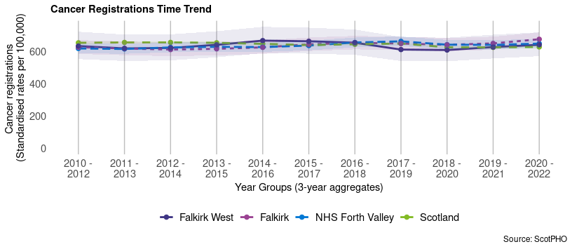

#### Figure 15: Early deaths from cancer (<75 years) over time and by area.

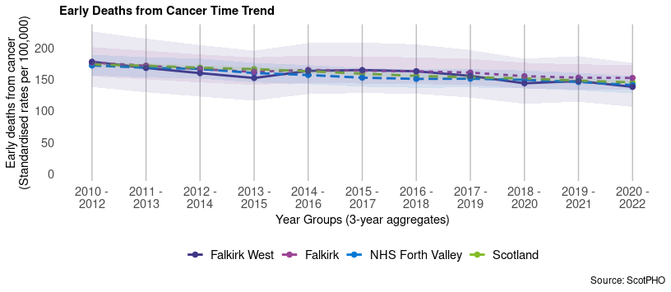

##### Page break

### Hospitalisations by condition

Patient hospitalisations can indicate how certain diseases have varying impacts on people’s lives. In the latest time period available in Falkirk West, the condition with the highest rate of hospitalisations was Coronary Heart Disease.

#### Table 8: Patient hospitalisations by condition and geographical area, age-sex standardised rates per 100,000.

|  |  |  |  |  |  |
| --- | --- | --- | --- | --- | --- |
| Disease | Latest time period | Falkirk West | Falkirk | NHS Forth Valley | Scotland |
| Asthma | 2021/22 - 2023/24 | 57.4 | 64.6 | 58.8 | 76.2 |
| Coronary Heart Disease | 2021/22 - 2023/24 | 305.0 | 344.7 | 323.5 | 326.8 |
| COPD | 2021/22 - 2023/24 | 191.0 | 209.2 | 193.6 | 210.1 |

### Anxiety, Depression and Psychosis prescriptions

In 2023/24, **22%** of people were prescribed medication for anxiety, depression or psychosis in Falkirk West Locality. This is a **27.9% increase** from the rate 10 years prior in 2013/14 which was 17.2%.

#### Figure 16: Anxiety, depression and psychosis prescriptions over time and by geographical area.

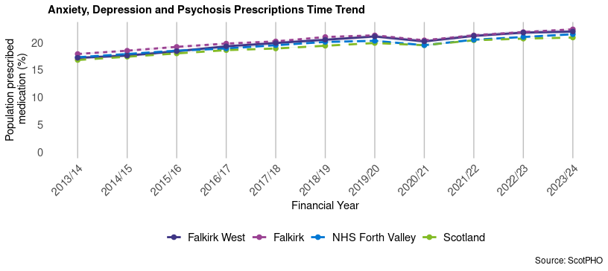

##### Page break

In 2023/24, Falkirk West had a larger proportion of the population being prescribed anxiety, depression and psychosis medication compared to the rest of Scotland (22% compared to 20.9%).

#### Figure 17: Percentage population prescribed medication for anxiety, depression and psychosis by area for the latest period available.

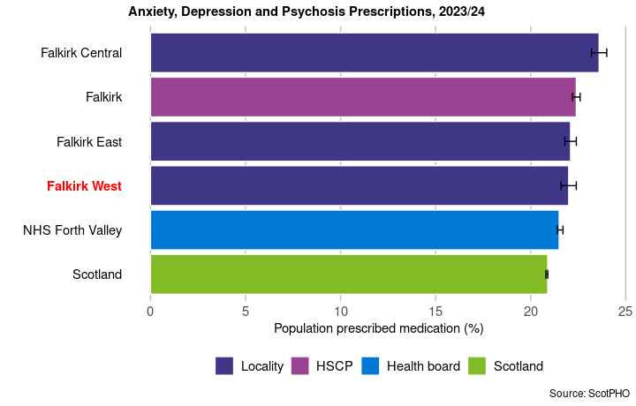

##### Page break

## Lifestyle and Risk Factors

**Summary**

Mental and physical well-being has close ties with people’s lifestyles and behaviours. Financial security, employment and location are influences that often have a bearing on these choices. Issues can develop when alcohol, smoking or drug use shape lives. This section provides data on drug-related hospital admissions, alcohol-related hospital admissions, alcohol-specific deaths and bowel screening uptake, to give an overview of some of the lifestyles and behaviours for the Falkirk West locality. These can give an idea of quality of life and prosperity.

For the most recent time period available3, Falkirk West had:

* **449** alcohol-related hospital admissions per 100,000 age-sex standardised population. This is lower than Scotland (532 admissions per 100,000)4.
* **18.8** alcohol-specific deaths per 100,000 age-sex standardised population. This is lower than Scotland (21.4 deaths per 100,000)4.
* **151** drug-related hospital admissions per 100,000 age-sex standardised population. This is lower than Scotland (202 admissions per 100,000)4.
* **68%** uptake of bowel screening among the eligible population, compared to 66.2% in Scotland.

### Alcohol-related Hospital Admissions

In 2022/23, the rate of alcohol-related admissions was **449** per 100,000 age-sex standardised population in Falkirk West. This is a 27.7% increase overall since 2002/03. Figure 18 shows a trend of alcohol-related hospital admissions for Falkirk West locality compared with Scotland, Falkirk HSCP and NHS Forth Valley from financial year 2002/03 to 2022/23.

Figure 19 then compares different areas, including the other localities in Falkirk, for the latest financial year. This bar chart shows that in 2022/23, Falkirk West locality had a lower alcohol-related hospital admissions rate compared to Scotland (449 and 532 admissions respectively).

##### Page break

#### Figure 18: Alcohol-related hospital admission rates by area and over time.

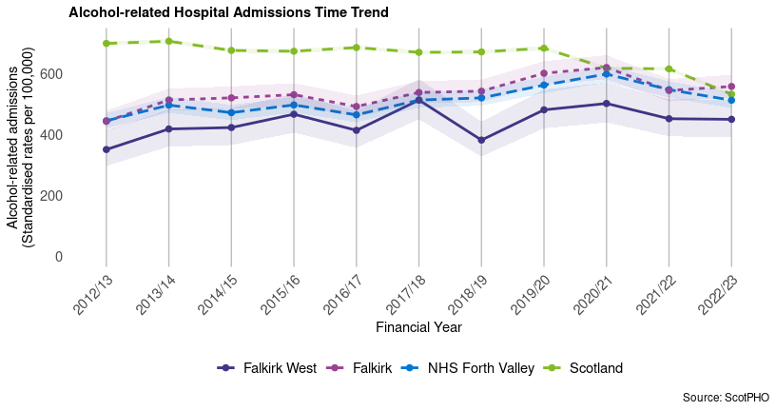

#### Figure 19: Alcohol-related hospital admissions by area for the latest time period.

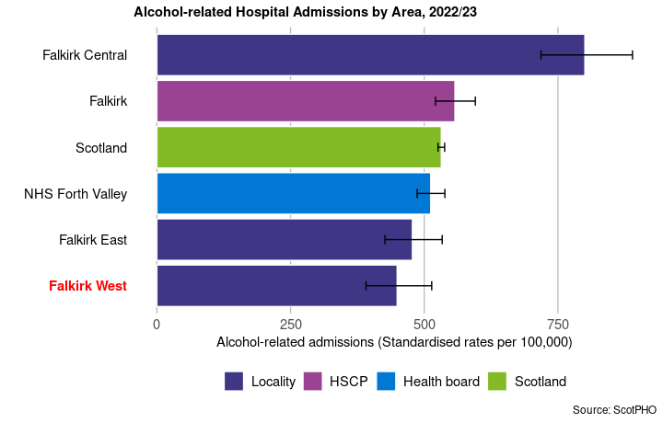

### Alcohol-Specific Deaths

Data on alcohol-specific deaths is available as 5-year aggregates. In Falkirk West, the latest rate of alcohol-specific deaths was **18.8** deaths per 100,000 age-sex standardised population. This is 19.7% higher than the rate in 2002 - 2006. Figure 21 also shows that the locality has a lower alcohol-specific death rate compared to Scotland overall (21.4 deaths per 100,000).

#### Figure 20: Alcohol-specific deaths by area and over time.

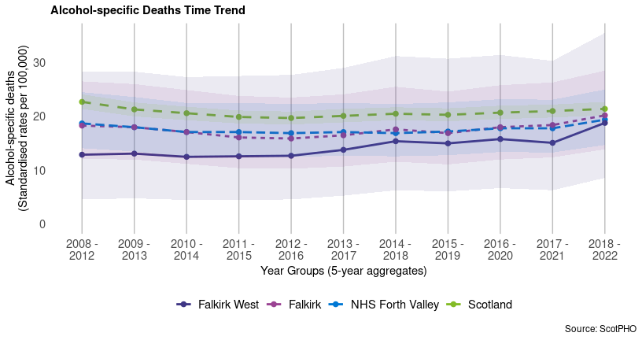

#### Figure 21: Alcohol-specific deaths by area for the latest time period available.

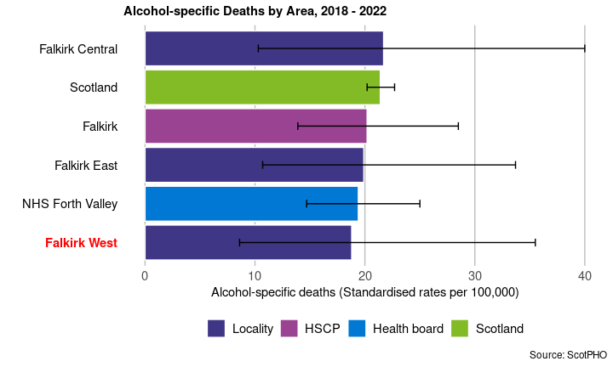

### Drug-related Hospital Admissions

There were **151** drug-related hospital admissions per 100,000 age-sex standardised population4 in the Falkirk West locality in the time period 2020/21 - 2022/23 (3-year financial year aggregate). This is a 494% increase since 2002/03 - 2004/05. A trend of the change in drug-related hospital admissions for the locality and comparable areas is shown in Figure 22 from 2010/11 - 2012/13 onward.

A comparison of areas at the most recent time period (2020/21 - 2022/23 aggregated financial years) is available in Figure 23 This shows the Falkirk West locality has a lower rate of drug-related hospital admissions than Scotland (202 admissions per 100,000).

#### Figure 22: Drug-related hospital admission rates by area and over time.

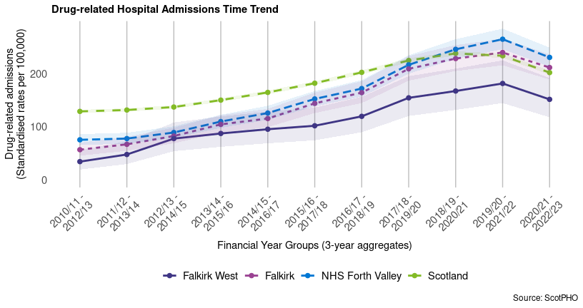

##### Page break

#### Figure 23: Drug-related hospital admission rates by area for the latest time period available.

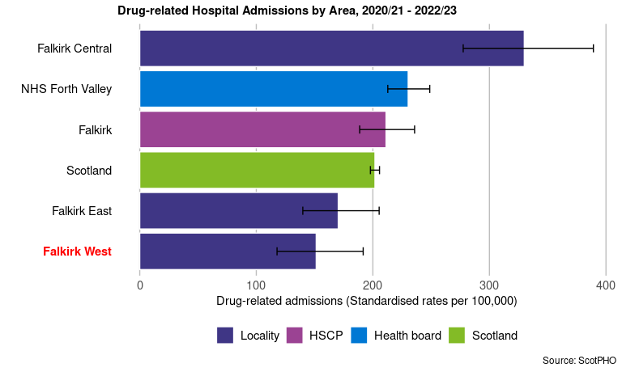

### Bowel Screening Uptake

Bowel screening is offered every two years to eligible men and women aged between 50-74 years old. Eligible people are posted a test kit which is completed at home. Since 1st April 2013, those aged 75 and over can also self-refer and opt into screening.

A trend of the percentage uptake of bowel screening among the eligible population is shown for Falkirk West and comparable areas. Data is presented as 3-year aggregates. The 2020 - 2022 uptake rate for Falkirk West is **68%**. This is a 26.9% increase since 2008 - 2010. As can be seen in Figure 25, in the latest estimate, the uptake in Falkirk West was higher than the uptake in Scotland overall (66.2%).

##### Page break

#### Figure 24: Bowel screening uptake for eligible men and women, by area and over time.

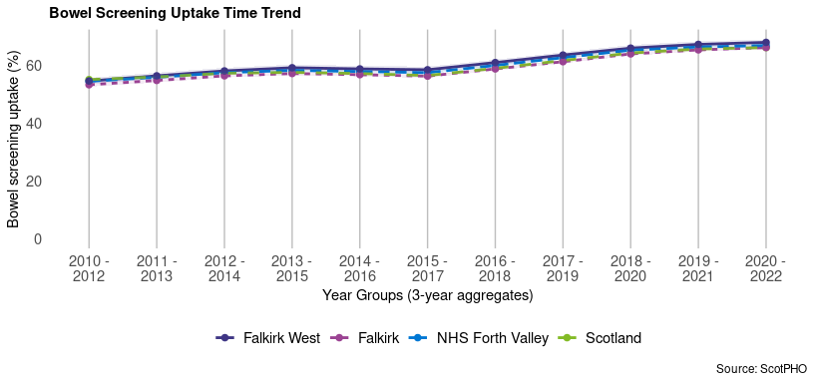

#### Figure 25: Bowel screening uptake by area for the latest time period available.

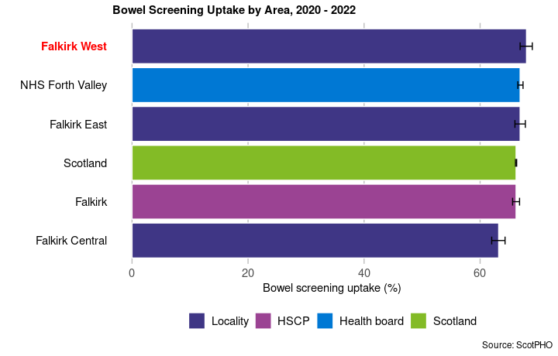

##### Page break

## Hospital and Community Care

**Summary**

**For the most recent time periods available, Falkirk West had:**

* **12,198** emergency hospital admissions per 100,000 population, compared to 10,963 in Scotland.
* **71,056** unscheduled acute specialty bed days per 100,000 population, compared to 77,702 in Scotland.
* **23,051** A&E attendances per 100,000 population, compared to 27,227 in Scotland.
* **50,123** delayed discharge bed days per 100,000 population aged over 65, compared to 48,494 in Scotland.
* **2,223** emergency hospital admissions from falls per 100,000 population aged over 65, compared to 2,307 in Scotland.
* **128.5** emergency readmissions (28 day) per 1,000 discharges, compared to 104.2 in Scotland.
* **1,675** potentially preventable hospital admissions per 100,000 population, compared to 1,691 in Scotland.

##### Page break

### Emergency Admissions

Figure 26 presents the emergency admissions rate per 100,000 population in the Falkirk West locality from 2017/18 to 2023/24.

As presented in Figure 26, the emergency admissions rate in the Falkirk West locality for 2023/24 is 12,198, a 20.2% increase since 2017/18. The Falkirk HSCP rate is 12,957, a 20.2% increase since 2017/18. The NHS Forth Valley health board rate is 12,287 in 2023/24, a 22.2% increase since 2017/18 and the Scotland rate is 10,963, a 0.8% increase since 2017/18.

#### Figure 26: Emergency admissions by geographical area

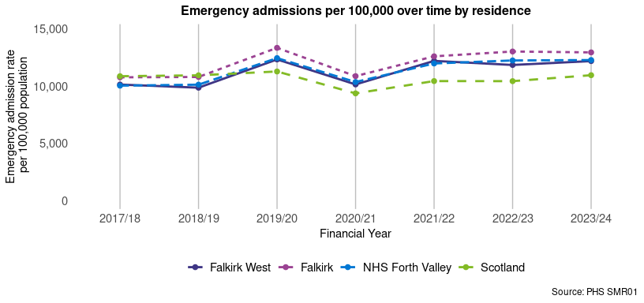

Figure 27 presents the emergency admissions rate per 100,000 population in the Falkirk West locality from 2017/18 to 2023/24 by age group.

As presented in Figure 27, the highest emergency admissions rate for the Falkirk West locality in 2023/24 is 36,203 per 100,000 population for the 75+ age group with a percentage increase of 5.3% since 2017/18. The lowest emergency admissions rate for Falkirk West in 2023/24 is 8,128 per 100,000 population for the 18 - 44 age group with a percentage increase of 30.7% since 2017/18.

#### Figure 27: Emergency admissions by age group

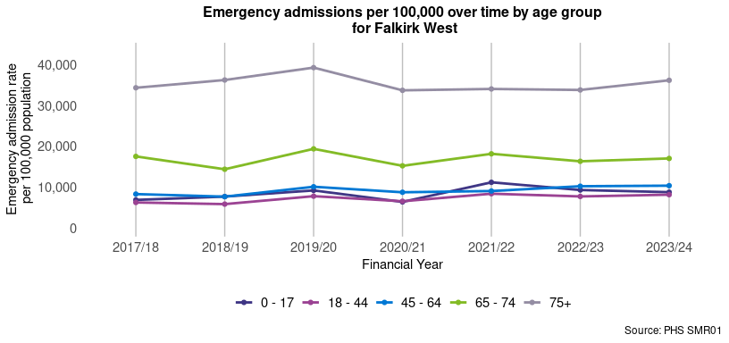

##### Page break

### Unscheduled Acute Bed Days

Figure 28 presents the unscheduled bed days rate per 100,000 population in the Falkirk West locality from 2017/18 to 2023/24.

As presented in Figure 28, the unscheduled bed days rate in the Falkirk West locality for 2023/24 is 71,056, a 3.9% increase since 2017/18 and the Falkirk HSCP rate is 82,225, a 10.5% increase since 2017/18. The NHS Forth Valley health board rate for 2023/24 is 78,858, a 13.5% increase since 2017/18 and the Scotland rate is 77,702, a 4.3% increase since 2017/18.

#### Figure 28: Unscheduled acute bed days by geographical area

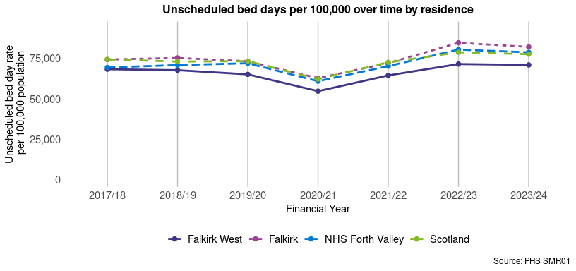

Figure 29 presents the unscheduled bed days rate per 100,000 population in the Falkirk West locality from 2017/18 to 2023/24 by age group.

As presented in Figure 29, the highest unscheduled bed days rate for the Falkirk West locality in 2023/24 is 441,567 bed days per 100,000 population for the 75+ age group with a percentage decrease of 7.6% since 2017/18. The lowest unscheduled bed days rate for Falkirk West in 2023/24 is 11,195 bed days per 100,000 population for the 0 - 17 age group with a percentage increase of 9.6% since 2017/18.

#### Figure 29: Unscheduled acute bed days by age group

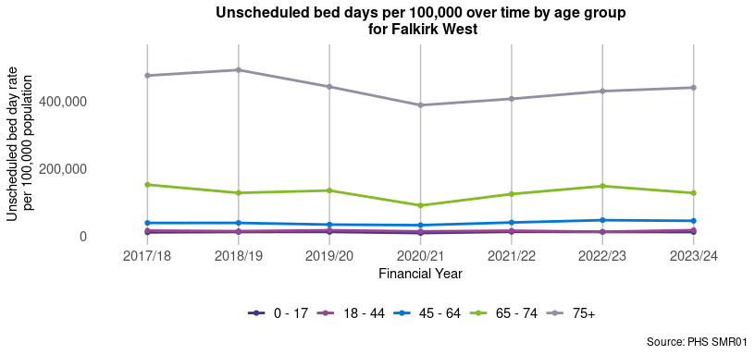

##### Page break

### A&E Attendances

Figure 30 presents the A&E attendance rate per 100,000 population in the Falkirk West locality from 2016/17 to 2023/24.

As presented in Figure 30, the A&E attendance rate per 100,000 in the Falkirk West locality for 2023/24 is 23,051, a 10% decrease since 2016/17 and the Falkirk HSCP rate is 24,040, a 6.2% decrease since 2016/17. The NHS Forth Valley health board rate for 2023/24 is 23,401, a 4.8% decrease since 2016/17 and the Scotland rate is 27,227, a 0.2% increase since 2016/17.

#### Figure 30: A&E attendances by geographical area

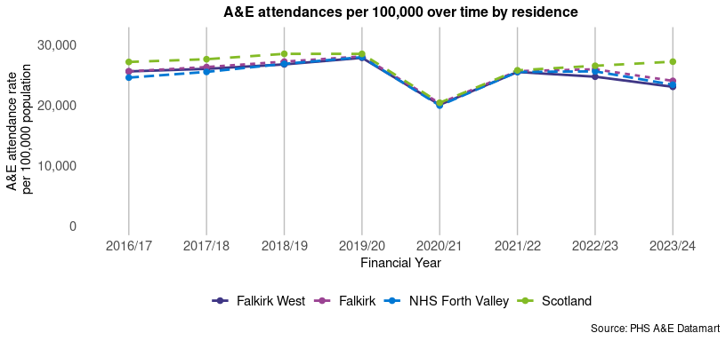

Figure 31 presents the A&E attendance rate per 100,000 population in the Falkirk West locality from 2016/17 to 2023/24 by age group.

As presented in Figure 31, the highest A&E attendance rate for the Falkirk West locality in 2023/24 is 37,799 per 100,000 population for the 75+ age group with a percentage increase of 6.4% since 2016/17. The lowest A&E attendance rate for Falkirk West in 2023/24 is 17,870 per 100,000 population for the 45 - 64 age group with a percentage decrease of 14.4% since 2016/17.

#### Figure 31: A&E attendances by age group

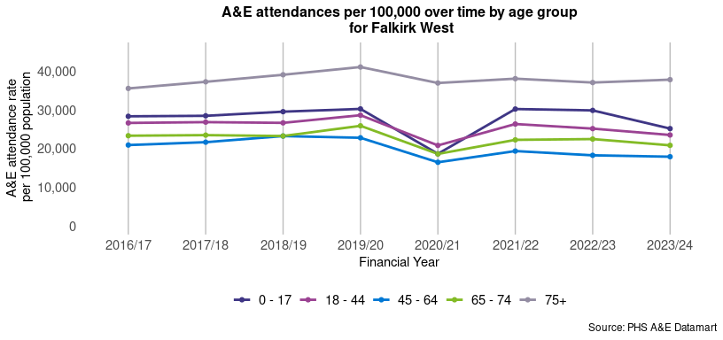

##### Page break

### Emergency Readmissions (28 days)

Figure 32 presents the emergency readmission (28 days) rate per 1,000 discharges in the Falkirk West locality from 2016/17 to 2023/24.

As presented in Figure 32, the emergency readmission (28 days) rate per 1,000 discharges in the Falkirk West locality for 2023/24 is 128.5, a 9.2% increase since 2016/17 and the Falkirk HSCP rate is 136.2, a 12.3% increase since 2016/17. The NHS Forth Valley health board rate for 2023/24 is 132.3, a 16.2% increase since 2016/17 and the Scotland rate is 104.2, a 3.4% increase since 2016/17.

#### Figure 32: Emergency readmissions (28 days) by geographical area

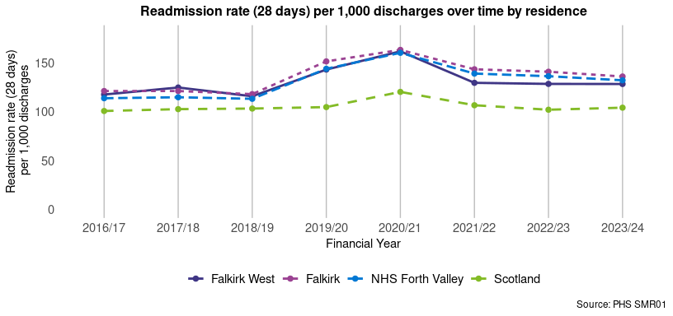

Figure 33 presents the emergency readmission (28 days) rate per 1,000 discharges in the Falkirk West locality from 2016/17 to 2023/24 by age group.

As presented in Figure 33, the highest emergency readmission (28 days) rate for the Falkirk West locality in 2023/24 is 136.3 per 1,000 discharges for the 75+ age group with a percentage decrease of 8.2% since 2016/17. The lowest emergency readmission (28 days) rate for the Falkirk West locality in 2023/24 is 115.5 per 1,000 discharges for the 45 - 64 age group with a percentage increase of 16.8% since 2016/17.

#### Figure 33: Emergency readmissions (28 days) by age group

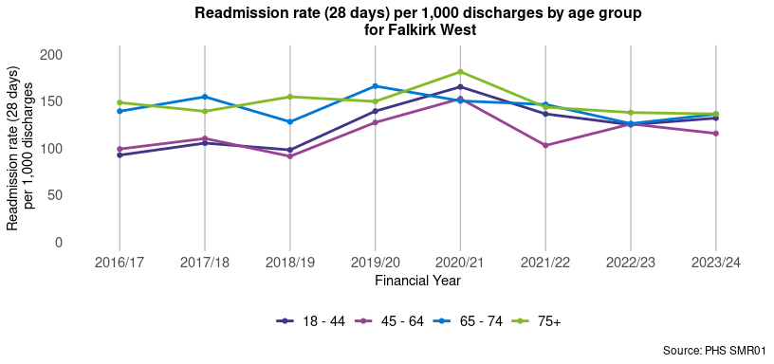

##### Page break

### Delayed Discharge Bed Days

Figure 34 presents the number of delayed discharge bed days per 100,000 population aged over 65+ in the Falkirk West locality from 2016/17 to 2023/24.

As presented in Figure 34, the number of delayed discharge bed days per 100,000 population aged over 65+ in the Falkirk West locality for 2023/24 is 50,123, a 17.4% increase since 2016/17 and the Falkirk HSCP rate is 69,635, a 62.5% increase since 2016/17. The NHS Forth Valley health board rate for 2023/24 is 56,872, a 62.7% increase since 2016/17 and the Scotland rate is 48,494, a 46.1% increase since 2016/17.

#### Figure 34: Delayed discharge bed days in the population aged 65+ by geographical area

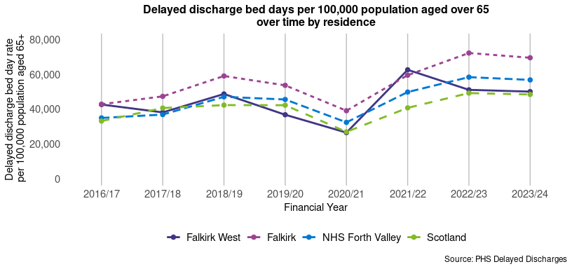

### Emergency admissions from a fall

Figure 35 presents the emergency admissions from falls rate per 100,000 population aged 65 and over in the Falkirk West locality from 2016/17 to 2023/24.

As presented in Figure 35, the emergency admissions from falls rate per 100,000 population aged over 65+ in the Falkirk West locality for 2023/24 is 2,223, a 34% increase since 2016/17 and the Falkirk HSCP rate is 2,458, a 24.4% increase since 2016/17. The NHS Forth Valley health board rate for 2023/24 is 2,395, a 33.6% increase since 2016/17 and the Scotland rate is 2,307, a 6.4% increase since 2016/17.

#### Figure 35: Falls in the population aged 65+ by geographical area

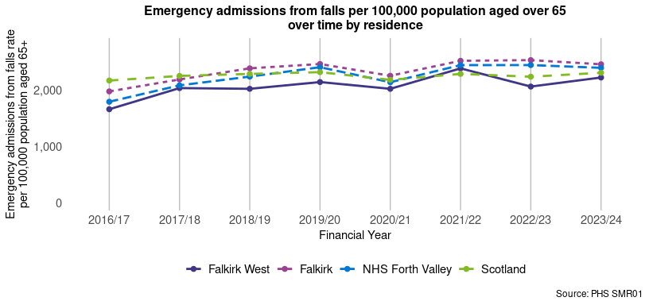

##### Page break

### Potentially Preventable Admissions (PPAs)

Information on the conditions included in Potentially Preventable Admissions (PPA)s is available in Appendix 3. In 2023/24, **42.5%** of PPAs in Falkirk West were amongst those aged 65 and over, and **57.5%** were amongst those aged under 65.

Figure 36 presents the PPA rate per 100,000 population in the Falkirk West locality from 2016/17 to 2023/24. The rate per 100,000 population for PPAs in the Falkirk West locality for 2023/24 is 1,675, a 10.5% increase since 2016/17 and the Falkirk HSCP rate is 1806, an 8.1% increase since 2016/17. The NHS Forth Valley health board rate for 2023/24 is 1,685, a 11.4% increase since 2016/17, 2023/24 and the Scotland rate is 1,691, a 1.9% decrease since 2016/17.

#### Figure 36: Potentially Preventable Admissions (PPAs) by geographical area

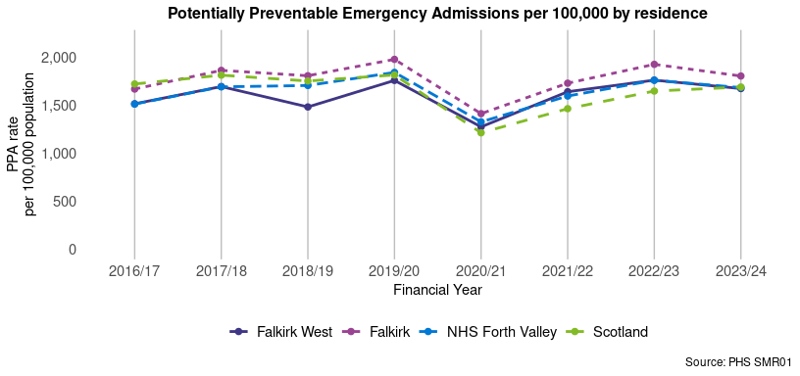

##### Page break

## Hospital Care (Mental Health Speciality)

**Summary**

This section looks at mental health-related unscheduled care indicators. For the most recent time period available, Falkirk West had:

* **214** psychiatric patient hospitalisations per 100,000, compared to 216.1 in Scotland4.

### Psychiatric patient hospitalisations

Figure 37 presents the psychiatric patient hospitalisation 3-year aggregate rate per 100,000 population in the Falkirk West locality from 2011/12 - 2013/14 to 2021/22 - 2023/24.

As presented in Figure 37, the 3-year aggregate psychiatric patient hospitalisation rate per 100,000 population in the Falkirk West locality for 2021/22 - 2023/24 is 214, a 14.4% decrease since 2011/12 - 2013/14 and the Falkirk HSCP rate is 229.4, a 15.7% decrease since 2011/12 - 2013/14. The NHS Forth Valley health board the 3-year aggregate rate for 2021/22 - 2023/24 is 227.2, a 17.9% decrease since 2011/12 - 2013/14 and the Scotland the 3-year aggregate rate is 216.1, a 24.4% decrease since 2011/12 - 2013/14.

#### Figure 37: Psychiatric patient hospitalisations by geographical area

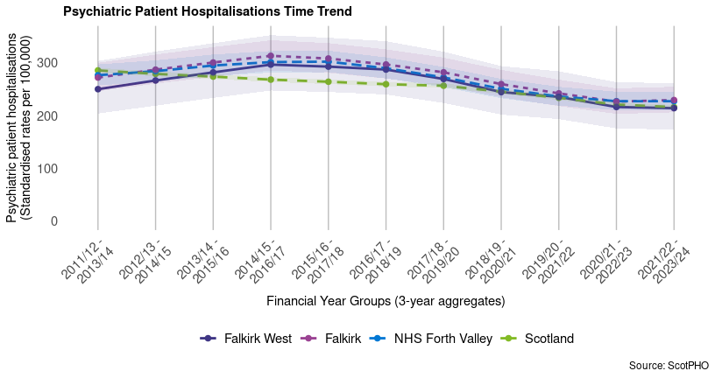

##### Page break

##### Page Break

### Footnotes

1. The National Records Scotland (NRS) does not currently provide population projections at the locality level. To explore how the population in Falkirk West is expected to change in the future, the percent changes in population projection to 2025 for Falkirk by age group and gender were calculated using the NRS Local Authority Population Projections. These percent changes were then applied to the Falkirk West 2022 mid-year population estimates (also split by age group and gender) to obtain population projection estimates for Falkirk West, based on the projections for the HSCP and the current population structure of the locality.
2. Care Home data included in the Services Map and Table was sourced from the [Care Inspectorate](https://www.careinspectorate.com/index.php/about-us). [GP Practice](https://www.opendata.nhs.scot/dataset/gp-practice-contact-details-and-list-sizes), [Hospital](https://www.opendata.nhs.scot/dataset/hospital-codes) and [A&E](https://www.opendata.nhs.scot/dataset/nhs-scotland-accident-emergency-sites) data were sourced from Public Health Scotland Open Data platform. Only services within the physical boundary of the HSCP or Locality are included in the map and table, so there may be services outside Falkirk that residents use but are not shown. Information on access deprivation was taken from the [ScotPHO profiles](https://scotland.shinyapps.io/ScotPHO_profiles_tool/) (The Scottish Public Health Observatory).
3. Sourced from [ScotPHO](https://scotland.shinyapps.io/ScotPHO_profiles_tool/). More recent data may be available for the indicators elsewhere.
4. ScotPHO data is often reported using the European Age-Sex Standardised Rate per 100,000. This allows for comparisons across different areas to be made. For more information on how these rates are calculated, please refer to the [PHS website: Geography, population and deprivation support](https://publichealthscotland.scot/services/geography-population-and-deprivation-support/population/).
5. Data on physical long-term conditions (LTC) is sourced from the Source Linkage Files (SLFs). These conditions are identified using ICD-9 and ICD-10 codes found in inpatient admissions’ diagnosis fields for acute and mental health cases. Note that this data does not include all service users in Scotland diagnosed with an LTC, as not all of these individuals have utilized these services. Additionally, LTC rates are based on an adjusted population indicator in the Source Linkage Files, ensuring that the population sizes align more closely with official estimates.

##### Page Break

## Appendices

### Appendix 1: Indicator Definitions

|  |  |
| --- | --- |
| Indicator | Definition |
| **A&E attendances** | The rate of A&E attendances per 100,000 population, includes data from ‘New’ and ‘Unplanned Return’ attendances at A&E, i.e. excludes those who are ‘Recall’ or ‘Planned Return’. This indicator only contains data from all sites that submit episode level data. This impacts Highland and Aberdeenshire partnerships in particular as they have a number of sites which submit aggregate data. |
| **Alcohol-related hospital admissions** | General acute inpatient and day case stays with diagnosis of alcohol misuse in any diagnostic position (ICD-10 code: E24.4, E51.2, F10, G31.2, G62.1, G72.1, I42.6, K29.2, K70, K85.2, K86.0, O35.4, P04.3, Q86.0, R78.0, T51.0, T51.1, T51.9, X45, X65, Y15, Y57.3, Y90, Y91, Z50.2, Z71.4, Z72.1). All rates have been standardised against the European standard population (ESP2013) and 2011-based population estimates. |
| **Alcohol-specific deaths** | Alcohol related deaths (based on new National Statistics definition): 5-year rolling average number and directly age-sex standardised rate per 100,000 population. (ICD-10 codes from the primary cause of death: E24.4,F10,G31.2,G62.1,G72.1,I42.6,K29.2,K70,K85.2,K86.0,Q86.0,R78.0,X45,X65,Y15). |
| **Asthma patient hospitalisations** | Patients discharged from hospital (annually) diagnosed with asthma: 3 year rolling average number and directly age-sex standardised rate per 100,000 population. All rates are standardised against the European standard population(ESP2013) and 2011-base population estimates. Patient is selected only once per year, based on their first asthma related hospital admission that year. |
| **Bowel screening uptake** | Bowel screening uptake for all eligible men and women invited (aged 50-74): 3-year rolling average number percentage. Eligible men and women are posted a guaiac-based faecal occult blood test kit (FOBT) which should be completed at home. This involves collecting 2 samples from each of 3 separate bowel movements. The kit is returned in a pre-paid envelope to the central screening centre in Dundee and tested for hidden traces of blood in the stool. Individuals who have a positive FOBT result are referred to their local hospital for assessment and, where appropriate, offered a colonoscopy as the first line of investigation. |
| **Cancer registrations** | New cancer registrations: 3 year rolling average number and directly age-sex standardised rate per 100,000 population. All rates have been standardised against the European standard population (ESP2013) and 2011-base population estimates. ICD10: C00-C96 excluding C44 (principal diagnosis only). |
| **Chronic Obstructive Pulmonary Disease patient hospitalisations** | Patients aged 16 and over discharged from hospital with COPD: 3-year rolling average number and directly age-sex standardised rate per 100,000 population. |
| **Coronary Heart Disease patient hospitalisations** | Patients discharged from hospital with coronary heart disease: 3-year rolling average number and directly age-sex standardised rate per 100,000 population. All rates have been standardised against the European standard population(ESP2013) and 2011-base population estimates. Patient is selected only once per year, based on their first CHD related admission to hospital that year. |
| **Death, aged 15-44** | Deaths from all causes (ages 15-44 years), 3 year rolling average number and directly age sex standardised rate per 100,000 population. All rates have been standardised against the European standard population (ESP2013). Deaths assigned to year based on death registration date. |
| **Delayed discharge bed days** | The number of bed days occupied by people over the age of 65 experiencing a delay in their discharge from hospital, per 100,000 population. Includes the following reason groups: all reasons, health and social care, patient/carer/family-related and code 9s. Length of delay is calculated from the patient’s ready for discharge date to either their discharge date within the specific calendar month or the end of the calendar month for patients who are still in delay. |
| **Drug-related hospital admissions** | General acute inpatient and day case stays with diagnosis of drug misuse in any diagnostic position (ICD10: F11-F16, F18, F19, T40.0-T40.9), 3-year rolling average number and directly age-sex standardised rate per 100,000 population. All rates have been standardised against the European standard population (ESP2013) and 2011-based population estimates. |
| **Early deaths from cancer** | Deaths from cancer (<75 years), 3 year rolling average number and directly age sex standardised rate per 100,000 population. All rates have been standardised against the European standard population (ESP2013). Death figures are based on year of registration. |
| **Emergency admissions** | Rate of emergency (non-elective) admissions of patients of all ages per 100,000 population, derived from data collected on discharges from non-obstetric and non-psychiatric hospitals (SMR01) in Scotland. Only patients treated as inpatients or day cases are included. The specialty of geriatric long stay is excluded. Data are reported by month of discharge. |
| **Emergency admissions from a fall** | Rate of acute emergency admissions (non-elective) of patients of all ages where a fall was logged as an ICD-10 code. ICD-10 codes W00-W19 were searched for in all diagnostic positions, in conjunction with the admission type codes 33 (Patient injury, home accident), 34 (Patient injury, incident at work) and 35 (Patient injury, other). |
| **Emergency readmissions (28 day)** | The rate of readmissions of all adults (18+) within 28 days of an admission per 1,000 discharges. An emergency readmission is where the subsequent admission is an emergency and occurs up to and including 28 days from the initial admission. The initial admission can be of any type but must end within the time period of interest. |
| **Life expectancy, females** | Estimated female life expectancy at birth in years, multi-year average (over 3 years for NHS Boards and Local Authorities, 5 years for Intermediate zones). Mortality data are based on year of registration. They also include non-Scottish residence so the number of deaths match those produced by NRS. |
| **Life expectancy, males** | Estimated male life expectancy at birth in years, multi-year average (over 3 years for NHS Boards and Local Authorities, 5 years for Intermediate zones) Mortality data are based on year of registration. They also include non-Scottish residence so the number of deaths match those produced by NRS. |
| **People living in 15% most ‘access deprived’ areas** | Number and percentage of population living in 15% most ‘access deprived’ areas (data zones) in Scotland. Calculated using 2011-base population estimates. |
| **Physical Long-Term Conditions (LTCs)** | Health conditions that last a year or longer, impact a person’s life, and may require ongoing care and support. The LTCs presented are: Arthritis, Atrial Fibrillation, Cancer, Coronary Heart Disease, Chronic Obstructive Pulmonary Disease (COPD), Cerebrovascular Disease, Dementia, Diabetes, Epilepsy, Heart Failure, Liver Failure, Multiple Sclerosis, Parkinson’s, and Renal Failure. |
| **Population prescribed drugs for anxiety/depression/psychosis** | Estimated number and percentage of population being prescribed drugs for anxiety, depression or psychosis. |
| **Potentially Preventable Admissions (PPA)** | Emergency admissions (non-elective) of patients of all ages for conditions based on 19 “ambulatory care sensitive conditions” from “The health of the people of NEW South Wales - Report of the Chief Medical Officer”. These conditions result from medical problems that may be avoidable with the application of public health measures and/or timely and effective treatment usually delivered in the community by the primary care team. Please see complete list of ICD-10 codes included in Appendix 3. |
| **Psychiatric patient hospitalisations** | Patients discharged from psychiatric hospitals: 3-year rolling average number and directly age-sex standardised rate per 100,000 population. Data taken from SMR04. All rates have been standardised against the European standard population(ESP2013) and 2011-base population estimates. Patient is selected only once per year, based on their discharge date. |
| **Unscheduled bed days** | Rate of unscheduled bed days of patients of all ages per 100,000 population, derived from data collected on discharges from non-obstetric and non-psychiatric hospitals (SMR01) in Scotland. Only patients treated as inpatients or day cases are included. Bed days for each month have been calculated based on the month in which the bed days were occupied. This differs from other analysis where bed days are reported by the month of discharge. |

##### Page break

### Appendix 2: Date of Indicator Data Extractions

|  |  |  |
| --- | --- | --- |
| Section | Indicator | Date of data extraction |
| **Demographics** | Population structure | 2025-04-17 |
| **Demographics** | Population projection | 2025-04-17 |
| **Demographics** | SIMD2016 | 2025-04-17 |
| **Demographics** | SIMD2020 | 2025-04-17 |
| **Housing** | Household estimates | 2024-11-01 |
| **Housing** | Household in each council tax band | 2024-11-01 |
| **Services** | GP practice locations | 2024-11-01 |
| **Services** | Care Home locations | 2024-11-01 |
| **Services** | A&E locations | 2024-11-01 |
| **General Health** | Life expectancy males | 2025-01-01 |
| **General Health** | Life expectancy females | 2025-01-01 |
| **General Health** | Deaths ages 15-44 years | 2025-01-01 |
| **General Health** | Physical Long-Term Conditions | 2025-01-01 |
| **General Health** | Cancer registrations | 2025-01-01 |
| **General Health** | Early deaths from cancer | 2025-01-01 |
| **General Health** | Asthma patient hospitalisations | 2025-01-01 |
| **General Health** | Coronary Heart Disease patient hospitalisations | 2025-01-01 |
| **General Health** | Chronic Obstructive Pulmonary Disease patient hospitalisations | 2025-01-01 |
| **General Health** | Population with a prescription for anxiery, depression or psychosis | 2025-01-01 |
| **Lifestyle & Risk Factors** | Alcohol related hospital stays | 2025-01-01 |
| **Lifestyle & Risk Factors** | Alcohol related mortality | 2025-01-01 |
| **Lifestyle & Risk Factors** | Drug-related hospital admissions | 2025-01-01 |
| **Lifestyle & Risk Factors** | Bowel screening uptake | 2025-01-01 |
| **Hospital & Community Care** | Emergency admissions (acute) | 2025-01-01 |
| **Hospital & Community Care** | Unscheduled bed days (acute) | 2025-01-01 |
| **Hospital & Community Care** | A&E Attendances | 2025-01-01 |
| **Hospital & Community Care** | Delayed discharges aged 65+ | 2025-01-01 |
| **Hospital & Community Care** | Fall admissions aged 65+ | 2025-01-01 |
| **Hospital & Community Care** | Emergency readmissions (28 day) | 2025-01-01 |
| **Hospital & Community Care** | Potentially Preventable Admissions (PPAs) | 2025-01-01 |
| **Hospital Care (Mental Health Specialty)** | Psychiatric patient hospitalisations | 2025-01-01 |

##### Page Break

### Appendix 3: Conditions included as Potentially Preventable Admissions (PPAs)

|  |  |  |
| --- | --- | --- |
| Condition | ICD10 codes included | Comments |
| Ear Nose And Throat | H66, J028, J029, J038, J039, J06, J321 | NA |
| Dental | K02, K03, K04, K05, K06, K08 | NA |
| Convulsions And Epilepsy | G40, G41, R56, O15 | NA |
| Gangrene | R02 | NA |
| Nutritional Deficiencies | E40, E41, E43, E550, E643, M833 | NA |
| Dehydration And Gastroenteritis | E86, K522, K528, K529 | NA |
| Pyelonephritis | N10, N11, N12 | NA |
| Perforated Bleeding Ulcer | K250, K251, K252, K254, K255, K256, K260, K261, K262, K264, K265, K266, K270, K271, K272, K274, K275, K276, K280, K281, K282, K284, K285, K286 | Excludes episodes with following main OPCS4 codes: S06, S57, S68, S70, W90, X11 |
| Cellulitis | L03, L04, L080, L088, L089, L980 | NA |
| Pelvic Inflammatory Disease | N70, N73 | NA |
| Influenza And Pneumonia | J10, J11, J13, J181 | NA |
| Other Vaccine Preventable | A35, A36, A370, A379, A80, B05, B06, B161, B169, B26 | NA |
| Iron Deficiency | D501, D508, D509 | NA |
| Asthma | J45, J46 | NA |
| Diabetes Complications | E100, E101, E102, E103, E104, E105, E106, E107, E108, E110, E111, E112, E113, E114, E115, E116, E117, E118, E120, E121, E122, E123, E124, E125, E126, E127, E128, E130, E131, E132, E133, E134, E135, E136, E137, E138, E140, E141, E142, E143, E144, E145, E146, E147, E148 | NA |
| Hypertension | I10, I119 | Exclude episodes with following main OPCS4 codes: K01 - K50, K56, K60 - K61 |
| Angina | I20 | Exclude episodes with main OPCS4 codes: K40, K45 K49, K60, K65, K66 |
| COPD | J20, J41, J42, J43, J44 | J20 only included if secondary diagnosis has one of J41 - J44 |
| Congestive Heart Failure | I110, I50, J81 | Exclude episodes with following main OPCS4 codes: K01 - K50, K56, K60 - K61 |