Appendix 1

Falkirk Health & Social Care Partnership Locality Planning

West Locality Plan 2026-2027
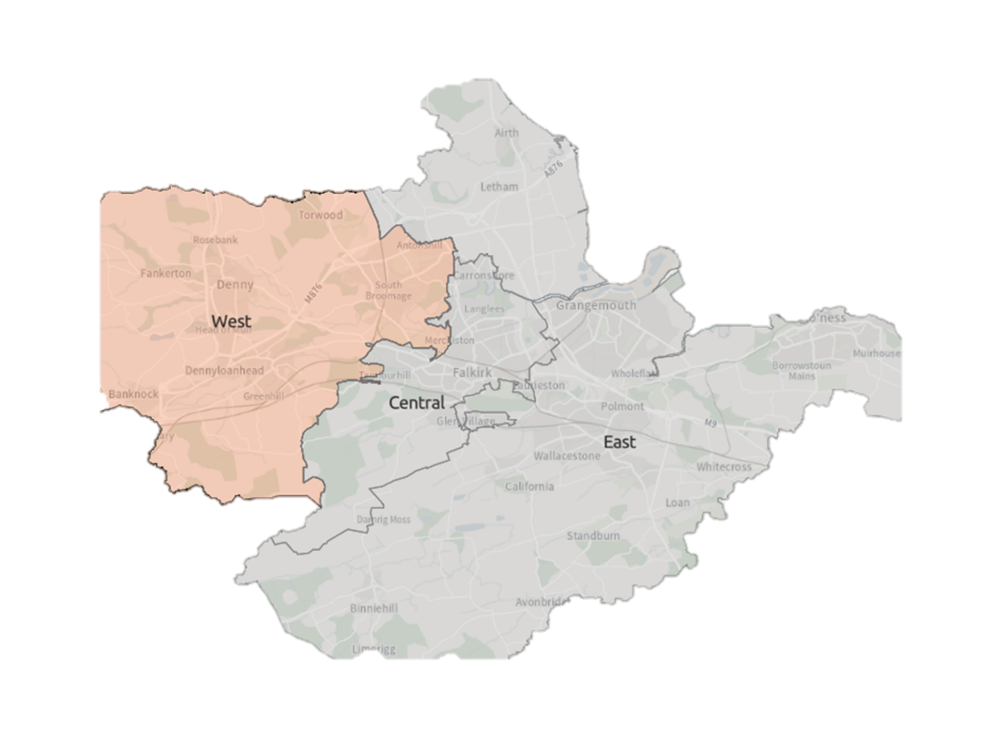


Contents
Introduction 2
Falkirk Health & Social Care Partnership 2
Locality Planning 2
Development of Falkirk West Locality Plan 3
Strategic Context 3
About Falkirk West Locality 6
Summary 6
Services In The Area 7
Primary Care Services 7
Third Sector & Communities 8
Community Learning and Development 8
Local Support 8
Previous Consultation & Engagement Feedback 9
Challenges in Falkirk West Locality 11
Guiding Principles & Priorities 16
Consultation & Engagement 17
Finance & Resources 18
Measuring Progress 19
Next Steps 20
Appendix 1: Strategy & Policy Context 21
Appendix 2: West Locality Delivery Plan 22
Appendix 3: Services in the Area 30

Document information
Date of issue:
Approval status:
Review date:
Available from:
Key contact:

Introduction

Falkirk Health & Social Care Partnership
Falkirk Health and Social Care Partnership (HSCP) is one of 31 integration bodies in Scotland, serving a population of over 160,000 across rural and urban communities. It aims to enable people in Falkirk to live full and positive lives within supportive and inclusive communities.
The Partnership’s workforce is employed by Falkirk Council, NHS Forth Valley, and its partners in the third and independent sectors. They work in local social work offices, health centres, GP Practices, community hospitals, care homes, intermediate care facilities to support people’s independence, day centres, and communities across the Falkirk area.
Falkirk Health and Social Care Partnership deliver care and support for adults and older people with mental health problems, long-term physical conditions, and substance misuse problems. The Partnership provides opportunities for learning, development and education Including mental health, oral health substance use and naloxone awareness to support staff, volunteers, and the wider community.
People who provide direct care for their loved ones, known as unpaid carers, are also supported by the Partnership through the Falkirk and Clackmannanshire Carers Centre.

The Partnership is run by its Integration Joint Board made up of representatives from Falkirk Council, NHS Forth Valley, the third sector, service users and carers.

The Board has responsibility for planning, resourcing and operating services, working to deliver the nine National Health & Wellbeing Outcomes.

Locality Planning
The Partnership has identified three locality areas for service planning and delivery purposes. Our locality areas are aligned to GP ‘clusters’:

- West: Denny, Bonnybridge, Banknock, Larbert and Stenhousemuir
- Central: Falkirk town, Camelon, Bainsford, Langlees, Hallglen
- East: Grangemouth, Bo’ness, Braes Villages, Airth and Letham

Working by locality provides the opportunity for the Partnership to design integrated services and realign resources to deliver the Falkirk HSCP Strategic Plan. This includes working alongside our partners within the Community Planning Partnership and collaborating on the Falkirk Plan and Community Action Plans.
Locality Plans set out priorities and actions to improve health and social care within the area based on community needs. The plans are intended for local residents, service users, third sector partners and operational staff involved in service delivery and planning.

Development of Falkirk West Locality Plan
Work started on the development of the Falkirk HSCP West Locality Plan with a self-evaluation assessment. The assessment involved:

- A review of available data
- Previous consultation and engagement feedback
- Board reports
- Staff feedback

A Locality Planning Steering Group was established to provide oversight and drive development of all three Locality Plans. The group involves key stakeholders and partners to support the plans development and implementation.

To support development of the West Locality Plan, a West Locality Working Group was convened. This brought together key stakeholders, staff and partners from across the locality area to help co-ordinate the development of the Plan, identify challenges within the Locality and priority areas to be addressed. The Working Group followed a bottom-up approach, ensuring the plan was co-produced with communities through a phase of public consultation & engagement.

As the plan moves into its implementation phase, the Working Group will expand membership to form the West Locality Delivery Group. The expanded group will include additional stakeholders, staff and partner representation. The key role of the Delivery Group will be to support the implementation and delivery of the Plan and contribute towards development of its future iteration.

Strategic Context
Figure 1: Locality Planning Development Process
The Strategic context set out below explains what is expected of Health and Social Care Partnership in Scotland, including Falkirk.

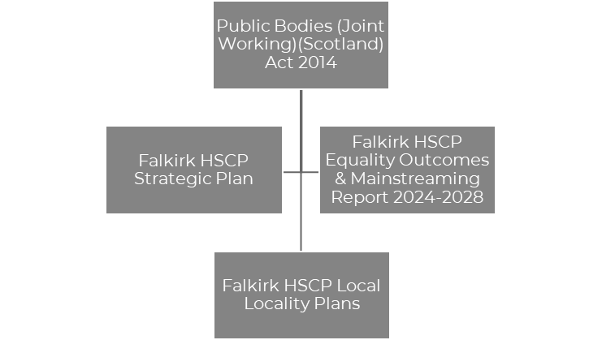
Figure 2: Strategic Context

Public Bodies (Joint Working) (Scotland) Act 2014
The Public Bodies (Joint Working) (Scotland) Act 2014 is the government legislation that underpins integration and the development of Health & Social Care Partnerships across Scotland. The Act sets out nine national outcomes for health & wellbeing, the preparation of Strategic Plans, and the requirement for HSCPs to establish localities within its area.

Falkirk HSCP Strategic Plan
Our Strategic Plan, Creating a Healthier Falkirk, sets out the outcomes and priorities we want to deliver to improve health and social care, reflecting the differences we want to make for individuals, families and communities across Falkirk. The Strategic Plan sets out how the Integration Joint Board (IJB) will plan and deliver services for the Falkirk area, using the integrated budgets under our control.

Four Strategic priorities have been identified that the Partnership believe will make the biggest difference and helping us achieve our outcomes. The priorities are:

- Support and Strengthen Community-Based Services
- Ensure People Can Access the Right Care, at the Right Time, in the Right Place
- Focus on Prevention, Early Intervention and Minimising Harm
- Ensure Carers are Supported in their Caring Role

These priorities are driven by three workstreams:

- Workforce
- Technology
- Communication and Engagement

The Strategic Plan is currently under review with a new iteration to be developed within 2026. The development will consider learning and insights from our Locality Plans to ensure the new Strategic Plan meets the needs and challenges of our communities.

Equality Outcomes & Mainstreaming Report
Falkirk HSCP Equality Outcomes & Mainstreaming Report supports the partnership’s commitment to promoting fairness, dignity and respect while delivering services that provide equal opportunity for all in Falkirk. The report sets out Equality Outcomes which will support the Partnership to achieve this aim. The Equality Outcomes are as follows:

- Equality Outcome 1: Older people who experience barriers to accessing internet-based health & social care services have alternative ways to access services

- Equality Outcome 2: People from Ethnic Minority backgrounds who experience language and cultural barriers have improved access to services

Falkirk HSCP Locality Plans
The Partnership is required to develop Locality Plans for each locality within the area. The plans should demonstrate how the Outcomes & Priorities of the Falkirk HSCP Strategic Plan are implemented at a local level to ensure services respond to the priorities, needs and challenges of communities.

While Locality Planning is guided by the Strategic Context outlined above, other strategies and workstreams within the HSCP and local partners must be aligned where possible. A list of all Strategies and plans connected to Locality Planning is outlined in Appendix 1. Alignment with plans will be reviewed as we further enhance our Locality Planning process.

About Falkirk West Locality

Summary
General Health
Population & Community
Total population 48,484













People living in most deprived areas has increased to 7.4%
Life Expectancy in years
Male: 77.4
Female:80.4
Most recent Information about health and wellbeing in Falkirk West Locality. Information extracted from Locality Profile: Falkirk West Locality, April 2025
& ScotPHO profiles

Increase in hospital admissions for falls (65+)
Alcohol-specific deaths increased (2018-2022)
Lifestyle & Risk Factors
Alcohol/drug-related hospital admissions lower than national average
19.2% aged 65+
20% increase in males aged 85+ (2017-2022)
22,013 dwellings
29.1% of 65+ have multiple long-term conditions
Increase in mental health prescriptions
Hospital Care
Higher delayed discharge rate (65+) than national average
68% bowel screening uptake (50-74 years)
Increased hospital admissions (75+)

Services In The Area
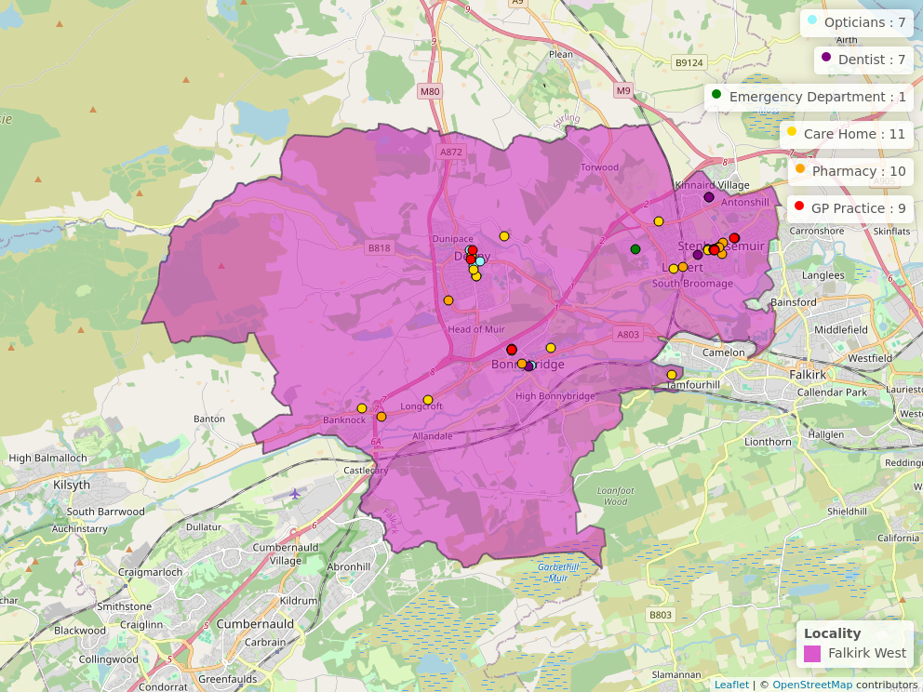
Figure 3: Public Health Scotland
Further Information for health & wellbeing Services can be found at NHS Inform. Details of services within the Figure 3 can be found at Appendix 3.

Primary Care Services
Capacity within GP practices were increased across Falkirk West as a result of the Forth Valley Primary Care Improvement Plan 2018-2021. As a result, additional Healthcare professionals were recruited to support increasing service demand. This has led to additional pressures on the capacity of facilities where practices are located.

Practices are contracted by NHS Forth Valley to provide medical services under the 2018 Scottish General Medical Services (GMS) Contract. 90% of healthcare encounters take place in general practice, however many practices in Scotland do not have enough clinicians to meet the needs of their patients. This creates a capacity and demand imbalance which is resulting in a lack of sustainability in general practice.

The British Medical Association (Scotland) has produced Safe Working Guidance for Practices. The guidance provides GPs with advice on how to safely manage workload such as redirecting patients to more suitable NHS services, the number of patient contacts per day and appointment times.

Practices will follow the Right Care, Right Place guidance to signpost individuals to appropriate health care provider. This can include dentist, optician, physiotherapist, mental health nurse and the Pharmacy First Scotland service.

Third Sector & Communities
CVS Falkirk & District are the Third Sector Interface for the Falkirk area and supports, promotes and develops the connection between the third sector and HSCP.

CVS Falkirk & District provided representation for the third sector and communities in the development of the West Locality Plan. Our third sector and community organisations are vital assets in our communities and will be important partners in the implementation and delivery of the West Locality Plan.

Community Learning and Development
Community Learning and Development work within communities to facilitate and enable community and group leadership within the West Locality. They support with community development across the Locality that local groups, particularly those providing low-level support have been engaged and involved in the Locality Planning process

Local Support
Falkirk Council have developed the Our Falkirk- Local Services Map. It highlights support available within Falkirk West Locality including provision for:

- Online access
- Food provision
- Money advice and support services
- Period Products
- Warm & Safe Welcoming Spaces

Previous Consultation & Engagement Feedback
Over recent years, the Partnership has engaged with residents in Falkirk West to assist with strategy development. Below is a summary of some of the key issues from previous engagement work and how the feedback has been represented within our various plans. It should be noted that although this has impacted West Locality, most of the feedback below has been Falkirk wide.

What We Have Been Told | What We Are Doing
“It is a postcode lottery for where you stay that depends on the support you will get.” | Two priorities are within the Strategic Plan to address the issues raised during the consultation to improve support within our communities and how individuals access services:  - ‘Support and Strengthen Community-Based services.’  - ‘Ensure people can access the right care, at the right time, from the right person.’
“Better communication between primary and secondary care would create better pathways between services.”  “Better local support in GP surgeries.” | ‘Communication & Engagement’ is within our current Strategic Plan as a cross-cutting priority. We recognise the need for clear, accessible and inclusive information to ensure individuals know what support is available and how it can be accessed.  The partnership has recently developed a Participation & Engagement Strategy 2024-2027 to improve engagement and working relationships with our communities.  The Strategic Plan commits to the further development of multi-disciplinary teams in communities, bringing together different health and social care professionals. This will ensure communities can access a wider range of professionals and services within GP practices and closer to their home.
“It’s important that we recognise the need for people to live well, not just live longer.” | ‘Focus on prevention, early intervention and minimising harm’ is a priority in the current Strategic Plan as we recognise addressing issues before they escalate will help improve people’s wellbeing.
“Appetite for community engagement but feel their views are not taken on board.”  “Better engagement with community, evening and weekends that suit individuals better. “ | The Partnerships recently developed Participation & Engagement Strategy 2024-2027 aims to improve working relationships between the Partnership and individuals in the community.  Officers have conducted in-person engagement with local groups across the community in Falkirk West Locality for the development of the West Locality Plan. The HSCP are committed to continuing to build on these relationships through future engagement exercises.
“Don’t know what alternative ways are to accessing services. Living on my own, no family to be shown what to do, nobody to ask for help.”  “The older population do not know how to access online services.” | An Action is included within the Equality Outcome & Mainstreaming Report:  - “We will communicate and promote traditional methods of accessing services with older people.”  As a result of the Action, some services are offering alternative appointment options which include telephone, in-person or face-to-face.
“Third sector organisations coming together (let down by statutory services and needs partnership working to minimise waiting time and barriers to access).” | The Falkirk Plan 2021-2030 has been refreshed and has a priority to improve working with our local third sector organisations and communities.  The Partnerships Participation & Engagement Strategy outlines the commitment to work closer with third sector organisations and community groups.
Foodbanks should be advertised better so people are more aware of them.  People should have access to affordable and nutritious food. | Denny, Dennyloanhead and Dunipace Community Action Plan has actions set out to improve both food provision and food education to improve access for diet and nutrition within the community.
More activities to promote good mental health for young people and educated on mental health | Denny, Dennyloanhead and Dunipace Community Action Plan looks to improve mental health support and improve awareness of support available locally in the area.  Work is currently ongoing within the Partnership to review current community support available for mental health and wellbeing and loneliness and to make information on support available more accessible.
“Little support for people with addictions.” | The Falkirk Alcohol & Drug Partnership have conducted Needs Assessment to support the development of their Delivery Plan which will look at substance use concerns in our communities with a focus on provision within Localities.
“Better support for Dementia.” | The Falkirk Dementia Strategy Group meet regularly to identify key priorities and review our dementia pathway to improve outcomes for people living with dementia. The group includes key stakeholders from social work, health, third sector, and carer representation.

Challenges in Falkirk West Locality
Falkirk HSCP recognises the challenges faced by communities within Falkirk West and are actively reviewing service delivery to ensure effective use of staff and resources. These challenges have supported with identifying the key priority areas outlined on page 16 and have been identified based on engagement feedback, available data, staff input and self-evaluation reports. While some of the challenges are specific to Falkirk West, many reflect wider issues across Falkirk area.

Access to Primary Care Services
Residents face difficulty securing appointments with GPs and other members of the primary care team within practices which can contribute to frustration for access and addressing health needs. Individuals are often unclear why they are being re-directed to additional health care providers and respondents to the consultation spoke about the 8am rush for appointments.

Access to Health and Social Care Services
Many individuals struggle to access or navigate internet-based service and are unaware about services available locally and where to find support or access these.

Access to Information
There is widespread uncertainty about where to find reliable information for health and social care services and where this can be accessed. This affects people's ability to make informed decisions about their health and wellbeing. There could be better access and information made available for community support such as local groups and organisations which can help individuals manage their health and wellbeing without the need to access statutory services.

Carers
Carers report high levels of emotional stress, anxiety, and burnout which can negatively impact their physical health. Carers that provide more hours of care a week experience greater health challenges. Many carers feel undervalued and seek more respect and appreciation from health and care providers. In the West Locality, feedback was shared about further information and support being made available to carers who support someone with dementia and for carers who live within the West Locality but care for someone in another local authority area.

Communication
Improved communication is needed between services and with service users. Clear information about the steps taken by services to support individuals would help with transparency and understanding about the challenges that services face.

Dementia
Respondents and staff highlighted gaps within dementia support, especially post-diagnosis which causes concerns especially for carers. A need was outlined for better information and support available to individuals with dementia and their careers.

Work is currently ongoing within Falkirk HSCP to address concerns with dementia. This includes the formation of Dementia Strategy Group who meet regularly to review dementia pathways and improve outcomes for people living with dementia.

Facilities & Community Space
There is concern over the potential loss of local facilities with community organisations lacking the capacity to take them on. This threatens the sustainability of vital community spaces and services for individuals who may require accessing health & social care support as an alternative.

Housing
Homelessness remains a significant issue, alongside long waiting lists for housing support and challenges in accessing aids and adaptations. Housing services have identified a rise in self-neglect and hoarding which is impacting on services and difficulty with individuals engaging with support available. Self-neglect and hoarding toolkit has been developed by partners involved.

Loneliness & Isolation
Respondents in the West Locality highlighted that loneliness & isolation is a factor that they recognise within their communities. Local community groups and organisations have set-up provision available within communities, particularly for the older population, to connect and access warm spaces where food and drink is available. Respondents also noted that loneliness can impact on recovery by not accessing support they need and speaking about ailments.

Mental Health & Wellbeing
Suicide prevention efforts have been ongoing in Denny & Bonnybridge. The community have developed a Community Charter of values and commitments for mental health and suicide prevention with support from CVS Falkirk & District. Local community groups and organisations exist across the West Locality providing support for mental health & wellbeing, but greater awareness of the groups and support offered could be advertised. Individuals accessing those groups acknowledged the vital support they offer not only for current mental health & wellbeing but also with prevention for conditions worsening.

Peer Support
Respondents highlighted a need for greater awareness and availability of peer support networks. Suggestions included increasing number of drop-ins or developing satellite groups which could evolve into community-led support hubs. Peer support was described as vital for individuals in recovery as hearing from the lived experience of others brought hope and encouragement. Expanding opportunities for peer support could enhance social prescribing improve signposting to community-based support.

Poverty and Inequality
Although West Locality has a lower proportion of people living in the most deprived areas, there has been an increase since 2016 of those living in the most deprived data zones. Poverty and inequality continue to affect specific areas such as Denny, Bonnybridge and Stenhousemuir, highlighting a need for targeted intervention and support.

Substance Use
While drug and alcohol-related hospital admissions are below the national average, alcohol-specific deaths rose between 2018 and 2022 indicating a need for focused prevention and support strategies. Recovery communities are vital for individuals that are in recovery, but concerns were raised about not being made aware of those options when within a clinical setting. It was suggested better awareness could be made about support available from hospitals and GP surgeries regarding community-based options.

Travel
Unreliable bus connectivity, especially to Forth Valley Hospital, limits access to essential services. A bid has been submitted through Community Choices to fund transport for excursions, aiming to improve mobility and social inclusion.

Trauma-Informed Approaches
There is a recognised need for services to become more trauma-informed to ensure individuals feel safe, supported, and understood when accessing support. Across the West Locality, teams have been proactively engaging with trauma-informed approaches, reflecting on their own practices and making changes where possible to better respond to the needs and experiences of those they support.

Working with Communities
Areas within the West Locality have community groups and organisations working collaboratively and being supported by CVS Falkirk & District. Feedback suggested a need for better engagement from statutory services with community groups and organisations and to work alongside local partners to strengthen this. There is a call for funding to prioritise early intervention and prevention activities alongside better sharing of health and wellbeing contacts among third sector organisations and partners.

Community groups and organisations have expressed concern about the funding landscape for the third sector. This uncertainty affects not only community leaders but individuals that rely on the groups for support. Organisations recognise the need to collaborate closely especially when funding is becoming limited.

Guiding Principles & Priorities
Below are the priority areas for Falkirk West Locality. The priorities have been identified by the Working Group as a result of the challenges identified within the West Locality. The priorities were finalised following public engagement and consultation work with the wider community.

The Delivery Plan within Appendix 2 sets out actions for each priority area and will be monitored by the Locality Delivery Group.

Priority: Making it Easier to Manage Your Health & Wellbeing
To support individuals, their carers and families to plan, manage and understand their own health, care and wellbeing needs.

Priority: Improved Access & Availability of Community-Based Support
Improvement in clear, accessible and inclusive support within the West Locality, ensuring service users are aware of support available and how it can be accessed.

Priority: Supporting Recovery and Reducing Mental Health Harms
Capturing all aspects that impact mental health & wellbeing and substance use (including tobacco) and ensuring adequate support for recovery is available.

Priority: Improved Partnership Working
Improving partnership working, communication and information sharing between services and partners resulting in improved trust, experiences and outcomes for service users.

Addressing Health & Social Inequalities

Focus on Person-Centred Care

Improving Trauma Informed Approaches

Eliminate discrimination, advance equality of opportunity & foster good relations

Guiding Principles

The priority areas will be supported by four guiding principles established by the Working Group. The guiding principles will be taken into account throughout each priority area and will underpin all work undertaken within the locality.

Consultation & Engagement
The phase of consultation and engagement for the development of the West Locality Plan was undertaken from 06 September 2025-15 October 2025. The consultation involved:

- An online survey available via participate+
- Summary document outlining the West Locality Planning process, previous engagement feedback and challenges presented.
- In-person meetings with local community groups and organisations.

Consultation fatigue was highlighted as a concern to officers when conducting previous consultation work for the Partnership. Therefore, the Working Group utilised data and feedback from previous engagement exercises to identify challenges and priority areas to address in Falkirk West.

The Consultation phase for the West Locality Plan followed a collaborative approach with individuals to refine the challenges, priority areas and actions to be implemented. This allowed the Plan to be co-produced by the communities and follow a bottom-up approach. The engagement targeted particular underrepresented groups highlighted by members within the Working Group.

Overall, 26 individuals completed the online survey and around 50 people consulted at 10 in-person events. A consultation report is available on the Falkirk Council Participate+ platform. The report outlines feedback received during consultation and where respondents were instrumental in the decision-making of the West Locality Plan.

Finance & Resources
The Integration Joint Board is primarily funded for services through contributions from Falkirk Council and NHS Forth Valley and has a duty to set a balanced annual budget aligned to the Strategic Plan.

In September 2024, the IJB agreed a Budget Strategy setting out an approach to meet a £21.164m financial gap over the next three years. In October 2025, a Business Case and Medium Term Financial Plan update was presented to IJB. The report provided an update on budget pressures and assumed funding for 2026/27.

The Partnership’s financial planning will be challenging throughout the duration of this Locality Plan. This is consistent with the position for both Falkirk Council, NHS Forth Valley and the overall Partnership. Work is under way to establish some initial locality budgets at this time, with further development required for coming years to review each locality teams budget resources and responsibilities.

Measuring Progress
The West Locality Delivery Plan within Appendix 2 outlines the tasks and measures to be undertaken for each action within the Delivery Plan. Progress towards the actions will be reviewed and monitored by the West Locality Delivery Group on a quarterly basis and reported to the Strategic Planning Group. A monitoring framework has been developed to ensure updates are regularly provided.

The Partnership’s Integration Joint Board receives regular performance reports. These reports ensure the Board fulfils its ongoing responsibility to ensure effective monitoring and reporting on the delivery of services. Future reports will provide information on performance against targets and measures set out in the West Locality Plan.

Next Steps
The West Locality Plan will move into its monitoring and implementation phase. This will begin with the formation of the West Locality Delivery Group and a quarterly meeting schedule arranged. The Delivery Group will ensure important stakeholders are represented and working with partners to expand community representation within the Locality Planning process. The Delivery Group will look to connect with ongoing groups and committees across the West Locality to provide connection and additional support towards implementation.

Discussions have begun with colleagues in the Community Planning Partnership to review the Locality Planning process and identify areas for alignment in Locality Planning work. Falkirk Councils Children and Families Social Work Services and Justice Social Work Services are now a part of the partnership. Over time, we will explore how integration can enhance and improve service delivery.

The West Locality Plan provides an important insight for the current development for the next iteration of the Falkirk HSCP Strategic Plan, which will be developed throughout 2026. The West Locality Plan will be pivotal in shaping the new Strategic Plan by providing opportunities and insights to ensure it will meet the priorities, needs and challenges currently faced in our communities.
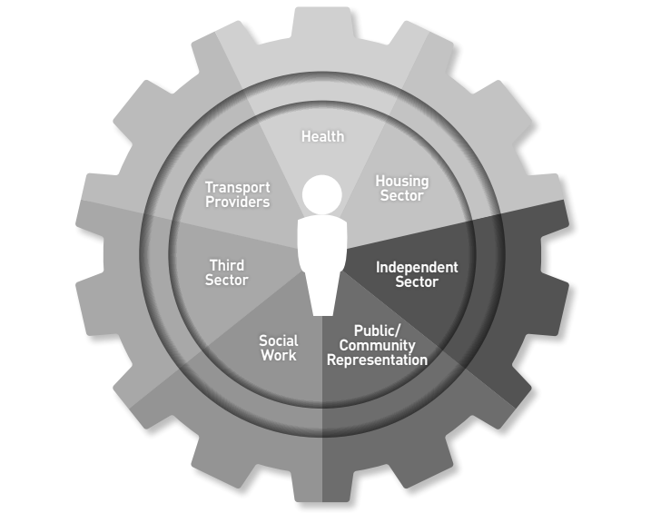
Figure 4: Locality Delivery Group Stakeholders

Appendix 1: Strategy & Policy Context
Below is a list of local and partner Strategies that have supported the development of Falkirk HSCP West Locality Plans.

Falkirk HSCP
- Falkirk HSCP Strategic Plan
- Falkirk HSCP Participation & Engagement Strategy
- Falkirk HSCP Carers Strategy
- Falkirk HSCP Equalities Outcomes & Mainstreaming Report
- Housing Contribution Statement
- Falkirk HSCP Independent Advocacy Strategic Planning 2025-2029

Data that supported the development of the plan was taken from:

- Falkirk HSCP Joint Strategic Assessment 2023
- Falkirk HSCP West Locality Profile 2025

Current plans are under development that have also supported the plans development. This includes the Falkirk Alcohol & Drug Partnership Delivery Plan, Gender-Based Violence Strategy, Advocacy Plan and Falkirk HSCP Learning Disability Strategy.

Falkirk Council
- The Falkirk Plan
- Denny, Dunipace and Dennyloanhead Community Action Plan 2021-30
- Building a Fairer Falkirk 2024-2029
- Falkirk Local Housing Strategy

NHS Forth Valley
- Population Health & Care Strategy
- Digital Health & Care Strategy
- Mental Health & Wellbeing Strategic Plan

Appendix 2: West Locality Delivery Plan

The Delivery Plan supports the implementation of the Partnership’s West Locality Plan for 2026-27. It has been developed by the West Locality Delivery Group who will continue to review and monitor its implementation. Progress will be reported to the Locality Planning Steering Group who will inform our Strategic Planning Group, Senior Leadership Team and Integration Joint Board. The Delivery Plan reflects related workstreams where applicable.

The Delivery Plan contains 14 actions, aligned to the four priority areas:

Action | Priority
1-4 | Making it Easier to Manage Your Health & Wellbeing
5-8 | Improved Access & Availability of Community-Based Support
9-12 | Supporting Recovery and Reducing Mental Health Harms
13-14 | Improved Partnership Working

Work will be in progress to implement actions within the Delivery Plan throughout the Locality Plans iteration. Synergies and duplicate actions between Localities have been reviewed and workstreams aligned where applicable. Development of the Delivery Plan has considered the upcoming review of the HSCP Strategic Plan and future Falkirk HSCP operating model. Once the current Locality Plan iteration is complete, we will review priority areas, actions and timescales to align with the new Falkirk HSCP Strategic Plan.

Priority: Making It Easier to Manage Your Health & Wellbeing

No. | What We Want to Achieve (Action) | How We Are Going to Achieve it (Task/Measure) | Resources (Lead) | Timescale
1 | Information and appropriate signposting are provided that can support individuals to manage their health & wellbeing. | Identify key community-led support that staff can signpost or refer people to. | Community Led Support Co-ordinator | June 2026
1 |  | Develop a standardised process when signposting or referring people to community led support. | Community Led Support Co-ordinator
1 |  | Identify what services need support and develop training for staff on effective conversations, signposting and referrals. | Community Led Support Co-ordinator
1 |  | Provide people requiring support with user-friendly information on available support and embed a waiting well approach across services. | Community Led Support Co-ordinator
1 |  | Track how often and to which services people are referred to and gather feedback on whether the support meets their needs. | Community Led Support Co-ordinator
2 | The workforce is poverty aware and recognises early intervention opportunities to signpost to relevant support services | Staff who have access to the Falkirk Councils OLLE training course have undertaken the Think Poverty module, with the number of completions provided by the Fairer Falkirk team. | Locality Lead  With Support from:  - Fairer Falkirk  - Public Protections Group | June 2026
2 |  | Think Poverty training sessions have been conducted initially with Adult Social Work Teams in line with Fairer Falkirk’s Action Plan.
2 |  | Public Protection Webinars are available for the workforce to access and improve their understanding of the impact of poverty.
2 |  | Services are updated with refreshed information to inform our communities on a Stay Safe, Well and Warm Campaign in a format that is accessible to them
3 | There is good visibility across the West Locality highlighting pathways and support for individuals and families experiencing poverty. |  | Citizen Advice Bureau  &  Community Advice Service | December 2026
3 |  | Identify current initiatives and uptake within West locality for access to support services within Citizen’s Advice Bureau and Community Advice Service. | Citizen Advice Bureau  &  Community Advice Service
3 |  | Identify priority locations for displaying support service information, for example areas of multiple deprivation. | Citizen Advice Bureau  &  Community Advice Service
4 | Empower people who live and work in the locality to be more aware of and informed about key health issues in the local community. | Increase in community assets (people, places, community) that have been supported to provide public and community health messaging, targeted towards known local locality needs. | Community Development  With Support from:  - Health Improvement Service, Public Health and Public Health Nutrition/Dietetics & Allied Health Professionals  - CVS Falkirk & District | December 2026
4 |  | Increase in people engaging with formal and informal learning on supporting health behaviour change and health and wellbeing issues.

Priority: Improve Access & Availability of Community-Based Support

No. | What We Want to Achieve (Action) | How We Are Going to Achieve it (Task/Measure) | Resources (Lead) | Timescale
5 | Information and knowledge about local services and support are available and promoted. | Compile a list of key local support services and resources, noting identified gaps in provision that the partnership can look to address within the locality. | Community-Led Support Co-ordinator | June 2026
5 |  | Create a user-friendly directory with information on support services and resources in a format that can be kept up-to-date. | Community-Led Support Co-ordinator | June 2026
5 |  | Deliver information sessions and training to increase staff knowledge of support. | Community-Led Support Co-ordinator | June 2026
5 |  | Promote awareness to the public. | Community-Led Support Co-ordinator | June 2026
6 | Explore options to develop an Active Outreach Programme based on local needs. | Conduct a needs assessment via CVS Falkirk & District’s Health and Wellbeing Forum to establish third sector capacity and desire to support the development of a local active outreach programme. | CVS Falkirk & District  With Support from:  - HSCP Planning & Performance Team  - Health Improvement Service | June 2026
6 |  | Produce a briefing paper to provide Locality Planning Delivery Groups with a mapped overview of community assets across localities, detailing their geographical locations, access times and availability; as well as a benchmark analysis of average hire costs for community spaces that charge for use. |  | June 2026
7 | Improve experiences of individuals accessing and using services | Staff are provided with learning and development opportunities to respond effectively to individuals’ circumstances and need at first point of contact | Locality Lead  - Trauma Informed Policy Officer  - Falkirk ADP Development Officer | December 2026
7 |  | Partners are provided opportunities to take part in Trauma Walk throughs of their services to identify and understand where improvement could be made to support service users’ experiences |  | December 2026
7 |  | “Let’s Talk About Stigma” Training has been conducted with partners in the West Locality to help reduce stigma around substance use, mental health and social disadvantage and equip partners with awareness tools and confidence to respond. |  | December 2026
8 | Identify and provide early and relevant support to hidden and new carers within the West Locality | Track and monitor Carers accessing support from the Carers Centre for the first time noting their supporting role and identify any gaps in support provided. | Carer Participation Development Worker  With support from:  HSCP Planning & Performance Team | June 2026

Priority: Supporting Recovery and Reducing Mental Health Harms

No. | What We Want to Achieve (Action) | How We Are Going to Achieve it (Task/Measure) | Resources (Lead) | Timescale
9 | Strengthen staff and partner understanding of substance use and recovery pathways in West Locality communities. | Information on presentations recovery pathways made available to distribute with partners | Falkirk ADP Development Officer | December 2026
9 |  | Targeted information provided to areas of challenge, such as social work, GP and Hospital discharge. | Falkirk ADP Development Officer | December 2026
10 | Explore opportunities to improve peer support available in West Locality to support with recovery | Identify current support available within West Locality | Falkirk ADP Development Officer  With Support from:  - Recovery Community  - CGL | December 2026
10 |  | Work with partners to better understand need for improved peer support |  | December 2026
10 |  | Work with partners to implement peer support groups in areas of need |  | December 2026
11 | Ensure alignment with Falkirk HSCP Dementia Strategy Group to support dementia-aware practice and promote community-based support available to people living with dementia. | Engage with Falkirk HSCP Dementia Strategy Group to stay informed about current workstreams and priorities related to dementia support in communities | Falkirk HSCP Planning & Performance Team | December 2026
11 |  | Circulate relevant information and updates with partners, staff and services within the West Locality to ensure consistent messaging and actions. | Falkirk HSCP Planning & Performance Team | December 2026
12 | Review Substance Use, mental health and wellbeing support within West Locality | Assess current support, identify gaps and review feasible improvement measures that can be taken to address gaps in provision | Falkirk HSCP Planning & Performance Team | December 2026
12 |  | Explore opportunities for the HSCP to take a proactive approach in highlighting and improving the support available | Falkirk HSCP Planning & Performance Team | December 2026

Improve Partnership Working

No. | What We Want to Achieve (Action) | How We Are Going to Achieve it (Task/Measure) | Resources (Lead) | Timescale
13 | Locality Delivery Group Set-up and Running to Support with Locality Planning. | Further Develop the Locality Planning Delivery Group and implement a framework to ensure the functionality of the group. | West Locality Delivery Group Chairperson  With support from:  Falkirk HSCP Planning & Performance team | December 2026
13 |  | Expansion of members to include further representation across the Locality, particular focus on Health colleagues and local community representation. |  | December 2026
14 | Improve relationship and communication between HSCP, local community groups and assets. | Involvement from Community Assets increased in locality planning development with opportunities tailored to their needs. | Falkirk HSCP Planning & Performance Team.  With Support from:  - Community Learning & Development  - CVS Falkirk & District | December 2026
14 |  | Co-ordinate future engagement opportunities within the West Locality, connecting where possible with engagement ongoing in the Community Planning Partnership |  | December 2026
14 |  | There is an uptake in engagement from the West Locality with individuals completing Participate+ surveys and hosting in-person engagement events. |  | December 2026

Appendix 3: Services in the Area
Breakdown of services provided within figure 3, page 7.
Optician | Address | Number
For Eyes (Bonnybridge) | 16 Main Street, Bonnybridge, FK4 1BT | 01324 819234
For Eyes (Denny) | 8 Broad Street, Denny, FK6 6DY | 01324 227787
For Eyes (Stenhousemuir) | 254 Main Street, Stenhousemuir, FK5 3JP | 01324 554453
Gardiners of Denny | 42A Stirling Street, Denny, FK6 6DJ | 01324 825991
Naylor Opticians | 34 Glasgow Road, Denny, FK6 6BA | 01324 822966
R D McFarlane Opticians | 334 Main Street, Stenhousemuir, FK5 3JR | 01324 562369
Stephen Beirne Optometrists | 242 Main Street, Stenhousemuir, FK5 3JP | 01324 227960

Dentist | Address | Number
Birchfield Dental Care | 35 Glasgow Road, Denny, FK6 5DW | 01324 873032
Bonnybridge Dental Practice | 4 Bridge Street, Bonnybridge, FK4 1AA | 01324 814234
Envisage Dental Health | 154 Main Street, Stenhousemuir, Larbert, FK5 3JP | 01324 562910
Forth Valley Smile Design | 374 Main Street, Stenhousemuir, Larbert, FK5 3JR | 01324 552892
Glenbervie Dental Clinic | Unit 7, Kinnaird Village Centre, McIntyre Avenue, Larbert, FK5 4XT | 01324 559809
Tryst Dental Practice | 134 King Street, Stenhousemuir, Larbert, FK5 4HT | 01324 552889

Care Home | Address | Number
Bankview Care Home | Kilsyth Road, Banknock, Bonnybridge, FK4 1TD | 01324 841090
Burnbrae Care Home | Burnbrae Road, Denny, FK6 | 01324 501850
Caledonian Court Care Home | Victoria Road, Larbert, FK5 4NA | 01324 556322
Crossroads Care Home | 1 Muirhall Road, Larbert, FK5 4RF | 01324 555230
Cunningham House | Duke Street, Denny, FK6 | 01324 823333
Denovan Care Home | Denovan Stable House, Denny, FK6 6BJ | 01324 826831
Glenbervie Care Home | Glenbervie Business Park, Bellsdyke Road, Larbert, FK5 4RB | 01324 281010
Summerdale Care Home | 2 Glasgow Road, Denny, FK6 6BA | 01324 822555
Summerford House | Summerford Road, Falkirk, FK1 5BT | 01324 501840
Thornton Gardens Care Home | 56 Main Street, Bonnybridge, FK4 1AW | 01324 812333
Wheatlands Care Home | Larbert Road, Bonnybridge, FK4 1ED | 01324 815621

Pharmacist | Address | Number
Denny Pharmacy | 1 Stirling Street, Denny, FK6 6EL | 01324 357760
Larbert Pharmacy | 94 Main Street, Larbert, FK5 3AS | 01324 557596
Lindsay & Gilmour Pharmacy | 1 High Street, Bonnybridge, FK4 1BX | 01324 812332
Lindsay & Gilmour Pharmacy | Bonnybridge Health Centre, Larbert Road, Bonnybridge, FK4 1ED | 01324 812342
Pines Pharmacy | Unit 1, The Pines, 5 Fleming Court, Denny, FK6 5HB | 01324 824044
Ren Pharmacy | 334a & 338 Main Street, Stenhousemuir, FK5 3JR | 01324 554135
Right Medicine Pharmacy | 88 Main Street, Carronshore, Falkirk, FK2 8EY | 01324 555544
Stenhousemuir Pharmacy | 13 King Street, Stenhousemuir, FK5 4HD | 01324 553323
Well Pharmacy | Hallam Road, Stenhousemuir, FK5 3BF | 01324 562007
Well Pharmacy | 120 Kilsyth Road, Haggs, Bonnybridge, FK4 1HP | 01324 841646
Your Local Boots Pharmacy | 11 Stirling Street, Denny, FK6 6EL | 01324 820625

Emergency Department | Address | Number
Forth Valley Royal Hospital | Stirling Road, Falkirk, FK5 4WR | 01324 566000

GP Practice | Address | Phone Number
Bonnybank Medical Practice | Larbert Road, Bonnybridge, FK4 1ED | 01324 812315
Bonnybank Medical Practice (Banknock) | Kilsyth Road, Banknock, FK4 1HX | 01324 841231
Carronbank Medical Practice | Carronbank House, Stenhousemuir, FK5 4SE | 01324 554100
Carronbank Medical Practice (Denny site) | Carronbank House, Denny, FK6 6GA | 01324 554100
Denny Cross Medical Centre | 1 Duke Street, Denny, FK6 6DB | 01324 822330
Ochil View Practice | Larbert Health Centre, Park Drive, Larbert, FK5 3BB | 01324 554136
Parkview Practice | Larbert Health Centre, Park Drive, Larbert, FK5 3BB | 01324 554411
Stenhouse Practice | Larbert Health Centre, Park Drive, Larbert, FK5 3BB | 01324 554136
Tryst Medical Centre | 431 King Street, Stenhousemuir, Larbert, FK5 4HT | 01324 551555
Viewpoint Practice | Larbert Health Centre, Park Drive, Larbert, FK5 3BB | 01324 552200

Third Sector & Communities
- CVS Falkirk & District have a directory available on their website which lists groups and organisations that are members of CVS Falkirk & District within our communities: Members Directory

- ALISS is a national digital programme enabling people and professionals to find and share information on health and wellbeing resources, services, groups, and support in their local communities and online: https://www.aliss.org/about-aliss/

- Falkirk HSCP Mental Health & Wellbeing Directory is available which outlines third sector and community-based services and support available in Falkirk. The directory is updated regularly.

Health Improvement Service
Forth Valley Health Improvement Service works to enhance health & wellbeing while reducing inequalities across Forth Valley. The team provides training, resources and specialist advice to partners on key health topics, including nutrition, mental health, tobacco, substance use, oral health, physical activity, sexual health and blood borne viruses health inequalities and multi-agency collaborative working. It also delivers community interventions such as Step on Stress and the Quit Your Way Stop Smoking Service.

Below is a list of available resources and training brochure available for people living and working across Forth Valley:
- Health Improvement Resource Service
- 2025/26 Training brochure

Allied Health Professionals
Allied Health Professionals (AHP) provide vital and valuable services alongside colleagues across the Falkirk Health & Social Care Partnership. AHPs focus on specific areas including:

- Physiotherapy
- Podiatry
- Dietetics
- Orthotics
- Occupational Therapy
- Speech and Language Therapy.

AHPs play a vital role in supporting individuals to manage and recover from conditions. They are located within GP Practices, hospitals and community settings, working closely with other health and social care professionals to provide holistic, person-centred care.

Below are useful link to some of the support available within the East Locality and wider Forth Valley area:

- NHS Forth Valley – Community Rehabilitation Services
- NHS Forth Valley – Physiotherapy
- NHS Forth Valley – Musculoskeletal (MSK)
- NHS Forth Valley – Podiatry
- NHS Forth Valley – Dietetics
- NHS Forth Valley – Nutrition
- NHS Forth Valley – Orthotics
- NHS Forth Valley – Occupational Therapy
- NHS Forth Valley – Speech and Language Therapy (SLT)

